Diverga as a Human-Mediated Epistemic Tool:
A BJET-Oriented Theoretical Framework

[Author Name]
[Affiliation]
[Author Note if Needed]

Abstract
This concept note reframes Diverga for the British Journal of Educational Technology as a human-mediated epistemic tool rather than a human-like AI assistant. The framework argues that the educational value of generative AI arises when human mediation makes plurality, dialogue, and accountable judgment visible. To avoid an overloaded and incoherent theoretical base, the model anchors the paper in three linked constructs: dialogic pedagogy, epistemic agency, and human mediation informed by value-sensitive design. Together, these constructs define a narrower and more defensible account of how Diverga could support learning. The framework also clarifies why a BJET submission should foreground educational mechanisms, design principles, and learner judgment rather than anthropomorphism or system novelty alone.
Keywords: dialogic pedagogy, epistemic agency, human mediation, generative AI, educational technology
Theoretical Framework
For a BJET submission, Diverga should be positioned as a human-mediated epistemic tool rather than as an AI system that merely appears human. The central claim is that generative AI becomes educationally valuable when human mediation structures multiple perspectives, dialogic reflection, and accountable judgment, not when automation simply increases speed or convenience (Turvey & Pachler, 2025; Wegerif & Casebourne, 2025). This move gives the paper a stable conceptual center and removes the need to combine too many loosely related theories at once.
A parsimonious model for Diverga can therefore be organized around three levels. First, dialogic pedagogy explains learning as participation in responsive dialogue among perspectives rather than the passive reception of fixed answers (Wegerif & Casebourne, 2025). Second, epistemic agency captures the learner's active work of comparing, contesting, integrating, and revising claims in relation to AI-generated alternatives. In educational AI environments, this agency is strengthened when learners receive support for reflection and self-regulation rather than only fluent output (Xu et al., 2025). Third, human mediation and value-sensitive design clarify why educational systems should expose curation, provenance, and contestability instead of presenting outputs as if they were fully autonomous or neutral (Prieto et al., 2025).
Figure 1
Conceptual Framework for Diverga in BJET
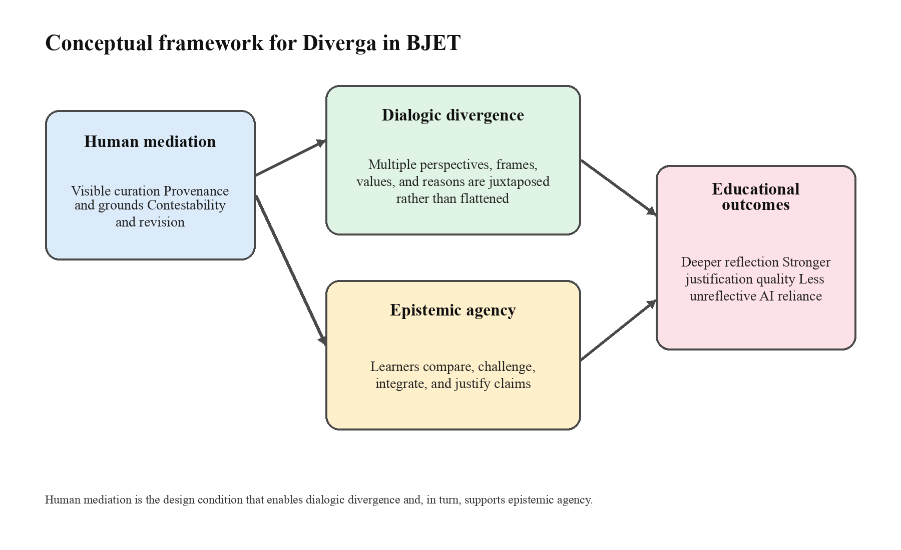
Note. The figure summarizes the proposed causal logic for a BJET-oriented paper: visible human mediation supports dialogic divergence, which in turn supports learners' epistemic agency and educational outcomes.
This framing leads to clearer BJET-facing research questions. A paper built from this framework can ask how visible human mediation shapes learners' epistemic agency, how students interpret curated traces of multiple perspectives, and whether this design reduces unreflective reliance while improving the quality of justification. Methodologically, the strongest path is a staged design-based program: qualitative elicitation with teachers and learners, iterative prototyping, and mixed-method evaluation combining interaction logs, artifacts, interviews, and a small number of validated measures (Prieto et al., 2025; Xu et al., 2025). This keeps the contribution educational and theoretical rather than merely technical.
The main implication is that the BJET version of the paper should not try to prove everything at once. It should avoid building a single study around agency, trust, engagement, anthropomorphism, diversity, and learning outcomes simultaneously. Instead, the paper should defend one coherent proposition: human-mediated dialogic divergence is an educational design strategy that can strengthen learners' epistemic agency in generative AI environments.
References
Prieto, L., Viberg, O., Yip, J., & Topali, P. (2025). Aligning human values and educational technologies with value-sensitive design. British Journal of Educational Technology, 56(4), 1299-1310. https://doi.org/10.1111/bjet.13602
Turvey, K., & Pachler, N. (2025). A topological exploration of convergence/divergence of human-mediated and algorithmically mediated pedagogy. British Journal of Educational Technology. Advance online publication. https://doi.org/10.1111/bjet.70007
Wegerif, R., & Casebourne, I. (2025). A dialogic theoretical foundation for integrating generative AI into pedagogical design. British Journal of Educational Technology. Advance online publication. https://doi.org/10.1111/bjet.70026
Xu, X., Qiao, L., Cheng, N., Liu, H., & Zhao, W. (2025). Enhancing self-regulated learning and learning experience in generative AI environments: The critical role of metacognitive support. British Journal of Educational Technology, 56(5), 1842-1863. https://doi.org/10.1111/bjet.13599

