The Calibration Gap: A Critical Review of Trust Research
in Educational AI and the Case for a Paradigm Shift

Hosung You
Department of Artificial Intelligence Convergence Education
Sungkyunkwan University

Author Note
Correspondence concerning this article should be addressed to Hosung You, Department of Artificial Intelligence Convergence Education, Sungkyunkwan University, Seoul, South Korea.

Abstract
The rapid integration of generative AI into education raises an urgent question: do learners trust AI systems appropriately? While Bastani et al. (2025) demonstrated that unrestricted AI tutoring access produced 17% lower performance on unassisted assessments—attributable to uncalibrated overtrust and cognitive offloading—the field lacks systematic tools for diagnosing where trust research stands and what it overlooks. This paper presents a critical review of 97 studies on trust in educational AI (2015–2026) from Web of Science, Scopus, PsycINFO, and supplementary citation tracking. We advance two contributions. First, we introduce a 5-domain Research Orientation Typology that classifies the corpus along a trust calibration maturity spectrum: Trust Adoption (D1, n=5), Trust Conceptualization (D2, n=11), Trust Design (D3, n=24), Trust Awareness (D4, n=41), and Trust Calibration (D5, n=16). This typology reveals that 83.5% of research remains below the calibration threshold, with 13 of 16 calibration-focused papers originating from adjacent disciplines rather than educational AI databases. Second, we argue for a paradigm shift from asking "Do learners trust AI?" to "Is their trust calibrated?"—a reframing grounded in the pronounced calibration gap we document: 84.5% of studies provided no explicit trust definition, only 7.2% measured trust empirically, and no study simultaneously measured both trust level and AI reliability. We introduce the Trust–AI Reliability Matrix as a diagnostic tool and outline a five-priority research agenda. The findings underscore that without calibration-oriented measurement and theory, the field cannot distinguish warranted trust from dangerous overreliance.
Keywords: trust calibration, educational AI, critical review, research typology, generative AI, metacognition

Introduction
The Problem: When Trust in AI Harms Learning
The promise of artificial intelligence in education rests on a deceptively simple assumption: that giving learners access to capable AI tools will improve learning. A landmark study by Bastani et al. (2025), published in the Proceedings of the National Academy of Sciences, dismantled this assumption. In a large-scale randomized controlled trial involving nearly a thousand students, unrestricted access to ChatGPT not only failed to improve learning outcomes but actively harmed them: students performed 17% worse on subsequent unassisted assessments. The mechanism was not a failure of AI capability but a failure of trust calibration—students uncritically accepted AI-generated outputs, bypassing the effortful cognitive processing that constitutes genuine learning. When a tutoring-oriented version that withheld direct answers was introduced, the negative effects disappeared.
This finding underscores a fundamental insight: the educational value of AI depends not on what the technology can do, but on whether learners trust it appropriately. The rapid integration of generative AI into higher education has created a design dilemma of autonomy and oversight. Granting AI systems broad autonomy risks fostering the uncritical dependence Bastani et al. (2025) documented. Imposing rigid constraints risks undermining the flexibility that makes AI-assisted learning potentially transformative (Kasneci et al., 2023). Navigating this dilemma requires understanding the mechanism that mediates between AI capability and learning outcomes—a mechanism that current research has largely overlooked.
This is not an isolated finding. Darvishi et al. (2024) documented how AI assistance can undermine student agency when learners defer uncritically to AI-generated feedback. Cotton et al. (2024) chronicled the academic integrity challenges that arise when students accept AI outputs without verification. In medical education, Kıyak et al. (2026) found that even explicit "ChatGPT can make mistakes" warnings failed to reduce overreliance on AI-generated clinical advice in a randomized controlled trial with medical students—a finding with direct implications for patient safety. The warning's failure to recalibrate trust illustrates a deeper issue: surface-level interventions that acknowledge AI fallibility without providing calibration tools leave the underlying trust miscalibration intact.
These cases share a common structure. In each, learners interact with AI systems whose reliability varies across tasks and domains, yet their trust in those systems operates as an undifferentiated global attitude rather than a calibrated, domain-specific judgment. The educational AI literature has documented this pattern extensively—but, as the present review demonstrates, it has not yet developed the measurement infrastructure or theoretical frameworks needed to move from documentation to intervention.
The Conceptual Problem: Trust Level Is Not Trust Calibration
The educational AI literature has grown rapidly, examining learning outcomes (Cotton et al., 2024), learner acceptance (Al-Adwan et al., 2023), and pedagogical integration (Baidoo-Anu & Ansah, 2023; Kasneci et al., 2023). Yet a critical variable remains undertheorized: learner trust. Trust is not merely an affective response but a calibration problem. Trust calibration refers to the correspondence between a person's trust in a system and the system's actual capabilities (Lee & See, 2004). Overtrust—where perceived capability exceeds actual capability—leads to uncritical acceptance and cognitive offloading (Risko & Gilbert, 2016; Sparrow et al., 2011). Undertrust leads to rejection of beneficial AI assistance (Parasuraman & Riley, 1997).
This distinction matters because current research overwhelmingly treats trust as a quantity to be maximized. Technology acceptance models (Davis, 1989; Venkatesh et al., 2003) position trust as a predictor of adoption—higher trust predicts greater use. But the Bastani et al. (2025) finding demonstrates precisely the problem with this logic: students who trusted ChatGPT more used it more, and learned less. The issue was not too little trust but miscalibrated trust—trust that did not correspond to the AI's actual pedagogical value for the given task.
The calibration concept introduces a crucial nuance absent from current discourse. A student who reports high trust in ChatGPT for summarizing well-documented historical events may be well-calibrated—the AI is indeed reliable for that task. The same student reporting identical trust for ChatGPT's ability to solve novel mathematical proofs is dangerously miscalibrated, because the AI's reliability for mathematical reasoning is substantially lower. Trust level is identical; calibration differs entirely. Without measuring both trust and the reliability baseline against which trust should be evaluated, the field cannot distinguish these states.
Existing Research Limitations
Despite the centrality of trust calibration, existing frameworks do not adequately address it. Technology acceptance models (Davis, 1989; Venkatesh et al., 2003) treat trust as a predictor of adoption, structurally unable to accommodate the possibility that adoption itself may be harmful when trust is miscalibrated. Self-regulated learning frameworks (Zimmerman, 2000; Winne & Hadwin, 1998) address calibration of self-judgments but not calibration of judgments about external AI systems. The trust-in-automation tradition (Lee & See, 2004; Hoff & Bashir, 2015) explicitly models calibration but has not been systematically translated to educational contexts where the user's cognitive development is itself at stake.
The result is a field that has produced extensive research on trust in educational AI without the conceptual or measurement infrastructure to assess whether that trust is warranted. Recent work has begun to bridge this gap—Pandey et al. (2025) examined epistemic trust in generative AI, and Lee et al. (2025) identified metacognitive sensitivity as a mechanism for trust calibration—but these contributions remain isolated rather than paradigmatic.
What is missing is not individual studies but a systematic accounting of where the field stands and what it overlooks: a diagnostic that can guide the transition from trust-level to trust-calibration research. The present paper provides this diagnostic by mapping the entire trust-in-educational-AI corpus onto a calibration maturity spectrum, identifying precisely where the field concentrates its attention and where critical blind spots persist.
Contributions
This paper addresses this gap through two contributions:
1. A 5-domain Research Orientation Typology that classifies 97 coded papers along a trust calibration maturity spectrum (D1–D5), revealing where the field concentrates its attention and where critical blind spots persist. This typology provides a diagnostic framework for the calibration gap—the finding that 83.5% of research operates below the calibration threshold.
2. A paradigm shift argument from trust-level to trust-calibration research, grounded in the empirical evidence of the calibration gap and operationalized through the Trust–AI Reliability Matrix, a diagnostic tool for assessing the alignment between learner trust and AI reliability.
Together, these contributions move beyond the conventional approach of cataloging what is known about trust in educational AI. Instead, they provide a structural diagnosis of what the field cannot currently see—and a framework for redirecting attention toward the questions that matter most for learner outcomes.
Research Questions
Three research questions guide this inquiry:
• RQ1: How does existing research approach trust in educational AI, and what research orientations characterize the field?
• RQ2: To what extent does current research address trust calibration, and where does a calibration gap persist?
• RQ3: What theoretical and methodological reframing is needed to advance trust calibration research in educational AI?
RQ1 motivates the Research Orientation Typology; RQ2 drives the calibration gap diagnosis; RQ3 grounds the paradigm shift argument and research agenda.
Conceptual Foundation
Trust Calibration: From Automation to Education
Lee and See (2004) defined trust as "the attitude that an agent will help achieve an individual's goals in a situation characterized by uncertainty and vulnerability" (p. 54). Critically, they distinguished trust level from trust calibration: the former captures how much a person trusts a system; the latter captures whether that trust corresponds to the system's actual reliability. A person with high trust in a highly reliable system is well-calibrated; the same level of trust directed at an unreliable system constitutes dangerous overtrust. This distinction—between the magnitude and the accuracy of trust—is foundational to the present paper.
Trust calibration fails in two modes. Overtrust occurs when trust exceeds the system's actual reliability, resulting in uncritical acceptance. In educational contexts, overtrust manifests as automation complacency (Parasuraman & Manzey, 2010) and cognitive offloading (Risko & Gilbert, 2016)—learners delegate not just task execution but the cognitive effort that produces learning. This is particularly insidious with large language models, whose fluent outputs mask variable reliability across domains (Ji et al., 2023). Bastani et al. (2025) documented precisely this mechanism: students bypassed productive struggle by accepting AI-generated solutions. Undertrust occurs when trust falls below the system's actual capability, causing learners to reject beneficial AI assistance and forgo scaffolded learning opportunities (Parasuraman & Riley, 1997).
Hoff and Bashir (2015) extended this foundation with a three-layer model distinguishing dispositional trust (stable personality-level tendencies shaped by age, culture, and experience), situational trust (context-dependent, influenced by task environment and perceived risk), and learned trust (accumulated through direct experience with a specific system). This temporal layering is particularly important in education, where trust evolves across an entire semester rather than during a single encounter. A student's dispositional trust may lead to initial openness to AI tools, but learned trust—the layer most amenable to educational intervention—should differentiate based on accumulating evidence of the system's domain-specific reliability. When learned trust fails to update appropriately in response to reliability evidence, miscalibration persists. Mayer et al. (1995) proposed the Ability-Benevolence-Integrity (ABI) model, increasingly applied to human-technology interaction (Lankton et al., 2015). In educational AI, ability maps to domain-specific accuracy, benevolence to the perception that the AI supports learning rather than replacing learner effort, and integrity to consistency and adherence to educational norms. De Visser et al. (2020) further contributed the concept of trust repair through calibration cues—system-initiated reliability signals that can restore appropriate trust levels after violations.
Translating these frameworks to education demands attention to what makes educational AI distinctive. Unlike industrial automation, where the user's goal is task completion, educational AI operates in a domain where the "user" is simultaneously a learner. This creates what we term the learner paradox: the most helpful AI response (providing the correct answer) may be the most pedagogically harmful one (depriving the learner of productive struggle). This paradox means that trust calibration in educational AI must account not only for accuracy-based trust—whether the AI's output is correct—but also for whether learners understand the pedagogical implications of their reliance patterns. A student who trusts ChatGPT to solve her calculus homework may be accurately trusting its mathematical capability while simultaneously miscalibrating the educational cost of bypassing the learning process.
SRL Calibration Versus Trust Calibration
Existing educational research addresses calibration extensively—but almost exclusively in the context of self-regulated learning. SRL calibration (Winne & Hadwin, 1998; Greene & Azevedo, 2007; Panadero, 2017) refers to the accuracy of learners' judgments about their own knowledge and performance. A well-calibrated learner accurately assesses what they know and do not know, enabling adaptive study strategies. Decades of research have established SRL calibration as a powerful predictor of academic achievement (Dunlosky & Rawson, 2012), with metacognitive monitoring as the operative mechanism (Nelson & Narens, 1990; Pieschl, 2009).
Trust calibration differs fundamentally from SRL calibration in its locus of uncertainty. Where SRL calibration asks, "How accurately do I judge my own capabilities?", trust calibration asks, "How accurately do I judge the AI system's capabilities?" This shift from self to external system has profound implications. SRL calibration improves through metacognitive training that enhances self-monitoring (Schraw, 1998). Trust calibration requires knowledge of the AI system's reliability profile—its strengths, limitations, and failure modes—a form of AI literacy (Long & Magerko, 2020) that goes beyond general self-regulation.
The distinction is not merely semantic. Consider a student who accurately recognizes that she struggles with integral calculus (high SRL calibration). When she turns to ChatGPT, however, she may grossly overestimate the AI's mathematical reasoning accuracy, accepting a subtly incorrect solution without verification (low trust calibration). Her SRL calibration does not protect her from trust miscalibration because the two involve different objects of judgment and different informational requirements. Existing SRL frameworks (Zimmerman, 2000; Winne & Hadwin, 1998; Panadero, 2017) address the first type of calibration; the second—trust calibration in AI-mediated learning—remains largely unaddressed.
Emerging work in adjacent fields supports this argument. Lee et al. (2025) identified metacognitive sensitivity as a key mechanism for calibrating trust with AI, establishing a direct conceptual bridge between metacognition research and trust calibration. Lee and Bosch (2025) showed that calibration discrepancy predicts subsequent metacognitive strategy use—directly linking trust calibration to SRL processes. Steyvers and Peters (2025) examined how metacognition and uncertainty communication interact between humans and large language models, further underscoring the need for calibration-specific frameworks. Lee, Lee, and Bosch (2025) found that learning behaviors mediate the effects of metacognitive calibration in AI-supported learning, suggesting that the two types of calibration interact in complex ways. This paper argues that trust calibration constitutes a distinct regulatory challenge demanding its own theoretical attention and design solutions. While SRL calibration has generated a robust research program with validated instruments, intervention designs, and longitudinal evidence (Pieschl, 2009; Panadero, 2017), trust calibration in educational AI remains at the pre-paradigmatic stage—lacking even the basic measurement infrastructure that SRL calibration has long enjoyed.
Why TAM/UTAUT Cannot Capture Calibration
Technology acceptance models constitute the most common theoretical framework in educational AI trust research. Yet their structural design makes them incapable of addressing calibration. In TAM (Davis, 1989) and UTAUT (Venkatesh et al., 2003), trust functions as one predictor among several—alongside perceived usefulness, ease of use, and social influence—of a single outcome: adoption intention. This architecture has two consequences relevant to calibration.
First, trust is always positioned as a variable to be maximized: higher trust predicts greater adoption, and greater adoption is implicitly desirable. There is no conceptual space for the possibility that trust can be too high—that the optimal trust level depends on the system's actual reliability for a given task. The very question the calibration lens asks—"Is this level of trust warranted?"—is structurally invisible within TAM/UTAUT.
Second, these models lack an AI reliability axis. They capture the learner's perceptions but not the system's actual capabilities. Without simultaneous measurement of both trust and reliability, calibration—the correspondence between the two—cannot be assessed. This is not a minor limitation; it is a structural blind spot that, following Kuhn (1962), characterizes what happens when a paradigm's assumptions render certain questions invisible. The field's reliance on technology acceptance frameworks has systematically directed attention toward the question "Do learners trust AI?" while obscuring the more consequential question "Is their trust calibrated?"
Review Approach
Review Type and Justification
This paper adopts a critical review approach (Grant & Booth, 2009). Unlike systematic or scoping reviews that aim for exhaustive coverage, a critical review prioritizes theoretical synthesis, critical appraisal, and gap identification to motivate new conceptual contributions (Pare et al., 2015). This choice reflects the paper's dual contribution: the Research Orientation Typology requires a corpus large enough for typological analysis, while the calibration gap diagnosis and paradigm shift argument require integrative theoretical reasoning rather than exhaustive enumeration. The critical review methodology is well-suited to this combination of empirical pattern identification and conceptual development, consistent with recognized review typologies (Peters et al., 2020). The approach follows Pare et al.'s (2015) criteria for critical reviews: going beyond describing the literature to analyzing, synthesizing, and reconceptualizing the field's orientation.
Search Strategy
We searched Web of Science, Scopus, and PsycINFO (2015–2026) combining trust-related terms ("trust" OR "trust calibration" OR "overtrust" OR "reliance" OR "overreliance") with educational AI terms ("educational AI" OR "AI-assisted learning" OR "generative AI" OR "intelligent tutoring" OR "AI in education"). This temporal scope captures the maturation of intelligent tutoring systems and the transformative period following public LLM releases. Papers were selected based on relevance to trust dynamics in educational AI, prioritizing: (a) empirical studies measuring trust or calibration; (b) theoretical frameworks addressing trust in learning environments; and (c) studies from adjacent fields with clear educational applicability.
Database searches were supplemented with backward and forward citation tracking from seminal works (Lee & See, 2004; Mayer et al., 1995; Hoff & Bashir, 2015; Bastani et al., 2025), yielding 16 additional papers from the human factors and HCI literature that directly address trust calibration measurement and intervention. We acknowledge that this supplementary search was purposively designed to capture calibration-relevant work; the resulting asymmetry between database-sourced and supplementary papers is reported transparently as evidence of the disciplinary blind spot rather than treated as a neutral sampling outcome. Through this process, 147 papers were identified for full-text analysis, comprising 81 papers from database searches and 16 from supplementary citation tracking (see Figure 1 for the PRISMA-style selection flow). Of these, 97 were coded using the 32-field coding scheme; the remaining 50 could not be coded due to full-text access limitations at the time of analysis. The coded corpus spans publication years from 2019 to 2026, with a heavy concentration in 2025 (64.9%), reflecting the rapid growth of trust-related AI scholarship following public LLM releases. Study types include reviews (50.5%), empirical studies (37.1%), theoretical papers (8.2%), and mixed methods studies (4.1%).
Figure 1
PRISMA-style flow diagram of the literature search and selection process.
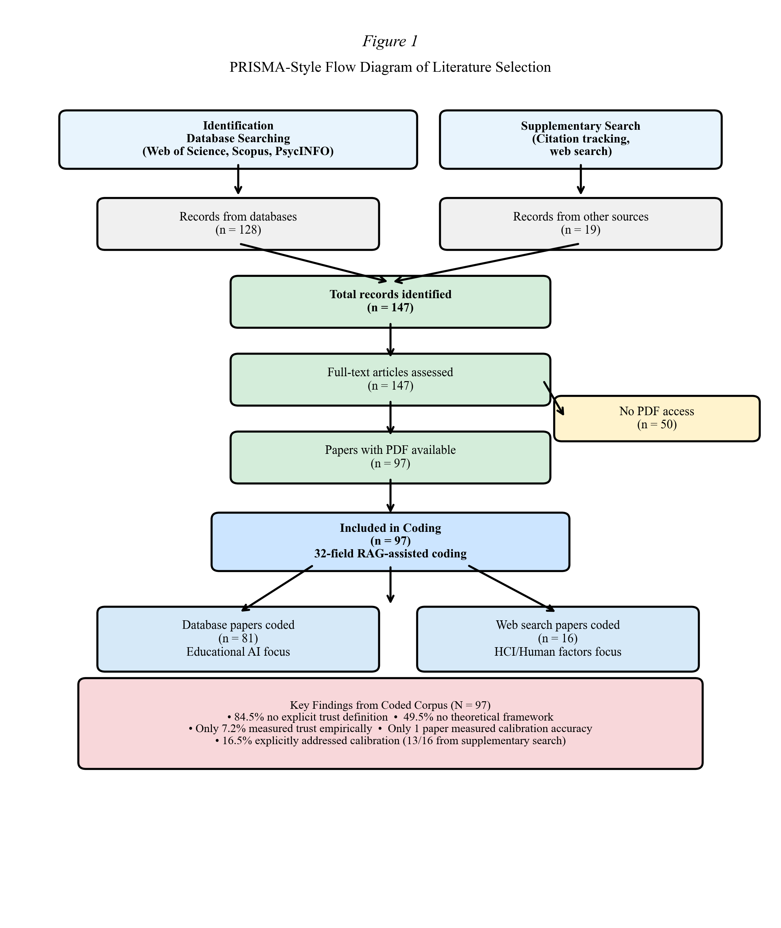
Coding and Analysis
Each paper was coded using a 32-field scheme capturing: bibliographic information (authors, year, source, DOI); trust conceptualization (definition presence, construct type, dimensionality); theoretical framework (named frameworks, engagement depth); measurement approach (trust measurement, calibration measurement, instrument type, measurement modality); calibration engagement (calibration addressed, overtrust discussed, undertrust discussed); and design features (scaffold proposed, scaffold type, oversight design). The full coding manual is available as a supplementary document.
Coding was conducted by the first author for all 97 papers. The second author independently coded a random subsample of approximately 20–30% to establish intercoder reliability. Cohen's kappa was computed for key categorical variables including addresses_calibration, overtrust_discussed, undertrust_discussed, scaffold_proposed, and theoretical_framework classification. Discrepancies were resolved through discussion; any remaining disagreements were adjudicated by consensus.
Selected works were analyzed thematically across three dimensions corresponding to the research questions: trust conceptualization and theoretical framing (RQ1), calibration engagement and measurement approaches (RQ2), and the calibration gap diagnosis motivating the paradigm shift argument (RQ3). Quantitative analysis of the coded data included frequency distributions, cross-tabulations (e.g., trust measured × calibration measured; domain × theoretical framework; domain × study type), and the domain distribution analysis reported in Section 4.
The 5-domain Research Orientation Typology was derived as a post-hoc classification using five coded variables (addresses_calibration, overtrust_discussed, undertrust_discussed, scaffold_proposed, theoretical_framework) applied through deterministic priority rules (see Section 4.1 and Appendix D). Because the typology is algorithmically derived from existing coded fields, its reliability is bounded by the reliability of its input variables. A typological approach was selected because it reveals structural patterns invisible in variable-by-variable analysis and provides the diagnostic power needed to identify the calibration gap (Bailey, 1994; Doty & Glick, 1994). This approach is consistent with Doty and Glick's (1994) argument that typologies constitute a unique form of theory building, organizing complex empirical landscapes into coherent configurations that generate testable predictions.
Methodological Limitations
This is not a full systematic review, and the search strategy does not claim exhaustive coverage. Several design choices constrain the findings and should be considered when interpreting the results. The literature search was limited to English-language publications, potentially excluding relevant work from non-Anglophone research traditions. 50 of 147 identified papers could not be coded due to full-text access limitations at the time of analysis, representing a potential source of selection bias. The supplementary citation tracking was purposively designed to capture calibration-relevant work from adjacent disciplines, introducing intentional selection bias that we report transparently throughout the findings. The resulting 16 supplementary papers are not representative of the broader educational AI corpus; rather, they serve as evidence that calibration research exists elsewhere while remaining absent from educational AI databases. These limitations and their implications for interpreting the domain distribution are discussed further in Section 7.1.
Findings: The Research Orientation Typology
Overview: Five Domains of Trust Research
To move beyond variable-by-variable reporting, we classified the 97 coded papers into a Research Orientation Typology comprising five domains arranged along a trust calibration maturity spectrum (Table 1; Figure 2). Each domain represents a qualitatively distinct orientation toward trust in educational AI, from acceptance-focused research (D1) through calibration-focused research (D5).
Figure 2
Research Orientation Typology distribution across five domains (D1–D5). The red dashed line marks the calibration threshold; 83.5% of studies fall below it (D1–D4), while only 16.5% reach D5 (Trust Calibration).
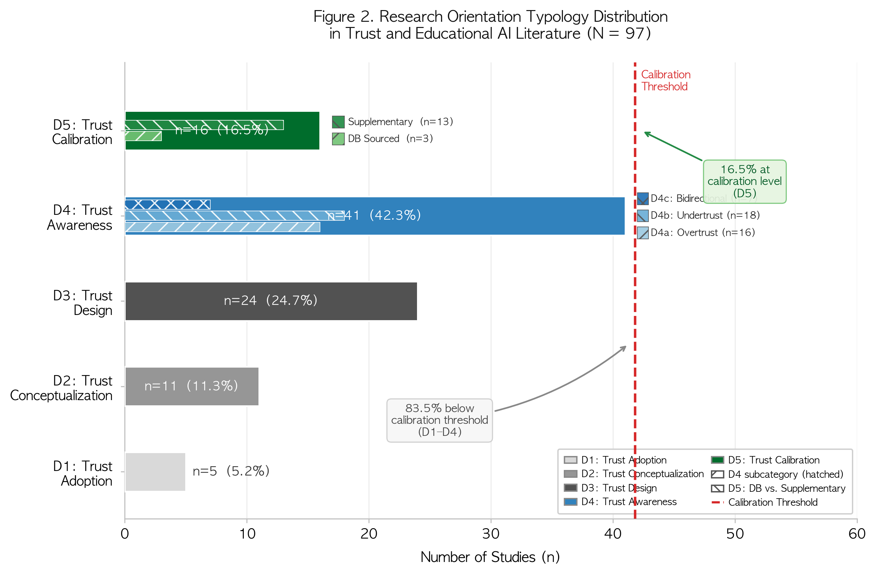
The classification uses five coded variables applied through deterministic priority rules (detailed in Appendix D). In order of priority: papers addressing calibration explicitly (addresses_calibration = "yes") are classified as D5; papers recognizing overtrust or undertrust with partial calibration engagement (addresses_calibration = "partially" AND at least one trust direction discussed) are classified as D4, with subcategories D4a (overtrust only), D4b (undertrust only), and D4c (both directions) based on directionality; papers proposing scaffolds without meeting D4/D5 criteria are D3; papers whose sole theoretical contribution is through TAM/UTAUT/DOI frameworks without other qualifying features are D1; and all remaining papers are D2. Priority ordering ensures that papers meeting multiple criteria are classified at their highest maturity level, preventing double-counting and ensuring mutually exclusive assignment.
The distribution reveals a field concentrated below the calibration threshold (Table 1; Figure 2): D1 (Trust Adoption, n=5, 5.2%), D2 (Trust Conceptualization, n=11, 11.3%), D3 (Trust Design, n=24, 24.7%), D4 (Trust Awareness, n=41, 42.3%), and D5 (Trust Calibration, n=16, 16.5%). Together, 83.5% of the corpus (D1–D4) operates without explicit calibration engagement. Only 16.5% reaches D5—and of those, 13 of 16 papers were identified through supplementary citation tracking from adjacent disciplines, not from the original educational AI databases. The corpus is temporally concentrated: 64.9% of papers were published in 2025, reflecting the rapid growth of GenAI-related trust scholarship.
D1: Trust Adoption (n=5, 5.2%)
Domain 1 encompasses studies that employ technology acceptance frameworks (TAM, UTAUT, DOI) as their sole theoretical orientation, treating trust exclusively as a predictor of AI adoption. In these studies, the research question is whether learners will adopt AI tools, with trust positioned alongside perceived usefulness, ease of use, and social influence as an antecedent of adoption intention. Representative D1 papers examine university students' intentions to use AI tools through survey instruments measuring acceptance constructs, reporting path coefficients from trust to behavioral intention.
The D1 orientation is structurally unable to address calibration because its dependent variable—adoption—is unidirectional. Higher trust leads to greater adoption, and the framework provides no mechanism for evaluating whether that trust is warranted. A student who trusts ChatGPT completely and adopts it for all tasks would score maximally on trust and adoption scales, regardless of whether the AI is reliable for those tasks. The limitation is not empirical but architectural: the framework's structure renders calibration invisible. The D1 papers constitute a methodologically rigorous but theoretically constrained tradition that, by design, cannot ask the question this review identifies as central. While their contributions to understanding adoption antecedents are valuable, their exclusive focus on acceptance means they cannot contribute to the calibration agenda without fundamental theoretical extension.
D2: Trust Conceptualization (n=11, 11.3%)
Domain 2 includes studies that discuss trust in educational AI at a general conceptual level without proposing design interventions, identifying specific miscalibration problems, or employing systematic theoretical frameworks. These papers acknowledge trust as a relevant variable in educational AI but treat it as self-evident rather than requiring operationalization. D2 papers typically review existing literature, identify trust as a concern in AI-mediated learning, and call for further research without specifying what form that research should take.
This domain reflects a broader pattern in the corpus: 84.5% of all 97 papers provided no explicit definition of trust, treating it as a concept requiring no specification. Only 9 papers (9.3%) offered an explicit operational definition, while 6 (6.2%) employed implicit definitions discernible from context. Yet trust is a documented multidimensional construct in both organizational (Mayer et al., 1995) and human factors traditions (Lee & See, 2004; Hoff & Bashir, 2015). The absence of definitional precision in D2 papers—and across much of the corpus—means that fundamentally different phenomena (dispositional tendencies, context-specific judgments, accumulated experiential assessments) are collapsed into a single undifferentiated variable, obscuring the kind of fine-grained analysis required for calibration research. The vast majority of the corpus—86 of 97 papers (88.7%)—conceptualized trust as "trust in AI" as a general construct, while only 6 papers (6.2%) employed the more specialized trust-in-automation framing from human factors research.
D3: Trust Design (n=24, 24.7%)
Domain 3 represents a substantial portion of the corpus: studies that propose scaffolds, design features, or interventions related to trust in AI-assisted learning. These papers go beyond conceptual discussion to recommend concrete design approaches. Overall, 63 papers (64.9%) across the corpus proposed some form of scaffold, with transparency mechanisms being the most common type (24 papers, 24.7%), followed by multiple scaffold combinations (24 papers, 24.7%), and other approaches (9 papers, 9.3%). The 24 D3 papers are those whose scaffold proposals are their primary contribution but which lack calibration criteria or trust direction awareness.
The critical limitation of D3 research is the absence of calibration criteria. When a D3 paper proposes "increasing transparency to build trust," it implicitly assumes that higher trust is always desirable. But transparency can paradoxically worsen calibration: if an AI system presents a confidently wrong answer with a clear, fluent explanation of its reasoning process, transparency may increase trust in an unreliable output. Consider an AI writing assistant that explains its essay structure with articulate reasoning—this transparency may lead a student to accept prose that sounds authoritative but contains factual errors. The design question should not be "How do we increase trust?" but "How do we align trust with reliability?"—a question that D3 research, by definition, does not ask.
Notably, metacognitive scaffolds—arguably the most directly relevant to calibration—appeared in only 3 papers (3.1%) of the total corpus, compared to 24 papers proposing transparency scaffolds. This asymmetry is consequential: transparency addresses the information available for trust judgments, while metacognitive scaffolds address the process by which learners evaluate that information. Calibration requires both, but the field overwhelmingly emphasizes the former. The near-absence of metacognitive scaffolds suggests that the field's design thinking is oriented toward giving learners more information about AI systems rather than developing learners' capacity to evaluate that information—a distinction that maps directly onto the difference between transparency-driven and calibration-driven design.
D4: Trust Awareness (n=41, 42.3%)
Domain 4 is the largest in the corpus, comprising 42.3% of all coded papers. These studies recognize and discuss overtrust and/or undertrust as problems, engage partially with calibration, but stop short of explicitly measuring or systematically addressing trust calibration. D4 represents the field's growing awareness that trust can be miscalibrated—coupled with an inability to move from problem recognition to problem measurement.
The D4 subcategories reveal the directionality of the field's trust awareness (Table 2). D4a (Overtrust Recognition, n=16, 16.5%) includes papers that discuss overreliance, uncritical acceptance, or automation complacency without addressing undertrust. These papers typically warn about students copying AI-generated content without verification or accepting AI recommendations uncritically, but they do not measure whether the observed reliance exceeds the AI's actual reliability—a measurement that would be required to confirm overtrust rather than merely infer it.
D4b (Undertrust Recognition, n=18, 18.6%) includes papers discussing AI skepticism, rejection, or resistance without addressing overtrust. These papers often frame learner reluctance to adopt AI tools as a barrier to be overcome, reflecting the adoption-oriented framing characteristic of the broader field.
D4c (Bidirectional Awareness, n=7, 7.2%) includes papers recognizing both directions of miscalibration. These papers are the most theoretically sophisticated within D4, acknowledging that trust can be both excessive and insufficient, but they remain below the D5 threshold because they do not measure or systematically address calibration.
The finding that D4b slightly exceeds D4a is notable: in the educational AI discourse, concerns about learners rejecting AI (undertrust) are marginally more common than concerns about learners overrelying on AI (overtrust). This asymmetry may reflect the field's prevailing interest in promoting AI adoption—a framing in which resistance to AI is coded as a problem to be solved. Yet the calibration perspective suggests that whether rejection or acceptance is problematic depends entirely on the AI's actual reliability for the given task. A learner who rejects an unreliable AI recommendation is exhibiting calibrated avoidance, not a problem requiring intervention.
The D4c papers—those recognizing both overtrust and undertrust—are theoretically closest to calibration research yet remain below the threshold because they identify the two failure modes without establishing measurement approaches for determining which mode applies in a given context. The 7 D4c papers acknowledge that trust can be both too high and too low, but none proposes methods for assessing whether a specific learner's trust is appropriate relative to the AI's actual capability.
The central insight from D4 is that recognizing a problem is not the same as measuring it. A paper that warns about student overreliance on ChatGPT for essay writing but does not assess whether students' trust in ChatGPT's writing ability corresponds to ChatGPT's actual writing reliability has identified a potential miscalibration without establishing whether one exists. This distinction—between awareness and measurement—is the threshold separating D4 from D5. The D4 cluster's dominance (42.3% of the corpus) indicates that the field is acutely aware of trust miscalibration as a problem but lacks the conceptual and measurement infrastructure to move from problem recognition to problem measurement.
D5: Trust Calibration (n=16, 16.5%)
Domain 5 encompasses the 16 papers that explicitly address trust calibration as a construct, measurement target, or intervention goal (Table 3). These papers engage directly with the correspondence between trust and system reliability, whether through experimental manipulation of calibration conditions, development of calibration measures, or systematic review of calibration methods.
The disciplinary composition of D5 is the most consequential finding for the calibration gap argument. Only 3 of the 16 D5 papers (#12 Safarov et al., 2026; #13 Wang et al., 2026; #101 Carter et al., 2024) were identified through the original educational AI database searches. The remaining 13 came from supplementary citation tracking targeting the human factors, HCI, and cognitive science literatures. In percentage terms: only 3 of 81 database-sourced papers (3.7%) reached D5, compared to 13 of 16 supplementary papers (81.3%). This asymmetry is not a methodological artifact; the supplementary search was purposively designed to find calibration-relevant work. Rather, the asymmetry is the finding: trust calibration is being studied productively in adjacent disciplines but has barely penetrated educational AI research.
The three database-sourced D5 papers share an important characteristic: all three employ Lee and See's (2004) or Hoff and Bashir's (2015) trust-in-automation framework, suggesting that explicit adoption of calibration-oriented theoretical frameworks is a necessary condition for calibration-focused research in educational AI. Carter et al. (2024) applied the Human-Automation Trust Expectation Model to educational contexts; Safarov et al. (2026) and Wang et al. (2026) both drew on Lee and See's framework combined with trust-in-automation constructs. This pattern reinforces the TAM lock-in argument: the theoretical framework researchers choose determines whether calibration becomes visible as a research question.
Key D5 exemplars illuminate what calibration research looks like (Table 3). Okamura and Yamada (2020) used behavioral dependence switching as a calibration proxy in human-AI collaboration tasks, demonstrating that adaptive calibration interventions can shift reliance patterns. Ma et al. (2024) demonstrated that self-confidence calibration prompts improve reliance behavior in AI-assisted decision making, providing direct evidence that metacognitive interventions can affect calibration. Li et al. (2024) directly manipulated AI confidence calibration levels to assess their effects on user trust, establishing a causal pathway from system-level calibration cues to user-level trust responses. Lee et al. (2025) established metacognitive sensitivity as a mechanism linking metacognition to trust calibration, providing the most direct conceptual bridge between SRL and trust calibration literatures. Vasconcelos et al. (2023) showed that explanations can reduce overreliance on AI systems during decision-making, though the effect operates through increased cognitive engagement rather than calibration per se. Wischnewski et al. (2023) surveyed 96 studies on trust calibration measurement for automated systems—a comprehensive mapping that notably identified zero studies from educational contexts. Mehrotra et al. (2024) systematically reviewed approaches to fostering appropriate trust in human-AI interaction, identifying the measurement gap as a central obstacle.
These D5 studies demonstrate three important points. First, calibration measurement methods exist and have been productively applied in adjacent disciplines. Second, these methods have not been adopted in educational AI research—the gap is one of disciplinary disconnection, not methodological impossibility. Third, the emerging metacognition-calibration bridge (Lee et al., 2025; Lee & Bosch, 2025; Steyvers & Peters, 2025) suggests that educational researchers are uniquely positioned to advance calibration research by connecting established SRL traditions with the trust calibration construct.
Cross-Cutting Observations
Four patterns cut across all five domains and provide additional context for the calibration gap argument.
First, the theoretical landscape is profoundly fragmented (Figure 5). Nearly half (49.5%) of papers employed no identifiable theoretical framework, proceeding directly from research questions to investigation without anchoring their inquiry in established theory. Among papers that did employ a framework, TAM/UTAUT variants constituted the largest cluster (22.7%), followed by DOI (13.4%) and AIED-specific frameworks (13.4%). Calibration-relevant frameworks—Lee and See's trust-in-automation model (7.2%) and Hoff and Bashir's three-layer model (2.1%)—appeared in a combined 9.3% of papers, less than half the prevalence of TAM/UTAUT alone. SRL frameworks, which are pedagogically most relevant to calibration given their emphasis on metacognitive monitoring, appeared in only 5 papers (5.2%). The calibration-relevant frameworks are marginalized precisely in the field where calibration matters most.
Figure 5
Theoretical framework landscape of the 97 coded studies. Nearly half (49.5%) employed no identifiable framework. Calibration-relevant frameworks represent only 9.3%.
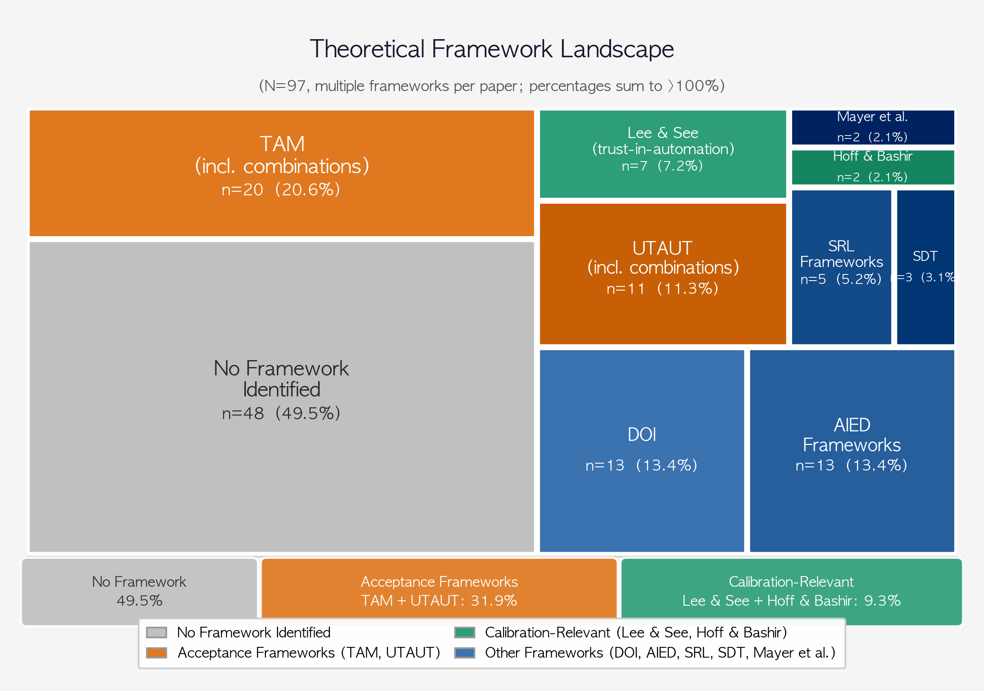
Second, the measurement infrastructure is sparse. Only 7 papers (7.2%) measured trust empirically in any form, only 1 (1.0%) measured calibration accuracy, and none measured both simultaneously. Among measurement approaches, the prevailing strategy relies on Likert-type self-report instruments administered as cross-sectional surveys. Behavioral measures of trust—examining AI output acceptance rates, usage frequency, or task delegation patterns—remain rare. Process-level measures (time spent verifying AI outputs, modification patterns, information-seeking behaviors) are entirely absent from the corpus. Yet process measures are precisely what would be needed to assess trust calibration in real time.
Third, the study types reveal a field heavy on synthesis and light on primary data: 50.5% of papers were reviews (narrative or systematic), 37.1% were empirical, 8.2% theoretical, and 4.1% mixed methods. D5 stands out as the most empirically active domain (56% empirical), while D2 is the most review-heavy (73%). The predominance of reviews across the corpus is not inherently problematic, but it means the field's conclusions about trust are built more on synthesis of existing knowledge than on new empirical evidence—particularly problematic when the existing knowledge base lacks calibration measurement.
Fourth, the corpus is temporally concentrated: 64.9% of papers were published in 2025, reflecting the rapid growth of GenAI-related trust scholarship following ChatGPT's public release. This recency suggests the field is in a formative period where paradigmatic choices—including whether to adopt a calibration lens—are still being made. The window for shifting the field's orientation from trust-level to trust-calibration research may be particularly open during this formative phase.
The Calibration Gap
Gap Diagnosis: Three Dimensions
The findings converge on a multidimensional gap at the intersection of trust conceptualization, measurement, and disciplinary exchange.
The definitional dimension. Of 97 papers, 82 (84.5%) provided no explicit definition of trust. Without definitional precision, the field cannot distinguish between trust as an attitude (Lee & See, 2004), trust as a belief about trustee characteristics (Mayer et al., 1995), and trust as behavioral intention (Davis, 1989)—constructs with different measurement requirements, antecedents, and implications for calibration. The absence of definition is not merely a scholarly oversight; it reflects a field treating trust as self-evident, which precludes the kind of construct refinement necessary for calibration research.
The measurement dimension. The progressive attrition from acknowledgment to measurement reveals the gap's empirical depth (Figure 3; Table 4). While 51 papers (52.6%) discussed overtrust or undertrust and 42 (43.3%) partially addressed calibration, only 16 (16.5%) explicitly engaged with calibration as a construct—and of those, only 3 came from educational AI databases. Most critically, only 7 papers (7.2%) measured trust empirically in any form, and only 1 measured calibration accuracy. No paper in the corpus measured both trust level and calibration simultaneously. The funnel from 97 to 0 illustrates that the gap is not merely at the periphery but at the core of the measurement enterprise.
Figure 3
The calibration gap: from acknowledgment to measurement. Left panel shows progressive attrition from total corpus (N=97) to empirical calibration measurement (n=1). Right panel compares calibration studies in automation (96; Wischnewski et al., 2023) versus educational AI (0).
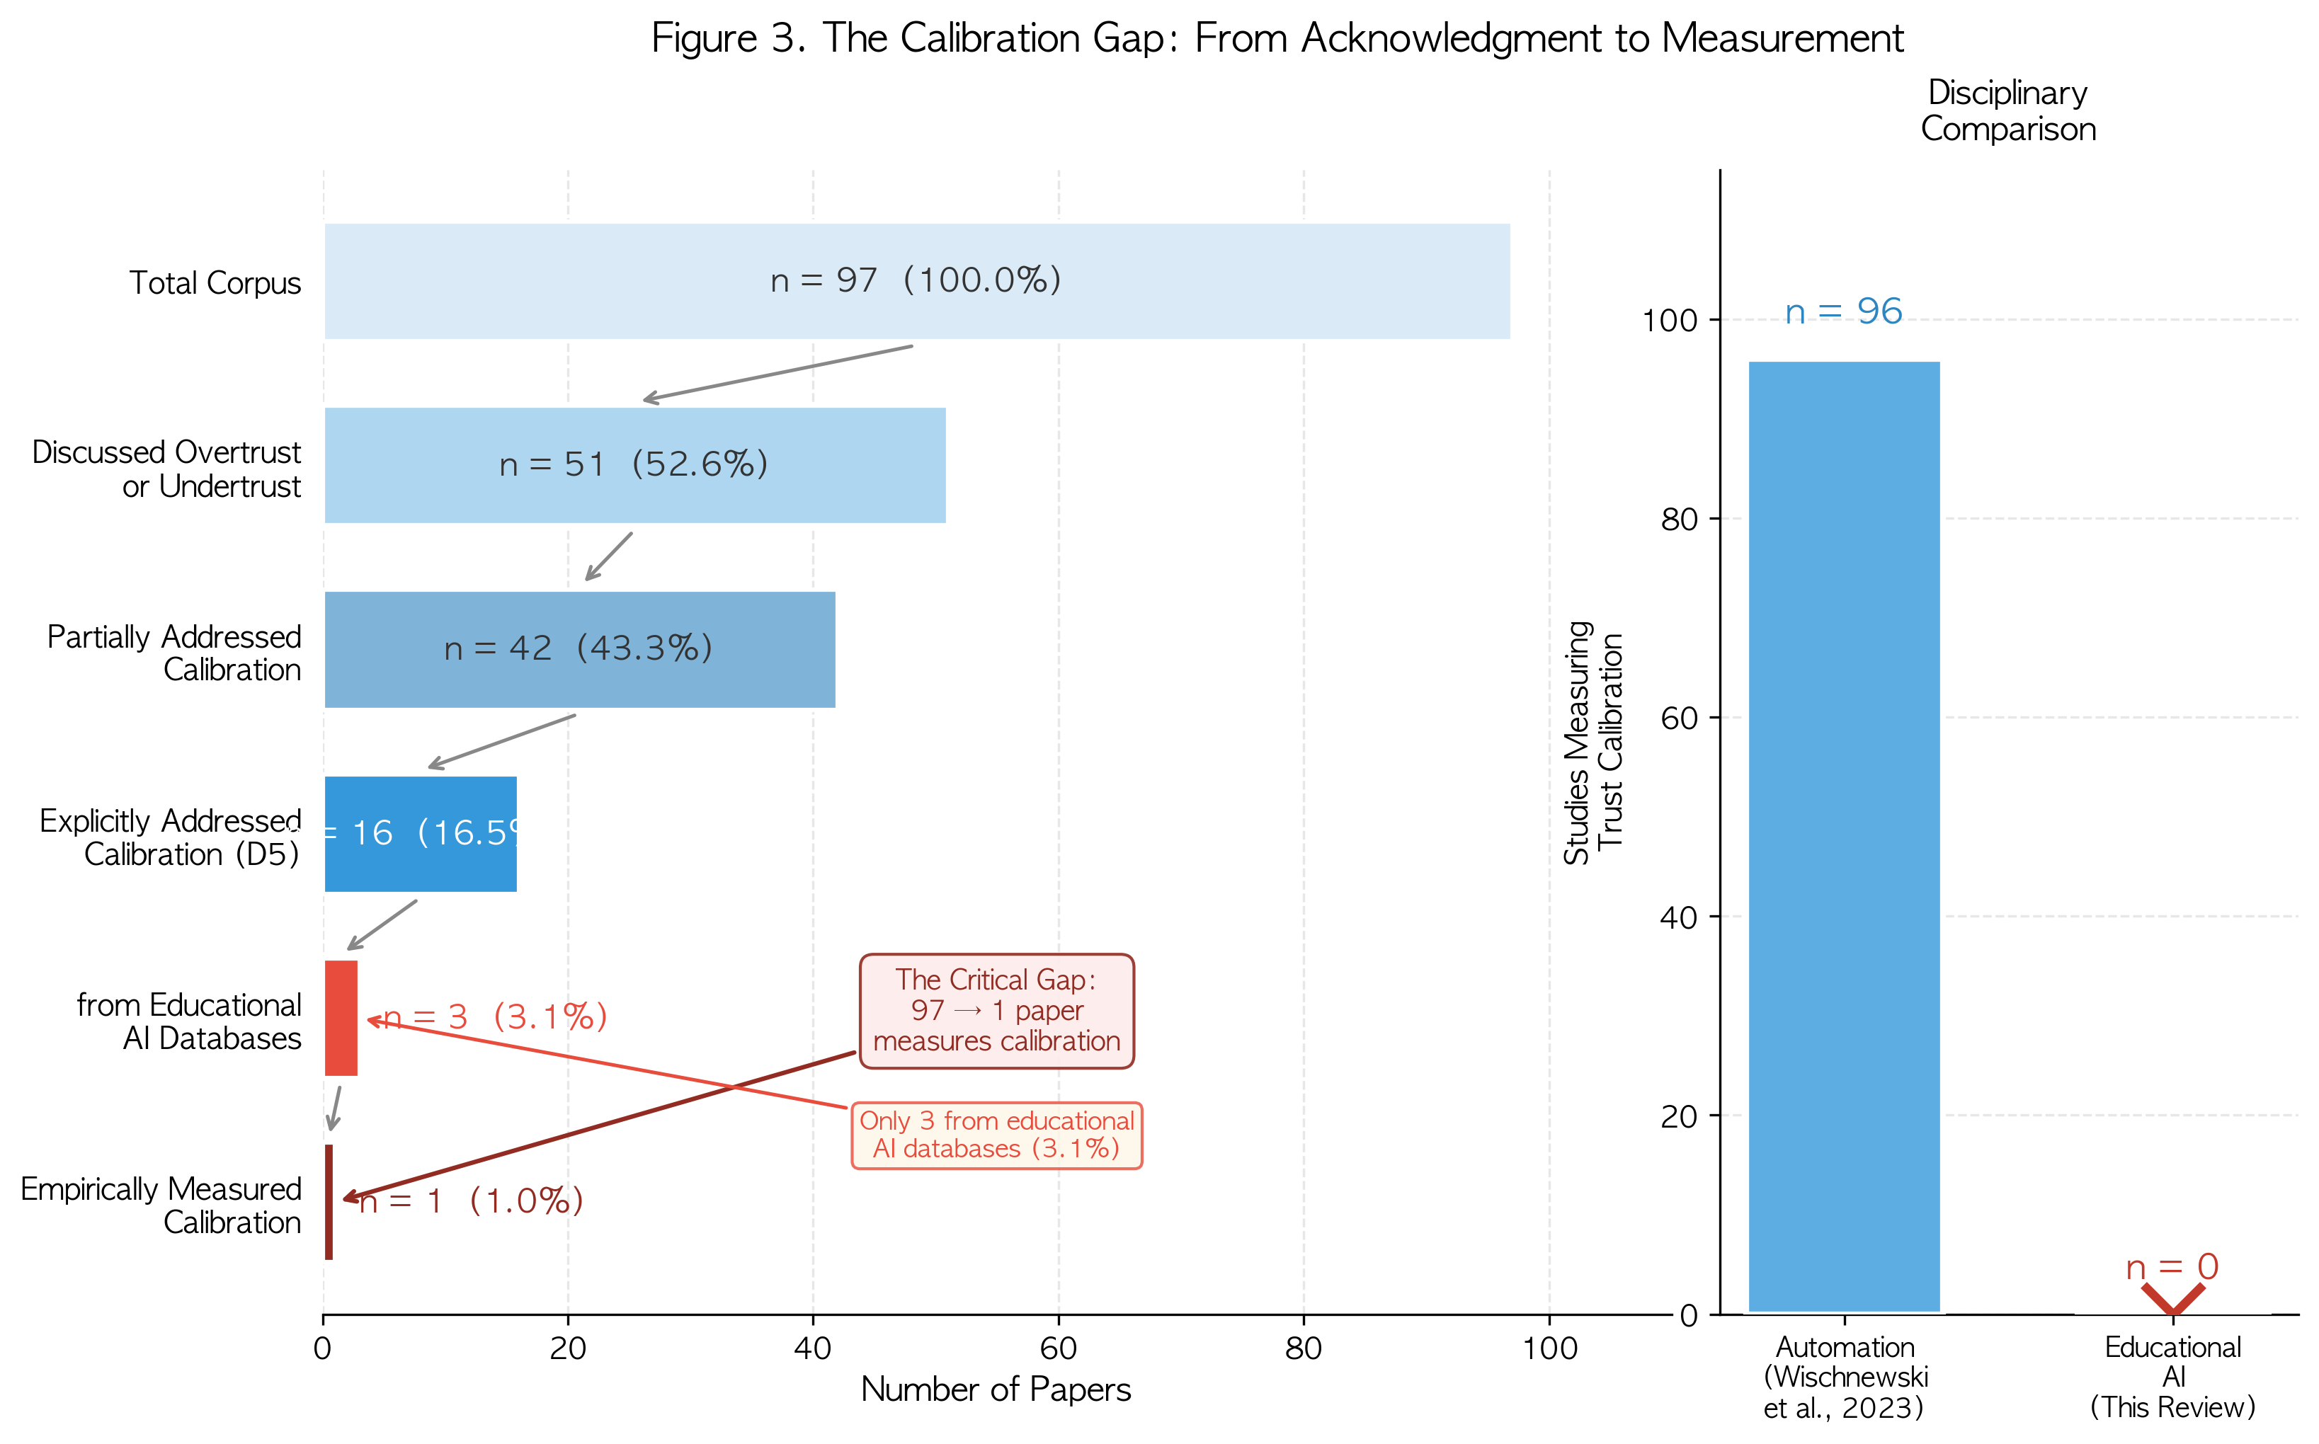
This absence reflects a fundamental measurement logic problem. To determine whether a learner's trust is calibrated requires two simultaneous measurements: (a) the learner's trust level and (b) the AI system's actual reliability for the given task. Measuring only trust level—as the existing literature overwhelmingly does—is analogous to measuring a student's confidence without measuring their actual performance: one can quantify the attitude but cannot determine whether it is warranted. A learner who reports high trust in an AI system that is, in fact, highly reliable for the given task is well-calibrated. A learner who reports equally high trust in a system that is unreliable for the given task is dangerously miscalibrated. Current measurement approaches cannot distinguish between these two states because they assess trust level without reference to the reliability baseline against which trust should be evaluated.
The disciplinary dimension. The D5 source analysis reveals a striking asymmetry: 13 of 16 calibration-focused papers originated from adjacent disciplines (human factors, HCI, cognitive science), not from educational AI databases. This pattern indicates not a methodological impossibility but a disciplinary disconnection. The contrast with Wischnewski et al.'s (2023) finding is instructive: their survey identified 96 studies measuring trust calibration for automated systems, demonstrating that calibration measurement is a mature research area in human factors. Yet none of those 96 studies addressed educational contexts.
We acknowledge that our supplementary search was designed to find calibration-relevant work, and therefore the 13:3 ratio partly reflects search strategy. However, the fact that only 3 of 81 database-sourced papers (3.7%) reached D5 is itself the evidence: the original educational AI databases, searched with broad trust-related terms, yielded almost no calibration-focused work. The gap is in the field, not in the search. This disciplinary disconnection means that educational AI researchers are, in effect, working on trust without access to the most developed body of calibration theory and measurement—a disconnection that the present review aims to make visible and actionable. The bridge-building work of Lee et al. (2025) and Lee and Bosch (2025), who explicitly connect metacognitive calibration from the SRL tradition with trust calibration from the automation tradition, demonstrates that disciplinary integration is both possible and productive. Yet these papers remain exceptional rather than representative.
Why the Gap Persists: TAM Lock-In
The persistence of the calibration gap is not random; it reflects a structural relationship between the field's dominant theoretical framework and the questions it can ask. TAM/UTAUT variants appeared in 22.7% of the corpus—the most common named framework family—and their structural design systematically directs attention toward adoption while rendering calibration invisible.
In TAM, trust functions as an independent variable predicting adoption intention. This creates what we term TAM lock-in: a self-reinforcing cycle in which (a) researchers adopt TAM because it is established and widely published, (b) TAM structures research around adoption questions, (c) adoption-focused research produces findings about trust level but not trust calibration, and (d) the absence of calibration findings reinforces the perception that calibration is not a productive research direction. The result is a form of what Kuhn (1962) described as "normal science" operating within a paradigm that makes certain questions invisible—not because they are unimportant, but because the paradigm's assumptions do not accommodate them.
The domain × framework cross-tabulation supports this interpretation (Figure 5). Calibration-relevant frameworks (Lee & See, Hoff & Bashir) are concentrated in D5, appearing in 6 of the 7 Lee & See papers that reached D5 but in zero D1, D2, or D3 papers. Conversely, TAM dominates D1 (by definition) and is prevalent in D3. The theoretical frameworks researchers choose shape which questions they can ask—and by extension, which domain of the typology their work inhabits.
The 49.5% of papers without any theoretical framework may paradoxically represent an opportunity: atheoretical research is not locked into TAM's structural limitations and could potentially be redirected toward calibration-oriented inquiry if appropriate frameworks were available and accessible. However, the depth of framework engagement further qualifies the prospects for such redirection: among papers employing a framework, 24 (24.7%) engaged at a superficial level, 21 (21.6%) at an applied level, and only 4 (4.1%) at a foundational level contributing to framework development. The predominance of superficial engagement suggests that even where frameworks are present, they often serve a legitimating function rather than a generative one.
The Cost of the Gap
The calibration gap is not merely an academic oversight; it carries concrete costs for educational practice and policy.
Bastani et al. (2025) documented one cost directly: 17% lower performance among students with unrestricted AI access, attributable to uncalibrated overtrust. Without calibration measurement infrastructure, educational institutions cannot distinguish between productive AI use (calibrated trust) and harmful AI dependence (overtrust)—and therefore cannot intervene before harm occurs. This cost is likely to scale: as AI tools become more integrated into curricula, the proportion of learner-AI interactions subject to potential miscalibration grows, yet the measurement infrastructure for detecting miscalibration remains absent.
In medical education, the cost takes on additional urgency. Kıyak et al. (2026) demonstrated that ChatGPT warnings fail to reduce overreliance on AI-generated clinical advice in randomized controlled conditions, suggesting that surface-level interventions are insufficient to correct trust miscalibration in high-stakes domains. If future physicians develop uncalibrated trust in AI diagnostic tools during training, the consequences extend far beyond educational outcomes.
The cost extends beyond individual learners to institutional and policy domains. The EU AI Act (European Union, 2024) classifies educational AI as high-risk (Annex III), requiring human oversight mechanisms and transparency provisions. UNESCO (2023) guidelines for generative AI in education emphasize the need for critical evaluation skills and appropriate learner-AI relationships. The UNESCO AI Competency Framework for Teachers (UNESCO, 2024) explicitly includes helping students critically evaluate AI outputs as a core competency. Yet all these frameworks implicitly require what the field currently lacks: methods to assess whether learners' trust in AI is appropriate. Policy mandates for "trustworthy AI" without calibration infrastructure risk creating compliance frameworks that cannot operationalize their stated goals.
The emerging literature on cognitive offloading (Risko & Gilbert, 2016; Sparrow et al., 2011) suggests an additional, more insidious cost: when learners delegate cognitive effort to AI systems without calibrated trust, they may experience not just performance decrements on specific tasks but broader erosion of the metacognitive skills needed for independent learning. If trust miscalibration becomes habitual, the cost is not merely a worse grade on a single assessment but a fundamentally diminished capacity for autonomous intellectual engagement. The cumulative effect of uncalibrated trust across thousands of student-AI interactions per semester—multiplied across millions of learners worldwide—represents a systemic risk to educational quality that the current research infrastructure is unequipped to monitor, measure, or mitigate.
The Trust--AI Reliability Matrix: A Diagnostic Tool
To operationalize the calibration concept, we propose the Trust–AI Reliability Matrix (Figure 4), a 2×2 framework mapping learner trust (high vs. low) against AI reliability (high vs. low) for a given task.
Figure 4
The Trust–AI Reliability Matrix. Four quadrants map learner trust (high/low) against AI system reliability (high/low). Quadrant II (Overtrust) represents the condition documented by Bastani et al. (2025).
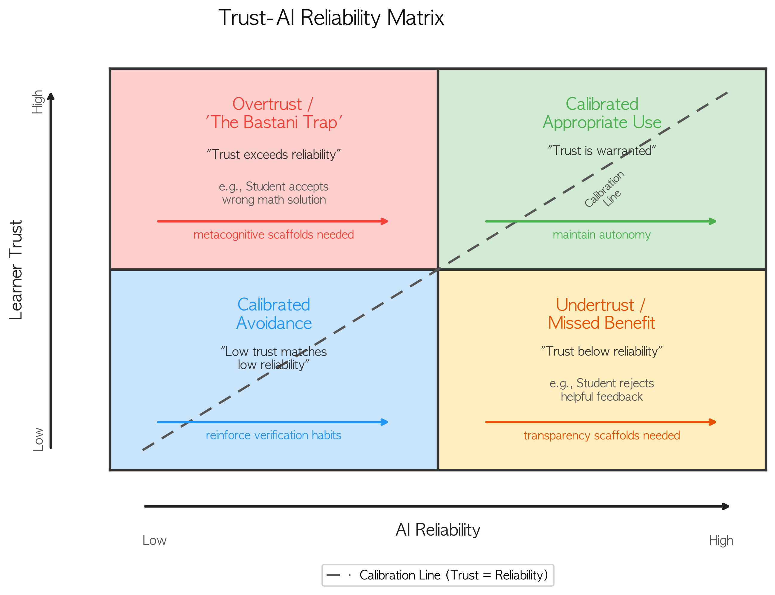
Quadrant I: High Trust + High Reliability = Calibrated Appropriate Use. Trust is warranted; the learner's reliance on the AI system is productive.
Quadrant II: High Trust + Low Reliability = Overtrust ("The Bastani Trap"). The most dangerous miscalibration. The learner trusts unreliable AI outputs, resulting in cognitive offloading and skill atrophy—the condition documented by Bastani et al. (2025). Kıyak et al. (2026) demonstrated that even explicit "ChatGPT can make mistakes" warnings fail to correct this miscalibration in medical education contexts.
Quadrant III: Low Trust + High Reliability = Undertrust / Missed Benefit. Skepticism that is virtuous in Quadrant II is maladaptive here. The learner forgoes beneficial AI assistance.
Quadrant IV: Low Trust + Low Reliability = Calibrated Avoidance. Low trust accurately reflects low reliability. The learner's decision to avoid or critically scrutinize AI outputs is appropriate and should be reinforced rather than corrected.
The matrix's power as a diagnostic tool lies in requiring both axes. Current research overwhelmingly measures only the vertical axis (learner trust) without the horizontal axis (AI reliability for the given task). Without both measurements, the field cannot determine which quadrant a learner occupies—and therefore cannot distinguish warranted trust from dangerous overreliance.
Discussion: Toward a Paradigm Shift
The Required Reframing
The calibration gap documented in this review calls for a fundamental reframing of trust research in educational AI. The dominant question—"Do learners trust AI?"—must give way to "Is their trust calibrated?" This is not merely a refinement; it represents what Kuhn (1962) termed a paradigm shift: a change in the questions a field asks, the variables it measures, and the assumptions it takes for granted.
Under the current paradigm, a finding that "students report moderate trust in ChatGPT" is treated as a complete result. Under the calibration paradigm, this finding is incomplete without a companion measurement: "ChatGPT's reliability for the assessed tasks was X%." Only with both measurements can the field determine whether moderate trust is appropriate (calibrated), insufficient (undertrust), or excessive (overtrust).
This reframing has precedent. The trust-in-automation field underwent a similar transition when researchers shifted from asking "Do operators trust automated systems?" to "Is their trust calibrated to the system's reliability?" (Lee & See, 2004; Parasuraman & Riley, 1997). That transition produced a productive research program spanning measurement development, intervention design, and system engineering (Wischnewski et al., 2023; Mehrotra et al., 2024). Educational AI research stands at an analogous juncture.
The typology developed in this review provides a roadmap for this transition. D1–D2 research establishes the terrain; D3 research proposes design solutions; D4 research recognizes the calibration problem; D5 research addresses it. The field's current center of gravity—D4, awareness without measurement—needs to shift toward D5, calibration with measurement.
This transition does not require abandoning existing research traditions. TAM-based research has produced valuable knowledge about adoption factors; design-focused research has generated useful scaffold proposals. The calibration paradigm does not reject these contributions but recontextualizes them. Adoption research becomes the baseline from which calibration questions arise: once we know that learners adopt AI, we can ask whether their trust in the adopted tool is calibrated. Design research becomes the intervention space: once we can measure calibration, we can test whether specific design features (transparency, metacognitive prompts, uncertainty displays) improve it. The paradigm shift enriches rather than replaces existing work.
Research Agenda
Five priority research directions emerge from the calibration gap:
Priority 1: Measurement infrastructure. The most urgent need is validated instruments for measuring trust calibration accuracy in educational AI contexts. The review's finding that zero papers simultaneously measured both trust level and AI reliability means the field currently has no empirical basis for calibration assessment. This requires multimethod approaches that simultaneously assess (a) learner trust in AI for specific tasks, (b) AI reliability for those tasks, and (c) the correspondence between the two. Process-level indicators—verification frequency, modification rates, information-seeking patterns—offer promising proxies for real-time calibration assessment. Existing instruments from the automation trust literature (Jian et al., 2000; Scharowski et al., 2025) may serve as starting points, but they require adaptation to educational contexts where the definition of "appropriate" trust includes pedagogical considerations absent from industrial settings.
Priority 2: Domain-specific calibration profiles. AI reliability varies dramatically across domains: ChatGPT may be highly reliable for summarizing well-documented topics, moderately reliable for essay feedback, and unreliable for mathematical proofs or clinical reasoning. Calibration research must therefore be domain-specific, mapping trust-reliability correspondences across subject areas (e.g., mathematics vs. writing vs. coding vs. science) and task types (e.g., factual retrieval vs. reasoning vs. creative generation). A learner who has developed calibrated trust in one domain cannot be assumed calibrated in another. The Trust–AI Reliability Matrix should be applied domain by domain, generating calibration profiles that capture the granularity of learner trust across the tasks they encounter.
Priority 3: Calibration interventions. Evidence from adjacent fields suggests promising intervention mechanisms—metacognitive prompting (Guo et al., 2022), productive failure (Kapur, 2008, 2016), uncertainty transparency (Lee & See, 2004), and desirable difficulties (Bjork & Bjork, 2011)—but these have not been tested specifically for trust calibration in educational AI. The finding that metacognitive scaffolds appear in only 3.1% of the corpus while transparency scaffolds appear in 24.7% suggests that the most calibration-relevant intervention type is the least explored. Experimental studies comparing intervention types across quadrants of the Trust–AI Reliability Matrix would advance the field from principled recommendation to evidence-based prescription. Ma et al. (2024) and Vasconcelos et al. (2023) provide methodological templates from HCI that could be adapted for educational contexts.
Priority 4: Longitudinal calibration development. How does trust calibration develop over time? Cross-sectional snapshots cannot capture the dynamic process by which learners develop (or fail to develop) calibrated trust across a semester of AI-assisted learning. Hoff and Bashir's (2015) three-layer model suggests that dispositional, situational, and learned trust evolve on different timescales; longitudinal designs are needed to trace how these layers interact in shaping calibration trajectories. Critical questions include: When do learners first develop differentiated trust across AI domains? What experiences trigger recalibration? Does calibration improve naturally with exposure, or does it require explicit intervention? Answering these questions requires tracking individual learners across extended periods of AI-assisted learning—a research design that none of the 97 coded papers employed.
Priority 5: Cultural and contextual variation. Trust dynamics operate differently across cultural contexts with varying power distance and uncertainty avoidance (Hofstede, 2001). Calibration research must investigate whether these cultural dimensions moderate calibration processes and whether interventions require culturally sensitive adaptation. The present corpus is heavily concentrated in Western educational contexts and English-language publications; calibration norms, trust formation patterns, and appropriate intervention strategies may differ substantially in East Asian, South Asian, or Sub-Saharan African educational systems where authority relationships and technology attitudes carry different cultural meanings (Table 5).
Practical Implications
For educators. Trust calibration should be recognized as a distinct learning objective alongside content mastery—the capacity to assess AI reliability for a given task and adjust reliance accordingly is an epistemic competence requiring explicit instruction (Long & Magerko, 2020; Ng et al., 2021). Educators can serve as trust calibration agents, using the Trust–AI Reliability Matrix to diagnose whether learners operate in calibrated or miscalibrated states and deploying targeted interventions: AI evaluation exercises for overtrusting learners, guided comparison tasks for undertrusting ones. Critically, AI literacy—including instruction on the probabilistic nature of LLM outputs and their domain-dependent accuracy variability—should be treated as a prerequisite for AI tool deployment, not an afterthought. The field's finding that 84.5% of papers provided no trust definition suggests that even researchers struggle with construct precision; educators will need structured support to operationalize calibration concepts in classroom practice.
For AI system designers. The central design principle this review supports is: design for calibration, not for trust. The dominant design logic treats higher trust as a success metric; the calibration paradigm reframes trust as a calibration target. Educational AI systems should aim not to increase trust but to align it with actual capability for specific tasks. Under conditions of low AI reliability, the design goal should be to reduce trust to a level commensurate with capability. This requires embedding both axes of the Trust–AI Reliability Matrix: learner trust monitoring (e.g., behavioral indicators of reliance patterns) and AI reliability benchmarking (e.g., domain-specific accuracy metrics). Transparency mechanisms should be complemented by metacognitive scaffolds that activate the evaluative processes learners need for calibrated trust judgments—the review's finding that metacognitive scaffolds appear in only 3.1% of the corpus, versus 24.7% for transparency scaffolds, suggests a critical design gap.
For policymakers. Regulatory frameworks for educational AI (European Union, 2024; UNESCO, 2023) mandate human oversight and appropriate trust, but the field currently lacks the measurement infrastructure to assess "appropriate trust." The EU AI Act's classification of educational AI as high-risk (Annex III) implies that learner trust calibration should be an evaluable criterion, yet no validated instruments exist for this purpose. Policy should explicitly acknowledge this infrastructure gap and incentivize the development of calibration assessment tools that can operationalize the regulatory intent. Without such tools, policy goals remain aspirational rather than enforceable.
Limitations and Conclusion
Limitations
Several limitations warrant acknowledgment. First, this paper adopted a critical review approach (Grant & Booth, 2009) rather than a full systematic review following PRISMA-ScR protocols (Peters et al., 2020). This enabled deeper theoretical synthesis and typology development but means the literature search, while systematic in its use of defined databases and search terms, was not exhaustive. Related work published outside our search terms or in non-indexed venues may have been missed.
Second, while coding involved two researchers—the first author coding all 97 papers and the second author independently coding a random 20–30% subsample—this remains a limitation compared to full dual coding of the entire corpus. Cohen's kappa values for key categorical variables are reported; the domain classification, as a derived variable computed algorithmically from existing coded fields, inherits the reliability of its input variables.
Third, the search was limited to English-language publications, potentially excluding relevant work from non-Anglophone research traditions where cultural dimensions such as power distance and uncertainty avoidance may shape trust dynamics differently (Hofstede, 2001).
Fourth, 50 of 147 identified papers could not be coded due to full-text access limitations at the time of analysis, representing a potential source of selection bias. These papers may include calibration-relevant work that would alter the domain distribution.
Fifth, 13 of 16 D5 papers came from supplementary citation tracking rather than database searches. We have argued that this asymmetry is itself evidence of the calibration gap rather than a methodological limitation, but we acknowledge that the supplementary search was designed to find calibration-relevant work. The finding that only 3 of 81 database-sourced papers (3.7%) reached D5 is the robust, design-independent evidence; the supplementary papers contextualize rather than inflate the gap. We report this transparently and encourage readers to weight the 3.7% finding as the primary evidence.
Sixth, the 5-domain Research Orientation Typology is a post-hoc classification applied to existing coded data. While the priority rules are deterministic, reproducible, and documented in Appendix D, the domain labels and boundaries represent analytic choices. Alternative priority orderings or boundary conditions could produce different distributions. The typology should be treated as a diagnostic tool for mapping the field's orientation landscape, not as a definitive taxonomy. External validation through independent application to new corpora would strengthen its utility.
Seventh, the paradigm shift argument from trust-level to trust-calibration research is a conceptual contribution that, while grounded in the empirical calibration gap, has not itself been empirically tested. Whether the reframing we propose actually produces better educational outcomes than trust-level research remains an open question requiring the empirical program outlined in Section 6.2.
Conclusion
This paper has advanced a core argument: the field of educational AI trust research is concentrated below the calibration threshold. Through a critical review of 97 studies on trust in educational AI (2015–2026), we documented a structural calibration gap manifesting across definitional, measurement, and disciplinary dimensions—a gap that existing theoretical frameworks, particularly technology acceptance models, are not designed to address.
The paper makes two contributions. First, the 5-domain Research Orientation Typology provides a diagnostic lens for this gap, classifying the corpus along a calibration maturity spectrum and revealing that 83.5% of research operates without explicit calibration engagement. The finding that the field's center of gravity resides in D4 (Trust Awareness)—problem recognition without problem measurement—identifies the precise transition point where investment could yield the greatest returns. Second, the paradigm shift argument—from "Do learners trust AI?" to "Is their trust calibrated?"—is grounded in the empirical evidence of the gap and operationalized through the Trust–AI Reliability Matrix, a diagnostic tool requiring both learner trust and AI reliability measurement.
As educational AI becomes increasingly embedded in learning environments worldwide, the stakes of this transition grow. Bastani et al. (2025) documented what happens when trust is uncalibrated in a controlled experimental setting; the uncontrolled deployment of AI tools across global education systems amplifies both the potential benefits of calibrated trust and the potential harms of miscalibration. The path forward requires what the field currently lacks: calibration-oriented measurement, theory, and intervention design. This review provides the diagnostic foundation; the empirical work remains to be done.

References
## References
Al-Adwan, A. S., Li, N., Al-Adwan, A., Abbasi, G. A., Albelbisi, N. A., & Habibi, A. (2023). Extending the technology acceptance model (TAM) to predict university students' intentions to use metaverse-based learning platforms. Education and Information Technologies, 28(9), 11823–11850. https://doi.org/10.1007/s10639-023-11816-3
Amershi, S., Weld, D., Vorvoreanu, M., Fourney, A., Nushi, B., Collisson, P., Suh, J., Iqbal, S., Bennett, P. N., Inkpen, K., Teevan, J., Kiber, R., & Horvitz, E. (2019). Guidelines for human-AI interaction. Proceedings of the 2019 CHI Conference on Human Factors in Computing Systems, 1–13. https://doi.org/10.1145/3290605.3300233
Anderson, T., & Shattuck, J. (2012). Design-based research: A decade of progress in education research? Educational Researcher, 41(1), 16–25. https://doi.org/10.3102/0013189X11428813
Arrieta, A. B., Diaz-Rodriguez, N., Del Ser, J., Bennetot, A., Tabik, S., Barbado, A., Garcia, S., Gil-Lopez, S., Molina, D., Benjamins, R., Chatila, R., & Herrera, F. (2020). Explainable artificial intelligence (XAI): Concepts, taxonomies, opportunities and challenges toward responsible AI. Information Fusion, 58, 82–115. https://doi.org/10.1016/j.inffus.2019.12.012
Azevedo, R., & Cromley, J. G. (2004). Does training on self-regulated learning facilitate students' learning with hypermedia? Journal of Educational Psychology, 96(3), 523–535. https://doi.org/10.1037/0022-0663.96.3.523
Bailey, K. D. (1994). Typologies and taxonomies: An introduction to classification techniques. Sage Publications.
Baidoo-Anu, D., & Ansah, L. O. (2023). Education in the era of generative artificial intelligence (AI): Understanding the potential benefits of ChatGPT in promoting teaching and learning. Journal of AI, 7(1), 52–62. https://doi.org/10.61969/jai.1337500
Bandura, A. (1997). Self-efficacy: The exercise of control. W. H. Freeman.
Bannert, M., Reimann, P., & Sonnenberg, C. (2009). Process mining techniques for analysing patterns and strategies in students' self-regulated learning. Metacognition and Learning, 4(2), 131–161. https://doi.org/10.1007/s11409-009-9040-2
Bannert, M., Sonnenberg, C., Mengelkamp, C., & Pieger, E. (2015). Short- and long-term effects of students' self-directed metacognitive prompts on mathematical problem-solving. Computers in Human Behavior, 52, 293–306. https://doi.org/10.1016/j.chb.2015.05.038
Bastani, H., Bastani, O., Sungu, A., Ge, H., Kabakcı, O., & Mariman, R. (2025). Generative AI can harm learning. Proceedings of the National Academy of Sciences, 122(2), e2412617122. https://doi.org/10.1073/pnas.2412617122
Belland, B. R. (2014). Scaffolding: Definition, current debates, and future directions. In J. M. Spector, M. D. Merrill, J. Elen, & M. J. Bishop (Eds.), Handbook of research on educational communications and technology (4th ed., pp. 505–518). Springer. https://doi.org/10.1007/978-1-4614-3185-5_39
Bjork, R. A., & Bjork, E. L. (2011). Making things hard on yourself, but in a good way: Creating desirable difficulties to enhance learning. In M. A. Gernsbacher, R. W. Pew, L. M. Hough, & J. R. Pomerantz (Eds.), Psychology and the real world: Essays illustrating fundamental contributions to society (pp. 56–64). Worth Publishers.
Black, P., & Wiliam, D. (1998). Assessment and classroom learning. Assessment in Education: Principles, Policy & Practice, 5(1), 7–74. https://doi.org/10.1080/0969595980050102
Carter, O. B. J., Loft, S., & Visser, T. A. W. (2024). Meaningful communication but not superficial anthropomorphism facilitates human-automation trust calibration: The Human-Automation Trust Expectation Model (HATEM). Human Factors, 66(11), 2485–2502. https://doi.org/10.1177/00187208231218156
Chen, X., Zou, D., Xie, H., Cheng, G., & Liu, C. (2022). Two decades of artificial intelligence in education: Contributors, collaborations, research topics, challenges, and future directions. Educational Technology & Society, 25(1), 28–47.
Cotton, D. R. E., Cotton, P. A., & Shipway, J. R. (2024). Chatting and cheating: Ensuring academic integrity in the era of ChatGPT. Innovations in Education and Teaching International, 61(2), 228–239. https://doi.org/10.1080/14703297.2023.2190148
Darvishi, A., Khosravi, H., Sadiq, S., Gasevic, D., & Siemens, G. (2024). Impact of AI assistance on student agency. Computers & Education, 210, 104967. https://doi.org/10.1016/j.compedu.2023.104967
Davis, F. D. (1989). Perceived usefulness, perceived ease of use, and user acceptance of information technology. MIS Quarterly, 13(3), 319–340. https://doi.org/10.2307/249008
de Visser, E. J., Peeters, M. M. M., Jung, M. F., Kohn, S., Shaw, T. H., Pak, R., & Neerincx, M. A. (2020). Towards a theory of longitudinal trust calibration in human–robot teams. International Journal of Social Robotics, 12(2), 459–478. https://doi.org/10.1007/s12369-019-00596-x
Doty, D. H., & Glick, W. H. (1994). Typologies as a unique form of theory building: Toward improved understanding and modeling. Academy of Management Review, 19(2), 230–251. https://doi.org/10.5465/amr.1994.9410210748
Dunlosky, J., & Rawson, K. A. (2012). Overconfidence produces underachievement: Inaccurate self evaluations undermine students' learning and retention of material. Learning and Instruction, 22(4), 271–280. https://doi.org/10.1016/j.learninstruc.2011.08.003
Dzindolet, M. T., Peterson, S. A., Pomranky, R. A., Pierce, L. G., & Beck, H. P. (2003). The role of trust in automation reliance. International Journal of Human-Computer Studies, 58(6), 697–718. https://doi.org/10.1016/S1071-5819(03)00038-7
European Union. (2024). Regulation (EU) 2024/1689 of the European Parliament and of the Council laying down harmonised rules on artificial intelligence (Artificial Intelligence Act). Official Journal of the European Union. https://eur-lex.europa.eu/eli/reg/2024/1689
Flavell, J. H. (1979). Metacognition and cognitive monitoring: A new area of cognitive-developmental inquiry. American Psychologist, 34(10), 906–911. https://doi.org/10.1037/0003-066X.34.10.906
Grant, M. J., & Booth, A. (2009). A typology of reviews: An analysis of 14 review types and associated methodologies. Health Information & Libraries Journal, 26(2), 91–108. https://doi.org/10.1111/j.1471-1842.2009.00848.x
Greene, J. A., & Azevedo, R. (2007). A theoretical review of Winne and Hadwin's model of self-regulated learning: New perspectives and directions. Review of Educational Research, 77(3), 334–372. https://doi.org/10.3102/003465430303953
Gunning, D., Stefik, M., Choi, J., Miller, T., Stumpf, S., & Yang, G.-Z. (2019). XAI — Explainable artificial intelligence. Science Robotics, 4(37), eaay7120. https://doi.org/10.1126/scirobotics.aay7120
Guo, L., Wang, W., Liao, J., & Cheng, S. (2022). Effects of metacognitive prompts on self-regulated learning: A meta-analysis. Frontiers in Psychology, 13, 1001498. https://doi.org/10.3389/fpsyg.2022.1001498
Hancock, P. A., Billings, D. R., Schaefer, K. E., Chen, J. Y. C., de Visser, E. J., & Parasuraman, R. (2011). A meta-analysis of factors affecting trust in human-robot interaction. Human Factors, 53(5), 517–527. https://doi.org/10.1177/0018720811417254
Hannafin, M., Land, S., & Oliver, K. (1999). Open learning environments: Foundations, methods, and models. In C. M. Reigeluth (Ed.), Instructional-design theories and models: A new paradigm of instructional theory (Vol. 2, pp. 115–140). Lawrence Erlbaum.
Hattie, J. (2009). Visible learning: A synthesis of over 800 meta-analyses relating to achievement. Routledge.
Hoff, K. A., & Bashir, M. (2015). Trust in automation: Integrating empirical evidence on factors that influence trust. Human Factors, 57(3), 407–434. https://doi.org/10.1177/0018720814547570
Hofstede, G. (2001). Culture's consequences: Comparing values, behaviors, institutions, and organizations across nations (2nd ed.). Sage.
Holmes, W., Bialik, M., & Fadel, C. (2019). Artificial intelligence in education: Promises and implications for teaching and learning. Center for Curriculum Redesign.
Ji, Z., Lee, N., Frieske, R., Yu, T., Su, D., Xu, Y., Ishii, E., Bang, Y. J., Madotto, A., & Fung, P. (2023). Survey of hallucination in natural language generation. ACM Computing Surveys, 55(12), 1–38. https://doi.org/10.1145/3571730
Jian, J.-Y., Bisantz, A. M., & Drury, C. G. (2000). Foundations for an empirically determined scale of trust in automated systems. International Journal of Cognitive Ergonomics, 4(1), 53–71. https://doi.org/10.1207/S15327566IJCE0401_04
Kapur, M. (2008). Productive failure. Cognition and Instruction, 26(3), 379–424. https://doi.org/10.1080/07370000802212669
Kapur, M. (2016). Examining productive failure, productive success, and constructive failure as a framework for reconceptualizing how failure can be productive. Instructional Science, 44(4), 321–338. https://doi.org/10.1007/s11251-016-9379-0
Kasneci, E., Sessler, K., Kuchemann, S., Bannert, M., Dementieva, D., Fischer, F., Gasser, U., Groh, G., Gunnemann, S., Hullermeier, E., Kruber, S., Kuber, G., Sachs, S., Seidel, T., Stadler, M., Wachter, B., Weidlich, J., & Kasneci, G. (2023). ChatGPT for good? On opportunities and challenges of large language models for education. Learning and Individual Differences, 103, 102274. https://doi.org/10.1016/j.lindif.2023.102274
Kıyak, Y. S., Coşkun, Ö., & Budakoğlu, I. I. (2026). 'ChatGPT can make mistakes' warnings fail: A randomized controlled trial. Medical Education, 60(2), 138–142. https://doi.org/10.1111/medu.70056
Kuhn, T. S. (1962). The structure of scientific revolutions. University of Chicago Press.
Lankton, N. K., McKnight, D. H., & Tripp, J. (2015). Technology, humanness, and trust: Rethinking trust in technology. Journal of the Association for Information Systems, 16(10), 880–918. https://doi.org/10.17705/1jais.00411
Lee, J. D., & See, K. A. (2004). Trust in automation: Designing for appropriate reliance. Human Factors, 46(1), 50–80. https://doi.org/10.1518/hfes.46.1.50.30392
Li, X., Hess, T. J., & Valacich, J. S. (2008). Why do we trust new technology? A study of initial trust formation with organizational information systems. The Journal of Strategic Information Systems, 17(1), 39–71. https://doi.org/10.1016/j.jsis.2008.01.001
Lo, C. K. (2023). What is the impact of ChatGPT on education? A rapid review of the literature. Education Sciences, 13(4), 410. https://doi.org/10.3390/educsci13040410
Loibl, K., Roll, I., & Rummel, N. (2017). Towards a theory of when and how problem solving followed by instruction works: A meta-analysis. Educational Psychology Review, 29(4), 693–715. https://doi.org/10.1007/s10648-016-9379-x
Logg, J. M., Minson, J. A., & Moore, D. A. (2019). Algorithm appreciation: People prefer algorithmic to human judgment. Organizational Behavior and Human Decision Processes, 151, 90–103. https://doi.org/10.1016/j.obhdp.2018.12.005
Long, D., & Magerko, B. (2020). What is AI literacy? Competencies and design considerations. Proceedings of the 2020 CHI Conference on Human Factors in Computing Systems, 1–16. https://doi.org/10.1145/3313831.3376727
Mayer, R. C., Davis, J. H., & Schoorman, F. D. (1995). An integrative model of organizational trust. Academy of Management Review, 20(3), 709–734. https://doi.org/10.5465/amr.1995.9508080335
McKenney, S., & Reeves, T. C. (2019). Conducting educational design research (2nd ed.). Routledge. https://doi.org/10.4324/9781315105642
Mollick, E. R., & Mollick, L. (2023). Using AI to implement effective teaching strategies in classrooms: Five strategies, including prompts. The Wharton School Research Paper. https://doi.org/10.2139/ssrn.4391243
Ng, D. T. K., Leung, J. K. L., Chu, S. K. W., & Qiao, M. S. (2021). Conceptualizing AI literacy: An exploratory review. Computers and Education: Artificial Intelligence, 2, 100041. https://doi.org/10.1016/j.caeai.2021.100041
OECD. (2024). AI, data and trust: How AI can support trustworthy data governance in education. OECD Publishing.
Panadero, E. (2017). A review of self-regulated learning: Six models and four directions for research. Frontiers in Psychology, 8, 422. https://doi.org/10.3389/fpsyg.2017.00422
Parasuraman, R., & Riley, V. (1997). Humans and automation: Use, misuse, disuse, abuse. Human Factors, 39(2), 230–253. https://doi.org/10.1518/001872097778543886
Pea, R. D. (2004). The social and technological dimensions of scaffolding and related theoretical concepts for learning, education, and human activity. The Journal of the Learning Sciences, 13(3), 423–451. https://doi.org/10.1207/s15327809jls1303_6
Peters, M. D. J., Marnie, C., Tricco, A. C., Pollock, D., Munn, Z., Alexander, L., McInerney, P., Godfrey, C. M., & Khalil, H. (2020). Updated methodological guidance for the conduct of scoping reviews. JBI Evidence Synthesis, 18(10), 2119–2126. https://doi.org/10.11124/JBIES-20-00167
Piaget, J. (1971). Biology and knowledge: An essay on the relations between organic regulations and cognitive processes. University of Chicago Press.
Pieschl, S. (2009). Metacognitive calibration — an extended conceptualization and potential applications. Metacognition and Learning, 4(1), 3–31. https://doi.org/10.1007/s11409-008-9030-4
Pintrich, P. R. (2000). The role of goal orientation in self-regulated learning. In M. Boekaerts, P. R. Pintrich, & M. Zeidner (Eds.), Handbook of self-regulation (pp. 451–502). Academic Press. https://doi.org/10.1016/B978-012109890-2/50043-3
Puntambekar, S., & Hubscher, R. (2005). Tools for scaffolding students in a complex learning environment: What have we gained and what have we missed? Educational Psychologist, 40(1), 1–12. https://doi.org/10.1207/s15326985ep4001_1
Reiser, B. J. (2004). Scaffolding complex learning: The mechanisms of structuring and problematizing student work. The Journal of the Learning Sciences, 13(3), 273–304. https://doi.org/10.1207/s15327809jls1303_2
Ryan, R. M., & Deci, E. L. (2000). Self-determination theory and the facilitation of intrinsic motivation, social development, and well-being. American Psychologist, 55(1), 68–78. https://doi.org/10.1037/0003-066X.55.1.68
Ryan, R. M., & Deci, E. L. (2017). Self-determination theory: Basic psychological needs in motivation, development, and wellness. Guilford Press. https://doi.org/10.1521/978.14625/28806
Schaefer, K. E., Chen, J. Y. C., Szalma, J. L., & Hancock, P. A. (2016). A meta-analysis of factors influencing the development of trust in automation: Implications for understanding autonomy in future systems. Human Factors, 58(3), 377–400. https://doi.org/10.1177/0018720816634228
Schraw, G. (1998). Promoting general metacognitive awareness. Instructional Science, 26(1–2), 113–125. https://doi.org/10.1023/A:1003044231033
Schraw, G., & Dennison, R. S. (1994). Assessing metacognitive awareness. Contemporary Educational Psychology, 19(4), 460–475. https://doi.org/10.1006/ceps.1994.1033
Shneiderman, B. (2020). Human-centered artificial intelligence: Reliable, safe & trustworthy. International Journal of Human-Computer Interaction, 36(6), 495–504. https://doi.org/10.1080/10447318.2020.1741118
Sparrow, B., Liu, J., & Wegner, D. M. (2011). Google effects on memory: Cognitive consequences of having information at our fingertips. Science, 333(6043), 776–778. https://doi.org/10.1126/science.1207745
Strzelecki, A. (2023). To use or not to use ChatGPT in higher education? A study of students' acceptance and use of technology. Interactive Learning Environments, 32(10), 5142–5155. https://doi.org/10.1080/10494820.2023.2209881
Sweller, J. (2011). Cognitive load theory. In J. Mestre & B. Ross (Eds.), The psychology of learning and motivation (Vol. 55, pp. 37–76). Academic Press. https://doi.org/10.1016/B978-0-12-387691-1.00002-8
UNESCO. (2023). Guidance for generative AI in education and research. UNESCO Publishing. https://doi.org/10.54675/EWZQ9535
UNESCO. (2024). AI competency framework for teachers. UNESCO Publishing. https://doi.org/10.54675/CCBF6077
van de Pol, J., Volman, M., & Beishuizen, J. (2010). Scaffolding in teacher–student interaction: A decade of research. Educational Psychology Review, 22(3), 271–296. https://doi.org/10.1007/s10648-010-9127-6
Venkatesh, V., Morris, M. G., Davis, G. B., & Davis, F. D. (2003). User acceptance of information technology: Toward a unified view. MIS Quarterly, 27(3), 425–478. https://doi.org/10.2307/30036540
Vygotsky, L. S. (1978). Mind in society: The development of higher psychological processes (M. Cole, V. John-Steiner, S. Scribner, & E. Souberman, Eds.). Harvard University Press.
Wang, M., & Zhang, J. (2026). AI-supported higher-order thinking and EFL writing quality: A mechanism-focused study. Acta Psychologica, 263, 106239. https://doi.org/10.1016/j.actpsy.2026.106239
Wiliam, D. (2011). Embedded formative assessment. Solution Tree Press.
Williams, R. (2025). Navigating the AI-enhanced learning landscape: A framework for integrating generative AI as a cognitive and metacognitive tool. Information, 16(1), 28. https://doi.org/10.3390/info16010028
Winne, P. H., & Hadwin, A. F. (1998). Studying as self-regulated learning. In D. J. Hacker, J. Dunlosky, & A. C. Graesner (Eds.), Metacognition in educational theory and practice (pp. 277–304). Lawrence Erlbaum.
Wood, D., Bruner, J. S., & Ross, G. (1976). The role of tutoring in problem solving. Journal of Child Psychology and Psychiatry, 17(2), 89–100. https://doi.org/10.1111/j.1469-7610.1976.tb00381.x
Woodworth, R. S. (1929). Psychology (Rev. ed.). Henry Holt.
Zawacki-Richter, O., Marin, V. I., Bond, M., & Gouverneur, F. (2019). Systematic review of research on artificial intelligence applications in higher education – Where are the educators? International Journal of Educational Technology in Higher Education, 16(1), 39. https://doi.org/10.1186/s41239-019-0171-0
Zimmerman, B. J. (2000). Attaining self-regulation: A social cognitive perspective. In M. Boekaerts, P. R. Pintrich, & M. Zeidner (Eds.), Handbook of self-regulation (pp. 13–39). Academic Press. https://doi.org/10.1016/B978-012109890-2/50031-7
Zimmerman, B. J. (2002). Becoming a self-regulated learner: An overview. Theory Into Practice, 41(2), 64–70. https://doi.org/10.1207/s15430421tip4102_2
—
## Additional References (Priority A–D Papers)
Chi, M. T. H., Siler, S. A., Jeong, H., Yamauchi, T., & Hausmann, R. G. (2001). Learning from human tutoring. Cognitive Science, 25(4), 471–533. https://doi.org/10.1207/s15516709cog2504_1
Sakamoto, T., Hasan, R., Lennon, M., Cody, J., Krumholz, H. M., & Schulz, W. L. (2024). Facilitating trust calibration in artificial intelligence–driven diagnostic decision support systems. Journal of Medical Internet Research, 26, e58666. https://doi.org/10.2196/58666
Ma, S., Kimani, E., Rowan, K., Feuerriegel, S., & Perer, A. (2024). Are you really sure? Understanding the effects of human self-confidence calibration prompts on trust, reliance, and task performance in AI-assisted decision making. Proceedings of the 2024 CHI Conference on Human Factors in Computing Systems, Article 671. https://doi.org/10.1145/3613904.3642671
Lee, J., Lee, S., & Steyvers, M. (2025). Metacognitive sensitivity: Key to calibrating trust with AI. PNAS Nexus, 4(3), pgaf133. https://doi.org/10.1093/pnasnexus/pgaf133
Lee, S., & Bosch, N. (2025). Calibration discrepancy predicts students' subsequent metacognitive strategy use in AI-supported learning. International Journal of Artificial Intelligence in Education. https://doi.org/10.1007/s40593-025-00514-5
Lee, S., Lee, S., & Bosch, N. (2025). Learning behaviors mediate the effects of metacognitive calibration in AI-supported learning. Proceedings of the 15th International Learning Analytics and Knowledge Conference (LAK '25). https://doi.org/10.1145/3706468.3706513
Li, Y., Chen, M., & Liao, Q. V. (2024). Understanding the effects of miscalibrated AI confidence on user trust. Proceedings of the 2024 CHI Conference on Human Factors in Computing Systems. https://doi.org/10.48550/arXiv.2402.07632
Wischnewski, M., Krämer, N., & Müller, E. (2023). Measuring and understanding trust calibrations for automated systems: A survey of the state-of-the-art and future directions. Proceedings of the 2023 CHI Conference on Human Factors in Computing Systems, Article 197. https://doi.org/10.1145/3544548.3581197
Mehrotra, S., Jonker, C. M., & Tielman, M. L. (2024). A systematic review of the research on fostering appropriate trust in human-AI interaction. ACM Computing Surveys, 56(12), 1–40. https://doi.org/10.1145/3696449
Nelson, T. O., & Narens, L. (1990). Metamemory: A theoretical framework and new findings. In G. H. Bower (Ed.), The psychology of learning and motivation (Vol. 26, pp. 125–173). Academic Press.
Okamura, K., & Yamada, S. (2020). Adaptive trust calibration for human-AI collaboration. PLOS ONE, 15(2), e0229132. https://doi.org/10.1371/journal.pone.0229132
Pandey, S., Creel, K. A., & Picard, R. W. (2025). Epistemic trust in generative AI. AI and Ethics. https://doi.org/10.1007/s43681-025-00686-7
Parasuraman, R., & Manzey, D. H. (2010). Complacency and bias in human use of automation: An attentional integration. Human Factors, 52(3), 381–410. https://doi.org/10.1177/0018720810376055
Pare, G., Trudel, M.-C., Jaana, M., & Kitsiou, S. (2015). Synthesizing information systems knowledge: A typology of literature reviews. Information & Management, 52(2), 183–199. https://doi.org/10.1016/j.im.2014.08.008
Risko, E. F., & Gilbert, S. J. (2016). Cognitive offloading. Trends in Cognitive Sciences, 20(9), 676–688. https://doi.org/10.1016/j.tics.2016.07.002
Safarov, C., Gadzinski, G., & Schlögl, S. (2026). In AI we trust? Exploring the role of explainable GenAI and expertise in education. Human Factors, 68(4), 487–503. https://doi.org/10.1177/00187208251401773
Scharowski, N., Perrig, S. A. L., von Felten, N., & Brühlmann, F. (2025). To trust or distrust trust measures: Validating questionnaires for trust in AI. Proceedings of the 2025 ACM Conference on Fairness, Accountability, and Transparency (FAccT). https://doi.org/10.48550/arXiv.2403.00582
Steyvers, M., & Peters, M. A. K. (2025). Metacognition and uncertainty communication in humans and large language models. Current Directions in Psychological Science. https://doi.org/10.1177/09637214251391158
Tomsett, R., Preece, A., Braines, D., Cerutti, F., Chakraborty, S., Srivastava, M., Pearson, G., & Kaplan, L. (2020). Rapid trust calibration through interpretable and uncertainty-aware AI. Patterns, 1(6), 100049. https://doi.org/10.1016/j.patter.2020.100049
Vasconcelos, H., Jörke, M., Grunde-McLaughlin, M., Gerstenberg, T., Bernstein, M. S., & Krishna, R. (2023). Explanations can reduce overreliance on AI systems during decision-making. Proceedings of the ACM on Human-Computer Interaction, 7(CSCW1), 1–38. https://doi.org/10.1145/3579605
Yin, M., Wortman Vaughan, J., & Wallach, H. (2019). Understanding the effect of accuracy on trust in machine learning models. Proceedings of the 2019 CHI Conference on Human Factors in Computing Systems, Article 279. https://doi.org/10.1145/3290605.3300509

