Running head: TRUST CALIBRATION TRAJECTORIES
Trust Calibration Trajectories Under Experimental Reliability Switches:
A Latent Class Growth Analysis of Chess Puzzle Solving With AI Recommendations
Hosung You
College of Education, Pennsylvania State University
Author Note
Hosung You [INSERT ORCID]
College of Education, Pennsylvania State University.
This study was pre-registered on the Open Science Framework (https://doi.org/10.17605/OSF.IO/JMQ84). The dataset analyzed in this study is publicly available from Bondi et al. (2023). The author has no conflicts of interest to disclose.
Correspondence concerning this article should be addressed to Hosung You, College of Education, Pennsylvania State University, University Park, PA 16802. Email: hosung@psu.edu

Abstract
Trust calibration—the alignment between a user’s reliance on an AI system and the system’s actual reliability—is critical for effective human-AI collaboration. While prior research has examined trust as a unidimensional construct, few studies have investigated the heterogeneity of trust calibration trajectories over time. Using data from an experimental chess puzzle study (N = 100 sessions, 50 participants in two conditions), we applied complementary analytic approaches—Latent Class Growth Analysis (LCGA) and Gaussian Mixture Model (GMM) clustering—to identify distinct trust calibration trajectory patterns following experimental reliability switches. LCGA identified two macro-level trajectory classes corresponding to experimental conditions (Entropy = 0.871, 96% classification accuracy), confirming the manipulation’s effectiveness. GMM revealed six micro-level subgroups within conditions, mapping onto five theoretically derived trajectory patterns: Convergent, Catastrophic, Oscillating, AI Benefit Emergence (ABE), and Extreme Compliance. In the High-to-Low reliability condition, 60% of participants exhibited Catastrophic over-reliance (trust inertia despite AI accuracy dropping from 100% to 20%), while 40% showed rapid Convergent adaptation. In the Low-to-High condition, 50% converged gradually, 28% oscillated, and 18% showed ABE—persistent under-reliance despite AI improvement. These findings provide the first experimental evidence for a five-pattern typology of trust calibration dynamics, with implications for designing adaptive AI systems that account for individual differences in trust updating.
Keywords: trust calibration, human-AI interaction, latent class growth analysis, trust trajectory, reliability switch, automation trust

Trust Calibration Trajectories Under Experimental Reliability Switches: A Latent Class Growth Analysis of Chess Puzzle Solving With AI Recommendations

Trust Calibration in Human-AI Interaction
The rapid integration of artificial intelligence systems into decision-making contexts—from medical diagnosis to educational tutoring—has elevated the importance of appropriate reliance on AI recommendations. Trust calibration, defined as the correspondence between a user’s trust in an AI system and the system’s actual trustworthiness, is essential for effective human-AI collaboration (Lee & See, 2004). Miscalibrated trust leads to two types of errors: over-reliance (following AI recommendations when the system is unreliable) and under-reliance (ignoring AI recommendations when the system is reliable; Parasuraman & Riley, 1997).
Prior research has primarily examined trust as a static or aggregate construct, measuring overall trust levels or mean reliance rates across experimental conditions (e.g., Dzindolet et al., 2003). However, trust is inherently dynamic—it develops, fluctuates, and sometimes deteriorates over the course of interaction (Lee & Moray, 1992; Muir & Moray, 1996). Understanding these dynamics requires moving beyond aggregate measures to examine individual trust trajectories over time. Recent theoretical developments suggest that individuals do not follow a single, universal trust adaptation pattern; instead, qualitatively distinct trajectory types may emerge depending on individual differences in trust updating mechanisms and the specific environmental conditions encountered (You, 2026).

A Bayesian Trust Update Model
To account for this heterogeneity, we adopt a Bayesian Trust Update Model in which trust at time t + 1 is updated according to a prediction error signal:
$$T_{t+1}=T_{t}+\left\{\begin{matrix}α^{+}⋅δ_{t} & \text{if }δ_{t}≥0 \\ α^{−}⋅δ_{t} & \text{if }δ_{t}<0\end{matrix}\right.$$
where $δ_{t}=R_{t}−T_{t}$ is the prediction error (discrepancy between observed AI reliability and current behavioral trust), and $α^{+}$ and $α^{−}$ are asymmetric learning rates for positive and negative prediction errors, respectively. The key insight is that $α^{+}$ and $α^{−}$ need not be equal: individuals may update trust more readily in response to positive evidence (AI succeeding) than negative evidence (AI failing), or vice versa. This asymmetry generates qualitatively distinct trajectory patterns, including regions of over-reliance (when behavioral trust exceeds AI capability) and under-reliance (when behavioral trust falls below AI capability).

Five Theoretically Derived Trajectory Patterns
Different configurations of $α^{+}$ and $α^{−}$ predict five distinct trajectory patterns (see Figure 2 for a visual summary of the theoretical predictions):
- Convergent ($α^{+},α^{−}>α_{min}$): Trust gradually converges toward actual reliability, regardless of direction. Both learning rates are active and sufficient.
- Stagnant ($α^{+}≈α^{−}≈0$): Trust remains fixed near its initial level, unresponsive to changes in AI reliability.
- Catastrophic ($α^{−}≈0$; requires $R↓$): When AI reliability drops suddenly, the individual fails to reduce trust, maintaining over-reliance despite clear evidence of declining performance.
- Oscillating (nonlinear or threshold-dependent $α$): Trust fluctuates non-monotonically, failing to achieve stable convergence.
- AI Benefit Emergence (ABE) ($α^{+}≈0$; requires $R↑$): When AI reliability improves, the individual fails to increase trust, maintaining under-reliance. The mathematical mirror of the Catastrophic pattern, first identified in exploratory analysis of educational data (You, 2026).

The Present Study
The present study applies this theoretical framework to an experimental dataset featuring an explicit AI reliability switch, providing an ideal testbed for identifying trust calibration trajectories. We analyze data from Bondi et al. (2023), in which participants solved chess puzzles with AI recommendations under two conditions: High-to-Low reliability (C1: AI accuracy ~80% then ~20%) and Low-to-High reliability (C2: AI accuracy ~20% then ~80%; see Figure 1). This design creates a powerful within-subject test: C1 forces participants from the calibrated region toward potential over-reliance as reliability drops, while C2 forces participants toward potential under-reliance as reliability increases. Whether and how quickly participants recalibrate reveals their trust updating characteristics.
We employ two complementary analytic approaches:
- Latent Class Growth Analysis (LCGA) to identify distinct trajectory shapes over time, modeling the temporal structure explicitly through piecewise linear growth curves.
- Gaussian Mixture Model (GMM) clustering to identify distinct behavioral profiles based on trajectory features, capturing within-condition heterogeneity.

Research Questions
RQ1: Does the experimental reliability switch produce distinct trust calibration trajectory classes? (LCGA)
RQ2: Within each experimental condition, what distinct trajectory patterns emerge? (GMM)
RQ3: Do the empirically identified patterns correspond to the five theoretically predicted trajectory types?
RQ4: How do LCGA and GMM results relate to each other, and what complementary insights does each method provide?

Hypotheses
H1: LCGA will identify at least two trajectory classes, primarily differentiated by experimental condition.
H2: In the C1 (High-to-Low) condition, at least two subgroups will emerge: one showing Catastrophic over-reliance (trust inertia) and one showing Convergent adaptation.
H3: In the C2 (Low-to-High) condition, at least two subgroups will emerge, including an ABE pattern (persistent under-reliance despite AI improvement).
H4: The Convergent pattern will be the most prevalent across both conditions.
H5: The calibration gap trajectory will show stronger condition differentiation than the raw behavioral reliance trajectory.

Method

Data Source
We conducted a secondary analysis of the experimental dataset from Bondi et al. (2023). The original study investigated human decision-making in chess puzzles with AI assistance.

Participants and Design
The dataset comprised N = 100 sessions from 50 participants, each completing two sessions in different conditions. The study used a within-subject design with two conditions: C1 (High-to-Low), in which AI accuracy was approximately 80% in Windows 1–4 and then approximately 20% in Windows 5–6; and C2 (Low-to-High), in which AI accuracy was approximately 20% in Windows 1–4 and then approximately 80% in Windows 5–6. Participants selected the best chess move from options, with AI recommendations provided. Each session comprised 30 trials organized into six windows of five trials each. The reliability switch occurred between trials 20 and 21 (between Window 4 and Window 5).

Ethical Considerations and Data Access
The dataset is publicly available from the original authors. Our secondary analysis was pre-registered on the Open Science Framework (OSF; https://doi.org/10.17605/OSF.IO/JMQ84).

Measures
Behavioral Reliance Rate (R_{b}). Behavioral reliance rate was computed as the number of trials where the participant followed the AI recommendation divided by the total trials in a given window. This was computed per window (five trials each), yielding six time points per session.
AI Accuracy (P). AI accuracy was computed as the number of trials where the AI recommendation was correct divided by the total trials in a given window. AI accuracy was coded as multiPV == 1—that is, a trial was scored as AI-accurate when the AI’s suggested move was the chess engine’s top-ranked move. Approximate values were ~80% (high reliability) or ~20% (low reliability) per window, with exact values varying due to the specific puzzles presented.
Calibration Gap (G). The calibration gap, defined as G = R_{b} – P, served as the primary outcome measure. Positive values indicate over-reliance (following AI more than warranted); negative values indicate under-reliance.
Operationalization of Behavioral Trust. Following the behavioral tradition in automation trust research (Lee & See, 2004), we operationalized trust as observed behavioral reliance rather than self-reported trust. Specifically, on each trial, participants saw the AI’s recommended chess move and made a final move selection. A trial was coded as AI-followed if the participant’s final move (bmove2) matched the AI suggestion (aisugg), regardless of whether the participant’s initial choice (bmove1) differed. This binary coding captures the revealed preference—what the participant actually did with the AI recommendation—as distinct from what they said about their trust. The behavioral reliance rate R_{b} is the proportion of AI-followed trials within each window.

Analytic Strategy

Phase 1: Descriptive Analysis
Window-level descriptive statistics by condition were computed, with particular focus on the switch effect between Windows 4 and 5.

Phase 2: Latent Class Growth Analysis
We used the lcmm R package (Proust-Lima et al., 2017) with the hlme() function to fit piecewise linear growth models to the calibration gap trajectory. The growth model was specified as:
$$G_{it}=β_{0}+β_{1}⋅{\text{Time}}_{t}+β_{2}⋅{\text{PostSwitch}}_{t}+e_{it}$$
where Time_{t} = t – 1 (ranging from 0 to 5) and PostSwitch_{t} = max(0, Time_{t} – 3.5), a piecewise slope capturing post-switch trajectory change. A random intercept was specified (random = ~1). We fit models with G = 1 through 6 classes, using 30 random starting values per model (gridsearch(rep = 30)). Model selection was based on BIC (primary), SABIC, and entropy (for classification quality).

Phase 3: Gaussian Mixture Model Clustering
We used the mclust R package (Scrucca et al., 2016) to cluster sessions based on trajectory features extracted from the window-level data. Twenty features per session were extracted, including slopes, standard deviations, reversals, and maximum drops for R_{b}, G, and appropriate reliance. Model selection was conducted using BIC across all Gaussian mixture model parameterizations (VEI, EII, etc.) and class numbers (G = 1 through 10).

Phase 4: Cross-Method Comparison
The Adjusted Rand Index (ARI) and cross-tabulation between LCGA and GMM class assignments were computed to evaluate convergence across analytic methods.

Results

Descriptive Results
The experimental manipulation produced large effects on the calibration gap. In C1 (High-to-Low), the calibration gap shifted from M = –0.164 (pre-switch) to M = +0.302 (post-switch), d = 2.10. The Window 4 to Window 5 jump was +0.568 (SD = 0.278). In C2 (Low-to-High), the calibration gap shifted from M = +0.211 (pre-switch) to M = –0.264 (post-switch), d = –2.06. The Window 4 to Window 5 jump was –0.612 (SD = 0.284). Both conditions showed very large effect sizes (|d| > 2.0), confirming that the reliability switch was a potent experimental manipulation.

LCGA Results

Calibration Gap Trajectory Classes
Table 1 presents the model selection results for the calibration gap LCGA models. The two-class model was selected based on the lowest BIC (369.1), which was lower than the three-class model by a margin of 15.6 (see Table 1). Entropy for the two-class solution was 0.871, indicating good classification quality.
Class 1 (n = 52) consisted of 49 C1 and three C2 sessions. Class 2 (n = 48) consisted of 47 C2 and one C1 session. This represents 96% accuracy in condition classification, confirming that the experimental condition is the dominant determinant of the calibration gap trajectory (see Figure 3).

Behavioral Reliance Trajectory Classes
Behavioral reliance (R_{b}) trajectories also yielded a two-class solution (BIC = 84.4, Entropy = 0.718), but with weaker condition separation: Class 1 (n = 88, all C1 + 39 C2) versus Class 2 (n = 12, one C1 + 11 C2). This supports H5: the calibration gap is a more sensitive indicator of condition effects than raw behavioral reliance.

GMM Results
The six-class VEI model was selected based on BIC optimization across all parameterizations. All six classes achieved perfect condition separation (100% C1 or 100% C2 within each class), indicating that condition-driven variance dominated the feature space (see Figure 4 and Table 2).

C1 (High-to-Low) Subgroups
Class 5: Catastrophic Over-Reliance (n = 30, 60% of C1). Despite AI accuracy plummeting from 0.800 to 0.200, R_{b} remained essentially flat, decreasing by only 0.080 (from 0.700 to 0.620). The calibration gap jumped by +0.720, representing severe over-reliance. At Window 5 (post-switch), R_{b} = 0.620, AI accuracy = 0.200, and the calibration gap was +0.420. This pattern persisted at Window 6 (R_{b} = 0.620, gap = +0.420). This corresponds to the Catastrophic pattern ($α^{−}≈0$; see Table 4).
Class 1: Rapid Convergent Adaptation (n = 20, 40% of C1). Behavioral reliance dropped by 0.460 upon the switch—a rapid, adaptive response. At Window 5, R_{b} = 0.310, AI accuracy = 0.200, and the calibration gap was +0.110, indicating near-appropriate calibration. This corresponds to the Convergent pattern ($α^{+},α^{−}>α_{min}$; see Table 4).

C2 (Low-to-High) Subgroups
Class 3: Gradual Convergent Adaptation (n = 25, 50% of C2). By Window 6, this group achieved a calibration gap of –0.072, approaching perfect calibration. Behavioral reliance increased from 0.280 to 0.728 as AI accuracy improved from 20% to 80%.
Class 2: Oscillating Adaptation (n = 14, 28% of C2). A non-monotonic R_{b} trajectory was observed (0.529, 0.571, 0.671, 0.357, 0.457, 0.429), with the highest gap variability (SD_{gap} = 0.421). This corresponds to the Oscillating pattern.
Class 4: AI Benefit Emergence (n = 9, 18% of C2). Despite AI accuracy of 80%, R_{b} remained at 0.200 and even decreased from Window 5 (R_{b} = 0.267) to Window 6 (R_{b} = 0.200). The calibration gap of –0.600 at Window 6 indicates severe under-reliance. This corresponds to the ABE pattern ($α^{+}≈0$; see Table 4).
Class 6: Extreme Compliance (n = 2, 4% of C2). Two sessions showed near-100% AI following regardless of accuracy, representing an extreme case of automation compliance.

Theoretical Pattern Mapping
Table 2 summarizes the mapping from empirically observed GMM classes to theoretically predicted trajectory patterns. Five of six GMM classes map directly onto the five theoretically predicted patterns. The sixth class (Extreme Compliance, n = 2) represents an additional, theoretically unanticipated extreme case.

Cross-Method Comparison
The Adjusted Rand Index between LCGA (G = 2) and GMM (G = 6) class assignments was ARI = .362, reflecting moderate agreement (see Table 3 and Figure 5). Cross-tabulation revealed that LCGA Class 1 (C1-dominant) comprised GMM Class 1 (Convergent) and GMM Class 5 (Catastrophic), while LCGA Class 2 (C2-dominant) comprised GMM Classes 2, 3, and 4 (Oscillating, Convergent, and ABE, respectively). This confirms that LCGA captures condition-level macro-structure while GMM captures within-condition micro-heterogeneity. The two methods provide complementary, not redundant, information.

Hypothesis Evaluation
Table 5 summarizes the evaluation of each hypothesis against the empirical results.
H1 (LCGA identifies at least two trajectory classes differentiated by condition): Supported. LCGA yielded G = 2 with 96% condition classification accuracy and Entropy = 0.871.
H2 (C1 contains Catastrophic and Convergent subgroups): Supported. GMM identified Class 5 (Catastrophic, 60% of C1) and Class 1 (Convergent, 40% of C1) within the C1 condition.
H3 (C2 contains an ABE subgroup): Supported. GMM Class 4 (ABE, 18% of C2) was identified within C2, alongside Convergent (50%) and Oscillating (28%) subgroups.
H4 (Convergent pattern is the most prevalent): Partially disconfirmed. Convergent was the most prevalent pattern overall (45%, combining Classes 1 and 3), but within C1, Catastrophic (60%) outnumbered Convergent (40%). The dominance of non-adaptive responding in the trust violation condition was not anticipated.
H5 (Calibration gap shows stronger condition separation than R_{b}): Supported. LCGA on the calibration gap achieved 96% condition classification accuracy versus R_{b}’s weak separation (88 vs. 12 class split).

Discussion

Summary of Findings
This study provides the first experimental evidence for five distinct trust calibration trajectory patterns following AI reliability switches. Using complementary LCGA and GMM analyses of chess puzzle data with experimental reliability manipulation, we confirmed four of five hypotheses (H1, H2, H3, H5), with H4 partially disconfirmed. Three key findings emerged. First, LCGA confirmed the experimental manipulation’s effectiveness (G = 2, 96% condition separation), establishing the reliability switch as the primary driver of trust calibration trajectories. Second, GMM revealed within-condition heterogeneity corresponding to five theoretically predicted patterns: Convergent, Catastrophic, Oscillating, ABE, and Extreme Compliance. Third, the Bayesian Trust Update Model successfully accounts for all observed patterns through different configurations of asymmetric learning rate parameters ($α^{+}$, $α^{−}$).

Trust Violation Produces Bifurcated Responses
The most striking finding is the 60:40 split within the C1 (High-to-Low) condition. Sixty percent of participants exhibited Catastrophic over-reliance after the trust violation—maintaining high AI following (R_{b} dropped only 0.080) despite AI accuracy plummeting from 100% to 20%. The remaining 40% showed rapid Convergent adaptation (R_{b} dropped 0.460).
This bifurcation indicates that trust violation does not produce a uniform response. Instead, it activates qualitatively different trust updating mechanisms in different individuals. In terms of the Bayesian model, Catastrophic responders have $α^{−}≈0$ (failure to learn from negative prediction errors), while Convergent responders have functional $α^{−}$.
This finding extends prior work on automation complacency (Parasuraman et al., 1993) by demonstrating that complacency is not universal but characterizes a majority subgroup (60%), with a substantial minority capable of rapid recalibration. The 60% prevalence of Catastrophic over-reliance is particularly concerning for safety-critical domains, where continued reliance on a degraded system can have severe consequences.

Trust Repair Reveals Three Distinct Pathways
In the C2 (Low-to-High) condition, three distinct adaptation pathways emerged:
- Gradual Convergence (50%). The most common response, achieving near-perfect calibration (gap = –0.072 by Window 6).
- Oscillation (28%). Non-monotonic fluctuation, suggesting threshold-dependent or overshooting trust updating.
- ABE (18%). Persistent under-reliance (gap = –0.600) despite 80% AI accuracy.
The diversity of C2 responses indicates that trust building is not a unitary process. Even when an AI system demonstrably improves, a substantial minority of users (18% ABE + 28% Oscillating = 46%) fail to reach appropriate calibration within the observation period, suggesting that trust repair after an initial negative experience requires more than simple exposure to improved performance.

Trust Hysteresis: Asymmetric Erosion and Building
The comparison between C1 (trust erosion) and C2 (trust building) reveals a striking asymmetry consistent with trust hysteresis. In C1, 60% of participants showed Catastrophic non-adaptation ($α^{−}≈0$)—they failed to reduce trust when R dropped. In C2, 50% showed gradual Convergent adaptation but 18% showed ABE non-adaptation ($α^{+}≈0$). The fact that non-adaptation was more prevalent in the erosion direction (60%) than the building direction (18%) is consistent with the canonical trust asymmetry (trust is harder to destroy than to build; Lee & Moray, 1992), but with an important nuance: the Catastrophic pattern represents a failure to erode trust (the opposite of what standard asymmetry predicts). This suggests that automation complacency (Goddard et al., 2012; Parasuraman et al., 1993) creates an additional barrier to downward recalibration beyond what simple learning rate asymmetry would predict. In decision field theory terms (Gao & Lee, 2006), the subjective evaluation of automation performance may be biased by prior positive experiences, creating an inertial force that resists trust erosion even in the face of clear reliability declines.

ABE: A Novel Pattern With Practical Significance
The AI Benefit Emergence pattern merits special attention as a theoretically and practically significant finding. ABE was first identified inductively in exploratory analysis of large-scale educational data (EdNet; You, 2026), where a subgroup of learners persistently under-relied on an AI tutoring system despite its demonstrated accuracy. The present study provides the first experimental confirmation of this pattern. The convergence is striking: ABE participants in both the educational dataset and the chess experiment exhibited calibration gaps of approximately –0.600, despite fundamentally different task domains, sample characteristics, and experimental designs.
This cross-domain replication suggests that ABE reflects a robust individual difference in trust updating—specifically, a near-zero positive learning rate ($α^{+}≈0$) that prevents upward recalibration even in the face of sustained positive evidence. ABE participants appear anchored to their initial negative impression of the AI system, consistent with first-impression effects and negativity bias in social judgment (Tversky & Kahneman, 1974). In the chess context, these individuals experienced the AI performing at ~20% accuracy during the first 20 trials and were subsequently unable to revise their behavioral reliance upward when the AI improved to ~80% accuracy. The fact that ABE participants’ reliance actually decreased from Window 5 (R_{b} = 0.267) to Window 6 (R_{b} = 0.200) suggests active resistance to the AI rather than passive inattention.
For AI system deployment, ABE has direct practical implications. It suggests that the initial user experience with an AI system may create lasting impressions that are resistant to subsequent positive evidence. Systems that are deployed before they reach high reliability risk creating a population of ABE users who will persistently under-utilize the system even after substantial improvements.

Implications for Adaptive AI System Design
The five-pattern typology identified in this study has several concrete implications for the design of AI systems that must maintain appropriate user trust.
Implication 1: Passive reliability changes are insufficient. The finding that 60% of users in the Catastrophic class maintained over-reliance despite an 80-percentage-point drop in AI accuracy demonstrates that simply changing system reliability does not automatically update user trust. AI systems must actively communicate reliability changes—for example, through explicit uncertainty displays, confidence indicators, or performance dashboards—rather than assuming users will detect and respond to performance shifts on their own.
Implication 2: Personalized trust calibration interventions. The five-pattern typology enables a move from one-size-fits-all interventions to targeted, profile-specific support. Catastrophic-prone users ($α^{−}≈0$) need explicit warnings or trust violation signals when system reliability declines. ABE-prone users ($α^{+}≈0$) need sustained positive evidence and gradual trust-building scaffolds, potentially including explanations of AI reasoning to support upward recalibration. Oscillating users may benefit from stable reliability exposure during early interactions to establish a consistent baseline.
Implication 3: First impressions matter for AI adoption. The ABE pattern demonstrates that initial negative experiences with an AI system create lasting under-reliance that is resistant to subsequent improvement. This finding has direct implications for AI rollout strategy: organizations should ensure that AI systems achieve high reliability during onboarding and early use phases. A premature deployment with mediocre reliability may permanently suppress adoption for a non-trivial fraction of users (18% in this study), even after the system improves substantially.
Implication 4: The learning rate parameters as design targets. The Bayesian Trust Update Model’s $α^{+}$ and $α^{−}$ parameters offer a framework for predictive personalization. Future adaptive systems could estimate individual learning rates from early interaction data—for instance, by observing how quickly a user adjusts reliance in response to the first few successes or failures—and then adjust the interface accordingly. Users with low $α^{−}$ (complacency-prone) could receive more salient reliability feedback; users with low $α^{+}$ (ABE-prone) could receive explanatory support. This moves trust calibration from a reactive process (detecting miscalibration after it occurs) to a proactive one (predicting and preventing it based on individual parameters).

Complementary Methods: LCGA and GMM
Our dual-method approach demonstrates the value of combining trajectory-explicit (LCGA) and feature-based (GMM) clustering for trust calibration research. LCGA answers whether the experimental manipulation produces distinct trajectory shapes (yes—two macro-level patterns with 96% condition separation). GMM answers what behavioral subgroups exist within conditions (five distinct patterns corresponding to theoretical predictions). Cross-method comparison (ARI = .362) confirms that the methods capture different levels of structure, providing complementary rather than redundant evidence. We recommend this approach as a methodological standard for trust trajectory research.

Limitations and Future Directions
Several limitations should be noted. First, with N = 100 sessions (50 per condition), some GMM classes are small (Class 4, n = 9; Class 6, n = 2). Larger samples are needed to replicate these patterns. Second, six windows (five trials each) provide limited temporal resolution for distinguishing true oscillation from measurement noise. Third, chess puzzles represent a specific domain; generalization to other human-AI interaction contexts requires further study. Fourth, each participant completed both conditions, meaning carry-over effects between sessions cannot be fully ruled out. Fifth, this study is registered as a secondary analysis of existing data. While analyses were pre-registered, the data were observed prior to the analysis plan (as disclosed in the pre-registration).
Future research should address these limitations through larger-sample studies with finer temporal resolution, extend the paradigm to applied domains (e.g., medical diagnosis, autonomous driving), and directly test whether identifying users’ trust updating profiles early in an interaction enables effective personalized interventions. The development of real-time $α$ estimation algorithms and their integration into adaptive AI interfaces represents a promising translational direction.

Conclusion
This study provides the first experimental evidence for a five-pattern typology of trust calibration trajectories—Convergent, Catastrophic, Oscillating, AI Benefit Emergence, and Extreme Compliance—following AI reliability switches. Using complementary LCGA and GMM analyses, we demonstrated that the same experimental event (a reliability switch) produces qualitatively different responses across individuals, driven by asymmetric trust updating mechanisms captured by the Bayesian Trust Update Model. The dominance of Catastrophic over-reliance (60%) in the trust violation condition and the persistence of ABE under-reliance (18%) in the trust repair condition challenge the assumption that users will naturally recalibrate trust when AI reliability changes. These findings establish that adaptive AI systems must account for individual differences in trust updating and actively support recalibration, rather than relying on passive reliability changes to guide user behavior.

References
Bondi, A., Kuo, Y.-L., Parvez, M. R., & Shah, J. (2023). Role of human-AI interaction in selective prediction. Proceedings of the AAAI Conference on Artificial Intelligence, 37(5), 5286–5294. https://doi.org/10.1609/aaai.v37i5.25684
Dzindolet, M. T., Peterson, S. A., Pomranky, R. A., Pierce, L. G., & Beck, H. P. (2003). The role of trust in automation reliance. International Journal of Human-Computer Studies, 58(6), 697–718. https://doi.org/10.1016/S1071-5819(03)00038-7
Gao, J., & Lee, J. D. (2006). Extending the decision field theory to model operators’ reliance on automation in supervisory control of multiple robots. IEEE Transactions on Systems, Man, and Cybernetics—Part A: Systems and Humans, 36(5), 943–959. https://doi.org/10.1109/TSMCA.2006.878984
Goddard, K., Roudsari, A., & Wyatt, J. C. (2012). Automation bias: A systematic review of frequency, effect mediators, and mitigators. Journal of the American Medical Informatics Association, 19(1), 121–127. https://doi.org/10.1136/amiajnl-2011-000089
Lee, J. D., & Moray, N. (1992). Trust, control strategies and allocation of function in human-machine systems. Ergonomics, 35(10), 1243–1270. https://doi.org/10.1080/00140139208967392
Lee, J. D., & See, K. A. (2004). Trust in automation: Designing for appropriate reliance. Human Factors, 46(1), 50–80. https://doi.org/10.1518/hfes.46.1.50.30392
Muir, B. M., & Moray, N. (1996). Trust in automation. Part II. Experimental studies of trust and human intervention in a process control simulation. Ergonomics, 39(3), 429–460. https://doi.org/10.1080/00140139608964474
Parasuraman, R., Molloy, R., & Singh, I. L. (1993). Performance consequences of automation-induced “complacency.” The International Journal of Aviation Psychology, 3(1), 1–23. https://doi.org/10.1207/s15327108ijap0301_1
Parasuraman, R., & Riley, V. (1997). Humans and automation: Use, misuse, disuse, abuse. Human Factors, 39(2), 230–253. https://doi.org/10.1518/001872097778543886
Proust-Lima, C., Philipps, V., & Liquet, B. (2017). Estimation of extended mixed models using latent classes and latent processes: The R package lcmm. Journal of Statistical Software, 78(2), 1–56. https://doi.org/10.18637/jss.v078.i02
Scrucca, L., Fop, M., Murphy, T. B., & Raftery, A. E. (2016). mclust 5: Clustering, classification and density estimation using Gaussian finite mixture models. The R Journal, 8(1), 289–317. https://doi.org/10.32614/RJ-2016-021
Tversky, A., & Kahneman, D. (1974). Judgment under uncertainty: Heuristics and biases. Science, 185(4157), 1124–1131. https://doi.org/10.1126/science.185.4157.1124
You, H. (2026). Trust calibration trajectories in AI-assisted learning: A Bayesian trust update model with empirical evidence from large-scale educational data. Manuscript in preparation.

Table 1
LCGA Model Selection Results for Calibration Gap Trajectories
Classes (G) | Log-Likelihood | Parameters | BIC | Entropy | Convergence
1 | –226.5 | 5 | 476.0 | — | 1
2 | –163.8 | 9 | 369.1 | 0.871 | 1
3 | –162.4 | 13 | 384.7 | — | 1
4 | –158.0 | 17 | 394.3 | — | 1
Note. Bold indicates the selected model. The two-class solution was selected based on the lowest BIC value (margin of 15.6 over the three-class solution). Entropy is reported only for the selected multi-class model. Models were estimated using hlme() from the lcmm R package with 30 random starting values per model. Convergence: 1 = converged.

Table 2
GMM Six-Class Solution: Descriptive Statistics and Theoretical Mapping
GMM Class | Theoretical Pattern | n (%) | Condition | Key Indicators
1 | Convergent (rapid) | 20 (20%) | C1 | R_{b} drop of 0.460 at switch; post-switch gap = +0.110
2 | Oscillating | 14 (14%) | C2 | Non-monotonic R_{b}; SD_{gap} = 0.421
3 | Convergent (gradual) | 25 (25%) | C2 | Gap = –0.072 by Window 6; gradual R_{b} increase
4 | ABE | 9 (9%) | C2 | R_{b} = 0.200 despite 80% AI accuracy; gap = –0.600
5 | Catastrophic | 30 (30%) | C1 | R_{b} drop of only 0.080 at switch; post-switch gap = +0.420
6 | Extreme Compliance | 2 (2%) | C2 | Near-100% AI following regardless of accuracy
Note. C1 = High-to-Low reliability condition; C2 = Low-to-High reliability condition. ABE = AI Benefit Emergence. Theoretical patterns are derived from the Bayesian Trust Update Model (You, 2026). All six classes achieved 100% condition purity.

Table 3
Cross-Tabulation of LCGA and GMM Class Assignments
 | GMM 1 (Convergent) | GMM 2 (Oscillating) | GMM 3 (Convergent) | GMM 4 (ABE) | GMM 5 (Catastrophic) | GMM 6 (Extreme Compliance) | Total
LCGA Class 1 | 19 | 0 | 3 | 0 | 30 | 0 | 52
LCGA Class 2 | 1 | 14 | 22 | 9 | 0 | 2 | 48
Total | 20 | 14 | 25 | 9 | 30 | 2 | 100
Note. LCGA Class 1 is C1-dominant (49 C1, 3 C2 sessions). LCGA Class 2 is C2-dominant (47 C2, 1 C1 session). Adjusted Rand Index (ARI) = .362, indicating moderate agreement between the two classification methods.

Table 4
Behavioral Reliance and Calibration Gap by Window and GMM Class
GMM Class | Pattern | n | W1 R_{b} | W1 Gap | W4 R_{b} | W4 Gap | W5 R_{b} | W5 Gap | W6 R_{b} | W6 Gap
1 | Convergent (rapid) | 20 | 0.630 | –0.170 | 0.770 | –0.230 | 0.310 | +0.110 | 0.340 | +0.140
2 | Oscillating | 14 | 0.529 | +0.329 | 0.357 | +0.357 | 0.457 | –0.343 | 0.429 | –0.371
3 | Convergent (gradual) | 25 | 0.280 | +0.080 | 0.288 | +0.288 | 0.592 | –0.208 | 0.728 | –0.072
4 | ABE | 9 | 0.133 | –0.067 | 0.222 | +0.222 | 0.267 | –0.533 | 0.200 | –0.600
5 | Catastrophic | 30 | 0.600 | –0.200 | 0.700 | –0.300 | 0.620 | +0.420 | 0.620 | +0.420
6 | Extreme Compliance | 2 | 0.900 | +0.700 | 1.000 | +1.000 | 1.000 | +0.200 | 1.000 | +0.200
Note. R_{b} = behavioral reliance rate; Gap = calibration gap (R_{b} – AI accuracy). AI accuracy was approximately 0.800 in high-reliability windows and 0.200 in low-reliability windows. For C1 (Classes 1 and 5), Windows 1–4 are high-reliability and Windows 5–6 are low-reliability. For C2 (Classes 2, 3, 4, and 6), Windows 1–4 are low-reliability and Windows 5–6 are high-reliability. ABE = AI Benefit Emergence. Values are class means computed from window-level data.

Table 5
Summary of Hypothesis Evaluation
Hypothesis | Prediction | Result | Verdict
H1 | LCGA identifies at least 2 classes by condition | G = 2, 96% condition separation | Supported
H2 | C1 contains Catastrophic + Convergent | Class 5 (60%) + Class 1 (40%) | Supported
H3 | C2 contains ABE subgroup | Class 4 (ABE, 18%) identified | Supported
H4 | Convergent is most prevalent | Overall 45%, but Catastrophic dominates C1 (60%) | Partially disconfirmed
H5 | Calibration gap > R_{b} for condition separation | 96% vs. 88/12 split | Supported

Figure 1
Experimental Design: AI Accuracy by Condition Across Windows
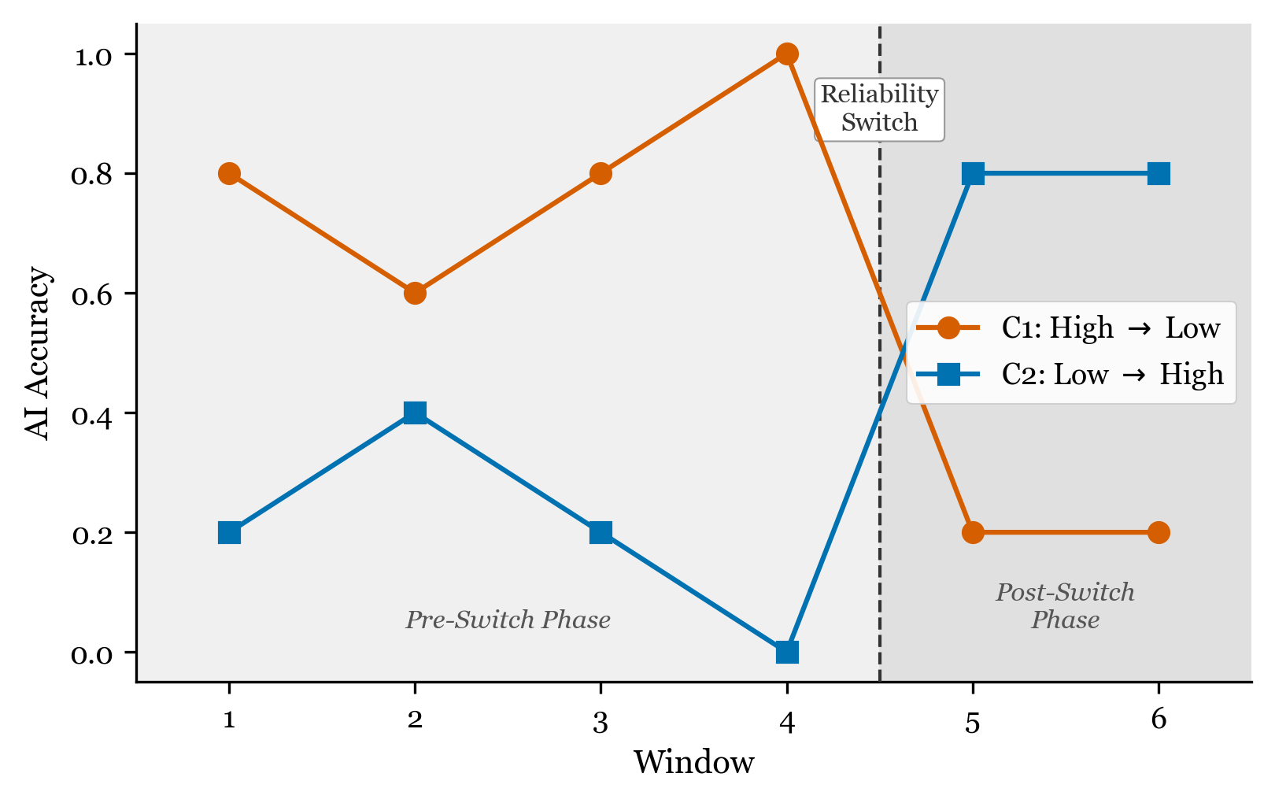
Experimental Design
Note. The figure illustrates the two experimental conditions. In C1 (High-to-Low), AI accuracy is approximately 80% in Windows 1–4 and drops to approximately 20% in Windows 5–6. In C2 (Low-to-High), AI accuracy is approximately 20% in Windows 1–4 and rises to approximately 80% in Windows 5–6. The vertical dashed line marks the reliability switch between Windows 4 and 5.

Figure 2
Theoretical Predictions for Five Trust Calibration Trajectory Patterns
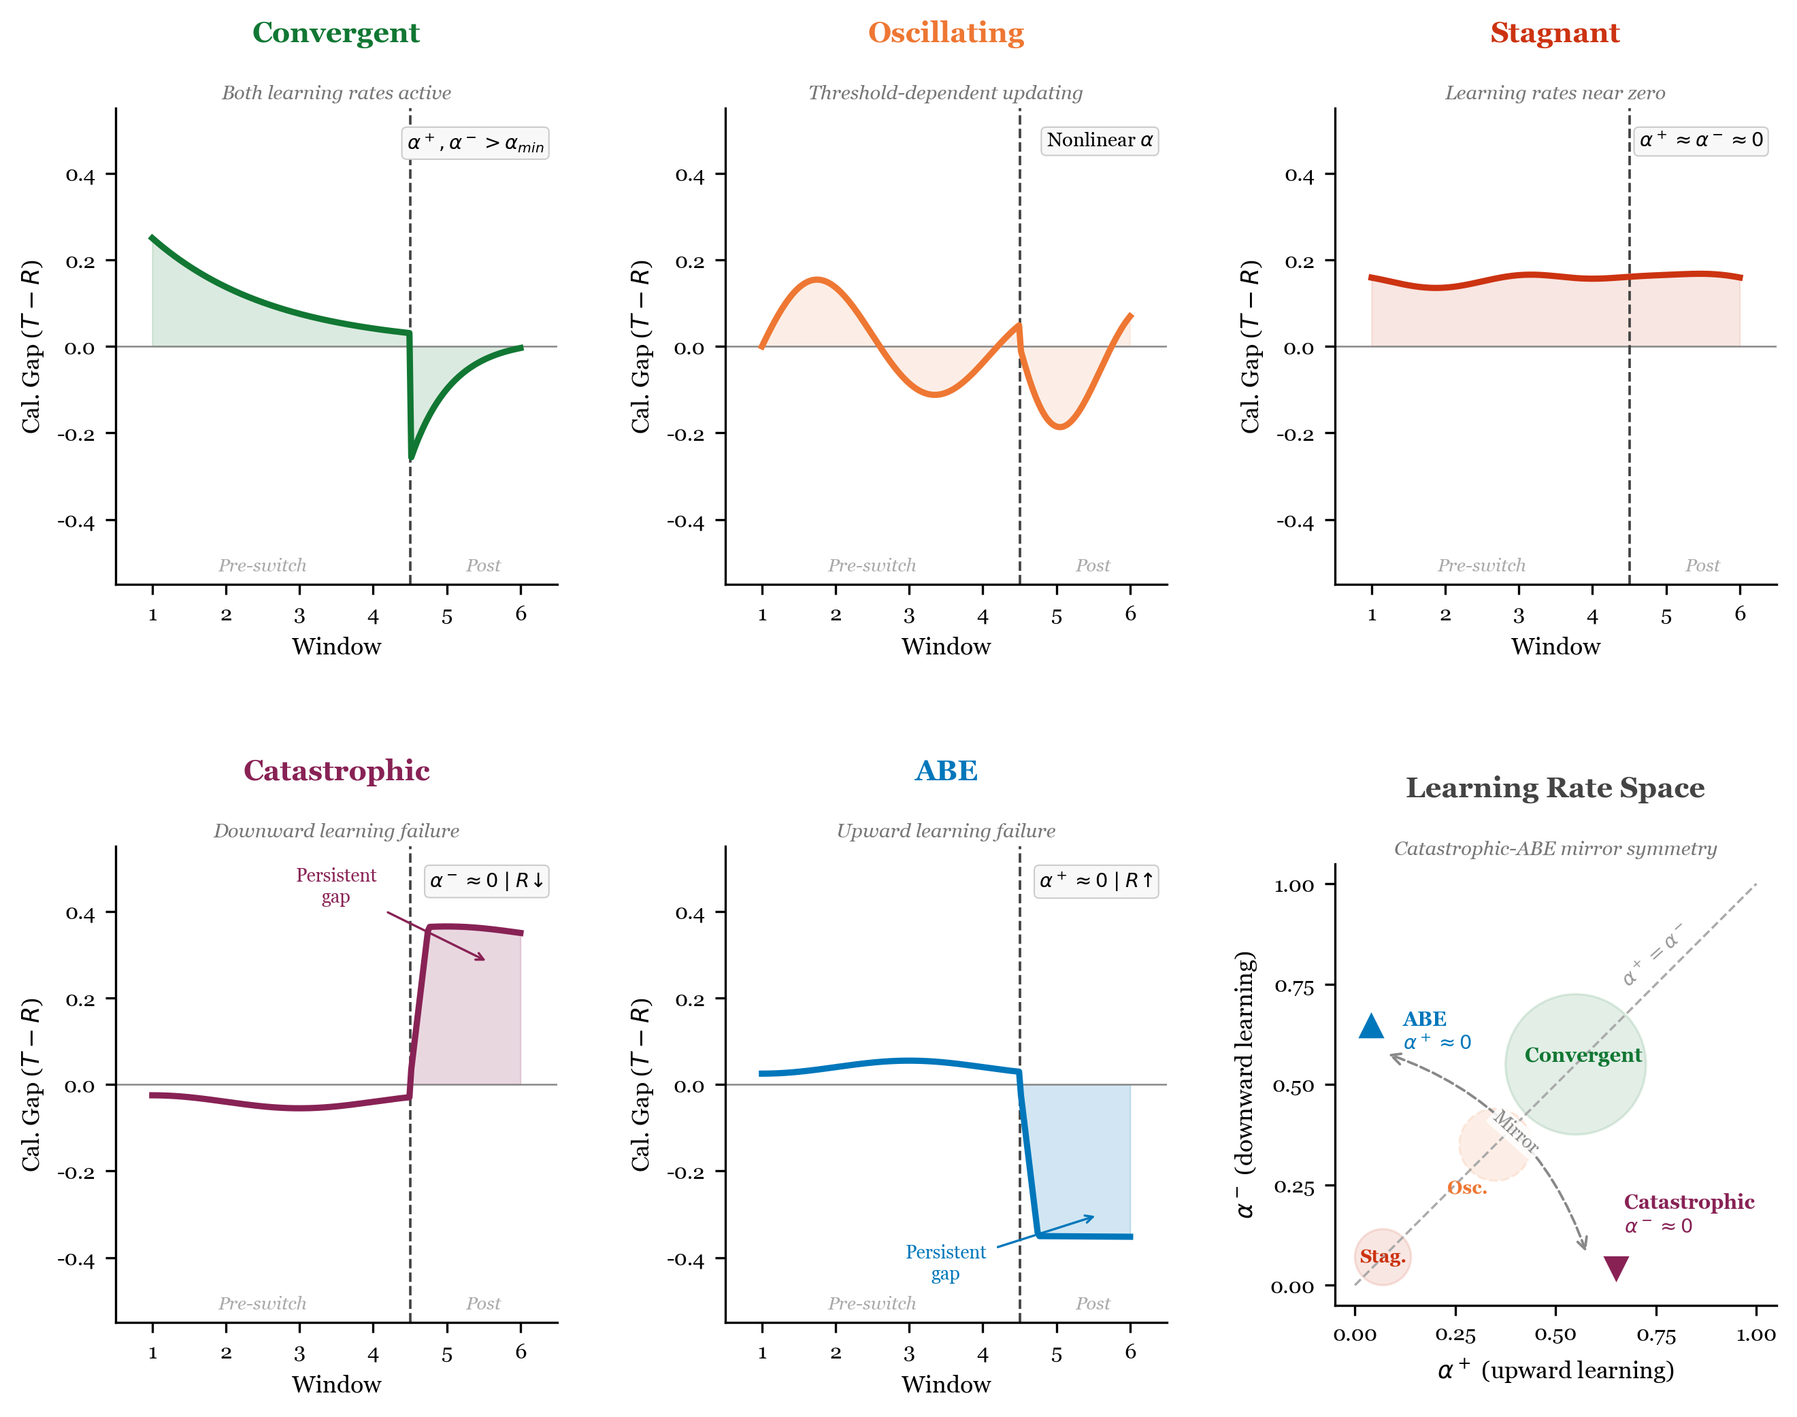
Theoretical Predictions
Note. Theoretical predictions for the five trajectory patterns derived from the Bayesian Trust Update Model, illustrated in the context of the chess puzzle experimental design. Each panel shows the predicted behavioral trust trajectory ($T_{t}$) relative to AI reliability ($R_{t}$) across six windows, given different configurations of the asymmetric learning rate parameters ($α^{+}$, $α^{−}$). The parameter space panel shows the mapping between learning rate configurations and predicted patterns. The vertical dashed line marks the reliability switch between Windows 4 and 5.

Figure 3
LCGA Calibration Gap Trajectories by Class
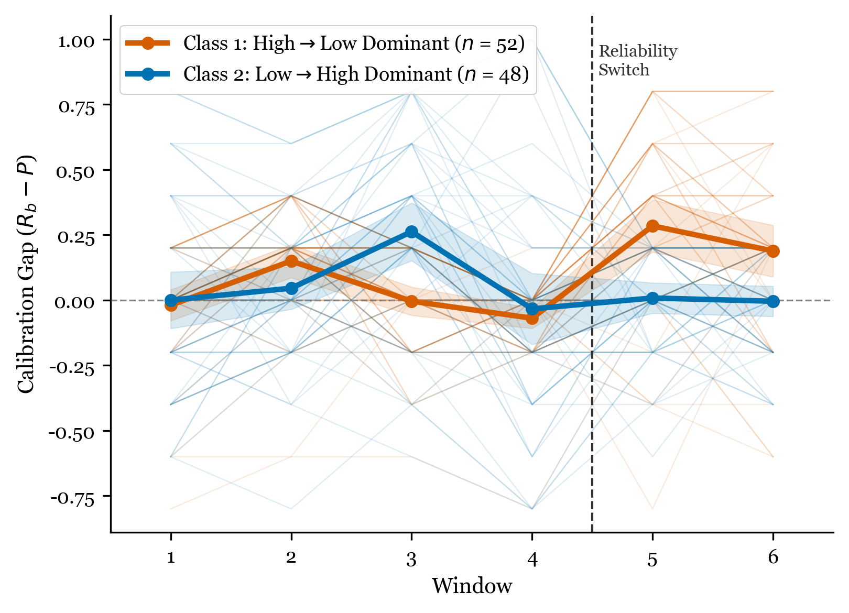
LCGA Trajectories
Note. Mean calibration gap trajectories for the two-class LCGA solution (G = 2). Class 1 (n = 52, C1-dominant) shows a shift from under-reliance to over-reliance at the switch point. Class 2 (n = 48, C2-dominant) shows a shift from over-reliance to under-reliance. Entropy = 0.871; classification accuracy = 96%.

Figure 4
GMM Six-Class Trajectory Profiles
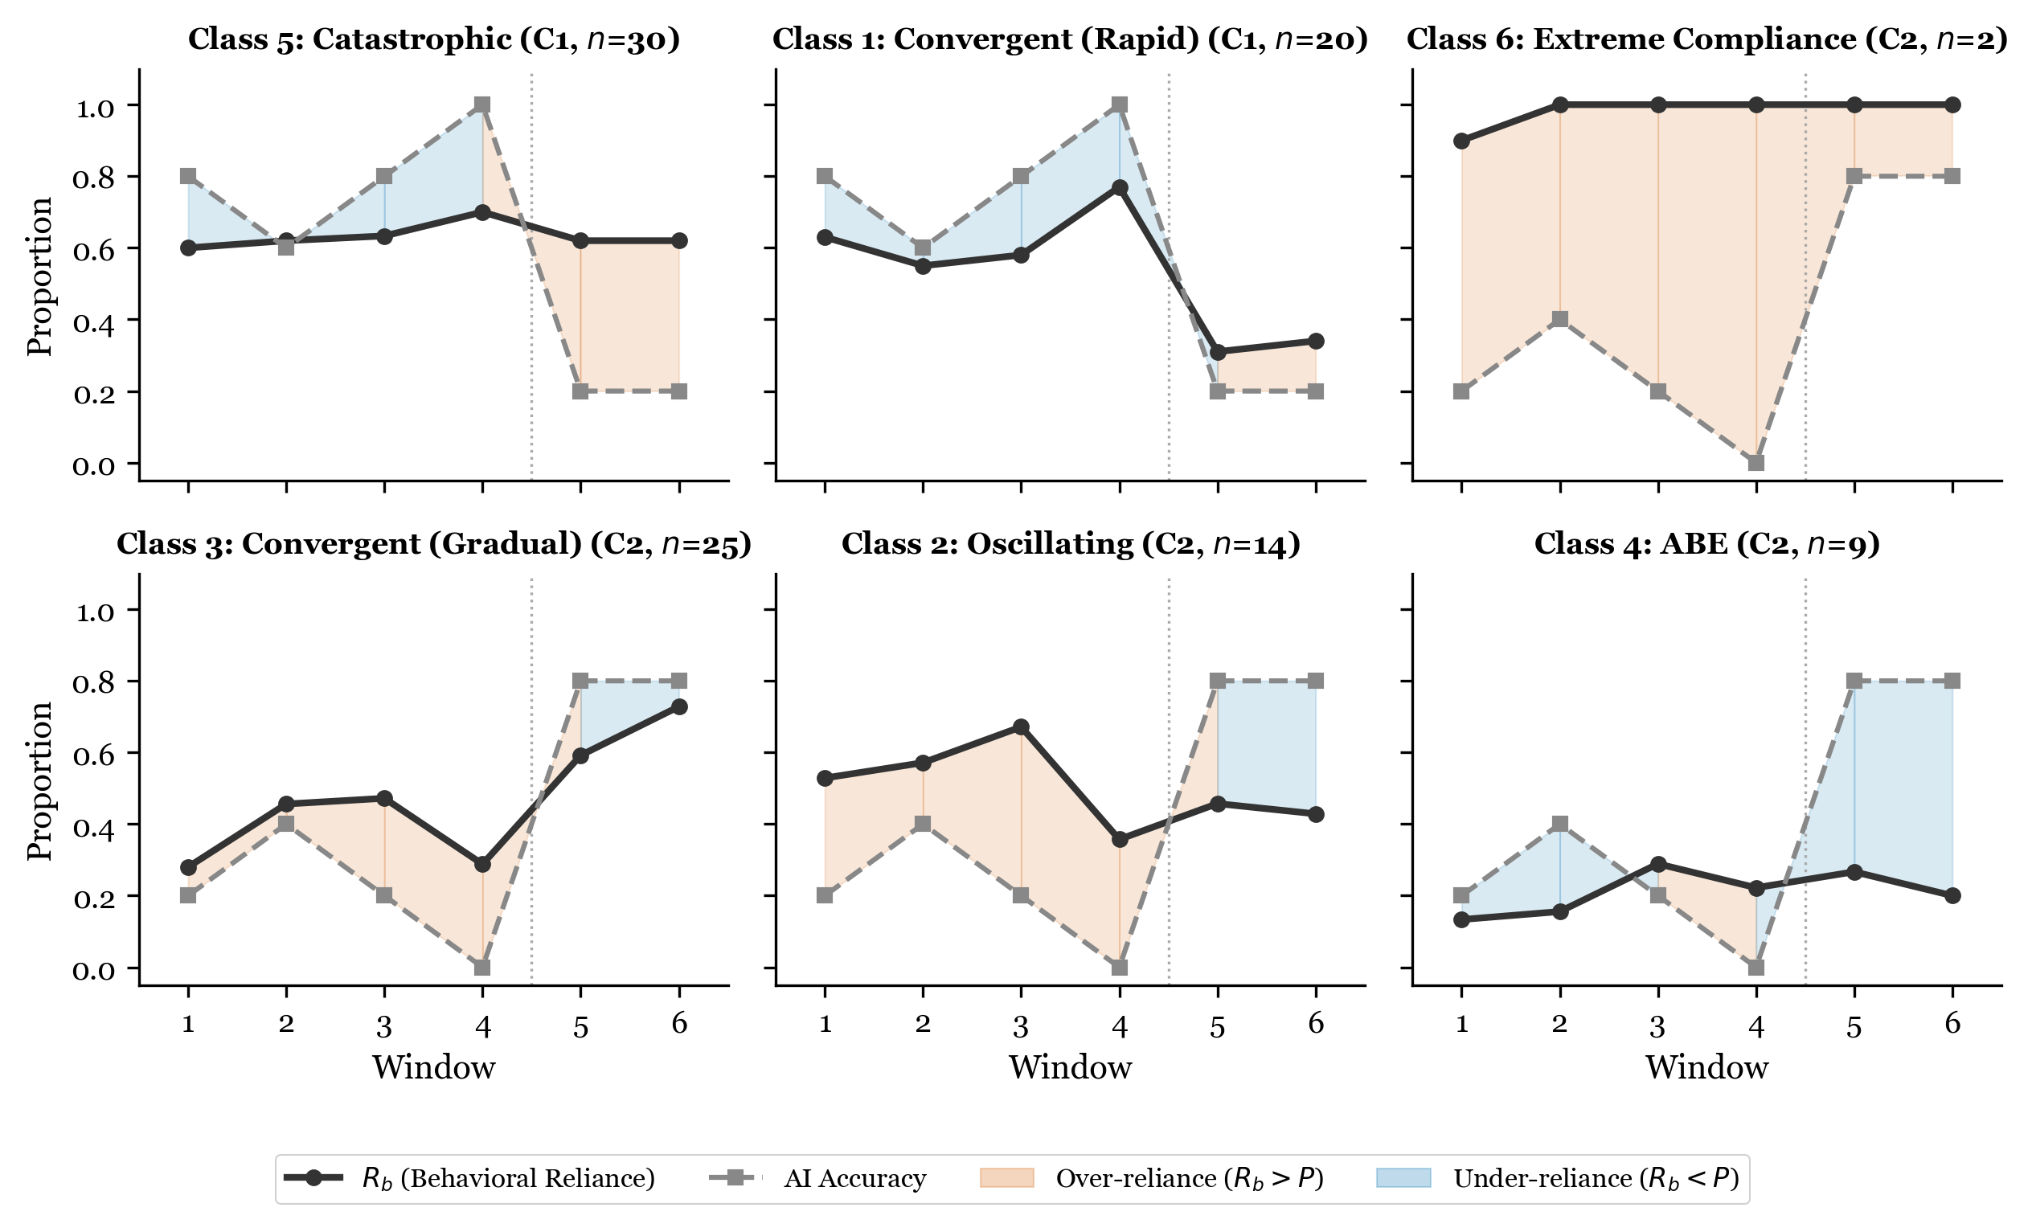
GMM Six-Class Profiles
Note. Trajectory profiles for the six-class GMM solution, showing behavioral reliance (R_{b}), AI accuracy, and calibration gap across six windows. Classes are labeled by their theoretical pattern mapping: Convergent (rapid), Oscillating, Convergent (gradual), AI Benefit Emergence (ABE), Catastrophic, and Extreme Compliance.

Figure 5
Cross-Method Comparison: LCGA and GMM Class Assignments
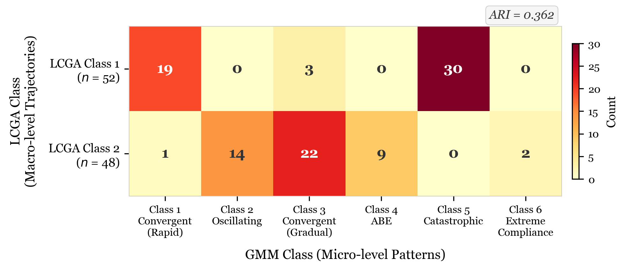
Cross-Method Comparison
Note. Heatmap showing the cross-tabulation of LCGA (two classes) and GMM (six classes) assignments. Adjusted Rand Index (ARI) = .362. LCGA captures condition-level macro-structure while GMM captures within-condition micro-heterogeneity.

