The Calibration Gap: A Systematic Review of Trust in Educational AI (2015–2026)
[Author Names]

Abstract
When AI tutoring tools harm rather than help learning, the mechanism is often trust miscalibration—learners’ trust in AI does not match the AI’s actual reliability. Bastani et al. (2025) found that unrestricted ChatGPT access reduced exam performance by 17%, not because the AI failed but because students accepted outputs uncritically. This is not an isolated finding: converging evidence documents cognitive offloading, uncritical acceptance, and overreliance across educational contexts (Darvishi et al., 2024; Kıyak et al., 2026).
Education researchers are deeply familiar with calibration. In the self-regulated learning (SRL) tradition, calibration refers to the accuracy of learners’ self-judgments (Winne & Hadwin, 1998). Trust calibration extends this logic to a new object: the accuracy of learners’ judgments about an AI system’s capabilities (Lee & See, 2004). While structurally analogous, the two require fundamentally different informational inputs—self-monitoring versus system monitoring—and thus different educational supports.
This systematic review of 97 studies on trust in educational AI (2015–2026) reveals that the field has not yet made this extension. We introduce a 5-domain Research Orientation Typology classifying the literature along a calibration maturity spectrum. The analysis exposes a calibration gap: 83.5% of studies remain below the calibration threshold; 84.5% provide no explicit trust definition; only 7.2% measure trust empirically; and no study simultaneously measures both learner trust and AI reliability. By contrast, Wischnewski et al. (2023) identified 96 automation/HCI studies employing such dual measurement—indicating that calibration methodology exists but has not penetrated educational AI research.
We argue for reframing the field’s central question from “Do learners trust AI?” to “Is their trust calibrated?” and introduce the Trust–AI Reliability Matrix as a diagnostic tool for aligning measurement with what matters for learner outcomes.
Keywords: trust calibration, educational AI, systematic review, self-regulated learning, metacognition, research typology

1. Introduction
The promise of artificial intelligence in education rests on the assumption that access to capable AI tools will improve learning. Bastani et al. (2025), in a large-scale randomized controlled trial, dismantled this assumption: unrestricted ChatGPT access reduced exam performance by 17%—not because the AI failed, but because students accepted outputs uncritically, bypassing the cognitive effort that produces learning. This is not an isolated finding. Darvishi et al. (2024) documented how AI assistance undermines student agency when learners defer uncritically to AI-generated feedback. Kıyak et al. (2026) found that even explicit warnings fail to reduce overreliance on AI-generated clinical advice in medical education—a finding with direct implications for patient safety. Cotton et al. (2024) chronicled academic integrity challenges arising when students accept AI outputs without verification.
These cases—and others documenting cognitive offloading (Anthropic, 2025), critical thinking decline (Gerlich, 2025), and systematic overreliance (Vössing et al., 2024)—share a common structure: learners interact with AI systems whose reliability varies across tasks and domains, yet their trust operates as an undifferentiated global attitude rather than a calibrated, domain-specific judgment. The convergence of these findings across independent research groups, educational levels, and disciplinary contexts suggests a structural problem rather than isolated incidents. The educational AI literature has documented this pattern extensively but has not developed the measurement infrastructure to move from documentation to intervention.
Education researchers are well acquainted with calibration through the self-regulated learning (SRL) tradition, where it denotes the accuracy of learners’ judgments about their own knowledge and performance (Winne & Hadwin, 1998; Stone, 2000). Trust calibration extends this same logic from self to system: it captures whether a learner’s trust in AI corresponds to the AI’s actual capabilities (Lee & See, 2004). While structurally analogous—both involve metacognitive judgment accuracy measured as the discrepancy between subjective judgment and objective criterion—they require fundamentally different informational inputs: self-monitoring versus system monitoring. A student with excellent SRL calibration may still dangerously overtrust AI, because the two involve different objects of judgment and different informational requirements.
Despite this conceptual readiness, existing frameworks do not adequately address trust calibration. Technology acceptance models (Davis, 1989; Venkatesh et al., 2003) treat trust as an adoption predictor—a variable to be maximized—structurally unable to accommodate the possibility that trust can be too high. Higher trust predicts greater adoption, and there is no conceptual space for the question the calibration lens asks: “Is this level of trust warranted?” SRL frameworks (Zimmerman, 2000; Winne & Hadwin, 1998) address calibration of self-judgments but not judgments about external AI systems; the informational inputs differ categorically. The trust-in-automation tradition (Lee & See, 2004; Hoff & Bashir, 2015) explicitly models calibration but has not been systematically translated to educational contexts. The combination of these limitations creates a structural blind spot: the field’s dominant frameworks direct attention toward “Do learners trust AI?” and “Do learners know what they know?” while obscuring the more consequential question “Is their trust in AI calibrated to AI’s actual capabilities?” What is missing is a systematic diagnostic of where the field stands and what it overlooks.
This systematic review addresses this gap through two contributions:
- A 5-domain Research Orientation Typology classifying 97 coded papers along a trust calibration maturity spectrum, revealing that 83.5% of research operates below the calibration threshold—the point at which trust is explicitly assessed against AI reliability.
- A reframing argument from trust-level to trust-calibration research, grounded in the empirical evidence of the calibration gap and illustrated through the Trust–AI Reliability Matrix, a diagnostic tool requiring both learner trust and AI reliability measurement.
Three research questions guide this review:
- RQ1: What research orientations characterize the educational AI trust literature, and how do they distribute along a calibration maturity spectrum?
- RQ2: To what extent does current research address trust calibration, and where does a calibration gap persist?
- RQ3: What reframing is needed to advance trust calibration research in educational AI?

2. Conceptual Background

2.1 Calibration in Education: The SRL Foundation
Education researchers have a long and productive relationship with calibration. In the SRL tradition, calibration refers to the accuracy of learners’ judgments about their own knowledge and performance (Winne & Hadwin, 1998; Stone, 2000). A well-calibrated learner accurately assesses what she knows and does not know, enabling adaptive study strategies; a poorly calibrated learner allocates study time inefficiently (Dunlosky & Rawson, 2012). Decades of research have established SRL calibration as a powerful predictor of academic achievement, with metacognitive monitoring as the operative mechanism (Nelson & Narens, 1990; Pieschl, 2009). The calibration construct has proven both theoretically productive and practically consequential, generating interventions that improve learning outcomes by improving the accuracy of learners’ self-assessments.
The calibration concept rests on a measurement logic that is both simple and powerful: compare a subjective judgment against an objective criterion and quantify the discrepancy. When the discrepancy is small, the learner is well-calibrated; when large, the learner is miscalibrated—either overconfident or underconfident. Stone (2000) identified principles that remain instructive: calibration is most meaningful at the item level rather than through global self-assessments, and it exhibits a characteristic hard-easy effect. This measurement logic—judgment versus reality—is the conceptual foundation that the present paper extends to a new domain.

2.2 From Self to System: Trust Calibration
The same calibration logic applies when the object of judgment shifts from self to an external AI system. Lee and See (2004) defined trust calibration as the correspondence between a person’s trust in a system and the system’s actual capabilities. Table 1 summarizes the structural parallel—and the critical divergences—between SRL calibration and trust calibration.
Table 1. SRL Calibration Versus Trust Calibration
Dimension | SRL Calibration | Trust Calibration
Object of judgment | Own knowledge and abilities | AI system’s capabilities
Locus of uncertainty | Self (internal) | External system
Core question | “Do I know this?” | “Can this AI do this?”
Measurement formula | |Self-prediction − Actual performance| | |Trust in AI − AI actual reliability|
Overestimation | “I know this” (actually does not) | “The AI is right” (actually wrong)
Underestimation | “I don’t know this” (actually does) | “The AI can’t do this” (actually can)
Improvement mechanism | Self-assessment, reflective journals | AI literacy, domain-specific verification
Information access | Introspective (imperfect but direct) | Observational (opaque, context-dependent)
Reference object stability | Changes slowly through learning | Changes abruptly (model updates, domain variation)
Research maturity | Mature (30+ years) | Pre-paradigmatic in education
The two forms of calibration are structurally analogous—both involve metacognitive judgment accuracy measured as a judgment-criterion discrepancy—but they diverge in ways that are consequential for educational design. First, information access differs fundamentally: SRL calibration draws on introspective access to one’s own cognitive states, while trust calibration requires inference about an opaque external system from observable outputs. A learner can reflect on whether she understands integral calculus; she cannot introspect about whether ChatGPT solves integrals correctly. Second, the reference object’s stability differs: a learner’s own capabilities change predictably through learning, while an AI system’s reliability varies dramatically across domains and can shift abruptly with model updates. Third, feedback mechanisms differ: SRL calibration improves through direct performance feedback, while trust calibration feedback requires knowing the AI’s actual accuracy on the specific task—information rarely available to learners. These differences mean that high SRL calibration does not guarantee high trust calibration; they are independent competencies requiring independent educational supports.
Emerging work supports this bridging. Lee et al. (2025) identified metacognitive sensitivity as a mechanism linking metacognition to trust calibration. Lee and Bosch (2025) showed that calibration discrepancy predicts metacognitive strategy use. Yet such integration remains exceptional.

2.3 Why Existing Frameworks Cannot Capture Trust Calibration
Neither dominant framework tradition in educational AI research can adequately address trust calibration. Technology acceptance models (TAM/UTAUT) position trust as a variable to be maximized: higher trust predicts greater adoption, and there is no conceptual space for trust being too high. These models also lack an AI reliability axis, making calibration assessment structurally impossible. This is not a minor limitation but a structural blind spot.
SRL frameworks face a different limitation: they address calibration of self-judgments but provide no mechanism for calibrating judgments about external systems. The informational inputs differ categorically. The combination of these limitations creates a structural blind spot: the field’s dominant frameworks direct attention toward “Do learners trust AI?” and “Do learners know what they know?” while obscuring the more consequential question “Is their trust in AI calibrated to AI’s actual capabilities?”

3. Method

3.1 Review Type
This systematic review follows PRISMA 2020 guidelines (Page et al., 2021), combining structured coding with critical synthesis for theoretical integration (Grant & Booth, 2009; Pare et al., 2015). The structured coding provides the empirical basis for the Research Orientation Typology and calibration gap diagnosis; the critical synthesis supports the reframing argument and research agenda. The PRISMA 2020 checklist is provided as supplementary material.

3.2 Search Strategy
We searched Web of Science, Scopus, and PsycINFO (2015–2026) combining trust-related terms (“trust” OR “trust calibration” OR “overtrust” OR “reliance” OR “overreliance”) with educational AI terms (“educational AI” OR “AI-assisted learning” OR “generative AI” OR “intelligent tutoring” OR “AI in education”). This temporal scope captures the maturation of intelligent tutoring systems and the transformative period following public LLM releases. Papers were included if they addressed trust dynamics in educational AI contexts, including empirical studies measuring trust or calibration, theoretical frameworks addressing trust in learning environments, and studies from adjacent fields with clear educational applicability. Papers were excluded if they addressed trust only in non-educational contexts without transferable implications, or if they discussed AI in education without addressing trust-related constructs.
Database searches were supplemented with backward and forward citation tracking from seminal works (Lee & See, 2004; Mayer et al., 1995; Hoff & Bashir, 2015; Bastani et al., 2025), yielding 16 additional papers from the human factors and HCI literature that directly address trust calibration measurement and intervention. We acknowledge that this supplementary search was purposively designed to capture calibration-relevant work; the resulting asymmetry between database-sourced and supplementary papers is reported transparently as evidence of a disciplinary blind spot rather than treated as a neutral sampling outcome.
Through this process, 147 papers were identified for full-text analysis: 81 from database searches and 16 from supplementary tracking, plus 50 that could not be coded due to full-text access limitations (see Figure 1).
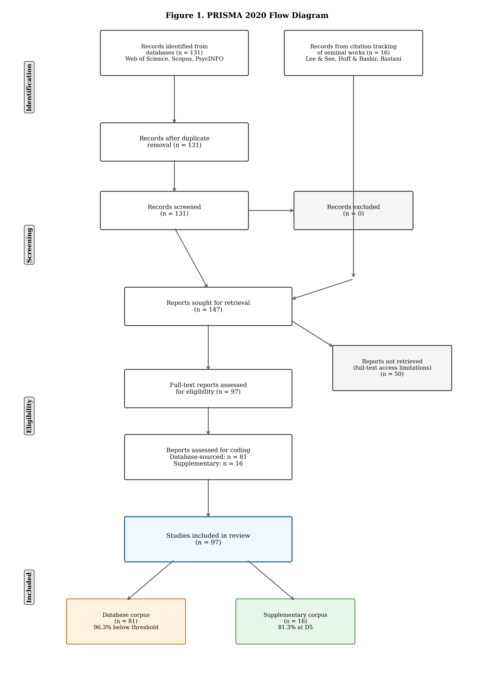 Of the 97 coded papers, the corpus spans 2019–2026, with 64.9% published in 2025. Study types include reviews (50.5%), empirical studies (37.1%), theoretical papers (8.2%), and mixed methods (4.1%). To ensure transparency, we report statistics separately for the database corpus (n=81), the supplementary corpus (n=16), and the combined corpus (n=97) throughout the results. [Sensitivity analysis: title/abstract screening of the 50 uncoded papers identified X as potentially calibration-relevant; sensitivity estimates are reported in Section 6.]

3.3 Coding and Analysis
Each paper was coded using a 32-field scheme capturing bibliographic information, trust conceptualization, theoretical framework, measurement approach, calibration engagement, and design features (full coding manual in supplementary materials). The first author coded all 97 papers; the second author independently coded a random subsample of approximately 20% (n=20) to establish intercoder reliability. Cohen’s kappa was computed for key categorical variables: addresses_calibration (κ = [TBC]), overtrust_discussed (κ = [TBC]), undertrust_discussed (κ = [TBC]), scaffold_proposed (κ = [TBC]), and theoretical_framework classification (κ = [TBC]). Discrepancies were resolved through discussion.
Selected works were analyzed thematically across three dimensions corresponding to the research questions: trust conceptualization and theoretical framing (RQ1), calibration engagement and measurement approaches (RQ2), and the calibration gap diagnosis motivating the reframing argument (RQ3). Quantitative analysis of the coded data included frequency distributions, cross-tabulations (e.g., domain × theoretical framework; domain × study type), and the domain distribution analysis reported in Section 4.
The 5-domain Research Orientation Typology was derived post-hoc from five coded variables applied through deterministic priority rules (detailed in Section 4.1 and supplementary Appendix D). Because the typology is algorithmically derived from existing coded fields, its reliability is bounded by the reliability of its input variables. A typological approach was selected because it reveals structural patterns invisible in variable-by-variable analysis (Bailey, 1994; Doty & Glick, 1994). We present this typology transparently as a post-hoc analytical tool, not a pre-specified coding category.

4. Results

4.1 Overview: The Research Orientation Typology
To move beyond variable-by-variable reporting, we classified the 97 coded papers into a 5-domain Research Orientation Typology arranged along a trust calibration maturity spectrum (Table 2; Figure 2). Each domain represents a qualitatively distinct orientation:
- D1 = “Will learners adopt AI?” (Trust Adoption)
- D2 = “Does trust matter?” (Trust Conceptualization)
- D3 = “How should we design for trust?” (Trust Design)
- D4 = “Can trust go wrong?” (Trust Awareness)
- D5 = “Is trust actually accurate?” (Trust Calibration)
The classification uses deterministic priority rules: papers explicitly addressing calibration are D5; papers recognizing overtrust/undertrust with partial calibration engagement are D4 (subcategorized by directionality); papers proposing scaffolds without D4/D5 criteria are D3; papers using TAM/UTAUT/DOI exclusively are D1; remaining papers are D2. Priority ordering ensures mutually exclusive assignment.
Table 2. Research Orientation Typology Distribution
Domain | Description | n | % | DB-sourced | Supplementary
D1: Trust Adoption | TAM/UTAUT/DOI exclusive | 5 | 5.2% | 5 | 0
D2: Trust Conceptualization | General trust discussion | 11 | 11.3% | 10 | 1
D3: Trust Design | Scaffold proposals without calibration | 24 | 24.7% | 22 | 2
D4: Trust Awareness | Overtrust/undertrust recognized | 41 | 42.3% | 41 | 0
D5: Trust Calibration | Calibration explicitly addressed | 16 | 16.5% | 3 | 13
Total |  | 97 | 100% | 81 | 16
Below calibration threshold (D1–D4) |  | 81 | 83.5% | 78 | 3
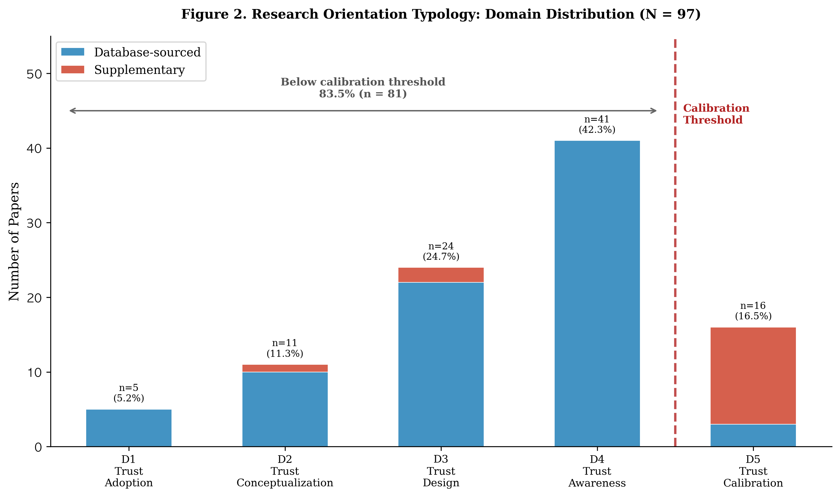
Figure 2. Research Orientation Typology: Domain distribution across the calibration maturity spectrum (N = 97). The dashed red line indicates the calibration threshold separating D4 (trust awareness without measurement) from D5 (explicit calibration engagement). Database-sourced papers shown in blue; supplementary papers in red.
The distribution reveals a field concentrated below the calibration threshold: 83.5% of the corpus operates without explicit calibration engagement. Among database-sourced papers alone, 78 of 81 (96.3%) fall below this threshold. The calibration threshold marks the transition from recognizing that trust can be problematic (D4) to assessing whether trust is accurate (D5)—analogous to the difference between noting that a student seems overconfident and actually measuring the discrepancy between confidence and performance.

4.2 D1–D3: Adoption, Conceptualization, and Design
D1 (Trust Adoption, n=5, 5.2%) encompasses studies employing TAM, UTAUT, or DOI as their sole framework, treating trust exclusively as a predictor of AI adoption. In these studies, trust is positioned alongside perceived usefulness, ease of use, and social influence as an antecedent of adoption intention. The D1 orientation is structurally unable to address calibration because its dependent variable—adoption—is unidirectional: higher trust leads to greater adoption, and the framework provides no mechanism for evaluating whether that trust is warranted. A student who trusts ChatGPT completely and adopts it for all tasks would score maximally on trust and adoption scales, regardless of whether the AI is reliable for those tasks. The limitation is not empirical but architectural: the framework’s structure renders calibration invisible. While D1 contributions to understanding adoption antecedents are valuable, their exclusive focus on acceptance means they cannot contribute to the calibration agenda without fundamental theoretical extension.
D2 (Trust Conceptualization, n=11, 11.3%) includes studies discussing trust in educational AI at a general conceptual level without design proposals, calibration criteria, or systematic frameworks. These papers acknowledge trust as a relevant variable but treat it as self-evident rather than requiring operationalization. This domain reflects a broader pattern: 84.5% of the corpus provided no explicit definition of trust. Only 9 papers (9.3%) offered explicit operational definitions, while 6 (6.2%) employed implicit definitions discernible from context. Yet trust is a documented multidimensional construct in both organizational (Mayer et al., 1995) and human factors traditions (Lee & See, 2004; Hoff & Bashir, 2015); without definitional precision, fundamentally different phenomena—dispositional tendencies, context-specific judgments, accumulated experiential assessments—are collapsed into a single undifferentiated variable, obscuring the fine-grained analysis required for calibration research. The vast majority of the corpus (88.7%) conceptualized trust as “trust in AI” as a general construct, while only 6.2% employed the more specialized trust-in-automation framing from human factors research.
D3 (Trust Design, n=24, 24.7%) represents studies proposing scaffolds, design features, or interventions related to trust. Overall, 63 papers (64.9%) across the corpus proposed some form of scaffold, with transparency mechanisms being the most common type (24.7%), followed by multiple scaffold combinations (24.7%), and other approaches (9.3%). The 24 D3 papers are those whose scaffold proposals are their primary contribution but which lack calibration criteria or trust direction awareness. The critical limitation of D3 is the absence of calibration criteria: when a paper proposes “increasing transparency to build trust,” it implicitly assumes higher trust is always desirable. Yet transparency can paradoxically worsen calibration—consider an AI writing assistant that explains its essay structure with articulate reasoning: this transparency may lead a student to accept prose that sounds authoritative but contains factual errors. The design question should not be “How do we increase trust?” but “How do we align trust with reliability?”—a question that D3 research, by definition, does not ask. Notably, metacognitive scaffolds appeared in only 3 papers (3.1%), compared to 24 proposing transparency scaffolds. This asymmetry is consequential: transparency addresses the information available for trust judgments, while metacognitive scaffolds address learners’ capacity to evaluate that information. Calibration requires both, but the field overwhelmingly emphasizes the former. The near-absence of metacognitive scaffolds suggests that the field’s design thinking is oriented toward giving learners more information about AI systems rather than developing learners’ capacity to evaluate that information.

4.3 D4: Trust Awareness (n=41, 42.3%)
D4 is the largest domain. These studies recognize overtrust or undertrust as problems and partially engage with calibration, but stop short of systematic measurement. D4 represents the field’s growing awareness that trust can be miscalibrated—coupled with an inability to move from recognition to measurement.
D4 subcategories reveal the directionality of this awareness. D4a (Overtrust Recognition, n=16, 16.5%) includes papers that discuss overreliance, uncritical acceptance, or automation complacency without addressing undertrust. These papers typically warn about students copying AI-generated content without verification, but they do not measure whether the observed reliance exceeds the AI’s actual reliability—a measurement that would be required to confirm overtrust rather than merely infer it. D4b (Undertrust Recognition, n=18, 18.6%) includes papers discussing AI skepticism, rejection, or resistance without addressing overtrust, often framing learner reluctance as a barrier to be overcome. D4c (Bidirectional Awareness, n=7, 7.2%) includes papers recognizing both directions of miscalibration; these are the most theoretically sophisticated within D4, acknowledging that trust can be both excessive and insufficient, but they remain below the D5 threshold because they do not measure or systematically address calibration. The 7 D4c papers acknowledge that trust can be both too high and too low, but none proposes methods for assessing whether a specific learner’s trust is appropriate relative to the AI’s actual capability.
That D4b slightly exceeds D4a is notable: concerns about learners rejecting AI marginally outnumber concerns about overrelying on it. This asymmetry may reflect the field’s prevailing adoption-oriented framing, in which resistance to AI is coded as a problem to be solved. The calibration perspective reframes this: whether rejection or acceptance is problematic depends entirely on AI reliability for the given task. A learner who rejects an unreliable AI recommendation exhibits calibrated avoidance, not a problem requiring intervention.
The central insight from D4 is that recognizing a problem is not the same as measuring it. A paper that warns about student overreliance on ChatGPT for essay writing but does not assess whether students’ trust in ChatGPT’s writing ability corresponds to ChatGPT’s actual writing reliability has identified a potential miscalibration without establishing whether one exists. This distinction—between awareness and measurement—is the threshold separating D4 from D5. That 56% of D4 papers employ no theoretical framework compounds the problem: the field’s most active researchers—those who recognize miscalibration—lack the conceptual tools to move from recognition to measurement.

4.4 D5: Trust Calibration (n=16, 16.5%)
D5 encompasses the 16 papers explicitly addressing trust calibration as a construct or measurement target. The disciplinary composition is the most consequential finding: only 3 of 16 D5 papers came from educational AI database searches; the remaining 13 were identified through supplementary citation tracking from human factors, HCI, and cognitive science. Among database-sourced papers, only 3 of 81 (3.7%) reached D5—the robust, design-independent evidence of the calibration gap.
All three database-sourced D5 papers share an important characteristic: all three employ Lee and See’s (2004) or Hoff and Bashir’s (2015) trust-in-automation frameworks, suggesting that explicit adoption of calibration-oriented theoretical frameworks is a necessary condition for calibration-focused research in education. This pattern reinforces the structural limitation argument: the theoretical framework researchers choose determines whether calibration becomes visible as a research question.
Key D5 exemplars illuminate what calibration research looks like. Okamura and Yamada (2020) used behavioral dependence switching as a calibration proxy in human-AI collaboration tasks, demonstrating that adaptive calibration interventions can shift reliance patterns. Ma et al. (2024) demonstrated that self-confidence calibration prompts improve reliance behavior in AI-assisted decision making, providing direct evidence that metacognitive interventions can affect calibration. Li et al. (2024) directly manipulated AI confidence calibration levels to assess their effects on user trust, establishing a causal pathway from system-level calibration cues to user-level trust responses. Lee et al. (2025) established metacognitive sensitivity as a mechanism linking metacognition to trust calibration, providing the most direct conceptual bridge between SRL and trust calibration literatures. Vasconcelos et al. (2023) showed that explanations can reduce overreliance on AI systems during decision-making, though the effect operates through increased cognitive engagement rather than calibration per se. Wischnewski et al. (2023) surveyed 96 studies on trust calibration measurement for automated systems—a comprehensive mapping that notably identified zero studies from educational contexts. Mehrotra et al. (2024) systematically reviewed approaches to fostering appropriate trust in human-AI interaction, identifying the measurement gap as a central obstacle.
These studies demonstrate three points: calibration measurement methods exist and have been productively applied in adjacent disciplines; these methods have not been adopted in educational AI research—the gap is one of disciplinary disconnection, not methodological impossibility; and the emerging metacognition-calibration bridge (Lee et al., 2025; Lee & Bosch, 2025; Steyvers & Peters, 2025) suggests that educational researchers are uniquely positioned to advance this work by connecting established SRL traditions with the trust calibration construct.

4.5 Cross-Cutting Patterns
Four patterns provide additional context. First, the theoretical landscape is profoundly fragmented: nearly half (49.5%) of papers employed no identifiable theoretical framework, proceeding directly from research questions to investigation without anchoring their inquiry in established theory. Among papers that did employ a framework, TAM/UTAUT variants constituted the largest cluster (22.7%), followed by DOI (13.4%) and AIED-specific frameworks (13.4%). Calibration-relevant frameworks—Lee and See’s trust-in-automation model (7.2%) and Hoff and Bashir’s three-layer model (2.1%)—appeared in a combined 9.3% of papers, less than half the prevalence of TAM/UTAUT alone. SRL frameworks, which are pedagogically most relevant to calibration given their emphasis on metacognitive monitoring, appeared in only 5 papers (5.2%)—and none in D5. The calibration-relevant frameworks are marginalized precisely in the field where calibration matters most.
Second, measurement infrastructure is sparse: only 7 papers (7.2%) measured trust empirically in any form, only 1 (1.0%) measured calibration accuracy, and none measured both simultaneously. Among measurement approaches, the prevailing strategy relies on Likert-type self-report instruments administered as cross-sectional surveys. Behavioral measures of trust—examining AI output acceptance rates, usage frequency, or task delegation patterns—remain rare. Process-level measures (time spent verifying AI outputs, modification patterns, information-seeking behaviors) are entirely absent from the corpus, yet process measures are precisely what would be needed to assess trust calibration in real time.
Third, the corpus is temporally concentrated: 64.9% published in 2025. This recency suggests the field is in a formative period where paradigmatic choices are still being made, presenting an opportunity for the reframing we propose.
Fourth, study types reveal a field heavy on synthesis and light on primary data: 50.5% reviews (narrative or systematic), 37.1% empirical, 8.2% theoretical, and 4.1% mixed methods. D5 stands out as the most empirically active domain (56% empirical), while D2 is the most review-heavy (73%). The predominance of reviews means the field’s conclusions about trust are built more on synthesis of existing knowledge than on new empirical evidence—particularly problematic when the existing knowledge base lacks calibration measurement.

4.6 The Calibration Gap
Before diagnosing the gap, it is worth recognizing what 97 papers have accomplished. The field has built a substantial awareness infrastructure: 42.3% of studies recognize that trust in AI can be miscalibrated, a majority (64.9%) propose some form of scaffold or design intervention, and the rapid literature growth signals that the community recognizes trust as a central concern. Yet four patterns within this productive activity reveal a structural disconnection between awareness and measurement. First, D4 is the largest domain (42.3%), yet 56% of D4 papers employ no theoretical framework—the awareness-tool gap. Second, the two research traditions closest to trust calibration have not converged: Lee and See’s framework appears in 7 papers with 6 concentrated in D5 (86%), while SRL frameworks appear in 5 papers with zero in D5—the cross-disciplinary disconnect. Third, transparency scaffolds appear in 24.7% of the corpus while metacognitive scaffolds appear in only 3.1%—the scaffold asymmetry. Fourth, of 16 D5 papers, only 3 came from educational AI databases—the D5 source asymmetry. These patterns converge on a single conclusion: the field has reached the threshold of calibration awareness without crossing into calibration measurement.
The definitional dimension. Of 97 papers, 82 (84.5%) provided no explicit definition of trust. Without definitional precision, the field cannot distinguish trust as attitude, belief, or behavioral intention—constructs with different measurement requirements and implications for calibration.
The measurement dimension. Progressive attrition from acknowledgment to measurement reveals the gap’s depth: 51 papers (52.6%) discussed overtrust or undertrust; 42 (43.3%) partially addressed calibration; 16 (16.5%) explicitly engaged with calibration; 7 (7.2%) measured trust empirically; 1 (1.0%) measured calibration accuracy; and 0 measured both trust and AI reliability simultaneously. The funnel from 97 to 0 illustrates that the gap is not at the periphery but at the core of the measurement enterprise. The contrast with adjacent disciplines quantifies this disconnection: Wischnewski et al. (2023), surveying studies in automation/HCI that simultaneously measured trust and system reliability, identified 96 such studies—a mature body of dual-measurement research. In the present corpus, no study performed this dual measurement. We note the structural asymmetry of this comparison: Wischnewski et al.’s corpus was assembled with dual measurement as an inclusion criterion, while ours used broader search terms. The comparison demonstrates that a reviewable body of calibration measurement work exists in automation/HCI but has not penetrated educational AI research. This is analogous to measuring a student’s confidence without measuring actual performance: one can quantify the attitude but cannot determine whether it is warranted—a state that would be unthinkable in SRL calibration research, where the comparison of judgment to criterion is the entire methodological foundation. A learner who reports high trust in an AI system that is, in fact, highly reliable for the given task is well-calibrated. A learner who reports equally high trust in a system that is unreliable for the given task is dangerously miscalibrated. Current measurement approaches cannot distinguish between these two states because they assess trust level without reference to the reliability baseline against which trust should be evaluated.
The disciplinary dimension. Of 16 D5 papers, 13 originated from adjacent disciplines, not educational AI databases. Only 3 of 81 database-sourced papers (3.7%) reached D5. This pattern indicates not a methodological impossibility but a disciplinary disconnection. The fact that only 3 of 81 database-sourced papers reached D5 is itself the primary evidence: the original educational AI databases, searched with broad trust-related terms, yielded almost no calibration-focused work. The gap is in the field, not in the search. Trust calibration is being studied productively elsewhere but has barely penetrated educational AI research. The bridge-building work of Lee et al. (2025) and Lee and Bosch (2025), who connect SRL and trust calibration traditions, demonstrates that integration is possible—yet remains exceptional.

5. Discussion

5.1 Reframing: From Trust Level to Trust Calibration
The calibration gap documented in this review calls for reframing the field’s central question from “Do learners trust AI?” to “Is their trust calibrated?” Under the current approach, a finding that “students report moderate trust in ChatGPT” is treated as a complete result. Under a calibration orientation, this finding is incomplete without a companion measurement of the AI’s actual reliability for the assessed tasks. Only with both can the field determine whether moderate trust is appropriate, insufficient, or excessive.
This reframing has precedent in education’s own history. The transition from measuring learner confidence to measuring calibration accuracy—from “How confident is this student?” to “Does their confidence match their actual performance?”—was the founding move of SRL calibration research (Winne & Hadwin, 1998; Stone, 2000), producing decades of productive inquiry that fundamentally changed how educators understand metacognition. The trust-in-automation field underwent a parallel transition from “Do operators trust automated systems?” to “Is their trust calibrated to the system’s reliability?” (Lee & See, 2004), producing a mature research program with 96 dual-measurement studies (Wischnewski et al., 2023; Mehrotra et al., 2024). Educational AI research stands at the same juncture—with the advantage of drawing on both precedents. The SRL tradition provides the metacognitive theory; the automation tradition provides the measurement logic. What is needed is integration.
This reframing does not require abandoning existing research traditions. Adoption research (D1) becomes the baseline from which calibration questions arise—once we know learners adopt AI tools, we ask whether their trust in those tools is calibrated. Design research (D3) becomes the intervention space where calibration-improving features are tested—not to increase trust, but to align it with reliability. Trust awareness research (D4) provides the problem recognition that calibration measurement operationalizes. The reframing enriches rather than replaces existing work, providing each domain with a calibration-oriented research question that extends its current orientation.

5.2 The Trust–AI Reliability Matrix
To illustrate the calibration concept as a diagnostic tool, we propose the Trust–AI Reliability Matrix (Figure 3), mapping learner trust (high vs. low) against AI reliability (high vs. low) for a given task.
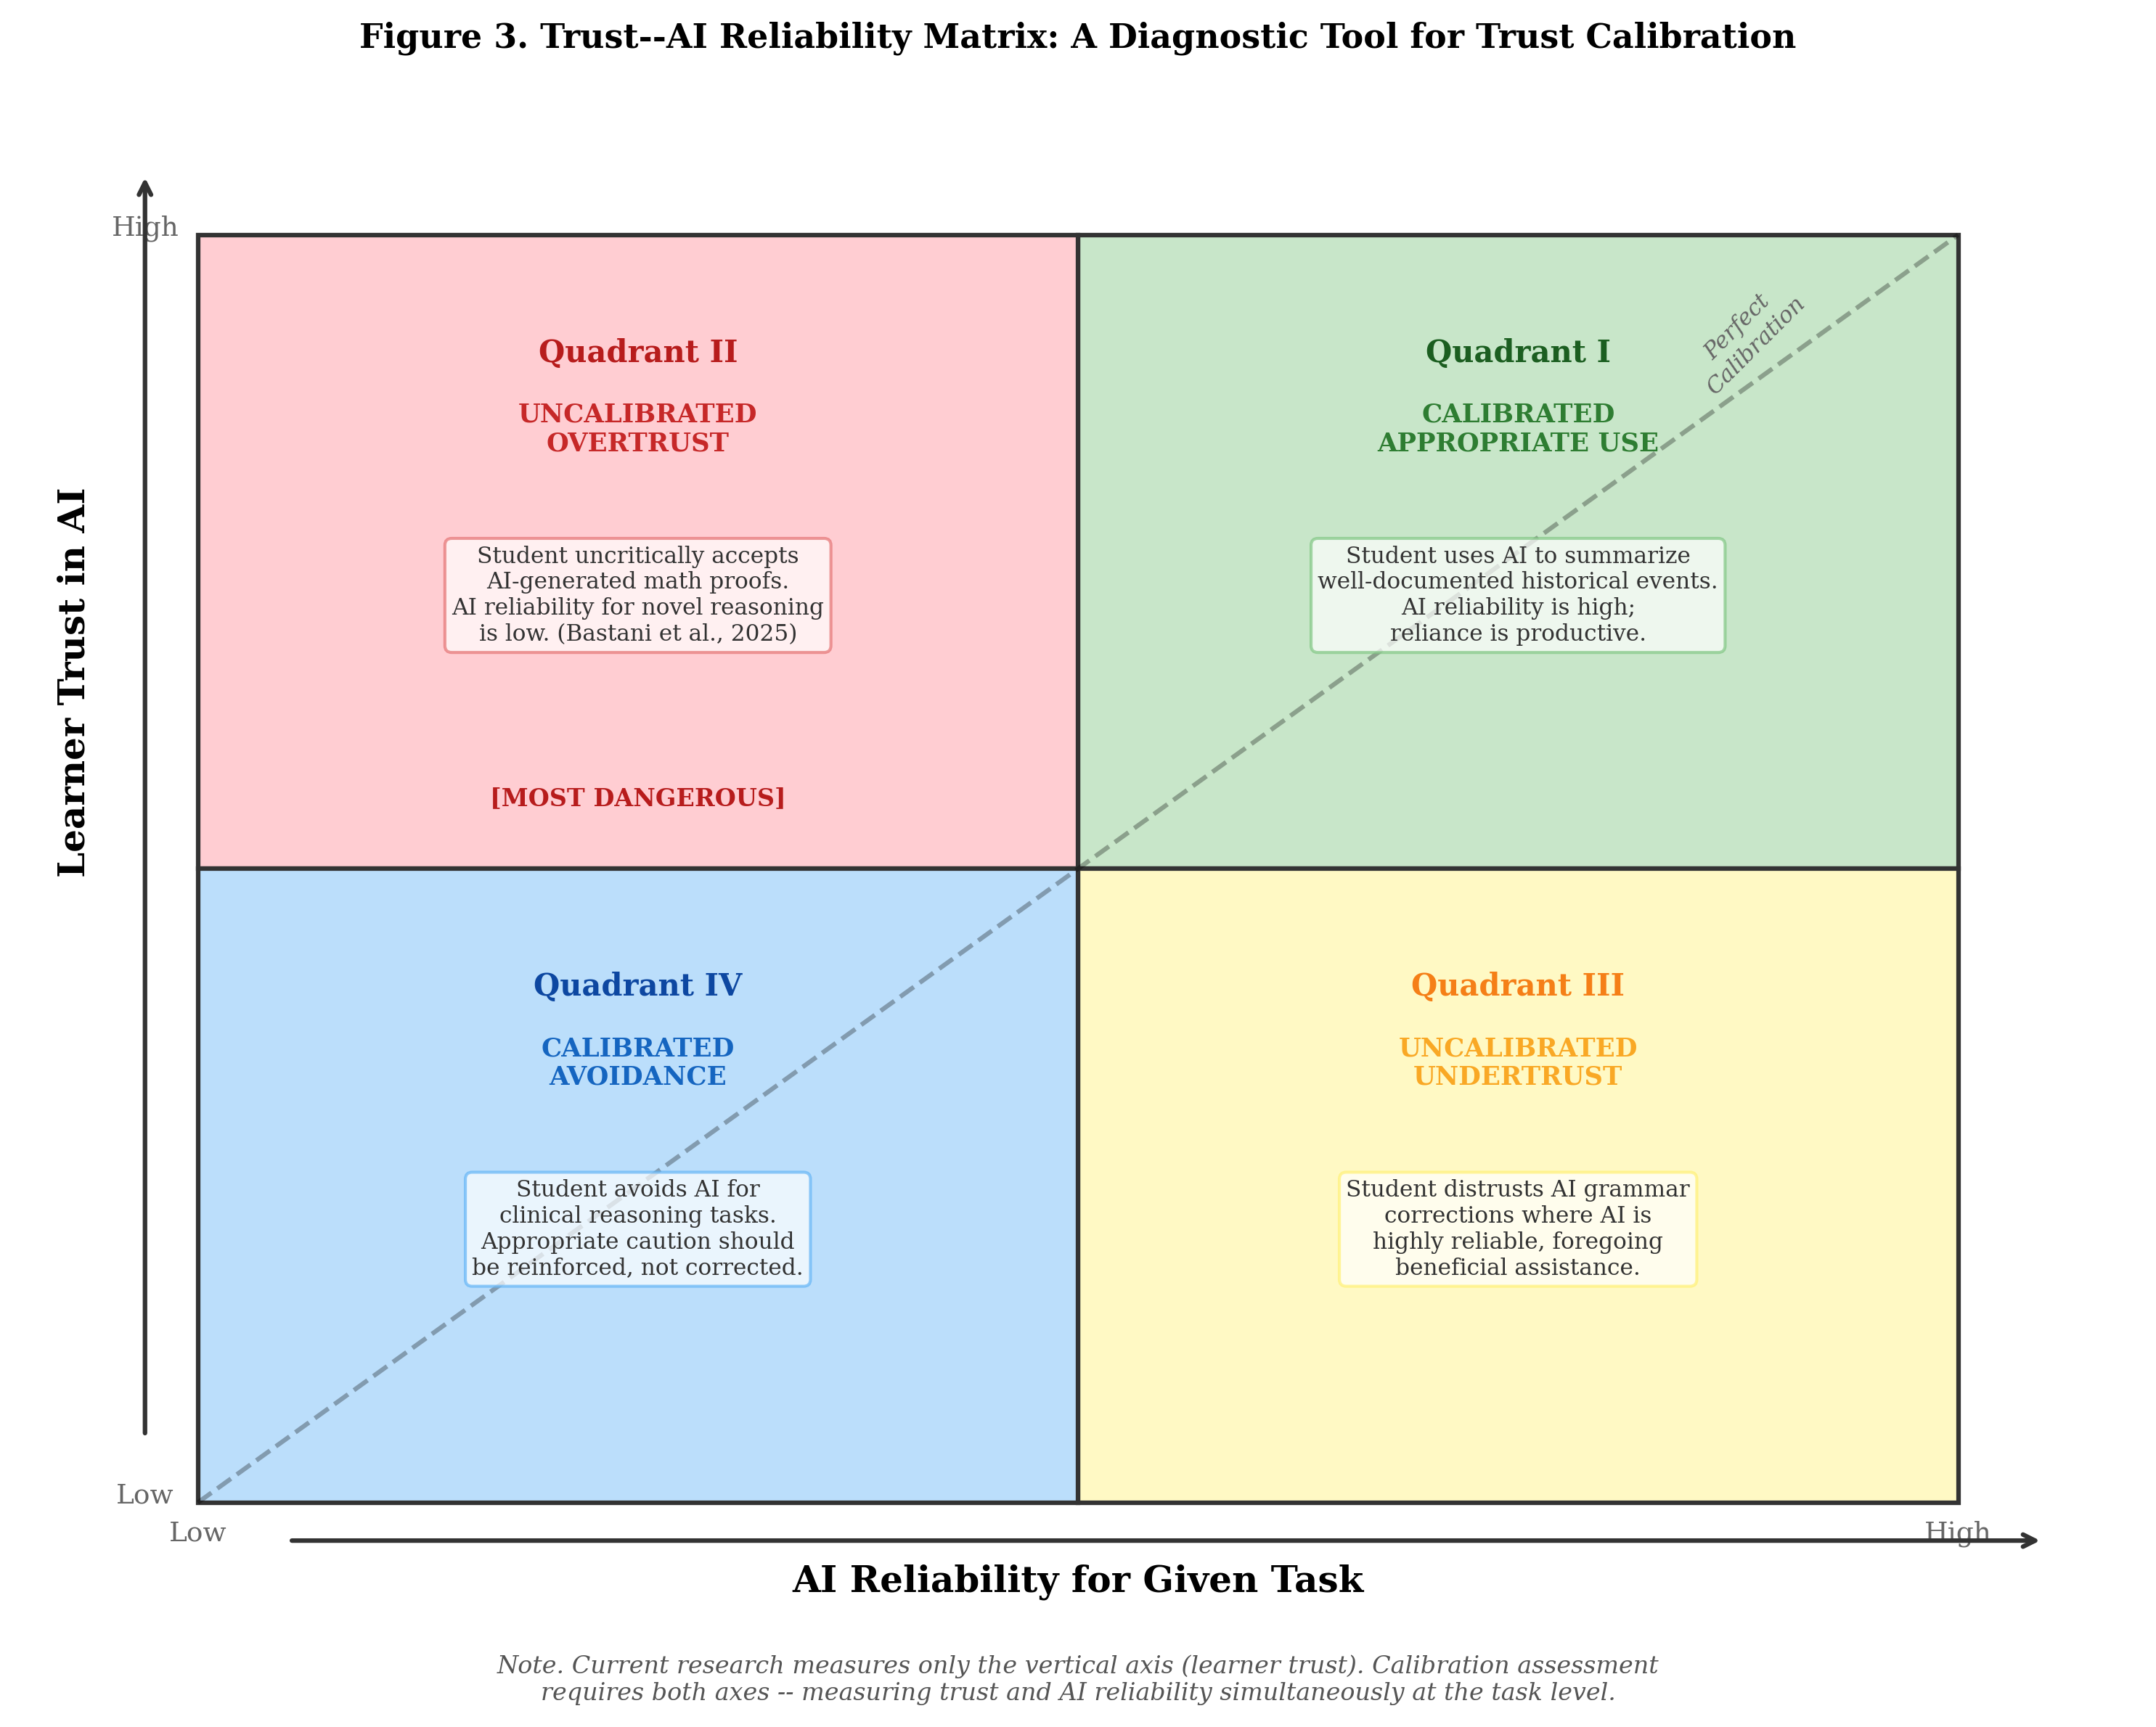
Figure 3. Trust–AI Reliability Matrix. Each quadrant represents a distinct calibration state defined by the intersection of learner trust and AI reliability for a given task. Educational scenarios illustrate each state. Current research predominantly measures only the vertical axis (learner trust), leaving the horizontal axis (AI reliability) unassessed.
Quadrant I: Calibrated Appropriate Use (High Trust + High Reliability). Trust is warranted. Example: a student uses AI to summarize well-documented historical events, where AI reliability is high and the student’s reliance is productive.
Quadrant II: Uncalibrated Overtrust (High Trust + Low Reliability). The most dangerous miscalibration. Example: a student uncritically accepts AI-generated mathematical proofs, where AI reliability for novel reasoning is low—the pattern documented by Bastani et al. (2025). Kıyak et al. (2026) showed that even warnings fail to correct this miscalibration in medical education.
Quadrant III: Uncalibrated Undertrust (Low Trust + High Reliability). Example: a student unnecessarily distrusts AI grammar corrections, where the AI is highly reliable, foregoing beneficial assistance.
Quadrant IV: Calibrated Avoidance (Low Trust + Low Reliability). Low trust accurately reflects low reliability. Example: a student avoids AI for clinical reasoning tasks, where appropriate caution should be reinforced rather than corrected.
The matrix’s diagnostic power requires both axes. Current research overwhelmingly measures only the vertical axis (learner trust) without the horizontal axis (AI reliability for the given task). Without both, the field cannot determine which quadrant a learner occupies—and therefore cannot distinguish warranted trust from dangerous overreliance. A study reporting that “students trust ChatGPT moderately” provides no diagnostic information: moderate trust is appropriate if ChatGPT is moderately reliable for the assessed task, but it constitutes dangerous overtrust if the AI is unreliable and dangerous undertrust if the AI is highly reliable. The matrix makes explicit what calibration research requires: simultaneous measurement of both axes, applied at the task level rather than globally.

5.3 Cross-Disciplinary Blind Spots
The cross-cutting analysis reveals why integration has not occurred organically. The two research traditions closest to trust calibration—SRL calibration (providing metacognitive theory) and trust-in-automation (providing measurement logic)—have not converged within education. SRL frameworks appear in 5 papers but zero in D5; Lee and See’s framework appears in 7 papers with 6 concentrated in D5 (86%). This means that education researchers who study metacognition and education researchers who study trust calibration are not reading each other’s work. AI literacy research (D3, n=24) investigates critical evaluation of AI outputs but does not measure whether those evaluations are accurate—the step that would transform AI literacy into calibration research.
The calibration gap reflects not a failure of individual studies but a disciplinary architecture in which calibration-relevant knowledge is distributed across traditions that do not communicate. The contrast with Wischnewski et al.’s (2023) finding is instructive: their survey identified 96 studies measuring trust calibration for automated systems, demonstrating that calibration measurement is a mature research area in human factors. Yet none of those 96 studies addressed educational contexts. Educational AI researchers are, in effect, working on trust without access to the most developed body of calibration theory and measurement—a disconnection that the present review aims to make visible and actionable.
Furthermore, the theoretical void in D4 (56% atheoretical) and the corpus at large (49.5% atheoretical) is arguably a larger structural issue than any single framework’s limitations. Nearly half the field operates without theoretical anchoring of any kind, which means calibration-oriented reframing requires not just framework substitution but framework adoption. The bridge-building work of Lee et al. (2025) and Lee and Bosch (2025), who explicitly connect metacognitive calibration from the SRL tradition with trust calibration from the automation tradition, demonstrates that disciplinary integration is both possible and productive—yet these papers remain exceptional rather than representative.

5.4 Research Agenda
Five priority directions emerge from the calibration gap:
Priority 1: Measurement infrastructure. Validated instruments for measuring trust calibration accuracy in educational AI contexts are the most urgent need. This requires multimethod approaches simultaneously assessing learner trust for specific tasks, AI reliability for those tasks, and the correspondence between the two. The measurement challenge has both a trust side and a reliability side. For trust, task-specific measures are needed rather than global attitudes—a learner’s trust in ChatGPT for grammar correction may differ substantially from their trust in it for mathematical proofs. Process-level indicators—verification frequency, modification rates, time spent evaluating AI outputs—offer promising behavioral proxies that complement self-report. For reliability, benchmarking AI accuracy on domain-specific tasks provides the criterion against which trust can be evaluated. Instruments from automation trust research (Jian et al., 2000) may serve as starting points but require adaptation for educational contexts where the stakes and feedback mechanisms differ.
Priority 2: Domain-specific calibration profiles. AI reliability varies dramatically across domains and task types, and calibration research must account for this variation. A student may be well-calibrated for AI grammar assistance but poorly calibrated for AI mathematical reasoning—and both judgments concern the same AI system. The Trust–AI Reliability Matrix should be applied domain by domain, generating calibration profiles that map trust-reliability correspondences across subject areas. Beginning with domains where AI reliability is readily quantifiable (mathematics, coding, factual recall) offers a pragmatic entry point.
Priority 3: Calibration interventions. Metacognitive prompting, productive failure (Kapur, 2008), uncertainty transparency, and desirable difficulties (Bjork & Bjork, 2011) are promising mechanisms that have not been tested for trust calibration in educational AI. The finding that metacognitive scaffolds appear in only 3.1% while transparency scaffolds appear in 24.7% identifies a critical design gap. Calibration interventions should aim not to increase or decrease trust but to align it with reliability—an objective that requires fundamentally different design principles than current trust-enhancement approaches.
Priority 4: Longitudinal development. How trust calibration develops over time is unknown. Whether calibration improves naturally with AI exposure—as learners accumulate experience with a system’s strengths and limitations—or requires explicit intervention has direct implications for educational design. SRL calibration research suggests that calibration does not reliably improve without instructional support (Dunlosky & Rawson, 2012); a parallel investigation for trust calibration would clarify whether similar scaffolding is needed.
Priority 5: Cultural and contextual variation. Trust dynamics differ across cultural contexts (Hofstede, 2001), and calibration norms may vary accordingly. Authority-oriented educational cultures may produce different calibration patterns than autonomy-oriented ones. The present corpus is concentrated in Western contexts and English-language publications, potentially excluding relevant perspectives on trust calibration from non-Anglophone research traditions.

5.5 Practical Implications
For educators. Trust calibration should be recognized as a learning objective alongside content mastery. Just as educators teach students to monitor their own understanding (SRL calibration), they should teach students to evaluate AI reliability across different tasks and domains. The Trust–AI Reliability Matrix provides a diagnostic tool: educators can help learners identify which quadrant they occupy for specific AI-task combinations, making miscalibration visible and actionable. AI literacy instruction—including the probabilistic nature of LLM outputs and domain-dependent accuracy—should precede AI tool deployment. The goal is not to discourage AI use but to develop calibrated AI users who appropriately trust, verify, and reject AI outputs based on domain-specific reliability.
For designers. The central design principle is: design for calibration, not for trust. Educational AI systems should aim not to maximize trust but to align it with actual capability. This requires making reliability information available alongside AI outputs—for instance, indicating confidence levels or known domain limitations. Transparency mechanisms should be complemented by metacognitive scaffolds that develop learners’ evaluative capacity, addressing the scaffold asymmetry identified in this review (24.7% transparency vs. 3.1% metacognitive).
For policymakers. The EU AI Act (European Union, 2024) classifies educational AI as high-risk, and UNESCO (2023, 2024) guidelines emphasize critical evaluation of AI outputs. Yet these frameworks implicitly require what the field currently lacks: methods to assess whether learners’ trust is appropriately calibrated. Without calibration measurement, compliance with these guidelines cannot be verified. Policy should incentivize calibration assessment tool development and require trust calibration evidence in educational AI evaluation frameworks.

6. Limitations
Several limitations warrant acknowledgment. First, 50 of 147 identified papers could not be coded due to full-text access limitations. Title/abstract screening of these papers identified [X] as potentially calibration-relevant. Sensitivity analysis indicates that even under conservative assumptions, the core findings remain robust: [sensitivity estimates TBC]. We encourage readers to weight the database-only finding—3 of 81 papers (3.7%) reaching D5—as the primary evidence.
Second, while the second author independently coded a 20% subsample with Cohen’s kappa values reported for key variables, this remains a limitation compared to full dual coding. Full dual coding of all 97 papers would provide stronger reliability evidence but was not feasible within the constraints of this study. The domain typology, as a derived variable computed algorithmically from coded fields, inherits the reliability of its input variables; if the input variables are reliably coded, the typology assignment is deterministic and therefore fully reproducible.
Third, the 5-domain typology is a post-hoc classification. The priority ordering reflects this paper’s theoretical commitments (calibration as the organizing principle). Alternative orderings could produce different distributions. We present the typology as a diagnostic tool for mapping the field’s orientation, not a definitive taxonomy.
Fourth, the supplementary citation tracking was purposively designed to capture calibration-relevant work, and 13 of 16 supplementary papers were classified as D5. We report database-sourced and supplementary statistics separately throughout to distinguish the robust finding (3.7% of database papers reaching D5) from the contextualized finding (16.5% of the full corpus).
Fifth, the corpus is temporally concentrated (64.9% published in 2025), meaning the findings represent a snapshot of a rapidly evolving field. Research orientations may shift as GenAI-related trust scholarship matures. However, this formative period also represents a window of opportunity for the reframing we propose.
Sixth, the search was limited to English-language publications, potentially excluding relevant work from non-Anglophone research traditions where trust dynamics and calibration norms may differ.
Seventh, operationalizing AI reliability—the second axis required for calibration assessment—presents domain-specific challenges. AI reliability is readily quantifiable for verifiable tasks (mathematics, coding, factual recall) but harder for tasks requiring qualitative judgment (essay feedback, clinical reasoning). This creates a measurement feasibility paradox: calibration may be easiest to study where the educational stakes are moderate and hardest where they are highest. SRL calibration research navigated a similar challenge by beginning with binary-outcome items and extending to complex assessments (Stone, 2000); a parallel trajectory may be productive for trust calibration.
Eighth, the reframing argument is a conceptual contribution that, while grounded in the empirical gap, has not been empirically tested. Whether the proposed reframing produces better educational outcomes than existing approaches remains an open question requiring intervention studies.

7. Conclusion
This systematic review of 97 studies on trust in educational AI (2015–2026) documents a structural calibration gap: the field has built substantial awareness of trust as a problem (D4 = 42.3%) but lacks the measurement infrastructure to assess whether trust is accurate. Among database-sourced papers, only 3.7% explicitly address calibration, and no study simultaneously measures both learner trust and AI reliability—the minimum requirement for calibration assessment.
The 5-domain Research Orientation Typology provides a diagnostic lens for this gap, revealing that 83.5% of research operates without explicit calibration engagement. The field’s theoretical landscape compounds the problem: calibration-relevant frameworks are marginalized (9.3% of the corpus), while nearly half the field (49.5%) operates without any theoretical framework.
We argue for reframing the field’s central question from “Do learners trust AI?” to “Is their trust calibrated?” This reframing follows precedents in both SRL calibration and trust-in-automation research, and the Trust–AI Reliability Matrix provides a diagnostic tool for operationalizing this shift. The reframing does not replace existing work but recontextualizes it: adoption research provides the baseline from which calibration questions arise, design research provides the intervention space where calibration-improving features are tested, and calibration measurement provides the evaluative criterion the field currently lacks.
As AI tools become increasingly embedded in learning environments worldwide, the consequences of miscalibrated trust—cognitive offloading, uncritical acceptance, overreliance on unreliable outputs—will compound. The educational AI community has built substantial awareness of trust as a concern; the next step is developing the measurement infrastructure to assess whether that trust is warranted. This review provides the diagnostic foundation; the empirical work—validated instruments, domain-specific calibration profiles, calibration interventions, and longitudinal evidence—remains to be done.

