Design Case Outline: Diverga
Target: International Journal of Designs for Learning (IJDL)
Format: First-person design case (~5,000 words)
Genre: Boling (2010); Smith (2010)
Proposed Title
"Scaffolding Without Replacing: A Design Case of Human Checkpoints and Verbalized Sampling in an AI Research Methodology Assistant"
Overview
Diverga is a 24-agent AI research methodology assistant built on Model Context Protocol (MCP). It was designed to address two problems in AI-assisted research: mode collapse (AI tools converging on the same predictable recommendations) and automation bias (researchers accepting AI output without critical evaluation). Unlike existing tools such as Elicit, Consensus, or ChatGPT, Diverga combines three mechanisms that make it function as a learning design embedded in a research tool:
• Multi-agent architecture with 24 specialized agents organized across 9 research methodology categories (Research Foundation, Literature, Design, Data, Analysis, Quality, Communication, Systematic Review, Ethics)
• Verbalized Sampling (VS) with Typicality Scores (T-Scores) that structurally enforce recommendation diversity and make the commonality of each recommendation transparent to the researcher
• Five required Human Checkpoints that function as cognitive forcing functions, halting AI processing and requiring the researcher to evaluate, decide, and articulate rationale before the system proceeds
The system was developed over 57 days (224 version-controlled commits), evolving from 20 agents to a peak of 44 before being consolidated to 24 through principled analysis of functional overlap and usage patterns. This iterative trajectory, including documented design failures, constitutes the core narrative of the design case.
Conceptual Framework
The paper integrates three conceptual elements (see Figure 1):
• Educational Design Research (McKenney & Reeves, 2012) provides the methodological structure. The development followed five iterative cycles of Analysis/Exploration, Design/Construction, and Evaluation/Reflection. Each cycle produced design insights that triggered the next cycle. The paper documents EDR phases 1 and 2; empirical evaluation (phase 3) is reserved for a companion paper.
• Cognitive Apprenticeship (Collins, Brown, & Newman, 1989) provides the theoretical lens for explaining why Diverga functions as a learning design rather than merely a tool. Six methods (modeling, coaching, scaffolding, articulation, reflection, exploration) map to the three design decisions. This framing is applied lightly: approximately 400 words distributed across the Introduction and Design Decisions sections, not as a standalone theoretical framework section.
• Cognitive Forcing Functions (Bucinca et al., 2021) provides the mechanism-level explanation for the Human Checkpoint design specifically: deliberate interruptions that shift processing from automatic acceptance to deliberate evaluation.
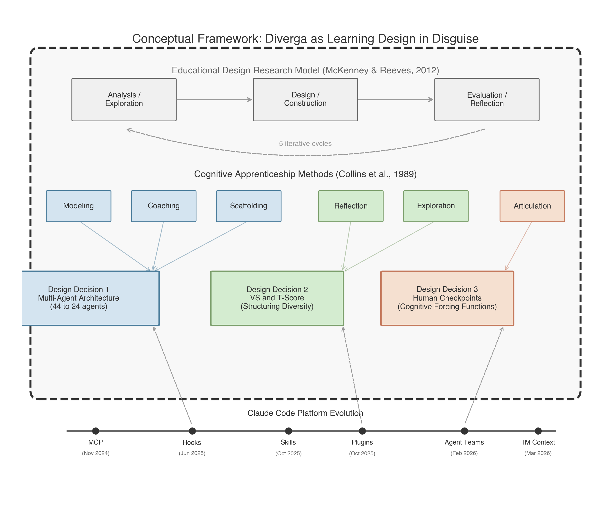
Figure 1. Conceptual Framework: EDR Model, Cognitive Apprenticeship Methods, Three Design Decisions, and Platform Evolution
Paper Structure
1. Introduction
This section establishes the problem and introduces the theoretical lens. AI research tools exhibit mode collapse: when asked for a theoretical framework, they recommend TAM; for qualitative design, thematic analysis; for meta-analysis, random effects. This convergence is compounded by automation bias (78% uncritical acceptance rate; Springer Nature, 2025). The design challenge is framed as a learning design problem: can an AI tool scaffold methodological reasoning rather than replace it?
Cognitive Apprenticeship (Collins et al., 1989) is introduced as the lens for interpreting why Diverga's design decisions function as learning design decisions. The six methods are briefly mapped to the three design decisions (Table 3 in the paper). The scope is stated: this paper tells the design story; empirical evaluation is a companion paper.
2. Design Context
The designer is a doctoral student who simultaneously built and studied the system. This dual role provides insider knowledge but introduces evaluation bias. An external collaborator with published IJDL design cases was invited to provide critical distance. Target users are social science doctoral students for whom research methodology decisions constitute core knowledge work. The technical platform (MCP + Claude Code) enabled a single developer to build a multi-agent system in 57 days.
3. Design Process: Five Iterative Cycles
This section tells the iterative design story. Each cycle follows the EDR structure: a problem or gap triggers analysis; a design response is constructed; evaluation reveals new issues that trigger the next cycle. Platform capabilities (Claude Code hooks, plugins, Agent Teams) co-evolved with the design, creating external triggers for iteration.
Cycle 1: Foundation (v1.0-v2.0; 2 days)
• Problem: LLM research assistants default to modal recommendations
• Design: 20 agents + Verbalized Sampling + T-Score system
• Feedback: marketplace compatibility issues; installation too complex
Recognized need for modular creativity mechanisms → triggered Cycle 2
Cycle 2: Sisyphus and Clean Slate (v3.0-v6.0; 3 days)
• Problem: VS alone was insufficient; creativity needed modularity
• Design: 5 creativity mechanisms; expanded to 33 agents; introduced Sisyphus Protocol (autonomous continuation)
• Feedback: Sisyphus Protocol removed human control entirely; added and removed the same day
Design failure established foundational principle → "AI works between checkpoints, humans decide at them"
Cycle 3: Expansion to Peak (v6.0-v6.7; 10 days)
• Problem: domain gaps in meta-analysis, systematic review, humanization
• Design: expanded to 44 agents; cross-platform support (Codex CLI, OpenCode); plugin marketplace
• Feedback: plugin discovery fragile (8 fix commits in one day); cross-platform parity never achieved (75%/70%)
Complexity exceeded maintainability threshold → triggered consolidation
Cycle 4: The Great Consolidation (v8.0-v11.0; 34 days)
• Problem: 44 agents, 3 platforms, 59KB configuration; most agents rarely used
• Design: MCP checkpoint enforcement; SQLite backend; then consolidation: 44 to 24 agents, cross-platform dropped
• Feedback: silent checkpoint bug discovered (all checkpoints auto-approved); 104-file Python module replaced by MCP
• Platform trigger: Claude Code hooks (June 2025) enabled architectural checkpoint enforcement, replacing unreliable behavioral instructions
Simplified foundation enabled new capabilities → triggered Cycle 5
Cycle 5: Stabilization (v11.1-v12.0; 7 days)
• Problem: simplified architecture needed new features (VS Arena, unified orchestration)
• Design: VS Arena with 5 epistemological personas; unified orchestrator; configuration slimmed from 16.8KB to <5KB
• Platform trigger: Agent Teams (Feb 2026) enabled genuine multi-agent debate; before this, VS Arena used simulated diversity in a single context window
System reached architectural stability → ready for user evaluation studies
4. Design Problem
This section defines the specific problems that the three design decisions address. Mode collapse is explained for a non-technical audience: AI systems trained to maximize prediction probability produce the most common output, not the most contextually appropriate one. This is analogous to standardized curricula that reduce pedagogical diversity. Automation bias compounds the problem: researchers know they should evaluate critically, but under time pressure, the path of least resistance is acceptance. No existing tool addresses both problems structurally.
5. Design Decisions and Rationale (core)
Each decision follows the design case pattern: decision point, alternatives considered, rationale for chosen approach, evidence of implementation, and the iterative feedback that shaped the decision.
5.1 Multi-Agent Architecture: From 44 to 24 Agents
The system grew from 20 to 44 agents before being consolidated to 24. The expansion revealed where complexity becomes counterproductive: functional overlap between agents, superlinear scaling of coordination overhead (Li et al., 2025), and user cognitive load. The 9-category structure maps to research design phases, not to AI system internals. The consolidation was scaffolding calibration in cognitive apprenticeship terms: reducing surface complexity so the intellectual structure of research design becomes the visible architecture.
• Cognitive Apprenticeship methods: Modeling (agents demonstrate expert reasoning), Coaching (domain-specific feedback), Scaffolding (task decomposition + fading via consolidation)
• Figures: architecture comparison diagram (v10 vs. v11)
• Tables: agent consolidation table with rationale for each merge
5.2 Verbalized Sampling and Typicality Scores
Mode collapse cannot be solved by prompting an AI to "be diverse"; diversity must be structurally enforced. VS (Zhao et al., 2024) generates recommendations across the full typicality spectrum. The critical design decision was to surface the T-Score to the researcher: a score of T = 0.82 signals a modal recommendation; T = 0.31 signals genuinely unconventional territory. This turns the T-Score into a metacognitive prompt. The VS Arena extends this through five epistemological persona agents, each structurally constrained from recommending what others are likely to recommend.
• Cognitive Apprenticeship methods: Reflection (T-Score as metacognitive device), Exploration (long-tail sampling + epistemological plurality)
• Iterative evolution: before Agent Teams, personas ran in the same context window (simulated diversity); after Agent Teams, each persona operates independently (genuine diversity)
5.3 Human Checkpoint System: Five Required Cognitive Forcing Functions
Checkpoints are not workflow approval gates; they are cognitive forcing functions (Bucinca et al., 2021) that interrupt automatic processing and require effortful evaluation. The design was shaped by two instructive failures. First, the Sisyphus Protocol (v5.0) attempted full autonomy between checkpoints and was reversed the same day. Second, a silent bug in v11.0 caused all checkpoints to auto-approve; the system appeared to have oversight but did not. These failures illustrate how difficult genuine human oversight is to implement in autonomous AI systems. The current design places five gates at cross-agent dependency points where decisions propagate through all subsequent outputs.
• Cognitive Apprenticeship methods: Articulation (researcher must verbalize decision rationale), Scaffolding (fading from many checkpoints to five)
• Platform evolution: before hooks (June 2025), checkpoints were behavioral instructions; after hooks, architectural enforcement
6. Design Tensions
Design cases document not only what was built but what remains uncertain. These tensions are inherent trade-offs in the current design, not failures to be fixed. Naming them contributes to the field's understanding of AI tool design for epistemic support. Each tension corresponds to a design decision and identifies an open empirical question that the companion evaluation paper will investigate.
• Simplicity vs. Specialization (from 5.1): 24 agents in 9 categories is principled but still complex. Does navigating this architecture require prior research design knowledge that novice users lack?
• Diversity vs. Coherence (from 5.2): VS Arena generates five divergent perspectives without synthesis. Does this plurality illuminate or overwhelm? This is the most important unresolved design problem.
• Oversight Rigor vs. Workflow Fluidity (from 5.3): five checkpoints interrupt cognitive flow. Does this produce genuine deliberation or habituated click-through? The silent auto-approval bug suggests the tension is real.
7. Reflection and Future Directions
Three transferable design principles emerge: (1) structural enforcement over instructional exhortation (design diversity into architecture, not instructions), (2) transparency as metacognitive prompt (surface information users need to calibrate reliance), and (3) checkpoints as cognitive forcing functions (mandatory pauses at consequential nodes, not at every step). The design case occupies EDR phases 1 and 2. Companion papers address methodology for studying artificial agency (Paper 2, BJET) and empirical evaluation of researcher performance effects (Paper 3, Computers & Education).
Figures and Tables
ID | Content | Section | Status
Figure 1 | Conceptual Framework (EDR + CA + Design Decisions + Platform) | 3 | Generated
Figure 2 | 5 EDR Cycles timeline with agent count and feedback arrows | 3 | Generated
Figure 3 | Platform-Design co-evolution (dual timeline) | 3 | Generated
Figure 4 | Architecture comparison: v10 (44) vs. v11 (24) | 5.1 | Generated
Figure 5 | Checkpoint flow with 5 REQUIRED gates and CA labels | 5.3 | Generated
Table 1 | Diverga vs. existing AI research tools | 2 | Draft ready
Table 2 | Agent consolidation summary (before/after/rationale) | 5.1 | Draft ready
Table 3 | Cognitive Apprenticeship methods mapped to Diverga | 1 | Draft ready
Table 4 | Design tensions with open empirical questions | 6 | Draft ready

Role Distribution (Proposed)
Task | Lead | Support
Design case structure and IJDL framing | Yang | You
Design rationale documentation | You | Yang
Architecture and technical descriptions | You | Yang
Design tension analysis | Joint | Joint
Artifact curation (figures, diagrams) | You | Yang
Introduction, Design Context writing | Yang | You
Design Decisions writing | You | Yang
Reflection, final review | Joint | Joint

Key References
Boling, E. (2010). The need for design cases: Disseminating design knowledge. International Journal of Designs for Learning, 1(1), 1-8.
Bucinca, Z., Malaya, M. B., & Gajos, K. Z. (2021). To trust or to think: Cognitive forcing functions can reduce overreliance on AI in AI-assisted decision making. Proceedings of the ACM on Human-Computer Interaction, 5(CSCW1), Article 188.
Collins, A., Brown, J. S., & Newman, S. E. (1989). Cognitive apprenticeship: Teaching the crafts of reading, writing, and mathematics. In L. B. Resnick (Ed.), Knowing, learning, and instruction (pp. 453-494). Erlbaum.
Li, Z., Zhang, Y., & Zhao, H. (2025). More agents is less: Scaling properties of multi-agent LLM systems. arXiv:2602.03794.
McKenney, S., & Reeves, T. C. (2012). Conducting educational design research. Routledge.
Smith, K. M. (2010). Producing the rigorous design case. International Journal of Designs for Learning, 1(1), 9-20.
Yang, M., & Harbor, J. (2023). Authentic learning design failures. International Journal of Designs for Learning, 14(1), 88-105.
Zhao, Y., et al. (2024). Verbalized sampling for language model selection. arXiv:2510.01171.
Accompanying Materials
A detailed draft (~4,800 words with all figures and tables embedded) is available as a companion document for reference during writing.

