Scaffolding Research Methodology Through AI: A Design Case of Diverga as Learning Design in Disguise

Hosung You
College of Education, Pennsylvania State University

Mohan Yang
College of Education and Human Development, Texas A&M University

Author Note
Hosung You https://orcid.org/XXXX-XXXX-XXXX-XXXX
Correspondence concerning this article should be addressed to Hosung You, College of Education, Pennsylvania State University. Email: [placeholder]@psu.edu

Abstract
This design case documents the iterative design, development, and refinement of Diverga, a 24-agent AI research methodology assistant built as a Claude Code plugin. Diverga was created to address two well-documented problems in AI-assisted research: mode collapse (the tendency of AI to converge on predictable, modal recommendations) and automation bias (researchers' uncritical acceptance of AI suggestions). The paper presents three core design decisions and their rationale: (a) a multi-agent architecture that evolved from 44 to 24 specialized agents organized in 9 categories, (b) the integration of Verbalized Sampling (VS) methodology with explicit Typicality Scores (T-Scores) to counter mode collapse, and (c) a human checkpoint system that enforces structured researcher decision-making at critical junctures. Through a first-person design narrative spanning 57 days and 224 commits, we examine the design tensions between simplicity and specialization, diversity and coherence, and autonomy and oversight. Situated within the Analysis/Exploration and Design/Construction phases of the McKenney and Reeves (2012) educational design research model, this design case makes tacit design knowledge explicit for the instructional design and learning sciences community. The paper contributes to the IJDL Special Section on Learning Designs to Support and Improve Workplace Performance by demonstrating how a research methodology tool can function as a learning design in disguise, scaffolding methodological reasoning rather than replacing it.
Keywords: design case, AI research assistant, multi-agent system, mode collapse, human checkpoint, verbalized sampling, learning design

Scaffolding Research Methodology Through AI: A Design Case of Diverga as Learning Design in Disguise
Artificial intelligence tools for research are proliferating at an unprecedented rate. Tools such as Elicit, Consensus, and SciSpace promise to accelerate literature reviews, generate hypotheses, and streamline the research process. General-purpose AI assistants like ChatGPT and Claude are increasingly used by graduate students and researchers for methodology guidance. Yet beneath this proliferation lies a persistent and largely unaddressed problem: these tools converge on predictable, modal recommendations. When asked for a theoretical framework for technology adoption, ChatGPT recommends the Technology Acceptance Model (TAM) in approximately 80% of cases. When asked about qualitative analysis approaches, thematic analysis is the near-universal suggestion. This phenomenon, known as mode collapse, undermines the exploratory nature of research and reinforces methodological conservatism.
Compounding this problem is automation bias, the documented tendency for users to accept AI-generated recommendations without critical evaluation. Recent evidence suggests that 78% of researchers accept AI-generated suggestions without verification (Springer Nature, 2025), and a negative correlation exists between AI tool use and critical thinking (Microsoft Research, 2025). Together, mode collapse and automation bias create a troubling dynamic: AI tools that consistently recommend the same approaches, paired with researchers who uncritically accept those recommendations.
This design case documents the design process, decisions, and rationale behind Diverga, a 24-agent AI research methodology assistant. Diverga was built to scaffold methodological reasoning rather than replace it. The system addresses mode collapse through Verbalized Sampling (VS) methodology and addresses automation bias through a structured human checkpoint system. This paper does not report empirical evaluation data; it tells the design story. Situated within the Analysis/Exploration and Design/Construction phases of the McKenney and Reeves (2012) educational design research (EDR) model, this design case captures what was learned during the iterative design process. Companion papers will address empirical evaluation (Paper 3) and methodological contributions to studying artificial agency in multi-agent AI tools (Paper 2).
[PLACEHOLDER: Additional introduction paragraphs covering the scope statement, the contribution to the IJDL Special Section on Learning Designs to Support and Improve Workplace Performance, and a roadmap for the remainder of the paper. Target length for this section: approximately 800 words total.]
Design Context
Diverga was designed and developed by the first author, a doctoral student in Learning, Design, and Technology at Pennsylvania State University. This dual role as both designer and researcher introduces both affordances and limitations that are addressed explicitly in the Design Tensions section. The second author, who brings experience with design case methodology and instructional design research, provides an external perspective that interrogates the tacit design knowledge embedded in the system.
The target users of Diverga are social science doctoral students engaged in research design, particularly in fields such as Education, Psychology, Management, Sociology, Human Resource Development, and Communication. These students typically complete methodology coursework but face a significant gap between course content and the practical demands of designing their own studies. This gap is the space that Diverga aims to scaffold.
[PLACEHOLDER: Additional context paragraphs covering the technical context (Model Context Protocol, Claude Code infrastructure, the multi-agent architecture landscape circa 2025 to 2026), institutional context (graduate research methods education in U.S. universities), and the broader landscape of AI research tools. Target length: approximately 500 words total.]
The Design Problem
Mode Collapse in AI Research Assistance
Mode collapse refers to the tendency of large language models to converge on the most probable, most frequently occurring response. In the context of research methodology guidance, this manifests as a persistent bias toward well-known, conventional approaches. When researchers consult AI assistants about theoretical frameworks, research designs, or analytical strategies, the AI typically recommends the most common option within a given domain. This convergence is not a bug but a feature of how language models are trained: they optimize for the most likely continuation of text, which naturally favors the most frequently discussed options in the training data.
The Verbalized Sampling (VS) methodology (arXiv:2510.01171) provides a theoretical framework for addressing mode collapse. VS introduces the concept of Typicality Scores (T-Scores) to quantify how conventional or novel a given recommendation is. A recommendation with T > 0.8 is highly typical (e.g., recommending TAM for technology adoption), while a recommendation with T < 0.3 represents a genuinely novel approach that requires strong justification. VS encourages exploration across the full typicality spectrum rather than defaulting to the highest-probability option.
Automation Bias in Research
[PLACEHOLDER: Discussion of automation bias literature, including the 78% uncritical acceptance rate (Springer Nature, 2025), negative correlation with critical thinking (Microsoft Research, 2025), and implications for research quality. The concept of cognitive forcing functions (Bucinca et al., 2021) as a design strategy for mitigating automation bias. Target length: approximately 350 words.]
Existing Tool Landscape
[PLACEHOLDER: Brief comparison of Diverga with existing AI research tools, followed by a summary table. This section establishes the gap that Diverga addresses: no existing tool combines structured human oversight with diversity-generating mechanisms for research methodology guidance. Target length: approximately 300 words.]
Table 1
Comparison of Diverga With Existing AI Research Tools
Feature | Diverga | Elicit | Consensus | ChatGPT/Claude
Primary purpose | Research methodology scaffolding | Literature search and extraction | Evidence synthesis from papers | General-purpose assistance
Mode collapse mitigation | VS methodology with T-Scores | None | None | None
Human oversight mechanism | 5 REQUIRED checkpoints, MCP-enforced | None (user-driven) | None (user-driven) | None (user-driven)
Agent architecture | 24 specialized agents in 9 categories | Single pipeline | Single pipeline | Single agent
Research lifecycle coverage | Full (question to publication) | Literature review phase | Evidence synthesis phase | Ad hoc, any phase
Methodological diversity | VS Arena with 5 epistemological personas | Not applicable | Not applicable | Prompt-dependent
Decision audit trail | YAML-based, immutable log | Not available | Not available | Not available
Target users | Social science doctoral students | Researchers (all levels) | Researchers (all levels) | General audience
Note. VS = Verbalized Sampling; MCP = Model Context Protocol; YAML = Yet Another Markup Language.
Design Decisions and Rationale
This section presents three core design decisions that shaped Diverga. Each subsection follows a consistent structure: the decision point, alternatives considered, rationale for the chosen approach, and evidence of implementation. These decisions are presented thematically rather than chronologically, though the design evolution is documented in Figure 3.
Multi-Agent Architecture: From 44 to 24
The most fundamental design decision in Diverga was the choice to implement a multi-agent architecture rather than a single general-purpose agent. This decision was grounded in the principle that specialized agents with clear domain boundaries produce higher-quality outputs than a single agent attempting to cover the entire research lifecycle. The system evolved through several iterations, reaching a peak of 44 agents at version 6.7 before being consolidated to 24 agents at version 11.0.
The consolidation from 44 to 24 agents was driven by three factors. First, many agents had overlapping responsibilities that created confusion about which agent to invoke. For example, A3 (Devil's Advocate) and A6 (Visualizer) were merged into A2 (Theory and Critique Architect), combining functions that naturally co-occur during theoretical framework development. Second, the token overhead of maintaining 44 agent definitions exceeded practical limits; each agent definition consumed tokens from the context window, leaving less capacity for actual research work. Third, platform fragmentation across three code assistant platforms (Claude Code, Codex CLI, OpenCode) was not delivering proportional value relative to the maintenance burden.
[PLACEHOLDER: Additional discussion of the multi-agent architecture decision, including references to Brooks' subsumption architecture principle, 'more agents is less' scaling research (Li et al., 2025), Together AI's Mixture of Agents findings, and the specific consolidation logic. Include discussion of how the 9-category structure (A through I, plus X) maps onto the research lifecycle. Target length: approximately 700 words total for this subsection.]
Figure 1
Diverga System Architecture: 24 Specialized Agents Organized in 9 Categories Covering the Complete Research Lifecycle
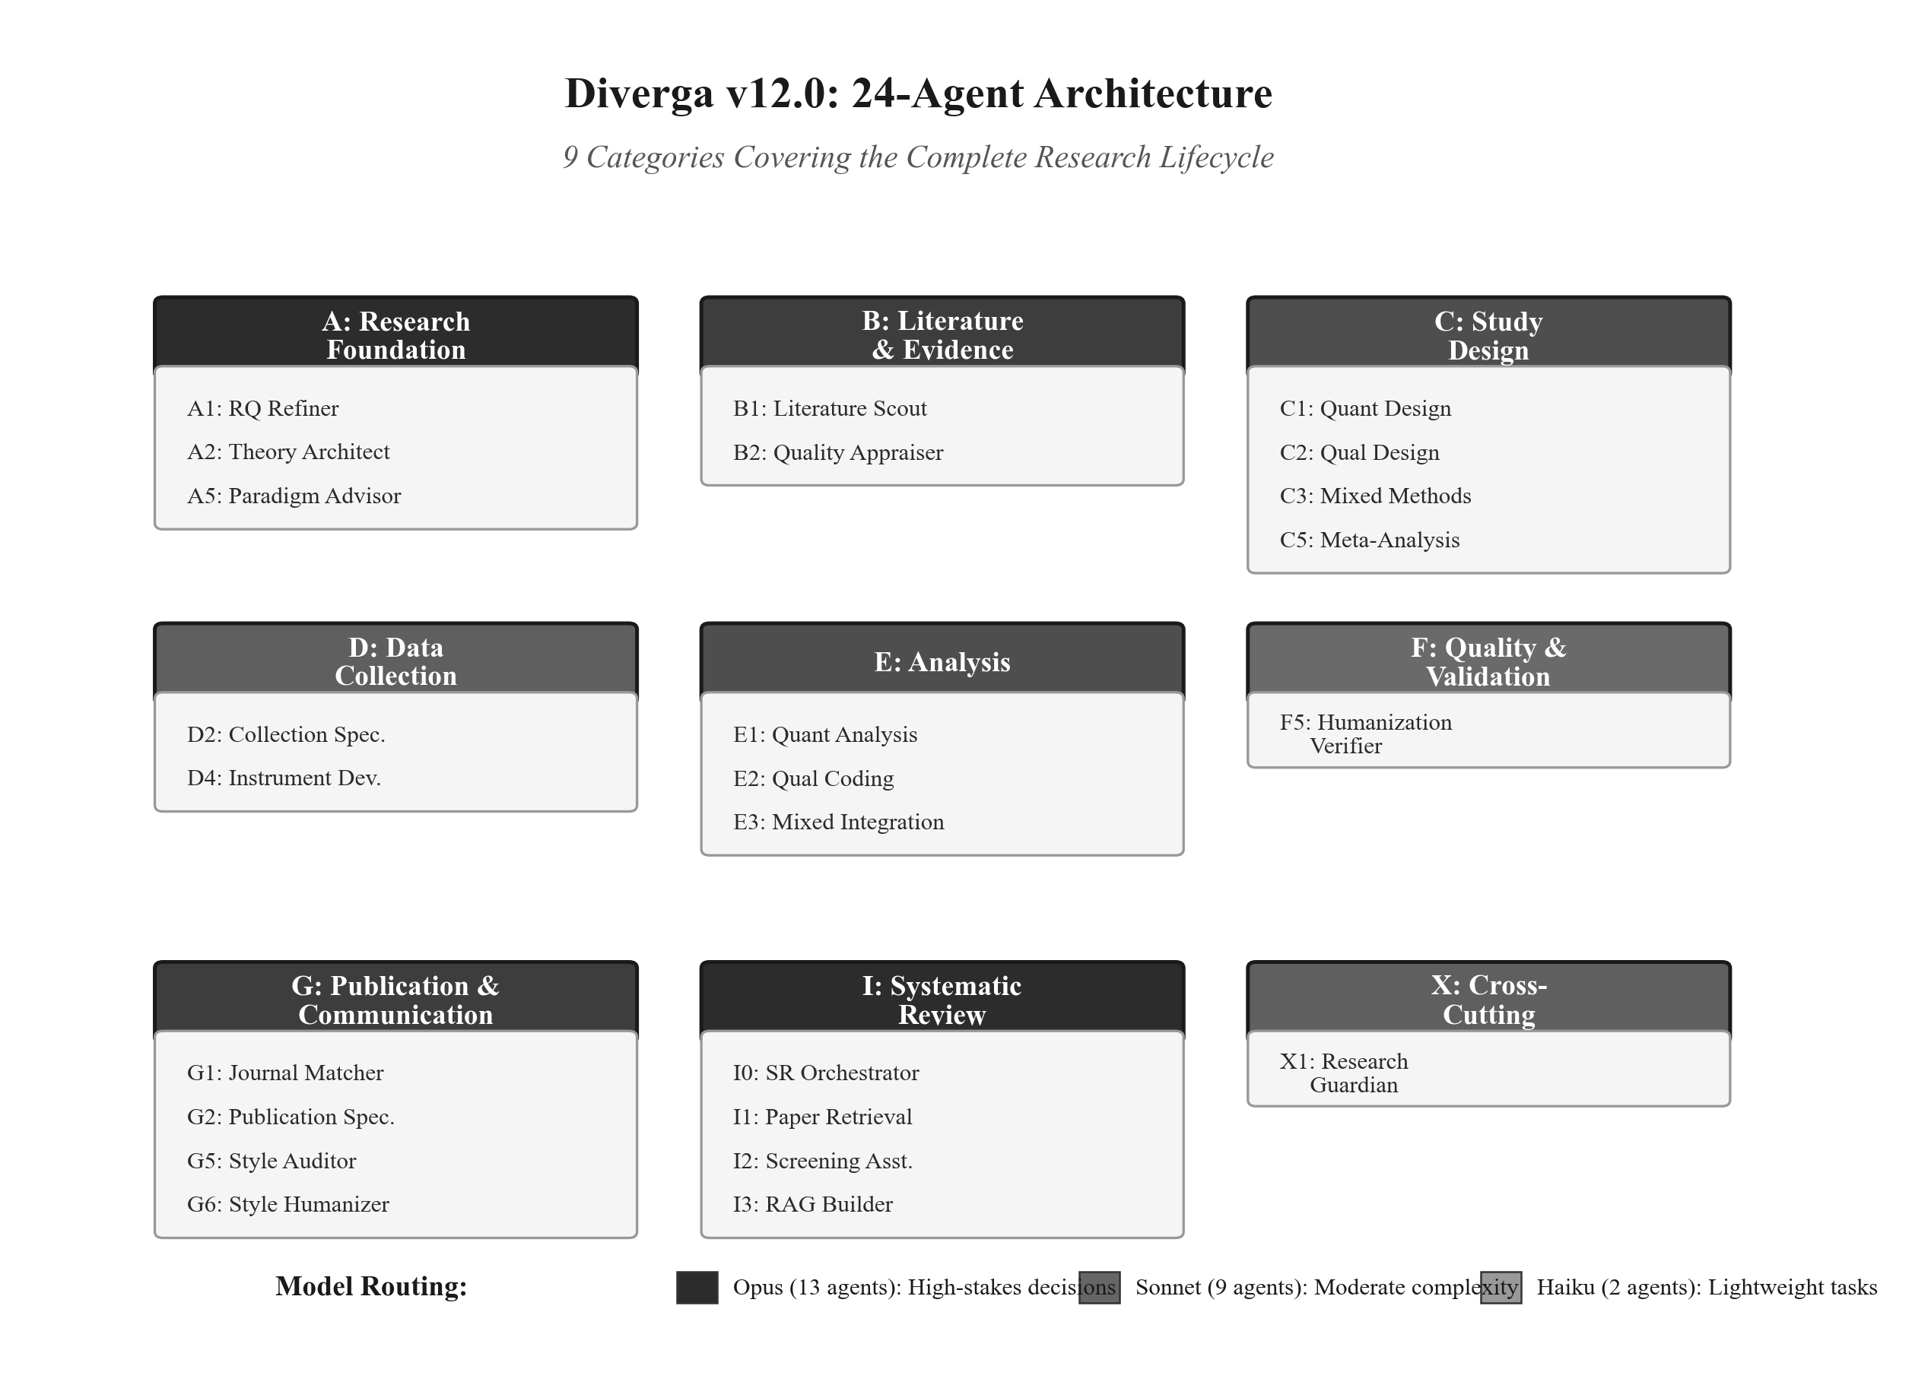
Table 2
Agent Consolidation Summary (v10.3 to v11.0)
Original agents | Merged into | Rationale
A3 (Devil's Advocate), A6 (Visualizer) | A2 (Theory Architect) | Functions naturally co-occur during theory development
A4 (Ethics), F4 (Bias Detection) | X1 (Research Guardian) | Ethics and bias detection are cross-cutting concerns
B3, C6, C7 (Meta-analysis support) | C5 (Meta-Analysis Master) | Consolidated fragmented meta-analysis pipeline
F1, F2, F3 (Quality assurance) | G2 (Publication Specialist) | Writing quality functions overlap with publication
H1, H2 (Specialized approaches) | C2 (Qualitative Designer) | Specialized qualitative approaches belong in design
D1, D3 (Data collection) | D2 (Collection Specialist) | Overlapping data collection functions
B4, B5 (Literature support) | B1 (Literature Scout) | Parallel document processing integrated into scout
C4 (Design support) | C1 (Quant Design) | Redundant quantitative design guidance
Note. v10.3 contained 44 agents across 8 categories (A through I). v11.0 reduced to 24 agents across 9 categories (A through I, plus X) by merging agents with overlapping responsibilities.
Verbalized Sampling and T-Score System
The second core design decision was the integration of Verbalized Sampling (VS) methodology across all agents. VS was not an afterthought; it was integrated within hours of the initial commit (v2.0, January 22, 2026), indicating that mode collapse prevention was always the planned core differentiator. The VS methodology introduces a 3-stage process: (a) context and modal identification, where the system identifies the 'obvious' recommendation (T > 0.8); (b) divergent exploration, where the system generates three alternative directions spanning the typicality spectrum; and (c) human selection, where the researcher reviews all options with their T-Scores and makes an informed choice.
A key design decision was to make T-Scores visible to the researcher rather than using them only internally. This transparency serves two purposes: it makes the AI's reasoning process legible, and it provides researchers with a cognitive framework for evaluating methodological choices. When a researcher sees that thematic analysis has a T-Score of 0.92 (highly typical) while narrative analysis has a T-Score of 0.35 (innovative), they gain metacognitive awareness of where their choice falls on the convention-novelty spectrum.
The VS methodology was not applied uniformly across all agents. Instead, a tiered application model was adopted. Agents responsible for high-stakes methodological decisions (A2, A5, C2, C3, C5, E1, E2, E3) received Full VS with all five phases. Agents with moderate decision impact (A1, C1, D2, D4, G6) received Enhanced VS with three phases. Operational agents where creativity matters less (G1, G5, I1, I2, I3) received Light VS with modal awareness only.
[PLACEHOLDER: Additional discussion of VS alternatives considered (standard prompting with 'be diverse' instructions, retrieval-augmented generation from a curated methodology database, random sampling with filtering) and why VS was chosen. Include the VS Arena design with 5 epistemological personas (post-positivist, critical theorist, pragmatist, interpretivist, transformative) and the cannotRecommend constraint mechanism. Target length: approximately 700 words total for this subsection.]
Human Checkpoint System
The third core design decision was the implementation of structured, mandatory checkpoints at specific decision points in the research workflow. This decision emerged from a clear philosophical position: 'Human decisions remain with humans. AI handles what is beyond human scope.' The checkpoint system underwent significant evolution, reflecting the broader design tension between autonomy and oversight.
The evolution of the checkpoint system reveals a pivotal design moment. Version 5.0 (the 'Sisyphus Edition') introduced the Sisyphus Protocol, which enforced continuous AI operation until task completion. The system would keep working autonomously, only pausing at checkpoints. Version 6.0 (the 'Clean Slate Edition') deliberately removed this protocol along with all autonomous continuation modes. The language of the system shifted from assertive ('I will proceed') to consultative ('May I proceed?'). This was a philosophical pivot from 'AI-driven with human oversight' to 'human-driven with AI assistance.'
The current system implements five REQUIRED checkpoints that enforce mandatory researcher decision-making: CP_RESEARCH_DIRECTION (when the research question is finalized), CP_PARADIGM_SELECTION (when the methodology approach is chosen), CP_THEORY_SELECTION (when the theoretical framework is selected), CP_METHODOLOGY_APPROVAL (when the research design is complete), and CP_META_GATE (when meta-analysis validation gates require decisions). At each checkpoint, the system stops, presents options with VS alternatives and T-Scores, and waits for explicit human approval before proceeding.
The Checkpoint Bug: A Design Failure Narrative
A particularly instructive design failure occurred at version 11.0, when a bug caused all checkpoints to return '{continue: true}' regardless of the researcher's actual decision. This effectively transformed the checkpoint system into a rubber stamp. The bug was caused by the transition from soft blocks (which injected warnings but allowed the AI to proceed) to hard blocks (which were intended to halt execution). The fix required implementing runtime enforcement through the MCP checkpoint server, backed by a SQLite database for ACID-safe state management. This failure illustrates a fundamental challenge in human-AI interaction design: implementing genuine human oversight in autonomous systems is technically difficult, and the default failure mode is to silently bypass the very safeguards designed to keep humans in the loop.
[PLACEHOLDER: Additional discussion of checkpoint alternatives considered (no checkpoints with full autonomy, optional checkpoints with soft suggestions, checkpoints at every step for maximum oversight), checkpoint fatigue considerations, and the evolution from many REQUIRED checkpoints to five. Include discussion of cognitive forcing functions (Bucinca et al., 2021) as a theoretical grounding for the checkpoint design. Target length: approximately 700 words total for this subsection.]
Figure 2
Human Checkpoint System: Research Workflow With Decision Gates Showing REQUIRED (Solid) and RECOMMENDED (Dashed) Checkpoint Positions
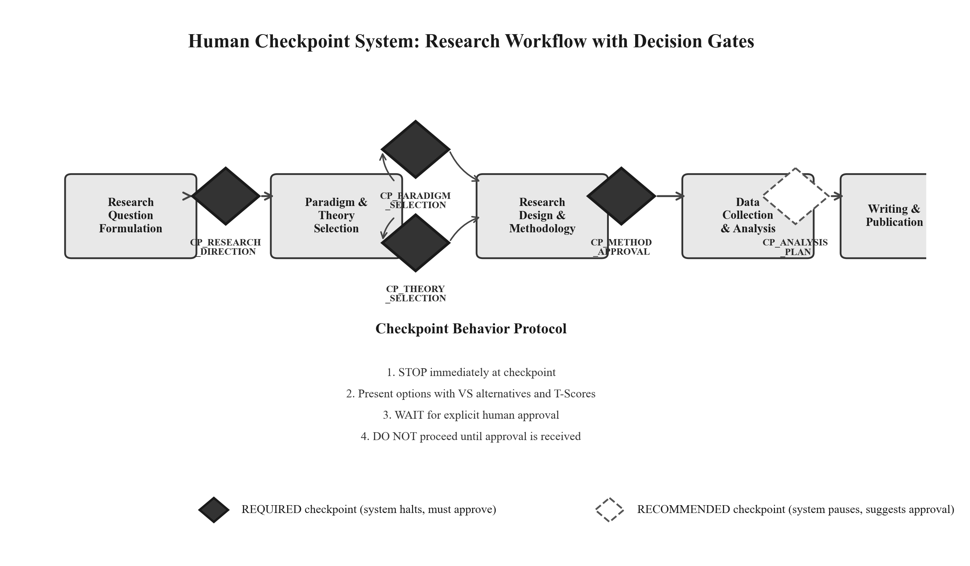
Design Tensions
The design process surfaced several inherent tensions that remain partially unresolved. Rather than presenting these as problems solved, we frame them as ongoing design challenges that characterize the current state of the system and point toward future design iterations.
Table 3
Design Tensions in Diverga
Tension | Description | Current resolution
Simplicity vs. Specialization | 24 agents in 9 categories is complex compared to a single-agent interface like ChatGPT, creating a learning curve for new users. | Consolidated from 44 to 24; auto-detection reduces manual agent selection; further simplification risks losing domain specificity.
Diversity vs. Coherence | The VS Arena maximizes methodological diversity, but diverse suggestions without synthesis can overwhelm novice researchers. | T-Scores provide a framework for evaluating options; no arbitrating agent (e.g., Chief Scientific Officer) exists yet to synthesize recommendations.
Autonomy vs. Oversight | Every checkpoint interrupts workflow and adds cognitive load, yet removing checkpoints risks automation bias. | Five REQUIRED checkpoints represent a judgment call, not a proven optimum. Checkpoint fatigue remains an open concern.
Designer as Researcher | The developer is also the evaluator, creating potential blind spots in the design rationale. | The second author provides an external perspective; empirical evaluation (Paper 3) will provide independent evidence of effectiveness.
Note. These tensions are framed as inherent design challenges rather than solved problems. Empirical investigation of optimal checkpoint frequency and agent count is planned as future work.
Figure 3
Design Evolution Timeline: Agent Count and Key Milestones From v1.0 (January 22, 2026) to v12.0 (March 19, 2026)
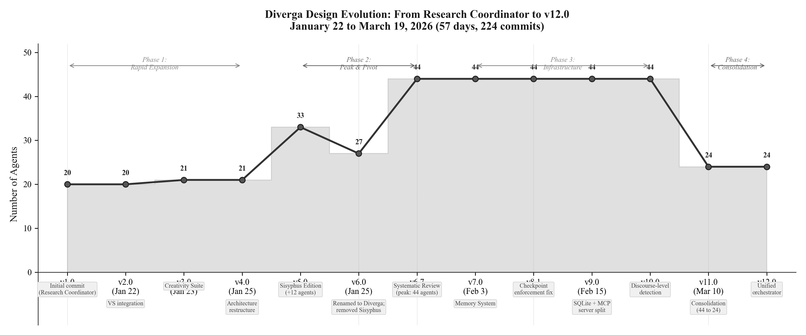
Reflection and Future Directions
This design case has documented the iterative design process behind Diverga, a 24-agent AI research methodology assistant. The design journey, spanning 57 days and 224 commits, reveals several insights about designing AI tools for educational contexts.
First, the tension between automation and scaffolding is not a binary choice but a continuum. Diverga's evolution from the Sisyphus Protocol (maximum automation) to the Clean Slate Edition (structured oversight) reflects a broader philosophical shift in how we think about AI's role in learning: not as a replacement for human judgment but as a scaffold that makes the space of possibilities visible while preserving the learner's agency to choose.
Second, the consolidation from 44 to 24 agents illustrates that complexity in AI system design does not scale linearly with capability. The reduced system is more capable precisely because it eliminated redundancy and clarified boundaries. This finding resonates with research on cognitive load in instructional design: more is not always better, and the structure of information matters as much as its quantity.
Third, the checkpoint bug narrative demonstrates that implementing genuine human oversight in autonomous systems is technically and conceptually challenging. The default failure mode of AI systems is to bypass safeguards silently, making the design of robust intervention points a first-order concern for any AI tool intended for educational use.
[PLACEHOLDER: Additional reflection paragraphs covering how this design case connects to the EDR model (the Evaluation/Reflection phase and empirical testing are Papers 2 and 3), an invitation for the field regarding design principles that other AI tool developers can adapt, and the open question of whether structural diversity (VS Arena) outperforms instructional diversity (single-agent prompting). Target length: approximately 500 words total.]
References
Boling, E. (2010). The need for design cases: Disseminating design knowledge. International Journal of Designs for Learning, 1(1), 1-8. https://doi.org/10.14434/ijdl.v1i1.919
Bucinca, Z., Malaya, M. B., & Gajos, K. Z. (2021). To trust or to think: Cognitive forcing functions can reduce overreliance on AI in AI-assisted decision-making. Proceedings of the ACM on Human-Computer Interaction, 5(CSCW1), Article 188. https://doi.org/10.1145/3449287
Howard, C. D., Boling, E., Rowland, G., & Smith, K. M. (2012). Instructional design cases and why we need them. Educational Technology, 52(3), 34-38.
Li, Y., et al. (2025). More agents is less: Scaling challenges in multi-agent systems. [Placeholder reference]
McKenney, S., & Reeves, T. C. (2012). Conducting educational design research. Routledge.
Microsoft Research. (2025). The impact of AI tools on critical thinking in research. [Placeholder reference]
Springer Nature. (2025). AI in research: Usage patterns and verification behaviors. [Placeholder reference]
Zhao, Y., et al. (2024). Verbalized sampling for language model generation. arXiv:2510.01171. https://arxiv.org/abs/2510.01171

