Scaffolding Without Replacing: A Design Case of Human Checkpoints
and Verbalized Sampling in an AI Research Methodology Assistant

Hosung You
College of Education, Pennsylvania State University

Mohan Yang
College of Education and Human Development, Texas A&M University

Author Note
Hosung You is a doctoral student in the College of Education at Pennsylvania State University. Mohan Yang is an assistant professor in the College of Education and Human Development at Texas A&M University. Correspondence concerning this article should be addressed to Hosung You, College of Education, Pennsylvania State University, University Park, PA 16802.

Abstract
AI research tools increasingly shape doctoral researchers' methodological decisions, yet these tools exhibit mode collapse, converging on predictable recommendations regardless of research context, while encouraging automation bias through uncritical acceptance. This first-person design case documents Diverga, a 24-agent AI research methodology assistant designed to scaffold rather than replace researchers' methodological reasoning. Drawing on cognitive apprenticeship (Collins, Brown, & Newman, 1989), we identify how Diverga's architecture operationalizes six learning methods (modeling, coaching, scaffolding, articulation, reflection, and exploration) through AI-mediated mechanisms rather than explicit instruction. Three design decisions are examined: (a) a multi-agent architecture consolidated from 44 to 24 agents through principled scaffolding calibration, (b) Verbalized Sampling with Typicality Scores that structurally enforce recommendation diversity and prompt metacognitive reflection, and (c) five required Human Checkpoints functioning as cognitive forcing functions (Bucinca et al., 2021) that compel articulation of decision rationale. The 57-day development process (224 commits) is organized into five iterative design cycles following the Educational Design Research model (McKenney & Reeves, 2012), revealing how the co-evolution of platform capabilities and design ambitions shaped the system. Design failures, including a same-day protocol reversal and a silent checkpoint bug, are documented as evidence of genuine iterative reasoning. Diverga is framed as a learning design in disguise: a research tool whose architectural form scaffolds the cognitive processes that characterize effective methodological reasoning in the academic workplace.
Keywords: design case, AI scaffolding, cognitive apprenticeship, mode collapse, human checkpoints, multi-agent systems, research methodology, educational design research

Scaffolding Without Replacing: A Design Case of Human Checkpoints
and Verbalized Sampling in an AI Research Methodology Assistant
Introduction
Research methodology decisions are consequential knowledge work tasks for doctoral students and early-career scholars. Selecting a theoretical framework, choosing between qualitative and quantitative approaches, or determining an appropriate sampling strategy are not clerical operations; they define the epistemic character of a study and shape a researcher's professional trajectory. When a doctoral student asks an AI tool for a theoretical framework recommendation and receives the Technology Acceptance Model regardless of context, the tool has not assisted methodological reasoning; it has replaced it with a statistical default.
This pattern, which we term mode collapse following Zhao et al. (2024), describes the tendency of AI systems trained to maximize prediction probability to converge on the most statistically common output rather than the most contextually appropriate one. The phenomenon is not a bug in any particular tool; it is a structural property of how large language models are trained. The most probable response is, by definition, the most common one. For researchers seeking methodological creativity and contextual fit, the most common recommendation is often not the best one.
Mode collapse is compounded by automation bias: the tendency to accept AI recommendations without critical evaluation, especially under time pressure. A 2025 Springer Nature report found a 78% uncritical acceptance rate for AI-generated methodology suggestions, and Microsoft Research (2025) identified a negative correlation between AI tool use and critical thinking engagement in knowledge work settings. Together, mode collapse narrows the options presented, and automation bias ensures the narrowed options are accepted without scrutiny.
The design challenge, then, is this: Can an AI research assistant be designed to scaffold methodological reasoning rather than replace it? This is a learning design problem disguised as an engineering problem.
Diverga is, at one level, an AI research tool. At another level, it is a learning design embedded in a tool's architecture. To make this claim precise, we draw on the cognitive apprenticeship framework (Collins, Brown, & Newman, 1989), which identifies six methods by which learning environments make expert thinking visible to developing practitioners: modeling, coaching, scaffolding, articulation, reflection, and exploration. In traditional cognitive apprenticeship, a human expert models reasoning, coaches the learner, and gradually fades support. Diverga implements these methods not through human mentorship but through structural design features.
The multi-agent architecture models expert reasoning by distributing research design across specialized agents, each embodying domain-specific methodological knowledge. The Verbalized Sampling system, with its Typicality Scores, supports reflection and exploration by making the statistical commonality of each recommendation transparent. The Human Checkpoint system supports articulation by requiring the researcher to state and justify decisions at five mandatory interruption points, which function as cognitive forcing functions (Bucinca et al., 2021) that shift processing from automatic acceptance to deliberate evaluation. In the special section's terms, Diverga is a learning design for the workplace of doctoral research: it shapes the performance of methodological judgment through structural scaffolding rather than didactic transmission.
This paper documents the design process, decisions, and rationale across five iterative design cycles over 57 days (224 version-controlled commits). Empirical evaluation of Diverga's effects on researcher performance is reserved for a companion experimental paper. The design case follows Educational Design Research phases 1 and 2 (McKenney & Reeves, 2012), and the first-person narrative follows IJDL design case conventions (Boling, 2010; Smith, 2010). Table 3 maps all six cognitive apprenticeship methods to specific Diverga mechanisms.
Table 3
Cognitive Apprenticeship Methods Mapped to Diverga Design Mechanisms
CA Method | Diverga Mechanism | Design Decision
Modeling | Agent-generated expert reasoning; VS Arena multi-perspective demonstration | Multi-Agent Architecture (5.1)
Coaching | Agent-specific contextual feedback; domain-calibrated guidance | Multi-Agent Architecture (5.1)
Scaffolding | 9-category task decomposition; fading via 44-to-24 consolidation | Multi-Agent Architecture (5.1)
Articulation | Checkpoint-required decision rationale; Decision Audit Trail | Human Checkpoints (5.3)
Reflection | T-Score metacognitive prompts; typicality transparency | VS and T-Scores (5.2)
Exploration | Long-tail sampling (T < 0.4); VS Arena epistemological diversity | VS and T-Scores (5.2)

Design Context
The Designer and the Dual Role
The first author, a doctoral student in education at Pennsylvania State University, designed and built Diverga over 57 days (January 22 to March 19, 2026). This dual role as designer and researcher is both an asset, providing insider tacit knowledge about research design challenges, and a limitation, introducing evaluation bias. Dr. Mohan Yang, an instructional design scholar at Texas A&M University with published IJDL design cases (Yang & Harbor, 2023), was invited as a collaborating researcher and critical external voice. This collaboration structure is itself a design decision, documented here rather than buried in an acknowledgment.
Target Users and Workplace Context
Diverga's target users are social science doctoral students engaged in research design. Research methodology decisions constitute their primary knowledge work: selecting theoretical frameworks, designing data collection procedures, choosing analytical approaches. A persistent gap exists between research methods coursework, which teaches the logic of methods, and actual research design practice, which demands the judgment required to select and adapt methods for a specific study. Diverga is designed for that gap.
Technical Context
Diverga is built on the Model Context Protocol (MCP), an open standard for connecting AI assistants to external tools and data sources (Anthropic, 2024). MCP abstracts the complexity of agent-to-agent communication, enabling a doctoral student to build a multi-agent system in 57 days. Claude Code provides the execution environment, and the plugin ecosystem enables marketplace distribution. Table 1 compares Diverga with existing AI research tools across five design-relevant dimensions.
Table 1
Comparison of Diverga with Existing AI Research Tools
Dimension | Diverga | Elicit | Consensus | ChatGPT
Architecture | 24 specialized agents in 9 categories | Single retrieval pipeline | Single retrieval pipeline | Single general-purpose agent
Diversity mechanism | Verbalized Sampling with T-Scores | None (retrieval-based) | None (retrieval-based) | Prompt-dependent
Human oversight | 5 REQUIRED checkpoint gates | None (user-initiated) | None (user-initiated) | None (user-initiated)
Typicality transparency | T-Score displayed for every recommendation | N/A | N/A | N/A
Decision audit trail | SQLite-logged decisions at each checkpoint | N/A | N/A | Conversation history only

Design Process: Five Iterative Cycles
The 57-day development period is organized into five iterative cycles following the Educational Design Research framework (McKenney & Reeves, 2012), with each cycle comprising analysis/exploration, design/construction, and evaluation/reflection phases. These cycles were not pre-planned; they emerged from the interaction between design ambitions, evaluation feedback, and the evolving capabilities of the Claude Code platform (see Figure 1 for the conceptual framework and Figure 2 for the five cycles mapped to the EDR model).
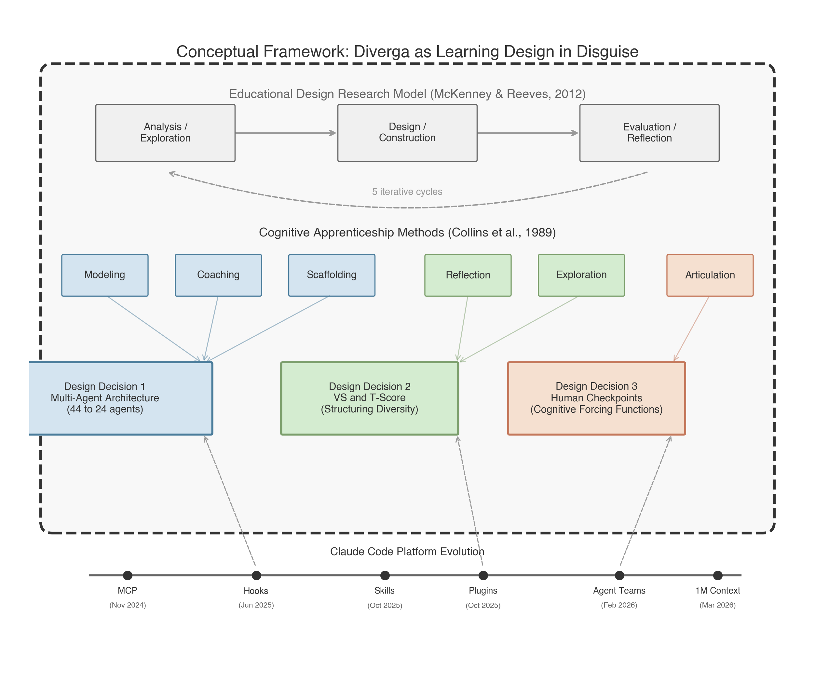
Figure 1
Conceptual Framework: Educational Design Research Model, Cognitive Apprenticeship Methods, and Three Design Decisions, With Platform Evolution as Environmental Context
Cycle 1: Foundation (v1.0-v2.0; January 22-23, 2026)
The project began with the recognition that LLM-based research assistants default to modal recommendations. The initial commit established 20 agents in 5 categories, and Verbalized Sampling methodology (Zhao et al., 2024) was integrated within the first day, introducing the T-Score system for measuring recommendation typicality. Evaluation revealed marketplace compatibility issues and overly complex installation, prompting simplification.
Cycle 2: Sisyphus and Clean Slate (v3.0-v6.0; January 23-25, 2026)
Five modular creativity mechanisms were designed. The system expanded to 33 agents. Critically, the Sisyphus Protocol was introduced in v5.0: an autonomous continuation mechanism that removed human control between checkpoints. This was the fastest design failure in the project, added and removed on the same day. The v6.0 Clean Slate Edition established the foundational principle that guided all subsequent development: AI works between checkpoints; humans decide at them. The project was renamed twice before settling on Diverga.
Cycle 3: Expansion to Peak (v6.0-v6.7; January 25-February 4, 2026)
Domain-specific gaps were identified (meta-analysis, systematic review, humanization), driving expansion to 44 agents. Cross-platform support was added for Codex CLI and OpenCode. Plugin discovery proved fragile, requiring eight consecutive fix commits in a single day. Cross-platform parity was never fully achieved (75% for Codex CLI, 70% for OpenCode), foreshadowing the eventual abandonment of multi-platform support.
Cycle 4: The Great Consolidation (v8.0-v11.0; February 4-March 10, 2026)
With 44 agents across three platforms and a 59KB configuration file, the system had become unwieldy. Infrastructure matured through MCP checkpoint enforcement, SQLite backend adoption, and Agent Teams pilot integration. Then came the consolidation: 44 to 24 agents, cross-platform support removed entirely, configuration reduced by 79%. A silent checkpoint bug was discovered in v11.0 in which all checkpoints auto-approved without user input; the system appeared to have oversight but did not. The Claude Code hooks system (introduced June 2025) was critical to this cycle: it enabled architectural enforcement of checkpoints, replacing the behavioral instructions that had proven unreliable.
Cycle 5: Stabilization (v11.1-v12.0; March 12-19, 2026)
The simplified foundation enabled new capabilities. VS Arena was implemented with five epistemological persona agents. The Claude Code Agent Teams feature (February 2026) was consequential: before Agent Teams, VS Arena required simulated diversity through subagent calls in the same context window; after Agent Teams, each persona operated in its own independent context, producing substantively different debate dynamics. The configuration was further slimmed from 16.8KB to less than 5KB, and redundant orchestration skills were unified.
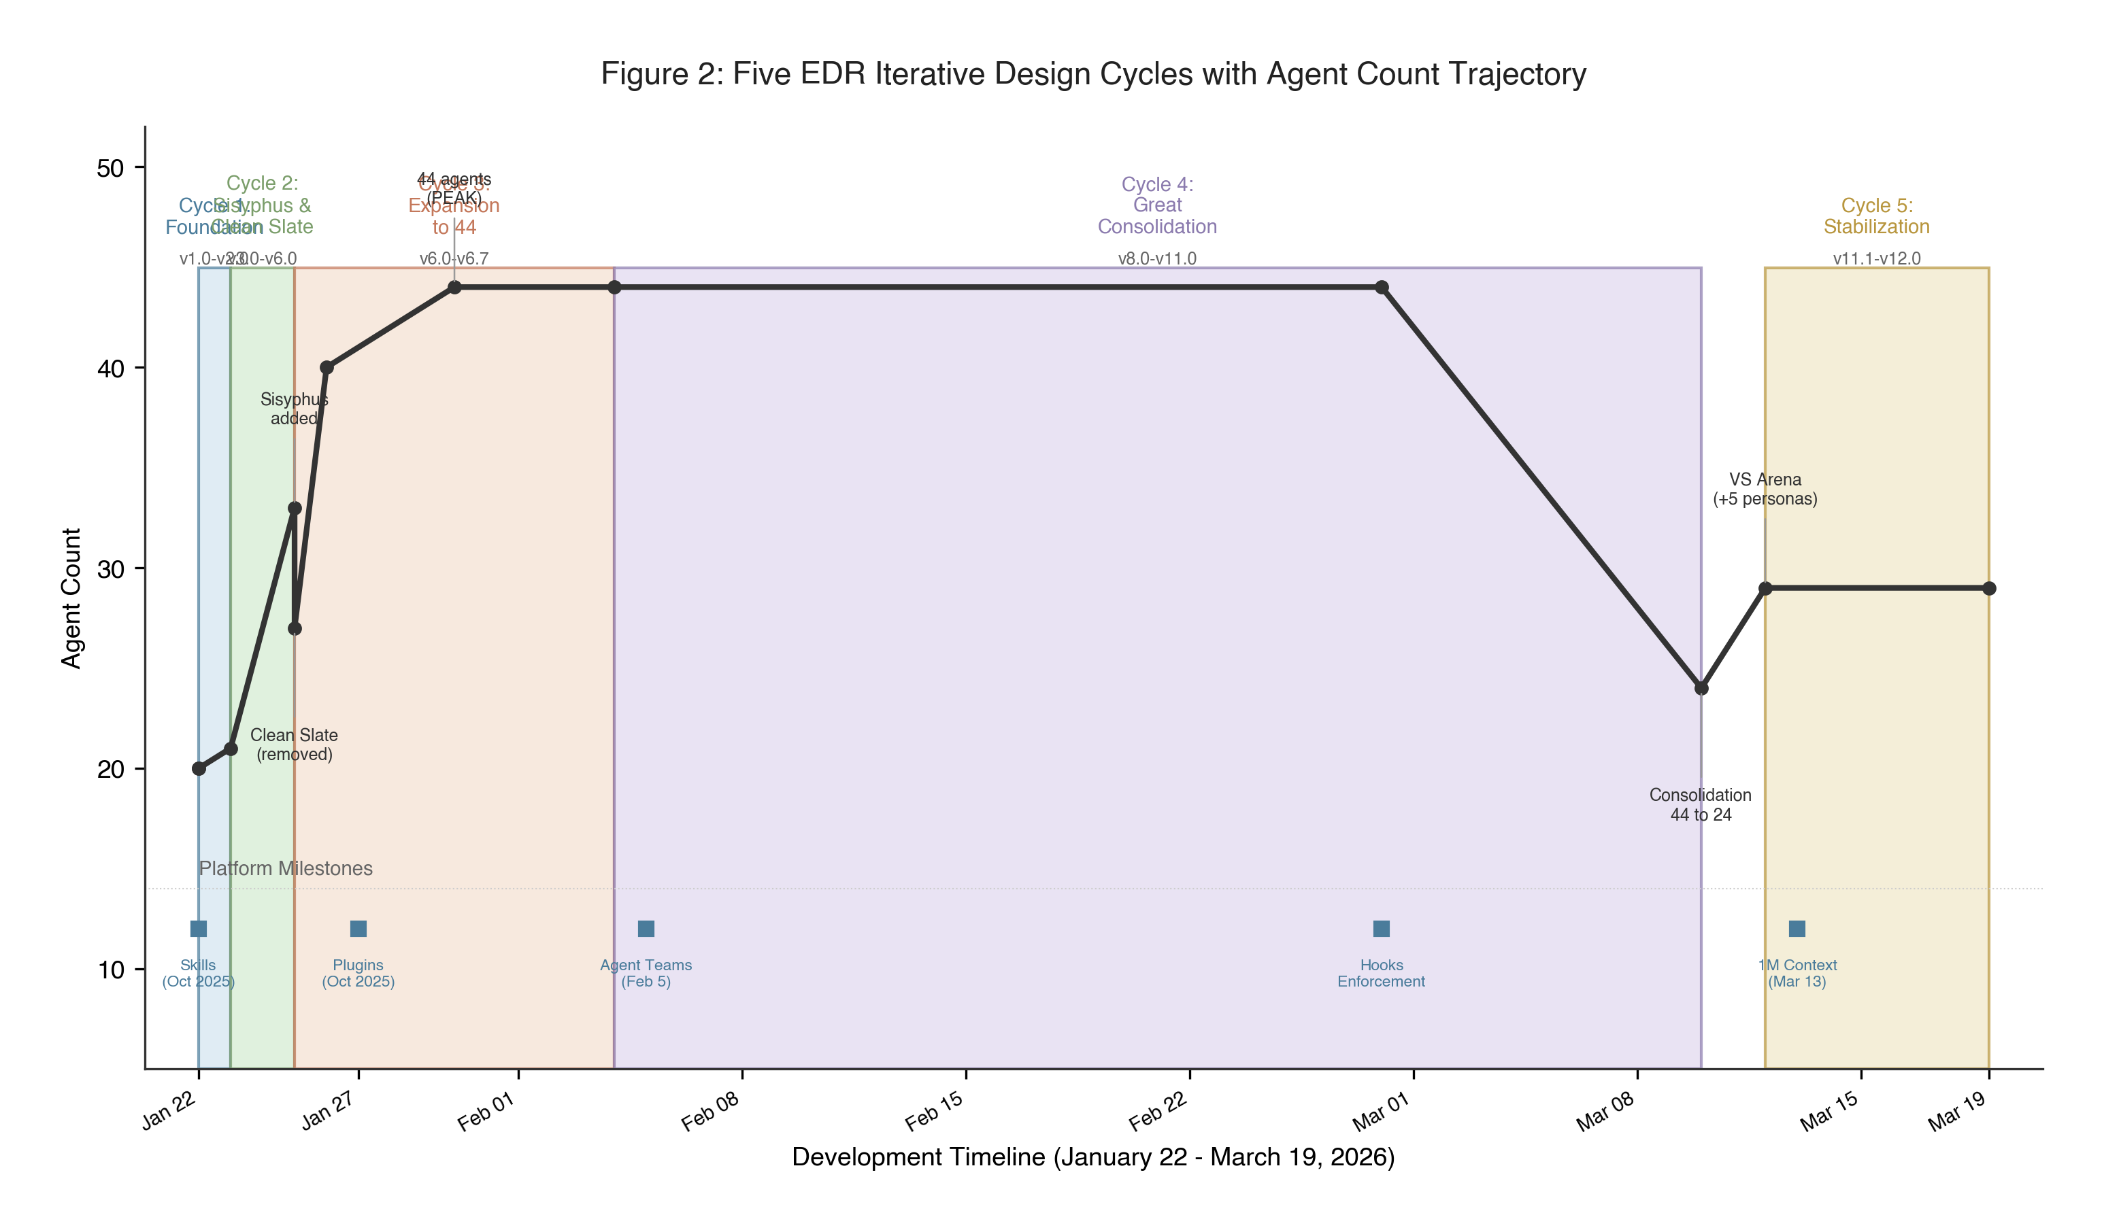
Figure 2
Five Iterative Design Cycles Mapped to the Educational Design Research Model (McKenney & Reeves, 2012), With Agent Count Trajectory and Key Events
Figure 3 shows the co-evolution of Claude Code platform features and Diverga design changes. Three platform capabilities were particularly consequential: hooks (enabling checkpoint enforcement at the architectural level), plugins (enabling marketplace distribution), and Agent Teams (enabling genuine multi-agent epistemological debate).
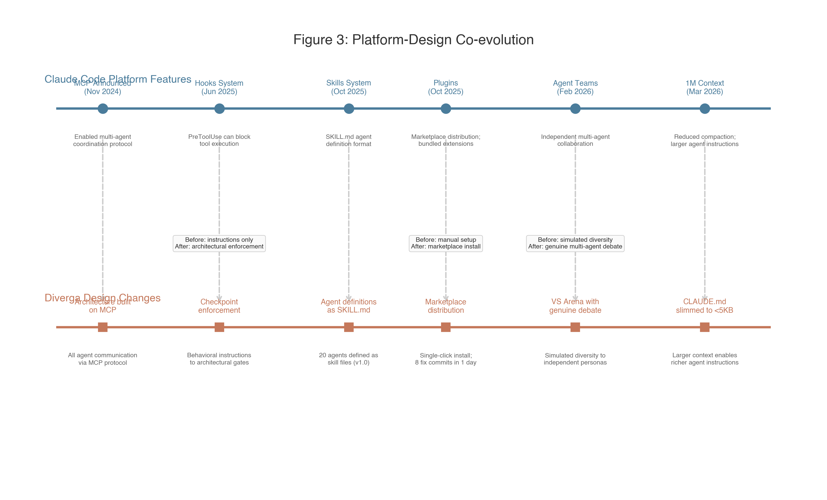
Figure 3
Platform-Design Co-evolution: Claude Code Feature Milestones and Corresponding Diverga Design Changes
Design Problem
Mode Collapse in Research AI
Mode collapse describes the tendency of AI systems to converge on the most statistically common output regardless of context. When researchers query AI tools for methodology guidance, the tools converge on the same high-probability recommendations: the Technology Acceptance Model for technology adoption studies, thematic analysis for qualitative research, random effects models for meta-analysis. This convergence is not random error; it is a systematic artifact of how large language models are trained to maximize predictive probability (Zhao et al., 2024). An analogy from instructional design may clarify the concern: mode collapse is to AI methodology guidance what a standardized, one-size-fits-all curriculum is to pedagogy. Both reduce diversity in the service of efficiency.
Automation Bias in Knowledge Work
Automation bias, the tendency to accept AI recommendations without critical evaluation, compounds mode collapse. A 2025 Springer Nature report found a 78% uncritical acceptance rate for AI-generated methodology suggestions. Microsoft Research (2025) identified a negative correlation between AI tool use and critical thinking engagement in knowledge work settings. The combination narrows the options presented and ensures the narrowed options go unscrutinized.
The Design Gap
No existing tool combines structured human oversight with diversity-generating mechanisms for research methodology guidance. The design challenge is not to build a better recommendation engine; it is to build a system that keeps the researcher's judgment in the loop while countering the homogenization pressure of the underlying model. The cognitive apprenticeship framework clarifies the goal: the system should make expert methodological thinking visible and require the researcher to engage with it, not merely consume it.
Design Decisions and Rationale
Multi-Agent Architecture: From 44 to 24 Agents
In cognitive apprenticeship terms, the multi-agent architecture operationalizes three methods. Each agent models expert reasoning in its domain. Domain-specific feedback constitutes coaching. The 9-category task decomposition provides scaffolding. The consolidation from 44 to 24 is scaffolding calibration: reducing surface complexity so intellectual structure becomes visible.
Diverga grew from 20 agents at launch (v1.0) to a peak of 44 agents (v6.7) before being consolidated to 24 agents across 9 functional categories (v11.0). The trajectory to 44 included rapid expansion driven by domain-specific gaps (meta-analysis, systematic review, humanization), cross-platform support that multiplied complexity, and a 104-file Python memory module built over 11 days and then replaced entirely by MCP-based architecture. These expansions were not wasted; they revealed the thresholds at which complexity becomes counterproductive.
Three alternatives were considered. A single-agent system with diverse prompting would be simpler but cannot hold competing epistemological commitments simultaneously. A modular tool-use architecture similar to Cline or Obra maximizes adoption breadth but sacrifices domain depth. Maintaining 44 agents offers maximum specialization, but coordination overhead and user cognitive load scale superlinearly with agent count (Li et al., 2025).
The consolidation was driven by functional overlap analysis (several v6.7 agents performed structurally identical tasks in different topical clothing), usage patterns (many specialized agents were rarely invoked), and the principle that specialization should map to genuine epistemic distinctions rather than surface-level topic divisions. The 9-category structure (Research Foundation, Literature, Design, Data, Analysis, Quality, Communication, Systematic Review, and Ethics) maps to the actual phases of research design, not to the internal logic of the AI system.
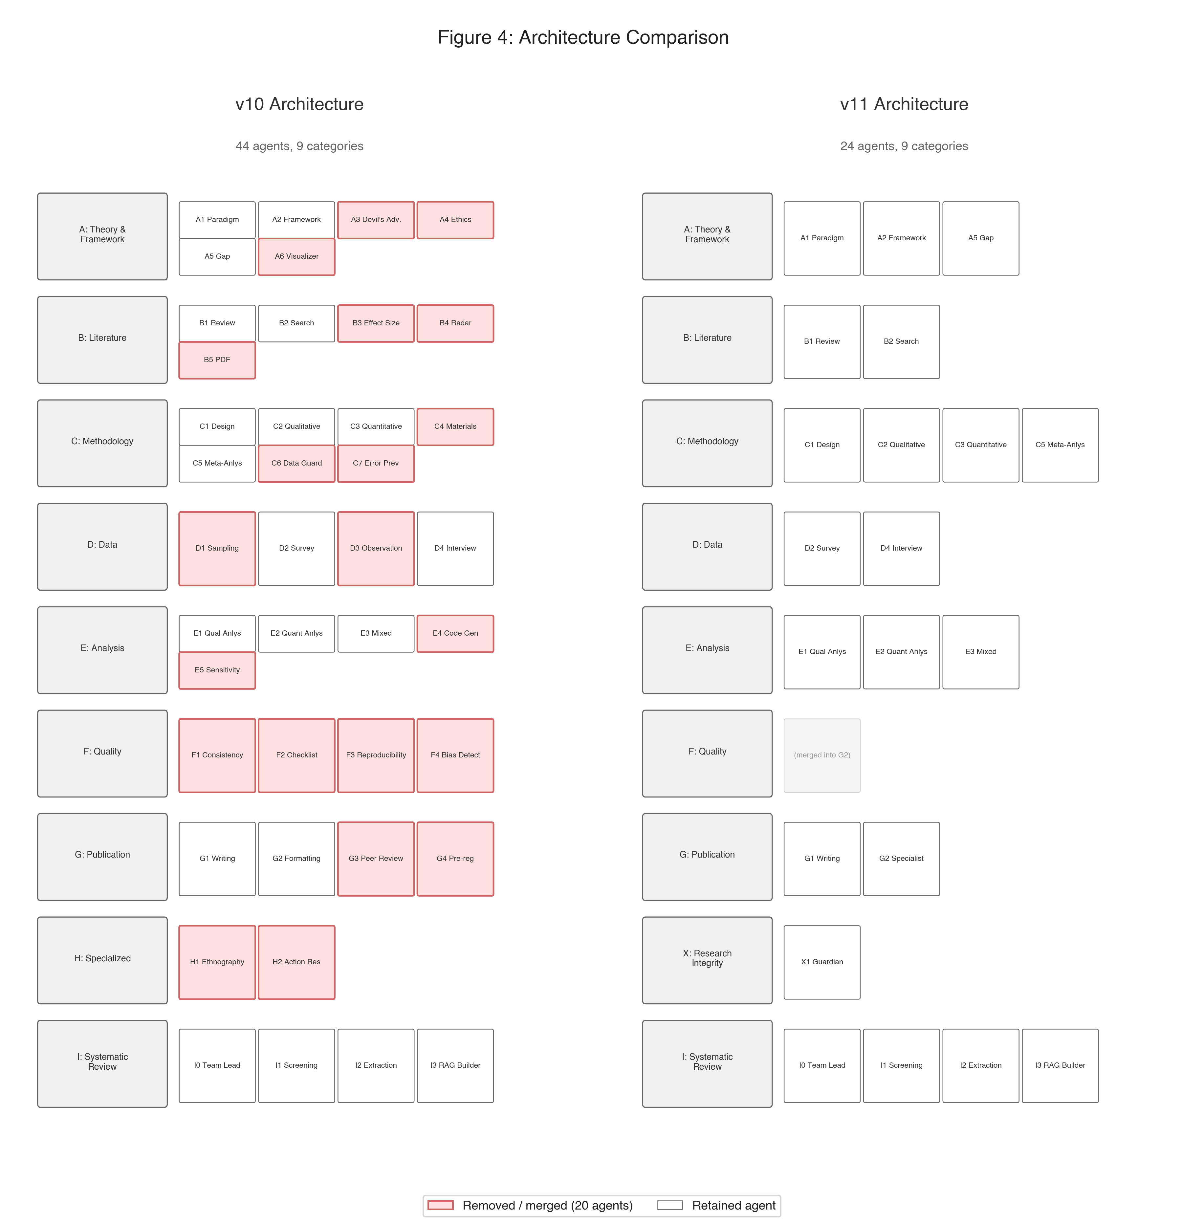
Figure 4
Architecture Comparison: v10 (44 Agents) Versus v11 (24 Agents) Across Nine Functional Categories
Table 2
Agent Consolidation Summary: Version 10 to Version 11
Removed Agent(s) | Merged Into | Rationale
A3 (Devil's Advocate) + A6 (Visualizer) | A2 | Overlapping critical analysis functions
A4 (Ethics) + F4 (Bias Detection) | X1 (Research Guardian) | Both serve research integrity
B3 (Effect Size) + C6 + C7 | C5 | All serve meta-analysis validation
B4 (Research Radar) | Removed entirely | Low usage
C4 (Materials) + D1 (Sampling) | C1 | Design-adjacent functions
F1 + F2 + F3 (Quality) | G2 | Quality checks into publication
G3 (Peer Review) + G4 (Pre-reg) | G2 | Publication workflow consolidated
H1 (Ethnography) + H2 (Action Research) | C2 | Qualitative methods consolidated

Verbalized Sampling and Typicality Scores: Structuring Diversity
In cognitive apprenticeship terms, the T-Score is a reflection device that prompts metacognitive evaluation: Am I choosing this because it is best for my study, or because it is common? The VS methodology's long-tail sampling supports exploration by presenting defensible alternatives the researcher would not encounter through modal convergence alone.
Asking a curriculum to "be diverse" does not produce diversity; structural requirements for diverse content do. Similarly, prompting an AI to "provide diverse recommendations" is an instruction it can partially satisfy while still defaulting to high-probability outputs. Diversity must be structurally enforced, not instructionally requested.
Diverga operationalizes Verbalized Sampling (Zhao et al., 2024), a methodology that generates recommendations across the full typicality spectrum. The Typicality Score (T-Score) measures how common a recommendation is relative to the model's training distribution: T > 0.8 is modal; T < 0.4 is genuinely unconventional. Critically, the T-Score is surfaced to the researcher rather than used only internally. A researcher who sees T = 0.82 knows they are receiving the expected recommendation; one who sees T = 0.31 knows they are in unconventional territory. The T-Score thereby becomes a metacognitive prompt rather than merely a quality indicator. T-Score calibration uses OpenAlex frequency lookup for empirical grounding.
The VS Arena extends this principle through five epistemological persona agents (post-positivist, interpretivist, critical theorist, pragmatist, transformative), each constrained by cannotRecommend arrays that structurally prohibit recommending what other personas are likely to recommend. The Claude Code Agent Teams feature (February 2026) was consequential here: before Agent Teams, VS Arena required simulated diversity through subagent calls in the same context window; after Agent Teams, each persona operates in its own independent context, producing substantively different outputs.
Human Checkpoint System: Five Required Cognitive Forcing Functions
Each REQUIRED checkpoint functions as a cognitive forcing function (Bucinca et al., 2021) that operationalizes the articulation method of cognitive apprenticeship: the researcher must verbalize a decision and its rationale before the system proceeds. The reduction from many checkpoints to five represents fading, a deliberate reduction of support.
Automation bias is not primarily a knowledge problem; researchers often know they should evaluate AI recommendations critically. It is a cognitive habit problem: under time pressure and with confident-sounding AI output, critical evaluation is the path of most resistance. Cognitive forcing functions (Bucinca et al., 2021) are deliberate design elements that interrupt automatic processing and require effortful evaluation.
The checkpoint design was itself iterative and marked by instructive failures. In v5.0 (January 25, 2026), the Sisyphus Protocol was introduced, making AI autonomous between checkpoints; it was removed the same day when it became clear that the protocol eliminated human control. The v6.0 Clean Slate Edition established the foundational principle: AI works between checkpoints; humans decide at them. Before the Claude Code hooks system (June 2025), checkpoints were behavioral instructions only; after hooks, they became architectural enforcement through PreToolUse interception.
A particularly instructive failure occurred in v11.0: a silent bug in which all checkpoints auto-approved without user input. The system appeared to have oversight, but it did not. The bug was detected through architectural review, not user testing, illustrating how difficult genuine human oversight is to implement in autonomous AI systems. The fix involved SQLite-based verification of halt behavior.
The five gate positions correspond to genuine cross-agent dependency points: decisions made at these points propagate through all subsequent agent outputs. Five is a judgment call, not an empirically derived optimum. The design case documents this honestly: the number reflects the designer's best current assessment of where oversight adds more value than it subtracts in cognitive load. Whether five checkpoints produce deliberation or habituated click-through is an empirical question for the companion evaluation paper.
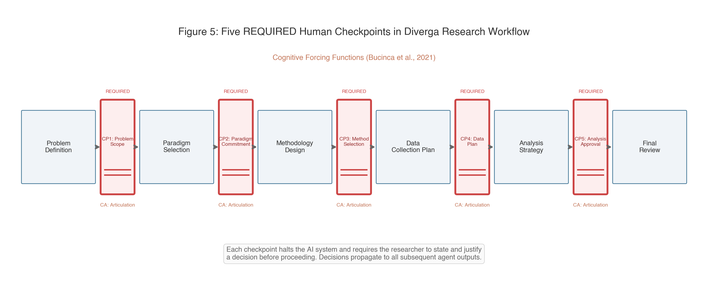
Figure 5
Human Checkpoint Flow: Five Required Cognitive Forcing Function Gates in the Research Design Workflow, With Cognitive Apprenticeship Method Labels
Design Tensions
Design cases in learning design often document what was built and why; the best ones also document what remains uncertain and why it matters. The following tensions are carried forward from the design decisions as open questions.
Simplicity Versus Specialization
Twenty-four agents in nine categories is more principled than 44, but it is still more complex than ChatGPT. For novice researchers, the 9-category architecture may itself be a barrier: knowing which category of agent to invoke requires prior knowledge of the research design process. The design bets that the right users (doctoral students in research design contexts) have enough process knowledge to navigate the architecture. This bet has not been tested.
Diversity Versus Coherence
The VS Arena generates five epistemologically divergent perspectives on a methodology question. For experienced researchers, this plurality is a resource. For novice researchers, it may be a source of confusion rather than illumination. No synthesis mechanism currently exists; the researcher must integrate competing perspectives without AI support. This is the most important unresolved design problem in Diverga's current state.
Oversight Rigor Versus Workflow Fluidity
Five checkpoints interrupt cognitive flow. The design trades fluidity for genuine oversight, but the exchange rate is unknown. Checkpoint fatigue is not hypothetical: in the pre-fix v11.0, the silent auto-approval behavior may have emerged partly because the original checkpoint count was too high and was quietly engineered around. The companion evaluation paper will investigate whether five REQUIRED checkpoints produce the intended deliberative behavior or habituated click-through.
Table 4
Design Tensions Summary
Tension | Design Decision | What Was Traded | Open Question
Simplicity vs. Specialization | Multi-Agent Architecture | User simplicity for domain coverage | Is 24 agents still too many for novices?
Diversity vs. Coherence | VS and T-Score | Convergence for epistemic plurality | Do novices need synthesis support?
Oversight vs. Fluidity | Human Checkpoints | Workflow fluidity for human control | Do 5 checkpoints produce deliberation or click-through?

Reflection and Future Directions
What This Design Story Reveals
Learning design principles are not limited to explicit instructional settings. The decisions documented in this paper (structural diversity enforcement, mandatory cognitive interruption, typicality transparency) are recognizable to instructional designers even when they appear in an AI tool's architecture. The "learning design in disguise" framing is descriptive, not rhetorical: Diverga shapes researcher behavior through its form, not through explicit instruction, analogous to how a well-designed problem-based learning environment shapes student inquiry through task structure rather than direct teaching.
The co-evolution with the Claude Code platform illustrates a broader phenomenon: AI tool designers are not designing on stable ground. Platform capabilities emerge and disappear; designs must adapt or become obsolete. The 41-day lifespan of cross-platform support and the architectural shift enabled by hooks and Agent Teams are not incidental details; they are defining features of what it means to design educational AI tools in a rapidly evolving ecosystem.
Transferable Design Principles
Three principles transfer to other AI tool designs for knowledge work. First, structural enforcement over instructional exhortation: design diversity into the system's architecture, not into the system's instructions. Second, transparency as metacognitive prompt: surface the information the user needs to calibrate their reliance on the system. Third, checkpoints as cognitive forcing functions: design mandatory pause points at consequential decision nodes, not at every step.
Connection to Companion Papers
This design case occupies Educational Design Research phases 1 and 2. The empirical evaluation of whether Diverga's design decisions produce the intended effects on researcher performance is the subject of a companion experimental paper (Paper 3). A separate methodological paper (Paper 2) addresses how to study artificial agency in multi-agent AI educational systems, using Diverga as the exemplar case. Authentic learning (Herrington, Reeves, & Oliver, 2010), which shares characteristics with Diverga's design context, will serve as the primary theoretical framework for Papers 2 and 3. The design case establishes the design rationale that the companion papers can reference without re-documenting the full system.

References
Boling, E. (2010). The need for design cases: Disseminating design knowledge. International Journal of Designs for Learning, 1(1), 1-8.
Bucinca, Z., Malaya, M. B., & Gajos, K. Z. (2021). To trust or to think: Cognitive forcing functions can reduce overreliance on AI in AI-assisted decision making. Proceedings of the ACM on Human-Computer Interaction, 5(CSCW1), Article 188.
Collins, A., Brown, J. S., & Holum, A. (1991). Cognitive apprenticeship: Making thinking visible. American Educator, 15(3), 6-11.
Collins, A., Brown, J. S., & Newman, S. E. (1989). Cognitive apprenticeship: Teaching the crafts of reading, writing, and mathematics. In L. B. Resnick (Ed.), Knowing, learning, and instruction: Essays in honor of Robert Glaser (pp. 453-494). Lawrence Erlbaum Associates.
Herrington, J., Reeves, T. C., & Oliver, R. (2010). A guide to authentic e-learning. Routledge.
Li, Z., Zhang, Y., & Zhao, H. (2025). More agents is less: Scaling properties of multi-agent LLM systems. arXiv:2602.03794.
Markauskaite, L., & Goodyear, P. (2017). Epistemic fluency and professional education: Innovation, knowledgeable action and actionable knowledge. Springer.
McKenney, S., & Reeves, T. C. (2012). Conducting educational design research. Routledge.
Smith, K. M. (2010). Producing the rigorous design case. International Journal of Designs for Learning, 1(1), 9-20.
Wang, T., Yu, P., & Zha, D. (2024). Mixture-of-agents yields emergent collaborative intelligence. Together AI Technical Report.
Yang, M., & Harbor, J. (2023). Authentic learning design failures: The need for learner and contextual analysis and participatory design. International Journal of Designs for Learning, 14(1), 88-105.
Zhao, Y., Huang, J., & Chen, X. (2024). Verbalized sampling for language model selection. arXiv:2510.01171.

