Design Case Outline: Diverga
Target: International Journal of Designs for Learning (IJDL) & Journal of Advances in Developing Human Resources (if we phrase it as a project developing research workforce)
Format: First-person design case (~5,000 words)
Genre: Boling (2010); Smith (2010)
Proposed Title
"Scaffolding Without Replacing: A Design Case of Human Checkpoints and Verbalized Sampling in an AI Research Methodology Assistant"
If we target ADHR:
Option1: Building the AI-Augmented Researcher: A Design Case of Human Checkpoints for Critical Expertise Development
Option 2: Developing the Future Research Workforce: Scaffolding AI Research Literacy through Verbalized Sampling and Human-in-the-Loop Design
Option 3: From Assistance to Mastery: Cultivating Critical Research Competencies through Scaffolding in AI-Enabled Environments
Overview
Diverga is a 24-agent AI research methodology assistant built on Model Context Protocol (MCP). It was designed to address the deskilling risk in the AI-augmented research workforce, where two interdependent threats erode professional expertise: mode collapse (AI tools converging on the same predictable recommendations) and automation bias (researchers accepting AI output without critical evaluation). Unlike existing tools such as Elicit, Consensus, or ChatGPT, Diverga combines three mechanisms that make it function as a learning design embedded in a research tool:
• Multi-agent architecture with 24 specialized agents organized across 9 research methodology categories (Research Foundation, Literature, Design, Data, Analysis, Quality, Communication, Systematic Review, Ethics)
• Verbalized Sampling (VS) with Typicality Scores (T-Scores) that structurally enforce recommendation diversity and make the commonality of each recommendation transparent to the researcher
• Five required Human Checkpoints that function as cognitive forcing functions, halting AI processing and requiring the researcher to evaluate, decide, and articulate rationale before the system proceeds
The system was developed over 57 days (224 version-controlled commits), evolving from 20 agents to a peak of 44 before being consolidated to 24 through principled analysis of functional overlap and usage patterns. This iterative trajectory, including documented design failures, constitutes the core narrative of the design case.
Theoretical & sTheoretical and Conceptual Frameworks
The paper integrates two distinct frameworks operating at different levels (see Figure 1):
Theoretical Framework: Cognitive Apprenticeship (Collins, Brown, & Newman, 1989) provides the theoretical lens for explaining why Diverga functions as a learning design rather than merely a tool. The theory holds that professional expertise develops through socially situated learning in which expert thinking is made visible to novices. Six methods (modeling, coaching, scaffolding, articulation, reflection, exploration) serve as theoretical design principles. This framework directly addresses the deskilling problem: if AI automation risks bypassing the cognitive engagement necessary for expertise development, CA specifies the conditions under which that engagement can be preserved and cultivated. The framework is applied throughout the design narrative (~400 words distributed across the Introduction and Design Decisions sections), not as a standalone theoretical analysis.
Conceptual Framework: Educational Design Research (McKenney & Reeves, 2012) serves as the conceptual and design framework that organizes the entire design case. EDR provides the iterative design process model through three phases: Analysis/Exploration, Design/Construction, and Evaluation/Reflection. The design case narrative follows this framework: each section corresponds to an EDR phase, and the five iterative cycles are analyzed through this structure. Cognitive Forcing Functions (Bucinca et al., 2021) are embedded within the Design/Construction phase as a specific design mechanism for the Human Checkpoint system, rather than as a co-equal framework element.

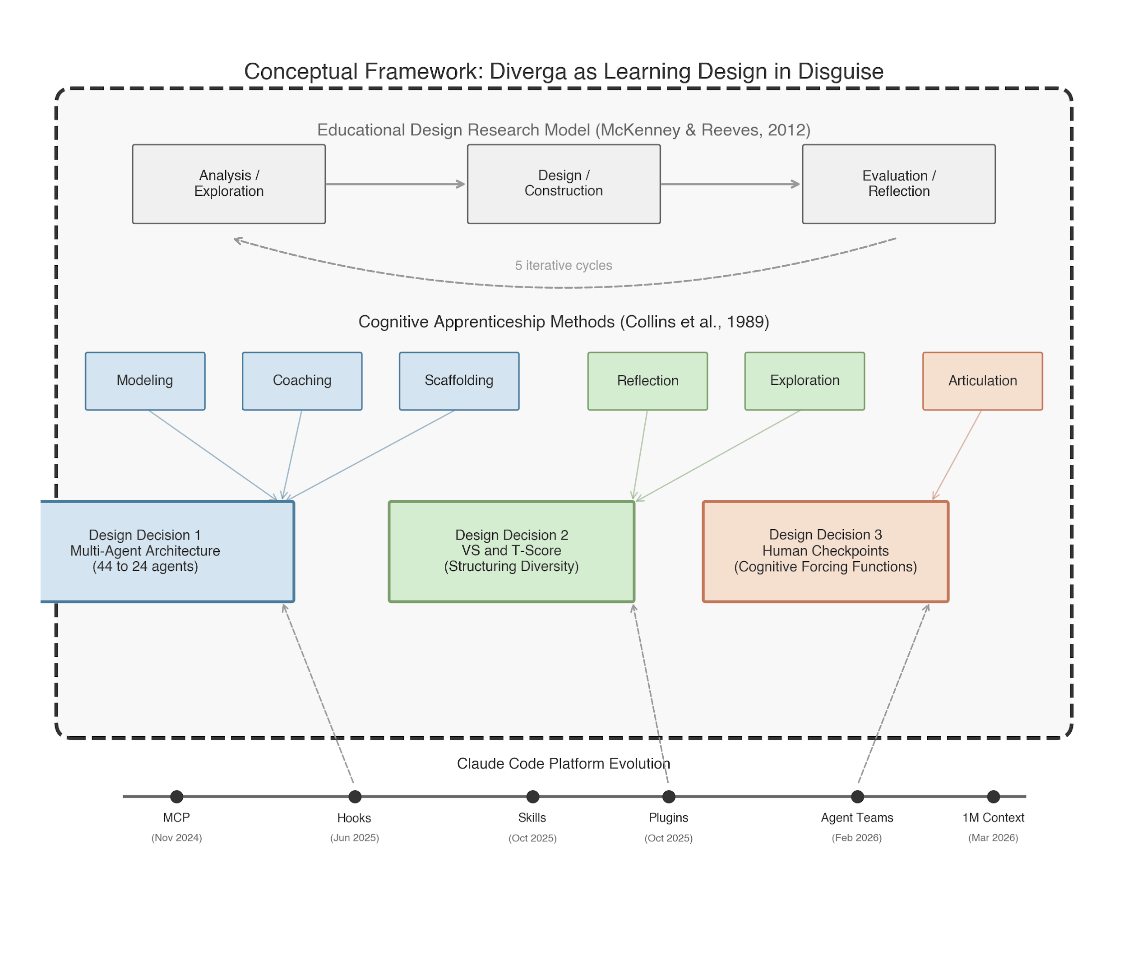
Figure 1. Theoretical and Conceptual Frameworks: Cognitive Apprenticeship (theoretical), EDR Model (conceptual/design), Three Design Decisions, and Platform Evolution
Paper Structure
1. Introduction
- the "deskilling" risk in the ai-augmented research workforce.
- establishing the dual threats to professional expertise: mode collapse (homogenized knowledge) and automation bias (uncritical acceptance).
- purpose: presenting a design case of a platform that prioritizes workforce development over task automation.
- significance to HRD: how "scaffolding without replacing" serves as a model for professional development in knowledge-intensive industries.
This section establishes the deskilling problem, introduces the design challenge, and frames the paper as a workforce development contribution with Cognitive Apprenticeship as the theoretical lens. (1.1) The AI-Augmented Research Workforce and Deskilling Risk (~100 words): AI tools are entering knowledge-intensive industries precisely when those industries require deep methodological judgment. Doctoral research training is a paradigm case of professional expertise formation. AI augmentation carries a structural risk of deskilling, eroding the very competencies it purports to support. (1.2) Dual Threats to Professional Expertise (~130 words): Mode collapse and automation bias as interdependent threats to professional expertise. Mode collapse produces homogenized knowledge; automation bias closes the critical loop (78% uncritical acceptance rate; Springer Nature, 2025; negative correlation with critical thinking, Microsoft Research, 2025). (1.3) Design Challenge and Purpose (~70 words): Can an AI research assistant scaffold methodological reasoning rather than replace it? Purpose: presenting a design case of a platform that prioritizes workforce development over task automation. (1.4) Significance to Professional Development (~80 words, NEW): "Scaffolding without replacing" serves as a model for professional development in knowledge-intensive industries where AI augmentation risks displacing expert judgment.
(1.5) Cognitive Apprenticeship as the Design Lens (~90 words): If the dual threats of mode collapse and automation bias operate by removing the user from the reasoning process, the design response must be a system that systematically reinserts the user into that process. Cognitive Apprenticeship, with its emphasis on coached practice and guided reflection, supplies that mechanism. Six methods are identified: modeling, coaching, scaffolding, articulation, reflection, and exploration. Each of Diverga's three core design decisions operationalizes a subset of these methods through architectural mechanisms rather than explicit instruction. (1.6) Preview of Design Decisions (~80 words): The multi-agent architecture models expert reasoning and scaffolds the research design process. The Verbalized Sampling system, with its Typicality Scores, supports reflection and exploration by making the statistical commonality of each recommendation transparent. The Human Checkpoint system supports articulation by requiring the researcher to state and justify decisions at mandatory interruption points, which function as cognitive forcing functions (Bucinca et al., 2021). (1.7) Scope Statement (~70 words): Design story only; empirical evaluation reserved for companion paper. EDR phases 1-2 (McKenney & Reeves, 2012). IJDL design case conventions (Boling, 2010; Smith, 2010).
2. Design Context
The designer is a doctoral student who simultaneously built and studied the system. This dual role provides insider knowledge but introduces evaluation bias. An external collaborator, who has extensive instructional design and research experience, joined the project to provide critical distance. Target users are social science doctoral students for whom research methodology decisions constitute core knowledge work. The technical platform (MCP + Claude Code) enabled a single developer to build a multi-agent system in 57 days.
3. Design Process: Five Iterative Cycles
This section tells the iterative design story. Each cycle follows the EDR conceptual framework: a problem or gap triggers analysis; a design response is constructed; evaluation reveals new issues that trigger the next cycle. Platform capabilities (Claude Code hooks, plugins, Agent Teams) co-evolved with the design, creating external triggers for iteration.
Cycle 1: Foundation (v1.0-v2.0; 2 days)
• Problem: LLM research assistants default to modal recommendations
• Design: 20 agents + Verbalized Sampling + T-Score system
• Feedback: marketplace compatibility issues; installation too complex
Recognized need for modular creativity mechanisms → triggered Cycle 2
Cycle 2: Sisyphus and Clean Slate (v3.0-v6.0; 3 days)
• Problem: VS alone was insufficient; creativity needed modularity
• Design: 5 creativity mechanisms; expanded to 33 agents; introduced Sisyphus Protocol (autonomous continuation)
• Feedback: Sisyphus Protocol removed human control entirely; added and removed the same day
Design failure established foundational principle → "AI works between checkpoints, humans decide at them"
Cycle 3: Expansion to Peak (v6.0-v6.7; 10 days)
• Problem: domain gaps in meta-analysis, systematic review, humanization
• Design: expanded to 44 agents; cross-platform support (Codex CLI, OpenCode); plugin marketplace
• Feedback: plugin discovery fragile (8 fix commits in one day); cross-platform parity never achieved (75%/70%)
Complexity exceeded maintainability threshold → triggered consolidation
Cycle 4: The Great Consolidation (v8.0-v11.0; 34 days)
• Problem: 44 agents, 3 platforms, 59KB configuration; most agents rarely used
• Design: MCP checkpoint enforcement; SQLite backend; then consolidation: 44 to 24 agents, cross-platform dropped
• Feedback: silent checkpoint bug discovered (all checkpoints auto-approved); 104-file Python module replaced by MCP
• Platform trigger: Claude Code hooks (June 2025) enabled architectural checkpoint enforcement, replacing unreliable behavioral instructions
Simplified foundation enabled new capabilities → triggered Cycle 5
Cycle 5: Stabilization (v11.1-v12.0; 7 days)
• Problem: simplified architecture needed new features (VS Arena, unified orchestration)
• Design: VS Arena with 5 epistemological personas; unified orchestrator; configuration slimmed from 16.8KB to <5KB
• Platform trigger: Agent Teams (Feb 2026) enabled genuine multi-agent debate; before this, VS Arena used simulated diversity in a single context window
System reached architectural stability → ready for user evaluation studies
4. Design Problem
This section defines the specific problems that the three design decisions address, corresponding to the Analysis/Exploration phase of the EDR conceptual framework. Mode collapse is explained for a non-technical audience: AI systems trained to maximize prediction probability produce the most common output, not the most contextually appropriate one. This is analogous to standardized curricula that reduce pedagogical diversity. Automation bias compounds the problem: researchers know they should evaluate critically, but under time pressure, the path of least resistance is acceptance. No existing tool addresses both problems structurally.
5. Design Decisions and Rationale (core)
Each decision follows the EDR Design/Construction phase, using the design case pattern: decision point, alternatives considered, rationale for chosen approach, evidence of implementation, and the design tension carried forward.
5.1 Multi-Agent Architecture: From 44 to 24 Agents
The system grew from 20 to 44 agents before being consolidated to 24. The expansion revealed where complexity becomes counterproductive: functional overlap between agents, superlinear scaling of coordination overhead (Li et al., 2025), and user cognitive load. The 9-category structure maps to research design phases, not to AI system internals. The consolidation was scaffolding calibration in cognitive apprenticeship terms: reducing surface complexity so the intellectual structure of research design becomes the visible architecture.
• Cognitive Apprenticeship methods: Modeling (agents demonstrate expert reasoning), Coaching (domain-specific feedback), Scaffolding (task decomposition + fading via consolidation)
• Figures: architecture comparison diagram (v10 vs. v11)
• Tables: agent consolidation table with rationale for each merge
5.2 Verbalized Sampling and Typicality Scores
Mode collapse cannot be solved by prompting an AI to "be diverse"; diversity must be structurally enforced. VS (Zhao et al., 2024) generates recommendations across the full typicality spectrum. The critical design decision was to surface the T-Score to the researcher: a score of T = 0.82 signals a modal recommendation; T = 0.31 signals genuinely unconventional territory. This turns the T-Score into a metacognitive prompt. The VS Arena extends this through five epistemological persona agents, each structurally constrained from recommending what others are likely to recommend.
• Cognitive Apprenticeship methods: Reflection (T-Score as metacognitive device), Exploration (long-tail sampling + epistemological plurality)
• Iterative evolution: before Agent Teams, personas ran in the same context window (simulated diversity); after Agent Teams, each persona operates independently (genuine diversity)
5.3 Human Checkpoint System: Five Required Cognitive Forcing Functions
Checkpoints are not workflow approval gates; they are cognitive forcing functions (Bucinca et al., 2021) that interrupt automatic processing and require effortful evaluation. The design was shaped by two instructive failures. First, the Sisyphus Protocol (v5.0) attempted full autonomy between checkpoints and was reversed the same day. Second, a silent bug in v11.0 caused all checkpoints to auto-approve; the system appeared to have oversight but did not. These failures illustrate how difficult genuine human oversight is to implement in autonomous AI systems. The current design places five gates at cross-agent dependency points where decisions propagate through all subsequent outputs.
• Cognitive Apprenticeship methods: Articulation (researcher must verbalize decision rationale), Scaffolding (fading from many checkpoints to five)
• Platform evolution: before hooks (June 2025), checkpoints were behavioral instructions; after hooks, architectural enforcement
6. Design Tensions
Design cases document not only what was built but what remains uncertain. These tensions are inherent trade-offs in the current design, not failures to be fixed. Naming them contributes to the field's understanding of AI tool design for epistemic support. Each tension corresponds to a design decision and identifies an open empirical question that the companion evaluation paper will investigate.
• Simplicity vs. Specialization (from 5.1): 24 agents in 9 categories is principled but still complex. Does navigating this architecture require prior research design knowledge that novice users lack?
• Diversity vs. Coherence (from 5.2): VS Arena generates five divergent perspectives without synthesis. Does this plurality illuminate or overwhelm? This is the most important unresolved design problem.
• Oversight Rigor vs. Workflow Fluidity (from 5.3): five checkpoints interrupt cognitive flow. Does this produce genuine deliberation or habituated click-through? The silent auto-approval bug suggests the tension is real.
7. Reflection and Future Directions
Three transferable design principles emerge: (1) structural enforcement over instructional exhortation (design diversity into architecture, not instructions), (2) transparency as metacognitive prompt (surface information users need to calibrate reliance), and (3) checkpoints as cognitive forcing functions (mandatory pauses at consequential nodes, not at every step). These principles constitute a model for professional development in knowledge-intensive industries: AI tools can be designed to scaffold expertise rather than replace it. The design case occupies EDR phases 1 and 2. Companion papers address methodology for studying artificial agency (Paper 2, BJET) and empirical evaluation of researcher performance effects (Paper 3, ETR&D).

Key References
Boling, E. (2010). The need for design cases: Disseminating design knowledge. International Journal of Designs for Learning, 1(1), 1-8.
Bucinca, Z., Malaya, M. B., & Gajos, K. Z. (2021). To trust or to think: Cognitive forcing functions can reduce overreliance on AI in AI-assisted decision making. Proceedings of the ACM on Human-Computer Interaction, 5(CSCW1), Article 188.
Collins, A., Brown, J. S., & Newman, S. E. (1989). Cognitive apprenticeship: Teaching the crafts of reading, writing, and mathematics. In L. B. Resnick (Ed.), Knowing, learning, and instruction (pp. 453-494). Erlbaum.
Li, Z., Zhang, Y., & Zhao, H. (2025). More agents is less: Scaling properties of multi-agent LLM systems. arXiv:2602.03794.
McKenney, S., & Reeves, T. C. (2012). Conducting educational design research. Routledge.
Smith, K. M. (2010). Producing the rigorous design case. International Journal of Designs for Learning, 1(1), 9-20.
Yang, M., & Harbor, J. (2023). Authentic learning design failures. International Journal of Designs for Learning, 14(1), 88-105.
Zhao, Y., et al. (2024). Verbalized sampling for language model selection. arXiv:2510.01171.
Accompanying Materials
A detailed draft (~4,800 words with all figures and tables embedded) is available as a companion document for reference during writing.

