Checkpoint-Mediated Agency Analysis: A Methodology for Studying Artificial Agency Effects in Multi-Agent AI Educational Systems

[Author names removed for double-anonymous review]
[Institutional affiliation removed for review]

Manuscript submitted for review: British Journal of Educational Technology, Special Issue SI-2026-000285
Word count (body text, excluding references): approximately 3,300

DRAFT: For Discussion Only (Not for Circulation)

Abstract
Research aims. As agentic AI systems enter educational contexts, researchers lack validated methodologies for distinguishing agentic participation from tool-based assistance, and for measuring how artificial agency redistributes epistemic labour at critical educational decision junctures. This paper proposes Checkpoint-Mediated Agency Analysis (CMAA), a methodology that leverages the structured human-AI interaction points inherent in checkpoint-governed multi-agent systems as natural measurement instruments for studying artificial agency effects on educational decision-making and the redistribution of epistemic labour.
Context. Grounded in Floridi's (2025) three criteria for artificial agency (interactivity, bounded autonomy, and adaptability), CMAA is developed through the design-based case of Diverga, a 24-agent AI research methodology assistant exhibiting the defining features of agentic AI: goal persistence across sessions, proactive initiative, multi-agent coordination, and architectural governance through mandatory human checkpoints. Diverga's architecture generates naturally occurring, multi-layered data about human-AI interaction at every critical research design juncture, enabling process-level analysis that conventional measurement approaches cannot provide.
Data and methods. Three methodological contributions are presented: (1) a framework mapping multi-agent checkpoint architectures onto Floridi's (2025) agency criteria and explicating their social-cognitive dynamics of learning, where epistemic labour is visibly redistributed between human and artificial agents; (2) five operationalized indicators for distinguishing agentic participation from tool-based assistance (Proactive Intervention Rate, State Utilization Depth, Decision Space Expansion, Governance Constraint Activation, and Coordination Complexity Index); and (3) a proposed embedded mixed methods proof-of-concept study design for initial empirical validation.
Outcomes and conclusions. CMAA addresses the field's need for methodologies that capture how epistemic labour is redistributed between human and artificial agents at decision junctures, revealing how artificial agency shapes the social-cognitive dynamics of learning by expanding, constraining, or redirecting the researcher's epistemic trajectory, and distinguishing agentic participation from tool-based assistance. Indicators are designed for transferability across agentic educational AI systems internationally, and are validated against the criterion of distinguishing agentic participation from tool-based assistance in authentic research task contexts.

Keywords: agentic AI, artificial agency, checkpoint-mediated analysis, epistemic labour redistribution, multi-agent systems, educational technology methodology, social-cognitive dynamics

Checkpoint-Mediated Agency Analysis: A Methodology for Studying Artificial Agency Effects in Multi-Agent AI Educational Systems
Introduction
The emergence of agentic AI systems in educational contexts, systems characterized by goal persistence, proactive initiative, multi-step coordination, and adaptive behavior across sessions, introduces a measurement challenge that existing educational technology research methodologies are ill-equipped to address. Technology Acceptance Model instruments, user satisfaction surveys, and learning outcome comparisons capture the consequences of AI use without illuminating the process by which artificial agency redistributes epistemic labour between human and artificial actors at critical decision junctures (Järvelä et al., 2023; Vaccaro et al., 2024). This gap is not merely methodological; it is consequential. Without process-level measurement of how, specifically, artificial agency intervenes in human reasoning, researchers cannot determine whether an agentic AI system is expanding the epistemic space available to learners, steering them toward predetermined paths, or silently governing decisions through architectural affordances that users neither observe nor resist.
The measurement problem is architecturally rooted. Consider a multi-agent educational AI system with mandatory human checkpoints, structured interaction points at which the system halts autonomous execution, presents alternatives, and awaits human decision before proceeding. At these checkpoints, the redistribution of epistemic labour is observable in principle: what alternatives did the system generate? What typicality distribution did those alternatives span? Which option did the human select, and with what deliberation depth? Yet standard behavioral observation methods, interaction logs limited to binary action data, and retrospective interview protocols all fail to capture this process with sufficient precision, because they were not designed around the architecture of artificial agency as Floridi (2025) defines it.
The missing analytical unit is the checkpoint: the structured human-AI interaction point at which artificial agency directly enters the social-cognitive dynamics of learning, reshaping not only what the researcher decides, but what options the researcher recognizes as available for decision. At these junctures, checkpoint-governed artificial agency participates in the shared regulation of inquiry, redistributing epistemic labour by generating, typicality-ranking, and presenting alternatives that may exceed what the human researcher would independently construct, while simultaneously constraining the decision space to architecturally generated options whose range and framing carry their own epistemic authority. Resolving this gap requires instruments calibrated to the defining distinction of agentic systems: not whether the AI produced output, but whether the human exercised deliberate epistemic agency in evaluating alternatives, the boundary between agentic participation, in which artificial initiative and human deliberation are jointly constitutive of the outcome, and tool-based assistance, in which the human retains sole initiative and the AI serves as a passive execution mechanism.
This paper proposes Checkpoint-Mediated Agency Analysis (CMAA), a methodology developed from and for checkpoint-governed multi-agent systems. CMAA operationalizes Floridi's (2025) three criteria for artificial agency into five measurable behavioral indicators and treats human checkpoints as natural measurement instruments that generate multi-layered data about the social-cognitive dynamics of human-AI interaction at the moments when artificial agency most directly shapes learning trajectories.
CMAA is developed through systematic analysis of Diverga, a 24-agent AI research methodology assistant developed through five iterative design cycles (224 version-controlled commits, 57 days) to embody artificial agency as Floridi defines it. A critical incident during development, in which system audit logs revealed that architecturally designated required checkpoints were being programmatically bypassed, generating approval tokens without user engagement, operationalised the measurement problem CMAA addresses with unusual clarity: architecturally claimed human oversight may diverge substantially from actual epistemic participation, and this divergence is invisible to conventional measurement approaches.
[OUTLINE: Introduction, remaining ~250 words]
• Paper contributions (three): CMAA framework, five indicators, proof-of-concept study design
• Paper structure overview (one paragraph)
• Transition to theoretical framework
Theoretical Framework
Artificial Agency and Its Educational Consequences
Following Floridi (2025), artificial agency is understood as a computational, goal-directed mode of action in service of human purposes, not a form of intelligence, consciousness, or intentionality. It is characterized by three minimal, non-anthropomorphic criteria: interactivity (reciprocal, bidirectional engagement with an environment), bounded autonomy (the capacity to initiate actions within programmed constraints while remaining subject to human override), and adaptability (modification of behavior based on accumulated feedback and changing conditions). Crucially, adaptive and autonomous behavior in artificial agents emerges from the integration of predefined objectives with learned patterns of action; the system does not self-determine goals. This framing distinguishes agentic AI from anthropomorphic interpretations and provides a precise basis for analyzing its educational consequences.
The defining boundary between agentic AI and other educational AI applications lies in initiative and persistence, rather than in generativity alone (Yan et al., 2024). Earlier AI-in-education systems, such as Intelligent Tutoring Systems, operate within a reactive paradigm, producing feedback or adaptation only in response to learner actions (Ouyang & Jiao, 2021). Generative AI assistants function as on-demand tools whose activity is episodic, prompt-driven, and externally initiated. Agentic AI systems, by contrast, incorporate persistent memory, dynamic task decomposition, and, in some cases, multi-agent orchestration, enabling them to initiate interaction, maintain trajectories over time, and participate continuously in the unfolding activity. Through these properties, agentic AI can act as collaborator, challenger, or moderator, thereby shaping the learning environment in ways that exceed the scope of tool-use frameworks.
The educational consequence of artificial agency is a function of how it reshapes the distribution of epistemic labour between human and artificial agents. Epistemic labour, the cognitive work of generating options, evaluating alternatives, calibrating confidence, and making consequential decisions, is distributed differently when an agentic system proactively presents alternatives (transferring option-generation from human to AI), makes typicality patterns visible (transferring meta-cognitive calibration to the AI), and enforces deliberation at governance checkpoints (redistributing the temporal and attentional resources devoted to each decision juncture). Whether this redistribution expands or constrains human reasoning is the central educational question that CMAA is designed to answer.
Checkpoints as Sites of Shared Regulation
Shared regulation theory (Järvelä et al., 2023) provides a productive lens for understanding human-AI interaction at mandatory checkpoints. In socially shared regulation of learning, monitoring, evaluation, and adaptive response are distributed across multiple participants engaged in a joint task. When an agentic AI system halts at a checkpoint, presents alternatives spanning a typicality spectrum, and awaits human evaluation and selection, it participates in a regulatory cycle: it monitors the current state of the task (via persistent memory), evaluates alternatives (via VS methodology), and provides recommendations that invoke human evaluation. The checkpoint is thus a site of structured shared regulation, not between two human agents, but between a human agent and an artificial agent operating within bounded authority.
The educational quality of this interaction depends on whether the human exercises genuine epistemic agency (exploring alternatives, challenging modal options, overriding recommendations) or acquiesces to the artificial agent's framing (selecting the modal option with minimal deliberation, a form of automation bias in the epistemic domain). At these junctures, checkpoint-governed artificial agency participates in the shared regulation of inquiry, redistributing epistemic labour by generating, typicality-ranking, and presenting alternatives that may exceed what the human researcher would independently construct, while simultaneously constraining the decision space to architecturally generated options whose range and framing carry their own epistemic authority.
Figure 1 presents the CMAA conceptual framework, mapping Floridi's (2025) agency criteria through Diverga's architecture to the five CMAA indicators.
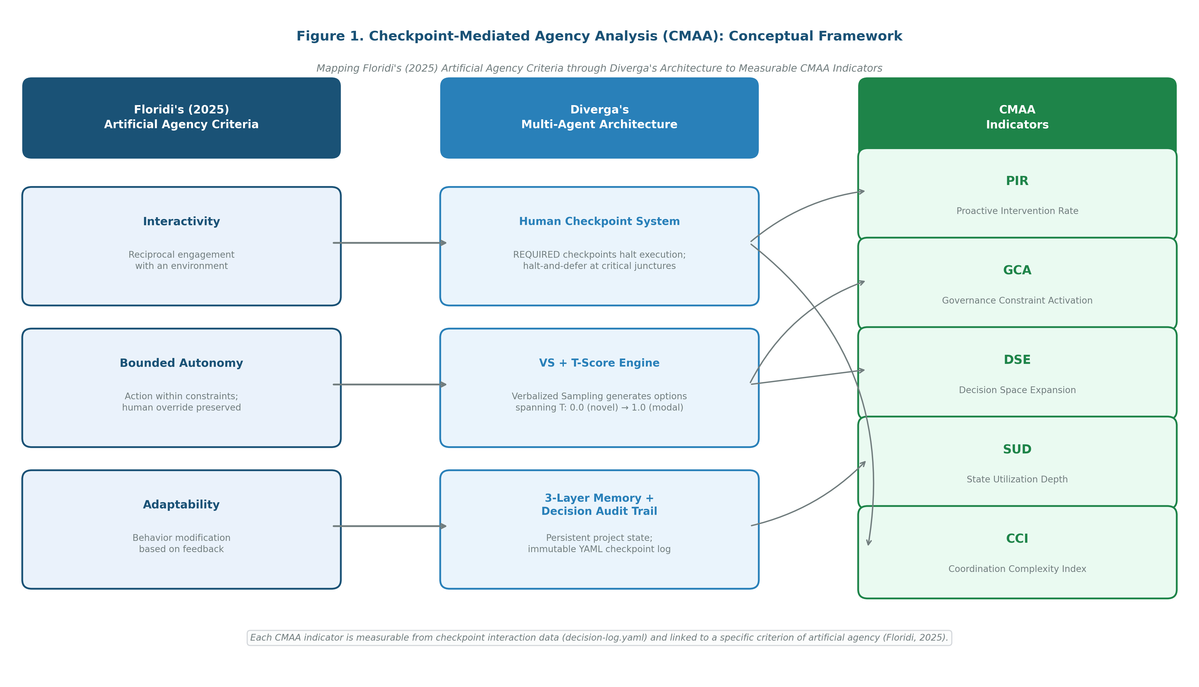
Figure 1
Checkpoint-Mediated Agency Analysis (CMAA) Conceptual Framework. Mapping of Floridi's (2025) three artificial agency criteria through Diverga's multi-agent architecture to five measurable CMAA indicators.
Note. Figure depicts the theoretical derivation chain from Floridi's (2025) philosophical framework to operationalized measurement indicators via the Diverga multi-agent checkpoint architecture.
Existing Measurement Approaches and Their Limitations
A deeper limitation unites existing approaches to measuring AI effects in education: they share an implicit assumption that AI operates as a tool whose effects can be assessed through input-output comparison, what the user intended versus what the system produced. This assumption is adequate for reactive systems but fails for agentic systems precisely because artificial agency, as Floridi (2025) defines it, involves initiative, persistence, and adaptive behavior that reshape the decision space before the user forms an intention. When an agentic system proactively halts execution, presents alternatives spanning a typicality spectrum, and withholds downstream processing until the human selects and justifies a choice, the system has already structured the epistemic field within which human reasoning will occur. No post-hoc instrument, whether a TAM questionnaire, an interaction log, or a retrospective interview, can recover the process by which this structuring occurred, because the structuring is complete before the user is aware a decision is needed.
[OUTLINE: §2.3: systematic review of existing approaches (~300 words)]
• TAM-derived instruments: measure adoption intent, not epistemic process (Davis, 1989; Venkatesh et al., 2003)
• Interaction log analysis: captures what was clicked, not why or at what deliberation depth
• Think-aloud + retrospective interview: rich but temporally decoupled from checkpoint architecture
• CMAA's contribution: reframe measurement site from post-hoc instrument to checkpoint-embedded data packet
Table 1 presents the mapping of theoretical constructs to CMAA indicators.
Table 1
Theoretical Constructs and CMAA Indicator Mapping
Theoretical Construct | Source | CMAA Indicator(s) | Measurement Logic
Interactivity | Floridi (2025) | CCI | Depth of multi-agent reciprocal coordination per session
Bounded Autonomy | Floridi (2025) | GCA, PIR | Governance enforcement rate; system-initiated deliberation frequency
Adaptability | Floridi (2025) | SUD, DSE | Context-sensitivity of alternative generation; trajectory shift across sessions
Epistemic Labour Redistribution | Järvelä et al. (2023) | DSE, SUD | Breadth of alternative space; utilization of accumulated decision context
Shared Regulation | Järvelä et al. (2023) | GCA, PIR | Activation of governance mechanisms; system-initiated deliberation cycles
Path Dependence | Yan et al. (2024) | Typicality Trajectory | T-score of selected options plotted sequentially across checkpoints
Note. T-score = Typicality Score (0.0 = maximally non-modal; 1.0 = maximally modal). PIR = Proactive Intervention Rate; SUD = State Utilization Depth; DSE = Decision Space Expansion; GCA = Governance Constraint Activation; CCI = Coordination Complexity Index.
The CMAA Framework
Measurement Pillars
CMAA rests on three methodological pillars that together enable process-level measurement of artificial agency effects. The first pillar treats checkpoints as natural measurement instruments: each required checkpoint interaction generates a structured data packet (the alternatives presented with T-scores, the human's selection, deliberation time from screen recording, and whether governance constraints were activated or bypassed) that is not collected through additional instrumentation but is a natural product of the agentic architecture. The second pillar uses Typicality Scores (T-scores, range 0.0 to 1.0) as process indicators: by tracking T-scores of selected versus non-selected options across all checkpoints, CMAA produces a Typicality Trajectory, a process-level indicator of whether the human is operating in the modal consensus region, actively exploring alternatives, or shifting trajectory over time. The third pillar uses the Decision Audit Trail as a longitudinal data source: the immutable YAML decision log records all checkpoint interactions across sessions, creating a longitudinal dataset that supports both within-session and cross-session analysis.
Figure 2 illustrates how a single required checkpoint interaction generates the multi-layered data packet that CMAA indicators draw upon.
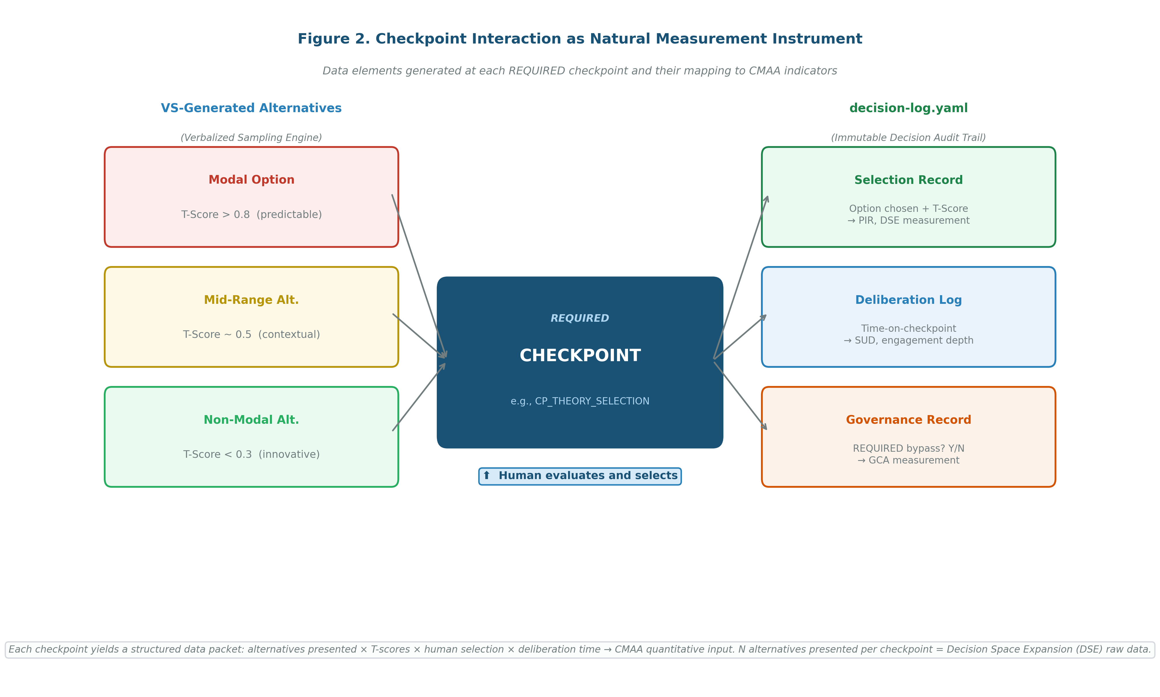
Figure 2
Checkpoint Interaction as Natural Measurement Instrument. Data elements generated at each required checkpoint and their mapping to CMAA indicators (decision-log.yaml).
Note. Each required checkpoint generates a structured data packet comprising alternative options with T-scores, human selection, deliberation time, and governance enforcement status; none requiring additional instrumentation.
CMAA Indicators: Operational Definitions
Table 2 presents the operational definitions, primary data sources, and measurement pillar alignment for the five CMAA indicators.
Table 2
CMAA Five Indicators: Operational Definitions and Data Sources
Indicator | Abbr. | Operational Definition | Data Source | Pillar
Proactive Intervention Rate | PIR | Ratio of system-initiated interactions (checkpoints at which the system halted execution without user prompt) to total agent activations in a session | decision-log.yaml (checkpoint_type field) | 1
State Utilization Depth | SUD | Mean number of prior Decision Audit Trail entries accessed by agents in subsequent sessions; quantifies whether the system draws on accumulated context or operates statelessly | decision-log.yaml + agent activation logs | 3
Decision Space Expansion | DSE | Mean T-score range of alternatives presented at each required checkpoint (T_max minus T_min per checkpoint, averaged across session); quantifies breadth of epistemic space constructed for the human | decision-log.yaml (T-score arrays) | 1, 2
Governance Constraint Activation | GCA | Proportion of required checkpoints at which governance constraints were actively enforced (downstream agents blocked until human selection logged) versus total required checkpoints; GCA < 1.0 indicates architecture-level bypass | decision-log.yaml (checkpoint status field) | 1, 3
Coordination Complexity Index | CCI | Mean number of active agent dependency chains traversed per session; computed as mean path length from session-initiating agent to terminal agent across all activated pathways | Agent activation log + prerequisite dependency graph | 3
Note. T-score range: 0.0 (maximally novel, non-modal) to 1.0 (maximally typical, modal consensus). GCA < 1.0 indicates that architecturally designated governance checkpoints were bypassed without user engagement.
Table 3
Floridi's Criteria, CMAA Indicators, and Diverga Implementation
Floridi Criterion | CMAA Indicator(s) | Diverga Implementation | Measurement Evidence
Interactivity | CCI | Agent Prerequisite Map; 24-agent dependency graph | Dependency chain length in activation log
Bounded Autonomy | GCA, PIR | Human Checkpoint System (required/advisory enforcement); Override Refusal mechanism | Proportion of required checkpoints with status = enforced in decision-log.yaml
Adaptability | SUD, DSE | 3-Layer Memory System; VS/T-score engine; Decision Audit Trail | Session-to-session DAT entry references; T-score array range per checkpoint
Note. VS = Verbalized Sampling. DAT = Decision Audit Trail. Diverga v12.0 implementation details in [Author(s), in preparation].
Typicality Trajectory Analysis
[OUTLINE: §3.3: Typicality Trajectory (~300 words)]
• Definition: T-score of selected option plotted sequentially across all required checkpoints in a session
• Three trajectory patterns: Modal Persistence (T > 0.8 sustained), Deliberate Exploration (mixed T-score range), Guided Departure (T < 0.5 following GCA activation)
• Combined with think-aloud data (qualitative) to explain why trajectories differ across participants
• Path dependence implications: early modal selections constrain downstream option space
Diverga as Design-Based Empirical Case
CMAA is not derived from theoretical speculation alone; it is grounded in systematic analysis of a system specifically designed to instantiate artificial agency as Floridi defines it. Diverga's development through five iterative design cycles (McKenney & Reeves, 2012), spanning 224 version-controlled commits over 57 days, provides design-based empirical evidence for each CMAA indicator's necessity, measurability, and theoretical grounding.
Critical Incident 1: The Checkpoint Bypass Problem and GCA
System audit logs from Diverga v11.0 revealed that architecturally designated required checkpoints were being programmatically bypassed, generating approval tokens without user engagement, while the system's interface presented no evidence of the bypass. This incident made concrete a measurement problem that had been theoretically anticipated but not yet operationalized: the distinction between architecturally claimed oversight and actual epistemic participation cannot be inferred from system architecture documentation alone. It requires direct measurement of whether governance constraints were activated at the decision juncture. The GCA indicator was formalized in direct response to this critical incident.
Critical Incident 2: Autonomous Mode Removal and PIR, DSE
An autonomous operation mode introduced during Cycle 2, enabling the system to proceed through multiple agent stages without checkpoint interruption, was removed within 24 hours upon recognition that initiative without structured pause at decision junctures eliminates the epistemic labour redistribution that constitutes artificial agency's educational value. The system could produce research design outputs, but the human researcher exercised no deliberate evaluation of alternatives along the way. This incident grounds the PIR and DSE indicators: what matters is not whether the system produces outputs, but whether it creates structured opportunities for human epistemic engagement at each decision juncture.
[OUTLINE: §4: remaining critical incidents (~300 words)]
• Critical Incident 3: Agent consolidation (44 to 24 agents) → CCI tractability: overlapping domains eliminated to ensure each checkpoint represents a distinguishable epistemic decision juncture
• Critical Incident 4: 3-Layer Memory introduction → SUD: agents begin drawing on prior session context across sessions
• Critical Incident 5: VS T-score formalization → DSE: typicality made explicitly visible to human at checkpoint
Table 4 summarizes the design cycle evidence supporting each CMAA indicator.
Table 4
Design Cycle Evidence for CMAA Indicators
Design Cycle | Key Incident | CMAA Indicator | Evidence Type
Cycle 2 | Autonomous mode removed (24 hours): initiative without checkpoints eliminates epistemic redistribution | PIR, DSE | Critical incident log; architectural decision record
Cycle 3 | v11.0 checkpoint bypass: required checkpoints bypassed silently via approval token generation | GCA | System audit log; version diff analysis
Cycle 4 | 3-Layer Memory introduced: agents begin drawing on prior session context across sessions | SUD | Feature commit history; agent behavior change log
Cycle 5 | 44 to 24 agent consolidation: overlapping domains eliminated for measurement tractability | CCI | Commit history; architecture comparison
Cycle 5 | VS T-score range formalized: typicality made explicitly visible to human at checkpoint | DSE | VS methodology specification commit
Note. Design cycles span 57 days, 224 version-controlled commits. Evidence types are retrievable from the version control history of the Diverga repository.
Proposed Proof-of-Concept Study
Note for Draft Review: This section presents the proposed empirical validation design. The study has not yet been conducted. IRB preparation is planned for April–May 2026; data collection is planned for August–September 2026. Section content is outlined below and will be developed into prose for the full manuscript following IRB approval.
Study Design
[OUTLINE: §5.1 Study Design]
• Within-subject counterbalanced; embedded mixed methods (CMAA quantitative strand + think-aloud qualitative strand)
• N = 5 doctoral students, purposeful maximum variation sampling (AI knowledge, methodology expertise, disposition, discipline)
• Conditions: unaided baseline (Phase 0) → Diverga-assisted (Phases 2–3)
• Single 1:1 Zoom session per participant (~2.5–3 hours); Zoom cloud recording; concurrent think-aloud
Research Scenarios
[OUTLINE: §5.2 Research Scenarios]
• Scenario A: "The impact of AI tools on K-12 student academic achievement", modal trap: Davis (1989) TAM, UTAUT variants
• Scenario B: "What factors shape academic socialization and research identity formation among first-generation doctoral students from racially underrepresented groups in STEM fields?", modal trap: Bandura (1986) SCT, Bronfenbrenner (1979); VS alternatives: Yosso (2005) Cultural Wealth Model, Communities of Practice (Wenger, 1998), Critical Race Theory in higher education, intersectionality frameworks
• Counterbalancing: 3 participants Scenario A → B; 2 participants Scenario B → A
CMAA Application
[OUTLINE: §5.3 CMAA Application]
• PIR, GCA: computed from decision-log.yaml per session
• DSE: T-score array analysis per checkpoint per participant
• SUD: cross-session DAT entry reference count
• Typicality Trajectory: plotted per participant, contextualized by concurrent think-aloud
• Full study design, participant profiles, and analysis plan reported in [Author(s), in preparation] (ETR&D)
Discussion
[OUTLINE: §6 Discussion (~700 words target)]
• 6.1 Theoretical contributions: first operationalization of Floridi's (2025) artificial agency criteria as educational measurement instruments; checkpoint as natural measurement instrument; CMAA as response to CFP Theme 7 requirement
• 6.2 Transferability: CMAA indicators are system-agnostic where checkpoint data is available; minimum architectural requirements; implications for design of future agentic educational AI systems
• 6.3 Limitations: CMAA derived from single system; design-based evidence precedes controlled empirical validation; T-score as uncalibrated typicality proxy; circularity in Diverga-CMAA-Diverga validation chain
• 6.4 Future directions: N = 5 proof-of-concept → N = 20+ comparative study; application to other agentic AI systems; cross-cultural validation
Conclusion
[OUTLINE: §7 Conclusion (~300 words target)]
• CMAA as methodological contribution to the emerging field of artificial agency measurement in education
• Three key claims: checkpoints as natural instruments, five indicators operationalizing Floridi, design-based grounding from five development cycles
• Call to the research community: adopt and adapt CMAA indicators as agentic AI systems multiply in educational contexts
References
Floridi, L. (2025). AI as agency without intelligence: On artificial intelligence as a new form of artificial agency and the multiple realisability of agency thesis. Philosophy & Technology, 38, 30.
Giannakos, M., Azevedo, R., Brusilovsky, P., Cukurova, M., Dimitriadis, Y., Hernandez-Leo, D., Järvelä, S., Mavrikis, M., & Rienties, B. (2025). The promise and challenges of generative AI in education. Behaviour & Information Technology, 44(11), 2518–2544.
Järvelä, S., Nguyen, A., & Hadwin, A. (2023). Human and artificial intelligence collaboration for socially shared regulation in learning. British Journal of Educational Technology, 54(5), 1057–1076.
McKenney, S., & Reeves, T. C. (2012). Conducting educational design research. Routledge.
Ouyang, F., & Jiao, P. (2021). Artificial intelligence in education: The three paradigms. Computers and Education: Artificial Intelligence, 2, 100020.
Vaccaro, M., Almaatouq, A., & Malone, T. (2024). When combinations of humans and AI are useful: A systematic review and meta-analysis. Nature Human Behaviour, 8(12), 2293–2303.
Wang, L., Ma, C., Feng, X., Zhang, Z., Yang, H., Zhang, J., Chen, Z., Tang, J., Chen, X., & Lin, Y. (2024). A survey on large language model based autonomous agents. Frontiers of Computer Science, 18(6), 186345.
Yan, L., Sha, L., Zhao, L., Li, Y., Martinez-Maldonado, R., Chen, G., & Gašević, D. (2024). Practical and ethical challenges of large language models in education: A systematic scoping review. British Journal of Educational Technology, 55(1), 90–112.
[Author(s)]. (in preparation). [Title removed for review: Paper 1, design case]. International Journal of Designs for Learning.
[Author(s)]. (in preparation). [Title removed for review: Paper 3, empirical application]. Educational Technology Research and Development.

