Checkpoint-Governed Agency and Methodological Reasoning: A Design-Based Study of Artificial Agency Effects on Doctoral Researchers

[Author names removed for double-anonymous review]
[Institutional affiliation removed for review]

Manuscript submitted for review: Educational Technology Research and Development (ETR&D)
Word count (body text, excluding references): approximately 3,600

DRAFT: For Discussion Only (Not for Circulation)

Abstract
Checkpoint-governed agentic AI systems present a distinctive design challenge: when an AI system presents multiple alternatives across a typicality spectrum and enforces human selection at mandatory decision junctures, does this architecture genuinely expand epistemic agency, or do researchers default to modal consensus regardless? This paper reports a design-based study examining how Diverga, a 24-agent checkpoint-governed AI research methodology assistant, affects the methodological reasoning processes of doctoral students in social science fields. Using a multiple case study design (N = 5, purposeful maximum variation sampling), participants engage in two research design tasks in a single structured session: an unassisted baseline condition and a Diverga-assisted condition with concurrent think-aloud protocol. Data sources include checkpoint interaction logs, think-aloud transcripts, screen recordings, pre/post design artifacts, and semi-structured interviews. Analysis integrates Checkpoint-Mediated Agency Analysis (CMAA) indicators ([Author(s)], forthcoming) to quantify epistemic labour redistribution at checkpoints with Activity Theory contradiction analysis to explain when and why deliberative scaffolding fails to activate genuine epistemic engagement. Six design principles are derived for checkpoint-governed agentic AI in educational research contexts, addressing mandatory enforcement, typicality visibility, and upstream-downstream architectural coupling. Findings contribute both empirical grounding for the CMAA framework and actionable design principles for researchers and developers building agentic AI systems intended to support, rather than replace, human epistemic agency.

Keywords: agentic AI, artificial agency, doctoral education, research methodology, checkpoint-mediated scaffolding, design-based research, mixed methods, epistemic labour

Checkpoint-Governed Agency and Methodological Reasoning: A Design-Based Study of Artificial Agency Effects on Doctoral Researchers
Introduction
Research methodology education occupies an unusual position in doctoral training: it is simultaneously the most discipline-generalizable skill doctoral students develop and the one most vulnerable to intellectual conformity. The pressure to adopt recognizable theoretical frameworks, frameworks that advisors, reviewers, and funding bodies recognize, produces a systematic pull toward modal consensus in research design. A doctoral student studying AI adoption reaches for Technology Acceptance Model; a student studying identity formation reaches for Social Cognitive Theory; a student studying community dynamics reaches for Communities of Practice. These frameworks are not wrong; they are simply predictable, and predictability forecloses the disciplinary creativity that genuine scholarly contribution requires.
This tendency toward modal consensus is observable in AI-assisted research tool use. Querying three widely used AI research assistants with the question "What theoretical framework should I use to study research identity formation among doctoral students?" yields a consistent pattern: Bandura's (1986) Social Cognitive Theory and Bronfenbrenner's (1979) ecological systems model are recommended within the first response. This is not incidental; it is a structural feature of large language model-based recommendation systems. Statistical patterns in training corpora produce statistically probable outputs; tools optimized for helpfulness converge on the most frequently cited frameworks. The result, mode collapse in which AI recommendations cluster at the modal consensus regardless of contextual nuance, is precisely the epistemic condition that careful doctoral training is designed to counteract.
Whether checkpoint-governed agentic AI systems, architecturally designed to generate and present alternatives across a typicality spectrum rather than defaulting to modal consensus, can mitigate this tendency is an open and important empirical question. Diverga is a 24-agent AI research methodology assistant built on the Model Context Protocol, designed to operationalize artificial agency (Floridi, 2025) through three mechanisms: (1) Verbalized Sampling (VS), which generates recommendations distributed across a typicality spectrum (T-score: 0.0 novel to 1.0 modal); (2) mandatory human checkpoints at epistemically critical decision junctures, enforcing human evaluation of alternatives before proceeding; and (3) an immutable Decision Audit Trail recording all checkpoint interactions. These mechanisms constitute a deliberate architectural response to mode collapse, but whether they succeed in supporting authentic methodological reasoning or whether researchers select the modal option regardless of the alternatives presented is an empirical question this study addresses.
This paper presents the design, protocol, and analysis plan for a multiple case study (N = 5) examining how interaction with Diverga's checkpoint system affects doctoral students' methodological reasoning diversity. Three research questions organize the inquiry: (RQ1) How does interaction with Diverga's checkpoint system affect the diversity of theoretical frameworks and methodological approaches considered by doctoral students? (RQ2) What patterns of epistemic labour redistribution, as measured by CMAA indicators, characterize doctoral students' interaction with checkpoint-governed agentic AI? (RQ3) What tensions emerge between the scaffolding intent of checkpoint-governed artificial agency and participants' actual epistemic engagement at checkpoints, and what design principles can be derived?
[OUTLINE: Introduction, remaining ~100 words]
• Paper structure overview (one paragraph)
• Relationship to [Author(s), forthcoming] BJET paper: this paper provides the first empirical application of the CMAA framework
Literature Review
[OUTLINE: §2 Literature Review (~900 words target)]
• 2.1 Agentic AI in Education: From Tool to Participant; reactive AIED → generative AI assistants → agentic AI: initiative and persistence as defining features (Ouyang & Jiao, 2021; Yan et al., 2024); multi-agent coordination (Wang et al., 2024); current knowledge gap: empirical studies of agentic AI effects on reasoning processes
• 2.2 Research Methodology Education at the Doctoral Level; challenges in methodology training: limited paradigm diversity, advisor influence, disciplinary norms; AI tools in research education; mode collapse as structural risk
• 2.3 Measurement Approaches for AI-Mediated Reasoning; think-aloud as process data (Ericsson & Simon, 1993); interaction log analysis: affordances and limitations; prior design-based studies; CMAA ([Author(s)], forthcoming) as measurement framework for this study
Theoretical Framework
Artificial Agency and Epistemic Labour Redistribution
This study adopts [Author(s)]'s forthcoming operationalization of Floridi's (2025) artificial agency criteria as its foundational frame, in which interactivity, bounded autonomy, and adaptability are treated as measurable properties of checkpoint-governed AI architectures rather than anthropomorphic attributes. In the context of doctoral research methodology education, the educational consequence of artificial agency is not primarily a function of AI output quality, but of how checkpoint interactions redistribute epistemic labour, the cognitive work of generating options, evaluating alternatives, calibrating confidence, and making consequential decisions, at moments when research design decisions are made.
Diverga's checkpoint system creates structured sites where this redistribution becomes observable: whether the human engages in genuine deliberation across VS-generated alternatives (one modal at T > 0.8, one contextually appropriate at approximately T = 0.5, and one non-modal but theoretically defensible at T < 0.3) or defaults to the modal option without inspection determines whether the redistribution resulted in expanded or constrained epistemic agency. This distinction, between deliberate engagement and automation deference at the checkpoint, is the central empirical question the study is designed to answer.
Authentic Learning as Evaluative Standard
Herrington et al.'s (2010) Authentic Learning framework provides the normative standard against which Diverga's effects are evaluated. Authentic learning involves ill-defined complex tasks, multiple perspectives, collaborative knowledge construction, reflection and metacognition, and articulation that renders tacit knowledge explicit. Diverga's design is explicitly informed by these features: VS methodology surfaces multiple perspectives through alternatives across paradigms; T-score visibility makes implicit typicality judgments explicit, supporting metacognition; forced deliberation at checkpoints creates natural articulation moments. Whether the system succeeds in producing these effects, or whether participants bypass the deliberation the architecture invites, is what the study examines.
Table 5 maps Authentic Learning characteristics onto Diverga mechanisms and study observation points.
Table 5
Authentic Learning Characteristics, Diverga Mechanisms, and Study Observation Points
AL Characteristic | Diverga Mechanism | Study Observation Point
Ill-defined complex tasks | Research design scenarios (Scenarios A and B) | Pre-task artifact complexity assessment
Multiple perspectives | VS T-score alternatives (5 paradigm personas) | DSE measurement; think-aloud at checkpoints
Reflection and metacognition | T-score visibility; forced checkpoint pause | Think-aloud during checkpoint deliberation
Articulation (tacit to explicit) | Required checkpoint: must select and proceed | Interview: "Why did you choose that option?"
Authentic assessment | Comparison of pre-task versus re-design artifact | Artifact analysis: framework diversity, coherence
Note. AL = Authentic Learning (Herrington et al., 2010). DSE = Decision Space Expansion. VS = Verbalized Sampling.
Activity Theory and Contradiction Analysis
Activity Theory (Engeström, 1987) provides the analytical lens for identifying tensions within the human-Diverga research design activity system. The primary contradiction under investigation is between tool mediation (checkpoint as epistemic scaffold, extending the researcher's methodological reach) and normative constraint (checkpoint as governance mechanism, limiting exploration to system-generated alternatives). Secondary contradictions are examined between the community of practice norms of the participant's discipline (established methodological expectations) and the VS recommendations that may challenge those norms. These contradictions surface in think-aloud data at checkpoints and in interview reflections on perceived versus actual agency.
Design Research Methodology
This study employs a design-based research approach (McKenney & Reeves, 2012) in which Diverga is the designed intervention under evaluation, and the research contributes both empirical findings and design principles for the broader field. The study constitutes Phase 2 of a broader EDR cycle: Phase 1 (design and construction of Diverga through five iterative cycles, 224 commits) is reported in [Author(s), in preparation]. The present study reports the initial evaluation phase, contributing design knowledge that will inform subsequent design iteration.
The design-based framing is appropriate for three reasons. First, Diverga's architecture embodies design decisions that are themselves theoretical claims about how artificial agency can support authentic learning. The study tests these claims in a naturalistic task context. Second, the small N of 5 participants is appropriate for an initial evaluation phase: the goal is to generate rich, process-level data sufficient to derive design principles and identify critical tensions for subsequent iteration, not to achieve statistical generalization. Third, ETR&D's design-based research genre supports the publication of evaluation studies before large-scale empirical replication, recognizing that design knowledge requires iterative refinement rather than single-study validation.
Study Design
Research Context and Participants
Participants are doctoral students in social science fields recruited through program listservs and research methods courses at [University]. N = 5, purposeful maximum variation sampling across four dimensions: AI knowledge (high/moderate/low), research methodology expertise (advanced/intermediate/novice), disposition toward AI (challenge-seeking/balanced/conservative), and disciplinary identity. Recruitment is conducted by a third party to reduce coercion risk given the researcher's role as tool developer (see §8.2). Participants must have completed at least one research methods course, have no prior Diverga experience, and provide informed consent. IRB application is planned for April–May 2026; data collection for August–September 2026.
Table 6 presents the illustrative sample profiling matrix.
Table 6
Sample Profiling Matrix (Illustrative: Actual Participants Selected Post-IRB Approval)
Participant | AI Knowledge | Methodology Expertise | Disposition | Discipline
P1 | High | Advanced | Challenge-seeking | Educational Psychology
P2 | Low | Intermediate | Conservative | Curriculum and Instruction
P3 | High | Novice | Balanced | Communication
P4 | Low | Advanced | Challenge-seeking | Sociology of Education
P5 | Moderate | Intermediate | Conservative | Higher Education
Note. Maximum variation sampling ensures the five-participant set covers the full AI knowledge × methodology expertise × disposition × discipline variation space. Minimum two participants with high AI knowledge; minimum two with low AI knowledge.
Research Scenarios
Two research design scenarios serve as the task stimuli. Scenario A ("The impact of AI tools on K-12 student academic achievement") activates the TAM/UTAUT modal trap, which large language models recommend consistently and immediately. Scenario B ("What factors shape academic socialization and research identity formation among first-generation doctoral students from racially underrepresented groups in STEM fields?") activates the Social Cognitive Theory (Bandura, 1986) and ecological systems model (Bronfenbrenner, 1979) modal trap, while supporting VS-generatable alternatives including Yosso's (2005) Cultural Wealth Model, Communities of Practice (Wenger, 1998), Critical Race Theory applied to higher education, intersectionality frameworks, and funds of knowledge approaches. Counterbalancing assigns three participants Scenario A followed by B; two receive B followed by A.
Session Protocol
Figure 3 presents the single-session protocol. Table 7 summarizes phase content, duration, and data collected.
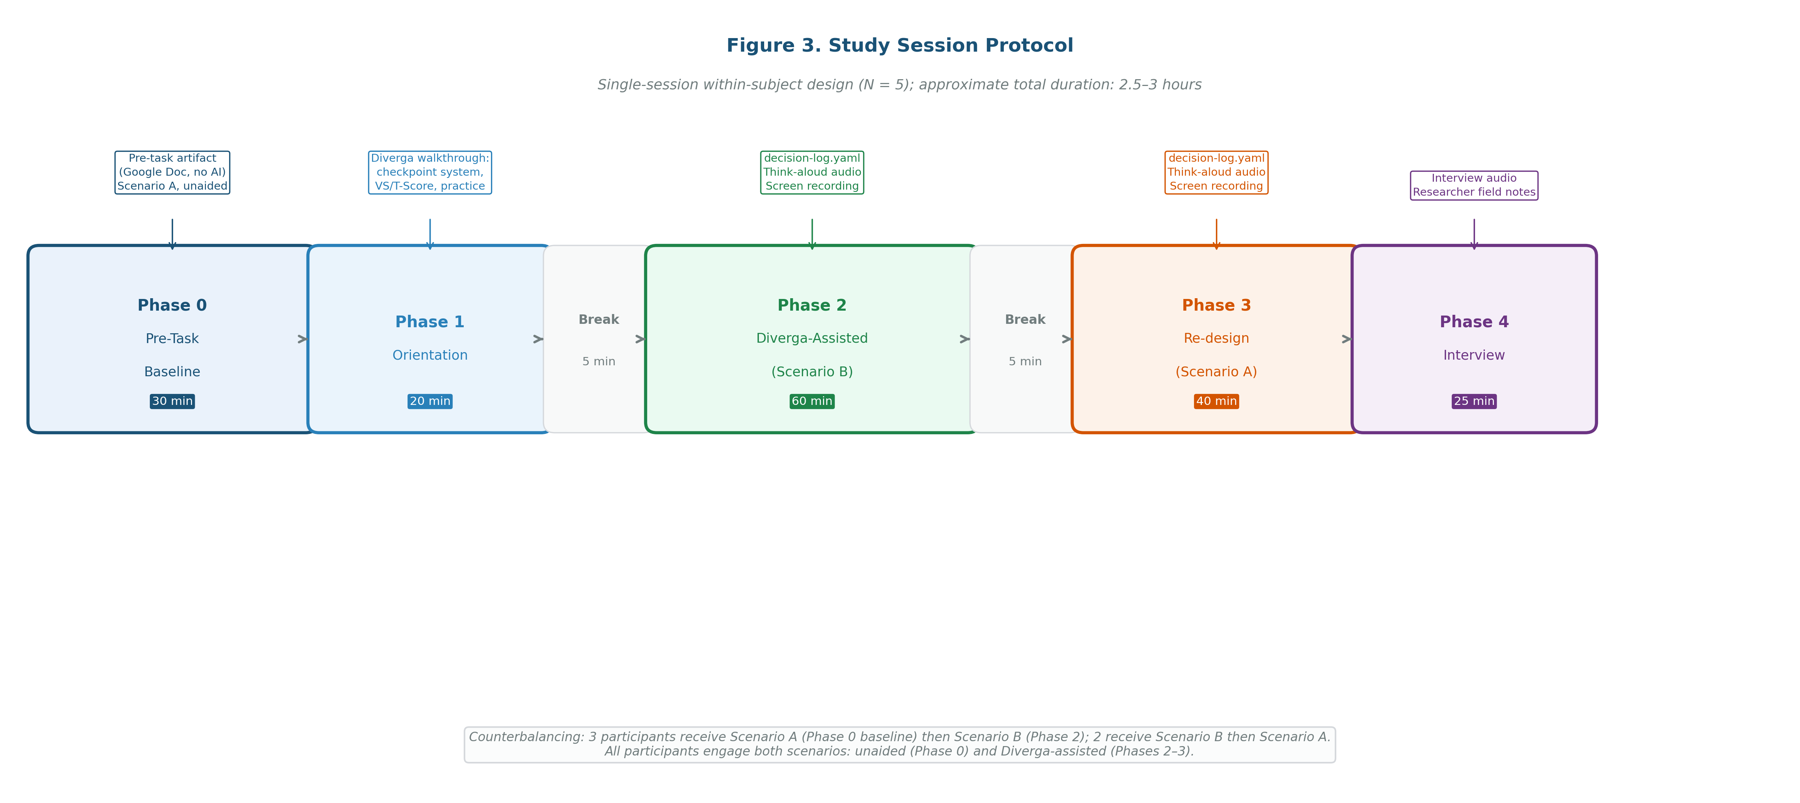
Figure 3
Study Session Protocol. Single-session within-subject design (N = 5); approximate total duration 2.5 to 3 hours. Counterbalancing: three participants receive Scenario A first; two receive Scenario B first.
Note. Total session time includes breaks between phases. Zoom cloud recording active during Phases 2 and 3; researcher camera off during Phases 2 and 3 to reduce demand characteristics.
Table 7
Session Protocol Summary
Phase | Task | Duration | Data Collected
Phase 0: Baseline | Design a study on Scenario A (counterbalanced). Written in Google Doc; no AI tools. | 30 min | Pre-task artifact (Google Doc)
Phase 1: Orientation | Diverga walkthrough: checkpoint system, VS/T-score, practice with neutral scenario. | 20 min | Orientation log (informal)
Break |  | 5 min
Phase 2: Diverga-Assisted | Design a study on Scenario B (counterbalanced). Diverga plus concurrent think-aloud. | 60 min | decision-log.yaml, think-aloud audio, screen recording
Break |  | 5 min
Phase 3: Re-design | Revisit Scenario A with Diverga. Think-aloud. How does approach change? | 40 min | decision-log.yaml, think-aloud audio, screen recording, re-design artifact
Phase 4: Interview | Semi-structured interview (four thematic blocks). | 25–30 min | Interview audio, researcher field notes
Note. Total session approximately 2.5 to 3 hours including breaks. Researcher is absent from Phase 2 and Phase 3 (Zoom host only, camera off) to reduce demand characteristics associated with developer-as-evaluator role.
Data Sources
Figure 4 presents the mixed methods data integration design. Table 8 summarizes data sources, collection methods, and analysis purposes.
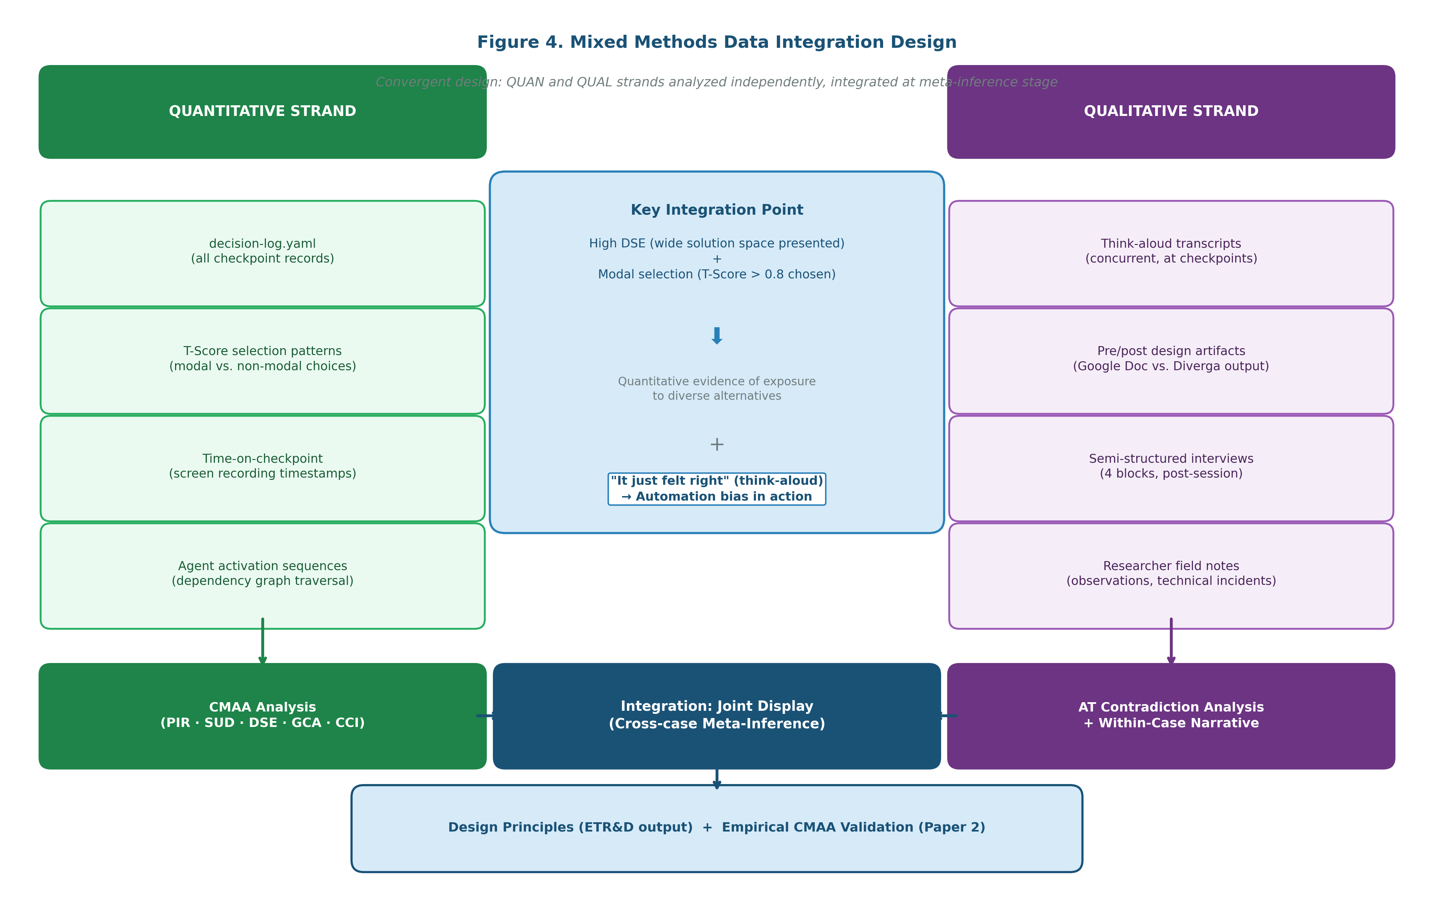
Figure 4
Mixed Methods Data Integration Design. Convergent design: QUAN (CMAA indicators) and QUAL (Activity Theory contradiction analysis) strands analyzed independently and integrated at meta-inference stage via joint display.
Note. Strand independence is maintained by completing CMAA quantitative analysis of checkpoint logs prior to qualitative AT coding of think-aloud transcripts, reducing the risk that log patterns anchor qualitative interpretation.
Table 8
Data Sources and Analysis Purposes
Data Source | Collection Method | Primary Analysis Purpose | Strand
Pre-task artifact | Google Doc (unaided) | Baseline: methodological reasoning without AI scaffolding | QUAL
Checkpoint logs | decision-log.yaml | Selection patterns, T-score choices, deliberation indicators | QUAN + QUAL
Think-aloud transcripts | Screen and audio recording | Cognitive processes at checkpoints; reasoning about alternatives | QUAL
Screen recordings | Zoom cloud recording | Behavioral patterns: T-score inspection, navigation, time-on-task | QUAN + QUAL
Post-task artifact | Diverga-assisted output | Framework diversity, design quality, comparison with pre-task | QUAL
Re-design artifact | Diverga-assisted output | Change patterns when revisiting unaided scenario with Diverga | QUAL
Semi-structured interview | Post-session audio recording | Reflective interpretation, perceived versus actual agency | QUAL
Researcher field notes | During and post-session | Contextual observations, nonverbal cues, technical incidents | QUAL
Note. QUAN = quantitative; QUAL = qualitative. Checkpoint logs and screen recordings serve both strands: behavioral patterns are quantified for CMAA indicators and the temporal sequence informs qualitative interpretation.
Analysis Plan
CMAA Application (Quantitative Strand)
Per participant, per session, the following indicators are computed from decision-log.yaml and the agent activation log: PIR (checkpoint interactions divided by total agent activations), DSE (mean T-score range per required checkpoint), GCA (proportion of required checkpoints with enforcement status confirmed), SUD (cross-session DAT entry reference count), and CCI (mean dependency chain length per session). Typicality Trajectory is plotted by graphing the T-score of the selected option at each required checkpoint sequentially across the session. These quantitative profiles form the QUAN strand of the convergent mixed methods design.
Activity Theory Contradiction Analysis (Qualitative Strand)
Table 9 presents the preliminary AT contradiction coding scheme. Coding unit is think-aloud utterances at or immediately surrounding checkpoints, plus interview reflections on specific checkpoint decisions.
Table 9
Activity Theory Contradiction Coding Scheme (Preliminary)
Code | Definition | Example Indicator
Tool-Scaffold | Checkpoint functions as epistemic scaffold; participant engages deliberatively with alternatives | "I hadn't considered Yosso; that actually fits better because..."
Tool-Constrain | Checkpoint constrains exploration; participant selects from presented options without generating own alternatives | "I'll just go with the first one"
Norm-Conflict | Participant's disciplinary community norms conflict with VS recommendation | "My advisor would never accept that framework in my field"
Override-Explicit | Participant explicitly overrides system recommendation with articulated reasoning | "The system suggests TAM but that's not appropriate here because..."
Automation-Deference | Participant defers to system recommendation with minimal deliberation AND without inspecting alternative T-scores (confirmed by log data: negligible deliberation time); note: a participant who reviews alternatives and reasonably selects the modal option is not coded here | "I'll just go with that one" [log confirms < 5 seconds at checkpoint, no T-score inspection]
Note. Codes applied to think-aloud transcripts by two independent coders; inter-rater reliability (Cohen's kappa) reported. AT = Activity Theory (Engeström, 1987). Automation-Deference requires behavioral log confirmation, not verbal deference alone.
Mixed Methods Integration
Integration occurs at the meta-inference stage via joint display: a cross-participant matrix with rows as participants and columns as CMAA indicator values plus AT contradiction type. The primary integration question is: where do high DSE scores (wide alternative space presented) co-occur with modal T-score selection (T > 0.8 chosen)? This intersection, where the participant saw diverse alternatives and selected the predictable one anyway, is the primary evidence signature for automation bias in the epistemic domain, and requires think-aloud data to explain why.
Design Principles
Note for Draft Review: DP1–DP3 are derived from the design phase and are instantiated in Diverga's current architecture. They are offered here as design-phase hypotheses subject to revision in light of empirical findings. DP4–DP6 are reserved for post-data-collection derivation; presenting all six principles from design reasoning alone would conflate design rationale with empirical finding. ETR&D readers should treat the full six-principle set as a contribution of the completed manuscript.
DP1, Mandatory checkpoint architecture: Checkpoints must be architecturally enforced (not advisory) to function as meaningful epistemic redistribution points. Advisory checkpoints are routinely bypassed; only required checkpoints generate the deliberation that makes epistemic labour redistribution observable and educationally meaningful. Design implication: systems that govern agency through advisory rather than mandatory checkpoints will not produce the GCA data needed to distinguish architecturally claimed oversight from actual epistemic participation.
DP2, Typicality visibility is necessary but insufficient: Presenting T-scores to users increases deliberation time at checkpoints but does not alone prevent modal selection. Typicality visibility requires accompanying deliberation scaffolding (for example, a prompt such as "The most novel option has T = 0.2, what would it mean for your research to choose this?") to activate genuine epistemic engagement. Design implication: display of typicality metadata without deliberation prompting is likely to function decoratively rather than cognitively.
DP3, Upstream decision openness: Agentic AI systems should be designed so that downstream agents do not constrain the option space available at upstream checkpoints. If the theory-selection agent implicitly forecloses methodological options for the design-methods agent, the epistemic redistribution at the upstream checkpoint is undermined by architectural coupling. Design implication: agent dependency graphs should be audited for option-space-constraining cascades before deployment in educational contexts.
[OUTLINE: DP4-DP6: derived from empirical data post-collection]
• DP4: [To be derived from empirical findings; anticipated to address deliberation scaffolding under time pressure]
• DP5: [To be derived from empirical findings; anticipated to address norm-conflict management]
• DP6: [To be derived from empirical findings; anticipated to address cross-session context utilization]
Discussion
Theoretical Contributions
[OUTLINE: §8.1 Theoretical Contributions (~300 words)]
• First empirical application of CMAA ([Author(s)], forthcoming)
• Evidence base for artificial agency effects on doctoral research methodology reasoning
• Activity Theory contradiction analysis as complement to CMAA quantitative indicators
Reflexivity and Limitations
The researcher occupies a dual role as both system developer and primary investigator, introducing layered reflexivity obligations. As developer, the researcher possesses architectural knowledge of Diverga that participants do not share: specifically, knowledge of what T-score distributions each checkpoint is designed to present and which selection patterns the system is designed to encourage. Three structural safeguards are employed. First, Activity Theory contradiction coding (Table 9) is conducted by a second coder working from transcripts alone, without access to checkpoint log data, before cross-analyst reconciliation, ensuring that qualitative interpretation is not anchored to quantitative patterns the developer can read in the logs. Second, the AT coding scheme includes codes explicitly designed to capture cases where Diverga constrains rather than supports epistemic agency (Tool-Constrain, Automation-Deference), providing an analytic pathway for negative findings structurally equivalent to codes capturing positive effects. Third, design principles DP4–DP6 are explicitly reserved for post-data-collection derivation, ensuring the study can generate findings that contradict or qualify DP1–DP3. These safeguards reduce but do not eliminate interpretive risks; findings should be treated as design-phase evidence informing subsequent independent replication rather than confirmatory findings.
Additional limitations: (a) N = 5 findings are illustrative, not generalizable; statistical comparison is not attempted. (b) All findings are bounded to Diverga's implementation; transferability requires testing across systems. (c) IRB-pending: all participant protections are formalized before data collection; protocol includes third-party recruitment and researcher absence during Phases 2–3 to reduce coercion risk. (d) DP1–DP3 are instantiated in the system before empirical evaluation begins; independent replication by researchers unaffiliated with Diverga's development is required to test these principles without circularity. (e) DSE values depend on T-scores generated by Diverga's VS engine, which is not independently validated. (f) Phase 1 orientation primes participants to the typicality spectrum concept before data collection; low T-score selections may reflect procedural demand rather than authentic epistemic exploration.
Implications for Practice
[OUTLINE: §8.3 Implications for Practice (~250 words)]
• Design guidance for researchers and developers building agentic AI for research education
• Implications for doctoral program design: when and how to introduce AI-assisted methodology tools
• Checkpoint-governed AI as complement (not replacement) for advisor mentorship in methodology learning
Conclusion
[OUTLINE: §9 Conclusion (~300 words target)]
• Study contribution: first empirical application of CMAA in a naturalistic doctoral research design context
• Design-based research contribution: six design principles for checkpoint-governed agentic AI in education (DP1–3 from design phase; DP4–6 from empirical data)
• Limitation and future directions: N = 20+ replication study planned; cross-institutional validation; independent replication by non-developer researchers
References
Bandura, A. (1986). Social foundations of thought and action: A social cognitive theory. Prentice-Hall.
Bronfenbrenner, U. (1979). The ecology of human development. Harvard University Press.
Davis, F. D. (1989). Perceived usefulness, perceived ease of use, and user acceptance of information technology. MIS Quarterly, 13(3), 319–340.
Engeström, Y. (1987). Learning by expanding. Orienta-Konsultit.
Ericsson, K. A., & Simon, H. A. (1993). Protocol analysis: Verbal reports as data (rev. ed.). MIT Press.
Floridi, L. (2025). AI as agency without intelligence: On artificial intelligence as a new form of artificial agency. Philosophy & Technology, 38, 30.
Herrington, J., Reeves, T. C., & Oliver, R. (2010). A guide to authentic e-learning. Routledge.
Hughes, L., Dwivedi, Y. K., Malik, T., Shawosh, M., Albashrawi, M. A., Jeon, I., & Walton, P. (2025). AI agents and agentic systems: A multi-expert analysis. Journal of Computer Information Systems, 1–29.
Järvelä, S., Nguyen, A., & Hadwin, A. (2023). Human and artificial intelligence collaboration for socially shared regulation in learning. British Journal of Educational Technology, 54(5), 1057–1076.
McKenney, S., & Reeves, T. C. (2012). Conducting educational design research. Routledge.
Ouyang, F., & Jiao, P. (2021). Artificial intelligence in education: The three paradigms. Computers and Education: Artificial Intelligence, 2, 100020.
Stake, R. E. (2006). Multiple case study analysis. Guilford.
Vaccaro, M., Almaatouq, A., & Malone, T. (2024). When combinations of humans and AI are useful: A systematic review and meta-analysis. Nature Human Behaviour, 8(12), 2293–2303.
Wang, L., Ma, C., Feng, X., Zhang, Z., Yang, H., Zhang, J., Chen, Z., Tang, J., Chen, X., & Lin, Y. (2024). A survey on large language model based autonomous agents. Frontiers of Computer Science, 18(6), 186345.
Wenger, E. (1998). Communities of practice: Learning, meaning, and identity. Cambridge University Press.
Yan, L., Sha, L., Zhao, L., Li, Y., Martinez-Maldonado, R., Chen, G., & Gašević, D. (2024). Practical and ethical challenges of large language models in education. British Journal of Educational Technology, 55(1), 90–112.
Yin, R. K. (2018). Case study research and design (6th ed.). Sage.
Yosso, T. J. (2005). Whose culture has capital? A critical race theory discussion of community cultural wealth. Race, Ethnicity and Education, 8(1), 69–91.
[Author(s)]. (in preparation-a). [Title removed for review: Paper 1, design case]. International Journal of Designs for Learning.
[Author(s)]. (forthcoming-b). [Title removed for review: Paper 2, CMAA methodology]. British Journal of Educational Technology.

