Paper A APA 7th Professional-Style Manuscript Scaffold: AI Adoption Meta-Analytic Structural Equation Modeling
Running head: AI Adoption MASEM Target-journal working fit: Computers & Education / adjacent educational technology journal Draft status: Team handoff scaffold, generated 20260615. Data boundary: Source-anchored adjudicated human reference standard plus researcher-approved S048 additions. Paper B reference standard remains unchanged.

Author Note
Author affiliations, acknowledgments, funding, conflicts of interest, data availability, preregistration status, and reproducibility materials will be inserted after the team confirms the final submission venue and repository visibility policy.

Abstract
Artificial intelligence (AI) adoption research in education has expanded rapidly, but the field remains theoretically fragmented because individual primary studies rarely estimate the full acceptance mechanism implied by technology acceptance and unified acceptance theories. This study synthesizes AI adoption evidence using a model-family meta-analytic structural equation modeling (MASEM) strategy. A full 10-construct acceptance network was retained as the theoretical target to preserve the field-level model implied by technology acceptance, unified theory, trust, anxiety, and self-efficacy traditions. Because no primary study reported a complete 10-construct correlation matrix, empirical MASEM was conducted through complete-case model families that tested structurally defensible submodels. The full10 evidence map showed complete pair-level theoretical coverage across all 45 construct pairs, but no complete-case full10 study. The core7 attitude-mediation model showed excellent fit, and paths from facilitating conditions to attitude, social influence to behavioral intention, attitude to behavioral intention, facilitating conditions to use behavior, and behavioral intention to use behavior were supported by likelihood-based confidence intervals. The trust6 model also showed excellent fit, with supported paths from effort expectancy to behavioral intention, trust to behavioral intention, and behavioral intention to use behavior. Anxiety and self-efficacy remain theoretically important but empirically underidentified in the present source-anchored matrix structure. The study contributes a transparent model-family MASEM template for distinguishing theoretical coverage from estimable structural evidence in AI adoption meta-analysis.
Keywords: artificial intelligence adoption, MASEM, technology acceptance, trust, attitude mediation, educational technology

Introduction
Artificial intelligence is becoming part of routine educational work, including tutoring, writing support, learning analytics, feedback generation, and administrative decision support. This rapid diffusion has produced a broad empirical literature on learners' and educators' intentions to use AI-supported systems, but the evidence base is uneven. Many studies adopt the language of the technology acceptance model (TAM), the unified theory of acceptance and use of technology (UTAUT), trust in automation, self-efficacy, anxiety, or related adoption frameworks; however, primary studies often estimate only selected paths from these theories. As a result, the literature contains many construct-pair correlations but relatively few complete correlation matrices capable of estimating the full acceptance system in one structural model (Davis, 1989; Davis et al., 1989; Venkatesh & Davis, 2000; Venkatesh et al., 2003; Venkatesh et al., 2012).
The central methodological problem is therefore not only whether AI adoption is associated with perceived usefulness, ease of use, social influence, trust, or other constructs. The harder question is whether the accumulated evidence can support a structural account of how those constructs work together. Meta-analytic structural equation modeling (MASEM) is well suited to this question because it synthesizes correlation matrices and tests theoretically specified structural models at the meta-analytic level (Cheung & Chan, 2005; Cheung, 2014, 2015; Jak & Cheung, 2018, 2020, 2024). Yet MASEM requires a defensible matrix structure. When construct coverage is sparse or uneven, a model that is theoretically appealing may be empirically underidentified or unstable. Paper A is designed to make that boundary explicit rather than hide it.

The Full10 Theoretical Target
The full10 model is not treated as the primary estimable complete-case model. Instead, it is retained as the theoretical target that defines the intended acceptance network for AI adoption in educational contexts. The 10 constructs are perceived usefulness or performance expectancy, perceived ease of use or effort expectancy, social influence, facilitating conditions, attitude, behavioral intention, use behavior, trust, anxiety, and self-efficacy. This target preserves the cumulative logic of TAM, TAM2, UTAUT, UTAUT2, trust-in-automation, and self-efficacy/anxiety traditions. It also prevents the manuscript from narrowing the theory simply because the available matrices are incomplete.
This distinction is important for the team. The full10 result should be written as a theoretical evidence map: all 45 pairwise construct relations are represented somewhere in the source-anchored dataset, which means the field has empirical contact with the complete acceptance network. However, the dataset does not yet contain enough complete 10-construct correlation matrices to estimate full10 MASEM as a primary empirical model. The contribution is therefore diagnostic and theory-preserving: the field has broad pair-level coverage, but not enough complete matrix density for a single omnibus MASEM.

Attitude Mediation as a Core Acceptance Mechanism
Attitude remains a theoretically meaningful mediator because classic reasoned-action and technology acceptance traditions position evaluative orientation as a mechanism linking beliefs to intention (Fishbein & Ajzen, 1975; Ajzen, 1991; Davis, 1989; Davis et al., 1989). In AI adoption, this matters because learners and educators may recognize a tool as useful or easy to use without necessarily forming a favorable evaluative stance toward using it in learning or teaching. Attitude captures this evaluative translation. It helps explain whether cognitive beliefs about the system become a motivational orientation that supports intention.
The Paper A core7 model uses attitude mediation as the main empirical acceptance mechanism. This route is more defensible than forcing the full10 model because the core7 subset has complete-case matrices and preserves the central TAM/UTAUT chain from beliefs and conditions to attitude, intention, and behavior. The core7 model therefore lets the manuscript test whether the accumulated AI adoption literature supports the classic belief-attitude-intention-behavior logic in a meta-analytic structural framework.

Trust as a Distinct AI Adoption Mechanism
Trust is not merely another predictor of intention in AI adoption. It is conceptually tied to the delegation, opacity, autonomy, and risk characteristics of AI-supported systems. Users often cannot fully inspect the reasoning process of AI tools, and educational contexts introduce additional stakes related to fairness, accuracy, privacy, assessment integrity, and dependency. Trust in automation and information systems research therefore provides a strong basis for treating trust as a mechanism that may transmit or supplement standard usefulness and ease-of-use pathways (Lee & See, 2004; McKnight et al., 2002; Gefen et al., 2003; Pavlou, 2003; Hancock et al., 2011; Glikson & Woolley, 2020).
The trust6 model contributes by testing whether a trust-centered acceptance mechanism is empirically supported in the available complete-case data. This is especially important for AI because traditional acceptance models may understate the role of perceived reliability, benevolence, competence, and vulnerability. A supported trust-to-intention path would indicate that AI adoption cannot be fully reduced to usefulness or ease-of-use beliefs. Instead, acceptance depends in part on whether users are willing to rely on AI systems under uncertainty.

Why Anxiety and Self-Efficacy Are Not Yet Confirmed
Anxiety and self-efficacy are theoretically important in AI adoption. Self-efficacy is grounded in social cognitive theory and computer self-efficacy research, where users' perceived capability shapes effort, persistence, and technology use (Bandura, 1977, 1997; Compeau & Higgins, 1995; Compeau et al., 1999; Marakas et al., 1998). Anxiety is similarly important because AI tools may evoke uncertainty, loss-of-control concerns, replacement concerns, performance pressure, or discomfort with algorithmic systems (Parasuraman, 2000; Meuter et al., 2003). In a full theory of AI adoption, both constructs can plausibly function as antecedents, moderators, or mediating mechanisms depending on the model specification.
The present manuscript should not claim that anxiety or self-efficacy are unimportant. The correct claim is narrower: the current source-anchored complete-case matrix structure does not yet allow a defensible primary MASEM that tests anxiety or self-efficacy as mediating mechanisms alongside the full acceptance network. Their status is therefore unresolved, not rejected. This distinction is central for team writing. Anxiety and self-efficacy belong in the full10 theoretical target and should be discussed as next-stage mechanisms, but the Results section should report them as underidentified in the current empirical MASEM route.

A Model-Family MASEM Strategy
Model-family MASEM is the primary empirical route for Paper A. Instead of treating failure to estimate a full10 model as a failed analysis, the study separates theoretical coverage from empirical estimability. The full10 model defines the comprehensive theory and provides a pairwise evidence map. Complete-case submodels then test structurally meaningful mechanisms that the data can support. This strategy aligns with methodological guidance that MASEM models must respect the correlation structure and missingness pattern of the evidence base, and with broader model-comparison logic that favors theoretically justified, estimable alternatives over a single forced omnibus model (Cheung & Chan, 2005; Cheung, 2014, 2015; Jak & Cheung, 2018, 2020, 2024; Burnham & Anderson, 2002; Landis, 2013; Valentine et al., 2022).
The study makes three contributions. First, it preserves the full AI adoption theory as a transparent 10-construct target rather than reducing the theory to the easiest estimable subset. Second, it tests two empirically supported model families: a core attitude-mediation model and a trust-mechanism model. Third, it documents why anxiety and self-efficacy remain theoretically important but empirically unresolved in the current matrix structure. This framing gives team members a stable foundation for future coding, adjudication, and manuscript development.

Theoretical Framework

Acceptance Beliefs, Attitude, Intention, and Use
TAM and UTAUT traditions argue that adoption begins with beliefs about usefulness, ease of use, social expectations, and enabling conditions. These beliefs shape attitude and behavioral intention, which in turn predict actual use (Davis, 1989; Davis et al., 1989; Venkatesh & Davis, 2000; Venkatesh, 2000; Venkatesh et al., 2003, 2012). In educational AI contexts, perceived usefulness can refer to learning support, productivity, personalization, or instructional efficiency. Ease of use can refer to interaction burden, prompt usability, or the effort needed to integrate AI into study or teaching routines. Social influence can capture peer, instructor, institutional, or professional norms. Facilitating conditions can include access, technical support, training, policy guidance, and infrastructure.
Attitude is positioned as a mediator because it represents the evaluative interpretation of these beliefs. A learner or educator may see an AI tool as useful but still develop a negative attitude if the tool feels unreliable, unfair, intrusive, or misaligned with educational values. Conversely, a favorable attitude can translate beliefs into intention even when use behavior depends on institutional conditions. The core7 model operationalizes this framework by testing paths from acceptance beliefs and conditions to attitude, intention, and behavior.

Trust in AI Systems
Trust becomes more salient as educational technologies become more autonomous and opaque. AI systems may generate recommendations, explanations, assessments, or feedback that users cannot fully verify. Trust therefore captures willingness to rely on a system under uncertainty (Lee & See, 2004; McKnight et al., 2002; Gefen et al., 2003; Pavlou, 2003; Glikson & Woolley, 2020). In the Paper A framework, trust is expected to connect standard acceptance beliefs to intention. Perceived usefulness and ease of use may increase trust because systems that appear competent and manageable are easier to rely on. Social influence may also shape trust when credible others endorse AI tools. Trust may then predict behavioral intention because users must be willing to depend on AI outputs before they incorporate them into consequential learning or teaching decisions.

Anxiety and Self-Efficacy as Future Mechanisms
Anxiety and self-efficacy are retained in the full10 target because they describe capability and affective threat mechanisms that standard acceptance models may miss. Self-efficacy may precede ease of use, reduce anxiety, or directly influence intention. Anxiety may reduce attitude, trust, or intention, especially when AI tools are perceived as threatening or difficult to control. However, the current empirical route cannot adjudicate these mechanisms because the available complete-case matrices do not yet include enough studies with anxiety/self-efficacy and the required surrounding constructs. The manuscript should therefore treat these constructs as theoretically specified but empirically pending.

Research Questions
RQ1: What does the full10 theoretical evidence map reveal about pairwise construct coverage and complete-case matrix feasibility in AI adoption research?
RQ2: Does a core acceptance model centered on attitude mediation fit the source-anchored complete-case data, and which structural paths are supported?
RQ3: Does a trust-centered acceptance model fit the source-anchored complete-case data, and which structural paths are supported?
RQ4: What do the current MASEM data structure and complete-case constraints imply for testing anxiety and self-efficacy as AI adoption mechanisms?

Method

Design
This study used meta-analytic structural equation modeling to synthesize AI adoption evidence. The analysis followed a model-family strategy. The full10 construct network was specified as the theoretical target and used to evaluate pairwise evidence coverage. Empirical structural models were then estimated only for complete-case model families that met the matrix requirements for MASEM. This design separates theory preservation from statistical estimability.

Literature Search and Eligibility
The broader project screened a large AI adoption evidence base and retained studies that reported quantitative associations among adoption constructs relevant to AI, educational technology, or AI-supported learning and teaching systems. Eligible studies reported sufficient information to extract or reconstruct correlation coefficients among the target constructs. The current Paper A scaffold uses the source-anchored adjudicated human reference standard with researcher-approved S048 additions. The final manuscript should update the PRISMA-style counts directly from the locked screening workbook before submission.

Coding and Source-Anchored Adjudication
Construct coding harmonized study-specific variables into the full10 construct taxonomy: perceived usefulness/performance expectancy, perceived ease of use/effort expectancy, social influence, facilitating conditions, attitude, behavioral intention, use behavior, trust, anxiety, and self-efficacy. Correlation values were treated as source-anchored when they could be traced to the original article, table, supplementary material, or adjudicated extraction record. Human-coded values form the reference standard for Paper A. AI-assisted additions are not treated as replacements for human judgment; they are included only when researcher-approved and documented as source-traced additions. The current analysis includes the researcher-approved S048 additions and leaves the Paper B reference standard unchanged.

Data Structure and Model Families
The analysis-ready input contained 836 extracted effect-size rows after the S048 approval update. The full10 theoretical target contains 45 unique construct pairs. All 45 pairwise relations were observed at least once, indicating broad theoretical coverage. However, no primary study supplied a complete 10-construct correlation matrix, so full10 TSSEM was not used as a primary empirical structural model. This limitation is a property of the available matrix structure, not evidence that the full10 theory is invalid.
Two complete-case empirical model families were retained. The core7 attitude-mediation model included perceived usefulness/performance expectancy, perceived ease of use/effort expectancy, social influence, facilitating conditions, attitude, behavioral intention, and use behavior. The trust6 mechanism model included perceived usefulness/performance expectancy, perceived ease of use/effort expectancy, social influence, trust, behavioral intention, and use behavior. Anxiety and self-efficacy remained in the full10 theoretical target but were not estimated as primary MASEM mechanisms because the complete-case matrix structure was insufficient for a defensible model-family estimate.

Meta-Analytic Structural Equation Modeling
MASEM analyses followed a two-stage structural equation modeling approach. Stage 1 synthesized study-level correlation matrices while accounting for between-study heterogeneity. Stage 2 estimated structural paths from the pooled correlation structure for each complete-case model family. Model fit was evaluated using chi-square, comparative fit index (CFI), Tucker-Lewis index (TLI), root mean square error of approximation (RMSEA), and standardized root mean square residual (SRMR). Structural paths were interpreted using likelihood-based 95% confidence intervals. Because standard errors, z statistics, and p values were not available for all path estimates, inferential language is based on whether likelihood-based confidence intervals excluded zero.

Reproducibility Materials
The manuscript scaffold, reference bank, model-family figures, fit table, and structural path table are stored in the project repository. The current package is located at paper_a/manuscript/target_journal/apa7_model_family_full_manuscript_scaffold_20260615/. The analysis inputs and derived tables are mirrored under data/04_extraction/05_llm_masem_substitution/results/paper_a_apa7_model_family_manuscript_package_20260615/.

Results

Full10 Theoretical Evidence Map
The full10 theoretical evidence map showed that all 45 construct pairs were observed at least once in the source-anchored dataset. This finding supports the use of full10 as the organizing theoretical target. At the same time, zero studies contained a complete 10-construct matrix. The full10 model therefore provides field-level theoretical coverage evidence but does not provide an estimable complete-case empirical MASEM in the current dataset.

Model-Family Fit
Core7 ATT mediation: k = , effect-size rows = , chi-square(5) = 6.146, p = 0.292, CFI = 0.999, TLI = 0.996, RMSEA = 0.009, SRMR = 0.043. Trust6 trust mechanism: k = , effect-size rows = , chi-square(4) = 8.957, p = 0.062, CFI = 0.996, TLI = 0.985, RMSEA = 0.011, SRMR = 0.040.
Both retained model families showed excellent approximate fit. The fit pattern supports the model-family route as the primary empirical strategy: rather than forcing a sparse full10 matrix, Paper A estimates theoretically meaningful submodels that are compatible with the available complete-case data.

Core7 Attitude-Mediation Model
The core7 model tested whether the accumulated AI adoption evidence supports a belief/condition-attitude-intention-behavior pathway. These results support attitude and behavioral intention as central mechanisms in the AI adoption process while also showing that not all belief-to-attitude or belief-to-intention links are equally stable in the current complete-case evidence base.

Trust6 Mechanism Model
The trust6 model tested whether trust operates as a distinct acceptance mechanism in the available AI adoption evidence. The supported trust-to-intention path indicates that AI adoption cannot be reduced to usefulness and effort beliefs alone. Trust appears to capture an additional reliance mechanism that is theoretically appropriate for AI systems.

Anxiety and Self-Efficacy Boundary
Anxiety and self-efficacy could not be tested as confirmed mediating mechanisms in the current primary MASEM route. This result should be interpreted as a data-structure limitation rather than a theoretical rejection. The constructs remain part of the full10 theoretical target, but additional source-level correlation extraction or future primary studies with fuller matrices are needed before their mediating role can be evaluated with the same confidence as the core7 and trust6 families.

Discussion: Writing Scaffold for Team Completion
The Discussion should develop four points. First, Paper A contributes a transparent distinction between theoretical coverage and estimable structural evidence. Second, the core7 findings provide meta-analytic support for an attitude/intention pathway in AI adoption. Third, the trust6 findings show that trust is a necessary AI-specific mechanism rather than a peripheral add-on. Fourth, the anxiety/self-efficacy boundary identifies a concrete agenda for future extraction and primary-study reporting.
The manuscript should avoid claiming that full10 MASEM was successfully estimated. It should also avoid claiming that anxiety or self-efficacy are unsupported. The accurate claim is that full10 has complete pair-level coverage but no complete-case omnibus model, whereas core7 and trust6 are the current empirical model-family results. Anxiety and self-efficacy are theoretically retained but empirically unresolved.

Tables and Figures to Insert
Table 1. Full10 construct taxonomy and theoretical role. Table 2. Model-family data structure, complete-case study counts, and fit indices. Table 3. Structural path estimates and likelihood-based confidence intervals. Figure 1. Full10 theoretical evidence map. Figure 2. Core7 attitude-mediation MASEM path diagram. Figure 3. Trust6 mechanism MASEM path diagram.

References
Ajzen, I. (1991). The theory of planned behavior. Organizational Behavior and Human Decision Processes, 50(2), 179-211. https://doi.org/10.1016/0749-5978(91)90020-T
Bandura, A. (1977). Self-efficacy: Toward a unifying theory of behavioral change. https://doi.org/10.1037/0033-295X.84.2.191
Bandura, A. (1997). Self-efficacy: The exercise of control. https://www.worldcat.org/title/36074515
Burnham, K. P., & Anderson, D. R. (2002). Model selection and multimodel inference. https://link.springer.com/book/10.1007/b97636
Celik, I. (2023). Towards intelligent-TPACK: An empirical study on teachers' professional knowledge to ethically integrate artificial intelligence-based tools into education. Computers in Human Behavior, 138, 107468. https://doi.org/10.1016/j.chb.2022.107468
Cheung, M. W.-L. (2014). Fixed- and random-effects meta-analytic structural equation modeling: Examples and analyses in R. https://doi.org/10.3758/s13428-013-0361-y
Cheung, M. W.-L. (2015). Meta-analysis: A structural equation modeling approach. https://www.wiley.com/en-us/Meta+Analysis%3A+A+Structural+Equation+Modeling+Approach-p-9781119993438
Cheung, M. W.-L. (2015). metaSEM: An R package for meta-analysis using structural equation modeling. https://doi.org/10.3389/fpsyg.2014.01521
Cheung, M. W.-L., & Chan, W. (2005). Meta-analytic structural equation modeling: A two-stage approach. https://doi.org/10.1037/1082-989X.10.1.40
Compeau, D. R., & Higgins, C. A. (1995). Computer self-efficacy: Development of a measure and initial test. https://doi.org/10.2307/249688
Compeau, D. R., Higgins, C. A., & Huff, S. (1999). Social cognitive theory and individual reactions to computing technology. https://doi.org/10.2307/249749
Davis, F. D. (1989). Perceived usefulness, perceived ease of use, and user acceptance of information technology. https://doi.org/10.2307/249008
Davis, F. D., Bagozzi, R. P., & Warshaw, P. R. (1989). User acceptance of computer technology: A comparison of two theoretical models. https://doi.org/10.1287/mnsc.35.8.982
Dwivedi, Y. K., Rana, N. P., Jeyaraj, A., Clement, M., & Williams, M. D. (2019). Re-examining the Unified Theory of Acceptance and Use of Technology. https://doi.org/10.1007/s10796-017-9774-y
Fishbein, M., & Ajzen, I. (1975). Belief, attitude, intention, and behavior: An introduction to theory and research. https://people.umass.edu/aizen/f&a1975.html
Gefen, D., Karahanna, E., & Straub, D. W. (2003). Trust and TAM in online shopping: An integrated model. https://doi.org/10.2307/30036519
Glikson, E., & Woolley, A. W. (2020). Human trust in artificial intelligence: Review of empirical research. https://doi.org/10.5465/annals.2018.0057
Hancock, P. A., Billings, D. R., Schaefer, K. E., Chen, J. Y. C., De Visser, E. J., & Parasuraman, R. (2011). A meta-analysis of factors affecting trust in human-robot interaction. Human Factors, 53(5), 517-527. https://doi.org/10.1177/0018720811417254
Jak, S., & Cheung, M. W.-L. (2018). Accounting for missing correlation coefficients in fixed-effects MASEM. https://doi.org/10.1080/00273171.2017.1375886
Jak, S., & Cheung, M. W.-L. (2020). Meta-analytic structural equation modeling with moderating effects on SEM parameters. https://doi.org/10.1037/met0000245
Jak, S., & Cheung, M. W.-L. (2024). A cautionary note on univariate-r approaches to MASEM. https://doi.org/10.1177/25152459241274249
Jak, S., Jorgensen, T. D., Verdam, M. G. E., Oort, F. J., & Elffers, L. (2021). Analytical power calculations for MASEM / webMASEM tutorial materials. https://webmasem.research.vu.nl/
Ke, Z., Zhang, Q., & Tong, X. (2019). Bayesian meta-analytic SEM. https://doi.org/10.1080/10705511.2018.1559062
Kelly, S., Kaye, S.-A., & Oviedo-Trespalacios, O. (2023). What factors contribute to the acceptance of artificial intelligence? A systematic review. https://doi.org/10.1016/j.tele.2022.101925
King, W. R., & He, J. (2006). A meta-analysis of the technology acceptance model. https://doi.org/10.1016/j.im.2006.05.003
Labadze, L., Grigolia, M., & Machaidze, L. (2023). Role of AI chatbots in education: Systematic literature review. https://doi.org/10.1186/s41239-023-00426-1
Landis, R. S. (2013). Successfully combining meta-analysis and structural equation modeling: Recommendations and strategies. https://doi.org/10.1177/1094428112464967
Lee, J. D., & See, K. A. (2004). Trust in automation: Designing for appropriate reliance. https://doi.org/10.1518/hfes.46.1.50_30392
Ma, Q., & Liu, L. (2004). The Technology Acceptance Model: A meta-analysis of empirical findings. https://doi.org/10.4018/joeuc.2004010104
Marakas, G. M., Yi, M. Y., & Johnson, R. D. (1998). The multilevel and multifaceted character of computer self-efficacy. https://doi.org/10.1287/isre.9.2.126
McKnight, D. H., Choudhury, V., & Kacmar, C. (2002). Developing and validating trust measures for e-commerce. https://doi.org/10.1287/isre.13.3.334.81
Meuter, M. L., Ostrom, A. L., Bitner, M. J., & Roundtree, R. (2003). The influence of technology anxiety on consumer use and experiences with self-service technologies. https://doi.org/10.1016/S0148-2963(01)00276-4
Parasuraman, A. (2000). Technology Readiness Index (TRI): Multiple-item scale to measure readiness to embrace new technologies. https://doi.org/10.1177/109467050024001
Pavlou, P. A. (2003). Consumer acceptance of electronic commerce: Integrating trust and risk with TAM. https://doi.org/10.1080/10864415.2003.11044275
Rogers, E. M. (2003). Diffusion of innovations (5th ed.). Free Press. https://www.worldcat.org/title/52030797
Schepers, J., & Wetzels, M. (2007). A meta-analysis of the technology acceptance model: Investigating subjective norm and moderation effects. https://doi.org/10.1016/j.im.2006.10.007
Scherer, R., Siddiq, F., & Tondeur, J. (2019). The technology acceptance model for explaining teachers' adoption of digital technology: A meta-analytic structural equation modeling approach. https://doi.org/10.1016/j.compedu.2018.09.009
Strzelecki, A. (2023). To use or not to use ChatGPT in higher education? A study on UTAUT and ChatGPT adoption. https://doi.org/10.1080/10494820.2023.2209881
Valentine, J. C., Pigott, T. D., & Rothstein, H. R. (2022). A primer on meta-analytic structural equation modeling. https://doi.org/10.1007/s11121-021-01298-5
Venkatesh, V. (2000). Determinants of perceived ease of use: Integrating control, intrinsic motivation, and emotion. https://doi.org/10.1287/isre.11.4.342.11872
Venkatesh, V., & Davis, F. D. (2000). A theoretical extension of TAM: Four longitudinal field studies. https://doi.org/10.1287/isre.11.2.186.11752
Venkatesh, V., Morris, M. G., Davis, G. B., & Davis, F. D. (2003). User acceptance of information technology: Toward a unified view. https://doi.org/10.2307/30036540
Venkatesh, V., Thong, J. Y. L., & Xu, X. (2012). Consumer acceptance and use of information technology: Extending UTAUT. https://doi.org/10.2307/41410412
Xue, S., Rashid, A. M., & Ouyang, S. (2024). The Unified Theory of Acceptance and Use of Technology (UTAUT) in higher education: A systematic review. https://doi.org/10.1177/21582440241229570
Xue, S., Rashid, A. M., & Ouyang, S. (2025). Technology Acceptance Model in Artificial Intelligence in Education: A meta-analytic structural equation modeling approach. https://doi.org/10.1177/21582440251409441
Yousafzai, S. Y., Foxall, G. R., & Pallister, J. G. (2007). Technology acceptance: A meta-analysis of the TAM, Part 1. https://doi.org/10.1108/17465660710834453
Yousafzai, S. Y., Foxall, G. R., & Pallister, J. G. (2007). Technology acceptance: A meta-analysis of the TAM, Part 2. https://doi.org/10.1108/17465660710834462
Yu, J., Downes, P. E., Carter, K. M., & O'Boyle, E. H. (2016). The problem of effect size heterogeneity in MASEM. https://doi.org/10.1037/met0000061

Table 1
Model-Family Fit and Data Structure
model_family | route | complete_case_k | effective_sample_size | chisq | df | p | CFI | TLI | RMSEA | RMSEA_low | RMSEA_high | SRMR | AIC | BIC
Core7 ATT mediation | paper_a_core7_att_mediation | 4 | 3172 | 6.146068230551 | 5 | 0.292264248522837 | 0.998954812099836 | 0.99561021081931 | 0.00850201983366504 | 0 | 0.0272077455324969 | 0.0434212863673674 | -3.853931769449 | -34.1645196832227
Trust6 trust mechanism | paper_a_trust6_mechanism | 7 | 10315 | 8.95695924483949 | 4 | 0.0621843448694528 | 0.996132571149242 | 0.985497141809656 | 0.0109613517607505 | 0 | 0.020731489744494 | 0.0398791860222943 | 0.956959244839492 | -28.0084584571819

Table 2
Structural Path Estimates and Confidence-Interval Inference
model_family | path | estimate | ci_lower_95 | ci_upper_95 | inference
Core7 ATT mediation |  | 0.156899763879046
Core7 ATT mediation |  | 0.126660032361982
Core7 ATT mediation |  | 0.107446688834282
Core7 ATT mediation |  | 0.33576322347565
Core7 ATT mediation |  | 0.186951315317732
Core7 ATT mediation |  | 0.1217756510213
Core7 ATT mediation |  | 0.189645876623912
Core7 ATT mediation |  | 0.511841812831585
Core7 ATT mediation |  | 0.332411358866946
Core7 ATT mediation |  | 0.575324230359965
Trust6 trust mechanism |  | 0.260646277765996
Trust6 trust mechanism |  | 0.140089538401588
Trust6 trust mechanism |  | 0.106795078184662
Trust6 trust mechanism |  | 0.365409268927441
Trust6 trust mechanism |  | 0.224823331654616
Trust6 trust mechanism |  | 0.183839611146121
Trust6 trust mechanism |  | 0.243077102668113
Trust6 trust mechanism |  | 0.714360911711239

Figures
Figure 1. Full10 theoretical evidence map.
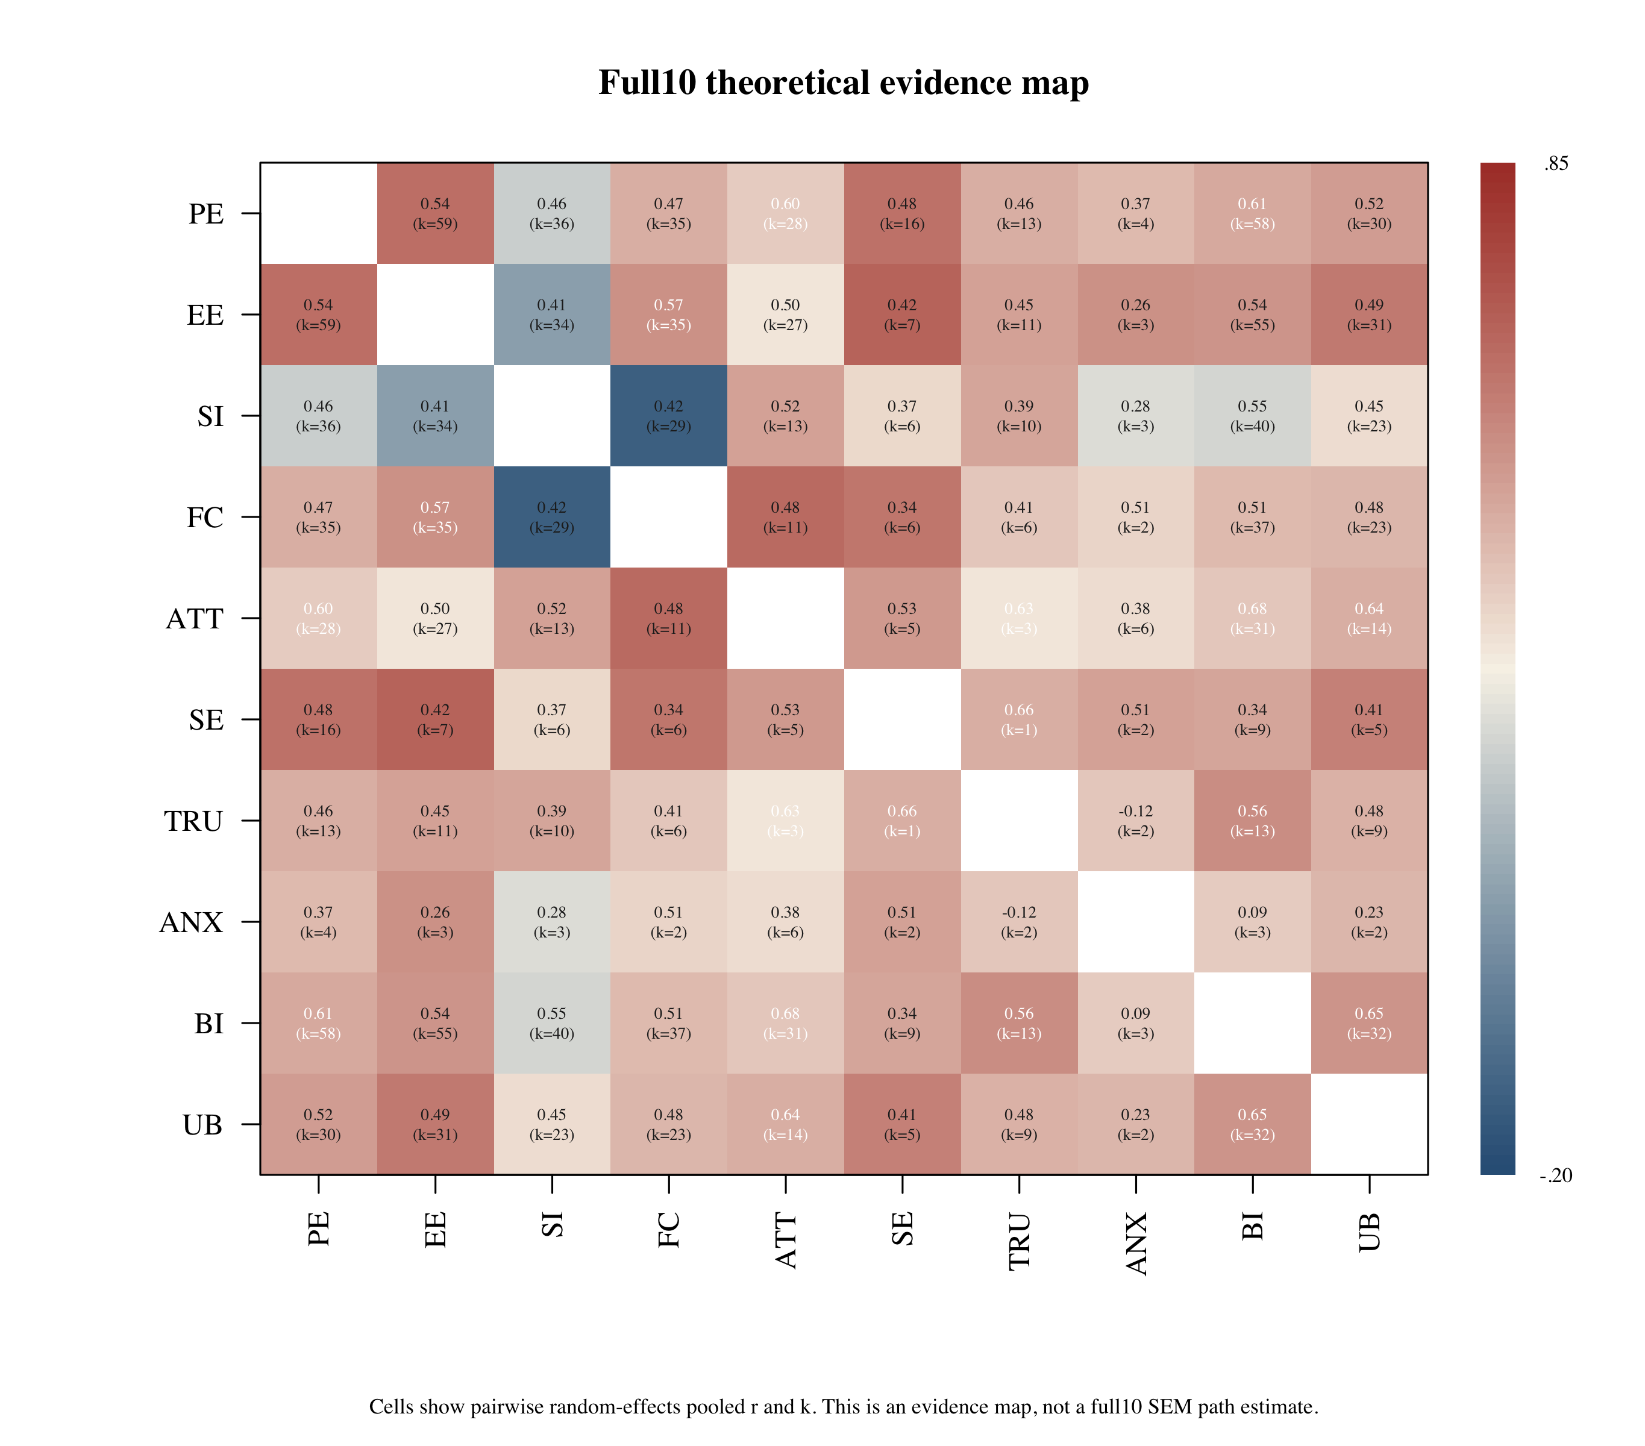
Note. Solid paths indicate likelihood-based 95% confidence intervals excluding zero; dashed paths indicate intervals including zero; dotted paths indicate incomplete interval bounds and are interpreted descriptively.

Figure 2. Core7 attitude-mediation MASEM path diagram.
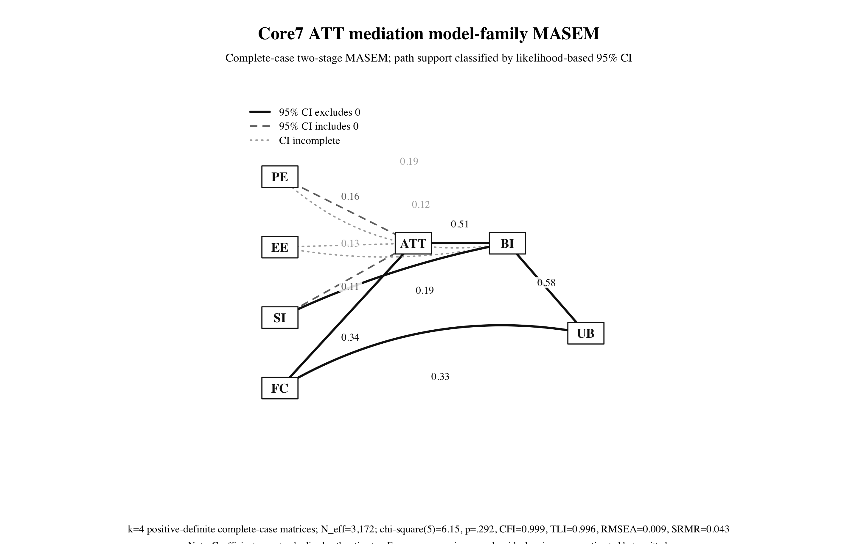
Note. Solid paths indicate likelihood-based 95% confidence intervals excluding zero; dashed paths indicate intervals including zero; dotted paths indicate incomplete interval bounds and are interpreted descriptively.

Figure 3. Trust6 mechanism MASEM path diagram.
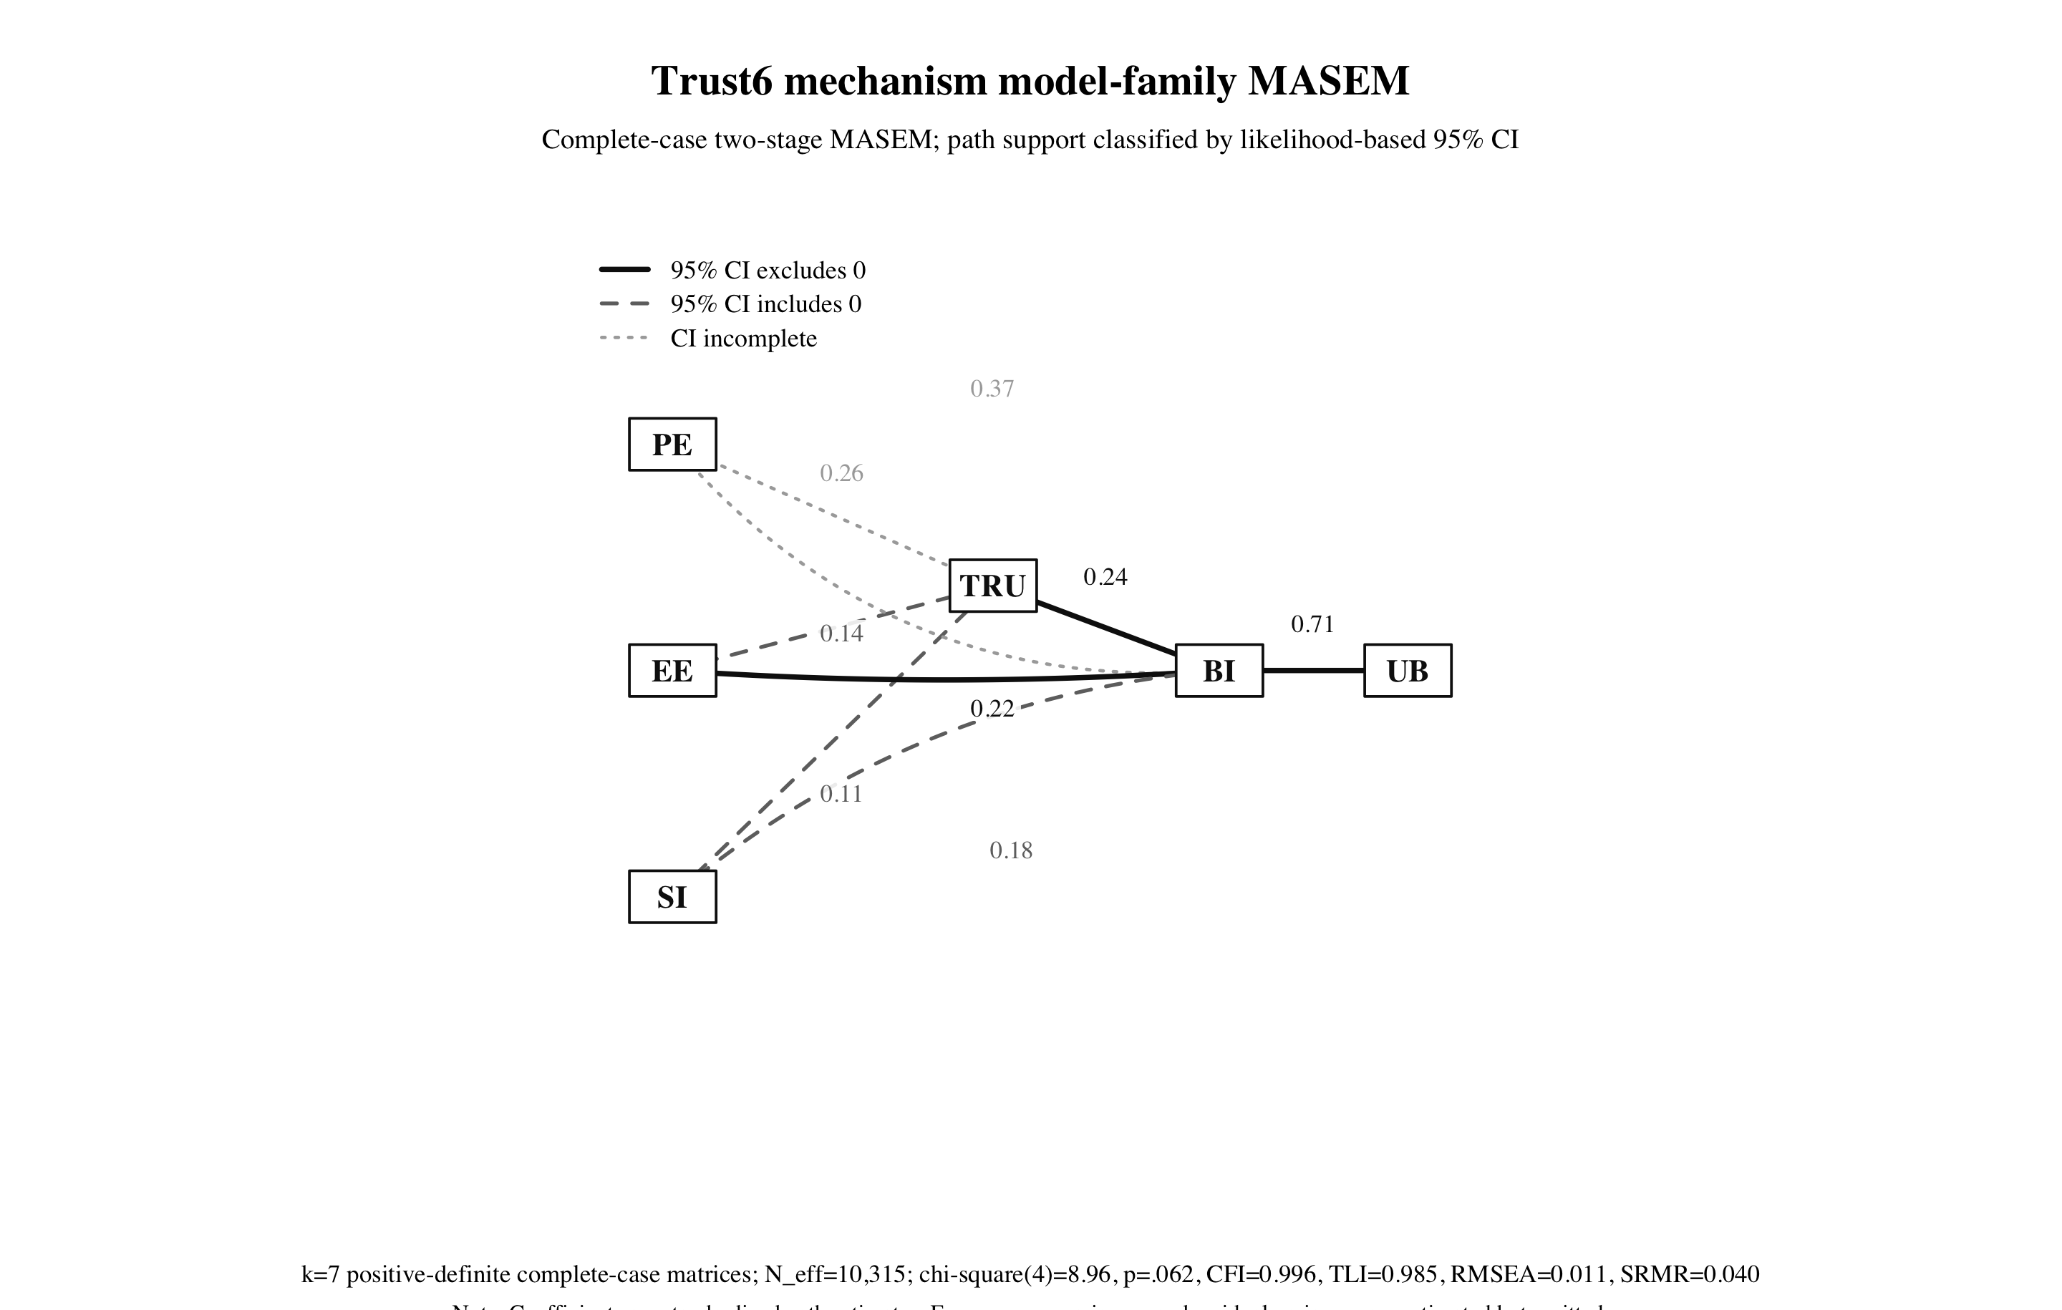
Note. Solid paths indicate likelihood-based 95% confidence intervals excluding zero; dashed paths indicate intervals including zero; dotted paths indicate incomplete interval bounds and are interpreted descriptively.

