Paper B Visual Upgrade Manuscript Insert Package
Date: 20260619
Purpose: replace the previous basic table/figure layer with a journal-style visual package aligned with current frontier studies on LLM-assisted evidence synthesis and data extraction.

Positioning
The flow diagram should be treated as a core Methods figure. It makes clear that Paper B evaluates a source-anchored validation workflow rather than an autonomous model replacement.
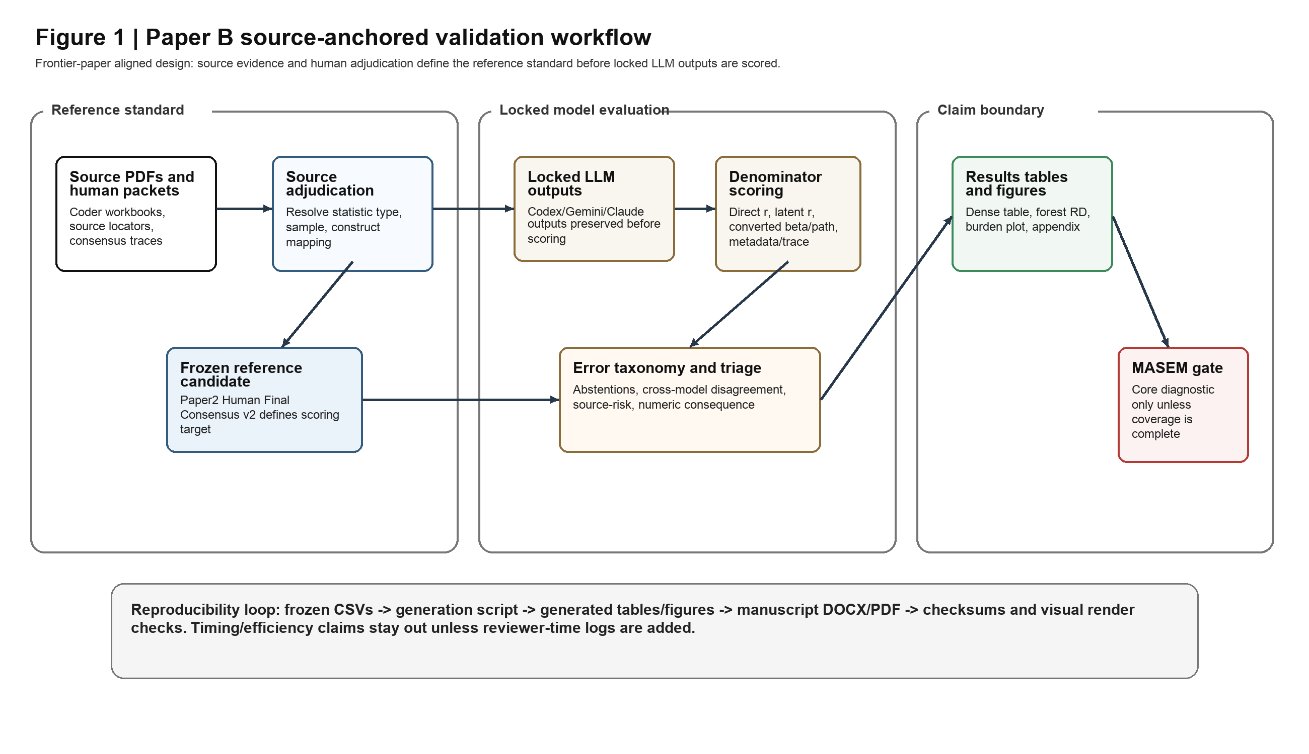
Figure 1. Source-anchored validation workflow for Paper B. The reference standard is frozen before locked LLM outputs are scored.

Results-Ready Table/Figure Layer
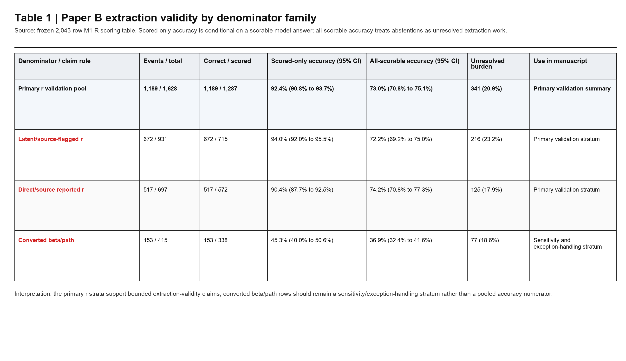
Table 1. Denominator-family extraction validity table. Accuracy is reported both conditional on scorable answers and across all scorable rows.
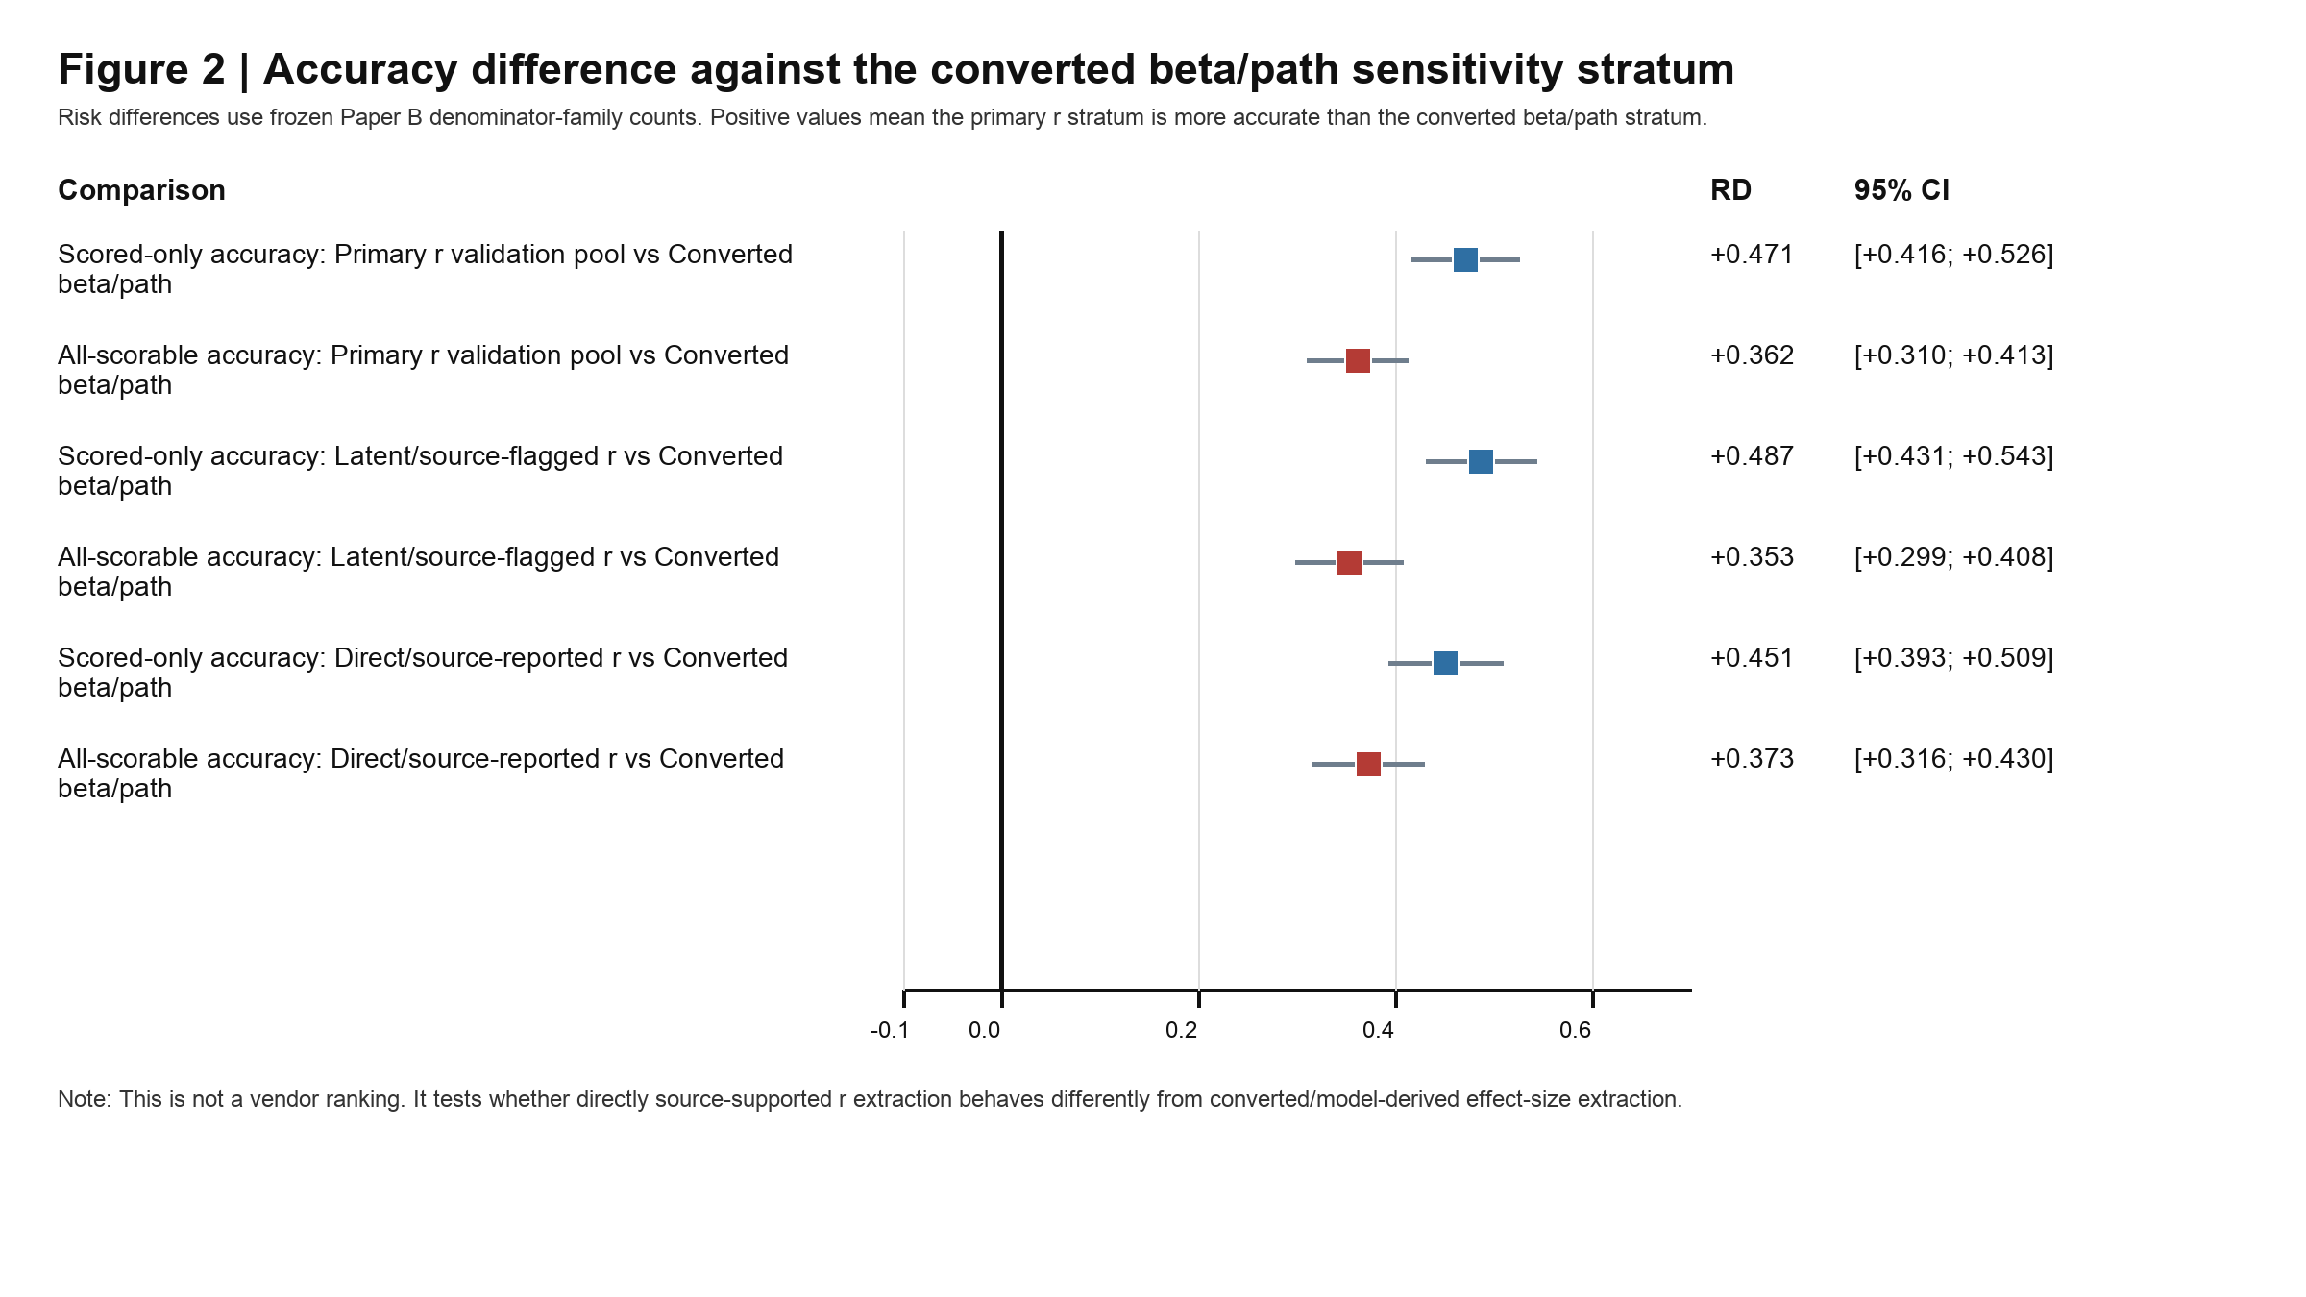
Figure 2. Forest-style risk-difference plot comparing primary r strata against the converted beta/path sensitivity stratum.
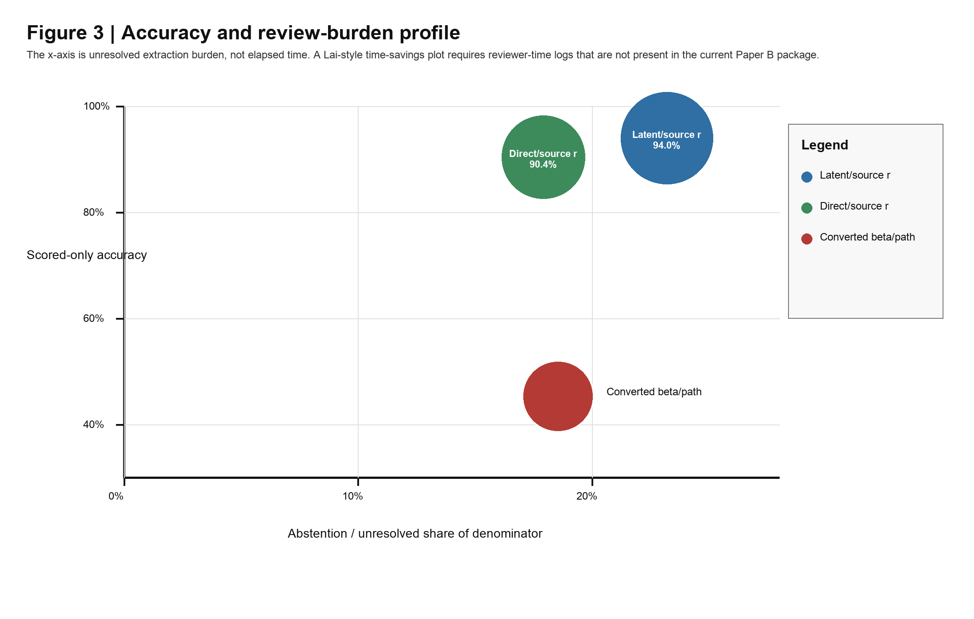
Figure 3. Accuracy and review-burden profile. This is not an elapsed-time plot; reviewer-time data are not yet available.
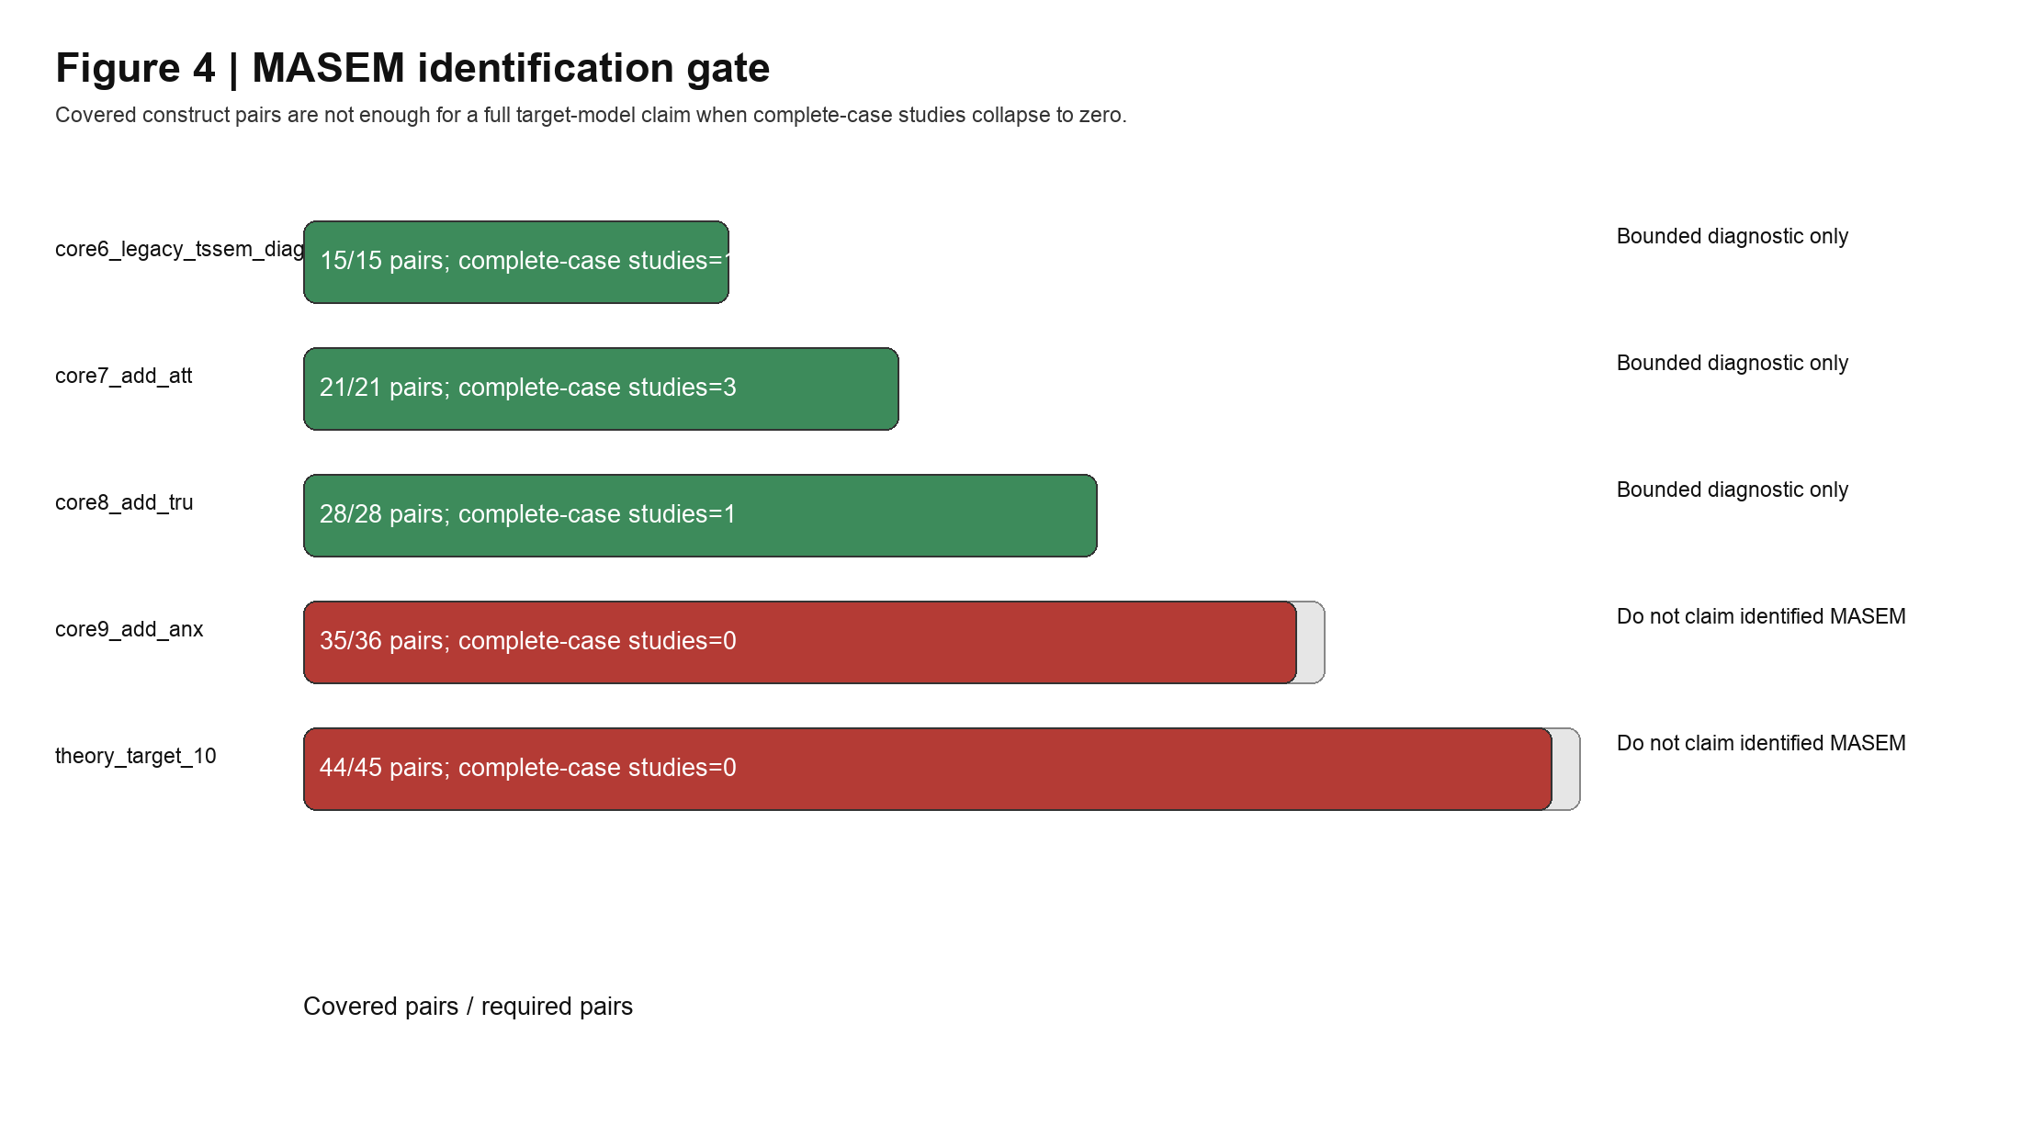
Figure 4. MASEM claim gate. Construct-pair coverage does not justify a full target-model claim when complete-case identification fails.

Frontier Reference Reinforcement
Reference | Frontier feature | Paper B use
Lai et al. 2025, npj Digital Medicine | Dense accuracy tables, risk-difference forest plot, accuracy-efficiency plot, process flow diagram. | Replicated as dense denominator table, RD forest-style plot, burden-not-time plot, and source-anchored flow diagram.
Farotimi et al. 2026, Research Synthesis Methods | GenAI evidence-synthesis disclosure and reporting framework. | AI disclosure, model-access boundary, reproducibility and claim-limit language.
Large Language Model-Assisted Risk-of-Bias Assessment in Randomized Controlled Trials Using RoB2 | Criterion-standard comparison, reviewer timing boundary, RoB-style screening/validation flow diagram. | Downloaded locally; 13 pages rendered/extracted; captions and tables inventoried for benchmark use.
Automated Data Extraction by Large Language Models: Assessing Accuracy in Comparison to Human Experts | Education meta-analysis extraction benchmark, frozen codebook, gold/silver reference standards, API extraction cost/time reporting. | Downloaded locally; 34 pages rendered/extracted; captions and tables inventoried for benchmark use.

Resolved Timing Boundary
No reviewer-time or per-study review-duration logs are available as of 2026-06-19. Do not generate a Lai-style elapsed-time efficiency plot or make a time-savings claim. Use the review-burden/triage figure instead. Paper B should report this as review burden and triage evidence, not as elapsed-time efficiency.

