Can a Prespecified LLM Workflow Augment MASEM-Ready Evidence Extraction?
Target journal: Research Synthesis Methods

Abstract
Data extraction for meta-analytic structural equation modeling (MASEM) requires reviewers to recover numeric source evidence, map constructs, distinguish direct correlations from converted statistics, and preserve provenance for downstream model fitting. We evaluated a prespecified locked-output LLM workflow against a source-anchored adjudicated human reference standard in an AI adoption evidence-synthesis project. Task units were analyzed by denominator family rather than as one pooled accuracy denominator. The full-corpus M1-R run covered 2,043 source-rendered task rows across nine locked shards, with no duplicate task IDs or post-repair model CLI failures. Primary correlation strata showed higher scored-only accuracy than converted beta/path rows, while abstentions and exception-layer rows identified where automated substitution was not authorized. Cross-model disagreement was retained as a review-triage signal but not as a vendor-ranking metric. Downstream evidence supported only a bounded core-6 TSSEM diagnostic; broader core7/core8 probes were too sparse for stronger SEM claims. The results support workflow augmentation, denominator-family validation, and human-supervised review triage, not autonomous replacement.
Keywords: evidence synthesis; data extraction; large language models; MASEM; validation; human-in-the-loop

Highlights

What is already known
LLMs can support parts of systematic review workflows, but data extraction accuracy is task-dependent and requires human verification.

What is new
This study evaluates a locked LLM workflow for MASEM-ready extraction using source-anchored adjudication, denominator-family scoring, and downstream diagnostics.

Potential impact for Research Synthesis Methods readers
The workflow shows how to evaluate LLM extraction without pooled accuracy overreach, vendor ranking, or replacement claims.

Introduction
Data extraction for meta-analytic structural equation modeling (MASEM) requires more than article summarization. A valid record must identify source-reported correlations, distinguish converted statistics from direct correlations, map constructs, preserve sample-size eligibility, and keep enough provenance to support downstream model fitting.
Large language models (LLMs) may reduce review burden, but evidence-synthesis methodology journals increasingly require validation designs that are transparent about model versioning, prompts, source conditions, human oversight, and reproducibility. Research Synthesis Methods now explicitly welcomes ML and GenAI evaluations in systematic review and meta-analysis contexts when the research design, validation, and reporting are sufficiently transparent.
This study evaluates a prespecified locked-output LLM workflow for MASEM-ready extraction in an AI adoption evidence-synthesis project. The contribution is not a model leaderboard. Instead, we ask whether a source-anchored LLM workflow can augment human review by structuring numeric extraction, uncertainty, source risk, and downstream substitution diagnostics without collapsing heterogeneous task families into one accuracy score.

Literature Review
Recent evidence-synthesis studies show that LLMs can support parts of data extraction, but performance depends strongly on the task, source material, and human verification design. Bibliographic or low-consequence metadata extraction is not equivalent to recovering a correlation matrix that will later feed TSSEM or OSMASEM.
The relevant methodological literature therefore points toward four requirements for this paper: a defensible human reference standard, locked and auditable model outputs, task-family denominators, and downstream consequence checks. Paper B follows that logic by separating direct correlations, source-type-flagged latent correlations, converted beta/path evidence, metadata and trace rows, and source-risk cases.
For MASEM specifically, numeric agreement is only one layer. A row that appears numerically close may still be unusable if it is a beta coefficient, an HTMT value, a duplicate-source trace, an ineligible source statistic, or a value without a source-supported sample size. The literature review should be expanded further before submission, but the Results and Discussion below already use this task-contingent framing.

Method
The validation corpus was derived from the AI adoption in higher education MASEM project. The workflow preserved raw independent human coder workbooks, generated human-human disagreement queues, adjudicated source-document disagreements, and then froze a source-anchored human reference layer before locked model evaluation.
The official current reference candidate is the Paper2 Human Final Consensus v2 packet prepared on 2026-06-05. The post-freeze full-corpus gate used a 213-study source-anchored reference, source-rendered task packets, and a full-corpus Step 5 shell containing 2,043 M1-R task rows.
The primary prespecified model for the full-corpus Step 5 run was Codex GPT-5.5. The full run was executed across nine locked shards. Claude Sonnet and Gemini 3 Flash outputs were retained for cross-model disagreement and triage sensitivity, not for vendor ranking.
Evaluation was conducted by denominator family. Direct/source-reported correlations, latent or construct correlations with source-type flags, and secondary beta/path converted effects were interpreted separately. Abstentions on scorable rows were counted as incorrect workflow outcomes. Fifteen exception-layer rows were interpreted by gate status rather than included in a generic full-corpus accuracy numerator.

Results
The full-corpus M1-R blocker was resolved on 2026-06-12. The source-packet-required run covered 2,043 eligible task units across nine locked shards, with no duplicate task identifiers and no post-repair model CLI failures. The run therefore provides full-corpus Step 5 evidence, but only under denominator-family and exception-aware interpretation.
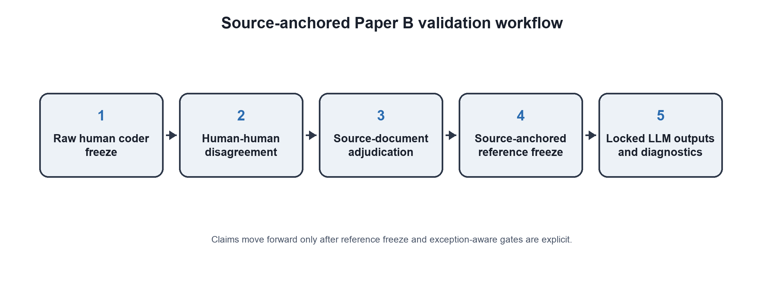
Figure 1. Source-anchored Paper B validation workflow. Claims move forward only after reference freeze and exception-aware gates.
Table 1. Data states and claim roles
Data state | Current evidence | Claim role
Frozen full-corpus reference | 213 studies; frozen 2026-06-09 | Governing reference layer
Full-corpus M1-R | 2,043 rows; nine locked shards | Denominator-family Step 5 evidence
Exception layer | 15 gate-status rows | Prevents generic pooled accuracy overreach
Core-6 TSSEM diagnostic | 16 complete-case studies in 2026-06-12 matrix audit; prior TSSEM diagnostic reported 15 studies | Bounded downstream diagnostic
Core7/core8 probes | 3 and 1 complete-case studies | Sparse-probe evidence, not main SEM extension

Table 2. Full-corpus M1-R outcomes by denominator family
Family | Rows | Scored | Correct | Incorrect | Abstained | Scored-only accuracy | All-scorable accuracy
Latent/source-flagged r | 931 | 715 | 672 | 43 | 216 | 94.0% | 72.2%
Direct/source-reported r | 697 | 572 | 517 | 55 | 125 | 90.4% | 74.2%
Converted beta/path | 415 | 338 | 153 | 185 | 77 | 45.3% | 36.9%

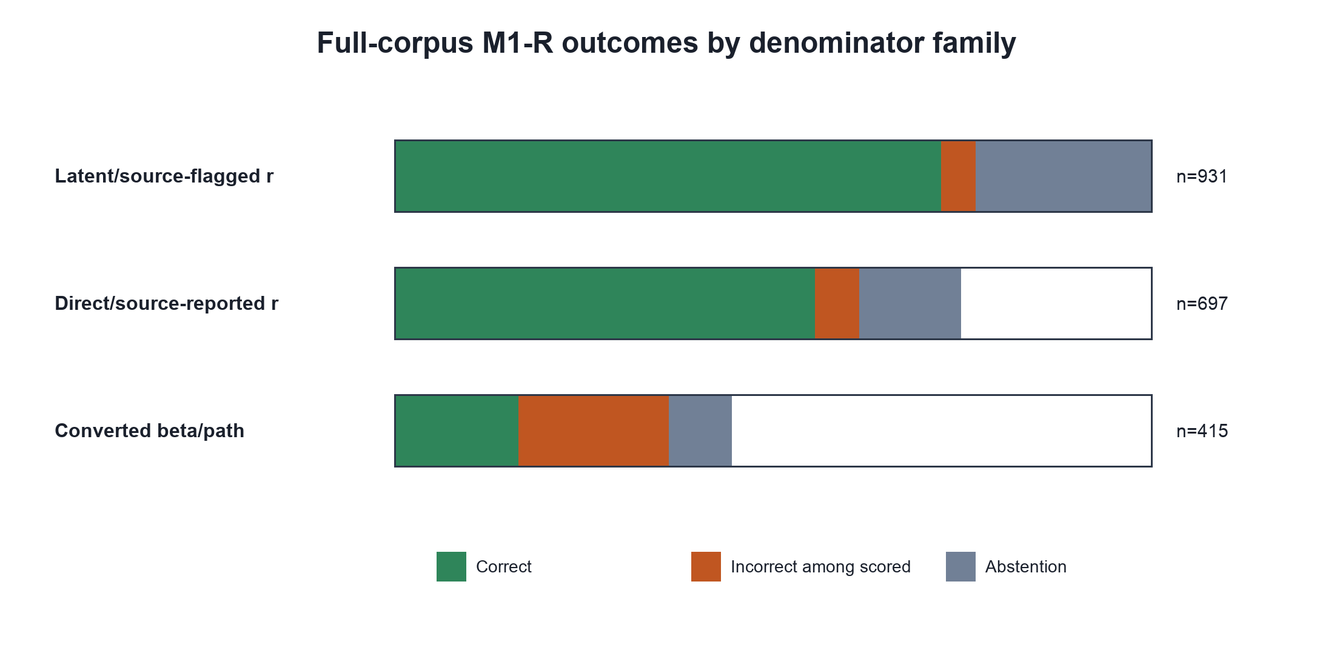
Figure 2. Denominator-family profile for the 2,043-row full-corpus M1-R run. Converted beta/path rows remain a sensitivity stratum.
Among latent/source-flagged correlation rows, 715 of 931 rows were scorable, 672 were correct, and 216 were abstentions. Among direct/source-reported correlation rows, 572 of 697 rows were scorable, 517 were correct, and 125 were abstentions. Among secondary beta/path converted rows, 338 of 415 rows were scorable, 153 were correct, and 77 were abstentions.
Scored-only accuracy was highest for the two primary correlation strata and weakest for converted beta/path rows. This pattern is substantively important: the model can reproduce many source-rendered numeric correlations, but converted or model-derived evidence remains a sensitivity stratum rather than a safe replacement layer.
RQ3 triage evidence showed that cross-model disagreement flagged 6,592 of 7,859 multi-model task units. Precision for identifying review-needed units was 0.999, recall was 0.843, and the review burden share was 0.839. Because the baseline review-needed rate was 0.994, cross-model disagreement should not be interpreted as a high-lift standalone detector. Its value is in organizing review attention together with source-risk, human-disagreement, abstention, and model-coverage signals.
Table 3. Review-triage signal validation
Signal | Flagged | True positives | False positives | Precision | Recall
blank behavior family | 6412 | 6412 | 0 | 1.000 | 0.821
primary not scored | 4335 | 4335 | 0 | 1.000 | 0.555
primary incorrect | 3474 | 3474 | 0 | 1.000 | 0.445
primary abstention | 979 | 979 | 0 | 1.000 | 0.125
source or trace risk | 601 | 601 | 0 | 1.000 | 0.077
human disagreement trace | 467 | 467 | 0 | 1.000 | 0.060
cross model behavior disagreement | 6592 | 6584 | 8 | 0.999 | 0.843
high consequence numeric | 454 | 451 | 3 | 0.993 | 0.058

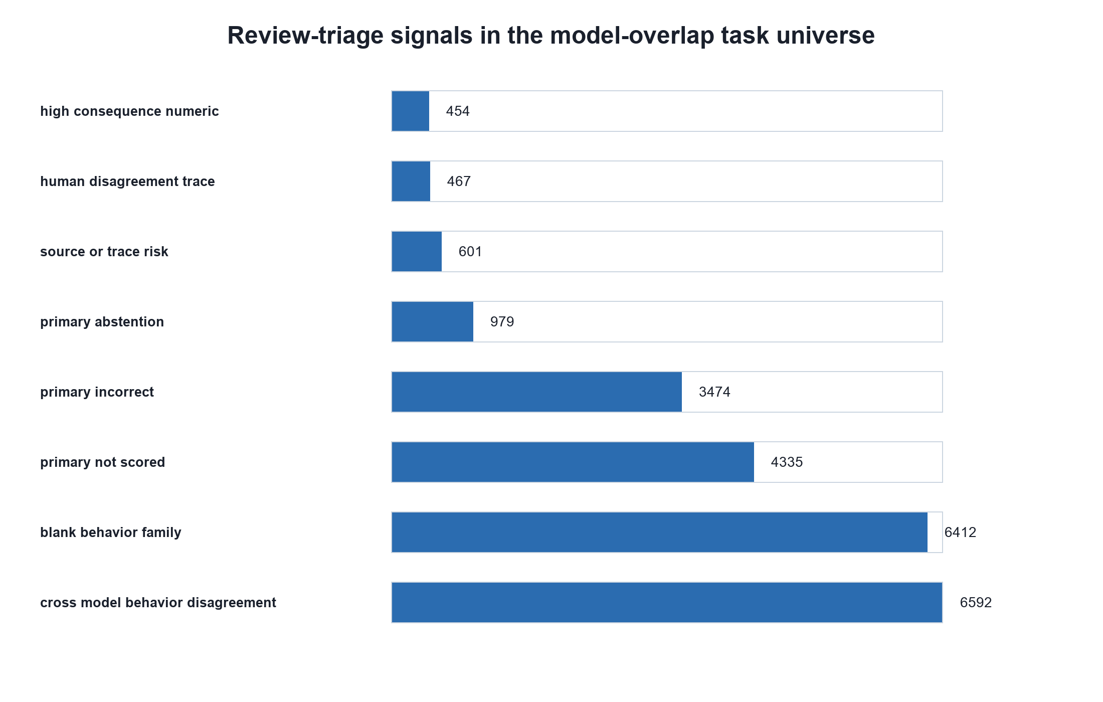
Figure 3. Main review-triage signal counts in the multi-model task universe.
The downstream diagnostic remained bounded. The core-6 construct set retained the defensible TSSEM/MASEM diagnostic lane. Core7 and core8 probes were attempted but were too sparse for stronger main-text extension: core7_add_att had only three complete-case studies and failed the Stage 2 path-model probe because the asymptotic covariance matrix was not positive definite; core8_add_tru had only one complete-case study.
Table 4. MASEM/TSSEM construct-set identification gates
Construct set | k | Required pairs | Covered pairs | Missing | Complete cases | Gate
Core 6 legacy TSSEM | 6 | 15 | 15 |  | 16 | Bounded
Core 7 plus ATT | 7 | 21 | 21 |  | 3 | Bounded
Core 8 plus TRU | 8 | 28 | 28 |  | 1 | Bounded
Core 9 plus ANX | 9 | 36 | 35 | ANX-TRU | 0 | Not identified
Theory target 10 | 10 | 45 | 44 | ANX-TRU | 0 | Not identified

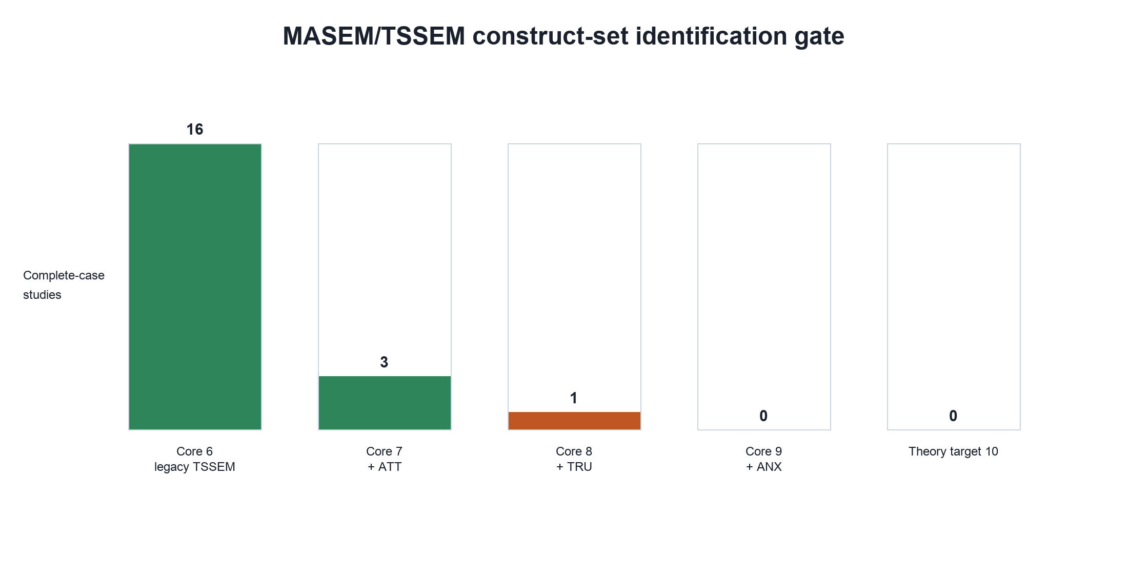
Figure 4. Construct-set identification gate for downstream TSSEM/MASEM reporting.

Discussion
The results support a workflow-augmentation claim. A locked LLM workflow can structure MASEM-ready extraction review, preserve model provenance, expose abstention behavior, and route expert attention to high-consequence numeric and source-risk rows. The evidence does not support an autonomous replacement claim.
The denominator-family results show why a single pooled accuracy score would be misleading. Direct/source-reported correlations and latent/source-flagged correlations carried different scoring implications, and converted beta/path rows were much less stable. A pooled score would obscure exactly the distinctions that matter for evidence synthesis.
The high cross-model-disagreement precision should be read cautiously. Because nearly all multi-model task units were review-needed under the current rules, precision is inflated by the base rate. The signal is still useful operationally because it clusters review work, but it does not prove that disagreement alone efficiently identifies rare errors.
The bounded core-6 diagnostic is equally important. In the expert-reviewed primary input, high-risk rows were retained under the human reference rather than autonomously replaced, and the diagnostic subset therefore did not change relative to the human-reference primary input. That is a conservative but methodologically useful result: the workflow can document where substitution is not authorized, not merely where a model appears correct.
For Research Synthesis Methods readers, the main contribution is a transparent evaluation design for LLM use in complex evidence synthesis. The study shows how to combine source-anchored adjudication, locked outputs, exception-aware scoring, denominator-family reporting, and downstream diagnostic boundaries. The public repository should expose share-safe data, code, prompts, manifests, and checksums while excluding raw PDFs, raw human workbooks, and private source packets.
The remaining limitation is that the Introduction, Literature Review, and Methods need final author polishing and reference completion. The Results and Discussion are now aligned with the current evidence boundaries: no vendor ranking, no pooled accuracy denominator, no autonomous replacement claim, and no all-construct/all-row SEM stability claim.

Data Availability
The share-safe Paper B public repository is available at https://osf.io/mkrgd/overview. If the 2026-06-12 full-corpus artifacts are redistributed as part of the public archive, the public manifest, checksums, and copied file set should be refreshed. Raw PDFs, raw human coder workbooks, private source packets, and unapproved raw model outputs should remain outside the public package.

References
Farotimi, O., Dunn, A., Van Lissa, C. J., Polanin, J. R., Mavridis, D., & Pigott, T. D. (2026). Guidance for manuscript submissions testing the use of generative AI for systematic review and meta-analysis. Research Synthesis Methods, 17, 237-239. https://doi.org/10.1017/rsm.2025.10058
Flemyng, E., & Noel-Storr, A. (2025). Responsible AI in Evidence Synthesis (RAISE): Guidance and recommendations (version 2). OSF. https://osf.io/cqa82
Gartlehner, G., Kahwati, L., Hilscher, R., Thomas, I., Kugley, S., Crotty, K., Viswanathan, M., Nussbaumer-Streit, B., Booth, G., Erskine, N., Konet, A., & Chew, R. (2024). Data extraction for evidence synthesis using a large language model: A proof-of-concept study. Research Synthesis Methods, 15, 576-589. https://doi.org/10.1002/jrsm.1710
Cheung, M. W.-L. (2015). Meta-analytic structural equation modeling. Wiley.
Jak, S., & Cheung, M. W.-L. (2020). Meta-analytic structural equation modeling with moderating effects on SEM parameters. Psychological Methods.
Page, M. J., McKenzie, J. E., Bossuyt, P. M., Boutron, I., Hoffmann, T. C., Mulrow, C. D., et al. (2021). The PRISMA 2020 statement. BMJ, 372, n71.

