From Theoretical Coverage to Estimable Model Families: A Meta-Analytic Structural Equation Modeling Study of AI Adoption
Author Note
This rebuild corrects the reporting layer of the Paper A scaffold. It adds APA-style table rules, a PRISMA 2020-style flow diagram, publication-oriented MASEM figures, and explicit source-count boundaries. Final author information, target-journal details, and full-text eligibility boxes require team confirmation.

Abstract
AI adoption research in education draws on technology acceptance, unified acceptance, trust, self-efficacy, and anxiety traditions, but individual studies rarely report complete correlation matrices needed to test the whole theoretical system. This study reconstructs AI adoption as a 10-construct theoretical target and evaluates which parts of that target are empirically estimable using model-family MASEM. The current PRISMA count lock identifies 224 unique included reports/studies after resolving a 225-row screening include set by merging one duplicate DOI. The full10 target achieved 45/45 pairwise coverage but zero complete 10-construct matrices, so empirical MASEM was conducted through core7 attitude-mediation and trust6 AI-reliance model-family descendants.

Method

PRISMA Count Lock
The repository previously contained a 224 versus 225 included-count discrepancy. The current audit found 225 included screening rows and one duplicate included DOI row, yielding a working lock of 224 unique included reports/studies.
Table 1
PRISMA Count Lock for Paper A
Item | Count
Records identified from databases | 22166
Duplicate records removed | 5977
Records after deduplication/screened | 16189
Records excluded before human review | 15532
Human-reviewed records | 657
Human-reviewed excluded rows | 432
Human-reviewed included rows | 225
Duplicate included DOI rows merged | 1
Unique included reports/studies current lock | 224
Note. The final full-text eligibility boxes still require team confirmation before journal submission.
Figure 1
PRISMA 2020 Flow Diagram for Paper A
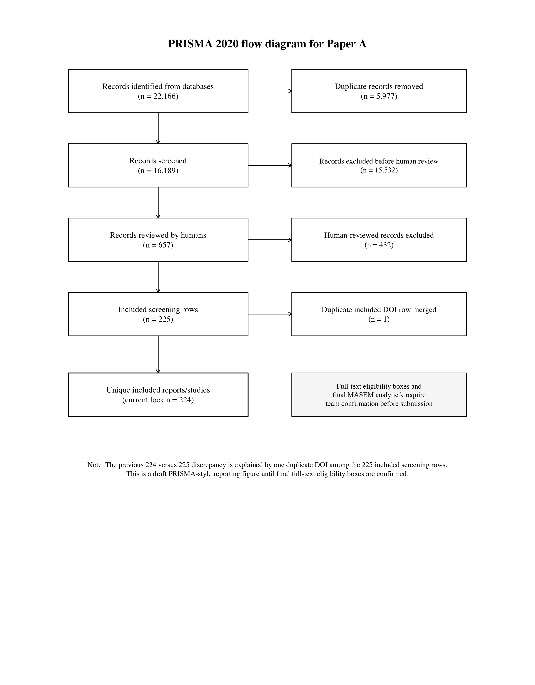
Note. The figure follows the PRISMA 2020 flow-logic format using currently locked local counts; full-text boxes remain pending team confirmation.

Theoretical Model-Family Specification
Table 2
Construct Genealogy and Model-Family Role in Paper A
Construct | Label | Origin | AI-Adoption Function | Role
PE | Performance expectancy / perceived usefulness | TAM, TAM2, UTAUT | Instrumental usefulness: AI improves learning, teaching, productivity, or task performance. | full10; core7; trust6
EE | Effort expectancy / perceived ease of use | TAM, computer self-efficacy, UTAUT | Operational ease: AI is manageable, learnable, and low burden. | full10; core7; trust6
SI | Social influence | UTAUT | Normative and institutional endorsement mechanism. | full10; core7; trust6
FC | Facilitating conditions | UTAUT | Resource and infrastructure mechanism enabling adoption and use. | full10; core7
ATT | Attitude | TRA/TPB, TAM | Evaluative mediator translating beliefs into intention. | full10; core7
TRU | Trust | Trust in automation, trust in IS, AI reliance | Reliance mechanism under AI opacity, uncertainty, and vulnerability. | full10; trust6
ANX | Anxiety | Technology readiness, affective threat | Threat/unease mechanism retained in theory but underidentified for primary MASEM. | full10; future mechanism
SE | Self-efficacy | Social cognitive theory, computer self-efficacy | Capability mechanism; currently feasible mainly in smaller supplemental sets. | full10; future mechanism
BI | Behavioral intention | TRA/TPB, TAM, UTAUT | Proximal motivational adoption outcome. | full10; core7; trust6
UB | Use behavior | TAM, UTAUT | Behavioral adoption/use outcome. | full10; core7; trust6
Note. PE = performance expectancy; EE = effort expectancy; ATT = attitude; TRU = trust; ANX = anxiety; SE = self-efficacy; BI = behavioral intention; UB = use behavior.
Figure 2
Theoretical Genealogy of Paper A Model Families
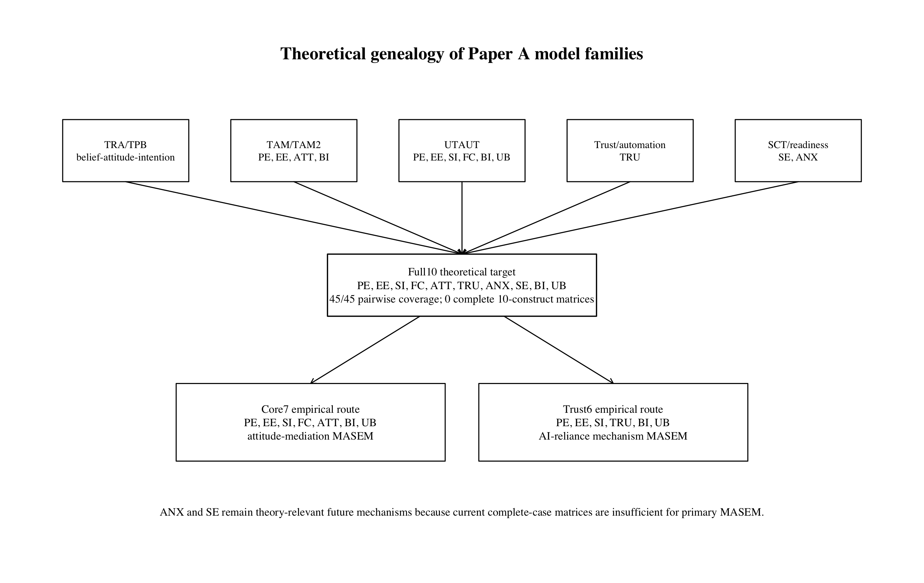
Note. The full10 target preserves theory; core7 and trust6 are empirical descendants supported by complete-case MASEM feasibility.
Figure 3
Paper A Analytic Workflow
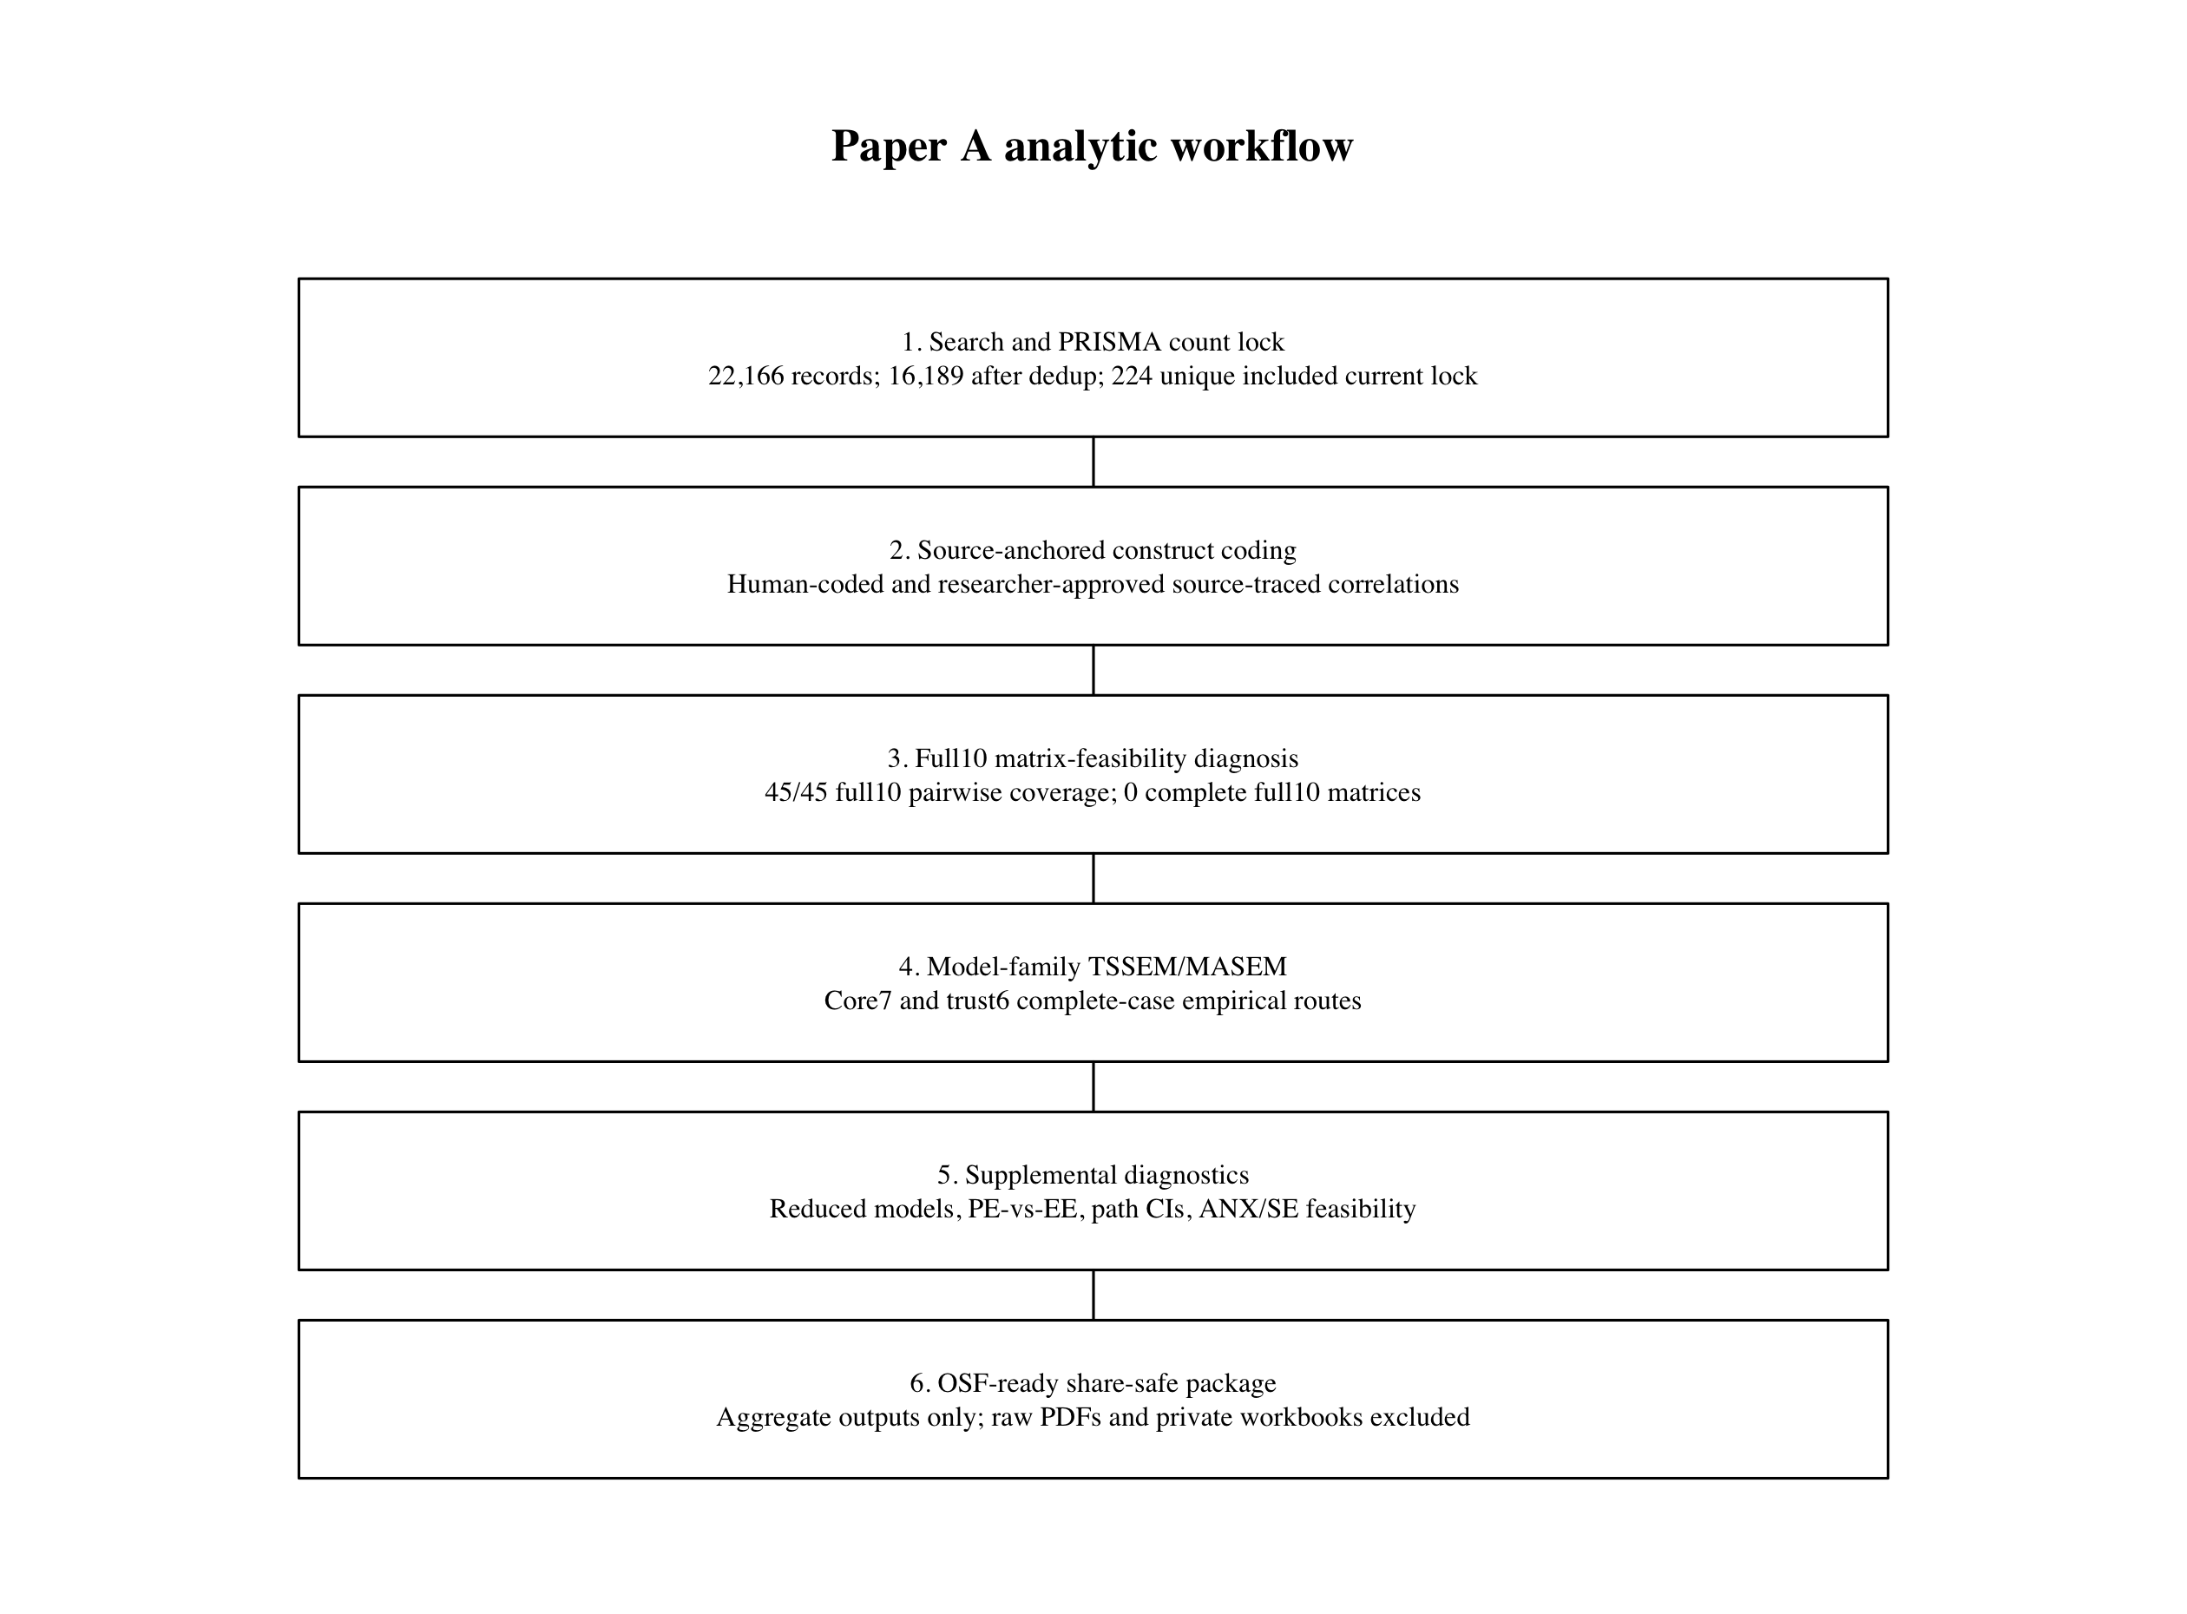
Note. The workflow separates PRISMA count lock, source-anchored coding, matrix diagnosis, MASEM, supplemental diagnostics, and share-safe OSF packaging.

Matrix-Feasibility Diagnosis
Table 3
Model-Family Matrix Feasibility
Model family | Constructs | Required pairs | Observed pairs | Partial studies | Positive-definite complete cases | Role
core7 ATT mediation | PE,EE,SI,FC,ATT,BI,UB | 21 | 21 | 72 | 4 | primary empirical model-family member
trust6 trust mechanism | PE,EE,SI,TRU,BI,UB | 15 | 15 | 73 | 7 | primary empirical model-family member
full10 theoretical target | PE,EE,SI,FC,ATT,SE,TRU,ANX,BI,UB | 45 | 45 | 77 | 0 | theoretical target and evidence map; not current primary SEM estimate
Note. Full10 has complete pairwise coverage but no complete 10-construct matrices; core7 and trust6 are the empirical model-family routes.
Figure 8
Model-Family Feasibility Diagnosis
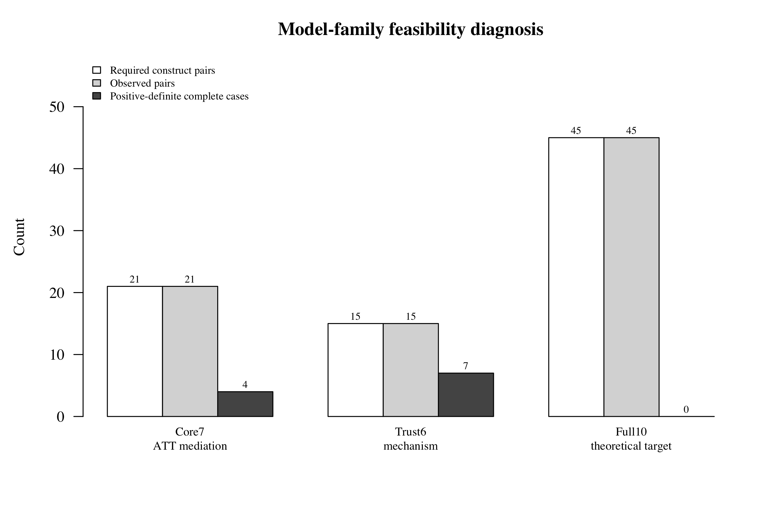
Note. Bars compare required pairs, observed pairs, and positive-definite complete-case matrices by model family.

Results

Full10 Evidence Map
Figure 4
Full10 Evidence Map
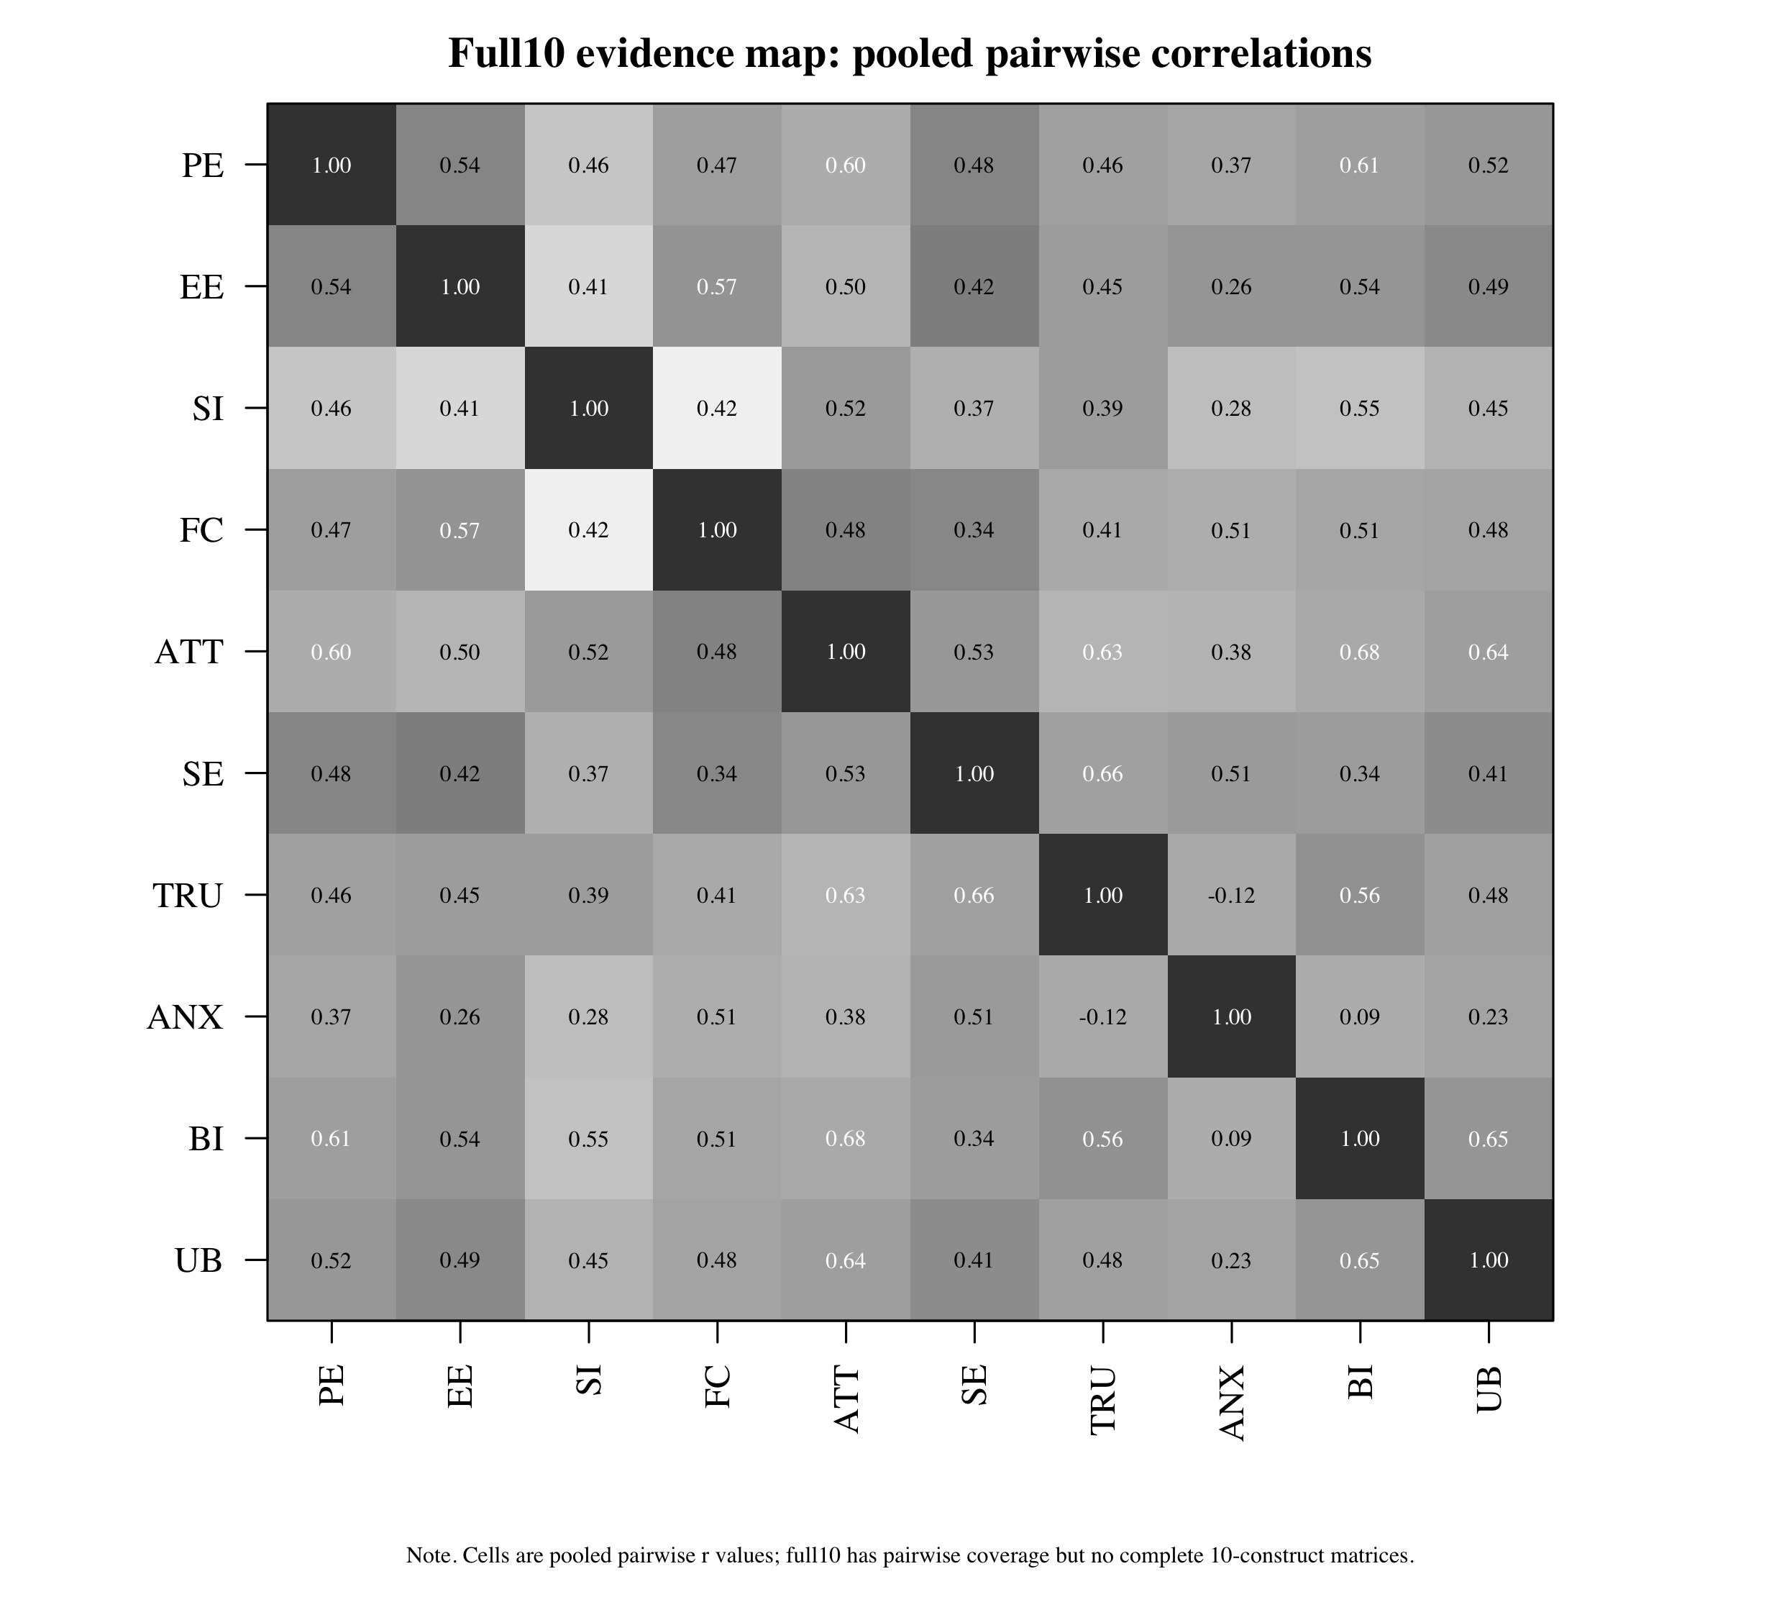
Note. Cells show pooled pairwise correlations. This is an evidence map, not a full10 SEM estimate.

Primary Model-Family Fit
Table 4
Primary Model-Family MASEM Fit
Model | k | N_eff | χ² | df | p | CFI | TLI | RMSEA | SRMR
Core7 ATT mediation | 4 | 3172 | 6.146 | 5 | .292 | 0.999 | 0.996 | 0.009 | 0.043
Trust6 trust mechanism | 7 | 10315 | 8.957 | 4 | .062 | 0.996 | 0.985 | 0.011 | 0.040
Note. Path p values are not reported because Stage 2 returned likelihood-based CIs but not finite standard errors for all paths.

Primary Structural Paths
Table 5
Primary MASEM Structural Path Estimates
Model | From | To | Estimate | 95% CI | Inference
Core7 ATT mediation | PE | ATT | 0.157 | [-0.170, 0.654] | not supported 95ci includes zero
Core7 ATT mediation | EE | ATT | 0.127 | [NA, NA] | ci incomplete
Core7 ATT mediation | SI | ATT | 0.107 | [-0.012, 0.215] | not supported 95ci includes zero
Core7 ATT mediation | FC | ATT | 0.336 | [0.099, 0.400] | supported positive 95ci
Core7 ATT mediation | PE | BI | 0.187 | [NA, 0.582] | ci incomplete
Core7 ATT mediation | EE | BI | 0.122 | [NA, 0.347] | ci incomplete
Core7 ATT mediation | SI | BI | 0.190 | [0.190, 0.530] | supported positive 95ci
Core7 ATT mediation | ATT | BI | 0.512 | [0.300, 0.738] | supported positive 95ci
Core7 ATT mediation | FC | UB | 0.332 | [0.114, 0.544] | supported positive 95ci
Core7 ATT mediation | BI | UB | 0.575 | [0.397, 0.753] | supported positive 95ci
Trust6 trust mechanism | PE | TRU | 0.261 | [NA, 0.438] | ci incomplete
Trust6 trust mechanism | EE | TRU | 0.140 | [-0.024, 0.285] | not supported 95ci includes zero
Trust6 trust mechanism | SI | TRU | 0.107 | [-0.049, 0.257] | not supported 95ci includes zero
Trust6 trust mechanism | PE | BI | 0.365 | [NA, 0.512] | ci incomplete
Trust6 trust mechanism | EE | BI | 0.225 | [0.045, 0.375] | supported positive 95ci
Trust6 trust mechanism | SI | BI | 0.184 | [-0.017, 0.372] | not supported 95ci includes zero
Trust6 trust mechanism | TRU | BI | 0.243 | [0.126, 0.352] | supported positive 95ci
Trust6 trust mechanism | BI | UB | 0.714 | [0.650, 0.781] | supported positive 95ci
Note. Supported paths are classified by 95% confidence intervals excluding zero; incomplete intervals are reported as indeterminate, not significant.
Figure 5
Core7 MASEM Path Model
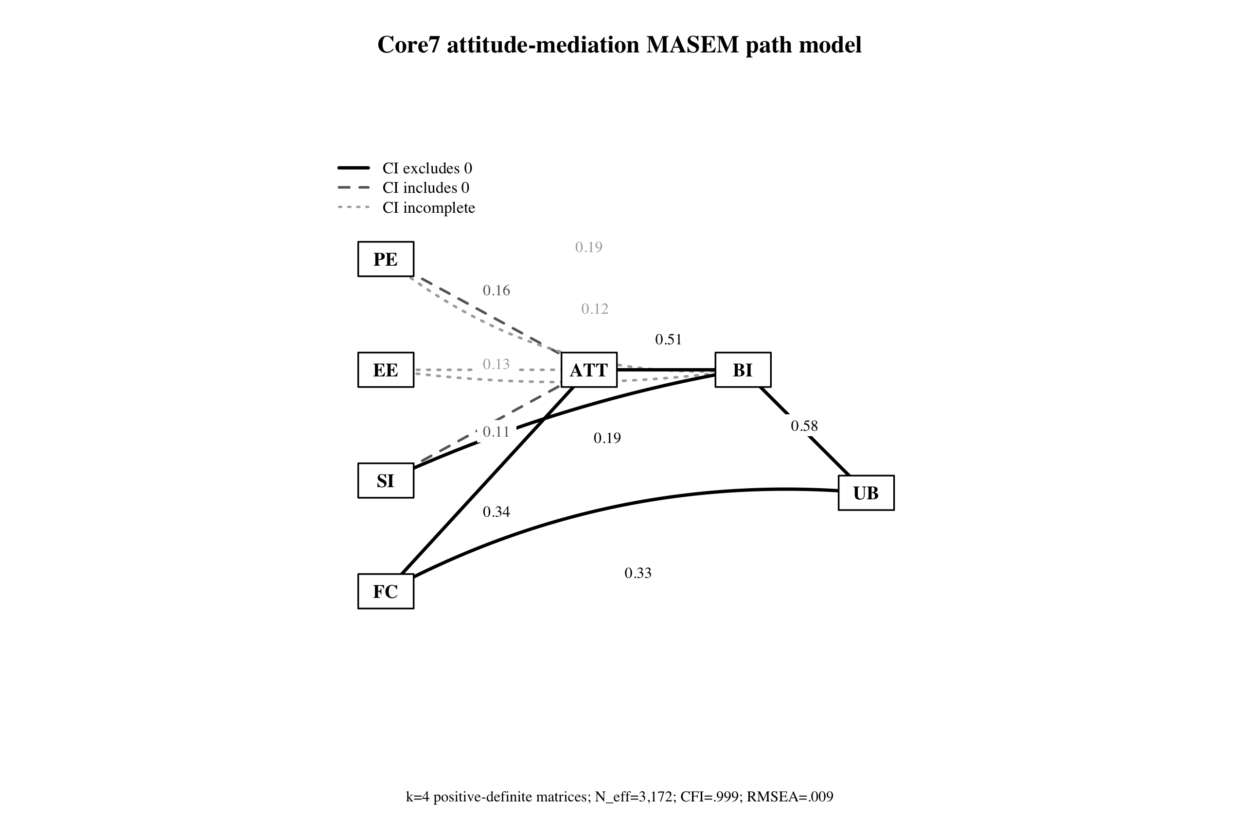
Note. Solid paths indicate CIs excluding zero; dashed paths include zero; dotted paths have incomplete intervals.
Figure 6
Trust6 MASEM Path Model
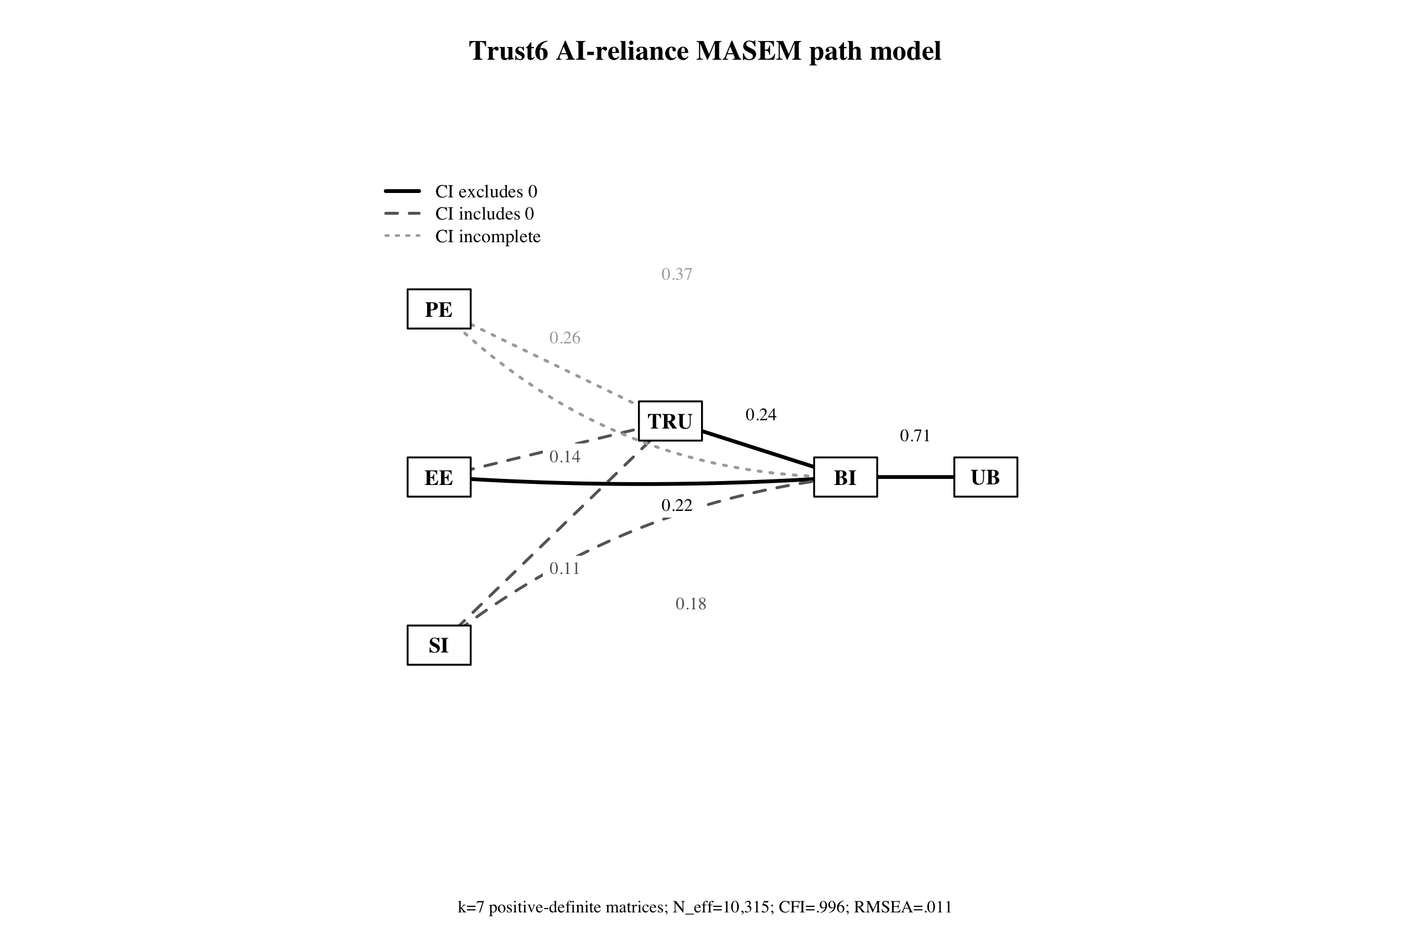
Note. Trust is reported as an AI reliance mechanism rather than a fully mediating mechanism.
Figure 7
Primary Path Estimate Coefficient Plot
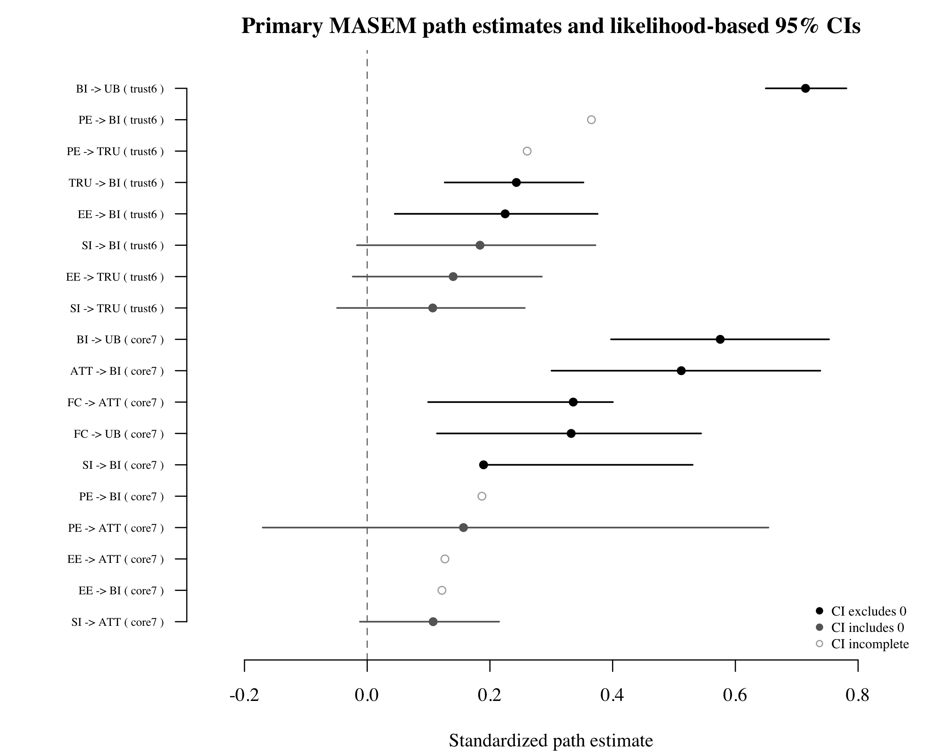
Note. Points are standardized path estimates. Horizontal bars are likelihood-based 95% CIs where available.

Supplemental Diagnostics
Table 6
Supplemental Reduced and Alternative Model-Family Diagnostics
Model | k | Status | χ² | df | p | CFI | RMSEA | AIC
core7_full | 4 | converged | 6.146 | 5 | .292 | 0.999 | 0.009 | -3.854
core6_no_ATT_direct_beliefs | 17 | converged | 1.780 | 3 | .619 | 1.000 | 0.000 | -4.220
core7_pure_ATT_mediation_no_direct_belief_BI | 4 | status_6 | 18.318 | 8 | .019 | 0.991 | 0.020 | 2.318
trust6_full | 7 | converged | 8.957 | 4 | .062 | 0.996 | 0.011 | 0.957
trust5_no_TRU_direct_acceptance | 20 | converged | 6.496 | 3 | .090 | 0.997 | 0.008 | 0.496
trust6_trust_mediator_no_direct_belief_BI | 7 | converged | 150.683 | 7 | < .001 | 0.888 | 0.045 | 136.683
se4_capability_effort_intention | 2 | status_6 | 2.916 | 2 | .233 | 0.999 | 0.022 | -1.084
Note. These are diagnostic comparisons; construct removal can change k and matrix structure, so they are not definitive nested tests.

PE Versus EE Role Comparison
Table 7
Performance Expectancy and Effort Expectancy as Distinct Mechanisms
Model | Predictor | Target | Estimate | 95% CI | Inference
Core7 ATT mediation | PE | ATT | 0.157 | [-0.170, 0.654] | not supported 95ci includes zero
Core7 ATT mediation | EE | ATT | 0.127 | [NA, NA] | ci incomplete
Core7 ATT mediation | PE | BI | 0.187 | [NA, 0.582] | ci incomplete
Core7 ATT mediation | EE | BI | 0.122 | [NA, 0.347] | ci incomplete
Trust6 trust mechanism | PE | TRU | 0.261 | [NA, 0.438] | ci incomplete
Trust6 trust mechanism | EE | TRU | 0.140 | [-0.024, 0.285] | not supported 95ci includes zero
Trust6 trust mechanism | PE | BI | 0.365 | [NA, 0.512] | ci incomplete
Trust6 trust mechanism | EE | BI | 0.225 | [0.045, 0.375] | supported positive 95ci
Note. The comparison concerns PE and EE roles across outcomes, not the PE-EE correlation.

Anxiety and Self-Efficacy Feasibility
Table 8
Targeted Anxiety and Self-Efficacy Feasibility Attempts
Model | Constructs | k | Status | CFI | RMSEA
se4_capability_effort_intention | SE,EE,BI,UB | 2 | status_6 | 0.999 | 0.022
se4_capability_attitude_intention | SE,ATT,BI,UB | 0 | not_run | NA | NA
anx4_threat_attitude_intention | ANX,ATT,BI,UB | 0 | not_run | NA | NA
anx4_trust_threat_reliance | ANX,TRU,BI,UB | 0 | not_run | NA | NA
se_anx_bi_capability_threat | SE,ANX,BI,UB | 0 | not_run | NA | NA
se_anx_tru_bi | SE,ANX,TRU,BI | 0 | not_run | NA | NA
Note. ANX and SE remain theory-relevant but currently underidentified for primary complete-case MASEM.

Discussion
The reporting rebuild strengthens Paper A by separating what is theoretically covered from what is structurally estimable. Full10 remains valuable as a theoretical target and evidence map; core7 and trust6 provide the current empirical model-family MASEM evidence. The next scientific step is not to force full10, but to finalize PRISMA/full-text boxes and improve source reporting so future analyses can test anxiety and self-efficacy more directly.

Data Availability
A share-safe Paper A public repository package is prepared locally and intended for a Paper A component under https://osf.io/mkrgd/overview. Raw PDFs, private source documents, raw coder workbooks, and runtime files are excluded.

