INTERNAL WORKING DOCUMENT | AI Adoption MASEM Project
Construct Boundary Discussion v2
Theoretical and Model-Level Analysis:
HM/ATT Inclusion Decision and ANX/PR Classification
Date | April 13, 2026
Status | Under active discussion -- no decisions recorded
PM | Hosung You
Audience | Internal team only

1. Correction: Previous Correlation-Matrix Estimate Was Unreliable
The prior discussion document (v1) reported only 5 MASEM-viable HM studies based on a narrow keyword search ('pearson correlation', 'correlation matrix'). A re-scan using broader patterns -- Fornell-Larcker tables, HTMT matrices, descriptive-statistics-plus-correlation tables -- reveals that 43 of 47 HM-operationalized studies report some form of inter-construct correlation. The '5 viable' figure is retracted. The analysis below replaces it with construct co-occurrence counts, which are the binding MASEM constraint.
Detection method | HM studies with correlation data | Note
Narrow: 'pearson correlation', 'correlation matrix' keywords only | 6 | Original estimate -- RETRACTED
Broad: Fornell-Larcker, HTMT, descriptive stats + r values, 'construct correlation' | 43 / 47 | Revised estimate
HM r-values detected in proximity of HM text | 29 / 47 | Intermediate confirmation
PLS-SEM studies (Fornell-Larcker correlations usable for MASEM) | 40 / 47 | PLS-SEM is NOT a disqualifier per se -- see Section 2
Table 1. Correlation detection: narrow vs. revised broad estimate.

2. The Real MASEM Constraint: Construct Co-occurrence
For MASEM Stage 1, we do not merely need a correlation matrix within a study; we need correlations between HM and every other construct in the target model. The binding question is therefore: among studies that operationalize HM, how many also operationalize each of the 10 constructs already in the model? Figure 1 shows the full co-occurrence pattern across all 47 HM studies.
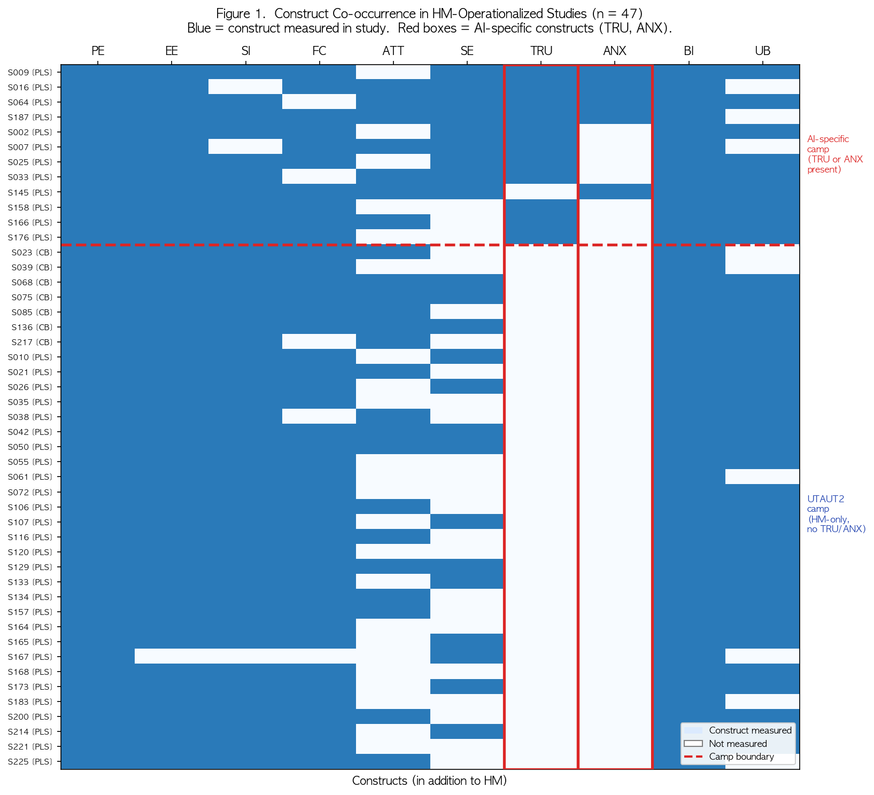
Figure 1. Construct co-occurrence in 47 HM-operationalized studies. Blue = construct measured. Red boxes = AI-specific constructs (TRU, ANX). Dashed line separates AI-specific camp (top) from pure UTAUT2 camp (bottom).

2.1 The Two-Camp Divide
Figure 1 reveals a clear structural divide in the literature. Studies that measure HM overwhelmingly belong to the UTAUT2 tradition and do NOT measure Trust (TRU) or Anxiety (ANX). Studies that do measure TRU and ANX are AI-specific in orientation and rarely include HM. This is not a data-quality problem -- it reflects two distinct theoretical traditions that have not converged in the empirical literature.
Cell (HM paired with) | k (studies co-measuring both) | vs. current model minimum | Assessment
PE | 44 | PE: k=186 standalone | Adequate
EE | 42 | EE: k=162 standalone | Adequate
SI | 40 | SI: k=114 standalone | Adequate
ATT | 38 | ATT: k=81 standalone | Adequate -- but see Section 4 on ATT-HM collinearity
BI | 44 | BI: k=185 standalone | Adequate
TRU | 13 | TRU: k=36 standalone | BELOW k=10 target; marginal
ANX | 5 | ANX: k=40 standalone | BELOW k=3 minimum for most HM-ANX cells
TRU AND ANX simultaneously | 2 | -- | Insufficient for any stable estimation
Table 2. HM cell k values (co-occurrence among 47 HM studies). Critical constraint: HM-ANX (k=5) and HM-TRU-ANX simultaneous (k=2).
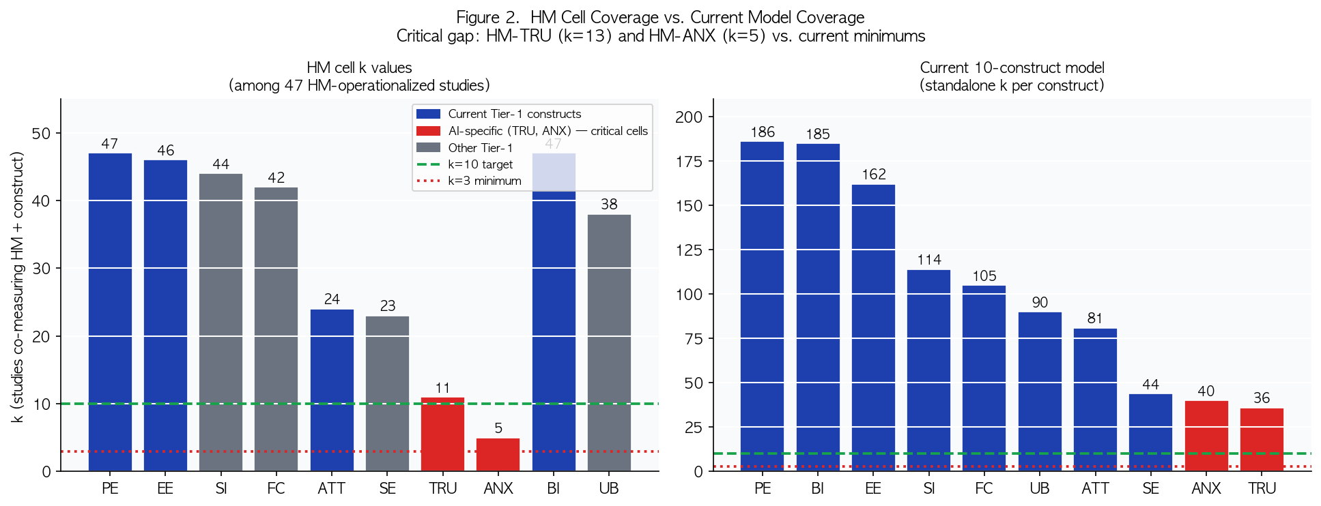
Figure 2. Left: HM cell k values when HM is added to the model. Right: current 10-construct model k values for reference. Note HM-TRU (k=13) and HM-ANX (k=5) fall far below current minimums.
Key implication: Even with 43 studies reporting correlation data, the HM-ANX cell has k=5 and the HM-TRU cell has k=13. More critically, only 2 studies measure HM, TRU, AND ANX simultaneously. This means Stage 1 would need to estimate the HM row of the 11x11 matrix with highly uneven cell coverage, violating the positive-definiteness assumption that underpins TSSEM/OSMASEM (Cheung, 2015).
Open Question 1: The HM-ANX cell (k=5) falls below the k=10 stable-estimation target and the HM-TRU-ANX simultaneous k=2 is essentially inestimable. Does this constitute a definitive coverage failure under Cheung (2015) criteria, or is there a methodological workaround (e.g., pairwise deletion with ridge correction)?
Open Question 2: PLS-SEM Fornell-Larcker correlations are inter-construct correlations and are technically extractable for MASEM. Should they be treated identically to CB-SEM Pearson correlations in Stage 1, or coded with a SEM-method moderator?

3. The Fundamental Question: Model Architecture Choice
Even if the co-occurrence problem could be resolved, including HM forces a fundamental architectural decision about the Stage 2 structural model. This is a theoretical choice, not a data problem. Figure 3 illustrates the two competing models.
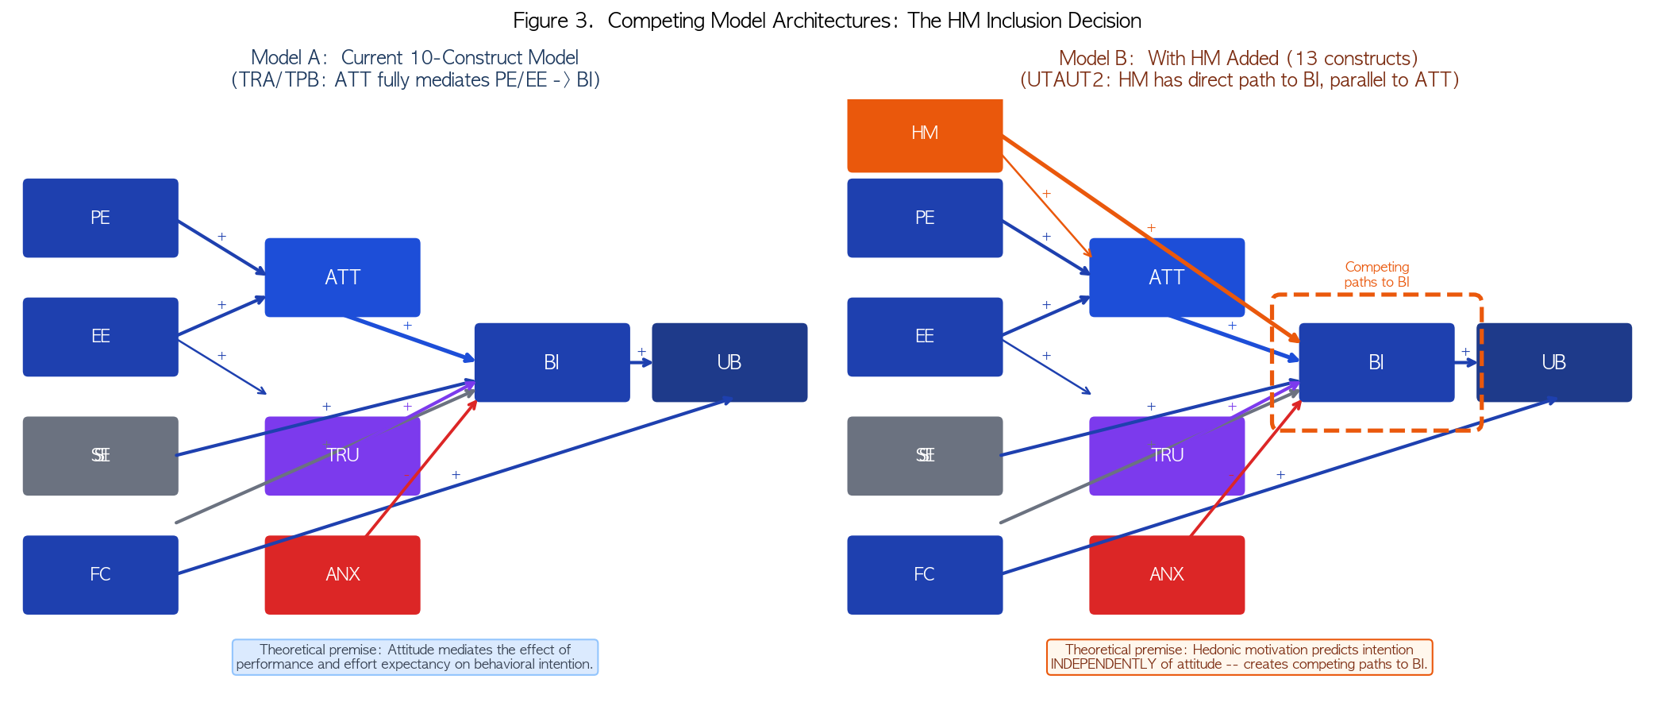
Figure 3. Model A (current, 10 constructs): ATT fully mediates PE/EE effects on BI. Model B (13 constructs): HM has a direct path to BI independent of ATT, creating competing predictors.

3.1 What Each Model Assumes
Dimension | Model A (Current -- No HM) | Model B (With HM)
Theoretical premise | TRA/TPB: attitude fully mediates the effect of beliefs (PE, EE) on behavioral intention | UTAUT2: hedonic motivation predicts BI directly, independently of and in parallel with attitude
Role of ATT | Central mediator between cognitive antecedents and intention | One of two parallel predictors of BI; its unique variance is reduced by HM
Role of affect in BI | Captured indirectly via ATT (which includes affective evaluation) | Split between ATT (evaluative affect) and HM (hedonic affect) as separate predictors
Structural paths to BI | ATT->BI; SI->BI; SE->BI; TRU->BI; ANX->BI | ATT->BI; HM->BI; SI->BI; SE->BI; TRU->BI; ANX->BI
Theoretical risk | Under-specifies hedonic motivation if it has unique variance in BI beyond ATT | Over-specifies if HM and ATT are measuring the same evaluative-affective process
Prior support | TAM meta-analyses (Scherer et al. 2019); TPB meta-analyses | UTAUT2 (Venkatesh et al. 2012); hedonic system literature
Table 3. Theoretical implications of Model A vs. Model B.

3.2 Nested Model Comparison
Because Model A is nested within Model B (Model A is Model B with the HM->BI path constrained to zero), a chi-square difference test or AIC/BIC comparison in Stage 2 could formally evaluate whether HM adds explanatory power. However, this comparison requires that HM be estimable in Stage 1 with adequate k across all 10 new cells -- which the co-occurrence analysis (Section 2) suggests is not currently achievable, particularly for the HM-ANX and HM-TRU cells.
Open Question 3: Is the nested model comparison (Model A vs. Model B) a research question worth pursuing in this study, or does it fall outside the scope of our AI-specificity hypothesis? Our primary RQ2 tests whether TRU and ANX add incremental power beyond Tier-1 constructs -- not whether HM adds power beyond ATT.
Open Question 4: If the team agrees that Model A (TRA/TPB mediation) is the correct theoretical frame for this study, HM is excluded on theoretical grounds alone -- the co-occurrence and coverage arguments become supporting evidence, not the primary rationale. Does the team endorse Model A as the theoretical commitment?

4. ATT-HM Collinearity: A Model-Level Concern
Even within Model B, a practical problem arises: ATT and HM are expected to correlate highly (r ≈ .60-.80 based on prior UTAUT2 studies and the overlapping item content shown in Figure 4). When two highly correlated constructs both predict the same outcome (BI) in a Stage 2 SEM, the result is inflated standard errors and unstable path estimates -- a multicollinearity problem at the latent variable level.
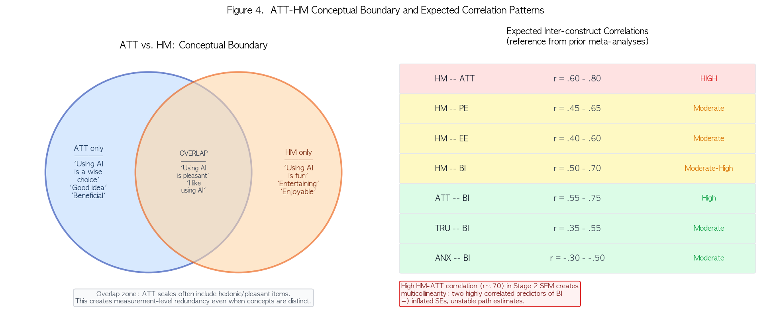
Figure 4. Left: conceptual boundary between ATT and HM (with overlap zone where ATT scales include hedonic/pleasant items). Right: expected inter-construct correlation ranges.
Construct pair | Expected r (literature) | Collinearity risk for Stage 2 SEM
HM -- ATT | r = .60 - .80 | HIGH: both predict BI; inflated SE for ATT->BI and HM->BI paths
HM -- PE | r = .45 - .65 | Moderate: PE->ATT->BI chain remains intact
HM -- EE | r = .40 - .60 | Moderate: acceptable
HM -- BI | r = .50 - .70 | Strong direct effect -- this is HM's justification
ATT -- BI | r = .55 - .75 | Current model: ATT remains the primary affective mediator
Table 4. Expected ATT-HM correlation and collinearity implications in Stage 2 SEM.
Note on measurement-level overlap: ATT scales in the AI adoption literature often include items like 'Using AI is pleasant,' 'I like using AI,' or 'Using AI is a satisfying experience.' These items are indistinguishable from HM items ('Using AI is enjoyable,' 'Using AI is fun'). When this overlap exists, pooling ATT and HM correlations across studies will conflate construct-level measurement inconsistency with true structural differences.
Open Question 5: Should an ATT item-level audit be conducted to determine how many of the 81 ATT studies include hedonic/pleasant items in their ATT scale? If >30% do, the ATT-HM boundary is already compromised in the existing model.

5. Revised Exclusion Rationale: What Should Be in the Manuscript
The current construct_selection_rationale.md (Section 4.1) states three reasons for HM exclusion. Based on the analysis in this document, the argument structure should be revised as follows.
Argument | Current rationale (v2026-04-03) | Revised recommendation | Strength
Structural inconsistency | HM serves as exogenous antecedent in some studies but ATT-equivalent position in others | REMOVE or REVISE: 98% of operationalized HM studies use HM as direct BI antecedent (UTAUT2-style). Inconsistency is minimal. | Empirically unsupported -- retract
Coverage failure | Not explicitly stated -- implied by k~33 estimate | ADD as primary argument: HM-ANX cell k=5, HM-TRU k=13, HM-TRU-ANX simultaneous k=2. Positive-definiteness of the augmented matrix is not achievable. | Empirically strong -- should lead
Model architecture conflict | Not stated | ADD as secondary argument: including HM shifts the model from TRA/TPB mediation (Model A) to UTAUT2 parallel-predictor (Model B), changing the theoretical commitment of the study. | Theoretically strong -- should be second
ATT-HM collinearity | Not stated | ADD as tertiary argument: expected r(HM,ATT) ≈ .60-.80 creates multicollinearity in Stage 2 SEM; ATT->BI and HM->BI path estimates would be unstable. | Model-level concern -- supporting
Low AI-specificity | Stated (Argument 2) | RETAIN: HM operates identically in social media and gaming contexts; no theoretical shift expected for AI-specific adoption. | Theoretical -- retain as supporting
Operationalization heterogeneity | Stated (Argument 3) | RETAIN with caveat: perceived enjoyment, intrinsic motivation, perceived fun vary across studies. Item-level audit needed to confirm. | Partially supported -- retain
Table 5. Recommended revisions to construct_selection_rationale.md Section 4.1.
Open Question 6: Should the rationale document be revised now (pre-coding completion) or after all 224 studies are coded and co-occurrence counts are finalized? A post-coding revision would have exact k values for every HM cell.

6. ANX vs. Perceived Risk: Standing Issues
This section retains the ANX/PR classification issues from v1, condensed.
Dimension | ANX (AI Anxiety) | Perceived Risk (PR)
Nature | Emotional state: fear, nervousness | Cognitive: probability x consequence
Item stem | "AI makes me anxious / nervous" | "There is a risk that AI will..."
Structural path | ANX->BI (-); ANX->ATT (-) | PR->ATT (-) typical
Boundary problem | Affective PR items overlap with ANX | Cognitive PR items do NOT map to ANX
Table 6. ANX vs. PR theoretical distinction.

6.1 S071 (Perceived Risk) Status
Evidence | Finding | Implication for coding
Model structure | PR->ATT (path coeff. = -0.104, p=.075). No PR->BI path. | Structural pattern matches cognitive PR, not affective ANX
Discussion text | "Concerns over accuracy and safety" -- cognitive framing | Supports cognitive PR interpretation
SEM method | PLS-SEM -- not extractable for Stage 1 regardless of classification | Classification decision has no MASEM impact for this study
Item text | Not recoverable from PDF or Emerald (paywall). Penn State library access needed. | Pending -- unmapped status maintained
Table 7. S071 evidence summary.
Open Question 7: For S190 (Time & Psychological Risks composite): map full scale to ANX, exclude on mixed-construct grounds, or include with sensitivity flag?
Open Question 8: Should the item-level ANX/PR boundary criterion (affective language -> ANX; probabilistic language -> exclude) be added to the coding manual as a formal decision rule?

7. Open Questions Summary
# | Issue | Options | Status
1 | HM-ANX cell (k=5): coverage failure? | (a) Yes -- exclude on coverage; (b) ridge/pairwise workaround | OPEN
2 | PLS Fornell-Larcker: treat as CB-SEM correlation? | (a) Yes -- identical treatment; (b) SEM-method moderator | OPEN
3 | Nested model comparison (A vs B) in scope? | (a) In scope as sensitivity; (b) Out of scope | OPEN
4 | Model A (TRA/TPB) as theoretical commitment? | (a) Endorse Model A; (b) Open to Model B | OPEN
5 | ATT item-level audit for hedonic items? | (a) Conduct audit; (b) Acknowledge as limitation | OPEN
6 | Revise construct_selection_rationale.md now or post-coding? | (a) Revise now; (b) After full coding | OPEN
7 | S190: ANX, exclude, or flagged? | (a) Map to ANX; (b) Exclude; (c) Sensitivity flag | OPEN
8 | ANX/PR boundary rule in coding manual? | (a) Add formal rule; (b) Case-by-case | OPEN
Table 8. Summary of open questions.

References
Bauer, R. A. (1960). Consumer behavior as risk taking. In R. S. Hancock (Ed.), Dynamic marketing for a changing world (pp. 389-398). AMA.
Cheung, M. W.-L. (2015). Meta-analysis: A structural equation modeling approach. Wiley.
Davis, F. D., Bagozzi, R. P., & Warshaw, P. R. (1992). Extrinsic and intrinsic motivation to use computers in the workplace. Journal of Applied Social Psychology, 22(14), 1111-1132.
Featherman, M. S., & Pavlou, P. A. (2003). Predicting e-services adoption. International Journal of Human-Computer Studies, 59(4), 451-474.
Fishbein, M., & Ajzen, I. (1975). Belief, attitude, intention, and behavior. Addison-Wesley.
Scherer, R., Siddiq, F., & Tondeur, J. (2019). The technology acceptance model (TAM): A meta-analytic structural equation modeling approach. Computers & Education, 141, 103616.
Venkatesh, V., Morris, M. G., Davis, G. B., & Davis, F. D. (2003). User acceptance of information technology. MIS Quarterly, 27(3), 425-478.
Venkatesh, V., Thong, J. Y. L., & Xu, X. (2012). Consumer acceptance and use of information technology: Extending UTAUT. MIS Quarterly, 36(1), 157-178.
Viswesvaran, C., & Ones, D. S. (1995). Theory testing: Combining psychometric meta-analysis and structural equation modeling. Personnel Psychology, 48(4), 865-885.
Wang, Y.-Y., & Wang, Y.-S. (2022). Development and validation of an artificial intelligence anxiety scale. International Journal of Human-Computer Interaction, 38(7), 617-630.

