From Theoretical Coverage to Estimable Model Families: A Meta-Analytic Structural Equation Modeling Study of AI Adoption
Author Note
Author affiliations, acknowledgments, funding, conflicts of interest, data availability, and repository policy will be completed after the team confirms the final target journal and OSF component.

Abstract
AI adoption research in education draws on technology acceptance, unified acceptance, trust, self-efficacy, and anxiety traditions, but individual studies rarely report the complete correlation matrices needed to test the whole theoretical system. This study reconstructs AI adoption as a full 10-construct theoretical target and evaluates which parts of that target are empirically estimable using model-family MASEM. The full10 target was generated by combining model-history reconstruction, inductive construct mapping, and matrix-feasibility diagnosis. Empirical MASEM was conducted through core7 and trust6 model-family descendants. Supplemental diagnostics examined reduced models, PE-versus-EE roles, omitted full10 pairs, and ANX/SE feasibility.

Introduction
AI-supported systems increasingly mediate writing, feedback, tutoring, learning analytics, assessment support, and administrative decision making in education. This study treats sparse matrix structure as a scientific finding rather than a nuisance, asking which parts of AI adoption theory are theoretically covered and which parts are empirically estimable.

Theoretical Evolution of Adoption Models
The adoption model lineage begins with belief-attitude-intention-behavior logic, then develops through TAM, TAM2, UTAUT, trust in automation, self-efficacy, and anxiety traditions. AI adoption extends this lineage because AI systems are opaque, probabilistic, autonomous, and consequential.

Constructing the Full10 Theoretical Target
The full10 target was produced through theory reconstruction, inductive construct mapping, and meta-analytic matrix diagnosis. Table 1 summarizes the construct genealogy.
Table 1
Construct Genealogy and Model-Family Role in Paper A
Construct | Label | Origin | AI-Adoption Function | Role
PE | Performance expectancy / perceived usefulness | TAM, TAM2, UTAUT | Instrumental outcome belief: AI improves learning, teaching, productivity, or task performance. | full10; core7; trust6
EE | Effort expectancy / perceived ease of use | TAM, computer self-efficacy, UTAUT | Operational-friction belief: AI is manageable, learnable, and low burden. | full10; core7; trust6
SI | Social influence | UTAUT | Normative/institutional pressure and endorsement mechanism. | full10; core7; trust6
FC | Facilitating conditions | UTAUT | Resource and infrastructure mechanism enabling evaluation and enacted use. | full10; core7
ATT | Attitude | TRA/TPB, TAM | Evaluative mediator translating beliefs into intention. | full10; core7
TRU | Trust | Trust in automation, trust in IS, AI reliance | AI-specific reliance mechanism under opacity, autonomy, uncertainty, and vulnerability. | full10; trust6
ANX | Anxiety | Technology readiness, affective threat | Threat/unease mechanism retained but underidentified for primary complete-case MASEM. | full10; future mechanism
SE | Self-efficacy | Social cognitive theory, computer self-efficacy | Capability mechanism; feasible mainly in smaller supplemental sets. | full10; future mechanism
BI | Behavioral intention | TRA/TPB, TAM, UTAUT | Proximal motivational outcome. | full10; core7; trust6
UB | Use behavior | TAM, UTAUT | Behavioral adoption outcome. | full10; core7; trust6
Note. PE = performance expectancy; EE = effort expectancy; ATT = attitude; TRU = trust; ANX = anxiety; SE = self-efficacy; BI = behavioral intention; UB = use behavior.
Figure 0
Paper A Research Procedure
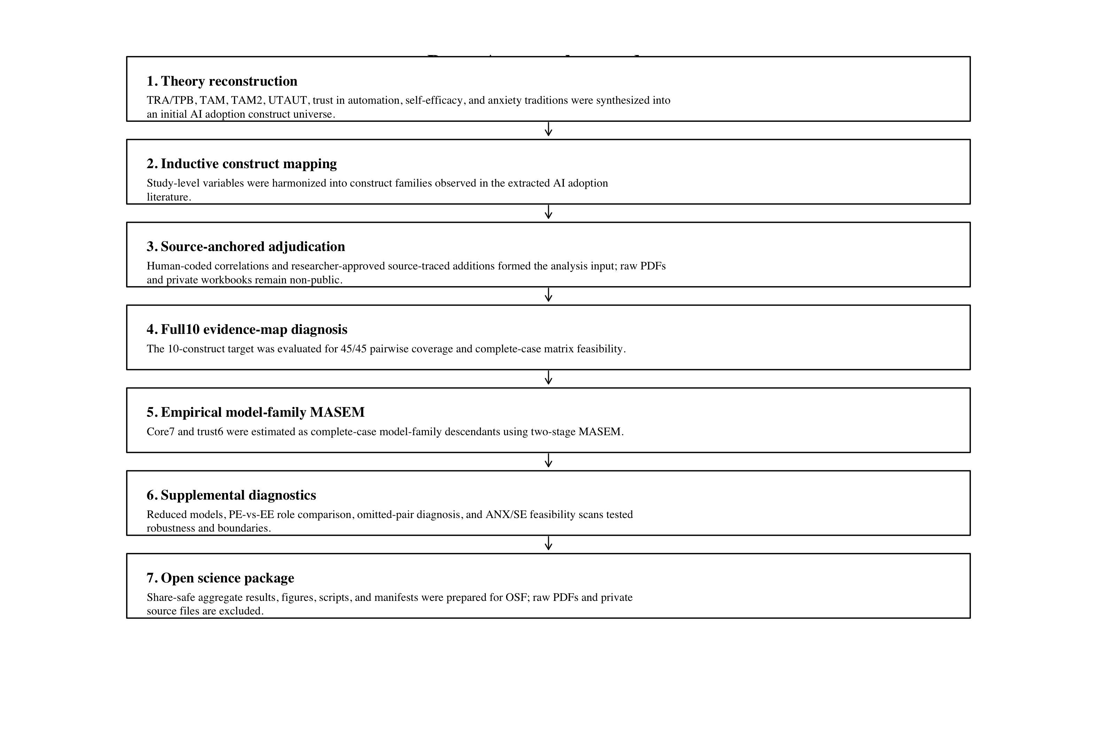
Note. The procedure separates theory reconstruction, source-anchored extraction, matrix diagnosis, model-family MASEM, supplemental diagnostics, and open science packaging.

Method

Design Overview
The study used a model-family TSSEM/MASEM design. The workflow intentionally separated theory construction, source-anchored data preparation, matrix-feasibility diagnosis, primary model-family MASEM, supplemental diagnostics, and open-science packaging.

Source-Anchored Construct Coding
The analysis used the source-anchored adjudicated human reference standard with researcher-approved S048 additions. Raw PDFs, private source documents, and raw coder workbooks are not redistributed.

Matrix-Feasibility Diagnosis
For each candidate model, the analysis evaluated required construct pairs, observed pairwise coverage, complete-case study availability, and positive-definiteness of study-level matrices.

Primary TSSEM/MASEM
Stage 1 synthesized complete-case correlation matrices using random-effects TSSEM. Stage 2 estimated prespecified structural paths for core7 and trust6. Path-level support was classified by likelihood-based 95% confidence intervals.

Supplemental Diagnostics
Supplemental diagnostics tested reduced models, PE-vs-EE role comparison, omitted full10 pairs, and ANX/SE-inclusive feasibility scans. They are sensitivity diagnostics, not definitive nested model-selection tests.

Results

Full10 Evidence Map
The full10 target achieved complete pairwise coverage across all 45 construct pairs. However, zero studies contained a complete 10-construct matrix, so full10 was not estimable as a single complete-case SEM.
Table 2
Primary Model-Family MASEM Fit
Model | k | N_eff | χ² | df | p | CFI | TLI | RMSEA | SRMR
Core7 ATT mediation | 4 | 3172 | 6.146 | 5 | .292 | 0.999 | 0.996 | 0.009 | 0.043
Trust6 trust mechanism | 7 | 10315 | 8.957 | 4 | .062 | 0.996 | 0.985 | 0.011 | 0.040
Note. Full10 is reported as a theoretical evidence map rather than an estimable complete-case SEM.
Figure 1
Full10 Theoretical Evidence Map
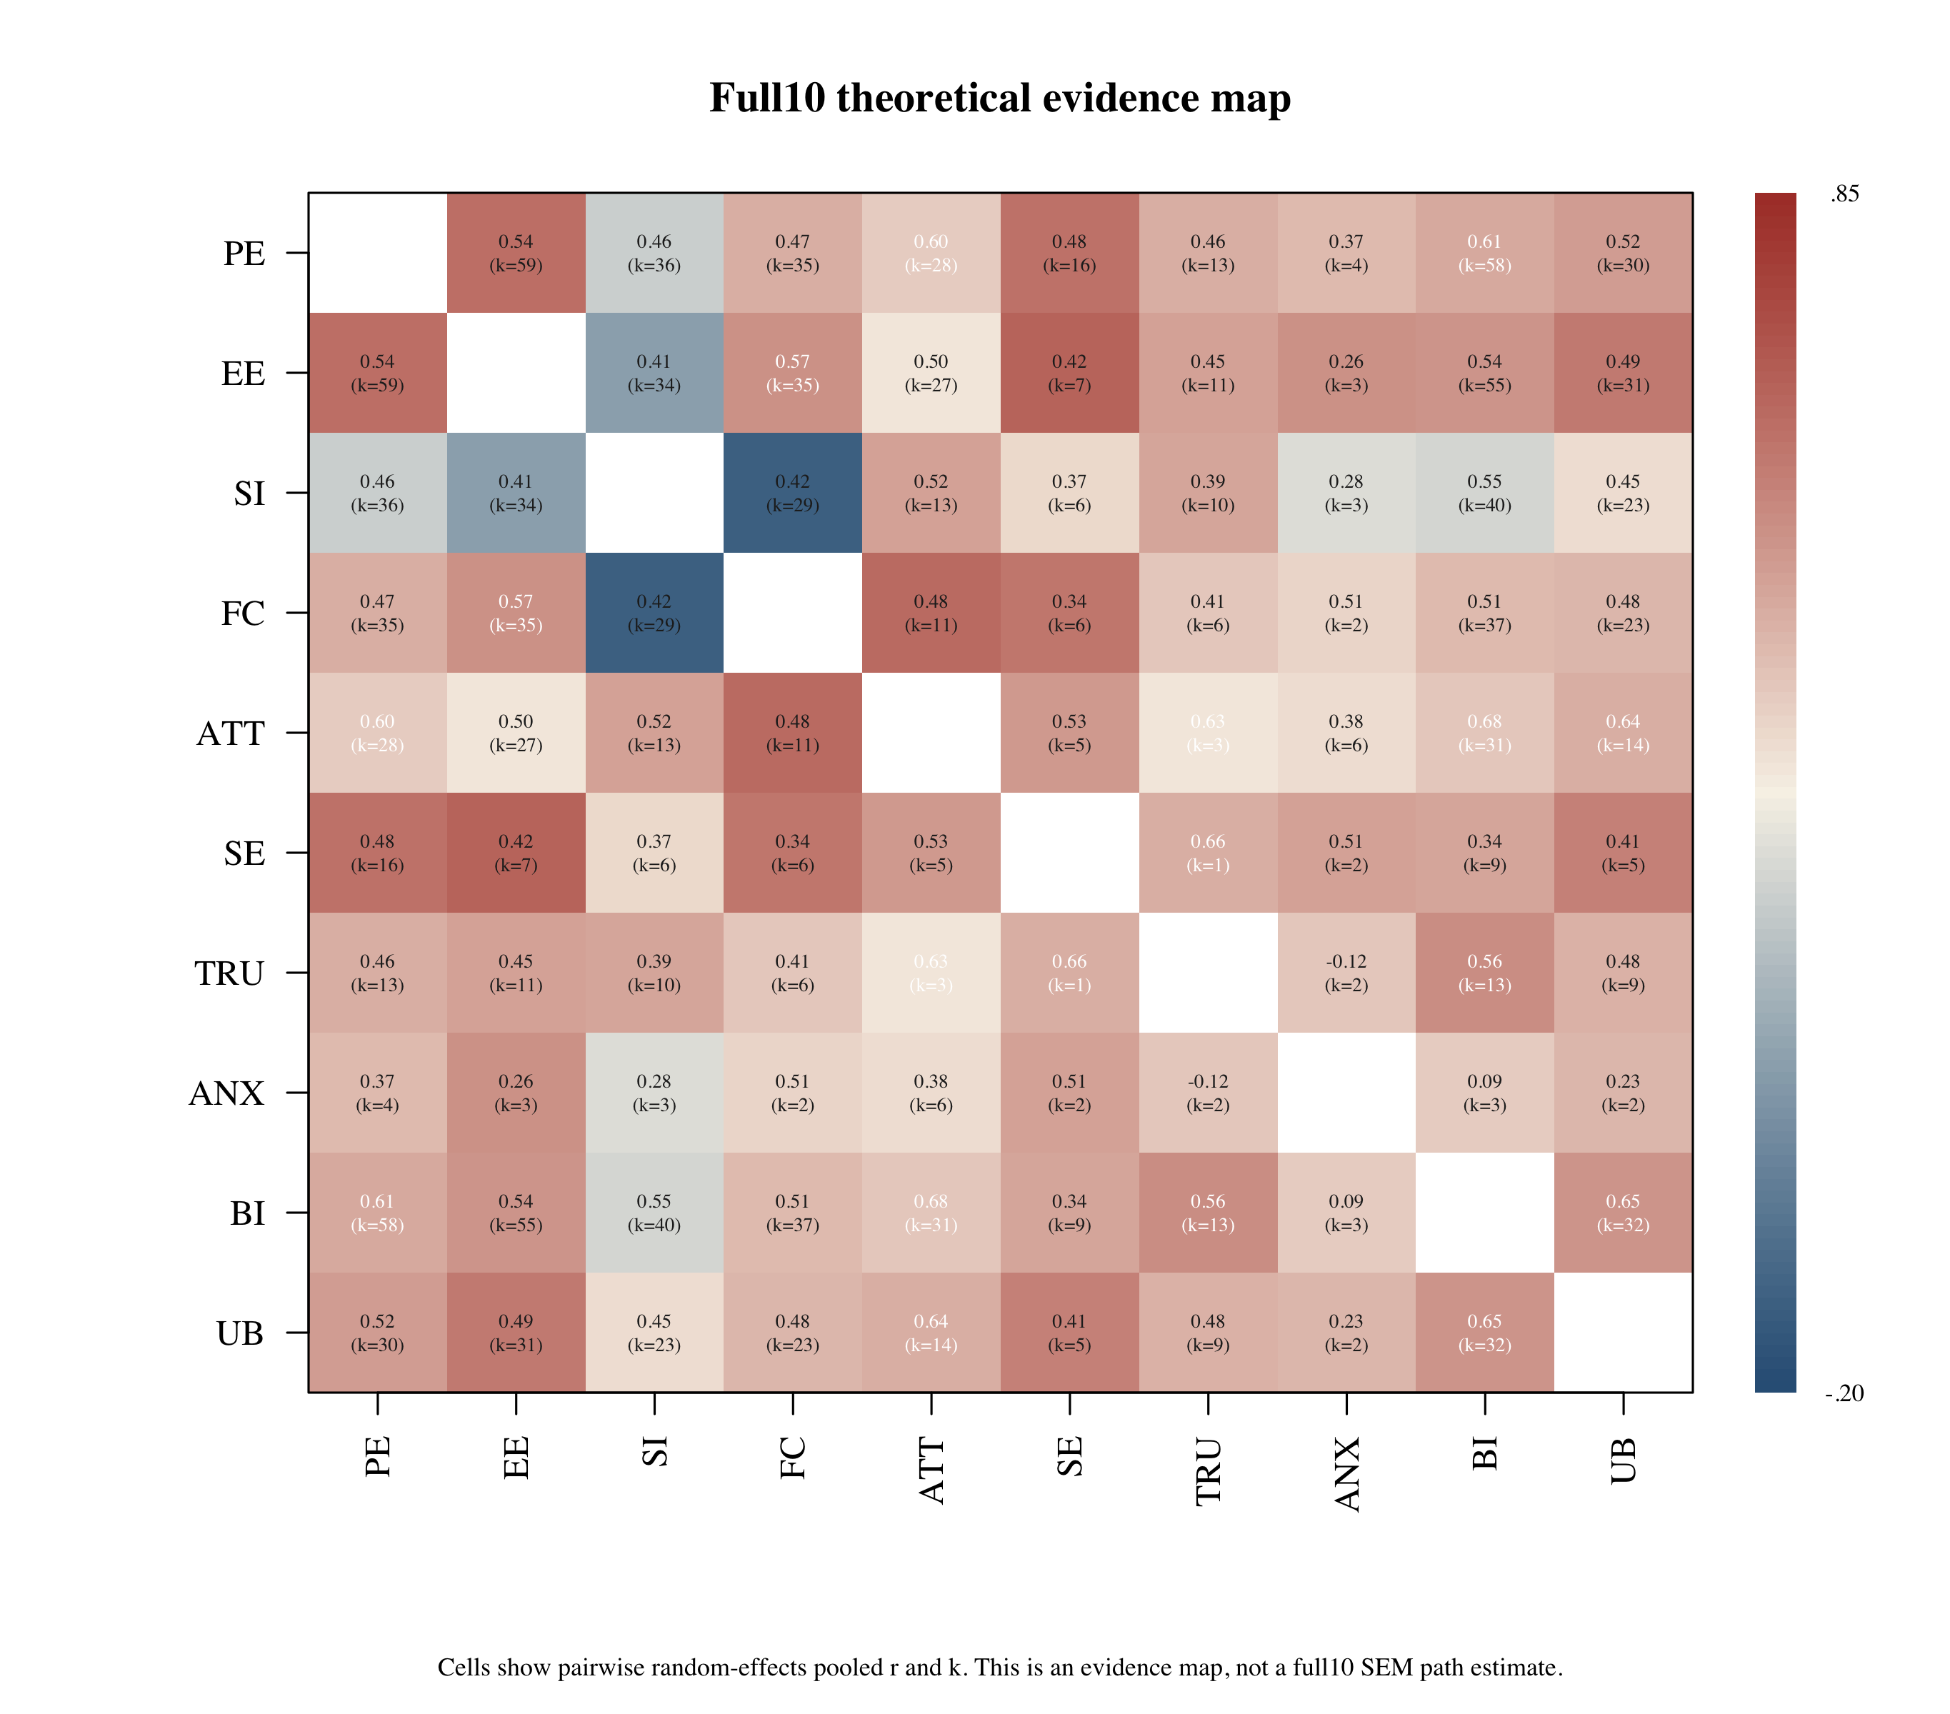
Note. Cells show pairwise random-effects pooled correlations and k. This is an evidence map, not a full10 SEM estimate.

Primary Structural Paths
Core7 supported FC -> ATT, SI -> BI, ATT -> BI, FC -> UB, and BI -> UB. Trust6 supported EE -> BI, TRU -> BI, and BI -> UB. Several PE paths were positive but interval-incomplete.
Figure 2
Core7 Attitude-Mediation MASEM Path Diagram
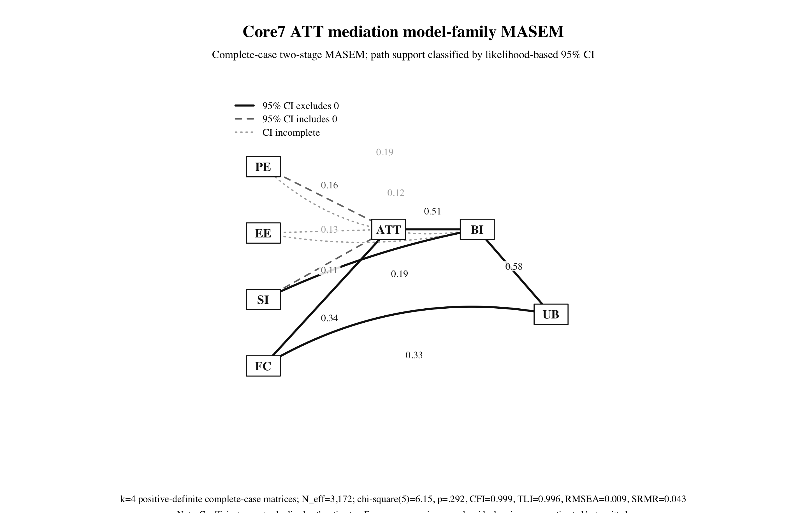
Note. Solid paths indicate likelihood-based 95% CIs excluding zero; dashed paths include zero; dotted paths have incomplete intervals.
Figure 3
Trust6 Mechanism MASEM Path Diagram
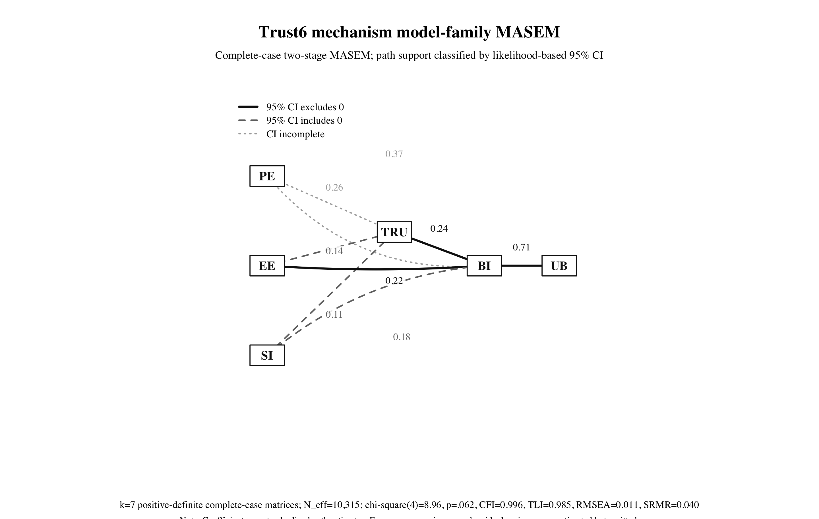
Note. Solid paths indicate likelihood-based 95% CIs excluding zero; dashed paths include zero; dotted paths have incomplete intervals.

Supplemental Model-Family Diagnostics
Supplemental diagnostics strengthened the model-family argument. Trust-only mediation fit poorly, supporting trust as a direct AI reliance mechanism rather than the sole mediator. Pure attitude mediation fit worse than the baseline core7 route, supporting direct belief-intention paths.
Table 3
Supplemental Reduced and Alternative Model-Family Diagnostics
Model | k | Status | χ² | df | p | CFI | TLI | RMSEA | SRMR | AIC
core7_full | 4 | converged | 6.146 | 5 | .292 | 0.999 | 0.996 | 0.009 | 0.043 | -3.854
core6_no_ATT_direct_beliefs | 17 | converged | 1.780 | 3 | .619 | 1.000 | 1.004 | 0.000 | 0.017 | -4.220
core7_pure_ATT_mediation_no_direct_belief_BI | 4 | status_6 | 18.318 | 8 | .019 | 0.991 | 0.975 | 0.020 | 0.066 | 2.318
trust6_full | 7 | converged | 8.957 | 4 | .062 | 0.996 | 0.985 | 0.011 | 0.040 | 0.957
trust5_no_TRU_direct_acceptance | 20 | converged | 6.496 | 3 | .090 | 0.997 | 0.991 | 0.008 | 0.032 | 0.496
trust6_trust_mediator_no_direct_belief_BI | 7 | converged | 150.683 | 7 | < .001 | 0.888 | 0.760 | 0.045 | 0.160 | 136.683
se4_capability_effort_intention | 2 | status_6 | 2.916 | 2 | .233 | 0.999 | 0.998 | 0.022 | 0.091 | -1.084
Note. Reduced models are diagnostic and not definitive nested tests because construct removal can change complete-case k and matrix structure.

PE Versus EE Role Comparison
PE and EE are distinct usefulness and effort mechanisms. EE -> BI was supported in trust6, whereas several PE paths were positive but interval-incomplete; therefore the manuscript should not claim universal PE or EE dominance.
Table 4
Performance Expectancy and Effort Expectancy as Distinct Mechanisms
Model | Predictor | Target | Estimate | 95% CI | Inference
Core7 ATT mediation | PE | ATT | 0.157 | [-0.170, 0.654] | not_supported_95ci_includes_zero
Core7 ATT mediation | EE | ATT | 0.127 | [NA, NA] | ci_incomplete
Core7 ATT mediation | PE | BI | 0.187 | [NA, 0.582] | ci_incomplete
Core7 ATT mediation | EE | BI | 0.122 | [NA, 0.347] | ci_incomplete
Trust6 trust mechanism | PE | TRU | 0.261 | [NA, 0.438] | ci_incomplete
Trust6 trust mechanism | EE | TRU | 0.140 | [-0.024, 0.285] | not_supported_95ci_includes_zero
Trust6 trust mechanism | PE | BI | 0.365 | [NA, 0.512] | ci_incomplete
Trust6 trust mechanism | EE | BI | 0.225 | [0.045, 0.375] | supported_positive_95ci
Note. The comparison concerns PE and EE roles across targets, not the PE-EE correlation.

Anxiety and Self-Efficacy Feasibility
Self-efficacy has more near-term empirical potential than anxiety in the current complete-case structure, but ANX/SE models remain exploratory or underidentified.
Table 5
Targeted Anxiety and Self-Efficacy Feasibility Attempts
Model | Constructs | k | Status | CFI | RMSEA
se4_capability_effort_intention | SE,EE,BI,UB | 2 | status_6 | 0.999 | 0.022
se4_capability_attitude_intention | SE,ATT,BI,UB | 0 | not_run | NA | NA
anx4_threat_attitude_intention | ANX,ATT,BI,UB | 0 | not_run | NA | NA
anx4_trust_threat_reliance | ANX,TRU,BI,UB | 0 | not_run | NA | NA
se_anx_bi_capability_threat | SE,ANX,BI,UB | 0 | not_run | NA | NA
se_anx_tru_bi | SE,ANX,TRU,BI | 0 | not_run | NA | NA
Note. ANX/SE models are feasibility diagnostics and should not replace the primary model-family MASEM.

Discussion

Theoretical Contribution
Paper A contributes a theory-preserving approach to AI adoption meta-analysis: it reconstructs full10 while refusing to overclaim an omnibus SEM that the matrix structure cannot support.

Trust in AI Systems
Trust is a central AI-specific reliance mechanism under opacity, autonomy, uncertainty, and vulnerability. It should not be framed as the only mediator of PE/EE/SI effects.

Performance Expectancy and Effort Expectancy
PE and EE represent different practical questions: whether AI is worth using and whether AI is manageable to use. Their roles differ across model families.

Anxiety and Self-Efficacy
Anxiety and self-efficacy are future mechanisms, not failed mechanisms. Pairwise evidence exists, but complete-case structural evidence is not yet sufficient for primary MASEM.

Methodological Contribution
The workflow preserves broad theory, diagnoses pair coverage and complete-case feasibility, estimates defensible model-family members, and reports supplemental diagnostics.

Limitations and Future Work
The main limitation is matrix sparsity. Future work should verify final PRISMA counts, strengthen ANX/SE complete-case evidence, and preregister the final model-family hierarchy before submission if stronger confirmatory language is desired.

Data Availability
A share-safe Paper A public repository package has been prepared locally and is intended for upload to a Paper A component under https://osf.io/mkrgd/overview. Raw PDFs, private source documents, raw coder workbooks, and runtime files are excluded.

References
(2003). Consumer Acceptance of Electronic Commerce: Integrating Trust and Risk with the Technology Acceptance Model. International Journal of Electronic Commerce, 7(3), 101-134. https://doi.org/10.1080/10864415.2003.11044275
Ajzen, I. (1991). The theory of planned behavior. Organizational Behavior and Human Decision Processes, 50(2), 179-211. https://doi.org/10.1016/0749-5978(91)90020-T
Bandura, A. (1977). Self-efficacy: Toward a unifying theory of behavioral change.. Psychological Review, 84(2), 191-215. https://doi.org/10.1037/0033-295X.84.2.191
Bandura, A. (1997). Self-efficacy: The exercise of control. https://www.worldcat.org/title/36074515
Burnham, K. P., & Anderson, D. R. (2002). Model selection and multimodel inference. https://link.springer.com/book/10.1007/b97636
Celik, I. (2023). Towards Intelligent-TPACK: An empirical study on teachers’ professional knowledge to ethically integrate artificial intelligence (AI)-based tools into education. Computers in Human Behavior, 138, 107468. https://doi.org/10.1016/j.chb.2022.107468
Cheung, M. W. L. (2014). Fixed- and random-effects meta-analytic structural equation modeling: Examples and analyses in R. Behavior Research Methods, 46(1), 29-40. https://doi.org/10.3758/s13428-013-0361-y
Cheung, M. W. L. (2015). metaSEM: an R package for meta-analysis using structural equation modeling. Frontiers in Psychology, 5. https://doi.org/10.3389/fpsyg.2014.01521
Cheung, M. W. L., & Chan, W. (2005). Meta-analytic structural equation modeling: A two-stage approach.. Psychological Methods, 10(1), 40-64. https://doi.org/10.1037/1082-989X.10.1.40
Cheung, M. W.-L. (2015). Meta-analysis: A structural equation modeling approach. https://www.wiley.com/en-us/Meta+Analysis%3A+A+Structural+Equation+Modeling+Approach-p-9781119993438
Compeau, D. R., & Higgins, C. A. (1995). Computer Self-Efficacy: Development of a Measure and Initial Test. MIS Quarterly, 19(2), 189-211. https://doi.org/10.2307/249688
Compeau, D., Higgins, C. A., & Huff, S. (1999). Social Cognitive Theory and Individual Reactions to Computing Technology: A Longitudinal Study1. MIS Quarterly, 23(2), 145-158. https://doi.org/10.2307/249749
Davis, F. D. (1989). Perceived Usefulness, Perceived Ease of Use, and User Acceptance of Information Technology. MIS Quarterly, 13(3), 319-340. https://doi.org/10.2307/249008
Davis, F. D., Bagozzi, R. P., & Warshaw, P. R. (1989). User Acceptance of Computer Technology: A Comparison of Two Theoretical Models. Management Science, 35(8), 982-1003. https://doi.org/10.1287/mnsc.35.8.982
Dwivedi, Y. K., Rana, N. P., Jeyaraj, A., Clement, M., & Williams, M. D. (2019). Re-examining the Unified Theory of Acceptance and Use of Technology (UTAUT): Towards a Revised Theoretical Model. Information Systems Frontiers, 21(3), 719-734. https://doi.org/10.1007/s10796-017-9774-y
Fishbein, M., & Ajzen, I. (1975). Belief, attitude, intention, and behavior: An introduction to theory and research. https://people.umass.edu/aizen/f&a1975.html
Gefen, D., Karahanna, E., & Straub, D. W. (2003). Trust and TAM in Online Shopping: An Integrated Model1. MIS Quarterly, 27(1), 51-90. https://doi.org/10.2307/30036519
Glikson, E., & Woolley, A. W. (2020). Human Trust in Artificial Intelligence: Review of Empirical Research. Academy of Management Annals, 14(2), 627-660. https://doi.org/10.5465/annals.2018.0057
Hancock, P. A., Billings, D. R., Schaefer, K. E., Chen, J. Y. C., de Visser, E. J., & Parasuraman, R. (2011). A Meta-Analysis of Factors Affecting Trust in Human-Robot Interaction. Human Factors: The Journal of the Human Factors and Ergonomics Society, 53(5), 517-527. https://doi.org/10.1177/0018720811417254
Jak, S., & Cheung, M. W. L. (2018). Accounting for Missing Correlation Coefficients in Fixed-Effects MASEM. Multivariate Behavioral Research, 53(1), 1-14. https://doi.org/10.1080/00273171.2017.1375886
Jak, S., & Cheung, M. W. L. (2020). Meta-analytic structural equation modeling with moderating effects on SEM parameters.. Psychological Methods, 25(4), 430-455. https://doi.org/10.1037/met0000245
Jak, S., & W.-L. Cheung, M. (2024). A Cautionary Note on Using Univariate Methods for Meta-Analytic Structural Equation Modeling. Advances in Methods and Practices in Psychological Science, 7(4), 25152459241274249. https://doi.org/10.1177/25152459241274249
Jak, S., Jorgensen, T. D., Verdam, M. G. E., Oort, F. J., & Elffers, L. (2021). Analytical power calculations for MASEM / webMASEM tutorial materials. https://webmasem.research.vu.nl/
Ke, Z., Zhang, Q., & Tong, X. (2019). Bayesian meta-analytic SEM. https://doi.org/10.1080/10705511.2018.1559062
Kelly, S., Kaye, S. A., & Oviedo-Trespalacios, O. (2023). What factors contribute to the acceptance of artificial intelligence? A systematic review. Telematics and Informatics, 77, 101925. https://doi.org/10.1016/j.tele.2022.101925
King, W. R., & He, J. (2006). A meta-analysis of the technology acceptance model. Information &amp; Management, 43(6), 740-755. https://doi.org/10.1016/j.im.2006.05.003
Labadze, L., Grigolia, M., & Machaidze, L. (2023). Role of AI chatbots in education: systematic literature review. International Journal of Educational Technology in Higher Education, 20(1), 56. https://doi.org/10.1186/s41239-023-00426-1
Landis, R. S. (2013). Successfully combining meta-analysis and structural equation modeling: Recommendations and strategies. https://doi.org/10.1177/1094428112464967
Lee, J. D., & See, K. A. (2004). Trust in Automation: Designing for Appropriate Reliance. Human Factors: The Journal of the Human Factors and Ergonomics Society, 46(1), 50-80. https://doi.org/10.1518/hfes.46.1.50_30392
Ma, Q., & Liu, L. (2004). The Technology Acceptance Model. Journal of Organizational and End User Computing, 16(1), 59-72. https://doi.org/10.4018/joeuc.2004010104
Marakas, G. M., Yi, M. Y., & Johnson, R. D. (1998). The Multilevel and Multifaceted Character of Computer Self-Efficacy: Toward Clarification of the Construct and an Integrative Framework for Research. Information Systems Research, 9(2), 126-163. https://doi.org/10.1287/isre.9.2.126
McKnight, D. H., Choudhury, V., & Kacmar, C. (2002). Developing and Validating Trust Measures for e-Commerce: An Integrative Typology. Information Systems Research, 13(3), 334-359. https://doi.org/10.1287/isre.13.3.334.81
Meuter, M. L., Ostrom, A. L., Bitner, M. J., & Roundtree, R. (2003). The influence of technology anxiety on consumer use and experiences with self-service technologies. Journal of Business Research, 56(11), 899-906. https://doi.org/10.1016/S0148-2963(01)00276-4
Parasuraman, A. (2000). Technology Readiness Index (Tri). Journal of Service Research, 2(4), 307-320. https://doi.org/10.1177/109467050024001
Rogers, E. M. (2003). Diffusion of innovations (5th ed.). Free Press. https://www.worldcat.org/title/52030797
Schepers, J., & Wetzels, M. (2007). A meta-analysis of the technology acceptance model: Investigating subjective norm and moderation effects. Information &amp; Management, 44(1), 90-103. https://doi.org/10.1016/j.im.2006.10.007
Scherer, R., Siddiq, F., & Tondeur, J. (2019). The technology acceptance model (TAM): A meta-analytic structural equation modeling approach to explaining teachers’ adoption of digital technology in education. Computers &amp; Education, 128, 13-35. https://doi.org/10.1016/j.compedu.2018.09.009
Schönbrodt, F. D., Wagenmakers, E. J., Zehetleitner, M., & Perugini, M. (2017). Sequential hypothesis testing with Bayes factors: Efficiently testing mean differences.. Psychological Methods, 22(2), 322-339. https://doi.org/10.1037/met0000061
Strzelecki, A. (2024). To use or not to use ChatGPT in higher education? A study of students’ acceptance and use of technology. Interactive Learning Environments, 32(9), 5142-5155. https://doi.org/10.1080/10494820.2023.2209881
Valentine, J. C., Cheung, M. W. L., Smith, E. J., Alexander, O., Hatton, J. M., Hong, R. Y., Huckaby, L. T., Patton, S. C., Pössel, P., & Seely, H. D. (2022). A Primer on Meta-Analytic Structural Equation Modeling: the Case of Depression. Prevention Science, 23(3), 346-365. https://doi.org/10.1007/s11121-021-01298-5
Venkatesh, V. (2000). Determinants of Perceived Ease of Use: Integrating Control, Intrinsic Motivation, and Emotion into the Technology Acceptance Model. Information Systems Research, 11(4), 342-365. https://doi.org/10.1287/isre.11.4.342.11872
Venkatesh, V., & Davis, F. D. (2000). A theoretical extension of TAM: Four longitudinal field studies. https://doi.org/10.1287/isre.11.2.186.11752
Venkatesh, V., Morris, M. G., Davis, G. B., & Davis, F. D. (2003). User Acceptance of Information Technology: Toward A Unified View1. MIS Quarterly, 27(3), 425-478. https://doi.org/10.2307/30036540
Venkatesh, V., Thong, J. Y. L., & Xu, X. (2012). Consumer Acceptance and Use of Information Technology: Extending the Unified Theory of Acceptance and Use of Technology1. MIS Quarterly, 36(1), 157-178. https://doi.org/10.2307/41410412
Xue, L., Mahat, J., & Ghazali, N. (2026). Technology Acceptance Model in Artificial Intelligence in Education: A Meta-Analysis. Sage Open, 16(1), 21582440251409441. https://doi.org/10.1177/21582440251409441
Xue, L., Rashid, A. M., & Ouyang, S. (2024). The Unified Theory of Acceptance and Use of Technology (UTAUT) in Higher Education: A Systematic Review. Sage Open, 14(1), 21582440241229570. https://doi.org/10.1177/21582440241229570
Yousafzai, S. Y., Foxall, G. R., & Pallister, J. G. (2007). Technology acceptance: a meta‐analysis of the TAM: Part 1. Journal of Modelling in Management, 2(3), 251-280. https://doi.org/10.1108/17465660710834453
Yousafzai, S. Y., Foxall, G. R., & Pallister, J. G. (2007). Technology acceptance: a meta‐analysis of the TAM: Part 2. Journal of Modelling in Management, 2(3), 281-304. https://doi.org/10.1108/17465660710834462

