**04/29/2025**

Wireframe

* Layout of the webpage
* Always do before you code everything
* Plan out header, footer, background colors, text colors, body, menu

Coding

* <div> = divides the text and makes it easier to organize
  + Ex: <div id=“wrapper”>
* Ctrl + / in front of text makes it a comment
* When you want to put in a special character, you need to find the html code and put it in

**HTML and CSS Reading**

HTML:

* Standard markup language for creating Web pages
* Labels pieces of content such as “this is a heading”
* HTML element is defined by a start tag and an end tag:
  + Ex: <tagname> Content goes here… </tagname>
* Browsers use HTML tags to determine how to display content
* Example:
* <!DOCTYPE html>  
  <html>  
  <body>  
    
  <h1>My First Heading</h1>  
  <p>My first paragraph.</p>  
    
  </body>  
  </html>
* <!DOCTYPE> = represents document type and helps browsers display web pages correctly
* Headings (<h1-h6>), Paragraphs (<p>), links (<a href=”link.com”>This is a link</a>), Images (<img src=“source.jpg” alt=“text_under_image” width=“number” height=“number”
* CTRL + U opens up source code

HTML Elements

* Anything from the start tag to the end tag
* Can have nested elements in them
* NEVER SKIP THE END TAG
* Empty elements
  + Have no content
  + <br> = defines a line break
* Not case sensitive

HTML Attributes

* Provide additional information about elements
* Always specified in the start tag
* Usually come in name/value pairs like: name=“value”
* href attribute
  + specifies URL of the page the link goes to in the <a> tag
* src attribute
  + specifies path to the image to be displayed
* style attribute
  + adds styles to an element, such as color, font, size
* lang attribute
  + specifies the language in the <html> tag
* title attribute
  + defines extra info about an element

Headings

* <h1-h6>
* To change size, use style= “font-size:60px;” attribute

Paragraphs

* <p>
* Always starts on new line; browsers automatically add some white space before and after a paragraph.
* <hr> = element that separates content or defines change in HTML page
  + Empty tag
* <pre> = element that displays in fixed-width format and preserves the spaces and line breaks

HTML Styles

* <tagname style=“property:value;”
* Adds color, font size, etc. to the text
* Background-color = defines background color for an HTML element
* Color property defines the text color for HTML element
* Font-family defines the font to be used for an HTML element
* Font-size
* Text-align

Text Formatting

* <b> - Bold text
* <strong> - Important text
* <i> - Italic text
* <em> - Emphasized text
* <mark> - Marked text
* <small> - Smaller text
* <del> - Deleted text
* <ins> - Inserted text
* <sub> - Subscript text
* <sup> - Superscript text

Comments

* <!-- This is a comment -->
* Place notifications and reminders in HTML code
* Can hide content temporarily; especially useful in debugging
* Can hide inline content

Links

* <a> tag
  + <a href=“url”>link text</a>
* Target attribute: specifies where to open the linked document
  + _self = default, opens doc in same window/tab
  + _blank = opens doc in new window or tab
  + _parent = opens doc in the parent frame
  + _top = opens doc in full body of the window
* Absolute vs. Relative URLs
  + Absolute gives full ink (<https://www.w3.org>)
  + Relative URLs is a link to a page within the same website (/css/default.asp)
  + To use an image as a link, put the <img> tag inside the <a> tag
  + Use mailto: inside href attribute to create a link that opens the user’s email program
* Button as a link
  + <button onclick=“document.location=‘default.asp’”>HTML Tutorial</button>
  + Need to add some JavaScript code
* Title attribute
  + Shows extra information most often as a tooltip text when mouse hovers over element

Images

* <img> = not technically inserted into a web page; it is an empty tag
* Src and alt are required attributes
* Recommended to use the style attribute
  + Prevents styles sheets from changing the size of images
* Float property lets the image float to right or left of a text

Favicon

* Small image displayed next to page title in the browser tab
* <https://favicon.cc> (create your own favicon)
* How to add
  + Save favicon image to root directory of webserver or create a folder in root directory called images
  + Add a <link> element to index.html file after the <title> element
  + <link rel=“icon” type=“image/x-icon” href=“/images/favicon.ico”>

HTML Tables

* <table>  
    <tr>  
      <th>Company</th>  
      <th>Contact</th>  
      <th>Country</th>  
    </tr>  
    <tr>  
      <td>Alfreds Futterkiste</td>  
      <td>Maria Anders</td>  
      <td>Germany</td>  
    </tr>  
    <tr>  
      <td>Centro comercial Moctezuma</td>  
      <td>Francisco Chang</td>  
      <td>Mexico</td>  
    </tr>  
  </table>
* <td> = table data tag; used in table cells
  + Everything between this tag is content of a table cell
* <tr> = table row; every table row starts with this
* <th> = table header; contents are bold and centered

HTML Lists

* Allow web devs to group a set of related items in list
* Unorderd HTML List
  + <ul> = starts the unordered list
  + <li> = each item starts with this, marked with bullets
* Ordered HTML List
  + <ol> = starts the ordered list
  + <li> = list item, in front of every list item
  + Marked with numbers by default
* Description lists
  + List of terms with a description of each term
  + <d1> = defines the description list
  + <dt> = defines the term (name)
  + <dd> = describes each term

HTML Forms

* Used to collect user input
  + Input is often sent to a server for processing
* <form> = used to create an HTML form for user input
* Container for different input elements
  + Text fields
  + Checkboxes
  + Radio buttons
  + Submit buttons

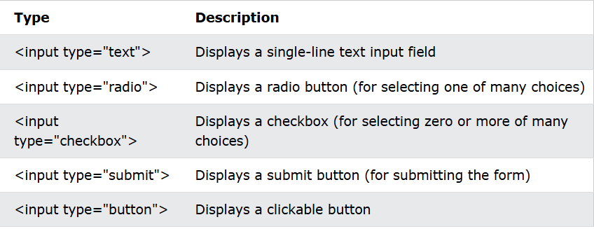

* <label> Element
  + Defines a label for many form elements
  + Useful for screen-reader users because it will read out loud the label
  + Toggles the radio button/checkbox when the text is clicked
  + For attribute of the label tag should be equal to the id attribute of the <input> element
  + Each input field must have a name attribute

**CSS**

CSS Introduction

* Cascading Style Sheets
* Describes how HTML elements are to be displayed on screen
* Can control the layout of multiple web pages all at once

CSS Syntax

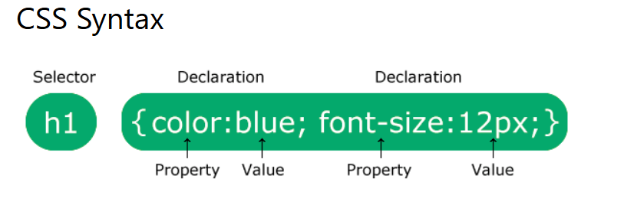

* P is a selector in CSS
* Color is a property
* Text-align is a property and center is the property value

CSS Selectors

* Used to “find” or select the HTML elements you want to style
* 5 categories
  + Simple selectors (select elements based on name, id, class)
  + Combinator selectors (select elements based on a specific relationship between them)
  + Pseudo-class selectors (select elements based on a certain state)
  + Pseudo-elements selectors (select and style a part of an element)
  + Attribute selectors (select elements based on an attribute or attribute value)
* CSS id Selector
  + #idnumber
* CSS class Selector
  + .class_name
* Universal Selector (*)
  + Selects all HTML elements on the page
* Grouping selectors
  + H1, h2, p { text-align: center; color: red; }

How to Add CSS

* External CSS
  + Change the look of entire website by changing just one file
  + Each page must include a reference to the external style sheet file inside the link element inside the head section
* Internal CSS
  + May be used if one single page has a unique style
  + Used inside the <style> element inside the head section
* Inline CSS
  + Apply unique style for a single element
  + Add the styles to the relevant element
* Multiple Style Sheets
  + If multiples properties were defined in different style sheets, the value from the last read style sheet will be used

CSS Comments

* /* This is a single-line comment */
* It can also span multiple lines

CSS Color

* Supports 140 standard color names
* <h1 style=“background-color:DodgerBlue;”>Hello World</h1>
* Color of text
  + <h1 style=“color:Tomato;”>Hello World</h1>
* Border colors
  + <h1 style=“border:2px solid Tomato;”>Hello World</h1>
* Can be specified using RGB values, HEX values, HSL values, RGBA values, HSLA values

CSS Background

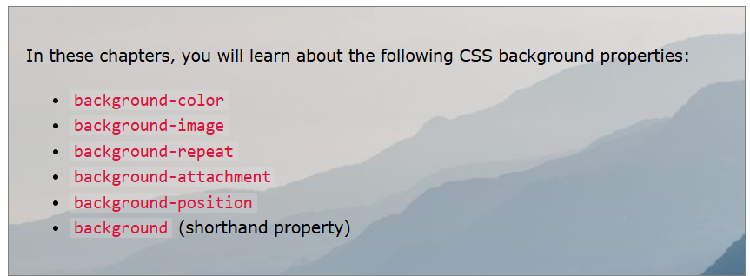

* Opacity property specifies the transparency of an element
  + Value from 0.0 to 1.0

CSS Border Style

* dotted - Defines a dotted border
* dashed - Defines a dashed border
* solid - Defines a solid border
* double - Defines a double border
* groove - Defines a 3D grooved border. The effect depends on the border-color value
* ridge - Defines a 3D ridged border. The effect depends on the border-color value
* inset - Defines a 3D inset border. The effect depends on the border-color value
* outset - Defines a 3D outset border. The effect depends on the border-color value
* none - Defines no border
* hidden - Defines a hidden border
* border-style property can have from one to four values
  + Examples: p.dotted {border-style: dotted;}  
    p.dashed {border-style: dashed;}  
    p.solid {border-style: solid;}  
    p.double {border-style: double;}  
    p.groove {border-style: groove;}  
    p.ridge {border-style: ridge;}  
    p.inset {border-style: inset;}  
    p.outset {border-style: outset;}  
    p.none {border-style: none;}  
    p.hidden {border-style: hidden;}  
    p.mix {border-style: dotted dashed solid double;}

CSS Margins

* Creates space around elements, outside of any defined borders
* Properties
  + margin-top
  + margin-right
  + margin-bottom
  + margin-left
* Values
  + Auto - the browser calculates the margin
  + Length- specifies a margin in px, pt, cm, etc.
  + %- specifies a margin in % of the width of the containing element
  + Inherit- specifies that the margin should be inherited from the parent element
  + (Negative values are allowed)
* Margin shorthand
  + Margin: top right bottom left;
  + P { margin: 25px 50px 75px;} (top is 25, right and left is 50, bottom is 75)
  + { margin: 25px 50px; } (top and bottom are 25, right and left are 50)

CSS Padding

* Same format as margin
* Generates space between an element’s content inside the borders
* Negative values are not allowed
* Box-sizing = property that keeps the width at a desired length

CSS Height and Width

* Max-width = sets the maximum width of an element
* H and W do not include padding, borders, or margins
* Values
  + auto - This is default. The browser calculates the height and width
  + length - Defines the height/width in px, cm, etc.
  + % - Defines the height/width in percent of the containing block
  + initial - Sets the height/width to its default value
  + inherit - The height/width will be inherited from its parent value

CSS Box Model

* Box that wraps around every HTML element
  + Content, Padding, Border, Margin

CSS Fonts

* Serif: have a small stroke at edges of each letter. Create formality and elegance
* Sans-serif: have clean lines; create modern and minimalistic look
* Monospace: all the letters have the same fixed width; create a mechanical look
* Cursive: imitate human handwriting
* Fantasy: fonts are decorative/playful
* Font-family property: specifies the font of the text
  + .p1 { font-family: “Times New Roman”, Times, serif; }

CSS Link states

* a:link - a normal, unvisited link
* a:visited - a link the user has visited
* a:hover - a link when the user mouses over it
* a:active - a link the moment it is clicked
* text-deccoration = removes underlines from links

CSS Lists

* list-style-type= specifies the type of list item marker
  + circle, square, upper-roman, lower-alpha
* list-style-image= specifies an image as the list item marker
* list-style-position= specifies position of list-item markers (bullet points)
  + outside, inside
* Short hand
  + Ul { list-style: square inside url} (type, position, image)

CSS Tables

* Border property specifies border on tables
* Border-collapse property sets whether the borders should be collapsed into a single border