Appendix A

Improved UML Sequence Diagram
ATM Cash Withdrawal Use Case

Diagram Overview
This appendix contains the complete reconstructed UML sequence diagram that addresses the deficiencies identified in the original design. The diagram demonstrates proper UML 2.x notation and includes comprehensive error handling and interaction flows.

Key Features Implemented:
- Lifelines for all three actors (User, ATM, Bank)
- Activation boxes showing periods of active processing
- Synchronous messages with solid arrows and parameters specified
- Return messages with dashed arrows showing responses
- alt (alternative) combined fragments for conditional logic
- loop combined fragment for PIN retry mechanism
- opt (optional) combined fragment for card ejection
- Guard conditions on all conditional branches
- Complete error handling paths for invalid PIN and insufficient funds

Reading the Diagram: Follow the lifelines from top to bottom. Messages flow horizontally between actors. The diagram spans the next two pages to maintain readability. Activation boxes (yellow rectangles on lifelines) indicate when a component is actively executing.

Sequence Diagram - Continued (Page 1 of 2)

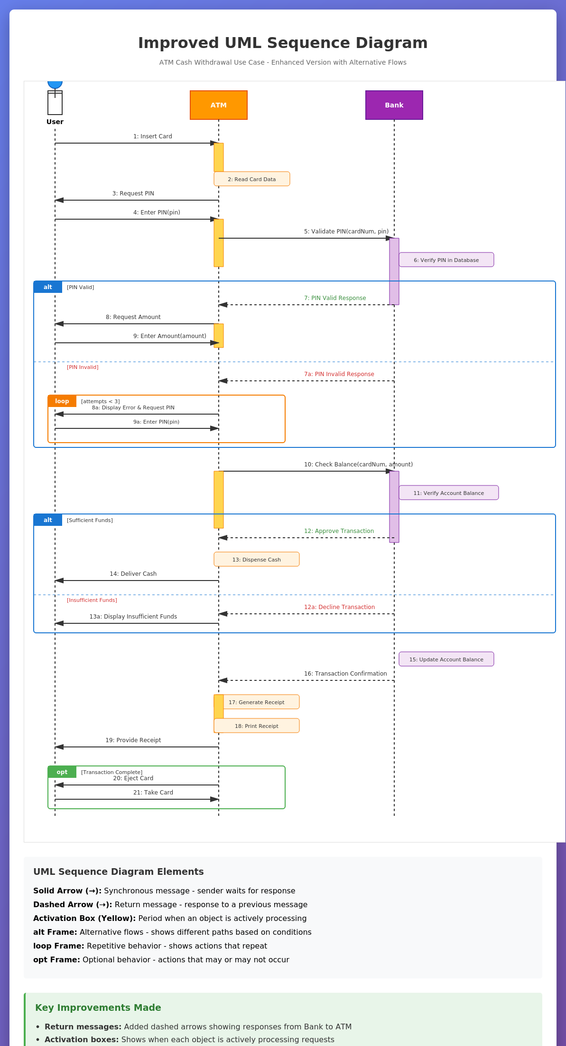

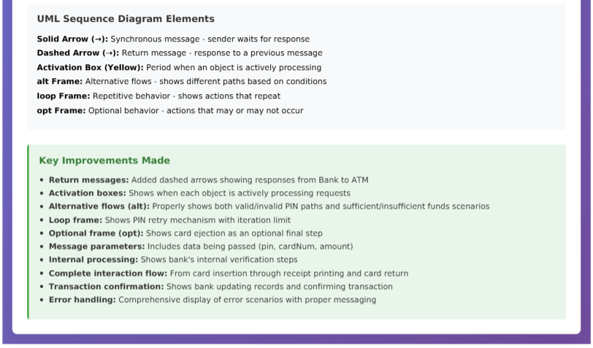
Diagram Explanation
1. Complete Error Handling
The improved diagram includes alt (alternative) combined fragments that show both successful and unsuccessful paths. When PIN validation fails, the diagram shows a loop that allows up to 3 retry attempts. Similarly, the balance check shows separate paths for sufficient and insufficient funds.

2. Return Messages
All synchronous messages now have corresponding return messages (dashed arrows). For example, after the ATM sends "Validate PIN" to the Bank, the Bank responds with either "PIN Valid Response" or "PIN Invalid Response." This completes the communication pattern and follows UML best practices.

3. Activation Boxes
Yellow activation boxes on each lifeline show exactly when each component is processing. This temporal information is critical for understanding system behavior and for implementation purposes.

4. Message Parameters
All messages include parameters showing what data is being passed. For example, "Enter PIN(pin)" and "Validate PIN(cardNum, pin)" clearly indicate the information flow between components.

5. Combined Fragments
The diagram uses three types of combined fragments: alt for alternatives (if-then-else logic), loop for iteration (PIN retry), and opt for optional behavior (card ejection). These constructs make the conditional logic explicit and easy to understand.

These improvements transform the sequence diagram from a simple "happy path" illustration into a comprehensive interaction model suitable for system implementation. The diagram now serves as both a communication tool for stakeholders and a technical blueprint for developers.

