Billy Lewis
CS 255 – Systems Analysis and Design
Professor Foss
February 22, 2026

7-3: Project Two - DriverPass System Design Document
Introduction
DriverPass is a driver training company designed to improve student success rates on Department of Motor Vehicles (DMV) driving exams. During the initial client interview, the owner, Liam, expressed the need for a comprehensive system that supports online learning, lesson scheduling, secure payment processing, and administrative oversight (Southern New Hampshire University [SNHU], 2026).
This document presents the complete system design for the DriverPass platform. It includes UML modeling artifacts (use case, activity, sequence, and class diagrams) and outlines the technical, security, and infrastructure requirements necessary to meet the client’s needs.

Use Case Diagram
The use case diagram models the functional interactions between system actors and the DriverPass platform.

The diagram (see Figure 1) illustrates six internal actors and two external systems interacting within the DriverPass system boundary.

Figure 1
DriverPass UML Use Case Diagram
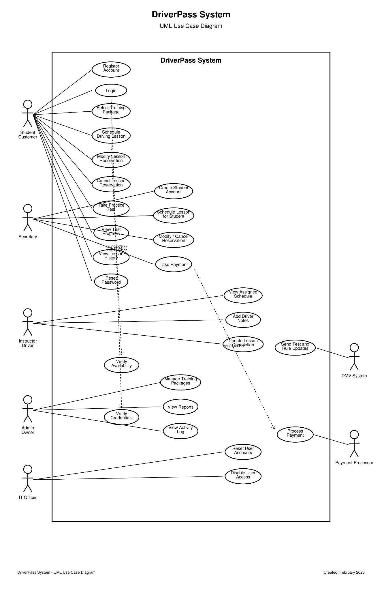

The use case diagram identifies all major functional requirements including account registration, lesson scheduling, package management, administrative oversight, and external integrations with the DMV and payment processor. Role-based responsibilities are clearly separated to enforce security and access control.

Activity Diagrams
Two key workflows were modeled using activity diagrams to represent business process logic.

Activity Diagram 1: Schedule Driving Lesson
This activity diagram (see Figure 2) illustrates the complete workflow for scheduling a driving lesson.

Figure 2
Activity Diagram – Schedule Driving Lesson Process
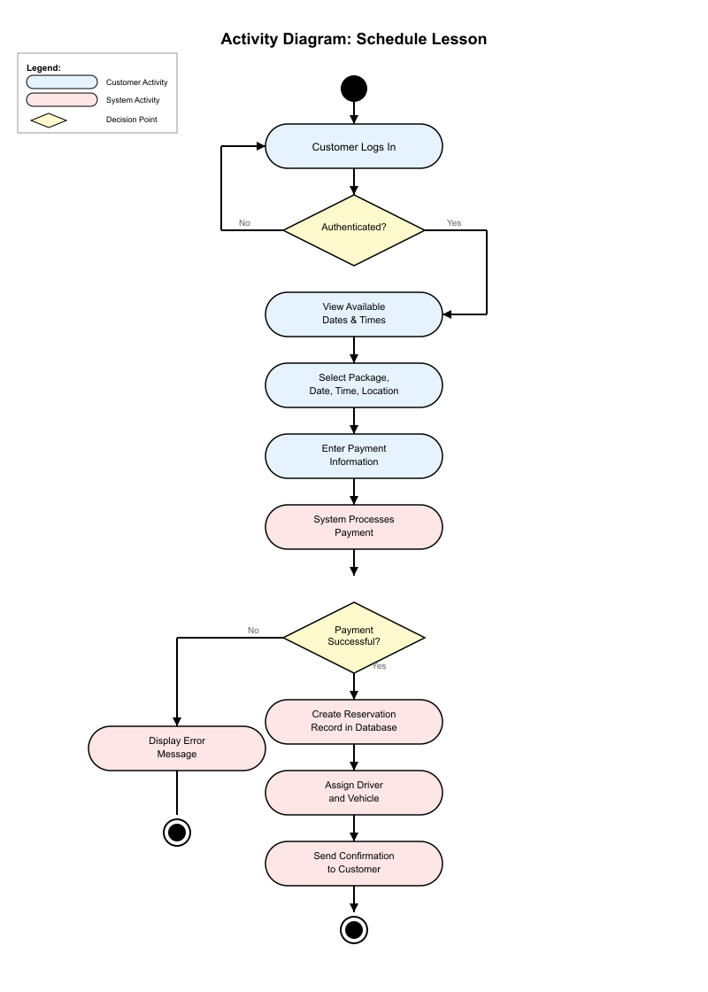

The process includes authentication validation, availability checking, package selection, payment processing, driver assignment, and confirmation delivery. Decision nodes ensure payment and authentication validation before reservation confirmation.

Activity Diagram 2: Take Practice Test
The second activity diagram (see Figure 3) models the workflow for completing an online practice test.

Figure 3
Activity Diagram – Online Practice Test Workflow
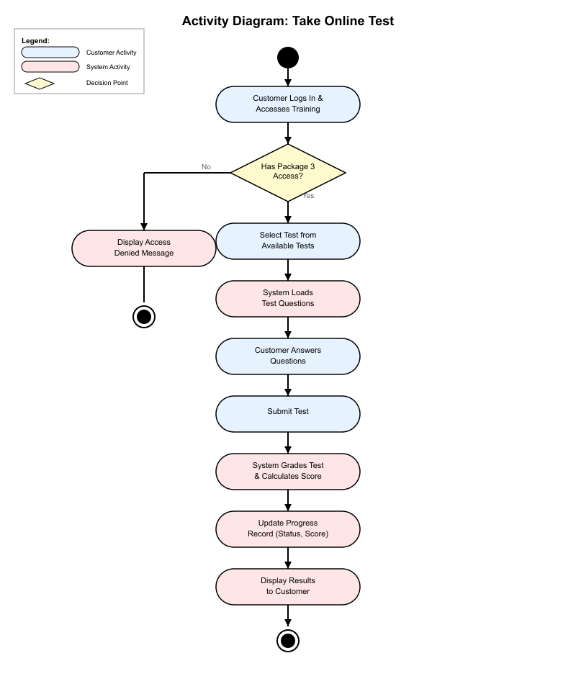

This workflow ensures only eligible students (Package Three) can access testing features. The system automatically grades responses and updates the student’s progress dashboard.

Sequence Diagram
The sequence diagram (see Figure 4) illustrates the time-ordered interaction between system components during lesson scheduling.

Figure 4
Sequence Diagram – Lesson Scheduling Interaction Flow
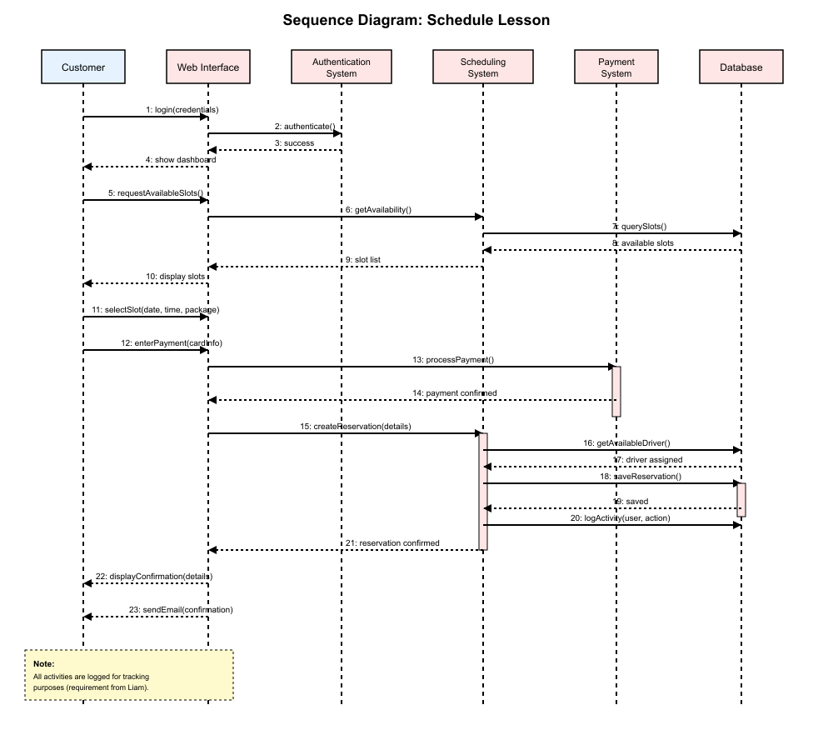

The diagram models message exchanges including login validation, availability query, payment authorization, reservation creation, database updates, activity logging, and confirmation notification. This diagram ensures correct system timing and dependency ordering.

Class Diagram
The class diagram (see Figure 5) represents the structural blueprint of the DriverPass system.

Figure 5
Class Diagram – DriverPass System Structure
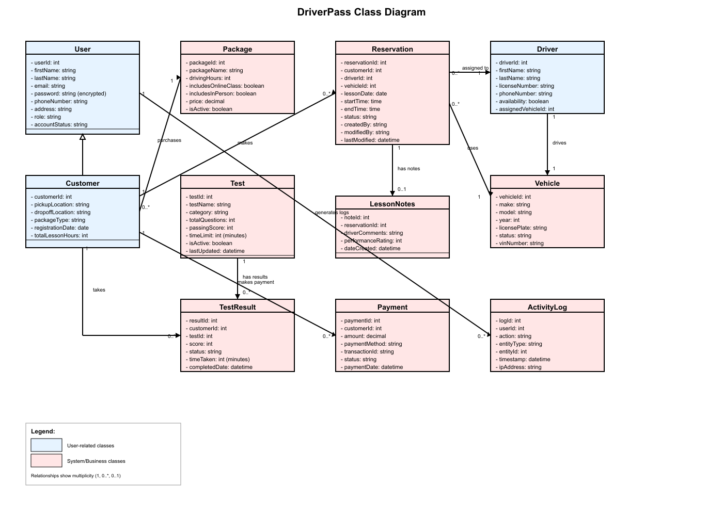

The class diagram defines object relationships, inheritance structures, and data attributes. It ensures the system maintains modularity, scalability, and data integrity while supporting all business requirements.

Technical Requirements

Infrastructure
The system will be hosted on a cloud platform such as AWS, Azure, or Google Cloud to meet the client’s request for cloud-based deployment (SNHU, 2026). The infrastructure includes auto-scaling, redundancy, and daily database backups.

Security
Security measures include:
- Role-based access control
- Multi-factor authentication for administrators
- Encrypted password storage
- PCI DSS–compliant payment processing
- SSL/TLS encryption
- Activity logging with immutable records
These features protect customer data and ensure accountability.

Conclusion
The DriverPass system design provides a secure, scalable, and fully integrated solution that meets all identified business and technical requirements. The UML diagrams included in this document model the system’s functional interactions, behavioral workflows, and structural relationships.
By leveraging cloud-based infrastructure, strong security controls, and automated business processes, the system enables DriverPass to operate efficiently while maintaining compliance and scalability for future growth.

References
Southern New Hampshire University. (2026). CS 255 DriverPass interview transcript. Course materials.

