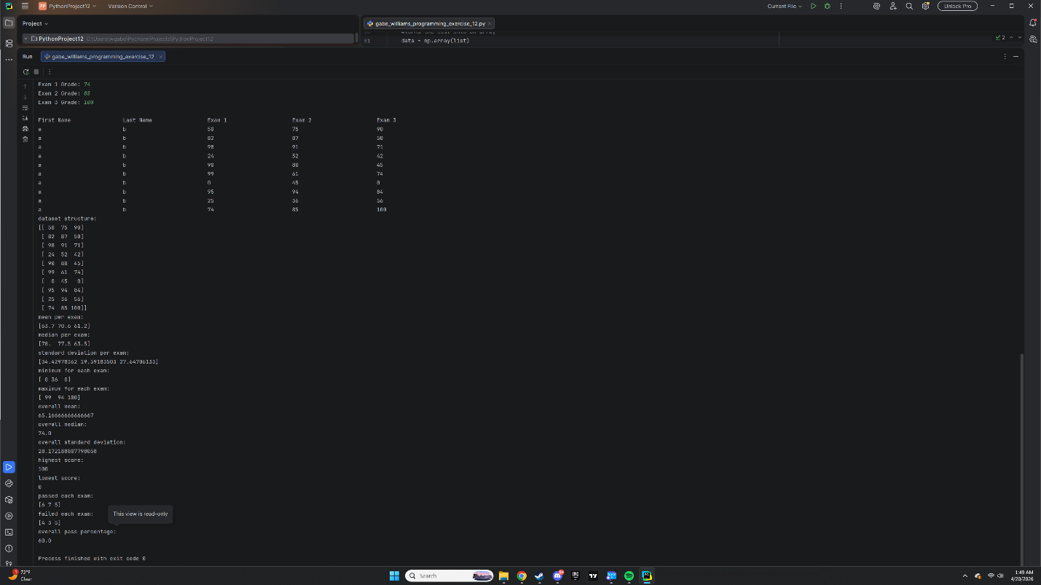
https://github.com/HotPickles/COP2373

