Hollis Veal

Project 2 Tests

Case: As a user, I want to add a new product into the system.

1. 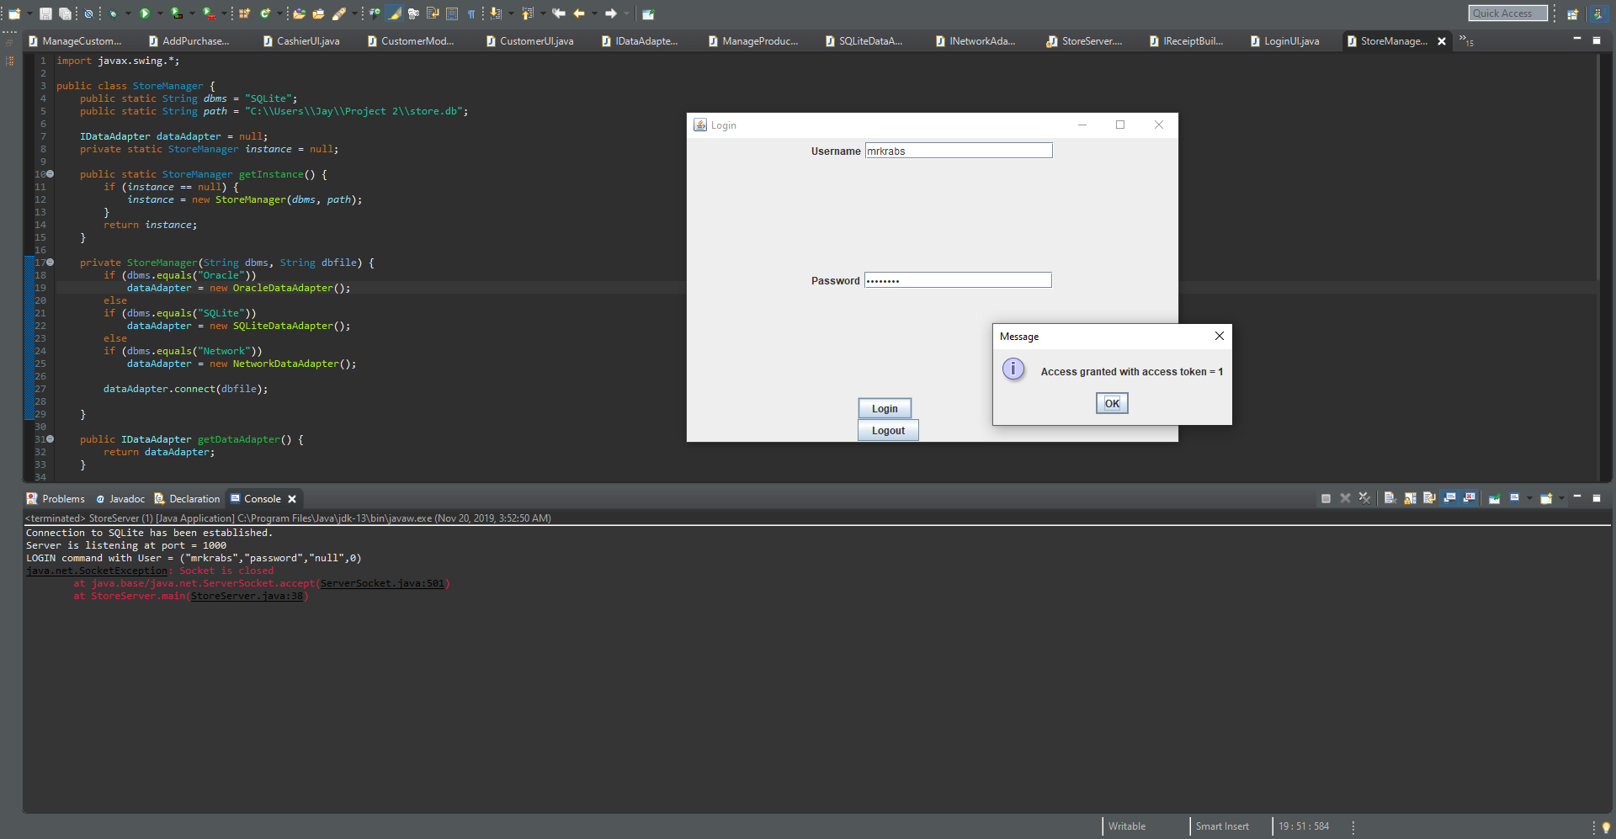First I have logged into the system as a manager so I can add a product.
2. 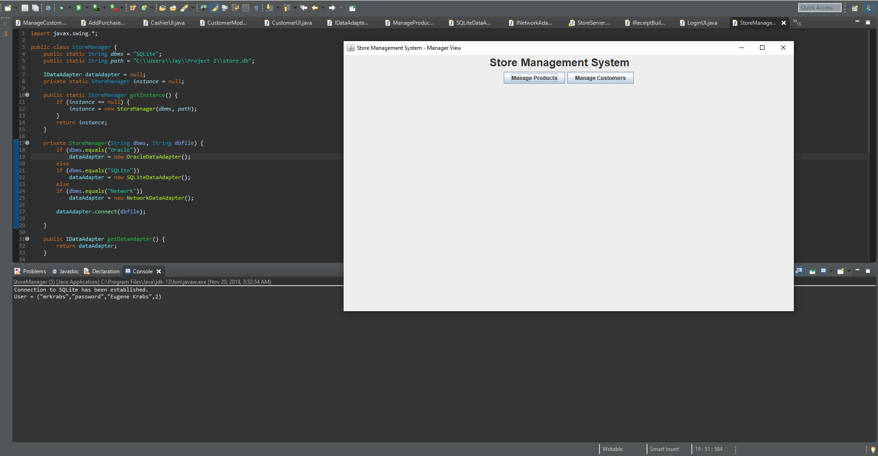This will take us to the Manager View.
3. 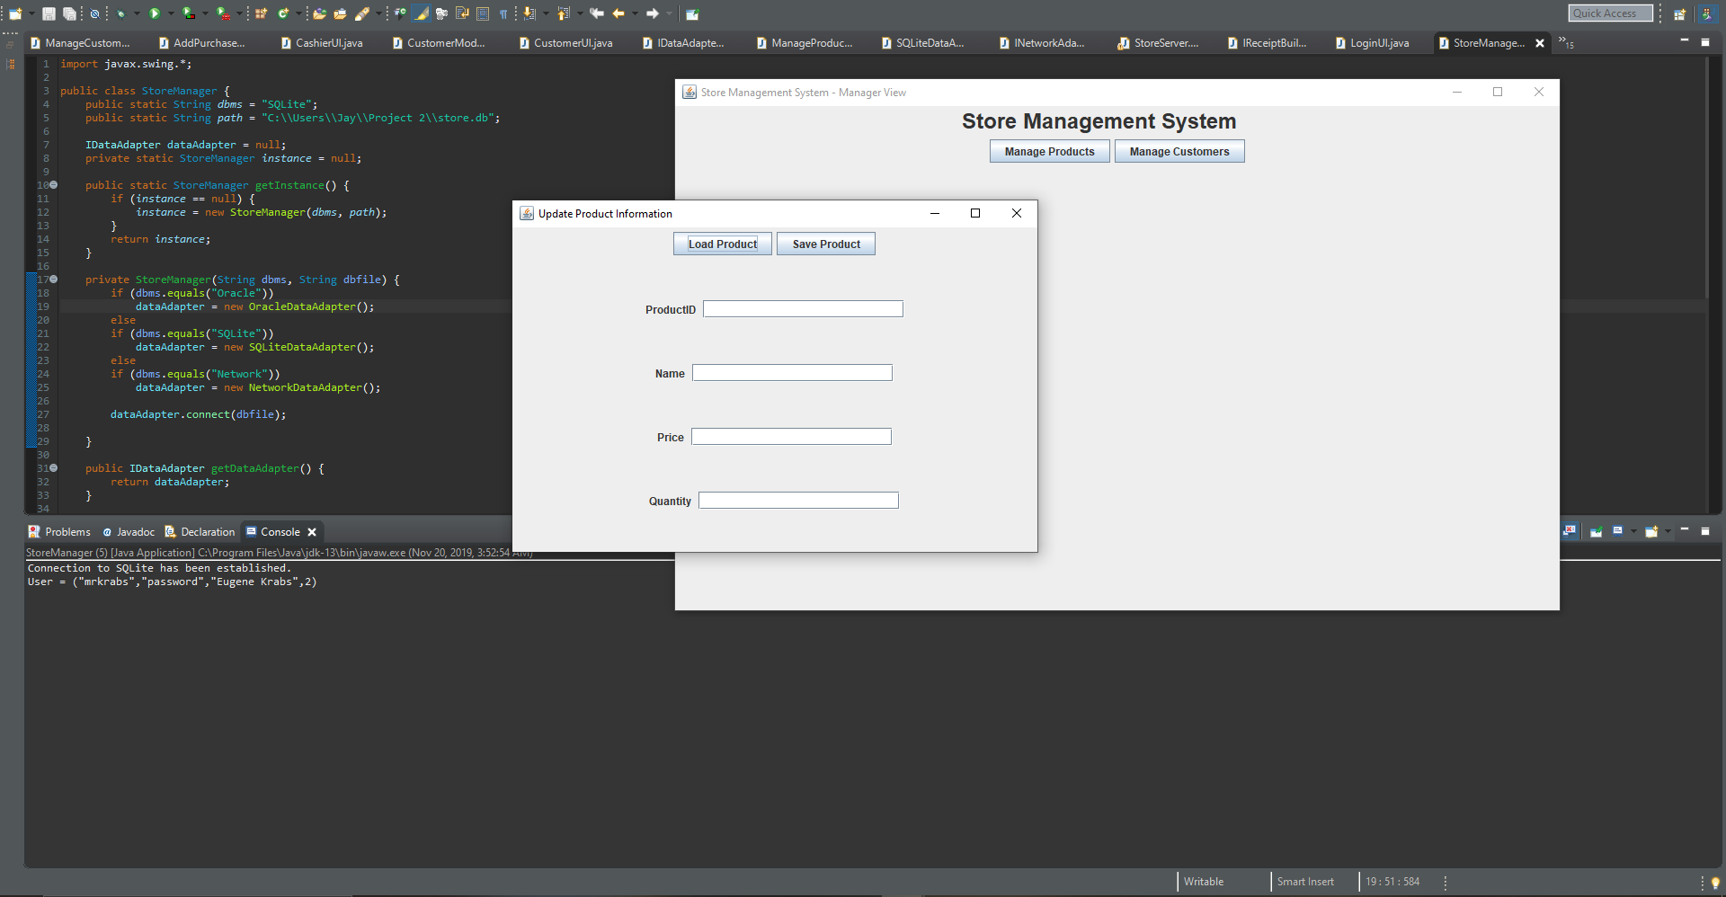From this view we will open the “Manage Products” screen.
4. Finally we insert our product information, save it, and get confirmation that it saved.

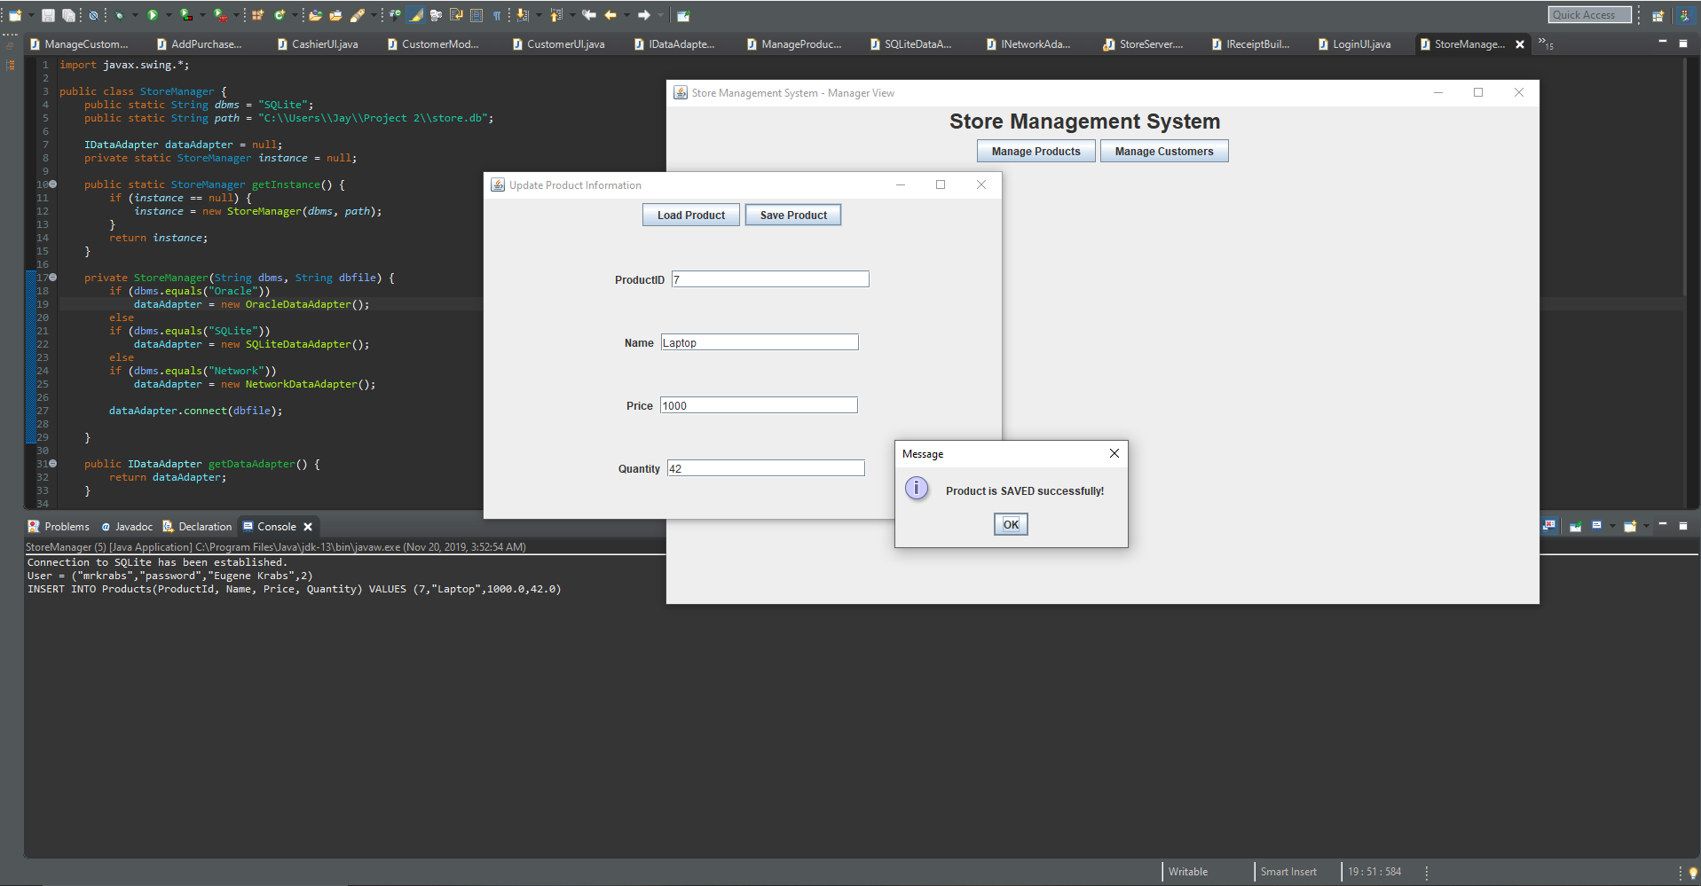

Case: As a user, I want to update a product in the system.

1. First I have logged into the system as a manager so I can update a product.
2. This will take us to the Manager View.
3. From this view we will open the “Manage Products” screen.
4. 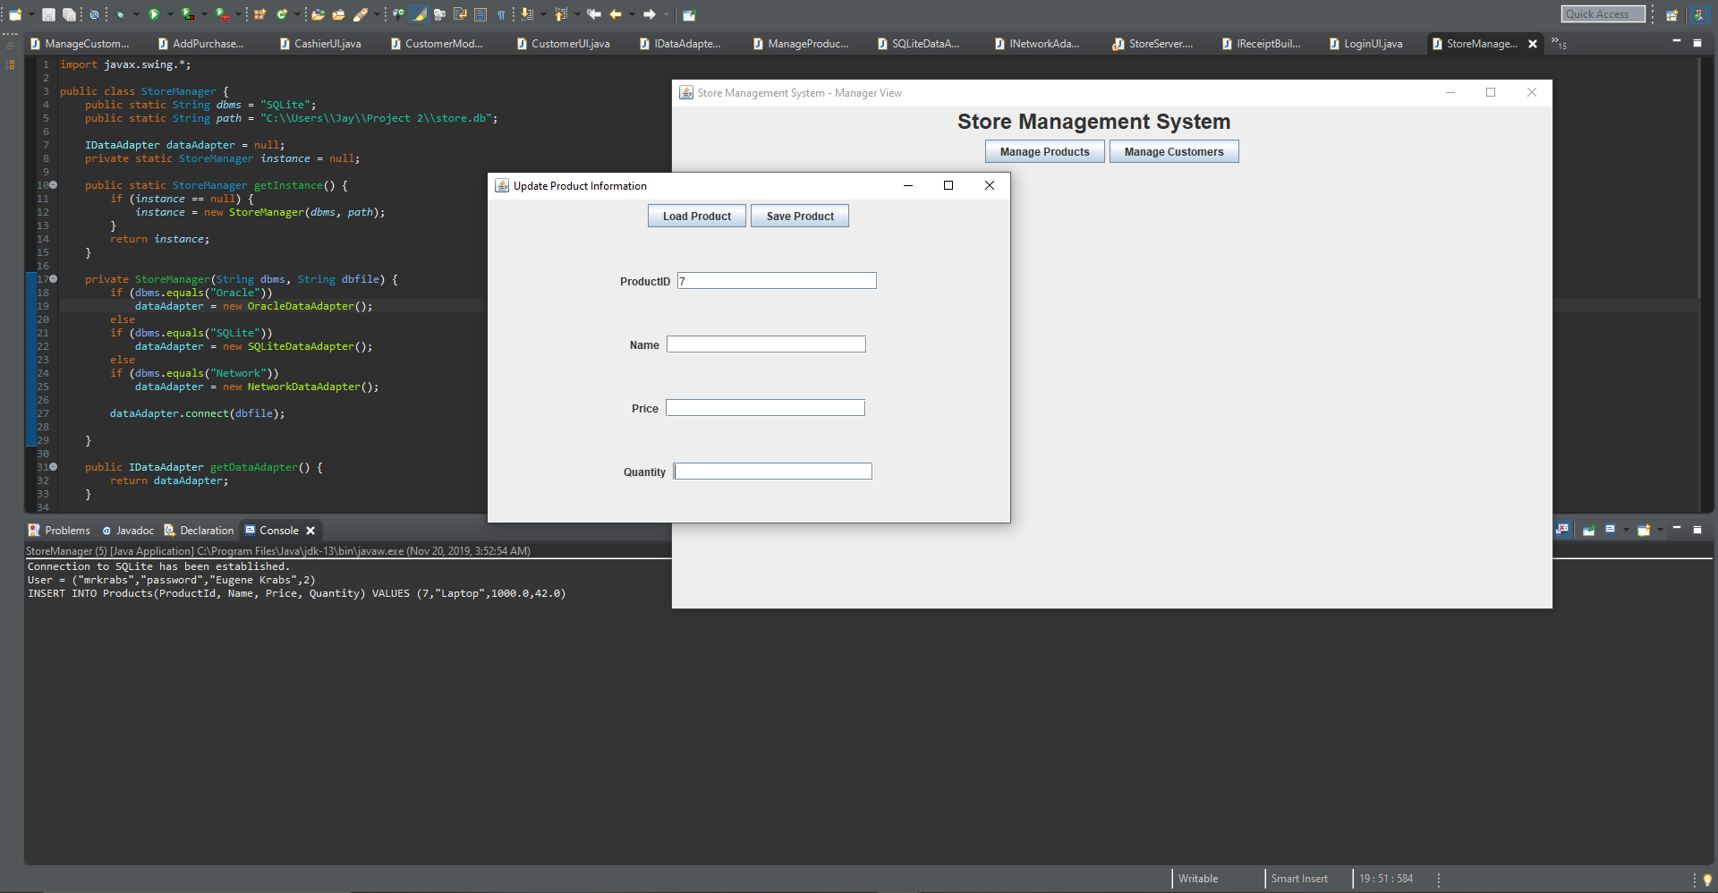We then fill in the ProductID and press “Load Product” to get the other information.
5. 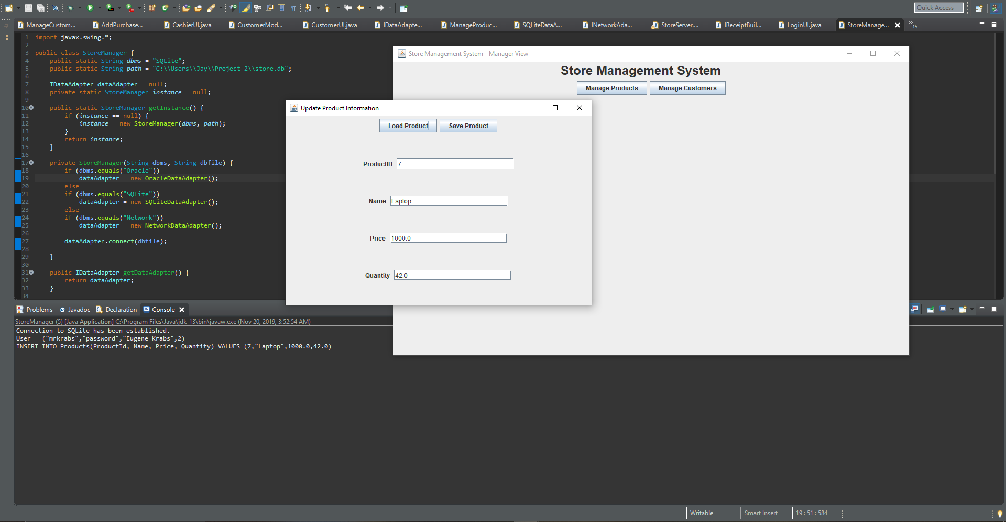Here we have successfully loaded in a product.
6. Finally we updated the information, click “Save Product”, and get a confirmation of success.

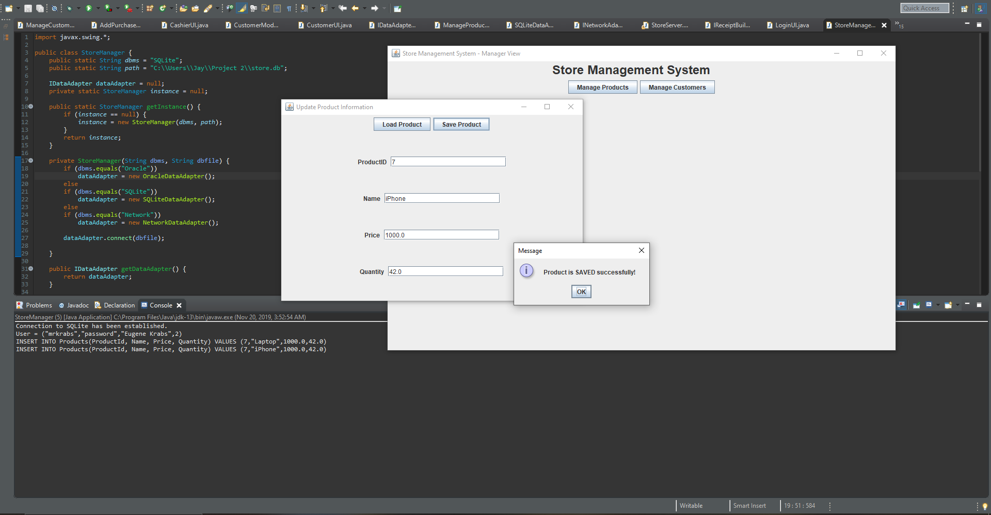

Case: As a user, I want to add a new customer into the system.

1. First I have logged into the system as a manager so I can add a customer.
2. This will take us to the Manager View.
3. 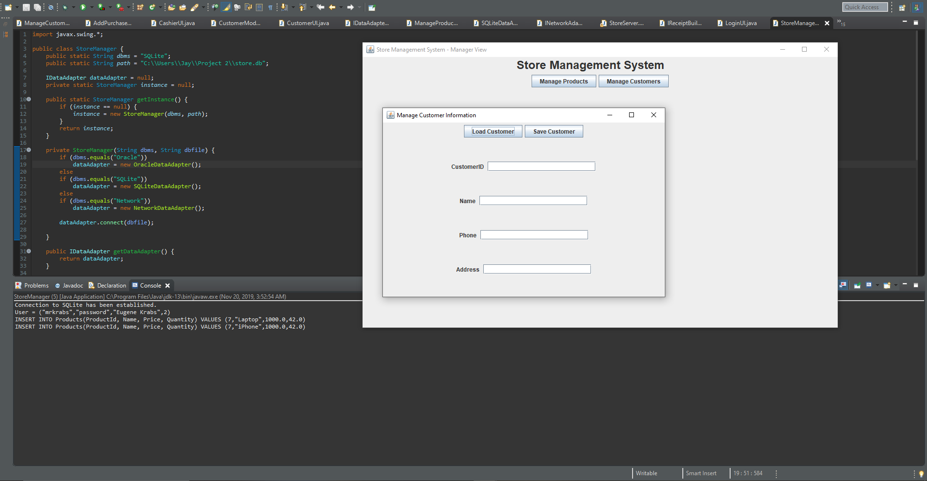From this view we will open the “Manage Customers” screen.
4. Finally we fill in the information, click “Save Customer”, and get confirmation of success.

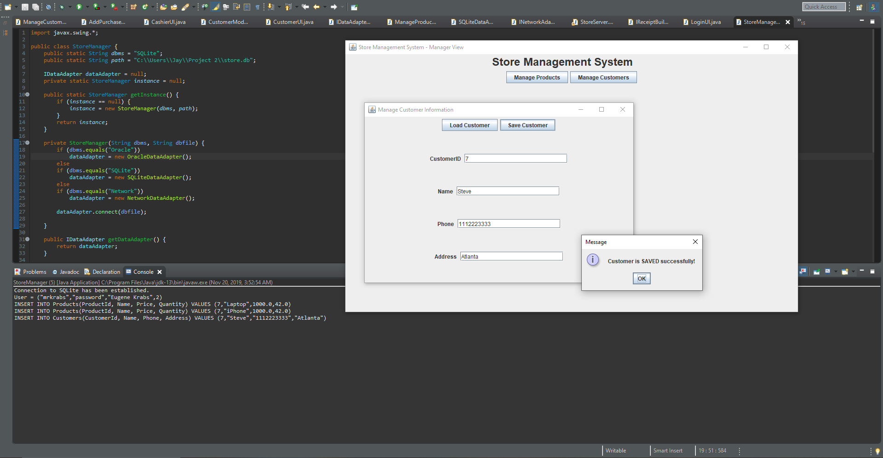

Case: As a user, I want to update a customer in the system.

1. First I have logged into the system as a manager so I can update a customer.
2. This will take us to the Manager View.
3. From this view we will open the “Manage Customers” screen.
4. We then fill in the CustomerID and press “Load Customer” to get the other information.

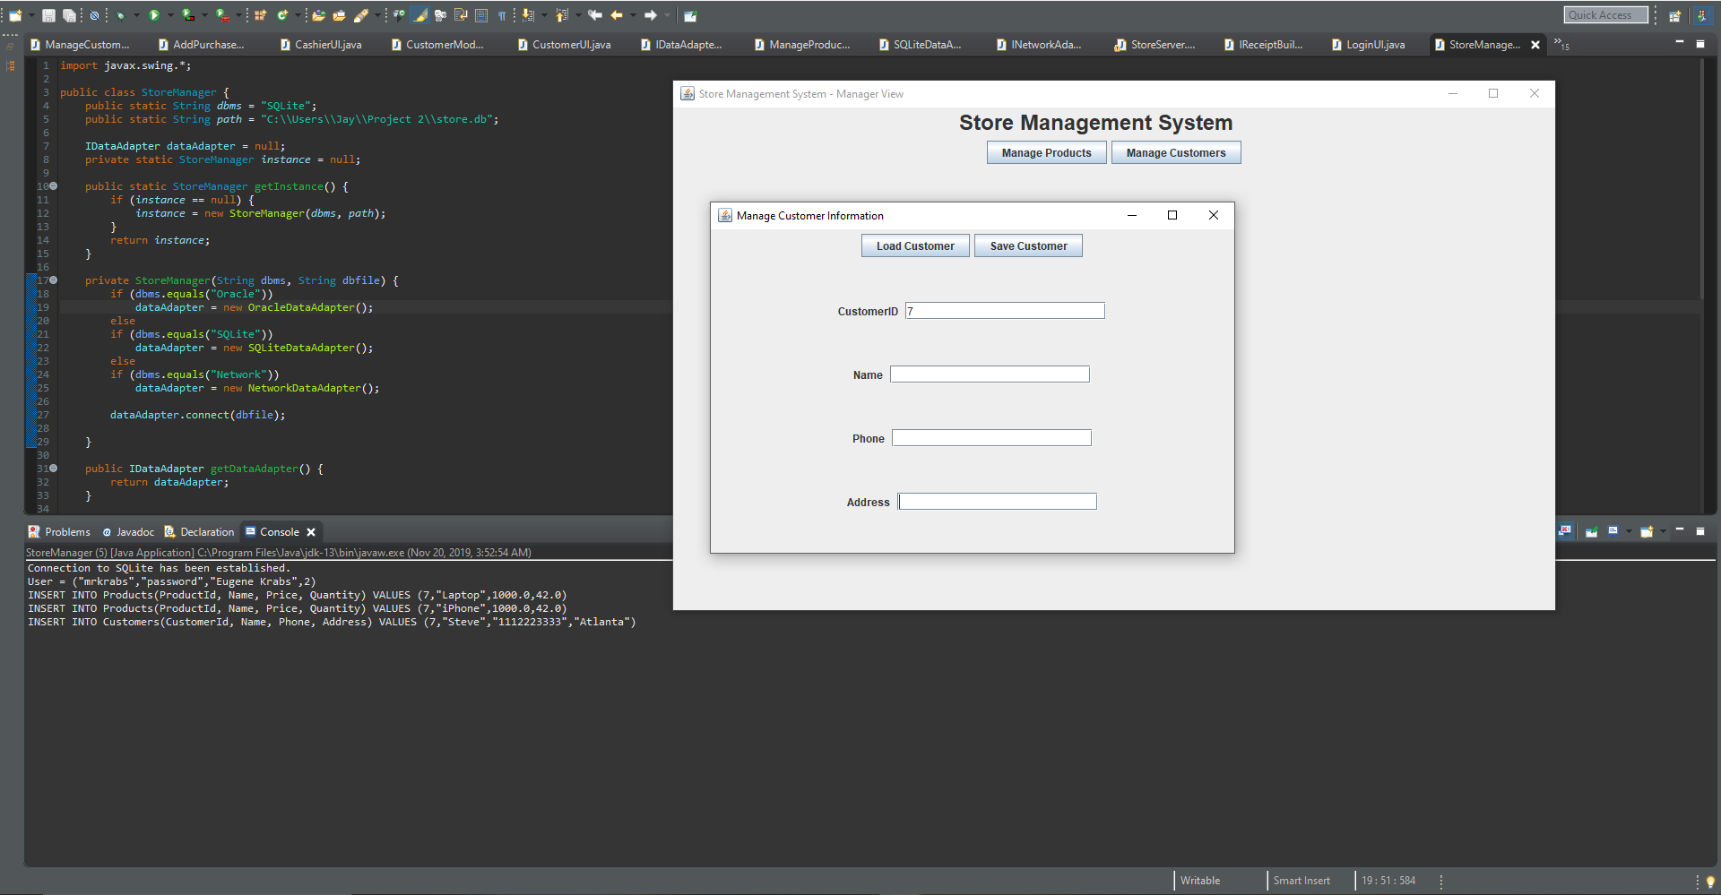

1. Here we have successfully loaded in a customer.

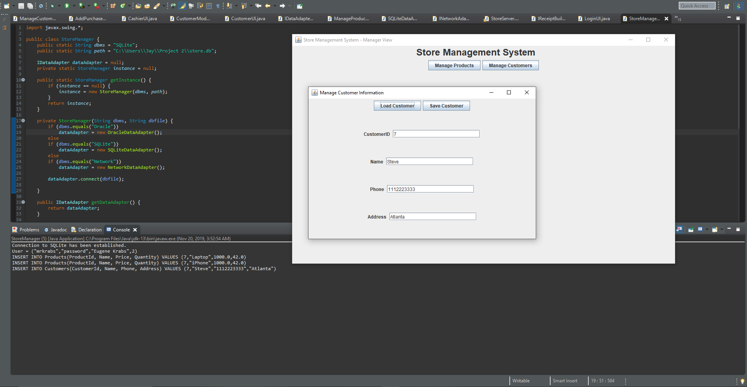

1. Finally we update the information, click “Save Customer”, and get confirmation of success.

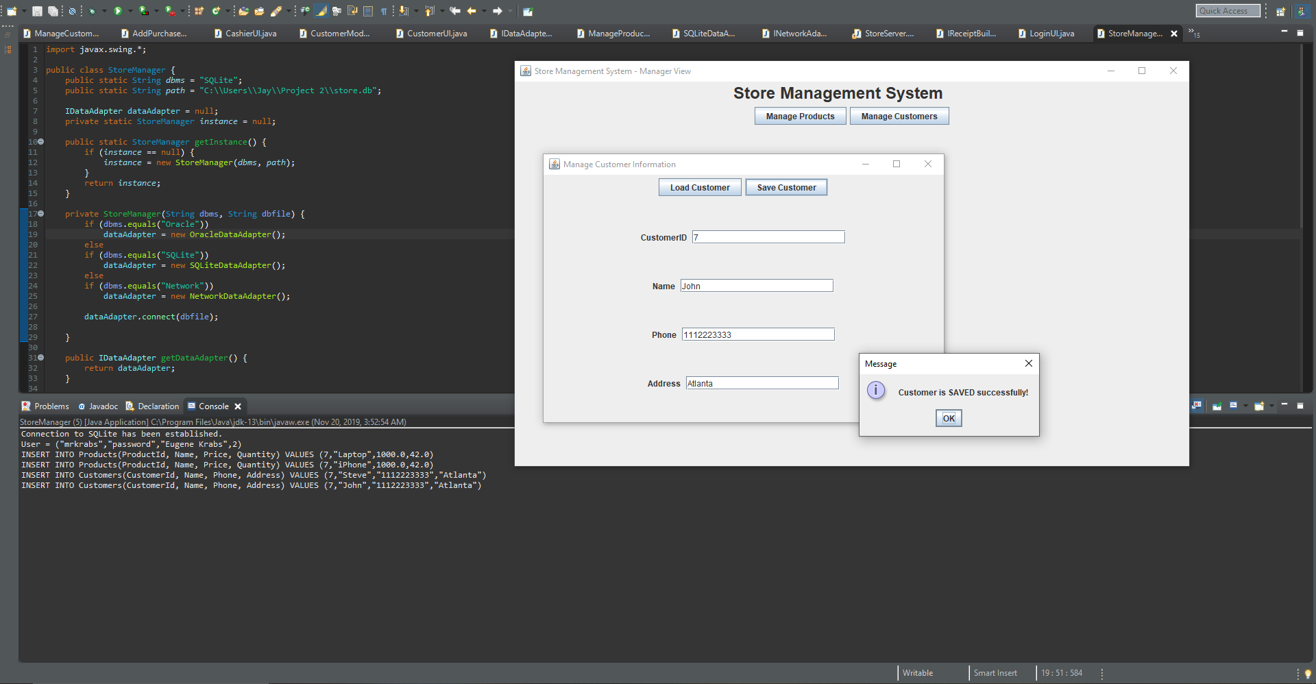

Case: As a user, I want to add a new purchase into the system.

1. First I have logged into the system as a customer so I can make a purchase.

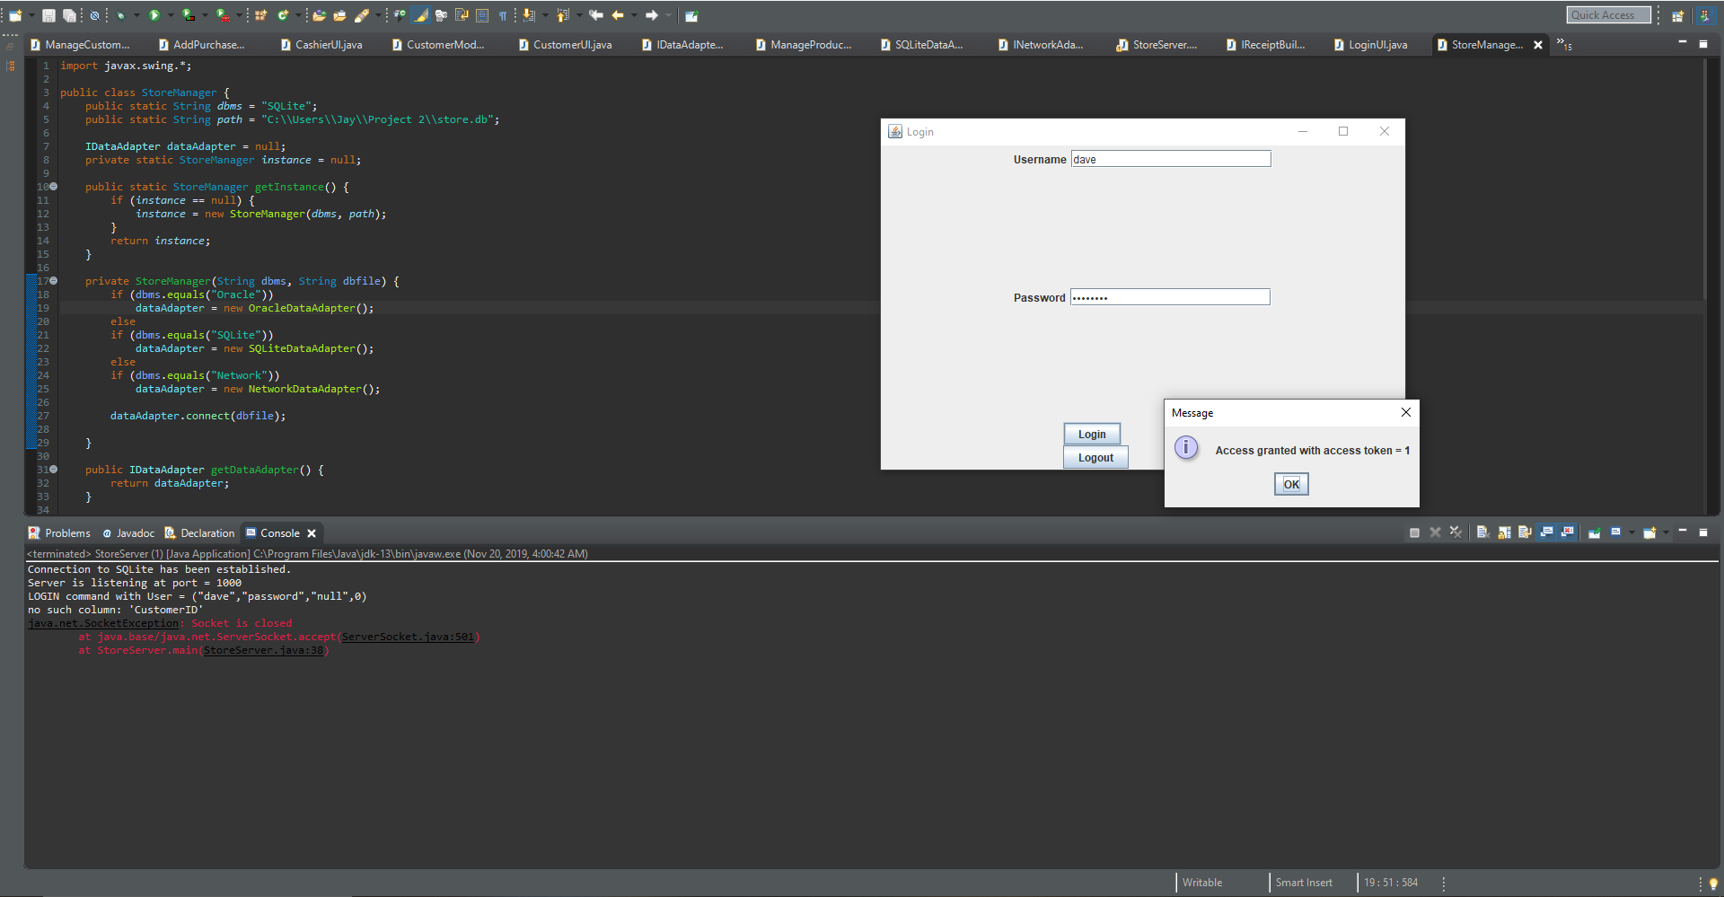

1. This is the Customer View.

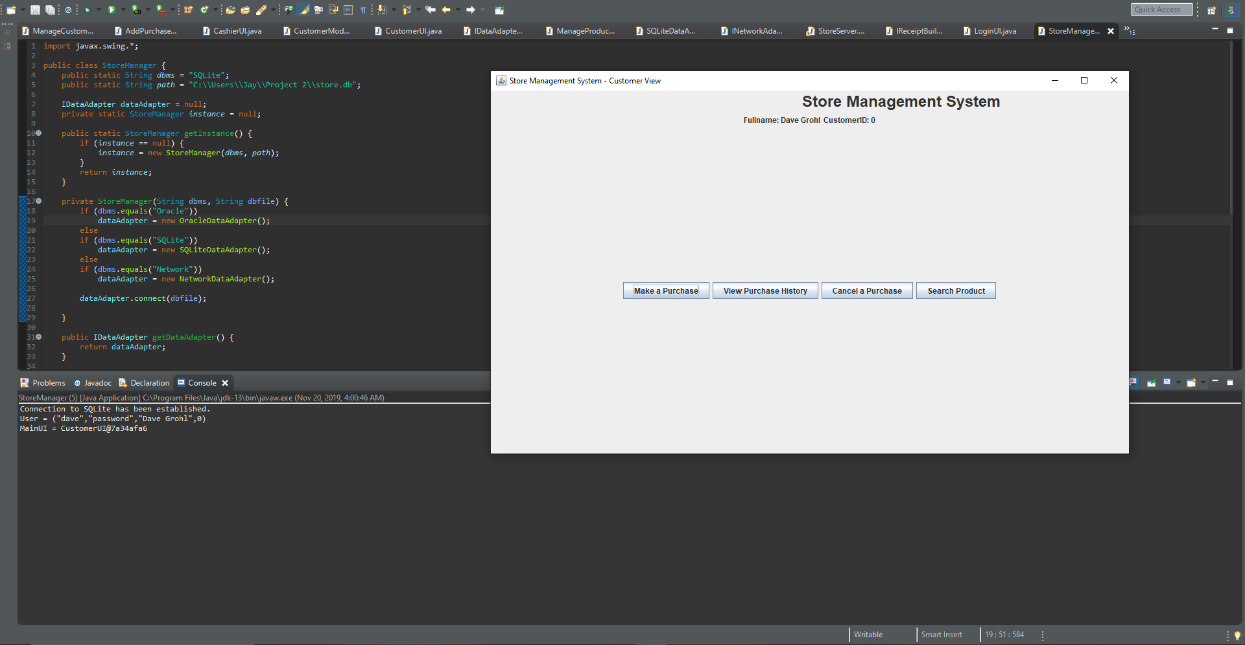

1. From here we click “Make a Purchase”

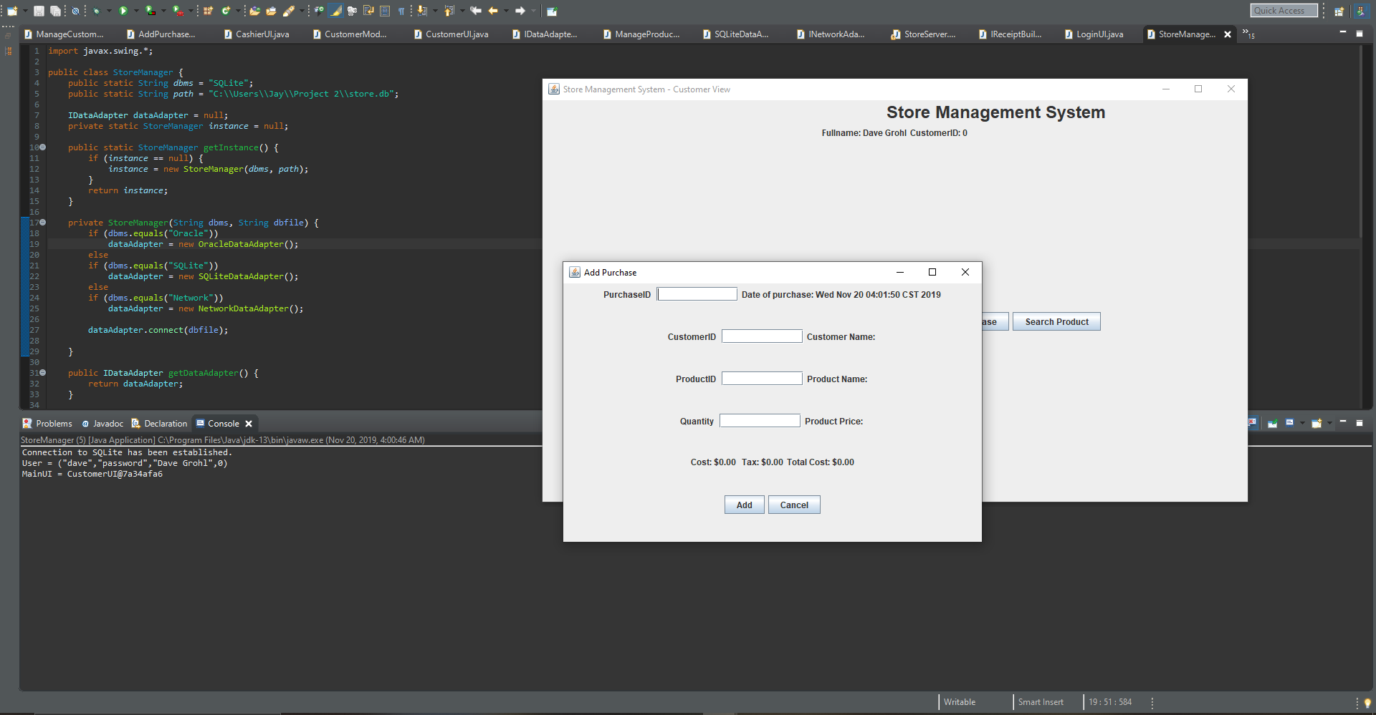

1. Finally we fill in the information, click “Add”, and get confirmation of success.

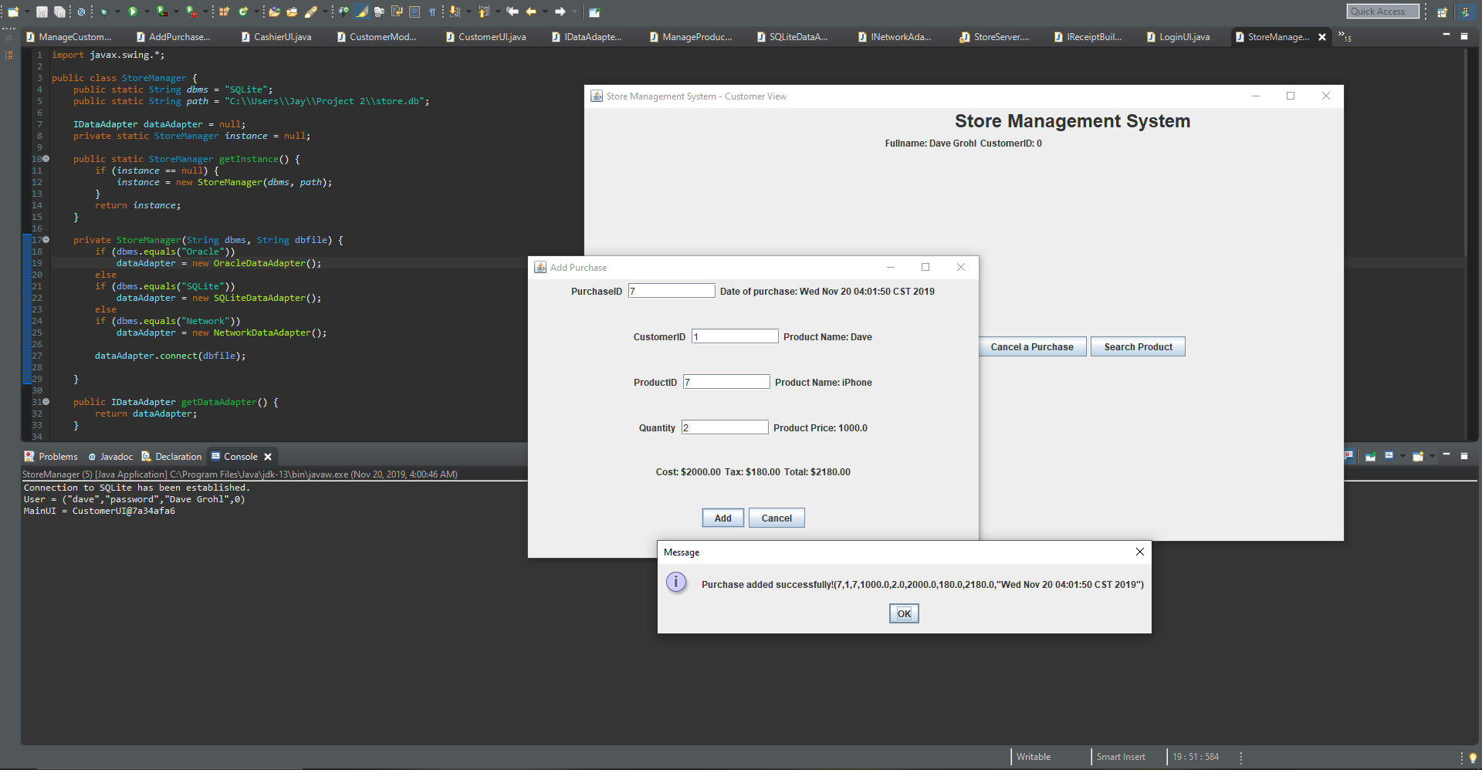

Case: As a user, I want to cancel a purchase from the system.

1. First I have logged into the system as a customer so I can cancel a purchase.



1. This is the Customer View.



1. From here we click “Cancel a Purchase”. This brings us to the cancellation screen.

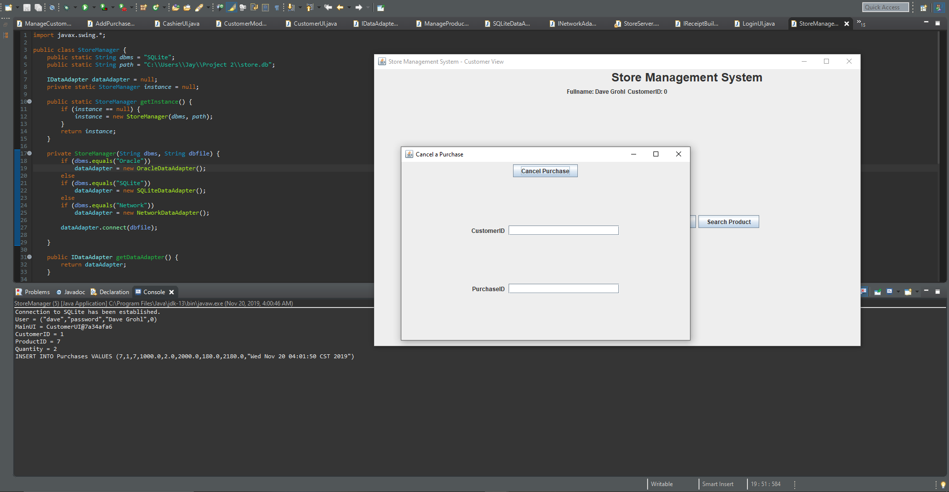

1. Here we confirm our PurchaseID to our CustomerID, click “Cancel Purchase”, and get confirmation that we have canceled our purchase.

