**Problem statement:** Analyzing changes in evolving data fromadvanced habitation systems.

The goal of this task is to create a framework that monitors and provides change detection in a multimodal system. **Our objective** is two-fold (a) To provide the mining of patterns from older data as changes in data could reflect long term/ previous trends. (b) Mining for patterns over near data – as recent changes in data could indicate the recurrences of the previously known pattern or an upcoming event.

**Reported outcomes:** An exhaustive survey of related datasets that capture multi-modal environments/systems.

**Specific Aims:**

1. Make an exploratory data visualization
   1. NASA Bearing Data Set
   2. NASA Battery Data Sets
2. Looked into the dataset
   1. NASA Randomized Battery Usage Data Sets
3. Extract relevant data from these datasets

**Key Accomplishments:**

1. Getting familiar with ploting large files using Python panda library
2. Trying to work with a dataset that seems to be similar to what was presented – by the TPOC

**Red Flags:**

1. After wrangling the datasets, we found that the NASA Battery Data Sets is not what we are looking for. The batteries are still useful after the experiments

**Future Work:**

1. Look at CNNs in TensorFlow
2. Try to work with some existing CNN in TensorFlow using the NASA Bearing Data Set

**Timeline (tentative timeline for the upcoming week)**

|  |  |  |  |  |  |  |
| --- | --- | --- | --- | --- | --- | --- |
| **Future Specific aims** | **10/02** | **10/03** | **10/04** | **10/07** | **10/08** | **10/09** |
| Looking at CNNs in TensorFlow |  |  |  |  |  |  |
| Using TensorFlow |  |  |  |  |  |  |
| Plot data and generate reports |  |  |  |  |  |  |

**References:**

[1] Brian Bole (2015). Description of Room Temperature Random Walk Charging and Discharging Data Sets

[2] Brian Bole (2015). Description of Room Temperature Random Walk Discharging Data Sets

[3] Brian Bole (2015). Description of Room Temperature Random Walk Discharging Experiments with Variable Recharging Periods

[4] Brian Bole (2015). Description of Right Skewed Random Walk Discharging Data Sets at 40C

[5] Brian Bole (2015). Description of Right Skewed Random Walk Discharging Data Sets

[6] Brian Bole (2015). Description of Left Skewed Random Walk Discharging Data Sets at 40C

[7] Brian Bole (2015). Description of Left Skewed Random Walk Discharging Data Sets

[8] Hai Qiu, Jay Lee, Jing Lin. “Wavelet Filter-based Weak Signature Detection Method and its Application on Roller Bearing Prognostics.” Journal of Sound and Vibration 289 (2006) 1066-1090

**Appendix A**

**Results**

Three datasets that were found had the potential to be explored as a multi-modal system.

One of them may be promising, since it has samples in throughout the lifespan of at least a bearing at a time.

Some plots were done to see how the data would behave.

Besides having the complete lifespan (test-to-failure) of at least one bearing per experiment, it also is a multi-modal dataset since all the bearings of each test were running and being measured at the same time, inside the same system.

The first test had the first 43 measurements taken every 5 minutes but besides that, all the other measurements were taken every 10 minutes.

Each sample (file) had a sampling rate of 20kHz and a one second duration with 20480 points. Each row is a data point. All the files are in ASCII format, with no extension.

Test 1 has 2,156 files and each bearing has 2 channels. At the end of the test-to-failure experiment, inner race defect occurred in bearing 3 and roller element defect in bearing 4.

Test 2 has 984 files and each channel represents a bearing. At the end of the test-to-failure experiment, outer race failure occurred in bearing 1.

Test 3 has 4,448 files and each channel represents a bearing. At the end of the test-to-failure experiment, outer race failure occurred in bearing 3.

Fig 1 – Beginning of the experiment, bearing 1 (the bearing that failed) at the second test

Fig 2 – End of the experiment, bearing 1 (the bearing that failed) at the second test

Fig 3 – Beginning of the experiment, bearing 2 (for comparison) at the second test

Fig 4 – End of the experiment, bearing 2 (for comparison) at the second test

The NASA Battery Data Sets looked promising with tests with different room temperatures:

43oC

24oC

4oC

multiple (24oC and 44oC)

different discharge types:

CC, 4A

CC, 2A

Multiple (1A, 2A & 4A) 0.05Hz square wave load

4A and 50% cycle

Stopping criteria:

20% fade in capacity

30% fade in capacity

Until the experiment control software crashed

*Note that there are several discharge runs where the capacity was very low. The cause for this is unknown.

Each test was made with 3 or 4 batteries at a time.

Fig 5 – Measured voltage of a battery in one of the datasets (while charging)

Fig 6 – Charged voltage of a battery in one of the datasets (while charging)

Fig 7 – Measured temperature of a battery in one of the datasets (while charging)

Fig 8 – Measured current of a battery in one of the datasets (while charging)

Fig 9 – Charged current of a battery in one of the datasets (while charging)

Fig 10 – Measured voltage of a battery in one of the datasets (while discharging)

Fig 11 – Voltage load of a battery in one of the datasets (while discharging)

Fig 12 – Measured temperature of a battery in one of the datasets (while discharging)

Fig 13 – Measured current of a battery in one of the datasets (while discharging)

Fig 14 – Charged current of a battery in one of the datasets (while discharging)

Fig 15 – Sense current of a battery in one of the datasets (impedance, real numbers)

Fig 16 – Battery current of a battery in one of the datasets (impedance, real numbers)

Along with each one of the NASA Randomized Battery Usage Data Sets, there is a HTML file with a complete description of the dataset and some graph plots.

Even though the tests were not done until failure, these datasets have some very interesting data.

Fig 17 – Pulsed charge on Room Temperature Random Walk Charging and Discharging Data Sets

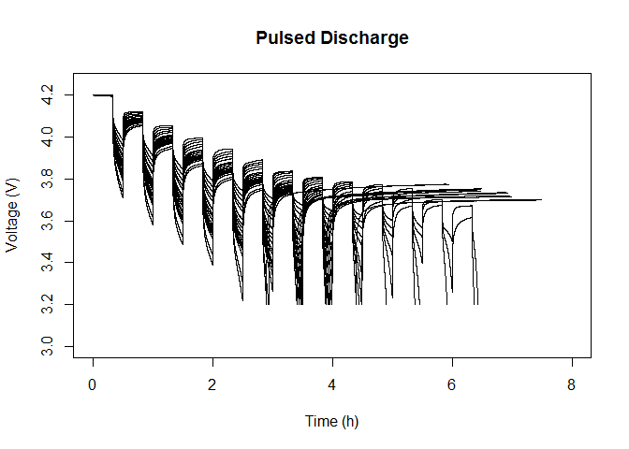

Fig 18 – Pulsed discharge on Room Temperature Random Walk Charging and Discharging Data Sets

Fig 19 – First 50 RW cycles on Room Temperature Random Walk Charging and Discharging Data Sets

Fig 20 – First 10 RW cycles on Room Temperature Random Walk Discharging Data Sets

Fig 21 - First 10 RW cycles on Room Temperature Random Walk Discharging Experiments with Variable Recharging Periods

Fig 22 - First 10 RW cycles on Right Skewed Random Walk Discharging Data Sets at 40C

These plots show that these datasets can be promising with the change point detection.