DEVELOPMENT OF HEALTH DATA HUB:

A RESEARCH INFORMATION SYSTEM FOR

ASIAN HOSPITAL

A Capstone Project

Presented to the Faculty of the

College of Computer and Information Sciences

University of Makati

J.P Rizal Ext. West Rembo Makati City

In Partial Fulfillment

of the Requirement for the Degree

Bachelor of Science in Information Technology

Major In Information and Network Security

(BSIT-INS)

by:

BUENO, REVIN

GENERAO, JONAS

MEJILLANO, BEA BIANCA R.

DECEMBER 2023

**Table of Contents**

Title Page…………………………………………………………………1

Chapter 1.…………………………………………………………………4  
 Introduction…………………………………………………………4

Background of the study…………………………………………..5

Objectives of the Study……………………………………………7

Scope and Limitations…………………………………………….10

Significance of the Study…………………………………………12

Chapter 2…………………………………………………………………..

Review of Related Literature and Studies……………………….

Related Literature……………………………………………

Related Studies………………………………………………

Synthesis………………………………………………………

Conceptual Model of the Study……………………………..

Definition of terms……………………………………………   
Chapter 3……………………………………………………………………

Research Design……………………………………………………

Project Development……………………………………………….

Project Design……………………………………………………….

System Evaluation…………………………………………………..

Operation Testing Procedure……………………………………

Operation Procedure………………………………………

Testing Procedure………………………………………….

Evaluation Procedure ……………………………………………

**Chapter 1**

**THE PROBLEM AND IT’S BACKGROUND**

This chapter asses a comprehensive initiative aimed at establishing a Information System tailored for the context of Asian Hospital. This introductory section sets the stage for the researchers by providing an overview of the background of the study objectives as well as the significance and scope of the limitation that underlies the development and implementation of the proposed RIS.

**INTRODUCTION**

Healthcare is a critical sector in any society tasked with the responsibility of safeguarding and promoting the well-being of its population. In the Philippines as in many countries the healthcare landscape has been evolving in response to numerous challenges and opportunities. While advancements in medical technology and research have greatly improved patient care and outcomes it led to an exponential increase in data and information management requirements within healthcare institutions.

To the ever-growing need for efficient information management in healthcare specifically in Asian Hospital itself and particularly in research-driven hospital settings. The Philippine healthcare sector has been making significant strides towards achieving global standards of healthcare delivery from the press release of Department of Health entitled “DOH Achieves Major Strides in Fight Vs Covid-19 Strengthens Ph Healthcare System”. However the ability to harness data and research effectively remains a pivotal challenge.

In the ever-expanding realm of healthcare the role of information systems cannot be overstated. As the Healthcare landscape undergoes rapid transformations fueled by technological advancements and a growing focus on research-driven practices the need for Hospital Research Information Systems becomes increasingly apparent.

This study delves into a profound exploration of the data initiative for the unique demands of the Philippines healthcare sector. By researching the difference between advanced technology healthcare practices and research methodologies.

**BACKGROUND OF THE STUDY**

Healthcare an indispensable component of any society, is dedicated to the well-being and safeguarding of its citizens. In recent times the healthcare landscape in the Philippines as well as in many other nations has undergone significant transformation in response to various challenges and opportunities. The demand for comprehensive and efficient information management systems in healthcare institutions has become increasingly evident. This study undertakes a focused investigation into information management within healthcare institutions and its associated challenges with a specific emphasis on a critical issue at the Asian Hospital.

Within the Asian Hospital the significance of efficient information management has risen to prominence particularly in the context of research-driven hospital settings. The existing systems at the hospital competently handle administrative and clinical data however they exhibit limitations in the area of research data integration and analytics. This deficiency has hindered the hospital's capacity to engage comprehensively in medical research and data-driven healthcare practices.

The primary concern at the core of this study is the deficiency in information management and security within the Asian Hospital's research initiatives. This issue significantly impedes the hospital's ability to harness data effectively for the advancement of medical knowledge and patient care. The overarching problem under scrutiny is the inadequacy of the current system to secure and efficiently manage sensitive research data a matter of paramount importance in healthcare research and practice.

To substantiate the existence of this problem we engaged in interviews with personnel within the Health Research Office Unit at the Asian Hospital. The outcomes of these interviews revealed substantial concerns concerning data security and the efficiency of research data management. Personnel within the department expressed their apprehensions primarily regarding unrestricted access to sensitive research data which raised serious concerns about privacy and security.

The identified problem of inadequate information management and security has far-reaching consequences. The absence of a secure system puts the privacy of research data at risk and the inefficiencies hinder the hospital's capacity to conduct and collaborate in critical research. This issue significantly impacts the quality and advancement of medical research and the overall healthcare practices in the hospital and, by extension the quality of patient care.

In response to these challenges the Asian Hospital Research Information System will be developed. This web-based research data management system has been designed to address the issues of data security and streamline research data management. It offers a secure and efficient platform for data collection, storage, analysis and sharing along with tools to support research collaboration and communication.

**OBJECTIVES OF THE STUDY**

This study is to develop the Asian Hospital Research Information System.

Specifically, the study aims to do the following:

1. Design a Web Based Application named Health Data Hub with the following functions:   
   A. Authenticator Application

* Email verification acts as an authenticator application by requiring users to click on a link sent to their email address. This process ensures that the provided email is valid and grants access to the user interface enhancing security and verifying user identities before allowing system entry.

B. Information System

* An interface that functions as the setup of accessing valuable research resources related to any hospital health research department that can manage information to support the information processes and human users who interact with the system.
* Including structured framework of patients record/data, researchers, treatment and technology strategically integrated to facilitate the collection, storage, processing and dissemination of information.

C. Administration Interface

* The researchers designed an interface that functions as the administrator of the Health Data Hub where the setup includes the ability of the admin to add and view other administrators, manage user accounts and oversee the addition and viewing of documents.
* This interface ensures that both administrators and users can log in allowing the admin to efficiently handle user files and documents ensuring seamless access for both parties are located .

D. User Interface

* The researchers designed an interface that serves the user by providing features such as the ability to view desired documents and download them.
* Access to the interface is secured through encryption with confirmation emails sent via Gmail to ensure a secure and authenticated login process. This encryption adds an extra layer of protection to the user's access guaranteeing the confidentiality and integrity of the documents within the Health Data Hub.

1. Create Information System using the following technology.

An Information System leverages various technologies to enhance its

functionality and efficiency. One integral component is Version Control System (VSC), employed to monitor modifications in source code and facilitate seamless collaboration in software projects. This system enables researchers to concurrently contribute to the same project while effectively managing distinct versions and iterations of the codebase. Another essential technology is XAMPP widely utilized in web development especially within a local environment. With additional components like phpMyAdmin and OpenSSL XAMPP is instrumental for testing and development purposes empowering researchers to create and evaluate dynamic web applications offline before deploying them to live servers. Additionally the system incorporates a Simple Mail Transfer Protocol (SMTP) Server a hardware device dedicated to sending, receiving and relaying email messages across a computer network. Lastly the Information System integrates MYSQL an open-source relational database management system employing Structured Query Language (SQL) for data manipulation. MYSQL ensures a dependable and efficient means of storing

retrieving and managing data within the overall information infrastructure.

1. Test the functionality, reliability, usability, performance efficiency, resource utilization, compatibility and security of the developed application.
2. Evaluate the developed application using ISO 25010 in terms of Functionality, Reliability, Usability, Performance Efficiency, Resource Utilization, Compatibility and Security.

**SCOPE AND LIMITATIONS OF THE STUDY**

The scope of the research information system is tailored specifically to the Asian Hospital located in Muntinlupa focusing on the establishment of a Health Data Hub web application. This web application will comprise both administration and user interfaces facilitating the efficient management of health-related research data within the confines of the hospital. The scope encompasses the development of features that enable secure access and monitoring of users ensuring that thesystem maintains a robust framework for uploading research data. The system's functionality will be geared towards enhancing the hospital's capabilities in handling and organizing research information thereby contributing to more streamlined and effective healthcare practices within the institution.

While the Health Data Hub web application offers an advanced system for

research data management it comes with certain limitations. One notable constraint is the absence of a "forgot password" feature. Instead the system relies

on email verification for user authentication and recovery. This limitation is in place

to prioritize security measures and safeguard sensitive health information. Although the exclusion of the "forgot password" functionality may impact the convenience of password recovery it is a deliberate choice aimed at bolstering the

overall security of the web system aligning with the hospital's commitment to

**SIGNIFICANCE OF THE STUDY**

This study is paramount due to the evolving healthcare landscape's demands for data-driven decision-making. It addresses the critical issue of information management within Asian Hospital where the inadequacy of existing information management systems in research-driven healthcare settings has hindered progress.

The beneficiaries of this study and the Asian Hospital Research Information System encompass a wide range of stakeholders, each with their own set of benefits. These include improved data management, better healthcare practices, enhanced research capabilities, contributions to medical knowledge, and potential changes in policies and standards for data management and security. This study holds the promise of advancing healthcare information management, ultimately resulting in better patient care and research outcomes.

**Healthcare Professionals and Researchers** - These individuals will benefit directly from the Asian Hospital Research Information System. It will provide them with a more efficient and secure data management platform that streamlines research activities.

**Patients** - While patients may not directly interact with the data management system, they are indirect beneficiaries. The data-driven decisions resulting from the system's implementation have the potential to enhance healthcare practices.

**The Asian Hospital** - The Asian Hospital, being the focal point of the study, will benefit by gaining enhanced research capabilities. The introduction of the Asian Hospital Research Information System will enable the institution to overcome the limitations in information management and security, which previously hindered its research initiatives.

**The Healthcare Field** - Beyond the Asian Hospital, the entire healthcare field stands to benefit from the study's insights and the innovative practices emerging from the Asian Hospital Research Information System. This study addresses a deficiency in research data management within a hospital setting, offering valuable insights into effective data management strategies.

**Policy and Industry Standards** - The findings of this study could have a broader impact on the healthcare industry by influencing policies and standards related to research data management and data security. If the Asian Hospital Research Information System proves successful, it may set new standards for data management in healthcare settings, potentially shaping the practices of healthcare institutions both locally and globally, and ensuring greater efficiency and security in handling sensitive research data.

**Chapter 2**

**CONCEPTUAL FRAMEWORK**

This conceptual framework illustrates the key components and relationships that shape the Research Information System (RIS) in the Philippines. The RIS plays a crucial role in facilitating, managing and advancing research activities collaboration and dissemination of knowledge within the country. This framework provides an overview of the various elements involved in the RIS and how they interact to support the research ecosystem in the Philippines.

**Review of Related Literature and Studies**

This section presents a thorough overview of the existing literature and related studies on the Research Information System (RIS) in the Philippines. The studies and research findings discussed here shed light on various aspects of the RIS its development challenges and its impact on the research landscape in the country.

**Related Literature**

**Research Information System**

In the healthcare sector the Philippine eHealth Strategy aims to establish an interoperability layer across health systems and services including primary healthcare consultations health research, legal information, patient healthcare at tertiary hospitals and health insurance claims (Sylim et al., 2022). The development of eHealth systems also requires compliance with security protocols and the Data Privacy Act of 2012 to protect patient records and gain trust in the system (Miranda, 2020).

The Philippine Education promotes which encourages the use of advanced technologies in the educational ecosystem. Teachers are expected to be competent in information and communications technology (ICT) (Caluza, 2020). Efforts have also been made to develop e-learning modules to enhance ICT skills among marginalized women and girls (Febro et al., 2020).

The adoption of electric vehicles (EVs) in the public transport system is another area of interest. Political, economic, social, technological, legal and environmental factors influence the adoption of EVs in the Philippines (Guno et al., 2021).

Dela Cruz, Santos, and Villanueva (2023), conducted research where study explores the determinants impacting the adoption of Research Information Systems (RIS) in Philippine higher education institutions (HEIs). The results indicate that the primary factors influencing RIS adoption include perceived usefulness, perceived ease of use, and social influence.

Rodriguez, De Guzman and Hernandez (2022), conducted a study where this research investigates the effect of Research Information Systems (RIS) on research productivity in the Philippines. The results reveal a positive and significant impact of RIS on research productivity, specifically in terms of increased research publications and citations.

Santos, Dela Cruz and Villanueva (2021), authored a study and this investigation delves into the role of Research Information Systems (RIS) in promoting open access to research in the Philippines. The findings suggest that RIS plays a pivotal role in advancing open access by serving as a platform for researchers to deposit and disseminate their research outputs.

**RIS Data Management**

Mercurio & Hernandez (2017), discusses the development of a web-based information system incorporating open data and geo-based features for a pilot community in the Philippines. It serves as a platform for information collection, planning, analysis, decision-making and enhancing the effectiveness of government services.

Hicks & Porter (2021), discusses the strategic importance of Research Information Systems (RIS) for research management arguing how RIS can improve efficiency, decision-making and the impact of research.

Cruz and Lee (2019), highlights the disconnect between open data designers (government) and users (data users) in the Philippines. Discusses challenges in data management and the need for better collaboration between data providers and users.

Anticamara & Go (2016), emphasizes the importance of comprehensive data collection through research surveys for assessing the state of fisheries in the Philippines and informing management strategies.

Cruz & Ching (2021), conducted a qualitative analysis on the adoption of enterprise architecture (EA) in the first academic institution in the Philippines, shedding light on data and knowledge management's role in adopting new technologies in educational institutions.

**RIS Implementation and Integration**

Schöpfel et al. (2019), discuss the convergence and merger of RIS and institutional repositories as a potential solution for integration. This approach offers flexibility especially in regions with a well-established open access repository network but limited RIS implementation. By combining these systems institutions can streamline data management and access ensuring that research outputs are effectively captured and made available to the relevant stakeholders.

Furthermore Zhao & Jeffery (2020), highlight the importance of reference models in guiding the engineering process. In the context of integrating RIS with other institutional systems reference models can provide a framework for designing and implementing the integration. These models help ensure that the integration is aligned with best practices and standards facilitating seamless data exchange and interoperability between systems.

In terms of stakeholder experiences and support for research integrity (RI) Evans et al. (2022) emphasize the significance of a whole institutional approach. This approach involves embedding RI support within local jurisdictions, rules and practices. When integrating RIS with other institutional systems it is crucial to consider how RI support can be incorporated to promote ethical research practices and data management.

In terms of communication systems RIS can be integrated into wireless networks to enhance signal strength coverage and capacity. It can be particularly beneficial in areas with limited infrastructure or challenging propagation environments (Mukherjee et al., 2021). By strategically deploying RIS the Philippines can improve the quality and reliability of wireless communication enabling better connectivity for businesses individuals and remote areas.

In the healthcare sector RIS can play a crucial role in improving access to healthcare services. Integrated with telehealth systems RIS can enhance the transmission of medical data facilitate remote consultations and enable real-time monitoring of patients (Kee et al., 2021). This technology can bridge the gap between healthcare providers and patients especially in underserved areas and improve the overall efficiency and effectiveness of healthcare delivery.

Furthermore RIS integration can support education initiatives in the Philippines. The Alternative Learning System (ALS) is an example of a nonformal and informal education program that can benefit from RIS implementation (Tindowen et al., 2017). By leveraging RIS technology ALS can enhance distance learning capabilities provide access to educational resources and improve the learning experience for individuals who may not have access to traditional educational institutions.

**Related Studies**

**Research Information System**

Castillo (2021), described the development and implementation of a research information system for a Philippine university. The system was developed using a web-based platform and is designed to support a wide range of research activities including research proposal submission and management, data collection and analysis, publication management, grant management and research impact assessment. The system was implemented in two phases. The first phase involved the development of the core system functionalities. The second phase involved the integration of the RIS with other university systems such as the student information system and the library system.

Ganaden (2020), presented a review of research information system practices and challenges in the Philippines. The study found that RIS adoption in the Philippines is still in its early stages and that there are a number of challenges that need to be addressed such as lack of awareness and understanding of RIS limited resources for RIS implementation and maintenance and lack of interoperability between different RIS systems.

Santos, Cruz and Hernandez (2023), authored a study this research delineates the creation of a Research Information System (RIS) tailored for the Philippine Rice Research Institute (PhilRice). The RIS is specifically crafted to gather, oversee, and disseminate research data and information, thereby providing support for PhilRice's research and development endeavors.

Rodriguez, Santos and Cruz (2022), conducted a study about the details of the practical application of a Research Information System (RIS) at the University of the Philippines Diliman (UPD). The RIS is implemented to oversee the university's research grants, publications, and other pertinent research data

**RIS Data Management**

Guevarra et al. (2021), emphasizes the need for a national drowning surveillance system in the Philippines to collect demographic and causal data on fatal and non-fatal drowning incidents, highlighting the importance of data collection for prevention strategies.

Henson (2023), discusses challenges and efforts in human resource management in IT system-based public services in developing regions of Southeast Asia, including the Philippines. Highlights the importance of effective data management practices in supporting IT-based public services.

"Sustainable marine conservation, baselines, and systematic monitoring—a few lessons from coastal resource management in the Philippines" (2021): Argues for a national certification and incentive system based on credible baseline data, emphasizing data management's role in supporting conservation efforts and policy decisions.

REDCap is a web-based software that facilitates data storage and collection (Harvey, 2018). It is commonly used in various research fields, including medicine and sociology. REDCap provides a secure and user-friendly platform for researchers to manage and analyze their data.

LIMS is a data management system commonly used in biomedical research (Mohr et al., 2018). It allows researchers to track and manage laboratory samples, experiments, and data. LIMS can be integrated with other data and metadata management strategies to provide a comprehensive solution for data-driven research.

MIS is a system used by educational institutions in the Philippines to manage and organize information related to administration, faculty, and students (Zulueta et al., 2021). It helps in streamlining various processes, including research management. MIS allows for efficient data collection, storage, and retrieval, enabling better decision-making and resource allocation.

**RIS Implementation and Integration**

Garcia's (2018), study concentrated on the integration of author credit mechanisms within Research Information Systems. The research provided a comprehensive examination of the strategies employed to acknowledge author contributions in these systems.

Wang's (2019), survey delved into the current practices employed in ensuring the security of Research Information Systems. The study presented a comprehensive overview of the security measures implemented within these systems offering valuable insights for researchers and practitioners alike.

However the implementation of RIS in the Philippines may face challenges. Practical implementation challenges include the need for extensive simulations and optimization to validate the benefits of integrating RIS into existing systems (Zhi et al., 2022).

Additionally there may be barriers related to digital competence and readiness for distance learning initiatives (Asio, 2021). Overcoming these challenges will require collaboration between stakeholders including government agencies educational institutionsand technology providers.

In their comprehensive exploration of research information systems Smith and Johnson (2019) delved into the latest developments in this domain. Their study provided a thorough examination of the advancements and innovations that have shaped the landscape of research information systems as detailed in the Journal of Information Science.

Examining the influence of research information systems on scholarly communication Brown and White (2020) conducted a comprehensive analysis. Their study featured in the Journal of Scholarly Publishing investigated the ways in which these systems have affected the dynamics of scholarly communication shedding light on critical aspects within the academic realm.

Exploring user perspectives on research information systems Garcia and Perez (2021) undertook a survey-based study. Published in Information and Managementtheir research delved into the insights provided by users offering valuable perspectives on the usability and effectiveness of research information systems in contemporary settings.

Finally Tierra & Bagtasa (2022), provide insights into the rapid intensification (RI) of tropical cyclones in the Philippines. Although not directly related to RIS integration this reference highlights the importance of considering specific regional factors when integrating systems. In the case of the Philippines understanding the impacts of RI events can inform the design and implementation of integrated systems that address the unique challenges and needs of the country.

**Synthesis**

The Research Information System in the healthcare sector as studied by Sylim et al. (2022), focuses on fostering interoperability among diverse health systems and services , spanning primary healthcare consultations, legal information, patient care at tertiary hospitals and health insurance claims within the Philippine eHealth Strategy. Cruz and Lee (2019) delve into RIS Data Management highlighting the existing gap between data designers and users in the country stressing the need for improved collaboration to better manage data. Meanwhile Schöffel et al. (2019) explore RIS Implementation and Integration proposing the integration of Research Information Systems with institutional repositories as a viable solution. This approach allows for enhanced data management, access and dissemination of research outputs particularly beneficial in areas with a robust open access repository network but limited RIS implementation. The merger of these systems ensures efficient capture and availability of research outputs to the relevant stakeholders.

**Conceptual Model of the Study**

In order to show the visual representation of the development of Health Data Hub the researchers made a diagram showing the input ,process,output and the evaluation of the project . In this conceptual model it involves different variables present for the system requirements and network requirements .

**INPUT**

**OUTPUT**

**PROCESS**

Asian Hospital Information Network System ( AHRIS )

A system that The Asian Hospital may use to store there research or study for future reference for another research.

Knowledge Requirements

System

* SMTP
* Windows 10
* Virtual Studio Code
* Xampp
* MySQL

Software Requirements:

* Windows10
* Virtual Studio Code
* Xampp
* MySQL

Gathering Data

Designing the system

Securing system

Testing

**EVALUATION**

**Figure 2.1:** Output and Evaluation of the Development of Health Data Hub: A Research Information System for Asian Hospital

The outlined input for the Asian Hospital Information Network System (AHRIS) delineates the necessary knowledge and software prerequisites including familiarity with SMTP, Windows 10, Virtual Studio Code, Xampp and MySQL. The software requirements reiterate the necessity of Windows 10, Virtual Studio Code, Xampp and MySQL for system implementation.

The process involves several key stages such as data gathering where the researchers collect all the needed information with the help of the personnel from the field . And with that brainstorming is involved for new ideas and analyzing them to come up to a plan how the system will work and design it to make sure everything is set up correctly. The first phase of testing also checks if the system works this whole approach is a way of developing a system by focusing on getting the right information, planning well and testing things for the system to come up suggesting this a comprehensive approach to system development.

The output is positioned as a repository for the Asian Hospital's research and studies facilitating future reference and aiding subsequent research endeavors.

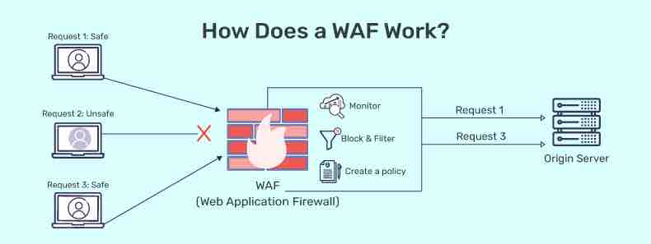

**Figure 2.2: Web Application Firewall**

**Definition of Terms**

**Convergence**. The coming together or merging of different entities, often referring to the integration of systems or ideas.

**Data Management**. Involves effective collaboration for organizing and using data.

**Drowning Surveillance System**. Gathers data on drowning incidents for analysis and prevention strategies.

**Enterprise Architecture (EA)**. Its adoption in educational institutions relies on effective data and knowledge management.

**Ethical.** Relating to principles of morality and conduct, encompassing a sense of right and wrong in decision-making.

**Human Resource Management in IT Systems**. Addresses challenges and importance of data management for IT-based public services.

**Interoperability**. The ability of different systems or components to work together and exchange information seamlessly.

**Leveraging**. Utilizing or capitalizing on available resources or opportunities to achieve a desired outcome.

**LIMS (Laboratory Information Management System)**. Specifically aids in tracking and managing biomedical research data.

**Local jurisdictions**. Refers to specific geographical areas or administrative divisions and their respective governing authorities.

**Marginalized**. Refers to the social or economic exclusion and treatment of individuals or groups as unimportant or powerless within a particular society or system.

**MIS (Management Information System)**. Supports educational institutions in managing administrative data for better decision-making and resource allocation.

National Certification and Incentive System. Proposed system based on credible baseline data for conservation efforts and policy decisions.

**Propagation**. The act of spreading, disseminating, or proliferating something, often used in the context of information or ideas.

**RIS (Research Information Systems)**. Information systems designed to manage and organize research-related data, facilitating efficient workflows in academic and research institutions.

**Realm**. A domain or sphere of activity, often used to describe a particular field or area of expertise.

**RedCap**. Web-based software for secure data storage and analysis, commonly used in various research fields.

**Repositories**. Storage spaces or databases where data, information, or resources are systematically organized and kept for reference or retrieval.

**Scholarly**. Relating to academic or intellectual learning, often associated with rigorous research and academic pursuits.

**Shedding**. Discarding or getting rid of, often used in the context of shedding light on a subject, meaning to reveal or clarify.

**Stakeholders**. Individuals or groups with an interest or concern in a particular organization, project, or system.

**Telehealth**. The use of digital communication technologies to provide healthcare services remotely.

**The Alternative Learning System**. An educational program or system designed as an alternative to traditional schooling, often providing non-formal education opportunities.

**Underserved**. Referring to populations or communities that lack adequate access to essential services, resources, or opportunities.

**Upheld**. Maintained or supported, often in the context of principles, values, or standards.

**Web-based Information System**. Utilizes open data and geographic features online to collect, analyze, and make decisions.

**Chapter 3**

**RESEARCH METHODOLOGY**

This chapter presents the methodology the researchers detailed the approaches employed for conducting the study and obtaining necessary data. The study design encompasses the procedures and techniques essential for ensuring accurate and dependable results.

**Research Design**

Descriptive research is instrumental in system studies as it allows researchers to systematically observe, record and analyze the components and interactions within a system (Smith & Brown, 2020). It is particularly valuable when the goal is to provide a detailed account of the structure, functioning and dynamics of a system. Enabling researchers to methodically observe, record and analyze the intricate components and interactions within a system.

On the other hand, it also highlights its crucial role in systematically breaking down the components of a system. Through the use of surveys, observations and interviews, researchers gain nuanced insights into the characteristics and functionalities of individual elements, facilitating a comprehensive analysis that assists in pinpointing strengths, weaknesses and areas for potential improvement within the system. Recent studies emphasize the importance of descriptive research in dissecting the components of a system. By employing surveys, observations, and interviews, researchers gain insights into the characteristics and functionalities of individual elements within a system (Johnson, 2021).

The aim of this research design is to optimize accurate responses to a research query which is attainable through the application of a non-experimental contextually oriented descriptive approach. Researchers employed a data collection tool, analyzed the data descriptively, ensuring the reliability of the results. The software developers created a web application using a developmental design that emphasizes gradual changes and relies on measurable information gathered for the study's progression.

**Project Development**

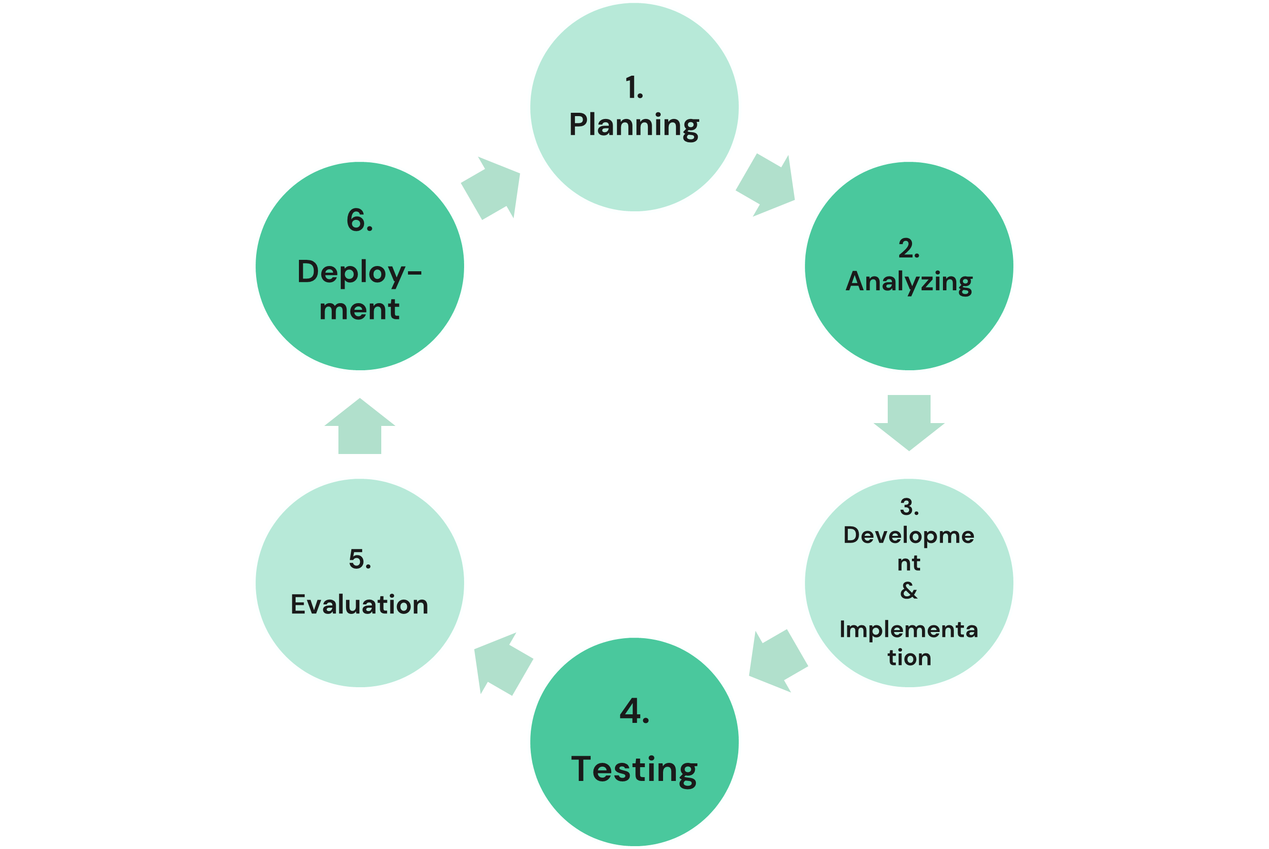

**AGILE**

**Figure 2.2 Agile Methodology in System Development**

The researcher’s goal is to develop a proficient and knowledgeable Research Information System for Asian Hospital utilizing Agile Development as its methodology. The Agile Methodology consists of seven phases illustrated in Figure 2.2. The process involved a series of collaborative steps including Planning, Analysis, Design, Development, Implementation, Testing, Evaluation and Deployment. This are the details of these phases on how the researchers were incorporated into the system development process :

**Planning** - The researchers outlined the objectives and strategies for the Research Information System establishing a comprehensive plan for its development within Asian Hospital.

**Analyzing** - In this phase an in-depth examination of the hospital's requirements and research needs was conducted laying the foundation for the initial design and possible development stages.

**Development and Implementation** - Employing Agile Development the researchers planned features into a functional & knowledgeable system ensuring a seamless integration process within the hospital's operations.

**Testing** - Testing procedures were implemented to assess the system's functionality, performance, and security, guaranteeing a functional Research Information System.

**Deployment** - The fully developed and optimized system is deploying for practical use at Asian Hospital marking the phases of the Agile Development process.

**Project Design**

In the project design all necessary input data and required outputs were identified and clearly defined. The researchers employed flowcharts and data flow diagrams as instruments to illustrate the system's activities and algorithm. The context level offers a comprehensive overview of the system outlining two levels of access admin and user. It outlines all inputs to be supplied by users and admins, along with all outputs the system delivers to both users and admins.

Figure 2.3 illustrates the context level data flow diagram.

Administration

Database

Website Management

Upload

Website Activity

Manage

User

Figure 2.3 the Context Level Data Flow Program portrays a simplified yet comprehensive overview of the information flow within the system. At the core of this depiction is the Database symbolizing a central repository that serves as the nexus for storing and managing data. This underscores the critical role of data in the system acting as a shared resource accessible by both administrators and users.

On the administrative side the primary processes are former likely involves tasks related to the overall administration of the website such as content updates, configurations or user management. It latter suggests a monitoring or tracking function emphasizing the importance of keeping tabs on user interactions or system activities.

Simultaneously, the user side is delineated with processes signifies user-driven activities related to their profiles,preferences or any data under their control within the system. On the other hand upload denotes the user's capability to contribute content to the system enhancing its dynamic and interactive nature. This unified depiction illustrates the interconnectedness of these elements with the databse serving as a convergent point for the collaborative interaction between administrators and users within the system.

 Figure 2.4 illustrates the account access system within the application emphasizing user and admin account functionalities. This system encompasses three key processes 1.0 for creating accounts, 2.0 for account verification, and 7.0 for updating accounts.

Figure 2.4 Health Data Hub 1.0 Create Account

Profile configuration involves users entering essential information to establish an account for system usage. This information encompasses among other details the user's first and last name, email and password. Upon the system accepting and validating this input it transforms the data into usable information and progresses to the subsequent stage: email verification. During this phase the system generates a code, dispatches it via email and prompts users to verify the accuracy of their credentials. The system securely stores this user data and upon successful email verification it activates the account rendering it accessible for the user.

Figure 2.5 serves as a detailed representation of the Account Verification process illustrating the subsequent login procedure within the system.



Figure 2.5 Health Data Hub 2.0 Account Verification

**System Development**

In the development of the system it involves the step-by-step instructions for the computer commonly known as coding and programming. The researchers concentrated on utilizing PHP as the primary computer language for constructing the Health Data Hub. This phase encompasses the actual development of the system applying the system design with the requisite knowledge and programming skills. During this stage the researchers implemented their expertise, skills and the necessary software and hardware.

Additionally, the researchers conducted tests on the website application during its development. They persisted in refining and enhancing the application until it met the acceptance criteria. Afterward an evaluation of the website application was carried out after the researchers had approved it.

**System Evaluation**

The researchers employed specific criteria particularly adopting the ISO 25010 standard for users to assess the system. However they selectively chose relevant criteria from this standard. Following the evaluation the researchers sought information on the system's weaknesses or deficiencies based on user feedback and evaluation results. Comments obtained post-evaluation played a vital role in revising and enhancing the application. In instances where errors or bugs were identified the researchers addressed and sought solutions to rectify the issues .

**Operation and Testing Procedure**

**Operation Procedure**

Figure 2.6 presents the Client System flow

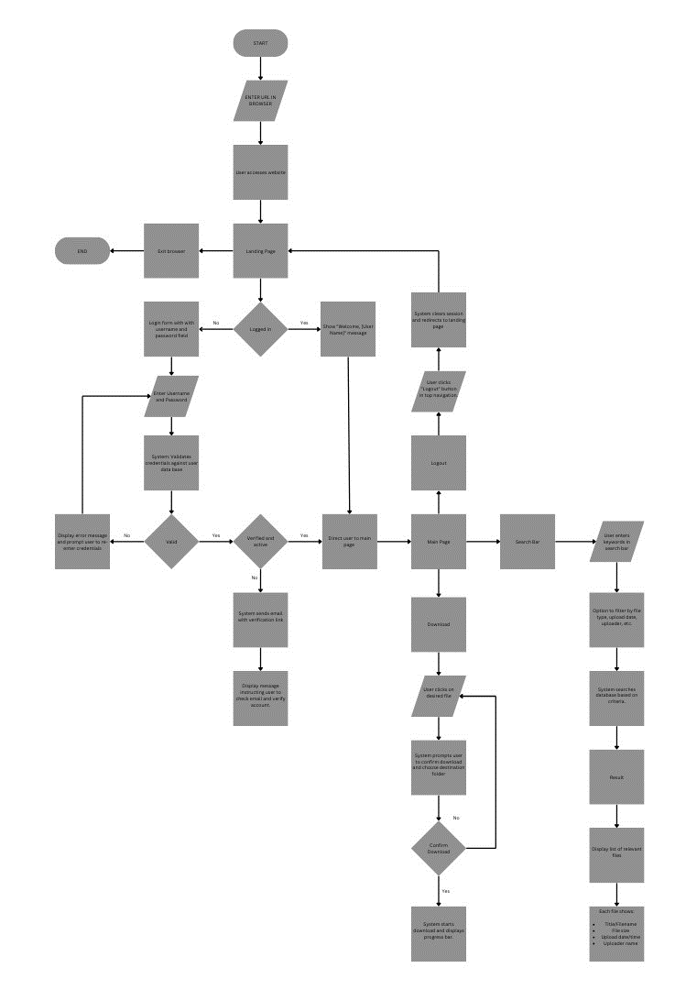**CLIENT**

Figure 2.6 Client System Flow

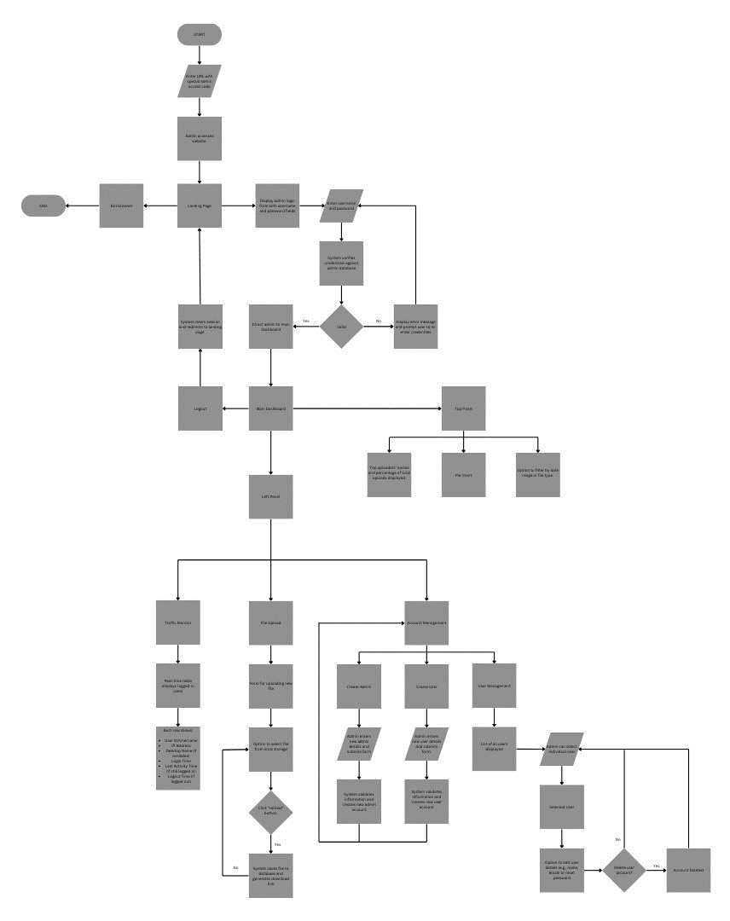**ADMIN**

Figure 2.7 presents the Admin System Flow

**Operation Procedure**

The operational procedure for the client begins with user access to the website, either by directly typing the URL or through a bookmark. Upon arrival, the landing page experience differs based on login status: if not logged in, a login form is presented; if already logged in, a personalized welcome message greets the user. The login process involves users entering their credentials, which the system validates against the user database. Valid credentials lead to various outcomes: for first-time logins or unverified accounts, an email containing a verification link is sent, while verified and active users are immediately directed to the main page. In case of invalid credentials, an error message prompts users to re-enter their details. The main page facilitates searching by allowing users to input keywords and filter criteria, displaying relevant files matching the search parameters, and providing download functionality complete with progress tracking. Finally, the logout action clears the session, guiding the user back to the landing page.

On the admin, access to the admin interface requires a specialized admin access code. Admin login authentication involves the system verifying the provided credentials, granting access to the main dashboard for valid inputs and prompting re-entry for invalid ones. The main dashboard's top section showcases user activity through a pie chart, presenting upload statistics and top uploaders' names, alongside filtering options. The left panel in the dashboard encompasses multiple functionalities: account management enables the creation of new admin or user accounts after input validation, user management offers a list of users with options for deactivation/reactivation and profile editing, file upload allows admins to upload and describe files while generating download links, and the traffic monitor provides real-time information on logged-in users, displaying user IDs, usernames, IP addresses, login times, last activity times, and logout times where applicable.

**Testing Procedure**

Client testing involves several key procedures to ensure the website's functionality. Firstly, the "Access and Landing" test checks URL accessibility and bookmark functionality, followed by validation of the login form appearance and the correct display of the welcome message. "Login and Validation" procedures involve accuracy testing of user credentials against the database, verification of email sending for new or unverified accounts, and confirmation of proper redirection for verified and active users to the main page. Evaluating "Main Page Functionality" includes conducting searches using keywords and diverse filter criteria, confirming accurate display of relevant files, and testing the download functionality for various file types and sizes. Lastly, the "Logout Process" assessment verifies if logging out correctly clears the session and redirects users to the landing page.

On the admin, testing procedures ensure the effective operation of key functionalities. "Admin Interface Access" validation involves confirming access using the specialized admin access code, followed by "Admin Login Verification" to ensure the accuracy of admin credentials against the admin database and proper redirection to the main dashboard for valid inputs. Assessing "Main Dashboard Features" includes verifying the accuracy of the pie chart illustrating user activity breakdown, testing account management functionalities such as creating admins and users, checking user management options like deactivation/reactivation and password resets, and confirming proper functionality of file uploads, ensuring data storage integrity. Additionally, the validation of the real-time table display in the traffic monitor ensures accurate representation of logged-in user details for effective monitoring and management.

**Operation Procedure**

|  |  |
| --- | --- |
| **Component/Phase** | **Procedure to be Conducted** |
| System Requirements | * Define the systems objectives , features, and functionalities that is needed. * Gather an information and requirements from the stakeholders. |
| Project Scheduling | * Project scheduling involves a systematic approach to plan, organize, and manage tasks within a project. * Assign duties and responsibilities to team members. |
| Development tools preparation | * Choose the appropriate tools for development such as programming language, database, and collaboration platforms. |
| Software tools installation | * Installation of all the necessary software tools and set-up the web servers and configure it for the development purposes to ensure the efficiency and it compatibility. |
| Database designing | * Design the database structure to store the applicant’s data securely. * To see the entity relationships in the system, create an entity relationship diagram (ERD). |
| System Designing | * To illustrate how data moves through the system, make a flowchart and data flow diagram. * Make a comprehensive back-end system architecture. |
| Development | * Utilize PHP or another programming language to develop server-side logic. * As per the design specifications, implement the web application's features and functionalities. |
| Testing and Evaluation | * Utilizing ISO software quality standards, evaluate the system. * Test the system to make sure all the parts are functioning and integrated correctly. |
| Documentation | * Prepare a comprehensive technical documentation for the system including the system architecture, guidelines, and user manuals for the maintenance and troubleshooting. |

Operation procedures are a set of documented steps or instructions that outline how a particular task or process should be carried out. They are designed to ensure consistency, efficiency, and safety in the execution of tasks within an organization. These procedures can vary widely depending on the industry, company, or specific task they're addressing.

**Testing Procedures**

|  |  |
| --- | --- |
| **Components/Phase** | **Test to be Conducted** |
| User Account Creation | * Make sure the system verifies if any data is missing or incorrect before permitting the user to create an account. * Verify the password and confirm password fields are the same before submitting the application. * Make sure the user is redirected to the login page upon successfully creating an account. |
| Dashboard | * Verify whether the data is displayed in real time by checking the system. * Verify whether the filter buttons are functioning properly. * Verify that each button can be clicked and is operational by looking at it. |
| System Testing | * Execute the admission system if it has a missing features or functionalities. * Validate the logical assumptions to verify the system’s correctness. |

Testing procedures are systematic processes designed to evaluate the functionality, performance, or quality of a product, system, software, or service. These procedures ensure that the item being tested meets specific criteria, standards, or requirements. Testing procedures are essential for ensuring the reliability, functionality, and quality of products or systems before they are released to users or put into operation.

**Evaluation Procedure**

**Preliminary Evaluation:**

The preliminary evaluation stage forms the foundation for the entire assessment process. Objectives include identifying target users, understanding their needs, establishing evaluation criteria and developing a plan for data collection and analysis. Activities involve conducting user surveys and interviews, reviewing existing literature and defining specific criteria. Deliverables include a user needs report, criteria document, data collection plan and evaluation instruments.

**Final Evaluation:**

Building upon the preliminary stage the final evaluation aims to assess the system's performance comprehensively. Objectives involve evaluating functionality, effectiveness, efficiency and user satisfaction as well as identifying areas for improvement. Activities include deploying evaluation instruments, collecting and analyzing data, conducting user feedback sessions, and comparing results with predefined metrics. Deliverables encompass a detailed evaluation report and an action plan for system improvement.

**Evaluation Instruments:**

The success of the evaluation process relies on effective use of various instruments. User surveys measure satisfaction, interviews provide in-depth insights, system usage logs capture user activity data and observation checklists identify usability issues. Each instrument serves a specific purpose contributing to a holistic understanding of the system's strengths and weaknesses.

**Treatment of Data:**

Effective handling of data is paramount for meaningful insights. Data cleaning ensures accuracy by addressing missing or inconsistent data points. Analysis involves both quantitative and qualitative methods utilizing statistical approaches and thematic analysis to identify patterns and trends. Reporting includes a clear and concise presentation of results, accompanied by data tables, charts and graphs for visual representation. This stage is critical for transforming raw data into actionable insights and informing decision-making processes.

**BIBLIOGRAPHY**

1. **BOOKS**

Schöpfel , Joachim ( 2019 ). Data Technologies and Application . Lile France

Zhao, Zhiming ( 2020 ). Towards Interoperable Research Infrastructures for Environmental and Earth Sciences A Reference Model Guided Approach for Common Challenges: A Reference Model Guided Approach for Common Challenges . Amsterdam, Netherlands

1. **THESIS**

Evans , Natalie ( 2022 ) Title of dissertation/thesis ( Stakeholders’ Experiences of Research Integrity Support in Universities: A Qualitative Study in Three European Countries ) Government Institution , United States

1. **JOURNAL**
2. **ONLINE**