**Project Contains-:**

1. Spring boot framework
2. Maven
3. JPA & JPQL

**What need’s to be updated before running the project?**

(*)Update the database connection in application.properties as I have connect with MYSQL database.

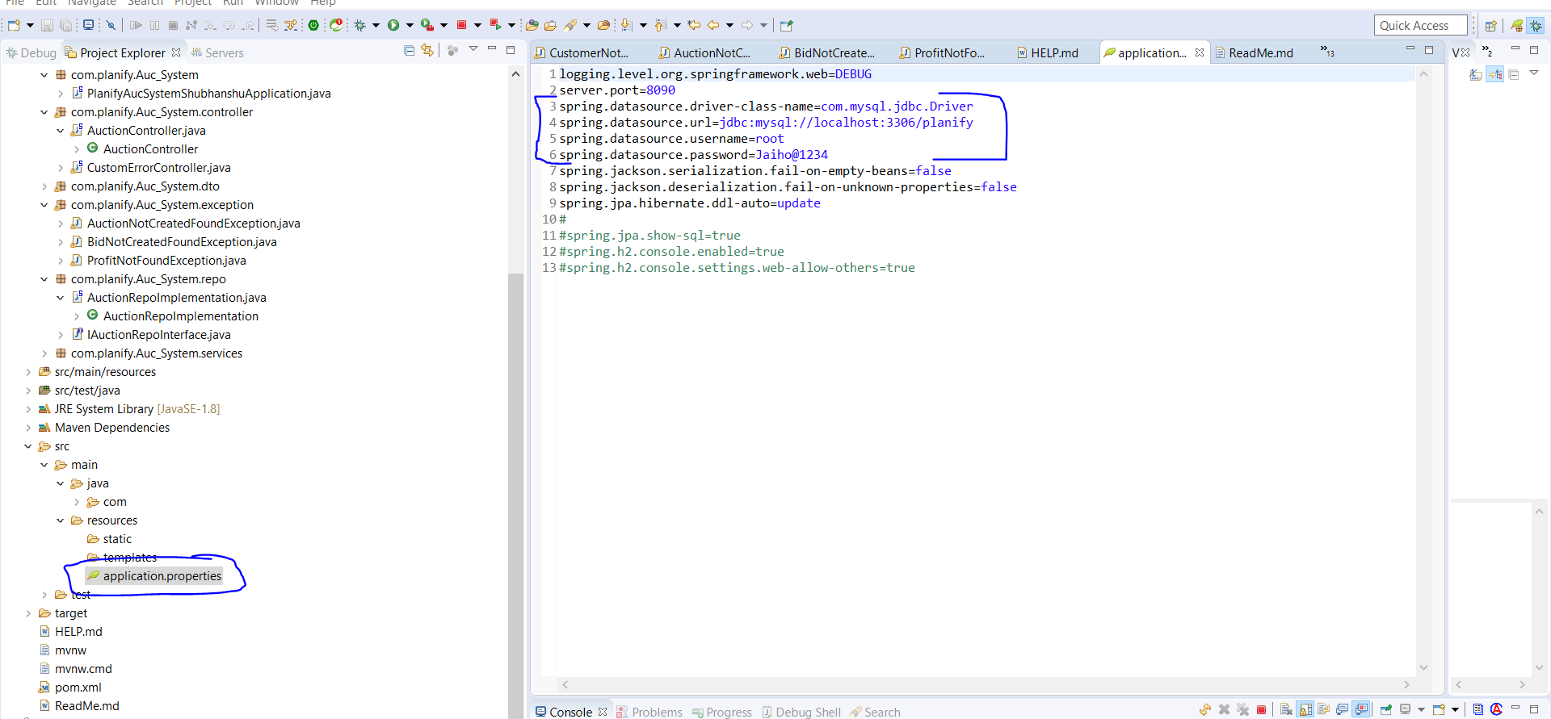

**(*)How to run this project?**

1. Import as existing maven project in eclipse/STS

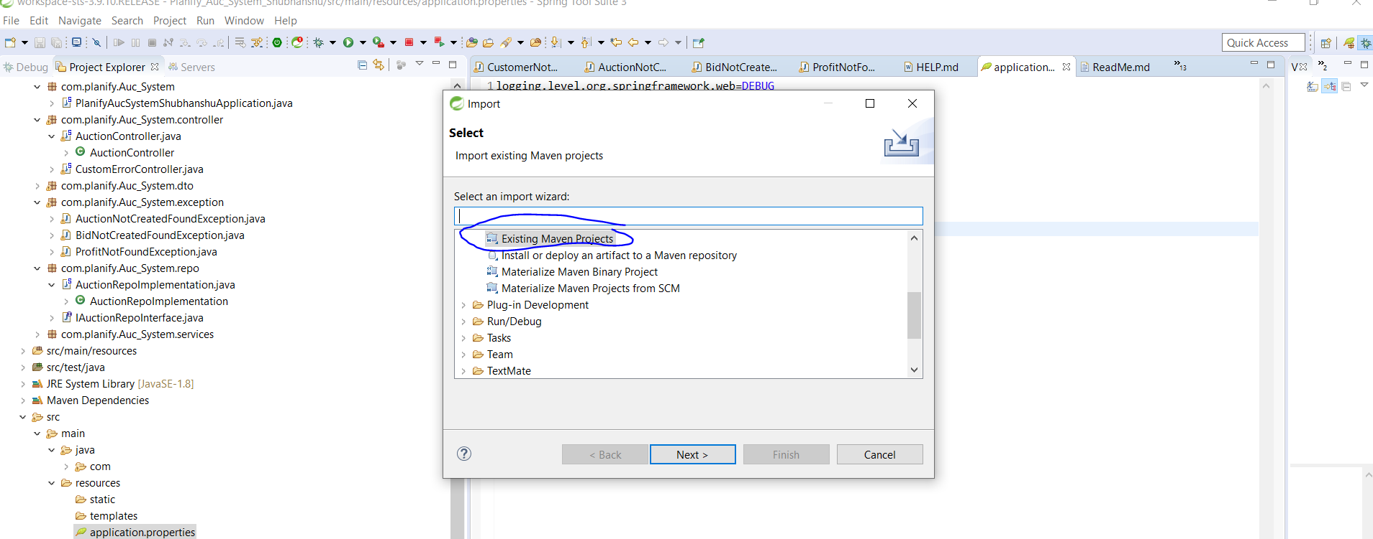

1. Right click on project --->Run as ----->Spring Boot app

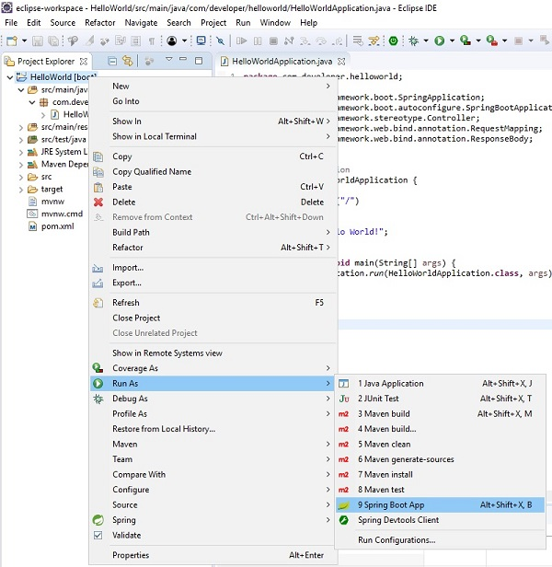

Testcase 1:

Adding Buyer:

In postman

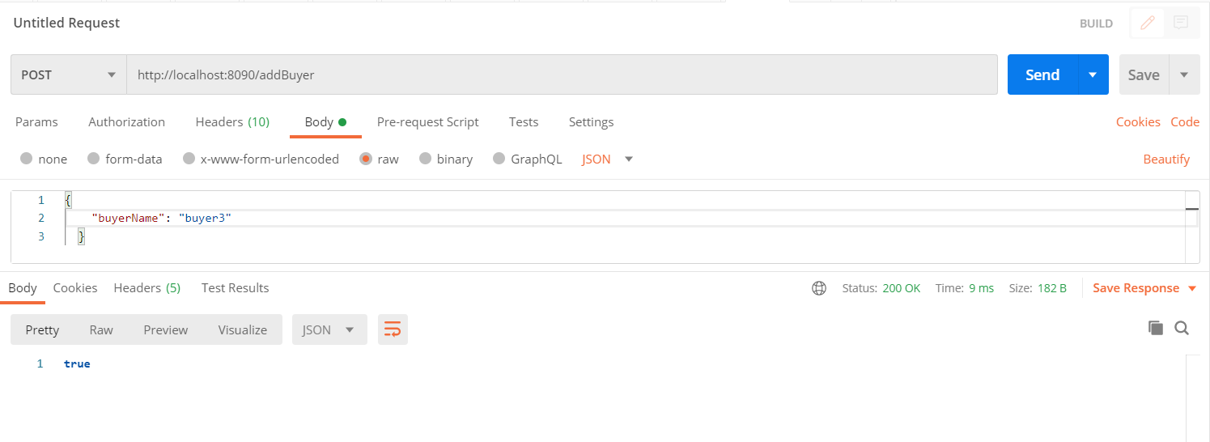

**In database**

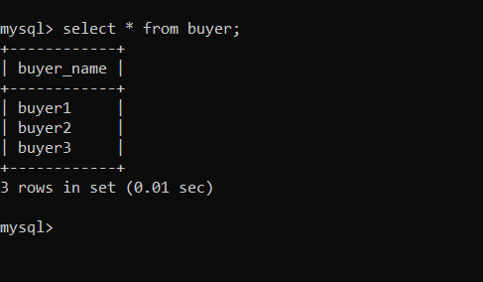

**Adding Seller:**

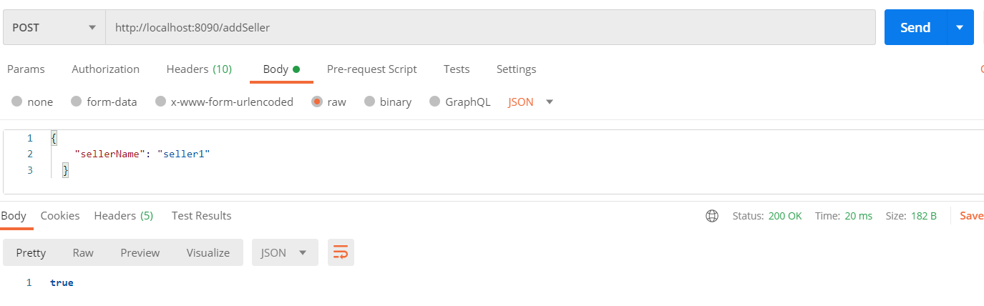

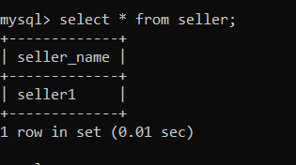

**Creating Auction:**

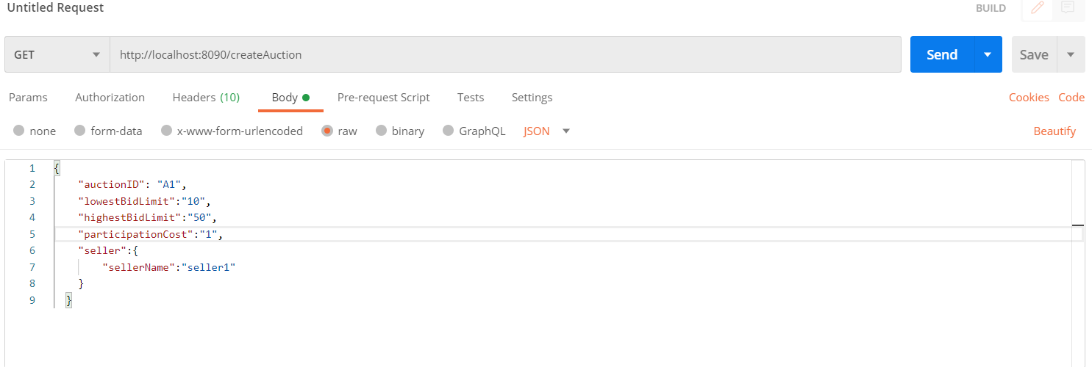

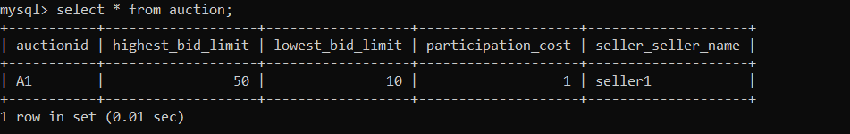

**Creating Bid:**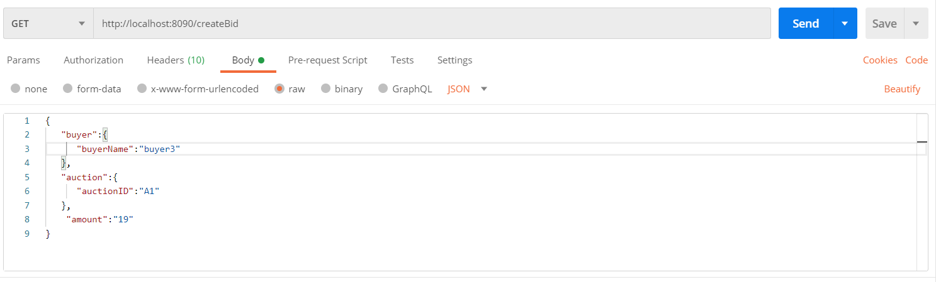

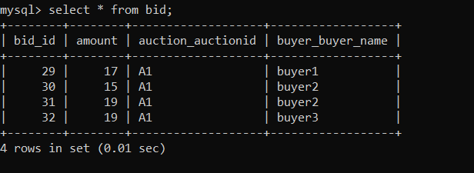

**CloseAuction:**

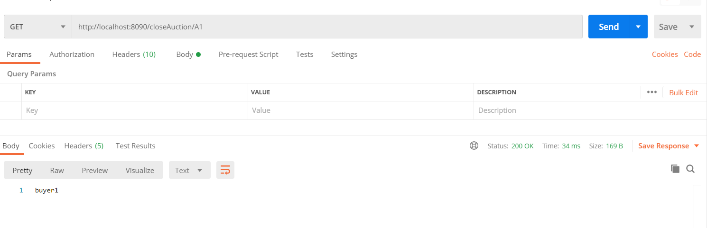

**GetProfit:**

