1. ERD

1. BFD

1. BPM
   1. Đặt phòng

3.2. Đặt dịch vụ

* 1. 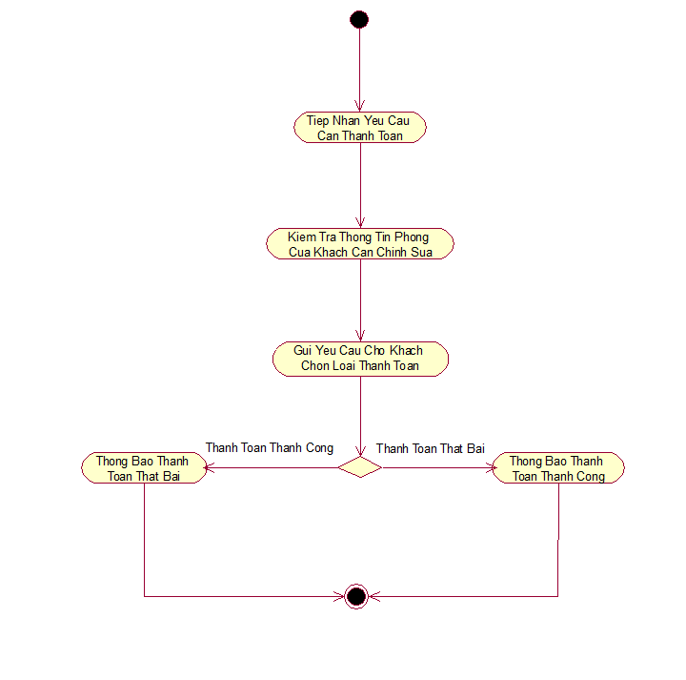Thanh toán