**CHAPTER - 1**

**INTRODUCTION**

1.Process Mining is often described as occupying the area between business process management and data mining. The speed, accuracy, and auditability these technologies deliver can result in significant cost savings and much faster time to market

2.It is a technique in the field of process management that supports the analysis of business processes based on event logs and drives improved efficiency, effectiveness, and compliance through its insight.

3.With the help of this technology, real workflows are compared with theory, which leads to better transparency as well as insight into the processes. This is necessary because the reality of the processes usually does not correspond to the ideas of the process participants and the work steps in reality are usually much more complex. You can imagine this like the promo pictures of empty vacation beaches, which are then totally overcrowded.

4.Process mining involves process like:

1. **Data Extraction**: Process mining requires data from various sources, such as event logs, ERP systems, databases, and more. Data extraction involves gathering and consolidating this information into a central repository.
2. **Data Transformation**: Once the data is collected, it needs to be transformed into a suitable format for process mining analysis. This may involve cleaning, filtering, and aggregating the data.
3. **Data Visualization**: Process mining results are often visualized through process maps, activity diagrams, and performance metrics. These visual representations help stakeholders understand the process flow, identify deviations, and measure process performance.

**CHAPTER 2**

**TECHNOLOGY**

Process Mining Technologies Process mining applies data science to discover, validate and improve workflows. By combining data mining and process analytics, organizations can mine log data from their information systems to understand the performance of their processes, revealing bottlenecks and other areas of improvement.

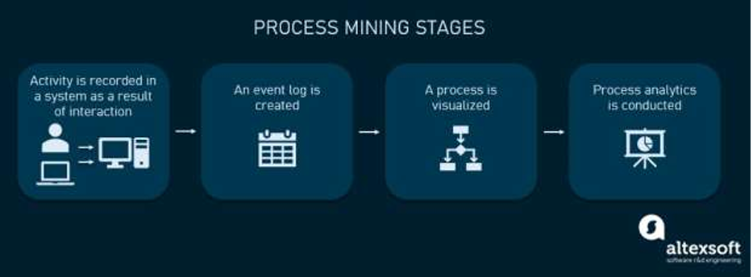

**Fig. 2.1: Process Mining Technology**

1.**App templates**

With the Process Mining service in Automation Cloud, you can create new process apps based on process-specific app templates. An app template contains a predefined set of dashboards and KPIs for process analysis and can be used as the starting point for creating your process apps. If available, an app template can include a built-in connector for a specific combination of a process and source system.

2.**Editing data transformations**

Transformations are applied to the data stored in the database to make sure the data adheres to a data schema which can be loaded in the Process Mining process app. In Process Mining, you can customize the transformations to adapt them to your data schema.

3.**Root cause analysis**

With Root cause analysis, you can compare the influence of case properties on a certain behavior to find significant data influencers for specific process situations. A set of cases is defined based on the period filter. This selection is called Reference cases. Within this set of cases, you can select the behavior that you want to analyze.

4.**Managing access control for process apps**

The Admin Console module enables you to manage access by assigning roles to users or groups. The permissions model allows you to integrate all your employees using Process Mining based on your business requirements.

5.**Extracting and loading data**

When creating a process app, you can upload data from .csv or .tsv files, or you can set up a connection to a source system using the extraction tools CData Sync or Theobald Xtract Universal. You can also use DataBridgeAgent to use custom. mvp connectors to upload data from your source.

**CHAPTER 3**

**APPLICATIONS**

These are just a few applications of process mining, and the specific use cases may vary depending on the industry and organization.

1. **Process Improvement**: Process mining can be used to identify bottlenecks, inefficiencies, and deviations in business processes, allowing organizations to optimize and improve their operations.

2. **Compliance Monitoring**: By comparing discovered process models with predefined models or business rules, process mining can help ensure compliance with regulations and standards.

3. **Risk Analysis**: Process mining can identify potential risks and vulnerabilities in processes, enabling organizations to take proactive measures to mitigate them.

4. **Performance Monitoring**: Process mining allows organizations to monitor key performance indicators (KPIs) and track process performance in real-time, facilitating data-driven decision making.

5. **Root Cause Analysis:** By analyzing event logs and process data, process mining can help identify the root causes of process issues or failures, enabling organizations to address them effectively.

6.**Automation and Digital Transformation**: Process mining can provide insights into manual and repetitive tasks, helping organizations identify opportunities for automation and digital transformation.

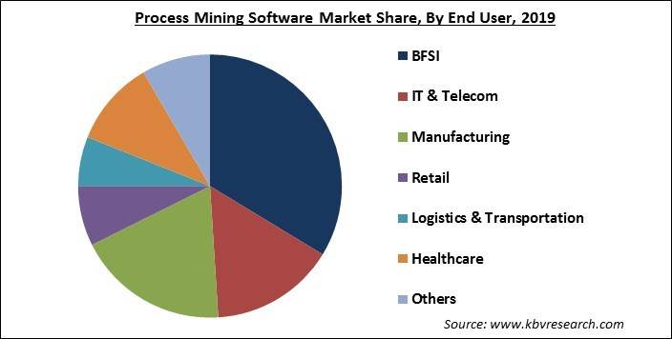

**Fig.3.1: Applications of Process Mining**

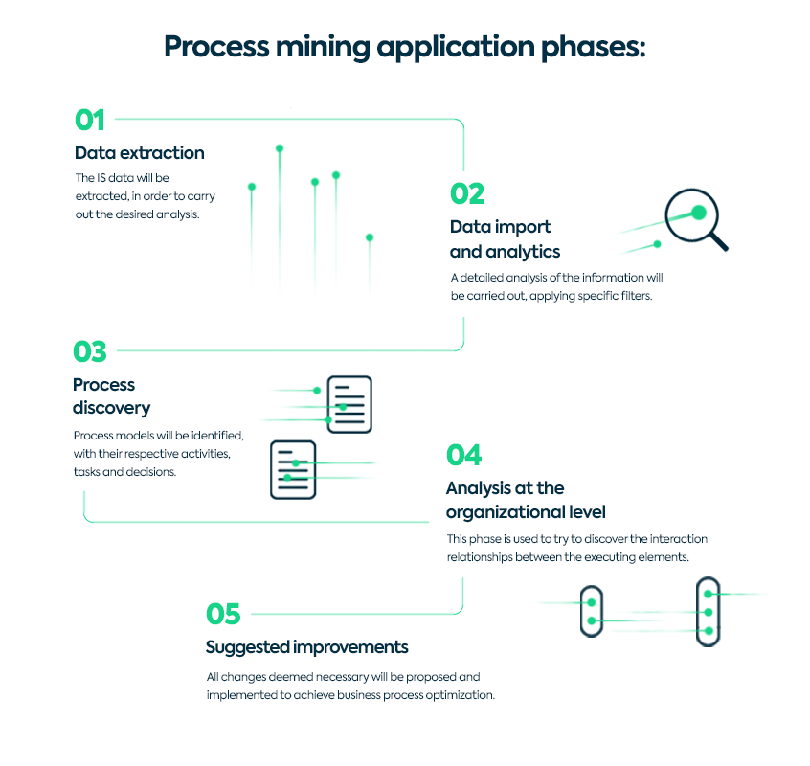

**Fig.3.2: Process Mining Application Phases**

**CHAPTER 4**

**MODULES**

**4.1 Introduction to Process Mining**

Process mining is a set of techniques used for obtaining knowledge and extracting insights from processes by the means of analyzing the event data, generated during the execution of the process.

This training track provides both the theoretical and applied foundations around Process Mining. Process mining reads this data, converts it into an event log, and then creates visualizations of the end- to-end process, along with insightful analytics.

An event log contains each step performed during the process (the activity), the time at which the event occurred (the timestamp), and for which instance of the process (the case ID). Using this event log, algorithms generate a process model that shows the process as it really is including the timing of each step and all variations from processes by the means of analyzing the event data, generated during the execution of the process

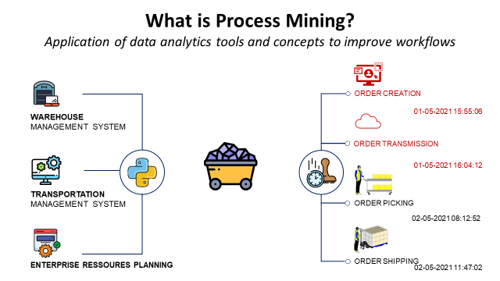

**Fig.4.1: Introduction to Process Mining**

**4.2 Process Mining Fundamentals**

The key Fundamentals of process mining refer to the core concepts and principles that underlie the analysis and improvement of business processes using process mining techniques.

It involves extracting insights from event data to understand how processes function, identifying bottlenecks, inefficiencies, and opportunities for optimization Key components include data extraction, process discovery, conformance checking, and process enhancement. Fundamentals of process mining refer to the core concepts and principles that underlie the analysis and improvement of business processes using process mining techniques.

It involves extracting insights from event data to understand how processes function, identifying bottlenecks, inefficiencies, and opportunities for optimization. Key components include data extraction, process discovery, conformance checking, and process enhancement.

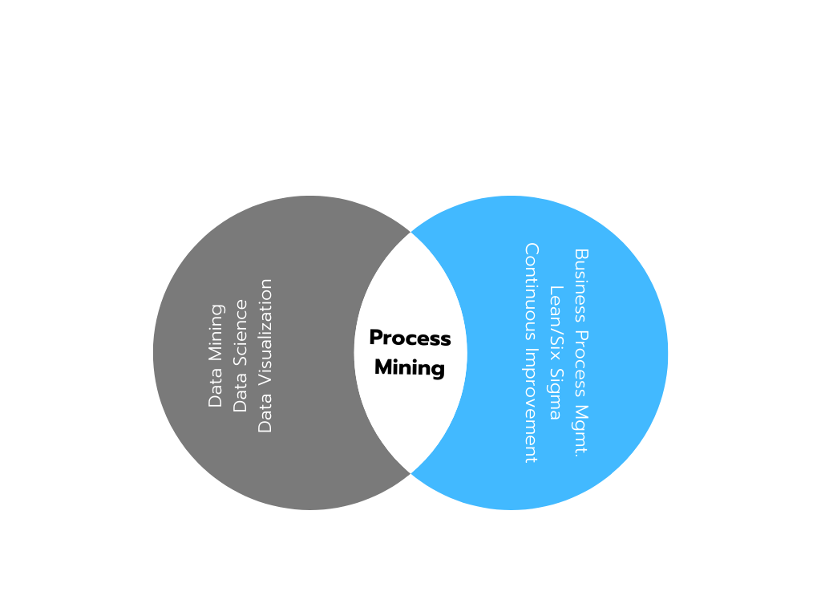

**Fig.4.2: Process Mining Fundamental**

**4.3 Rising Star- Technical**

* This refers to emerging trends and advancements in process mining, such as new algorithms, techniques, and tools that enhance the capabilities and applications of process mining.

It consists mainly two types. They are:

* PQL Queries
* Get Data into EMS

**4.3.1 PQL Queries:**

* PQL (Process Query Language) Queries are an essential component ofprocess mining. They allow analysts to extract valuable insights from process data.
* PQL Queries enable you to explore and analyze process behavior, identify bottlenecks, measure performance, and discover patterns with in the data.
* By using PQL Queries, you can ask specific questions about your process and obtain meaningful answers.

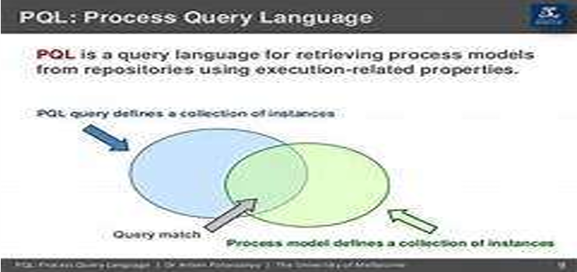

**Fig.4.3: PQL Query Language**

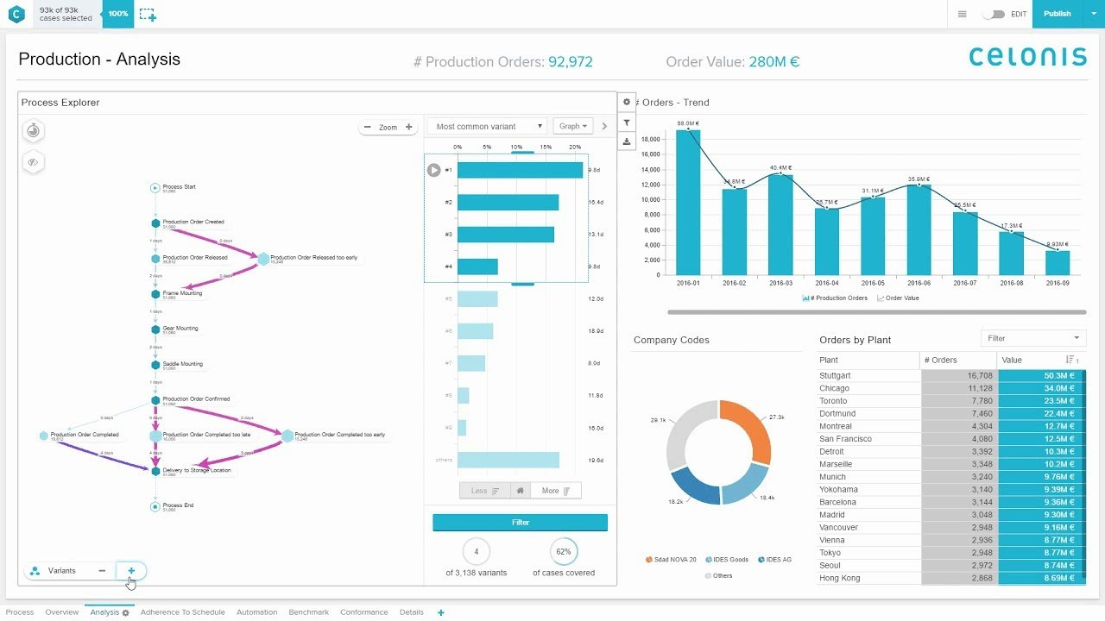

**Fig.4.4: Analysis in Process Mining Editor**

**4.3.2 Get Data into EMS**

* EMS (Event Management System) plays a crucial role in process mining as it serves as the central repository for process data. Get data into EMS involves integrating data from various sources such as ERP systems, databases, log files, and other data formats.
* It is important to ensure data accuracy, completeness, and consistency. Efficient data management in EMS includes data collection, cleansing, transformation, and storage to enable effective process mining analysis.

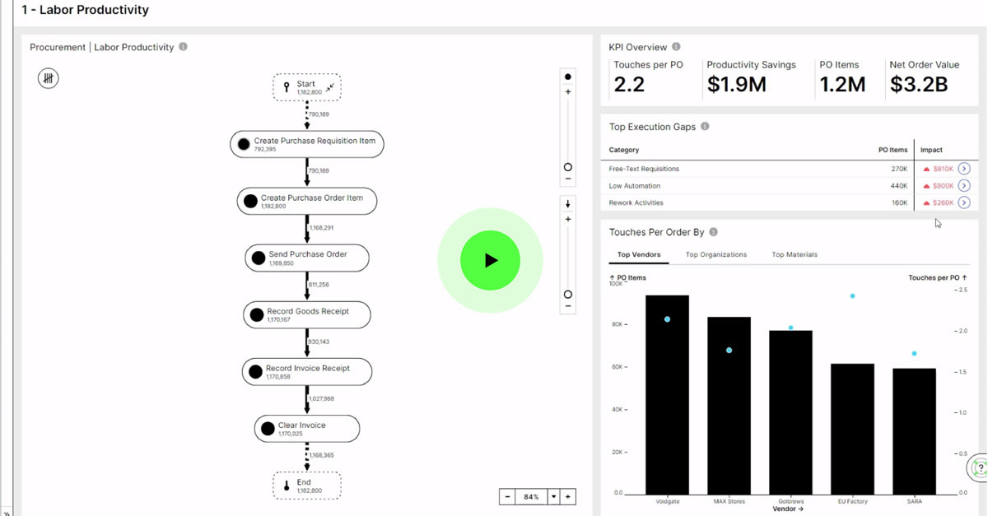

**Fig.4.3: Get Data into EMS**

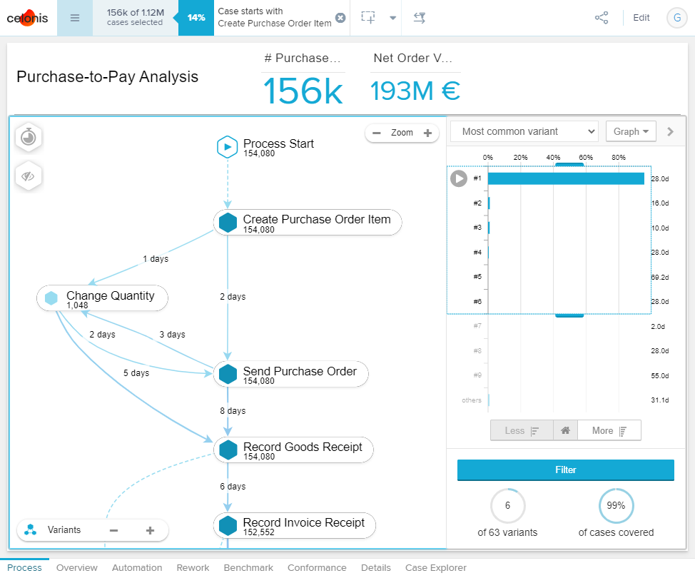

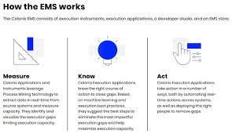

**Fig.4.4: Visualization of EMS**

**CHAPTER 5**

**REAL TIME APPLICATIONS**

These are just a few examples of how process mining can be applied across different industries.

The specific applications and benefits may vary depending on the organization and its unique processes.

* **Healthcare**: Process mining can be used to analyze patient care pathways and identify bottlenecks or inefficiencies in hospital workflows. It can help optimize patient flow, reduce waiting times, and improve resource allocation.
* **Manufacturing**: Process mining can be applied to analyze production processes and identify areas for improvement. It can help optimize production cycles, reduce waste, and enhance overall operational efficiency.
* **Finance**: Process mining can be used to analyze financial processes, such as invoice processing or loan approvals. It can help identify process bottlenecks, streamline workflows, and improve compliance with regulatory requirements**.**
* **Customer Service**: Process mining can be applied to analyze customer service processes, such as call handling or complaint resolution. It can help identify areas for improvement, optimize response times, and enhance customer satisfaction.
* **Supply** **Chain Management:** Process mining can be used to analyze supply chain processes, such as order fulfillment or inventory management. It can help identify inefficiencies, optimize logistics, and improve overall supply chain performance
* **Root Cause Analysis**: Process mining techniques can identify the root causes of process inefficiencies or deviations by analyzing event data. This helps organizations pinpoint the underlying issues and take targeted actions to address them.
* **Process Enhancement**: Based on process mining insights, organizations can redesign and optimize their processes to eliminate bottlenecks, reduce costs, and improve customer satisfaction.

These outcomes highlight the potential benefits of process mining in terms of process improvement, compliance, and data-driven decision-making

CHAPTER **6**

**OUTCOMES**

The outcomes of the topic on process mining can include:

* **Improved Process Efficiency**: By analyzing event logs and process data, process mining can identify bottlenecks, inefficiencies, and deviations in business processes. This information can help organizations optimize their processes and improve overall efficiency.
* **Process Discovery**: Process mining techniques can automatically discover and visualize the actual process flows based on event logs. This helps organizations gain a better understanding of their processes, identify process variants, and uncover hidden patterns or deviations.
* **Conformance Checking**: Process mining can compare discovered process models with predefined process models or business rules to assess compliance. It can identify deviations, non-compliance, and potential risks, enabling organizations to take corrective actions.
* **Performance Monitoring:** Process mining allows organizations to monitor and measure process performance indicators, such as cycle times, throughput, and resource utilization. This helps in identifying performance issues, evaluating process

**CHAPTER 7**

**CONCLUSION**

* process mining is a powerful technique that enables organizations to analyze and improve their business processes.
* By leveraging process mining, companies can gain valuable insights into their processes, identify bottlenecks, measure performance, and discover patterns and trends.
* Process mining fundamentals include data extraction, data transformation, and data visualization. These foundational elements are essential for effectively applying process mining techniques and deriving actionable insights from process data.
* Rising star technical topics in process mining, such as PQL Queries and getting data into EMS, further enhance the capabilities of process mining