LAGUNA STATE POLYTECHNIC UNIVERSITY
SANTA CRUZ CAMPUS • COLLEGE OF COMPUTER STUDIES
DEPARTMENT OF COMPUTER SCIENCE

THE RIGHT CALL
EMERGENCY DISPATCH ACADEMY
OFFICIAL WEB GAME USER MANUAL — VERSION 1.0 (2026)
An AI-Enhanced Gamified Intelligent Tutoring Simulation for Emergency Preparedness
Parent Academic Project: SafeScape 2.0
Official Web Platform Access URL:
https://bfpscberong.app
Software System / Game Title: | The Right Call — Emergency Dispatch Academy (SafeScape 2.0)
Access Paradigm & Deployment: | Web Game (HTML5 / WebGL / WASM via https://bfpscberong.app)
Target Learning Audience: | Student Trainees, Cadets, Community Responders, Dispatch Trainees
Software Authors / Developers: | DELA PAZ, ZYRIL G. | DELOS REYES, AXCEL ANDREI V. | LACHANO, JHED AERON V.
Undergraduate Thesis Adviser: | DR. MIA V. VILLARICA, DIT (Associate Dean, College of Computer Studies)
Technical Evaluation Committee: | MARK P. BERNARDINO (System Expert) | ROXANNE R. GARBO (Technical Editor) | EDWARD S. FLORES (Statistician)
Institutional Partner Agency: | Bureau of Fire Protection (BFP) — Santa Cruz Municipal Fire Station, Laguna
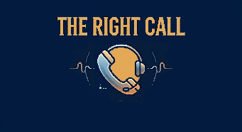
Figure 1: Official Logo — The Right Call: Emergency Dispatch Academy

I. Introduction
The Right Call — Emergency Dispatch Academy is an interactive emergency telecommunications and tactical incident dispatch simulation game developed under the SafeScape 2.0 research initiative. The software places learners into the critical operational role of an emergency response dispatcher serving the municipality of Santa Cruz, Laguna, Philippines. Rather than functioning as a passive digital textbook or an arcade vehicle simulator, the game presents a live geographic operations board where trainees must intake emergency calls, interpret frantic citizen dialogue, formulate life-safety instructions, and deploy specialized municipal response units under realistic operational pressure.
1.1 Purpose and Educational Scope
Emergency telecommunicators serve as the vital initial link in the emergency response chain. Dispatchers are tasked with determining incident severity, extracting essential geospatial information, reassuring panicked callers, providing immediate pre-arrival safety guidance (such as crawl-low-in-smoke or spinal stabilization protocols), and deciding exactly which municipal agency must be mobilized to the scene. Poor or delayed dispatch decisions can result in catastrophic loss of life and property.
The educational purpose of The Right Call is to bridge the gap between theoretical fire-safety principles and high-stress operational execution. By simulating authentic Philippine emergency reports across fire, medical trauma, and civil security incidents, the academy provides learners with measurable, repeatable cognitive training.
1.2 Core Pedagogical Objectives
The curriculum and operational simulation of The Right Call are engineered around four primary learning competencies:
- Situational Triage & Hazard Assessment: Develop cognitive mastery in assessing caller statements, identifying hidden hazards (e.g. electrical hazards, hazardous chemicals, structural collapse), and establishing situational urgency within seconds.
- Pre-Arrival Life-Safety Protocol Adherence: Learn and apply verified Bureau of Fire Protection (BFP) standard operating procedures, including exit drills in the home (EDITH), grease fire smothering techniques, and safe evacuation guidelines before first responders arrive.
- Tactical Emergency Fleet Allocation: Master the jurisdiction, operational equipment, and response capabilities of Santa Cruz municipal agencies: Bureau of Fire Protection (BFP), Municipal Disaster Risk Reduction and Management Office (MDRRMO), and the Philippine National Police (PNP).
- Operational Incident Management Under Pressure: Develop emotional composure and rapid decision-making capacity under dynamic shift constraints, multi-incident queues, and simulated communications latency.
■ Pedagogical Note — Focused Scope of this Manual
This official user manual exclusively documents 'The Right Call — Emergency Dispatch Academy'. All guidance, control specifications, workflows, and screenshots represent the authentic emergency dispatch operations board. Mechanics from separate household inspection modules (such as physical character movement, search checklists, or appliance inspections) are completely excluded as they belong to separate systems.

II. Accessing the Web Game
The Right Call is built and distributed exclusively as an interactive web game. It does not require installing standalone software packages, downloading executable installers, or configuring complex desktop launchers. Users access the complete learning academy directly through standard modern web browsers on internet-connected devices.
2.1 Verified Access Procedure via the Berong E-Learning Platform
To launch and access The Right Call, follow these step-by-step verified procedures:
Step 1: 1. Open a Supported Web Browser: Launch a modern, standards-compliant web browser. Google Chrome, Microsoft Edge, Mozilla Firefox, or Apple Safari with WebGL 2.0 and WebAssembly (WASM) support are recommended.
Step 2: 2. Navigate to the Official Access Portal: In the browser address bar, enter the verified portal address: https://bfpscberong.app and press Enter.
Step 3: 3. Locate the Simulation Hub: On the Berong E-Learning Platform home dashboard, navigate to the Games & Simulations directory or select the interactive training portal tab.
Step 4: 4. Launch The Right Call: Click or tap the simulation card titled The Right Call — Emergency Dispatch Academy.
Step 5: 5. Web Engine Initialization: The portal loads the Godot 4 WebAssembly runtime container. Allow approximately 5 to 15 seconds for asset decompression, engine initialization, and audio caching over your internet connection.
Step 6: 6. Splash Screen & Main Menu: Once initialization is complete, the animated academy splash screen will transition smoothly to the primary Main Menu operations screen.
Step 7: 7. Begin Training Session: Select your desired operational mode (Tutorial, BFP Assessments, Normal Mode, or Professional Mode) using the visible on-screen interface.
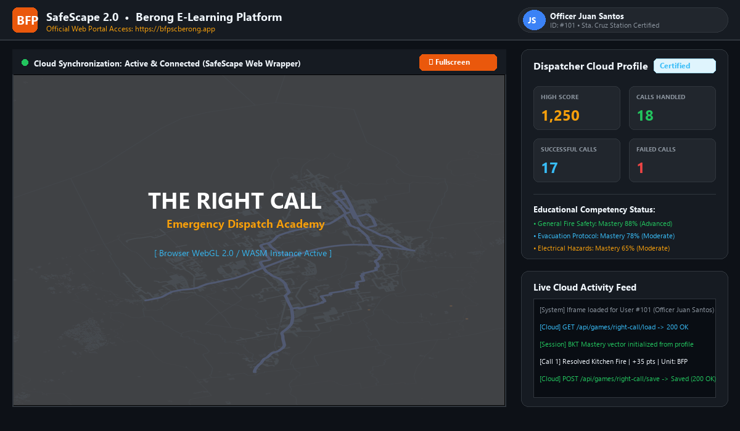
Figure 2: Web Platform Architecture — Berong E-Learning Portal (https://bfpscberong.app) embedding The Right Call runtime iframe with cloud synchronization and live dispatcher profile metrics.
2.2 System & Browser Architecture
The Right Call operates within an embedded web architecture designed for lightweight, high-performance execution:
- Host Iframe Wrapper: The host web page embeds the Godot 4 HTML5 export inside a responsive 16:9 aspect-ratio frame. URL search parameters (such as user_id and player_name) are automatically parsed by the game's CloudSaveManager to associate the trainee's station profile.
- Cloud Synchronization: During live emergency handling, completion events and performance scores dispatch asynchronous window.parent.postMessage({ type: 'RIGHT_CALL_SAVE', payload }) notifications to the host wrapper, which securely forwards progress to the cloud API.
- Local Persistence Fallback: If network connectivity drops or the user operates in an offline demonstration environment, the game seamlessly falls back to browser localStorage (user://player_progress.json) without disrupting the dispatch shift.
■ Critical Platform Restrictions — Web Game Verification
• The Right Call is strictly a web application. Do NOT attempt to locate, download, or launch a 'TheRightCall.exe' file.
• There is NO desktop installation wizard, setup package, or native device-selection screen.
• Access is universally performed via https://bfpscberong.app on desktop computers, laptops, tablets, or touchscreen devices through standard web browsers.

III. Main Menu and Getting Started
Upon successful web loading, the trainee is greeted by the academy splash screen, followed by the Main Menu operations terminal. The interface is optimized with a clean dark theme, clear typography, and a live background simulation rendering Santa Cruz patrol vehicles navigating municipal roadways.
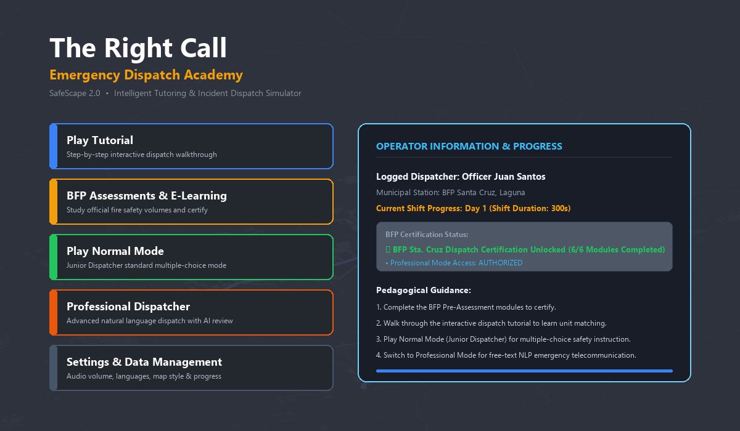
Figure 3: Main Menu Terminal — Live Santa Cruz patrol map background, primary action buttons, dispatcher profile card, and certification lock status.
3.1 Main Menu Interface Elements
The Main Menu provides direct on-screen buttons for all training workflows:
- Play Tutorial: Engages an interactive guided call walkthrough. The tutorial coach highlights key interface components (caller transcript, decision cards, dispatch fleet) and guides the trainee through handling a live emergency call with zero penalty.
- BFP E-Learning & Assessments: Opens the academic fire-safety study and examination hub. Trainees can study official BFP volumes (Modules 1 through 6) and take modular quizzes required to earn the BFP Sta. Cruz Dispatch Certification.
- Play Normal Mode: Launches standard dispatch shifts (Junior Dispatcher). In Normal Mode, callers present emergencies with structured multiple-choice decision cards, immediate feedback, and optional protocol hints.
- Professional Dispatcher: Engages the advanced dispatch simulator. In Professional Mode, structured cards are replaced with a free-text response field where trainees type natural-language instructions evaluated by an intelligent NLP engine. Requires BFP Certification to unlock.
- Settings & Data Management: Opens an in-game modal overlay allowing trainees to adjust audio volume sliders (Master, BGM, SFX), change interface languages (Taglish, English, Tagalog), inspect evaluation reports, or perform session resets.
3.2 Recommended First-Launch Pathway
To maximize learning effectiveness and unlock all simulation features, trainees are strongly advised to follow this structured four-stage sequence:
Stage 1: 1. Complete BFP Pre-Assessments: Enter 'BFP E-Learning & Assessments' and complete all 6 modules. Achieving 100% completion unlocks the BFP Sta. Cruz Dispatch Certification.
Stage 2: 2. Execute Interactive Tutorial: Run the 'Play Tutorial' mode to become familiar with map controls, marker selection, dialogue streaming, and vehicle deployment.
Stage 3: 3. Practice in Normal Mode: Play Day 1 shifts in Normal Mode to build fast hazard-recognition reflexes using multiple-choice decision cards.
Stage 4: 4. Advance to Professional Mode: Enter Professional Dispatcher mode to test true telecommunicator competency using typed, real-time natural language instructions.

IV. On-Screen Controls and Interface
The Right Call is engineered as an on-screen touch and click interface. Trainees interact with all simulation systems using a computer mouse (pointing and clicking) or a touchscreen display (tapping and dragging). In Godot Engine project settings, pointing/emulate_touch_from_mouse is enabled, ensuring identical responsiveness across desktop mice, trackpads, and mobile touch surfaces.
■ Verified Interaction Method — No Physical Keyboard Navigation
The game does NOT utilize keyboard navigation, arrow keys, or WASD physical movement controls for gameplay. All actions—answering calls, selecting options, dispatching units, and panning the operations map—are performed entirely through visible on-screen elements. For text entry in Professional Mode, an on-screen Virtual Touch Keyboard is provided alongside physical keyboard support.

4.1 Complete On-Screen Interface Reference Table
The table below documents every active on-screen element verified within the project codebase:
On-Screen Element | Purpose & System Role | How to Use It
Operations Map Viewport | Interactive geographic display of Santa Cruz, Laguna road network, barangay zones, and moving patrol vehicles. | Click and drag (or touch and drag) to pan across the municipality. Use mouse wheel or pinch-to-zoom to zoom in/out.
Emergency Incident Marker | Flashing badge that spawns along roadways indicating a new citizen 911 distress call. | Click or tap the active flashing marker on the map to answer the call and open the live call handling terminal.
Off-Screen Alert Indicator | Directional edge chevron indicating active calls positioned outside the current visible viewport. | Click or tap the edge chevron; the viewport automatically pans directly to the off-screen incident location.
Home / Menu Button | Top-left navigation icon allowing the dispatcher to pause the shift and exit to the Main Menu. | Click or tap the Home icon in the top HUD. Prompts a confirmation dialog to save shift progress before exit.
Shift Timer & HUD | Displays elapsed shift time, remaining seconds (300s total), active day number, and accumulated score. | Monitored passively during gameplay. Flashes yellow when shift completion thresholds (250 pts) are reached.
Caller Portrait & Emotion | Visual portrait box showing the citizen caller and their emotional state (panicked, calm, relieved). | Displays automatically during live call handling to provide visual empathy cues and caller identity context.
Operator Emotion Portrait | Visual avatar of Dispatcher Berong reflecting operational accuracy and stress levels. | Monitors performance. Shifts dynamically from Calm to Serious/Stern when the trainee commits dispatch mistakes.
Live Transcript Stream | Scrolling radio communications terminal displaying incoming caller statements and system logs. | Dialogue streams line-by-line automatically. Drag or scroll the transcript box up/down to review earlier caller statements.
Decision Option Cards | Multiple-choice response cards presented in Normal Mode containing candidate safety instructions. | Click or tap the card representing the safest protocol action. Correct cards highlight green; errors prompt retry.
Typed Response LineEdit | Text entry field appearing in Professional Mode for typing open-ended natural language advice. | Click/tap the text box, type emergency instructions using physical keyboard or virtual keyboard, and press Enter or Submit.
Submit Response Button | Dedicated button alongside the typed response field to confirm and submit instructions. | Click or tap 'Submit' after entering free-text advice to trigger natural language processing evaluation.
Virtual Keyboard Toggle | Floating keyboard icon enabling an on-screen QWERTY touch keyboard for touchscreen users. | Tap the keyboard icon in the bottom-right of the call panel to toggle the virtual touch keyboard on/off.
Hint Button ('?') | Contextual help icon available in Normal Mode providing BFP guidebook references for the active call. | Click or tap the hint button to display pre-arrival advice suggestions without penalizing the overall score.
Dispatch BFP Button | Tactical deployment button for sending BFP Fire Engines to suppress fires or perform extrications. | Click or tap 'Dispatch BFP' once safety advice is accepted. Dispatches fire truck from BFP Santa Cruz Station.
Dispatch MDRRMO Button | Tactical deployment button for sending MDRRMO Ambulances to medical or trauma emergencies. | Click or tap 'Dispatch MDRRMO' to deploy ambulance and paramedic crew from the Santa Cruz MDRRMO Station.
Dispatch PNP Button | Tactical deployment button for sending Philippine National Police patrols to crimes and public threats. | Click or tap 'Dispatch PNP' to dispatch patrol officers from the Santa Cruz Municipal Police Station.
En Route Status Bar | Live progress indicator displaying vehicle travel countdown, transit speed, and scene arrival. | Monitored passively. Displays 'Units Arrived on Scene' when the vehicle reaches the incident coordinate.
SOP Guidebook Button | Quick-reference manual button embedded in the call panel header. | Click or tap to open a modal reference summarizing unit matching rules and primary first-aid reminders.
Settings Button | Quick access button to the settings overlay for volume, language, and reset options. | Click or tap the gear icon in the HUD or menu to adjust settings without losing active session state.
Shift Review Accordion | Interactive post-shift summary displaying scores, call evaluations, and protocol comparisons. | Click or tap individual incident rows to expand detailed explanations of why specific advice succeeded or failed.

V. Complete Gameplay Walkthrough
A standard shift in The Right Call follows a disciplined, 13-step emergency telecommunication loop. The walkthrough below details the exact chronological sequence experienced by a trainee during live dispatch operations:
Step 1: Open Operations Board: The shift commences on the Santa Cruz operations board. Trainees monitor the road network where municipal patrol units circulate along verified OpenStreetMap coordinates. The top HUD displays the shift countdown timer (300 seconds total) and current day counter (Day 1).
Step 2: Identify Incoming Emergency Report: A citizen call triggers an alert. A bright flashing incident marker spawns at a road coordinate, accompanied by an audible telephone ring. If the incident is located outside the active view, an off-screen edge chevron points towards its direction.
Step 3: Answer Call & Engage Terminal: Click or tap the flashing incident marker (or edge chevron). The map dims slightly, and the centered Live Call Terminal opens. The incident banner displays the barangay location, preliminary classification, and urgency rating.
Step 4: Stream Caller Dialogue & Transcript: Radio squelch sounds play as caller dialogue streams into the transcript box line-by-line. The citizen caller describes their emergency (e.g., dense smoke in a bedroom, a sparking electrical wire, or a fall victim with severe back pain).
Step 5: Perform Situational Triage: Analyze the caller's statement against BFP fire safety principles. Determine whether immediate life safety is at risk, identify the specific hazard class (e.g., grease fire, electrical hazard, trauma), and note if any individuals are trapped or injured.
Step 6: Formulate Protocol-Compliant Safety Instruction: In Normal Mode, examine the 3 (or 4) decision option cards presented. In Professional Mode, review the situation and prepare to type concise, direct guidance into the response field.
Step 7: Submit Response & Review Feedback: Click/tap the selected decision card (or click 'Submit' after typing). The system immediately evaluates the instruction: Safe (+20 pts), Uncertain (+5 pts), or Unsafe (-10 pts). The dialogue transcript updates with the dispatcher's exact words.
Step 8: Handle Retries & Error Correction: In Normal Mode, selecting an unsafe or incorrect option triggers an immediate educational modal explaining why the instruction is dangerous (e.g., pouring water on hot oil causes an explosive fireball). Trainees must retry and select the correct advice.
Step 9: Unlock Fleet Dispatch Phase: Once compliant safety advice has been accepted by the caller, the emergency fleet dispatch phase unlocks. The dispatch buttons illuminate, and the system displays the recommended agency based on incident triage.
Step 10: Select & Deploy Response Units: Select the appropriate municipal agency button: Dispatch BFP (Fire Engine), Dispatch MDRRMO (Ambulance), or Dispatch PNP (Police Patrol). Sending the correct unit earns +15 points. In Normal Mode, incorrect units are rejected with an advisory retry notice.
Step 11: Monitor Unit Transit & Road Navigation: The selected vehicle deploys from its municipal station (BFP Santa Cruz, MDRRMO, or PNP Station) and calculates the shortest road route using Dijkstra/graph pathfinding across Santa Cruz coordinates. An on-screen status bar shows remaining travel time.
Step 12: Maintain Line Until Scene Arrival: In accordance with standard 911 dispatch protocols, the trainee must keep the caller calm and maintain communication until emergency units physically arrive on scene. The call cannot be prematurely terminated while responders are en route.
Step 13: Resolve Incident & Record Shift Scoring: Upon vehicle arrival at the incident coordinate, the emergency status updates to 'Units on Scene — Operation Completed'. Speed bonuses (+10 or +5 pts) are calculated, BKT competency mastery updates, and the trainee continues to the next queued emergency.
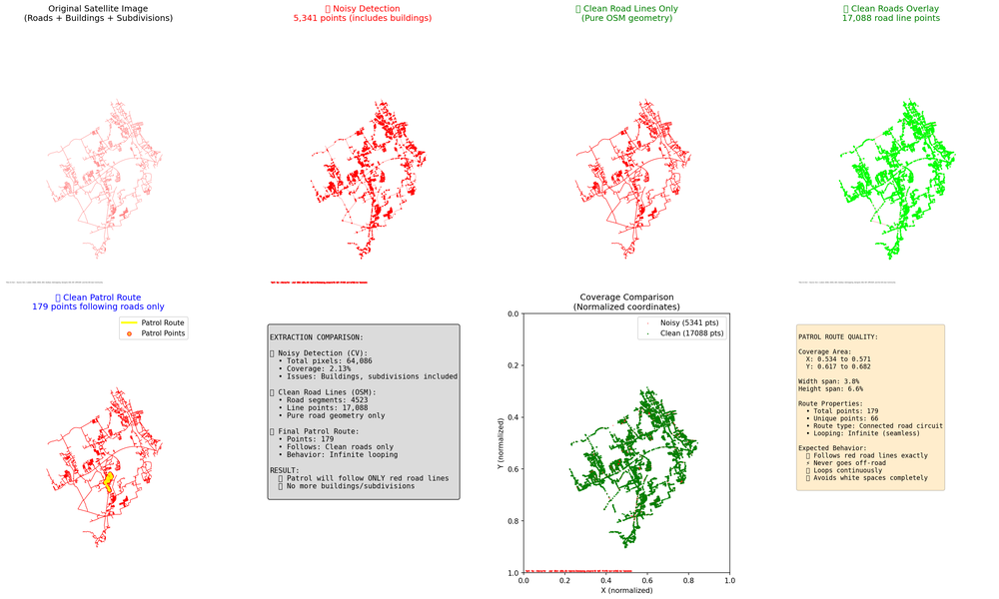
Figure 4: Santa Cruz Geographic Operations Board — Road network coordinates, municipal barangay zones, service stations, and moving patrol vehicles.
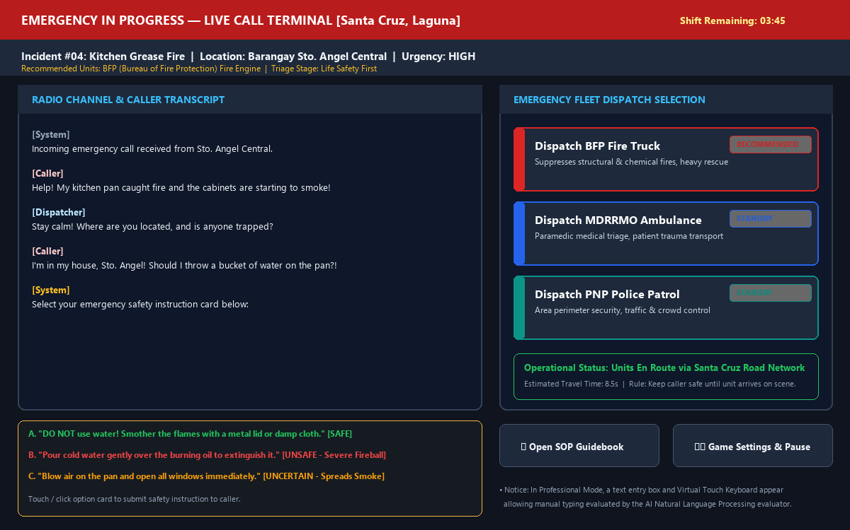
Figure 5: Live Call Handling Terminal — Caller dialogue streaming, multiple-choice decision cards, agency dispatch controls, and live vehicle transit status.

VI. Emergency Agencies and Dispatch Decisions
The Right Call accurately models the municipal emergency response infrastructure of Santa Cruz, Laguna. Three primary government response agencies are implemented within the game's dispatch engine, each maintaining distinct operational equipment, jurisdictional responsibilities, and station locations.
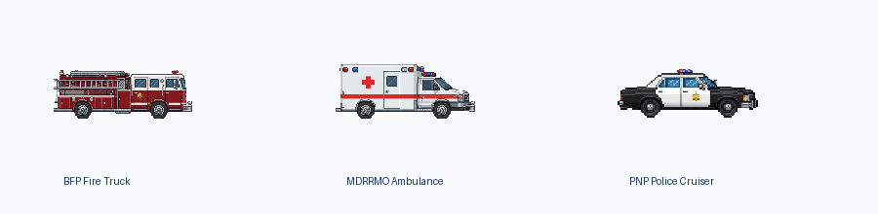
Figure 6: Verified Emergency Response Fleet — Bureau of Fire Protection (BFP) Fire Engine, MDRRMO Paramedic Ambulance, and PNP Police Patrol Unit.
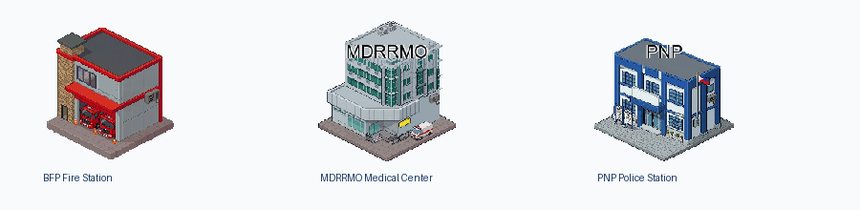
Figure 6b: Santa Cruz Municipal Response Stations — BFP Santa Cruz Fire Station, MDRRMO Municipal Rescue Station, and PNP Municipal Police Station.
6.1 Dispatch Decision Reference Matrix
The reference table below defines the authoritative mapping between incident categories, deployed units, and operational consequences:
Agency & Emblem | Unit Types | Primary Incident Scope | Dispatch Method | Consequences of Mismatch
Bureau of Fire Protection (BFP) | BFP Fire Engine / Pumper Truck / Heavy Rescue Squad | Structural fires (Class A), electrical fires (Class C), grease/chemical fires (Class B/K), hazardous material spills, structural collapse, and technical vehicle extrication. | Click / tap 'Dispatch BFP' button in the vehicle grid once life safety guidance is accepted. | Dispatch rejected in Normal Mode with corrective explanation. In Professional Mode, improper unit arrival severely delays fire suppression (+15s penalty) and reduces shift score.
Municipal Disaster Risk Reduction & Management Office (MDRRMO) | Emergency Paramedic Ambulance / Patient Transport Unit | Medical trauma, falls from height, severe bleeding, cardiac arrest, respiratory distress, heat exhaustion, and hospital transfers during vehicular collisions. | Click / tap 'Dispatch MDRRMO' button in the vehicle grid once triage advice is accepted. | Dispatch rejected in Normal Mode. In Professional Mode, sending non-medical units leaves injured victims un-stabilized, resulting in critical condition deterioration and score deductions.
Philippine National Police (PNP) | PNP Police Patrol Car / Tactical Response Cruiser | Crimes in progress, domestic violence, active assaults, armed threats, aggressive disturbances, burglary, and securing perimeters around major hazard zones. | Click / tap 'Dispatch PNP' button in the vehicle grid once caller safety guidance is accepted. | Dispatch rejected in Normal Mode. In Professional Mode, deploying unarmed responders into hostile situations places personnel at risk, generating severe protocol violation penalties.

VII. Game Modes and Response Evaluation
The Right Call features two distinct operational game modes designed to accommodate different stages of operator competency:
7.1 Junior Dispatcher (Normal Mode)
- Access: Entry: Accessible immediately from the Main Menu ('Play Normal Mode') without prerequisite certification.
- Interaction: Input Style: Structured Multiple-Choice Decision Cards.
- Operational Flow: Mechanics: Each emergency scenario presents 3 or 4 candidate safety instructions tailored to the incident type. The trainee evaluates the caller's predicament and selects the protocol-compliant option.
- Evaluation System: Evaluation Labels: Options are categorized into three verified evaluation tiers:
- • Safe (+20 pts): Fully protocol-compliant instruction that protects human life and mitigates danger.
- • Uncertain (+5 pts): Partially helpful or overly cautious advice that fails to address the immediate hazard.
- • Unsafe (-10 pts): Dangerous or contraindicated instruction (e.g., throwing water on a grease fire).
- Pedagogical Remediation: Retry Mechanism: In Normal Mode, choosing an unsafe option does NOT terminate the simulation. An educational dialog appears explaining why the choice was hazardous, and the trainee is permitted to retry until the safe action is identified.
7.2 Professional Dispatcher (NLP Free-Response Mode)
- Access: Entry: Requires earning the BFP Sta. Cruz Dispatch Certification by completing all 6 BFP assessment modules (or enabling the temporary evaluation test override in settings).
- Interaction: Input Style: Open-ended Free-Text Response Field with On-Screen Virtual Touch Keyboard support.
- Operational Flow: Mechanics: Structured decision cards are removed. Trainees must formulate and type concise pre-arrival safety instructions directly to the citizen caller.
- Evaluation Pipeline: Dual-Layer NLP Evaluation Architecture: User-typed text is analyzed through a robust two-tier evaluation pipeline:
- • Tier 1 (Remote LLM Evaluator): When connected, responses are evaluated via a specialized Large Language Model trained on BFP standard operating procedures. The evaluator checks for keyword intent, life-safety compliance, and tone in Taglish, English, or Tagalog.
- • Tier 2 (Deterministic Local Fallback): If internet connectivity is absent or the remote service times out, an internal deterministic keyword evaluator instantly analyzes the text for mandatory emergency terms (e.g. 'smother', 'lid', 'crawl', 'unplug', 'evacuate') ensuring uninterrupted gameplay.
- Operational Standard: Perfectionist Mode: In Professional Mode, Perfectionist Mode is enforced by default. Dispatch buttons remain locked until the dispatcher has provided verified safe guidance to the caller, preventing reckless early deployment.

VIII. Adaptive Learning and Assessment
SafeScape 2.0 incorporates a closed-loop educational machine learning architecture that models each trainee's knowledge growth in real time and adapts scenario difficulty accordingly.
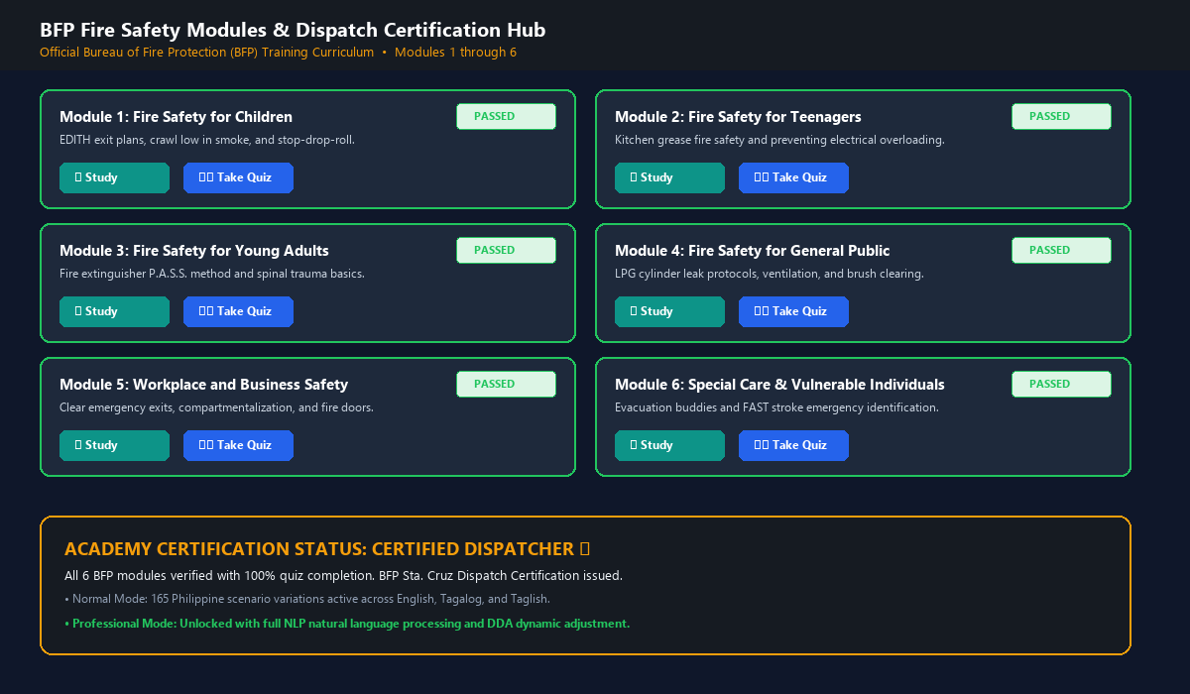
Figure 7: BFP Pre-Assessment Curriculum Hub — Six comprehensive fire safety volumes covering EDITH, grease fires, fire extinguishers, LPG leaks, business exits, and vulnerable populations.
8.1 BFP Fire Safety Pre-Assessment Curriculum
The foundational learning curriculum consists of six modular fire safety volumes derived directly from official Bureau of Fire Protection educational guidelines. Each module includes a study guide and a 10-question evaluation quiz (total 60 questions):
- Module 1: Fire Safety for Children — EDITH exit plans, crawling low in smoke, and stop-drop-and-roll instructions.
- Module 2: Fire Safety for Teenagers — Kitchen grease fire safety, smothering techniques, and avoiding electrical multi-plug overloading.
- Module 3: Fire Safety for Young Adults — Fire extinguisher P.A.S.S. protocol (Pull, Aim, Squeeze, Sweep) and spinal trauma stabilization.
- Module 4: Fire Safety for General Public — LPG cylinder leak mitigation (shutting main valve, zero spark flicking), ventilation, and brush fire clearing.
- Module 5: Workplace and Business Safety — Workplace exit clearance, fire compartmentalization, and maintaining self-closing fire doors.
- Module 6: Special Care & Vulnerable Individuals — Assisting vulnerable individuals, evacuation buddy systems, and FAST stroke identification.
8.2 Bayesian Knowledge Tracing (BKT) Mathematical Model
The Right Call tracks learner competency across six distinct fire-safety skills using standard Bayesian Knowledge Tracing (BKT). Each trainee's mastery probability P(L) is updated following every decision point:
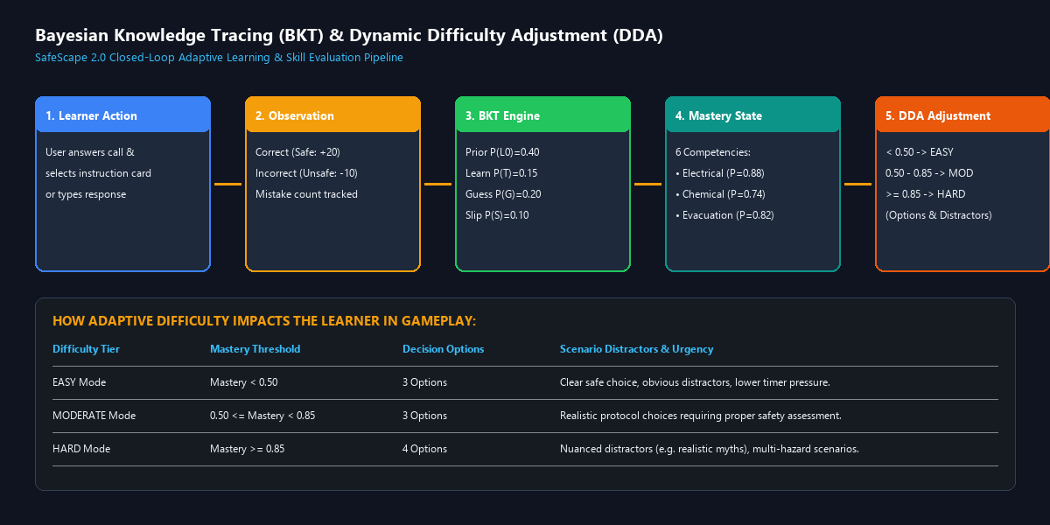
Figure 8: Closed-Loop BKT & DDA Architecture — Real-time observation ingestion, Bayesian mastery updating across 6 competencies, and dynamic scenario difficulty scaling.
The system implements the authentic BKT equations and verified parameters:
- Initial Prior Knowledge: P(L0) = 0.40 (Initial prior knowledge probability)
- Learning Transition Rate: P(T) = 0.15 (Transition probability / learning rate per decision)
- Guess Probability: P(G) = 0.20 (Guess rate probability)
- Slip Probability: P(S) = 0.10 (Slip rate probability)
When a trainee answers a decision point, the posterior mastery probability is updated via Bayes' rule:
Posterior Update: P(L | Correct) = [ P(L) * (1 - P(S)) ] / [ P(L) * (1 - P(S)) + (1 - P(L)) * P(G) ]
Knowledge Transition: P(L_new) = P(L | Obs) + (1 - P(L | Obs)) * P(T)
8.3 Dynamic Difficulty Adjustment (DDA) Engine
Rather than exposing arbitrary game levels, the system maps the learner's live BKT mastery directly into deterministic difficulty tiers:
- EASY Tier: Mastery probability < 0.50. Scenarios provide 3 candidate choices with obvious distractor options and reduced time pressure, allowing beginners to consolidate basic rules.
- MODERATE Tier: Mastery probability between 0.50 and 0.85. Scenarios provide 3 candidate choices with realistic, common misconceptions requiring careful evaluation.
- HARD Tier: Mastery probability >= 0.85. Scenarios expand to 4 candidate choices with subtle distractors, multi-room fire developments, and compressed response windows.

IX. Scoring and Session Results
The Right Call employs a transparent, objective scoring matrix reflecting real-world dispatch priorities: life safety, protocol precision, unit accuracy, and response speed.
9.1 Scoring Rules and Point Matrix
The table below details all verified point awards and deductions active in the simulation engine:
Evaluation Event | Score Adjustment | Operational Context
Safe Instruction Selected | +20 Points | Awarded when the trainee selects fully compliant life-safety guidance on first attempt.
Uncertain Instruction Selected | +5 Points (+1 Mistake) | Awarded for partially correct advice; records one operational mistake on dispatcher profile.
Unsafe Instruction Selected | -10 Points (+1 Mistake) | Deducted for hazardous instructions (e.g. water on grease fire); triggers mandatory retry dialog.
Correct Emergency Unit Dispatched | +15 Points | Awarded when the dispatched agency matches the primary hazard category (e.g. BFP for structural fire).
Incorrect Unit Dispatched (Normal) | 0 Points (Rejected) | In Normal Mode, incorrect units are rejected with an advisory notice, requiring correct re-selection.
Fast Response Speed Bonus | +10 Points | Awarded if the entire emergency call and dispatch resolution completes in under 16-30 seconds.
Moderate Response Speed Bonus | +5 Points | Awarded if the emergency call resolves between 28 and 60 seconds of initial spawn.
Shift Minimum Passing Score | 250 Points Required | Trainees must accumulate at least 250 points during their 300-second shift to advance to the next Day.
9.2 End-of-Shift Review Screen
When the 300-second operational shift expires (and active en route units have resolved their scenes), the Shift Review & Evaluation screen is displayed. The screen presents an interactive accordion list detailing every call handled during the shift:
- Score Breakdown: Displays initial decision score, unit dispatch accuracy, speed bonuses, and total shift points accumulated.
- Detailed Incident Feedback: Clicking any incident card expands a protocol review explaining the educational rationale behind the situation.
- Comparative Analysis ('What If'): Trainees can review unselected distractor options to understand why alternative actions would have worsened the incident.
- Day Advancement: If the score meets or exceeds 250 points, the trainee advances to Day 2 (featuring elevated caller volume and faster response requirements).
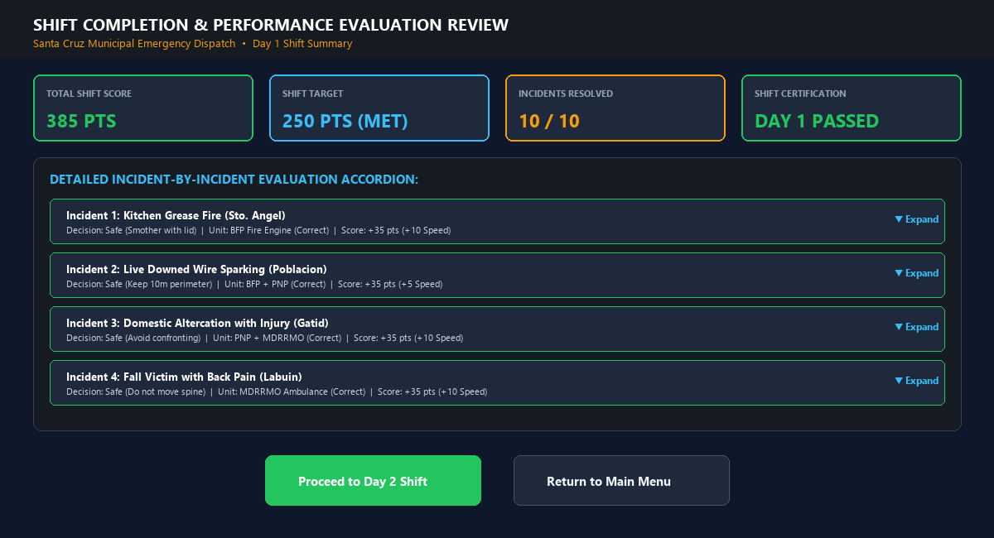
Figure 9: Shift Review & Evaluation Terminal — Total score summary, passing status, interactive incident accordion breakdown, and day progression options.

X. Settings and Progress
The Right Call features a comprehensive settings overlay accessible from the Main Menu or by clicking the gear icon during active gameplay:
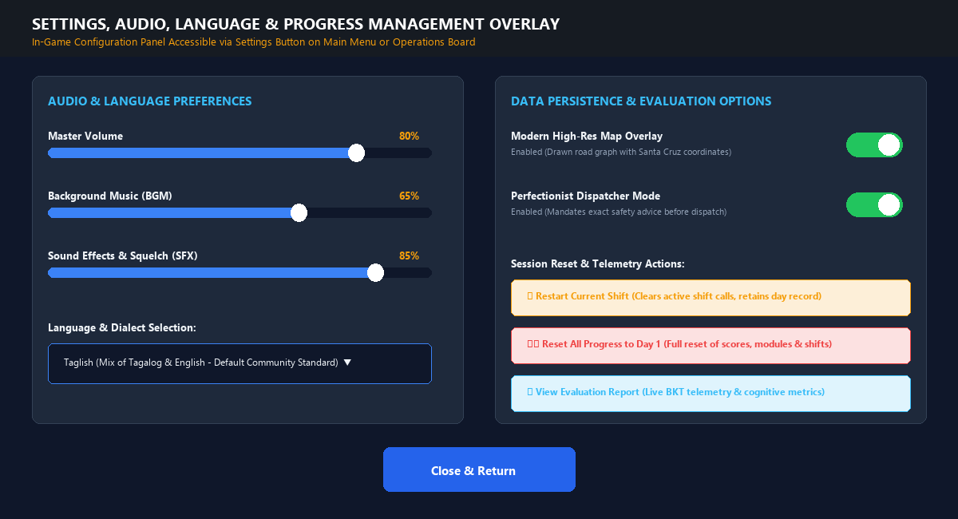
Figure 10: In-Game Settings & Progress Overlay — Audio sliders, language dropdown, map style toggle, perfectionist mode switch, and verified data reset options.
10.1 Verified Settings Options
- Audio Controls: Individual volume sliders for Master, Background Music (BGM), and Radio Squelch Sound Effects (SFX). Changes take effect instantly via the central AudioManager autoload.
- Language Selection: Dropdown menu offering three localized community dialects: Taglish (Default bilingual mix of Tagalog and English standard in Philippine emergency services), English Only, and Tagalog Only.
- Map Display Toggle: Toggle between the modern high-resolution rendered road graph overlay and the legacy simplified patrol map.
- Perfectionist Mode: When Professional Mode is unlocked, trainees can toggle Perfectionist Mode to mandate compliant safety instructions before dispatch buttons unlock.
- Soft Reset ('Restart Shift'): Clears active shift incidents and resets the shift timer while retaining the trainee's overall Day counter, score record, and BKT mastery state.
- Hard Reset ('Reset All Progress'): Clears all saved shift data, resets BKT mastery to default priors (0.40), and returns the profile to Day 1 after double confirmation.
- View Evaluation Report: Displays live BKT mastery probabilities across all 6 competencies alongside session telemetry logs.
- Save & Exit: Saves current progress and safely exits to the Main Menu without forfeiting completed incident points.

XI. Tips and Best Practices
To excel as an emergency telecommunicator and achieve high competency ratings in The Right Call, trainees should adhere to these verified dispatch principles:
- 1. Read the Entire Distress Report Before Responding: Always let the caller complete their initial statement. Crucial details—such as whether smoke is gray or black, or whether a victim is unconscious—are revealed in the opening lines.
- 2. Prioritize Life Safety Over Property Preservation: Property can be replaced; human lives cannot. Always instruct callers to evacuate burning structures, keep low under toxic smoke, and avoid attempting to fight large fires.
- 3. Recognize Hazardous Counter-Measures: Water must NEVER be applied to burning cooking oil (grease fire) or active electrical equipment. Water conducts electricity and causes burning oil to violently aerosolize into a lethal fireball.
- 4. Strictly Enforce Spinal Stabilization: If a caller reports falling from a tree or vehicle and experiences neck or back pain, instruct them to remain completely still. Moving a trauma victim risks severing the spinal cord.
- 5. Match Agencies Accurately: Review the incident type carefully before clicking dispatch buttons. Sending a police patrol to a chemical warehouse fire delays life-saving fire suppression equipment.
- 6. Consult the On-Screen SOP Guidebook: Click the '📖 Guidebook' button whenever faced with an ambiguous situation. The guidebook contains verified protocol summaries with zero score penalty.
- 7. Maintain Line Until Unit Arrival: Never attempt to close a call while emergency responders are en route. You must remain on the line to monitor conditions until units announce scene arrival.
- 8. Utilize Post-Shift Review Explanations: Carefully review the Shift Review accordion at the end of each day. Inspecting distractor explanations is the fastest method to correct cognitive misconceptions.

XII. Troubleshooting and Frequently Asked Questions
The troubleshooting matrix below provides solutions for common issues encountered during web game access:
Observed Issue | Verified Potential Cause | Recommended Resolution
Web page loads but canvas remains black. | Browser lacks WebGL 2.0 acceleration or hardware graphics acceleration is disabled. | Enable 'Hardware Acceleration' in browser settings (chrome://settings/system). Update graphics drivers and refresh.
Game loading hangs at 95% or WASM error. | Corrupted browser cache or intermittent network timeout during WebAssembly download. | Perform a hard reload (Ctrl + Shift + R or Cmd + Shift + R) to clear cached WASM binaries and re-download fresh assets.
No sound effects, squelch, or music audible. | Modern browsers block autoplaying web audio until the user interacts with the canvas. | Click or tap anywhere within the game viewport. Check in-game Settings overlay to verify Master and BGM sliders are above 0%.
On-screen buttons do not respond to clicks/taps. | A modal dialog (such as the Shift Review or Tutorial focus) is active in the background. | Look for an open confirmation box. Click 'OK' or 'Close' to dismiss active modal overlays and restore button input.
Incident markers not appearing on the map. | Maximum waiting call capacity (3 calls) reached, or shift timer has expired. | Resolve existing active calls on the operations board. If shift timer reached 0:00, click Home or wait for shift review to conclude.
Typed response evaluation takes longer than 5s. | Remote LLM service latency or intermittent network connectivity. | Wait momentarily; the system's local deterministic fallback automatically engages after timeout to evaluate keywords seamlessly.
Progress resets upon closing browser tab. | Browser is running in Private/Incognito mode or third-party cookies/storage are blocked. | Operate in standard browser mode. Ensure localStorage is permitted for https://bfpscberong.app to maintain saved shifts.

XIII. Glossary of Terms
Bayesian Knowledge Tracing (BKT): A probabilistic machine learning algorithm that estimates a learner's latent mastery of specific skills over successive learning opportunities using prior, learning, guess, and slip parameters.
Bureau of Fire Protection (BFP): The primary government agency in the Philippines responsible for fire prevention, suppression, and emergency medical/rescue services.
Dynamic Difficulty Adjustment (DDA): An automated computational mechanism that scales game challenge (distractor subtlety, option counts) in real time based on observed learner mastery.
Emergency Dispatcher: A certified telecommunicator responsible for answering emergency calls, determining incident priority, providing life-safety advice, and dispatching response units.
Exit Drills In The Home (EDITH): An official BFP fire safety program teaching households to plan and practice two distinct escape routes from every room in their residence.
Natural Language Processing (NLP): Artificial intelligence technologies that analyze and evaluate human language responses against standard operating procedure guidelines.
Municipal Disaster Risk Reduction & Management Office (MDRRMO): The local government emergency management office coordinating paramedic ambulances and disaster relief.
P.A.S.S. Method: Standard fire extinguisher deployment acronym: Pull the pin, Aim at the base of fire, Squeeze the lever, Sweep from side to side.
Philippine National Police (PNP): The national law enforcement agency responsible for public safety, criminal apprehension, and perimeter security.
Standard Operating Procedure (SOP): Formal, verified protocols governing emergency handling, triage, and agency deployment.

XIV. Support, Credits, and Document Control
14.1 Academic & Development Credits
- Student Researchers & Developers: DELA PAZ, ZYRIL G. | DELOS REYES, AXCEL ANDREI V. | LACHANO, JHED AERON V.
- Thesis Adviser: DR. MIA V. VILLARICA, DIT (Associate Dean, College of Computer Studies)
- Technical Evaluation Committee: MARK P. BERNARDINO (System Expert) | ROXANNE R. GARBO (Technical Editor) | EDWARD S. FLORES (Statistician)
- Partner Agency: Bureau of Fire Protection (BFP) — Santa Cruz Municipal Fire Station, Laguna
- Academic Institution: Laguna State Polytechnic University (LSPU), Santa Cruz Campus — College of Computer Studies
14.2 Document Revision History
Version | Release Date | Primary Changes | Authorization
v1.0 (Official) | October 2026 | Initial official user manual exclusively documenting The Right Call emergency dispatch web simulation. Focuses strictly on emergency telecommunication, BFP SOP protocols, and tactical fleet deployment. | LSPU CCS / BFP Sta. Cruz
14.3 Technical Inquiries & Platform Access
The Right Call — Emergency Dispatch Academy is accessed online at https://bfpscberong.app. For academic evaluations, thesis documentation requests, or institutional inquiries, contact the College of Computer Studies, Laguna State Polytechnic University, Santa Cruz Campus.

