AI Smart Learning Companion:
Test and Refinement of the Model

Harshitha Chennareddy, Hotragn Pettugani, Mengxia Qiu
Group 10
Northeastern University
INFO 7375 Prompt Engineering for Generative AI
Professor: Shirali Patel
April 5, 2026

1. Objective
This assignment focused on testing and refining the Generative AI application developed across Assignments 3, 4, and 5. The goal was to transition from building new functionality to validating what already existed, identifying what was breaking under real usage, and systematically improving both the backend logic and user-facing experience through iterative development. Building on earlier work with prompt engineering, RAG pipelines, fine-tuning, and LangChain integration, this phase treated the application as something approaching a real product and asked whether it actually held up under structured testing.
The work involved two parallel tracks: automated testing using pytest to catch regressions and verify logic at the unit and integration level, and hands-on user testing to surface the kinds of problems that only become visible when someone unfamiliar with the codebase tries to use the tool. Each issue found led to a targeted iteration, and each iteration was tested again before being considered done.
2. Project Overview
The application is an AI Smart Learning Companion, specifically a Quiz Generation System designed for graduate students. Users upload lecture slides in PDF format, select a topic, and the system generates a structured quiz grounded in the uploaded material. The interface allows users to choose difficulty levels (Easy, Medium, Hard), question formats (MCQ, Short Answer, Mixed), and interact with the quiz in either Test Mode or Study Mode.
The system supports three generation pipelines. The Fine-tuned mode uses a custom fine-tuned GPT-4.1-mini model trained on course lecture data from earlier assignments. The Grounded RAG mode retrieves relevant chunks from uploaded PDFs using ChromaDB and constrains the LLM to generate questions only from retrieved content. The Experimental mode exposes three prompt variants (V1, V2, V3) for side-by-side comparison, with V3 using a two-step decomposition chain that first extracts key concepts and then generates the quiz, building directly on the decomposed design validated in Assignment 5.
The target audience is graduate students preparing for exams, particularly those working from lecture slides who want an interactive, self-evaluative way to study. While the application was functional at the start of this phase, several areas required refinement. The interface had too many exposed controls for first-time users, JSON parsing from the model was inconsistent, short-answer scoring was unreliable, and groundedness evaluation was artificially low in certain modes. These observations directly informed the feature enhancements and testing strategy described below.
Figure 1
QuizLab Application Main Interface
[Insert screenshot here]
Note. The sidebar displays file upload, topic input, difficulty selector, format selector, and quiz mode toggle. The main workspace area shows the generated quiz with evaluation metrics.
Figure 2
Advanced Options Panel (Collapsed)
[Insert screenshot here]
Note. The Advanced Options expander contains temperature slider, prompt wording style, comparison mode toggle, and experimental variant selector. These are hidden by default to reduce cognitive load for first-time users.
3. Feature Enhancement
Several improvements were implemented based on internal evaluation and direct observation of how the app behaved during testing. These ranged from quick UI fixes to a significant rework of the answer evaluation pipeline.
3.1 Simplified Interface and Default Flow
The most visible change was a redesign of the sidebar to reduce the number of decisions a user has to make on first use. Core actions like file upload, topic entry, and quiz generation stayed front and center. Advanced controls including temperature settings, prompt variants, and comparison mode were moved into a collapsible "Advanced Options" section using Streamlit's expander widget. A default mode (Fine-tuned, Medium difficulty, Mixed format) was established so that users unfamiliar with prompt engineering could generate a quiz without configuring anything.
3.2 Test Mode and Study Mode
Two distinct interaction modes were introduced to support different learning workflows. In Test Mode, users answer all questions and receive scores and feedback only after clicking Submit, simulating a realistic self-assessment. In Study Mode, answers and explanations are visible immediately alongside each question, making it suitable for concept review. The Submit button is hidden entirely in Study Mode since submitting does not apply there.
Figure 3
Test Mode vs. Study Mode Comparison
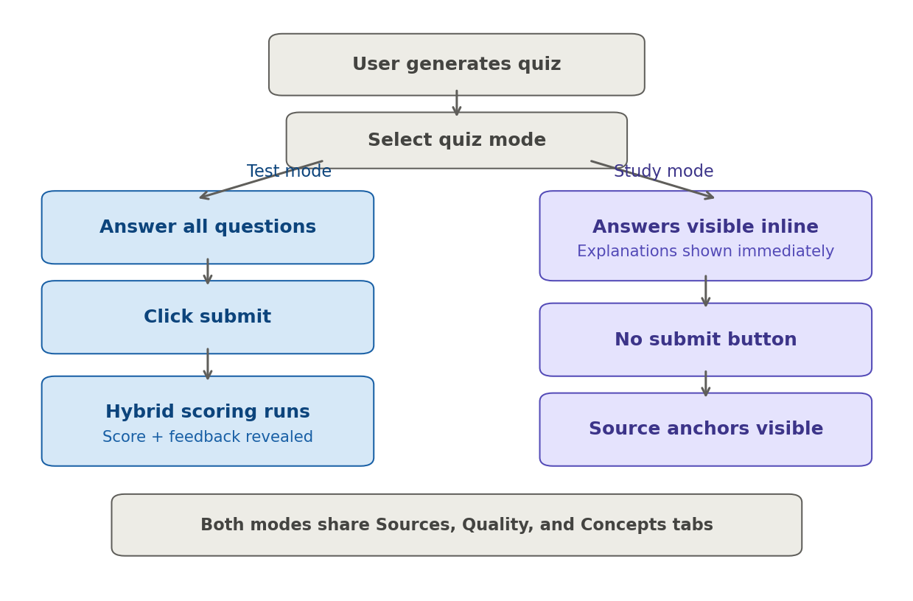
Note. Left path: Test Mode requires answering all questions and clicking Submit before feedback is shown. Right path: Study Mode displays answers and explanations immediately with no Submit button.
3.3 Source Transparency
A dedicated Sources tab was added to display the specific lecture snippets retrieved during quiz generation. Each source shows the PDF filename and a preview of the retrieved chunk. This gives users visibility into what content the model was working from and lets them verify whether a question is genuinely grounded in their uploaded material. This directly addresses the Assignment 5 feedback suggesting human verification of grounding.
For V3 (Experimental), a Concepts tab surfaces the extracted concepts before quiz generation, showing the intermediate reasoning step. The Concepts tab is only rendered when V3 is active. In earlier versions it appeared regardless of mode and displayed an ambiguous empty-state message, which confused users. This was cleaned up so the tab either does not appear or shows a clear explanation that concept extraction is exclusive to Experimental V3 mode.
3.4 Hybrid Short-Answer Scoring
This was the most significant feature change. The original scoring for short-answer and application-type questions relied entirely on exact string matching after normalization. During testing with real lecture slides, we found that correct answers phrased differently from the expected answer were consistently marked wrong. A valid answer like "This iterative cycle allows the model to dynamically adjust its approach based on new information" would be rejected because it did not match the stored acceptable_answers word for word.
The replacement is a three-tier hybrid scoring pipeline implemented in app.py. This approach directly addresses the Assignment 5 feedback recommendation to incorporate self-critique and human-like evaluation beyond automated LLM scoring.
Tier 1: Exact Match. Both the student's answer and each acceptable answer are normalized (lowercased, whitespace collapsed) and compared directly. If any match, the answer is accepted immediately.
Tier 2: Semantic Similarity. If no exact match is found, the system computes cosine similarity between the student's answer embedding and each acceptable answer embedding using OpenAI's text-embedding-3-small model. If the similarity score is above 0.85, the answer is accepted. If below 0.45, the answer is rejected outright.
Tier 3: LLM Judge. For borderline cases (similarity between 0.45 and 0.85), an LLM judge (gpt-4o-mini at temperature 0) evaluates the answer in context. The judge receives the question, correct answer, acceptable answers, source anchor, and explanation, then returns a structured JSON verdict.
The thresholds were chosen after manual testing across a range of lecture-derived questions. The high threshold (0.85) catches obvious paraphrases without needing an LLM call. The low threshold (0.45) filters out clearly wrong answers early. Everything in between gets human-like judgment from the LLM. Here is the core routing logic:
SEMANTIC_HIGH_THRESHOLD = 0.85
SEMANTIC_LOW_THRESHOLD = 0.45

def get_answer_match_info(question, answer):
# MCQ: direct option comparison
if question["type"] == "mcq":
correct = answer == question["correct_answer"]
return {"correct": correct, "method": "mcq", ...}

# Tier 1: Exact normalized match
for expected in expected_answers:
if normalize_text(expected) == normalize_text(answer):
return {"correct": True, "method": "exact", ...}

# Tier 2: Semantic similarity
similarity = semantic_similarity_score(answer, expected_answers)
if similarity >= SEMANTIC_HIGH_THRESHOLD:
return {"correct": True, "method": "semantic_high", ...}
if similarity < SEMANTIC_LOW_THRESHOLD:
return {"correct": False, "method": "semantic_low", ...}

# Tier 3: LLM judge for borderline
judge_correct, judge_reason = llm_judge_answer(question, answer, ...)
return {"correct": judge_correct, "method": "llm_judge", ...}

Figure 4
Hybrid Scoring Pipeline Flow
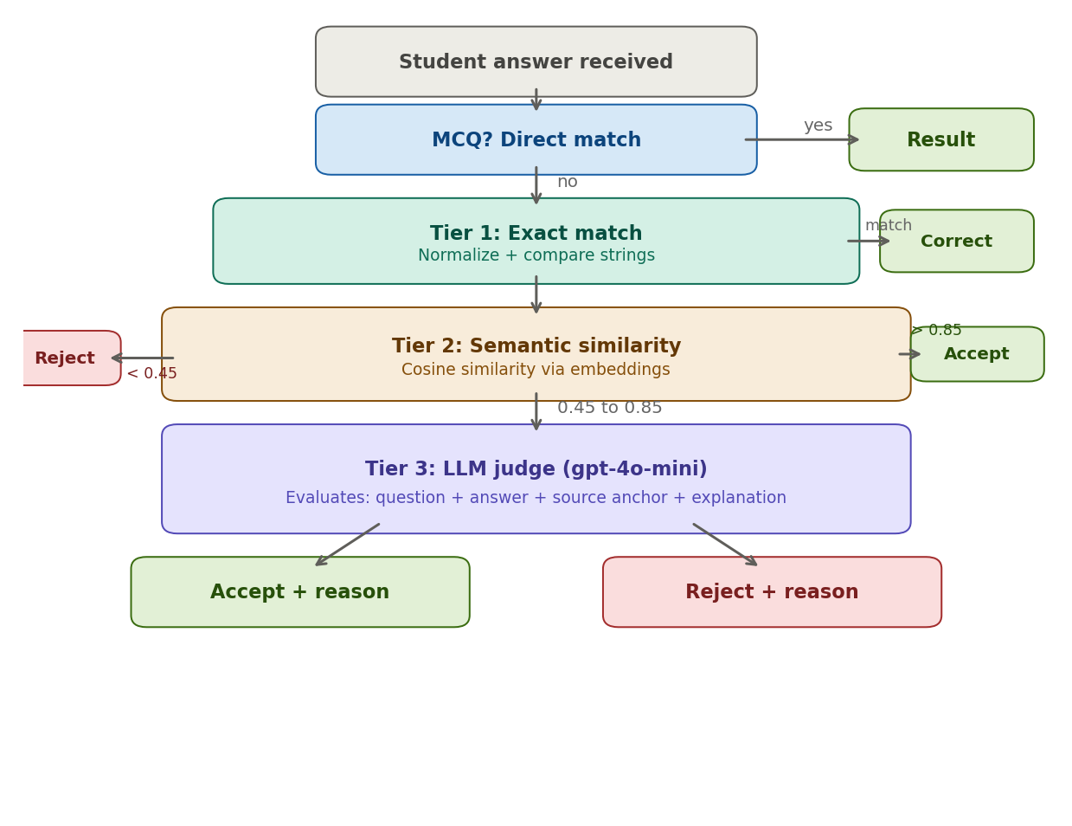
Note. MCQ answers go through direct matching. Short-answer and application questions pass through three tiers: exact normalized match, embedding-based semantic similarity (with threshold gates at 0.85 and 0.45), and an LLM judge for borderline cases.
3.5 Groundedness Evaluation Fix
The evaluation system scores each generated quiz on four metrics: Format, Groundedness, Coverage, and Consistency, each on a 0 to 5 scale. During testing, the groundedness score was coming in artificially low (around 1.7/5) for quizzes generated in V3/Experimental mode. The root cause was that the evaluation logic was checking source_anchor phrases against only the first 280 characters of each retrieved chunk. Since the model's source anchors often referred to content deeper in the retrieved chunk, they never appeared in the truncated preview. The fix was to pass the full retrieved text into the evaluation function:
# BEFORE (only checked short preview)
source_text = " ".join(item["preview"].lower() for item in sources)

# AFTER (checks full text, falls back to preview)
source_text = " ".join(
item.get("full_text", item.get("preview", "")).lower()
for item in sources
)

Figure 9
Groundedness Scoring Fix: Before vs. After
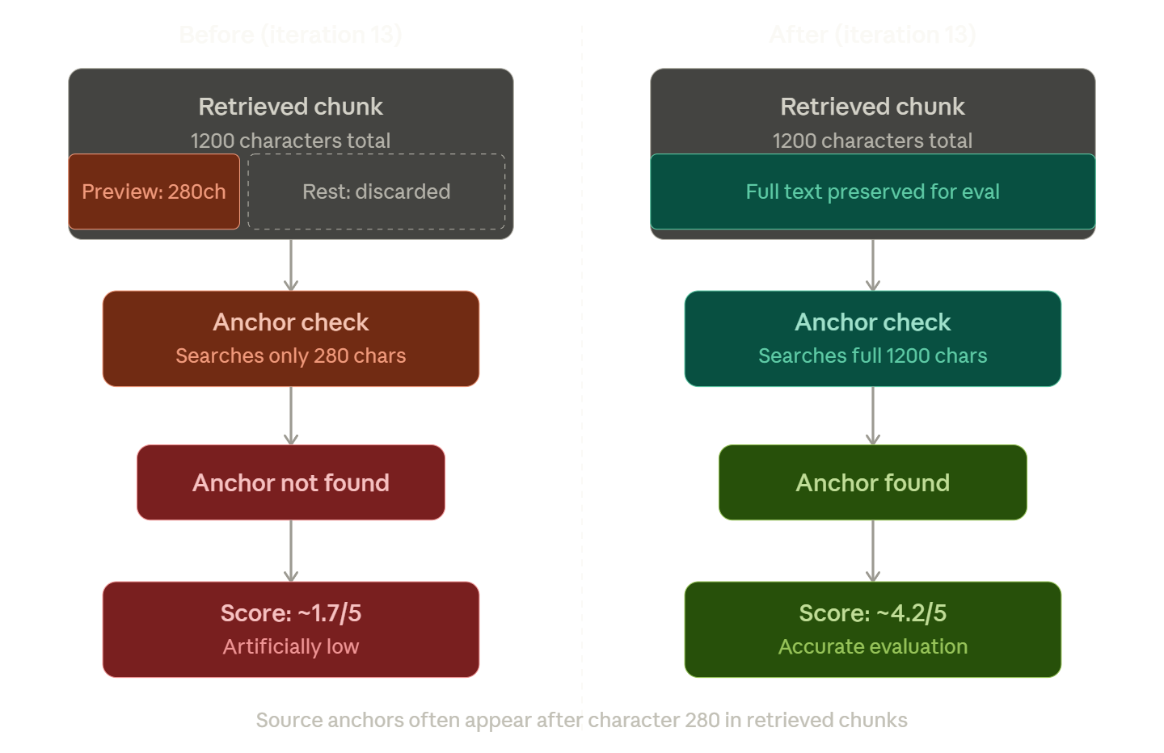
Note. Left: evaluation checked anchors against only a 280-character preview, causing valid anchors deeper in the chunk to fail. Right: after the fix, the full retrieved text is searched, raising scores from approximately 1.7/5 to 4.2/5.
3.6 Dynamic Quiz Format Instructions
Before this change, the system always generated a mixed quiz (3 MCQ, 2 short answer, 1 application) regardless of what the user selected in the UI. A helper function was introduced to generate format-specific instructions injected into each prompt variant at runtime:
def _get_format_instructions(question_type: str) -> str:
qtype = (question_type or "").strip().lower()
if qtype == "mcq":
return "Output exactly 6 questions, and all 6 must be of type mcq."
elif qtype == "short answer":
return "Output exactly 6 questions, and all 6 must be of type short_answer."
else:
return "Output exactly 6 questions: 3 mcq, 2 short_answer, 1 application."

3.7 Evaluation Metrics Integration
A lightweight evaluation system was integrated directly into the interface, surfacing four metrics per generated quiz in a dedicated Quality tab. Format Score measures structural correctness. Groundedness Score checks how many source_anchor values actually appear in the retrieved source text. Coverage Score measures concept diversity by counting unique source anchors. Consistency Score is a heuristic based on the generation variant, with V1 starting at 3.5 and V2/FT at 5.0.
Figure 5
Quality Metrics Dashboard
[Insert screenshot here]
Note. Screenshot of the Quality tab showing four metric columns: Format, Groundedness, Coverage, Consistency, each scored out of 5, with evaluation notes beneath.
4. Test and Evaluation
Testing was conducted on two fronts: automated backend testing using pytest, and structured user testing with participants working through the full quiz generation and answering workflow.
4.1 Automated Testing
The automated test suite was built using pytest and organized into four focused files, each targeting a specific layer of the application (see Table 1).
Table 1
Automated Test Suite Organization
Test File | Purpose
test_backend.py | Baseline backend validation: JSON parsing, quiz structure coercion, evaluation metric computation, empty quiz handling.
test_backend_unit.py | Detailed unit checks: format instructions per quiz type, topic prompt generation, full-text groundedness scoring, fallback when full_text is missing.
test_backend_integration.py | Mocked pipeline behavior: end-to-end V2 and V3 generation with DummyLLM, variant comparison, format selection propagation.
test_app_hybrid_scoring.py | Frontend answer evaluation: hybrid scoring tiers (exact, semantic, LLM judge), MCQ matching, empty answer handling, quiz submission and reset.

Figure 12
Test Suite Architecture
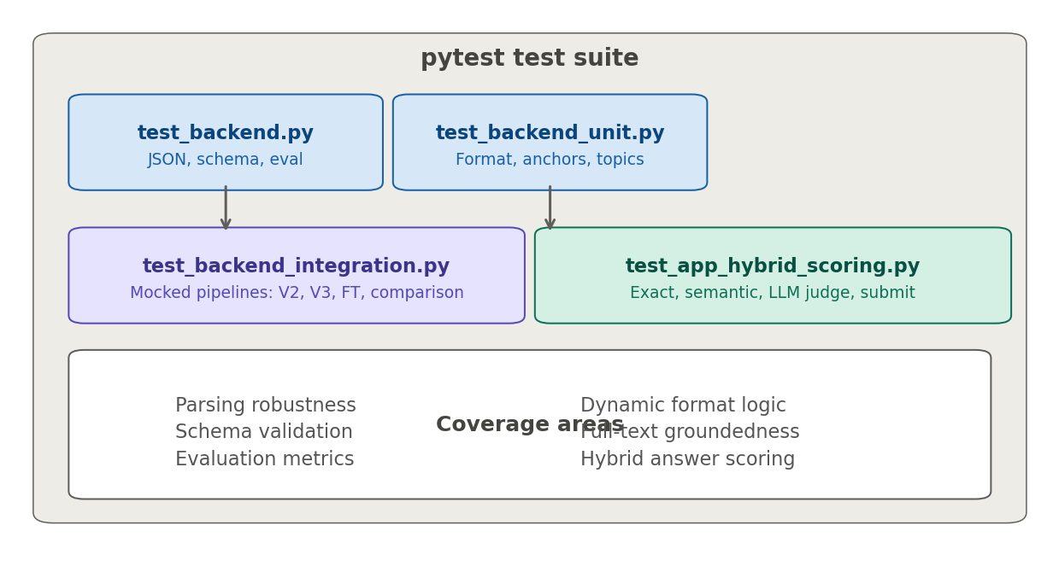
Note. Four test files organized by layer. Backend tests cover parsing and schema validation. Integration tests mock the full pipeline. Hybrid scoring tests exercise the three-tier answer evaluation logic.
The test suite covers several categories of behavior. For parsing robustness, there are tests for clean JSON responses, markdown-wrapped outputs, wrapped-in-text responses, and completely invalid inputs. For schema validation, the tests verify that the coercion function fills in missing fields, pads MCQ options to exactly 4, normalizes invalid question types to MCQ, and populates acceptable_answers for short-answer questions. For evaluation metrics, tests confirm that scores respond correctly to different inputs, including that repeated source anchors produce lower coverage and that V1 receives a lower consistency score than V2.
For the hybrid scoring pipeline, the tests use monkeypatching to control the semantic_similarity_score and llm_judge_answer functions, allowing each tier to be tested independently without live API calls:
def test_short_answer_borderline_calls_llm_judge_accept(monkeypatch):
q = make_short_question()
monkeypatch.setattr(app, "semantic_similarity_score",
lambda a, e: 0.56)
monkeypatch.setattr(app, "llm_judge_answer",
lambda question, answer, expected: (True, "Grounded paraphrase."))
result = app.get_answer_match_info(q,
"Students need an easier way to discover relevant tech events.")
assert result["correct"] is True
assert result["method"] == "llm_judge"

For integration behavior, the tests mock the LLM and retrieval layer using DummyLLM classes that return pre-defined JSON strings, allowing the full pipeline to be exercised without live API calls. Tests verify that V2 returns quiz data with the correct variant label, V3 returns extracted concepts, and the variant comparison function returns exactly three results.
4.1.1 Test Results.
All tests passed across all four test files. The suite can be run with:
pytest -v # Run all tests
pytest -v test_backend*.py # Backend tests only
pytest -v test_app_*.py # Scoring tests only

Figure 6
Pytest Output: All Tests Passing
[Insert screenshot here]
Note. Terminal screenshot showing pytest -v output with all test names listed and PASSED status, summary line showing total tests passed with zero failures.
4.2 User Testing
User testing was conducted with participants who were asked to upload lecture slides from the course modules, enter a topic, generate a quiz, attempt a subset of questions, and review the explanations and sources provided. Participants rated the application on four dimensions: ease of use, usefulness for studying, trust in generated content, and clarity of feedback. This addresses the Assignment 5 feedback recommendation to incorporate human evaluation alongside automated scoring.
The simplified interface significantly reduced friction for first-time users. Several participants noted they could generate a quiz within seconds of opening the app without reading any instructions. Study Mode was well-received for concept-level learning. The Sources tab had a measurable effect on trust: users who checked the sources reported higher confidence that the quiz was based on their actual lecture content.
One recurring piece of feedback was that short-answer scoring felt unfair before the hybrid pipeline was introduced. After the fix, users who retested reported that their correct-but-differently-worded answers were now being accepted, which improved their perception of the system's fairness.
Figure 7
User Testing: Short-Answer Feedback Display
[Insert screenshot here]
Note. Screenshot showing a completed quiz with short-answer feedback visible, including scoring method (semantic_high), similarity score, and explanation.
4.3 Performance Evaluation
Using the four predefined metrics, we compared performance across generation modes and prompt variants (see Table 2).
Table 2
Evaluation Metrics Across Generation Variants
Variant | Format | Groundedness | Coverage | Consistency
V1 (Baseline) | 4.2/5 | 3.3/5 | 4.2/5 | 3.0/5
V2 (Hardened) | 5.0/5 | 4.2/5 | 5.0/5 | 5.0/5
V3 (Decomposed) | 5.0/5 | 4.5/5 | 5.0/5 | 4.3/5
FT (Fine-tuned) | 5.0/5 | 4.0/5 | 5.0/5 | 5.0/5

Figure 10
Evaluation Metrics Comparison Across Variants
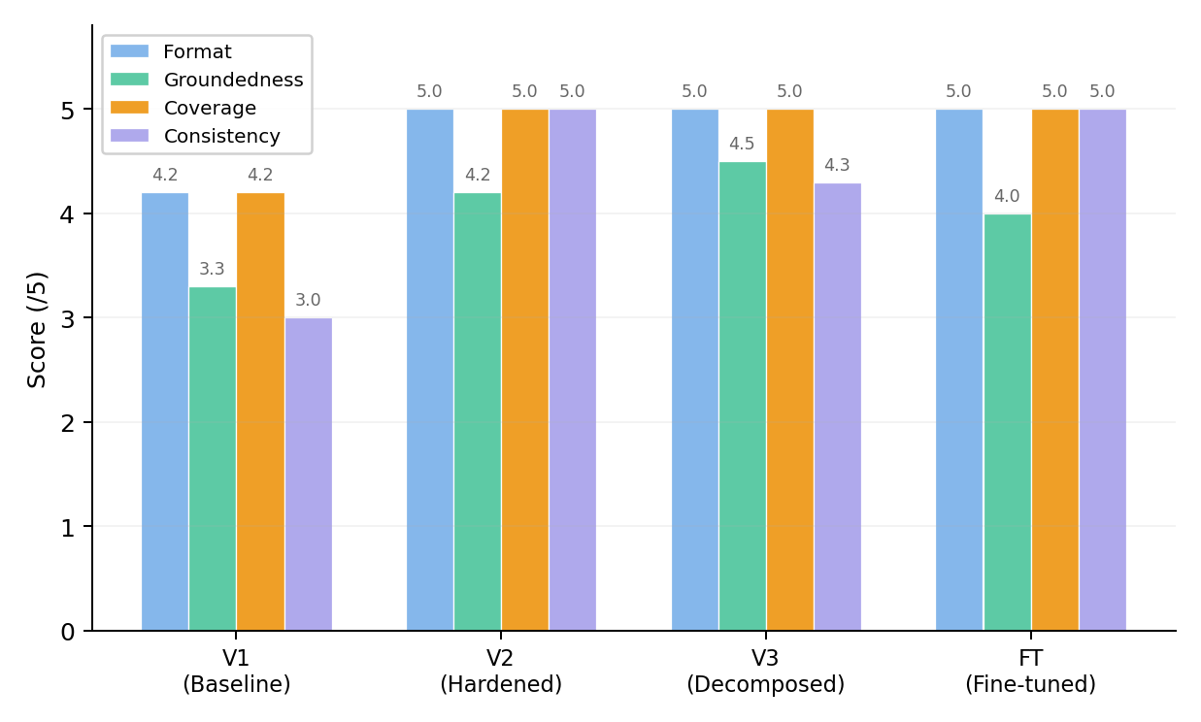
Note. V1 shows the lowest scores across all metrics. V2 and V3 achieve near-perfect Format and Coverage. The Fine-tuned mode matches V2 on Consistency but falls slightly behind V3 on Groundedness.
V2 and V3 showed improved structural consistency compared to V1, consistent with the pattern observed in Assignment 5 where V1 scored 3/5 on Format and V3 achieved 5/5 across all metrics. The fine-tuned mode produced the most stable outputs across repeated runs but was slightly less grounded than V3 since it does not use retrieval. The RAG mode improved traceability at the cost of depending on retrieval quality.
5. Iterations
Testing results drove seventeen distinct iterations, each targeting a specific problem identified during evaluation. Table 3 provides a summary, followed by detailed walkthroughs of the most significant ones.
Figure 11
Iteration Methodology: Test, Identify, Fix, Retest
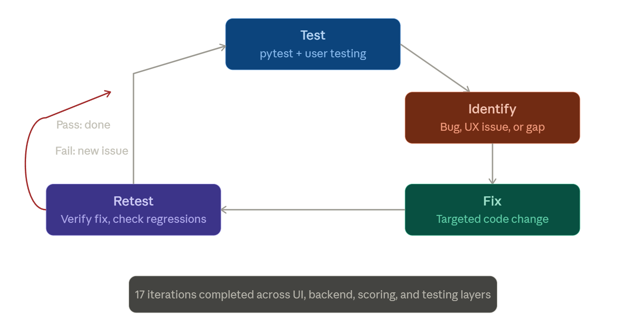
Note. The cycle loops back to Test after each fix. If retesting reveals a new issue (as happened with Iterations 11-12), the cycle re-enters through the Identify stage.
Table 3
Iteration Summary
# | Description | Layer
1 | Moved advanced controls to collapsible section; established clean default flow | UI (app.py)
2 | Introduced Test Mode and Study Mode with distinct UI behavior | UI (app.py)
3 | Added Sources tab with retrieved lecture snippets and anchor previews | UI (app.py)
4 | Implemented robust JSON extraction with markdown and malformed output handling | Backend
5 | Integrated four evaluation metrics (Format, Groundedness, Coverage, Consistency) | Backend
6 | Relaxed groundedness matching to allow partial token overlap | Backend
7 | Extended initial test suite with parsing, schema, and evaluation edge cases | Testing
8 | Replaced exact-match scoring with hybrid pipeline (exact + semantic + LLM judge) | Scoring (app.py)
9 | Recalibrated similarity thresholds; improved LLM judge context | Scoring (app.py)
10 | Fixed quiz submission KeyError by falling back to positional indexing | UI (app.py)
11 | Added dynamic format instructions for MCQ-only, short-answer-only, and mixed quizzes | Backend
12 | Fixed prompt template KeyError caused by QUIZ_SCHEMA placeholder in LangChain | Backend
13 | Extended groundedness evaluation to use full retrieved text instead of 280-char preview | Backend
14 | Expanded test suite with unit, integration, and hybrid scoring test files | Testing
15 | Fixed misleading default selection on MCQ radio buttons (index=None) | UI (app.py)
16 | Hid Submit button entirely in Study Mode instead of rendering it disabled | UI (app.py)
17 | Improved Concepts tab behavior: hidden or explained in non-V3 modes | UI (app.py)

5.1 Iteration 8: Hybrid Short-Answer Scoring
This was the most impactful single iteration. The problem was that exact string matching after normalization is fundamentally insufficient for open-ended questions where students phrase their answers in their own words. The LLM judge prompt was carefully constructed to evaluate answers in full context, receiving the question, expected answer, correct answer, source anchor, and explanation. This gives the judge enough context to distinguish between a genuine paraphrase and a superficially similar but actually wrong answer.
def llm_judge_answer(question, answer, expected_answers):
judge = get_judge_llm() # gpt-4o-mini, temperature=0
prompt = f"""
You are grading a student's short-answer response.
Judge using: the question, expected answers,
correct answer, source anchor, and explanation.
Accept paraphrases that preserve the same meaning.
Reject answers that are unrelated or contradictory.
Return JSON: {{"is_correct": bool, "reason": "..."}}
"""
response = judge.invoke(prompt)
data = json.loads(response.content)
return bool(data["is_correct"]), data.get("reason", "")

5.2 Iterations 11-12: Dynamic Format Instructions and Template Fix
These two iterations illustrate a common pattern in this project: one fix surfacing another problem. Iteration 11 introduced the _get_format_instructions helper to generate format-specific instructions. But once injected into the prompt templates, the curly braces in QUIZ_SCHEMA were being interpreted by LangChain's PromptTemplate as unresolved variables, causing a KeyError at runtime. Iteration 12 fixed this by refactoring the prompts to concatenate the schema as a plain string rather than embedding it as a template variable.
5.3 Iteration 13: Full-Text Groundedness Scoring
The groundedness evaluation was checking source anchors against a 280-character preview of each retrieved chunk. Since the model's anchors often came from deeper in the chunk, they were failing the grounding check and producing scores around 1.7/5. The fix preserved the full chunk text in _build_context_and_sources and updated _evaluate_quiz to match against it:
def test_evaluate_quiz_uses_full_text_not_just_preview():
sources = [{
"source": "slides.pdf",
"preview": "This preview does not contain the anchor.",
"full_text": "...buried anchor phrase deep in the chunk...",
}]
result = _evaluate_quiz(quiz, sources, "V2")
assert result["groundedness_score"] > 0

5.4 Iterations 15-17: UI Polish
These three iterations came directly from user testing. Iteration 15 fixed a misleading red dot on the default MCQ radio button by setting index=None so nothing is pre-selected. Iteration 16 hid the Submit button entirely in Study Mode rather than showing it in a disabled state. Iteration 17 cleaned up the Concepts tab to only appear when V3 is active.
6. Guardrails
The application includes several guardrails at different layers to handle edge cases and prevent degraded user experiences.
Input Validation. The app requires at least one uploaded PDF and a non-empty topic before allowing quiz generation. Empty or whitespace-only topics are rejected with a warning message.
JSON Parsing Safety. The _extract_json function in backend.py handles three common model output formats: clean JSON, markdown-wrapped JSON, and JSON embedded in surrounding text. If none of these patterns match, it raises a ValueError with a user-friendly error message suggesting the user try a different mode or lower the temperature.
Schema Coercion. The _coerce_quiz_structure function fills in missing fields, normalizes question types, pads MCQ options to exactly 4, and ensures acceptable_answers is populated for short-answer types. This prevents downstream rendering failures even when the model output is incomplete.
Scoring Safety. The hybrid scoring pipeline handles edge cases including empty answers (returns immediately with method "none"), zero vectors in cosine similarity (returns 0.0 instead of division error), and unparseable LLM judge responses (defaults to rejecting the answer).
Additional guardrails planned for future iterations include rate limiting on LLM judge calls to prevent excessive API costs, more granular error handling for retrieval failures when ChromaDB returns fewer chunks than expected, input sanitization for the topic field to prevent prompt injection, and a confidence threshold below which the system explicitly tells the user it is not confident in the evaluation rather than returning a borderline verdict.
7. Reflection
The test and evaluation process proved effective at surfacing problems that would not have been caught through development alone. Automated testing was particularly valuable for catching regressions early. Several of the later iterations, including the dynamic format fix (Iteration 12) and the prompt template fix, were identified directly through failing integration tests rather than manual observation. The mocked testing approach was also necessary because it allowed the pipeline to be validated end-to-end without incurring live API costs on every test run.
User testing surfaced a different category of problems. Issues like the misleading radio button default, the disabled Submit button in Study Mode, and the ambiguous Concepts tab were all functionally invisible in automated tests but immediately apparent to real users. This confirmed the Assignment 5 feedback recommendation that human evaluation is essential alongside automated scoring.
The most common challenge was the cascading nature of changes. Introducing dynamic format instructions immediately broke the prompt templating system, which required its own fix and another round of integration tests. This pattern where one improvement surfaces another problem repeated several times throughout the iteration cycle, and it reinforced the value of having a comprehensive test suite. Without it, each regression would have needed manual rediscovery.
One area that remained imperfect was groundedness scoring. Even after switching to full retrieved text, the lexical matching approach has inherent limits. Semantically correct questions that use different phrasing from the source can still receive low scores. A more robust long-term solution would involve embedding-based groundedness evaluation, mirroring the hybrid approach adopted for short-answer scoring.
Looking ahead, there are two improvements that would strengthen the system. First, applying self-consistency techniques by running the generation pipeline multiple times and aggregating results would reduce the run-to-run variance observed in V2 and V3, directly addressing the variance issue identified in Assignment 5. Second, adding a self-criticism node between concept extraction and quiz generation in the V3 pipeline, as suggested in the Assignment 5 reflection, would automatically review and correct extracted concepts before quiz generation begins.
From a process standpoint, the iterative cycle of test, identify, fix, retest worked well for this project. The structured test suite made it possible to change one thing and immediately verify that nothing else broke. If we were to do this again, we would invest in the test suite earlier in the project rather than building it up during the refinement phase.
8. Application Documentation
8.1 Architecture
The application is split into two main files. app.py handles the Streamlit frontend, session state management, quiz rendering, and the hybrid answer scoring pipeline. backend.py handles quiz generation, PDF loading, RAG retrieval, prompt construction, JSON parsing, schema coercion, and evaluation metrics. It exposes generate_quiz_experiment and generate_variant_comparison as the main entry points called by the frontend.
Figure 13
Assignment Evolution: A3 Through A6
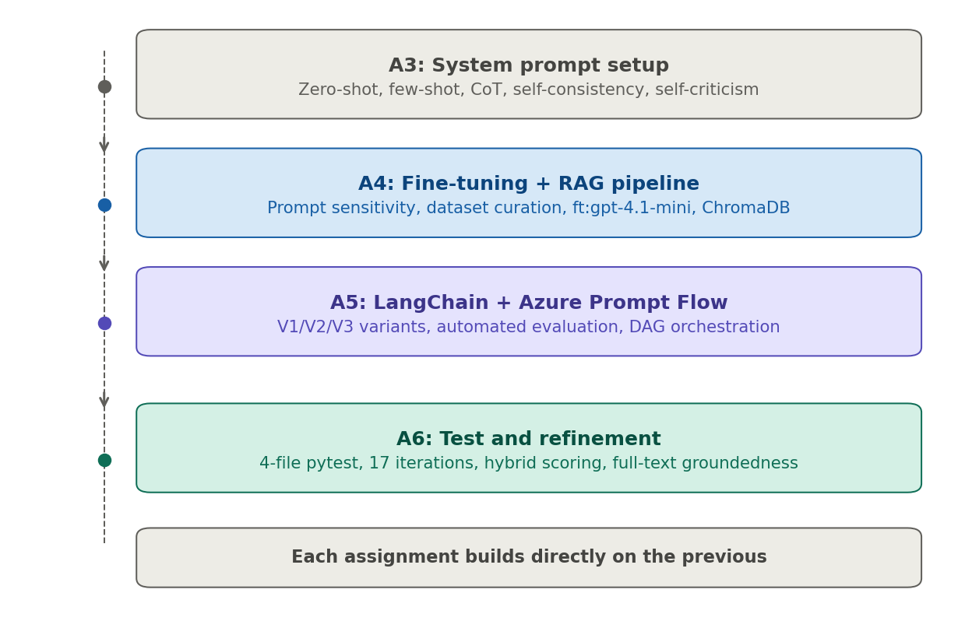
Note. Each assignment builds directly on the previous. A3 established the prompt pipeline. A4 added fine-tuning and RAG. A5 introduced LangChain automation and variant comparison. A6 focused on testing, iteration, and scoring refinement.
Figure 8
System Architecture Diagram
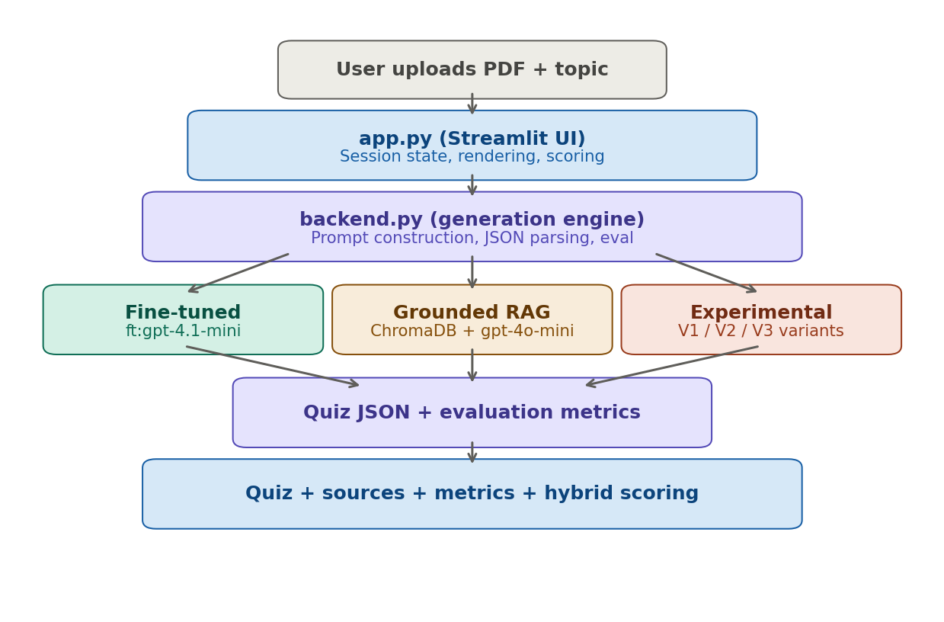
Note. User uploads a PDF and enters a topic through app.py. The backend routes to one of three generation modes (Fine-tuned, Grounded RAG, or Experimental). The output quiz is evaluated on four metrics and rendered with hybrid scoring support.
8.2 Generation Modes
Fine-tuned Mode uses the custom fine-tuned model (ft:gpt-4.1-mini) trained on course lecture data. Does not use retrieval; sends full notes directly to the model.
Grounded RAG Mode splits uploaded PDFs into chunks using RecursiveCharacterTextSplitter (chunk_size=1200, overlap=100), indexes them in ChromaDB with text-embedding-3-small, retrieves the top 3 chunks for the given topic, and constrains the LLM to generate questions only from retrieved content.
Experimental Mode exposes three prompt variants. V1 is a minimal baseline. V2 is a hardened variant with detailed instructions and difficulty definitions. V3 is a two-step decomposition chain that extracts key concepts first, then generates the quiz anchored to those concepts (see Figure 14).
Figure 14
V3 Decomposition Pipeline
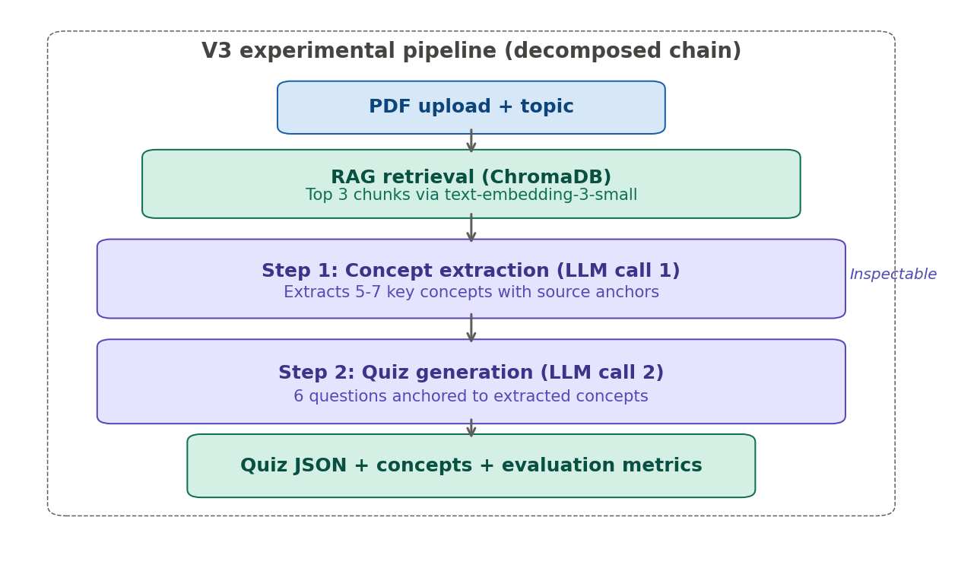
Note. The two-step chain first extracts 5-7 key concepts from the retrieved lecture content, then generates 6 quiz questions anchored to those concepts. The intermediate concept output is inspectable for debugging and auditing.
8.3 Running the Application
pip install streamlit langchain langchain-openai \
langchain-community chromadb tiktoken pypdf python-dotenv pandas

echo 'OPENAI_API_KEY=your_key_here' > .env
echo 'OPENAI_FINE_TUNED_MODEL=ft:gpt-4.1-mini-...' >> .env

streamlit run app.py # Launch the app
pytest -v # Run all tests

8.4 Changes Made Since Assignment 5
Table 4
Summary of Changes Since Assignment 5
Area | Before | After | Impact
Short-answer scoring | Exact string match only | 3-tier hybrid (exact + semantic + LLM judge) | Correct paraphrases accepted
Groundedness eval | 280-char preview only | Full retrieved text | Scores up from ~1.7 to ~4.2
Quiz format | Always mixed output | Dynamic format instructions | User selection respected
MCQ default | First option pre-selected | index=None (no selection) | No misleading red dot
Study Mode UI | Submit button disabled | Submit button hidden | Context-aware interface
Concepts tab | Visible with empty state | Hidden or explained in non-V3 | Reduced confusion
Test coverage | Basic backend tests | 4-file suite: unit, integration, scoring | Regressions caught early

8.5 User Feedback and How It Was Addressed
"I got marked wrong but my answer was right" was the most common complaint before the hybrid scoring pipeline. Users who wrote correct answers in their own words were penalized by exact matching. Resolved in Iterations 8 and 9.
"What does this red dot mean?" referred to the default radio button selection on MCQ questions. Fixed in Iteration 15.
"Why is there a Submit button in Study Mode?" pointed out the mismatch between mode intent and available actions. Fixed in Iteration 16.
"The Concepts tab is empty, is something broken?" came from users in non-V3 modes. Fixed in Iteration 17.
"How do I know these questions are from my slides?" was addressed by the Sources tab (Iteration 3) and the groundedness evaluation fix (Iteration 13).
. References
Kim, P., Wang, W., & Bonk, C. J. (2025). Generative AI as a coach to help students enhance proficiency in question formulation. Journal of Educational Computing Research, 63(3), 565-586. https://doi.org/10.1177/07356331251314222
Lee, D., & Palmer, E. (2025). Prompt engineering in higher education: A systematic review to help inform curricula. International Journal of Educational Technology in Higher Education, 22(7), 1-22. https://doi.org/10.1186/s41239-025-00503-7
Lewis, P., et al. (2020). Retrieval-augmented generation for knowledge-intensive NLP tasks. Advances in Neural Information Processing Systems, 33, 9459-9474. https://arxiv.org/abs/2005.11401
Roediger, H. L., & Karpicke, J. D. (2006). Test-enhanced learning: Taking memory tests improves long-term retention. Psychological Science, 17(3), 249-255.
Sweller, J. (1988). Cognitive load during problem solving: Effects on learning. Cognitive Science, 12(2), 257-285.

Course Materials:
Patel, S. (2026). INFO 7375 Modules 1-10 [Lecture slides]. Northeastern University.

Tools and Libraries:
LangChain (v0.2.16). https://python.langchain.com
OpenAI GPT-4o-mini / GPT-4.1-mini API. https://openai.com
Chroma vector database. https://www.trychroma.com
Streamlit. https://streamlit.io

