Supplementary Items for Assignment 5 Document
Copy-paste these into your local Word doc at the locations indicated below.

ITEM 1: Bottleneck Analysis Table
WHERE TO ADD: Section 3 (Original Prompt Analysis), right after the paragraph that ends with '...leaving room for the model to drift.' and before the paragraph starting 'These findings motivated our three-variant design.'

# | Bottleneck | Impact
1 | No definition of what makes a question Easy vs. Hard | Model may not calibrate difficulty consistently
2 | Persona framing ("Socratic Tutor mode") adds ambiguity | Model may add Socratic questions or dialogue instead of direct quiz items
3 | Single-step: notes to quiz with no intermediate reasoning | Hard to verify the model is grounding questions in the notes
4 | Grounding constraint is stated but not enforced | Model can still introduce external knowledge without explicit penalty guidance

ITEM 2: Iterative Improvement Flow Diagram
WHERE TO ADD: Section 5 (Prompt Refinement and Iterative Improvements), at the end of the section, after the Iteration 3 paragraph. Add as a Figure with caption.
Suggested caption: Figure 11 - Iterative Prompt Refinement Flow (V1 to V2 to V3)

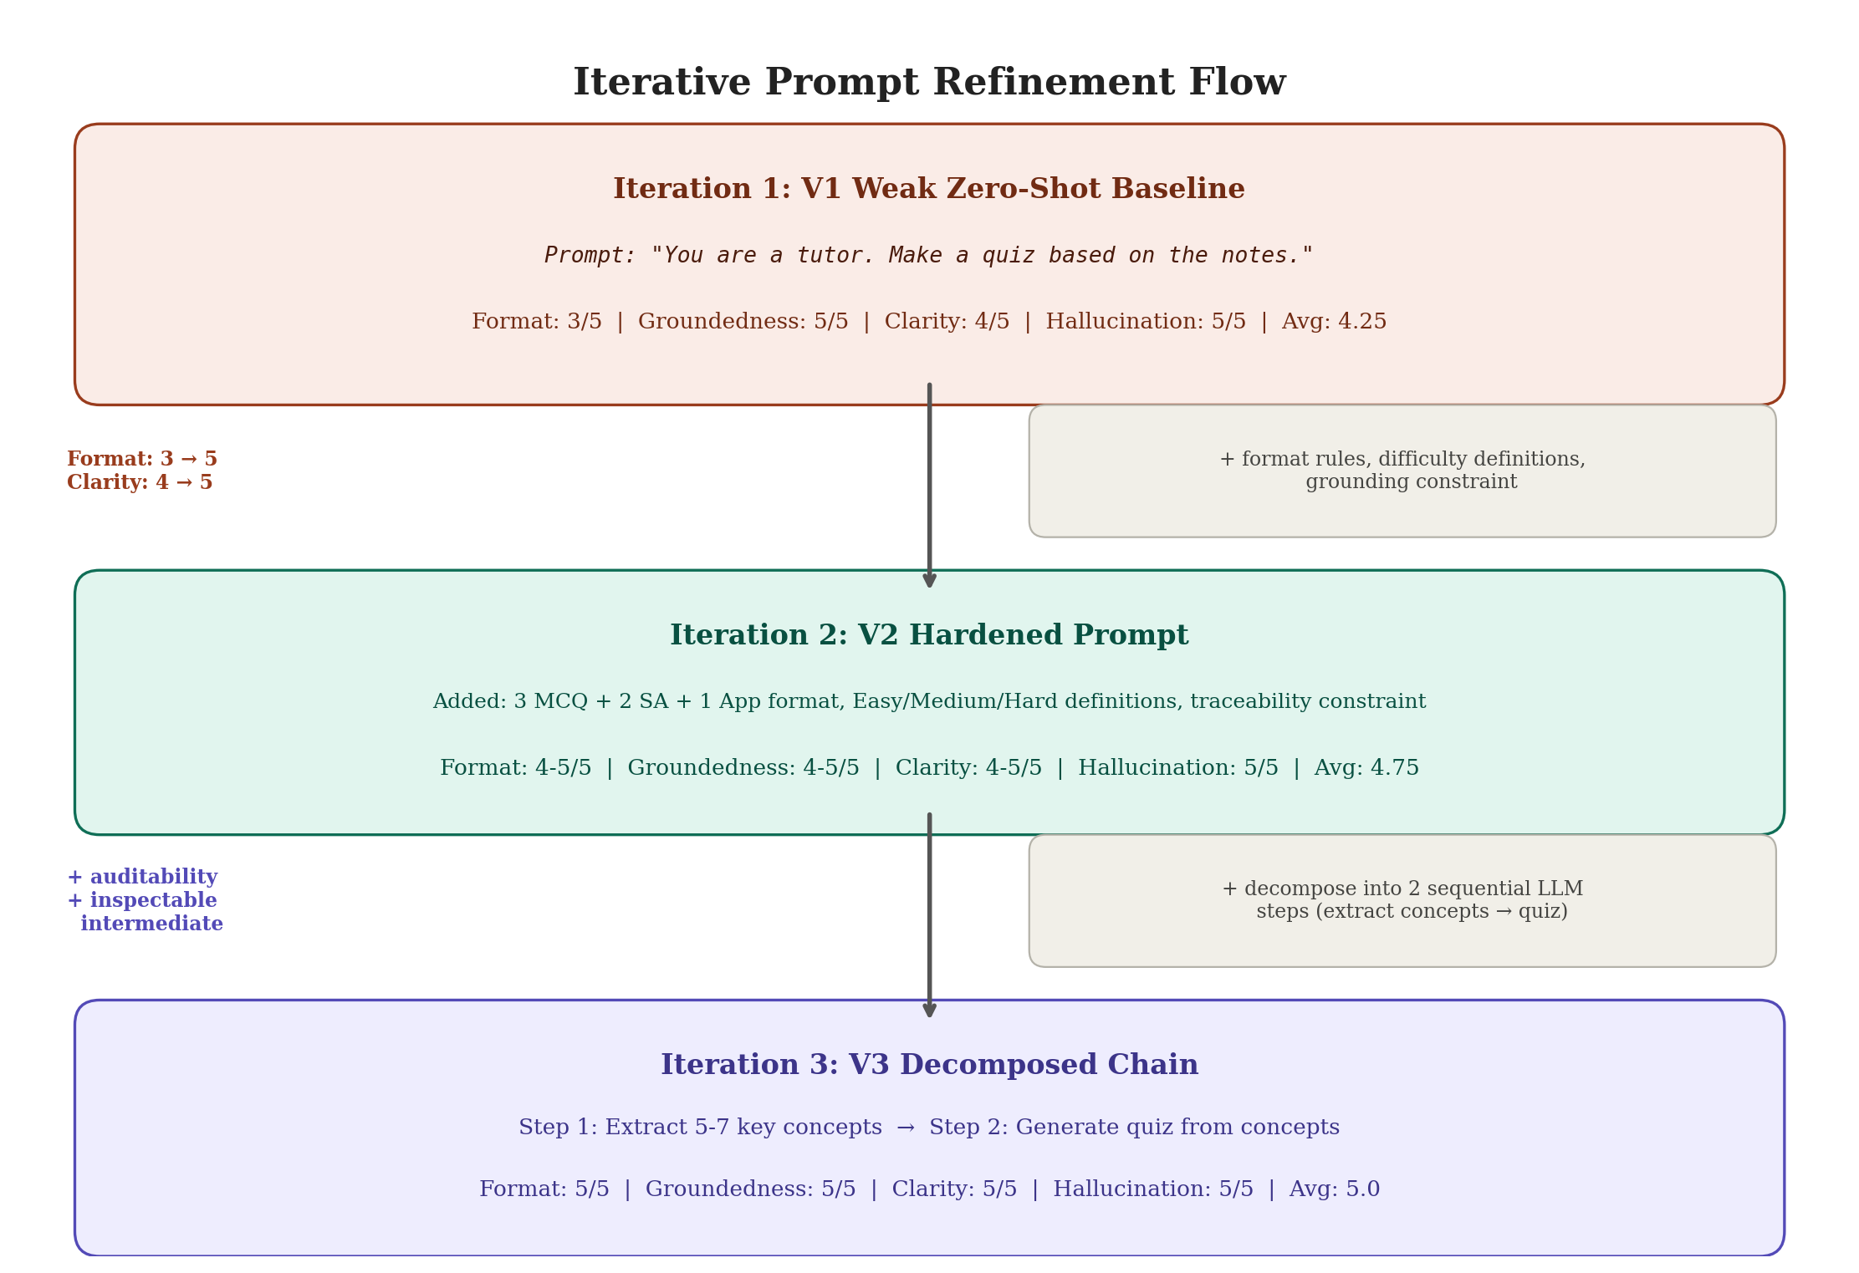

ITEM 3: Variance Observation Table
WHERE TO ADD: Section 5, after the Iteration 3 paragraph and flow diagram, as a new sub-paragraph titled 'Variance Observation'. Add before the Section 6 page break.

Suggested paragraph to add before the table:
Across multiple runs of the experiment, we observed that V2 and V3 both showed score fluctuations, while V1 remained perfectly stable. V1's minimal prompt produces the most deterministic output because there are no complex instructions to interpret differently. V2 and V3's richer prompts give the model more to work with, which improves average quality but introduces run-to-run variability. In production, Self-Consistency and Self-Criticism techniques would address this.

Run | V1 Format / Clarity | V2 Format / Clarity | V3 Format / Clarity
Run A | 3 / 4 | 5 / 5 | 4 / 4
Run B | 3 / 4 | 5 / 5 | 5 / 5
Run C | 3 / 4 | 4 / 4 | 5 / 5

ITEM 4: LangChain vs Azure Prompt Flow Comparison Table
WHERE TO ADD: Section 4, at the start of Section 4.3 (Azure Prompt Flow Implementation), right after the heading and before the paragraph about implementing V3.

 | LangChain (Notebook) | Azure Prompt Flow
Course slides (RAG) | Automatic via Chroma retriever | Manual: context pasted from Cell 17
Flow structure | Code (Python functions) | Visual DAG (node-based interface)
Evaluation | Automated scoring across 3 topics | Manual inspection of each node output
Strength | Full pipeline automation + metrics | Visualization, auditability, deployability

ITEM 5: Iterative Improvement Summary Table
WHERE TO ADD: Section 5, at the very end of the section (after the variance observation and before the Section 6 page break).

Variant | Key Change | Format | Clarity | Avg | Stability
V1 Baseline | Minimal zero-shot | 3/5 | 4/5 | 4.25 | High
V2 Hardened | Explicit format + difficulty rules | ~5/5 | ~5/5 | ~5.0 | Moderate
V3 Decomposed | Two-step chain (extract then quiz) | ~5/5 | ~5/5 | ~5.0 | Moderate

Suggested paragraph after the table:
V1 to V2 demonstrates that explicit prompt constraints produce the biggest measurable quality jump. V2 to V3 adds auditability through decomposed flow engineering. The variance observed in V2 and V3 reveals a property of LLM evaluation and points toward Self-Consistency and Self-Criticism as natural next steps for a production-ready pipeline.

