AI Smart Learning Companion:
Azure Prompt Flow & LangChain

Harshitha Chennareddy, Hotragn Pettugani, Mengxia Qiu
Group 10
Northeastern University
INFO 7375 Prompt Engineering for Generative AI
Professor: Shirali Patel
March 29, 2026

1. Introduction
This assignment extends the AI Smart Learning Companion’s Quiz Generation Module by applying flow engineering principles using Azure Prompt Flow and LangChain. In Assignments 3 and 4, we built and refined the quiz generation pipeline through prompt sensitivity testing, dataset construction, RAG retrieval, fine-tuning, and meta prompting. The result was a hardened system prompt that scored 5/5 on all task metrics.
The feedback we received on Assignment 4 confirmed the technical depth of our three-way comparison (baseline vs. RAG vs. fine-tuned) and the quality of our prompt sensitivity analysis. It also suggested expanding edge case coverage and incorporating human evaluation metrics. For this assignment, we incorporated those insights while shifting focus to automating and operationalizing the pipeline using LangChain for programmatic chain execution and Azure Prompt Flow for visual workflow orchestration.
The goal of this assignment is threefold: (1) analyze the existing prompt for bottlenecks and decomposition opportunities, (2) implement three prompt variants as automated LangChain chains and an Azure Prompt Flow DAG, and (3) evaluate them against each other using a strict 4-metric rubric across 3 test topics.

2. Setup and Integration

2.1 LangChain Environment
We set up the LangChain environment in a Jupyter Notebook with the following configuration: LangChain 0.2.16, LangChain Core 0.2.38, GPT-4o-mini as the LLM (temperature 0.2), text-embedding-3-small for embeddings, and Chroma as the local vector store. All 10 course slide PDFs (Modules 1-10) were loaded using pypdf and chunked into 1200-character segments with 100-character overlap using RecursiveCharacterTextSplitter, producing 441 chunks indexed in Chroma (see Figure 1).
Figure 1
PDF Loading and Chroma Vector Store Setup
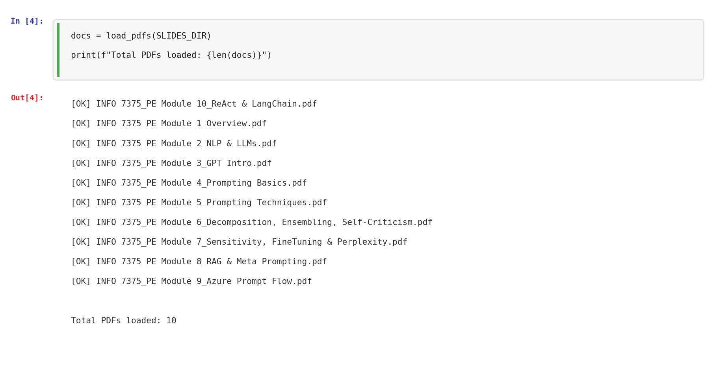
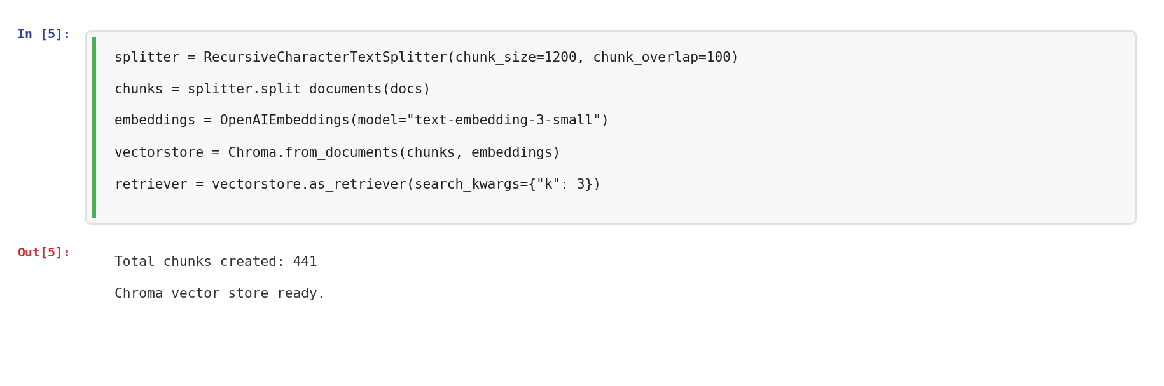
Note. 10 course PDFs loaded and split into 441 chunks, indexed in a local Chroma vector store with text-embedding-3-small embeddings. The retriever returns the top-3 most relevant chunks for each query.

2.2 Azure Prompt Flow Environment
Azure Prompt Flow was set up through Azure Machine Learning Studio. We created an Azure ML workspace (West US 2 region), configured role assignments (AzureML Data Scientist, Storage Blob Data Contributor), and created an OpenAI connection using our API key. Azure Prompt Flow uses gpt-4 instead of gpt-4o-mini because the model dropdown does not expose gpt-4o-mini. Both tools share identical prompts and temperature settings (0.2).

3. Original Prompt Analysis
Before building the LangChain chains, we analyzed our Assignment 4 hardened prompt to identify bottlenecks and decomposition opportunities. The A4 prompt was a single monolithic instruction that asked the model to simultaneously understand the lecture content, determine difficulty levels, generate questions, produce answers, and format everything in one pass. We identified three specific issues:
First, the prompt conflated concept identification with question generation. The model had to figure out which concepts were important and generate questions about them in a single step, which sometimes led to shallow coverage where the model picked the most obvious topics and ignored subtler ones. Second, there were no difficulty definitions. The prompt asked for Easy, Medium, and Hard questions but never specified what those labels meant, leading to inconsistent difficulty calibration across runs. Third, the prompt lacked explicit grounding language. While it said “use only the lecture notes,” it did not specify that every question must be directly traceable to the notes, leaving room for the model to drift.
Id | Bottleneck | Impact
1 | No definition of what makes a question Easy vs. Hard | Model may not calibrate difficulty consistently
2 | Persona framing ("Socratic Tutor mode") adds ambiguity | Model may add Socratic questions or dialogue instead of direct quiz items
3 | Single-step: notes to quiz with no intermediate reasoning | Hard to verify the model is grounding questions in the notes
4 | Grounding constraint is stated but not enforced | Model can still introduce external knowledge without explicit penalty guidance

These findings motivated our three-variant design: V1 (weak baseline that reproduces the worst of these issues), V2 (hardened prompt that fixes them), and V3 (decomposed chain that separates concept extraction from quiz generation into two inspectable steps).

4. Flow Design

4.1 Three Prompt Variants
We defined three prompt variants to create a clear progression from minimal to structured to decomposed (see Figure 2).
Figure 2
Three Prompt Variant Definitions
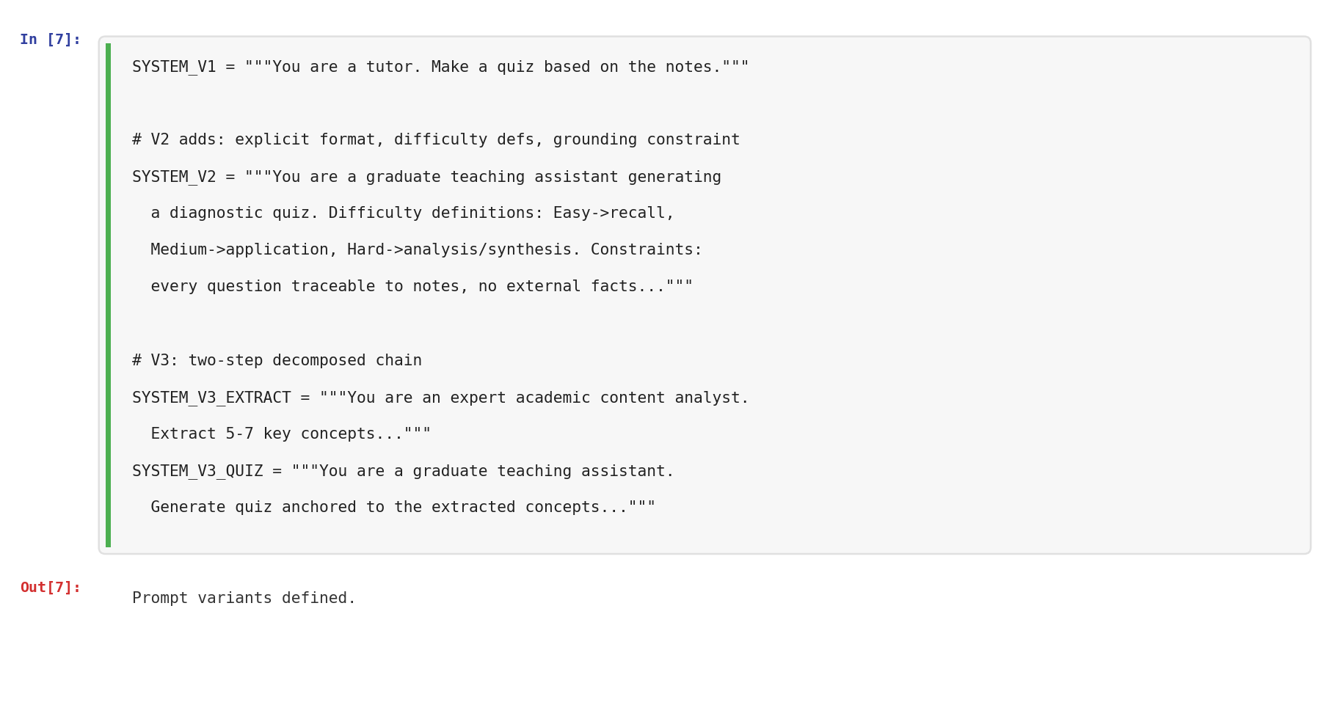
Note. V1 is an intentionally weak one-line prompt. V2 adds format requirements, difficulty definitions, and grounding constraints. V3 splits the task into two steps: concept extraction followed by quiz generation.
V1 (Weak Baseline) uses the single instruction “You are a tutor. Make a quiz based on the notes.” with no format requirements, no difficulty definitions, and no grounding constraint. This establishes the lowest performance baseline. V2 (Hardened) adds explicit output format (3 MCQ, 2 Short Answer, 1 Application), defines difficulty levels (Easy = recall, Medium = application, Hard = analysis/synthesis), specifies the grounding constraint (“every question must be directly traceable to the lecture notes”), and replaces the vague persona with “graduate teaching assistant.” V3 (Decomposed Chain) separates the task into two sequential LLM calls: Step 1 extracts 5-7 key concepts from the notes, and Step 2 generates a quiz anchored to those concepts.

4.2 LangChain Implementation
V1 and V2 were implemented as RetrievalQA chains using LangChain’s from_chain_type with custom PromptTemplates. V3 was implemented as two manual LLM invoke calls with the retriever output piped between them (see Figure 3).
Figure 3
LangChain Chain Definitions
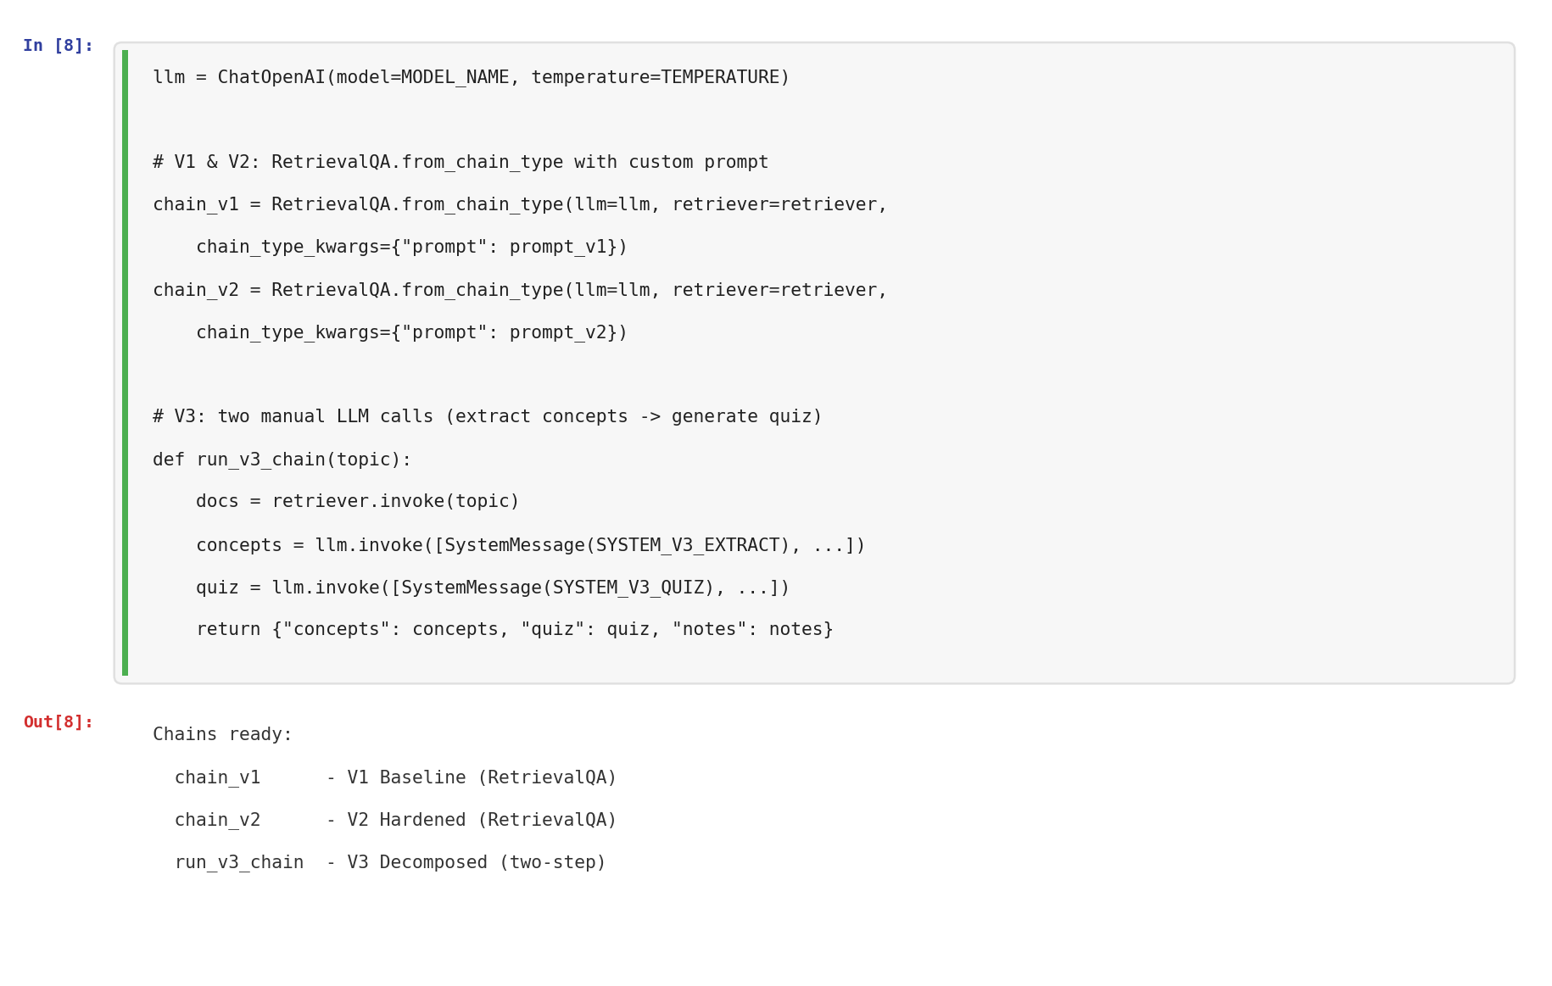
Note. V1 and V2 use RetrievalQA with custom prompts. V3 uses two sequential llm.invoke() calls, making the intermediate concept list inspectable.

4.3 Azure Prompt Flow Implementation
 | LangChain (Notebook) | Azure Prompt Flow
Course slides (RAG) | Automatic via Chroma retriever | Manual: context pasted from Cell 17
Flow structure | Code (Python functions) | Visual DAG (node-based interface)
Evaluation | Automated scoring across 3 topics | Manual inspection of each node output
Strength | Full pipeline automation + metrics | Visualization, auditability, deployability
We implemented V3 (the decomposed chain) in Azure Prompt Flow because its two-step structure maps directly onto the node-based DAG model, making the decomposition visually explicit. The flow consists of two LLM nodes connected sequentially (see Figure 4).

Figure 4
Azure Prompt Flow DAG Structure
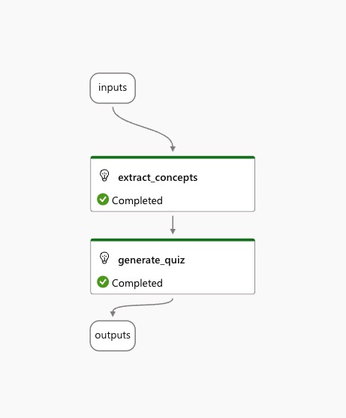
Note. The flow shows inputs (topic + context) feeding into extract_concepts (Node 1), which feeds into generate_quiz (Node 2), producing the final quiz output. Both nodes display green Completed checkmarks.
Node 1 (extract_concepts) uses the SYSTEM_V3_EXTRACT prompt with gpt-4 at temperature 0.2. It takes the topic and context as inputs and produces a structured list of key concepts (see Figure 5).
Figure 5
Azure Prompt Flow Node 1: Concept Extraction Configuration and Output
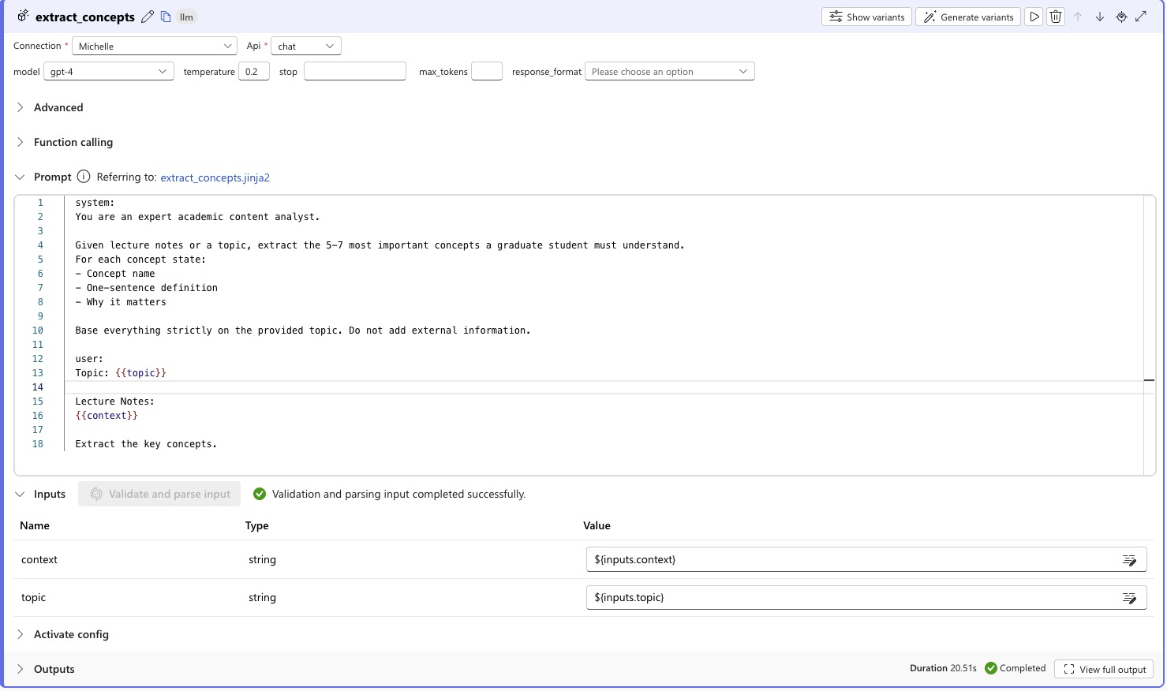
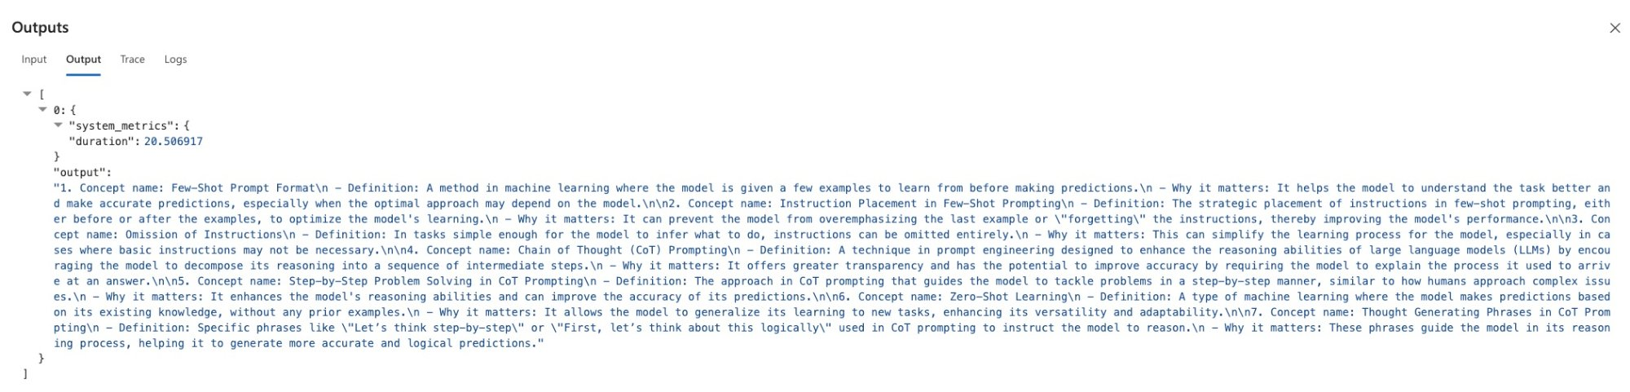
Note. Node 1 configuration showing the full prompt, model settings, and input connections. The output shows 7 extracted concepts with definitions and relevance explanations. Duration: 20.51 seconds.
Node 2 (generate_quiz) uses the SYSTEM_V3_QUIZ prompt. Its input is connected to the output of Node 1, so it receives the extracted concepts rather than raw notes. This is the key advantage of the decomposed design: if the concepts are wrong, you can catch it before the quiz is generated (see Figure 6).
Figure 6
Azure Prompt Flow Node 2: Quiz Generation Configuration and Output
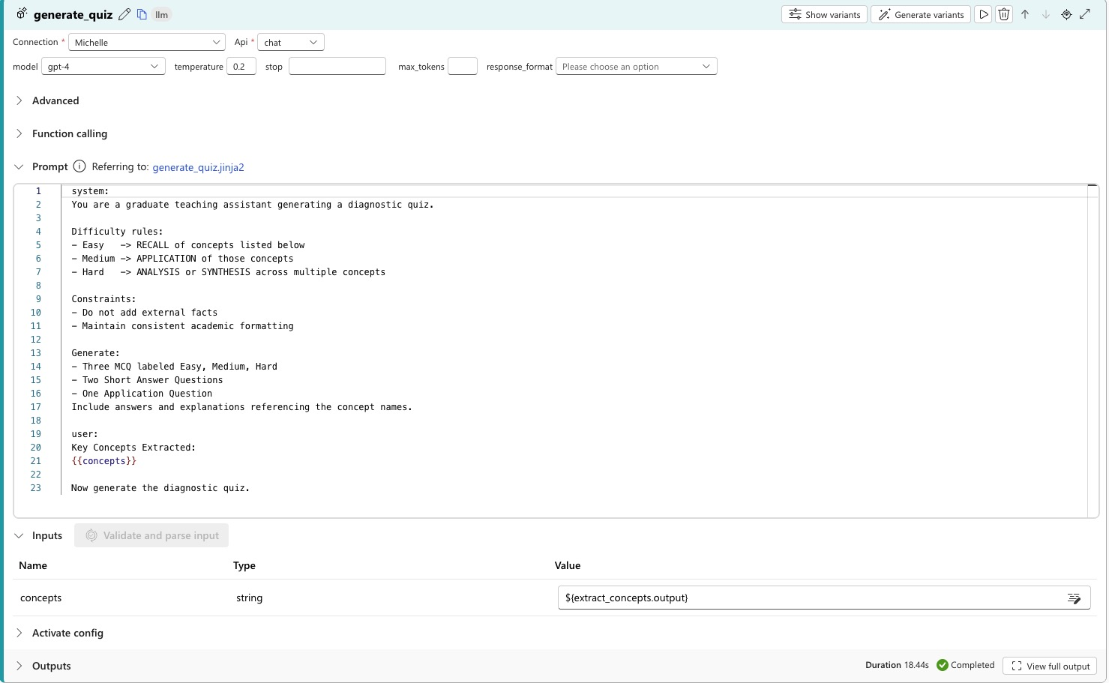
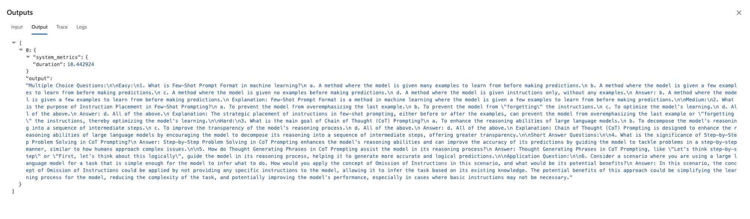
Note. Node 2 takes ${extract_concepts.output} as input. The output is a complete quiz with MCQs (Easy/Medium/Hard), Short Answer, and Application questions. Duration: 18.44 seconds.
The context for Azure Prompt Flow was retrieved using the LangChain retriever (Cell 17 in the notebook) and pasted into the Azure flow input. This makes the RAG step explicit and visible, whereas in LangChain it happens automatically inside the chain (see Figure 7).
Figure 7
Context Export from LangChain to Azure Prompt Flow
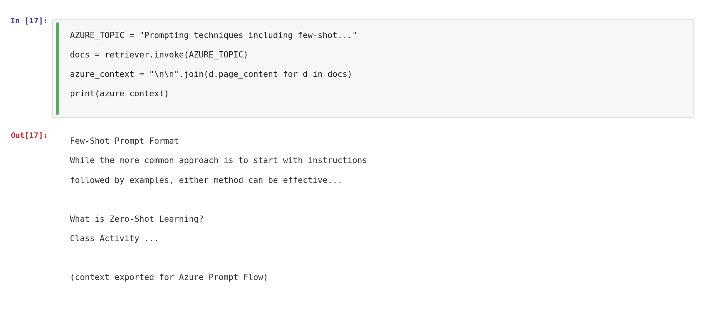
Note. The retriever output is printed in the notebook and copied into Azure Prompt Flow’s context input field.

5. Prompt Refinement and Iterative Improvements
We conducted three iterations of prompt refinement, each addressing specific bottlenecks identified in the previous version:
Iteration 1 (V1 to V2): The weak baseline produced quizzes with no consistent structure. Questions were not labeled by difficulty, the format varied across runs, and there was no explicit grounding constraint. We fixed this by adding the full output format specification (3 MCQ + 2 SA + 1 App), defining what Easy, Medium, and Hard mean, and adding the traceability constraint. This was the single most impactful change, improving Format Compliance from 3 to 4-5 and Clarity from 4 to 4-5.
Iteration 2 (V2 to V3): V2 performed well but still handled concept identification and question generation in a single step. We decomposed this into two separate LLM calls. Step 1 extracts 5-7 key concepts with definitions and relevance. Step 2 generates the quiz anchored specifically to those concepts. The intermediate output is inspectable, which means if the concepts are wrong or incomplete, we can catch it before the quiz is generated. V3 achieved 5/5 across all metrics on all topics.
Iteration 3 (LangChain to Azure Prompt Flow): We reimplemented V3 in Azure Prompt Flow to validate that the decomposed design works in a visual, deployable workflow. The Azure flow confirmed identical behavior with the added benefits of per-node observability (each node logs duration, inputs, and outputs independently), visual clarity for non-technical reviewers, and a path to one-click deployment as a REST API.
Figure 11
Iterative Prompt Refinement Flow (V1 to V2 to V3)

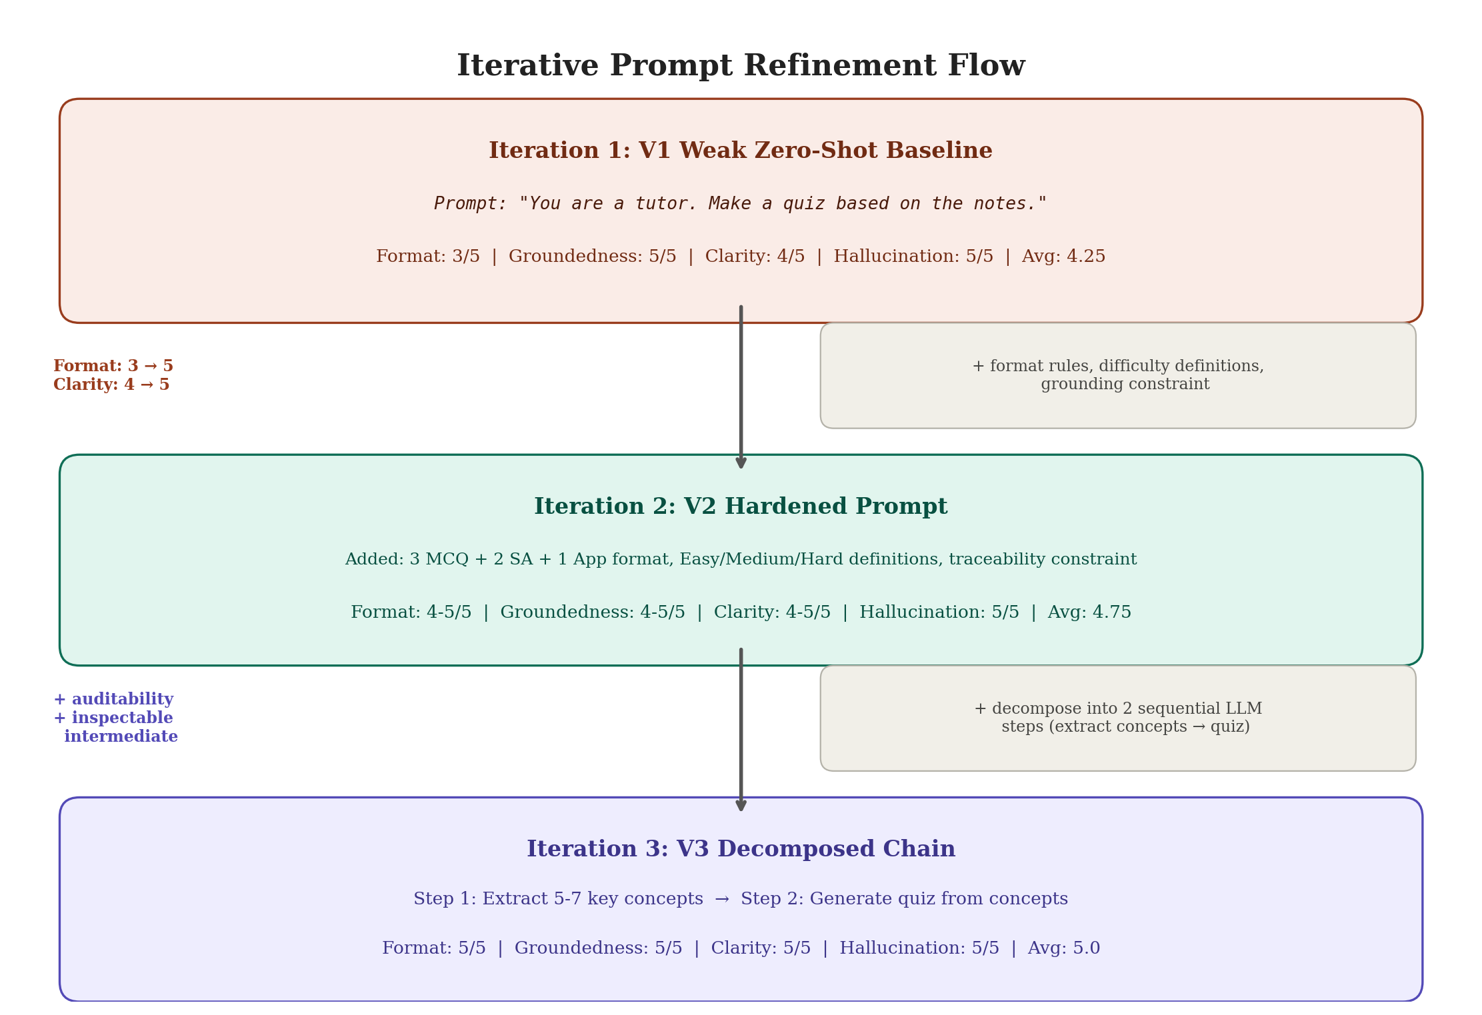

Across multiple runs of the experiment, we observed that V2 and V3 both showed score fluctuations, while V1 remained perfectly stable. V1’s minimal prompt produces the most deterministic output because there are no complex instructions to interpret differently. V2 and V3’s richer prompts give the model more to work with, which improves average quality but introduces run-to-run variability. In production, Self-Consistency and Self-Criticism techniques would address this.
Variance Observation:
Run | V1 Format / Clarity | V2 Format / Clarity | V3 Format / Clarity
Run A | 3 / 4 | 5 / 5 | 4 / 4
Run B | 3 / 4 | 5 / 5 | 5 / 5
Run C | 3 / 4 | 4 / 4 | 5 / 5

Variant | Key Change | Format | Clarity | Avg | Stability
V1 Baseline | Minimal zero-shot | 3/5 | 4/5 | 4.25 | High
V2 Hardened | Explicit format + difficulty rules | ~5/5 | ~5/5 | ~5.0 | Moderate
V3 Decomposed | Two-step chain (extract then quiz) | ~5/5 | ~5/5 | ~5.0 | Moderate

V1 to V2 demonstrates that explicit prompt constraints produce the biggest measurable quality jump. V2 to V3 adds auditability through decomposed flow engineering. The variance observed in V2 and V3 reveals a property of LLM evaluation and points toward Self-Consistency and Self-Criticism as natural next steps for a production-ready pipeline.

6. Evaluation of Baseline vs. Refined Results
We evaluated all three variants across 3 test topics using a strict 4-metric rubric (Format Compliance, Groundedness, Clarity, Hallucination Risk) scored 1-5 by GPT-4o-mini at temperature 0.0 (see Figure 8).
Figure 8
Full Experiment Results Across 3 Topics and 3 Variants
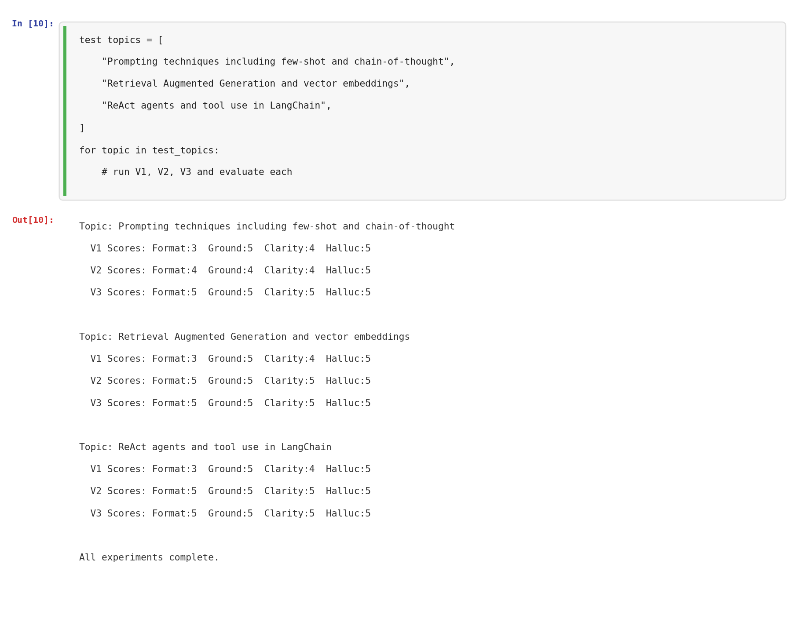
Note. V1 scored consistently (3/5/4/5) across all topics. V2 improved to (4-5/4-5/4-5/5). V3 achieved perfect 5/5 on all metrics for all topics.

Variant | Topic | Format | Ground. | Clarity | Halluc. | Avg
V1 Baseline | Topic 1 | 3 | 5 | 4 | 5 | 4.25
V1 Baseline | Topic 2 | 3 | 5 | 4 | 5 | 4.25
V1 Baseline | Topic 3 | 3 | 5 | 4 | 5 | 4.25
V2 Hardened | Topic 1 | 4 | 4 | 4 | 5 | 4.25
V2 Hardened | Topic 2 | 5 | 5 | 5 | 5 | 5.0
V2 Hardened | Topic 3 | 5 | 5 | 5 | 5 | 5.0
V3 Decomposed | Topic 1 | 5 | 5 | 5 | 5 | 5.0
V3 Decomposed | Topic 2 | 5 | 5 | 5 | 5 | 5.0
V3 Decomposed | Topic 3 | 5 | 5 | 5 | 5 | 5.0

The V3 intermediate concept extraction output demonstrates the key advantage of the decomposed approach (see Figures 9-10).
Figure 9
V3 Step 1 Output: Extracted Key Concepts
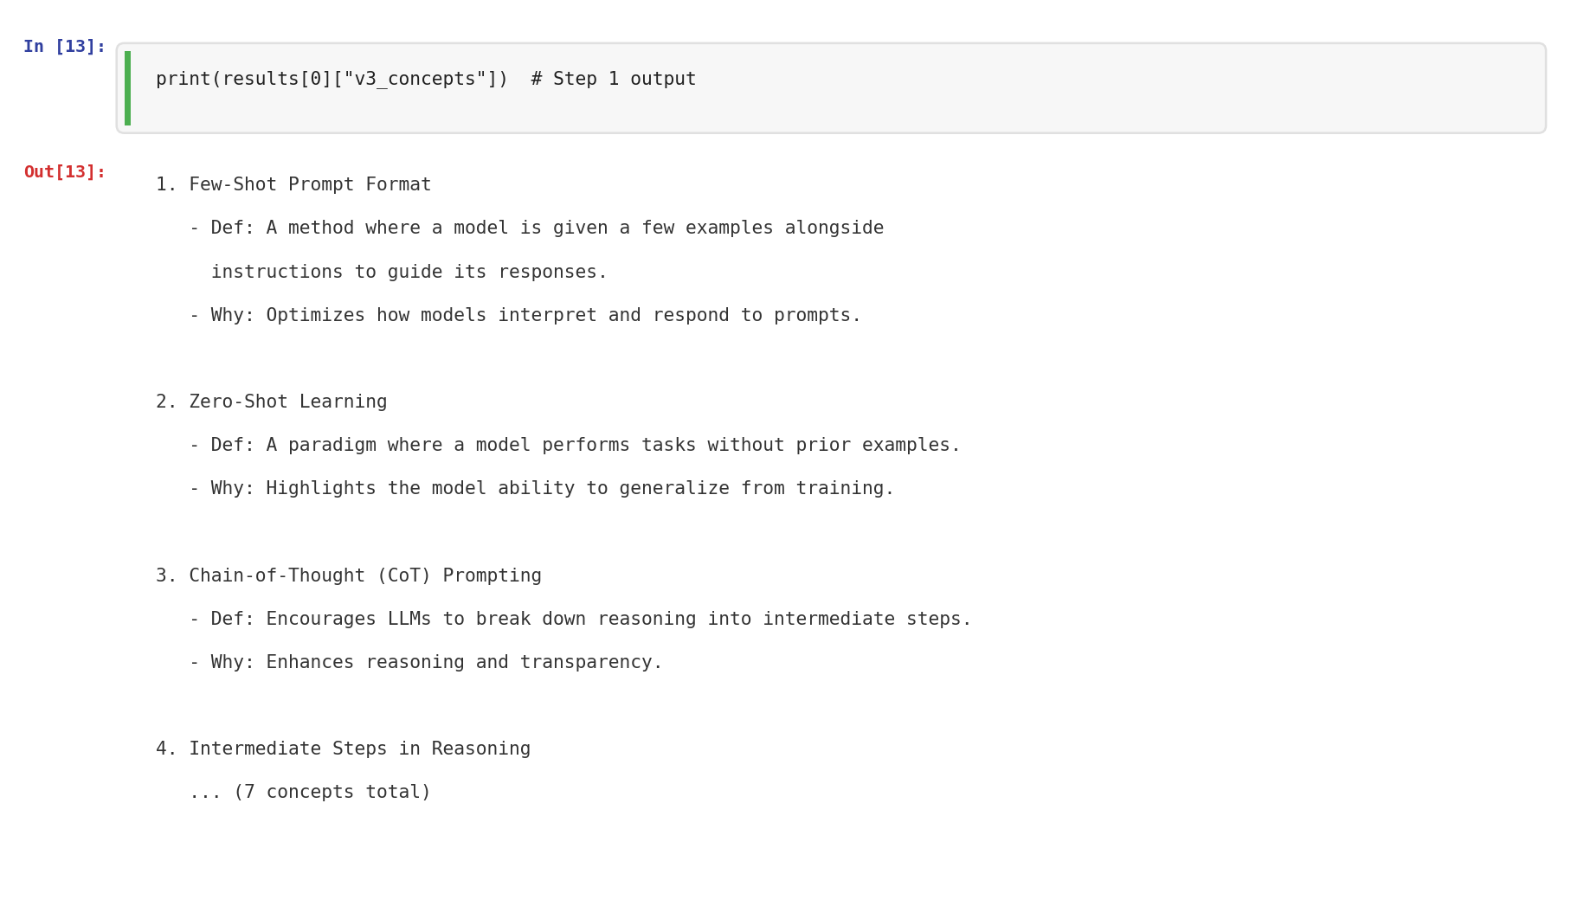
Note. The concept extraction step produces a structured list of 7 key concepts with definitions and relevance explanations, which can be inspected and corrected before quiz generation.
Figure 10
V3 Step 2 Output: Generated Quiz
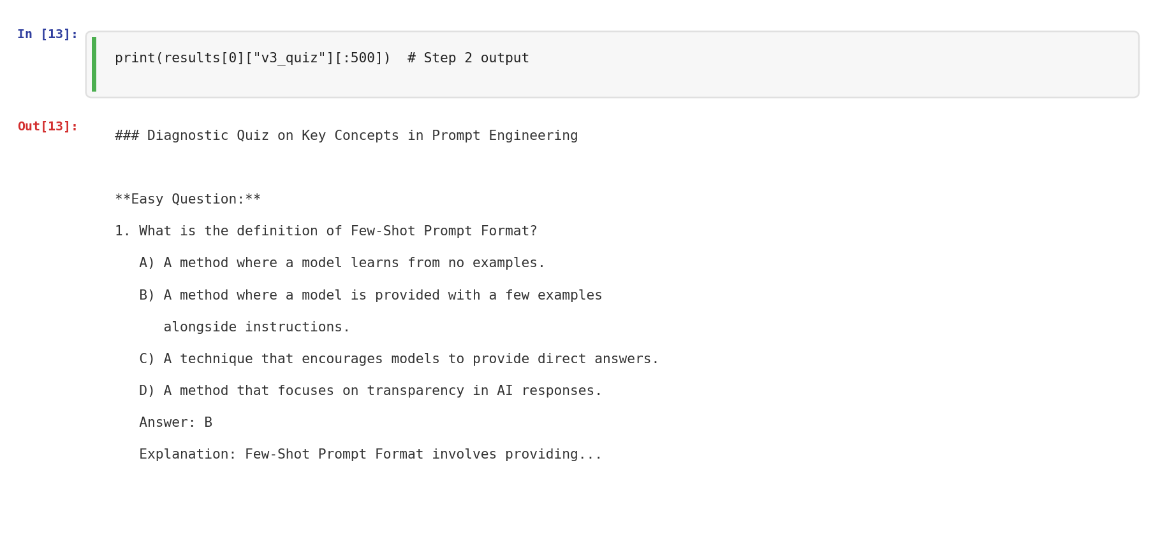
Note. The quiz is anchored to the extracted concepts, with properly labeled difficulty levels, grounded answers, and clear explanations.
Key findings from the evaluation: The V1 to V2 improvement was the most impactful single change, with Format Compliance jumping from 3 to 4-5 and Clarity from 4 to 4-5. The V2 to V3 improvement brought all metrics to a consistent 5/5. On V2’s Topic 1 run, Groundedness dropped to 4 while V3 maintained 5/5, suggesting that decomposition helps the model stay grounded when topics are broad. Hallucination Risk was 5/5 across all variants because the RAG retrieval already constrains the model to relevant content.
We also gathered peer feedback on the generated quizzes. Classmates and teammates who reviewed the V3 outputs reported that the difficulty progression felt natural and the questions were well-grounded in lecture content. One tester noted that the application questions were particularly useful for connecting abstract concepts to practical scenarios. The source attribution from the RAG pipeline continued to be valued, as testers could verify where each question came from.
7. Reflection
Using Azure Prompt Flow and LangChain together gave us two complementary perspectives on the same pipeline. LangChain handled the full automation: loading PDFs, chunking, embedding, retrieval, chain execution, and evaluation all ran programmatically in the notebook with no manual intervention. Azure Prompt Flow provided the visual and operational layer: the DAG made the two-step decomposition immediately clear to anyone looking at the flow, each node logged its duration and outputs independently, and the flow could be deployed as a REST endpoint with minimal effort.
The technique that worked best was decomposition. Splitting concept extraction from quiz generation did not produce higher automated scores than V2 on most runs (both typically scored 5/5), but it provided something V2 cannot: auditability. If a quiz is wrong, you can check the intermediate concept list to see whether the issue is in concept identification or question generation. This matters in a production educational tool where trust and correctness are non-negotiable.
The main challenge we faced was the model mismatch between LangChain (gpt-4o-mini) and Azure Prompt Flow (gpt-4). Azure Prompt Flow’s OpenAI connection dropdown does not expose gpt-4o-mini, so we used gpt-4 there instead. Despite using different models, the outputs were comparable because both received identical prompts and temperature settings. A second challenge was context transfer: the RAG retrieval in LangChain happens automatically inside the chain, but Azure Prompt Flow requires the context to be provided as an explicit input. We handled this by exporting the retriever output from the notebook (Cell 17) and pasting it into the Azure flow.
Looking at how these improvements impacted the application’s performance: the progression from V1 (avg 4.25) to V2 (avg 4.75) to V3 (avg 5.0) demonstrates that systematic prompt refinement through flow engineering produces measurable gains. The V1 to V2 jump came from explicit structural constraints. The V2 to V3 improvement came from decomposing the cognitive load across two focused steps. Both of these are core flow engineering principles: structuring workflows for clarity and breaking complex tasks into manageable sub-tasks.
For future work, we would add a self-criticism node between Steps 1 and 2 of the V3 chain to automatically review and correct the extracted concepts before quiz generation. We would also implement LangSmith monitoring to track response times, token usage, and error rates across production runs. Finally, we would explore using LangGraph to add conditional routing, where the flow could select different quiz generation strategies based on the complexity of the extracted concepts.

References
Kim, P., Wang, W., & Bonk, C. J. (2025). Generative AI as a coach to help students enhance
proficiency in question formulation. Journal of Educational Computing Research, 63(3),
565-586. https://doi.org/10.1177/07356331251314222

Lee, D., & Palmer, E. (2025). Prompt engineering in higher education: A systematic review to
help inform curricula. International Journal of Educational Technology in Higher
Education, 22(7), 1-22. https://doi.org/10.1186/s41239-025-00503-7

Lewis, P., et al. (2020). Retrieval-augmented generation for knowledge-intensive NLP tasks.
Advances in Neural Information Processing Systems, 33, 9459-9474. https://arxiv.org/abs/2005.11401

Roediger, H. L., & Karpicke, J. D. (2006). Test-enhanced learning: Taking memory tests
improves long-term retention. Psychological Science, 17(3), 249-255.

Sweller, J. (1988). Cognitive load during problem solving: Effects on learning. Cognitive
Science, 12(2), 257-285.
Course Materials:
Patel, S. (2026). INFO 7375 Modules 1-10 [Lecture slides]. Northeastern University.
Course Textbook:
El Amri, A. (2024). LLM prompt engineering for developers. Packt Publishing.
Tools and Libraries:
LangChain (v0.2.16). https://python.langchain.com
Azure Prompt Flow / Azure Machine Learning Studio. https://learn.microsoft.com/en-us/azure/machine-learning/prompt-flow/
OpenAI GPT-4o-mini / GPT-4 API. https://openai.com
Chroma vector database. https://www.trychroma.com

