TP noté C# Dotnet Ryan Amsellem—Bousignac

Partie 1)

Capture 1 :

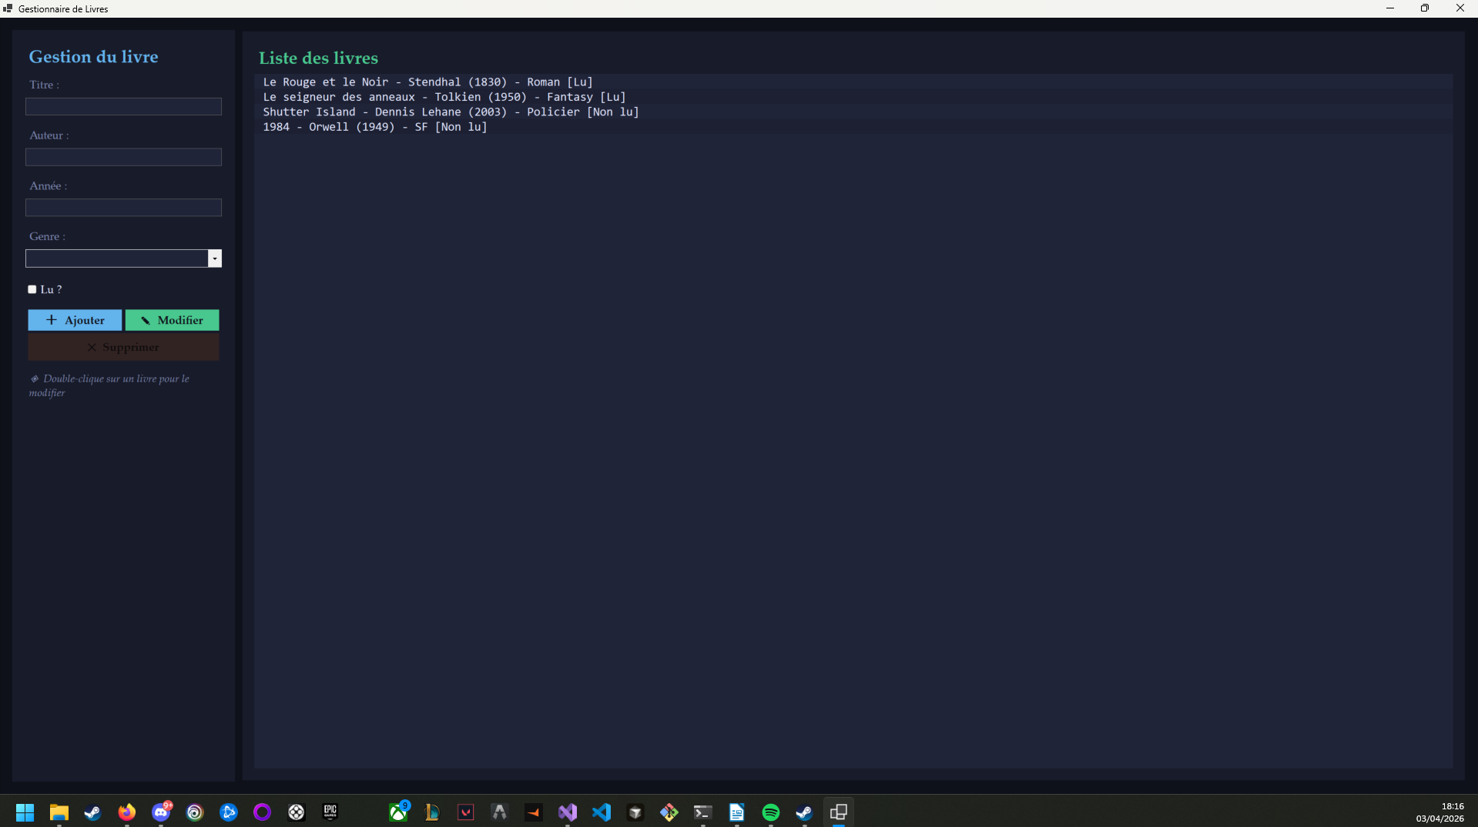

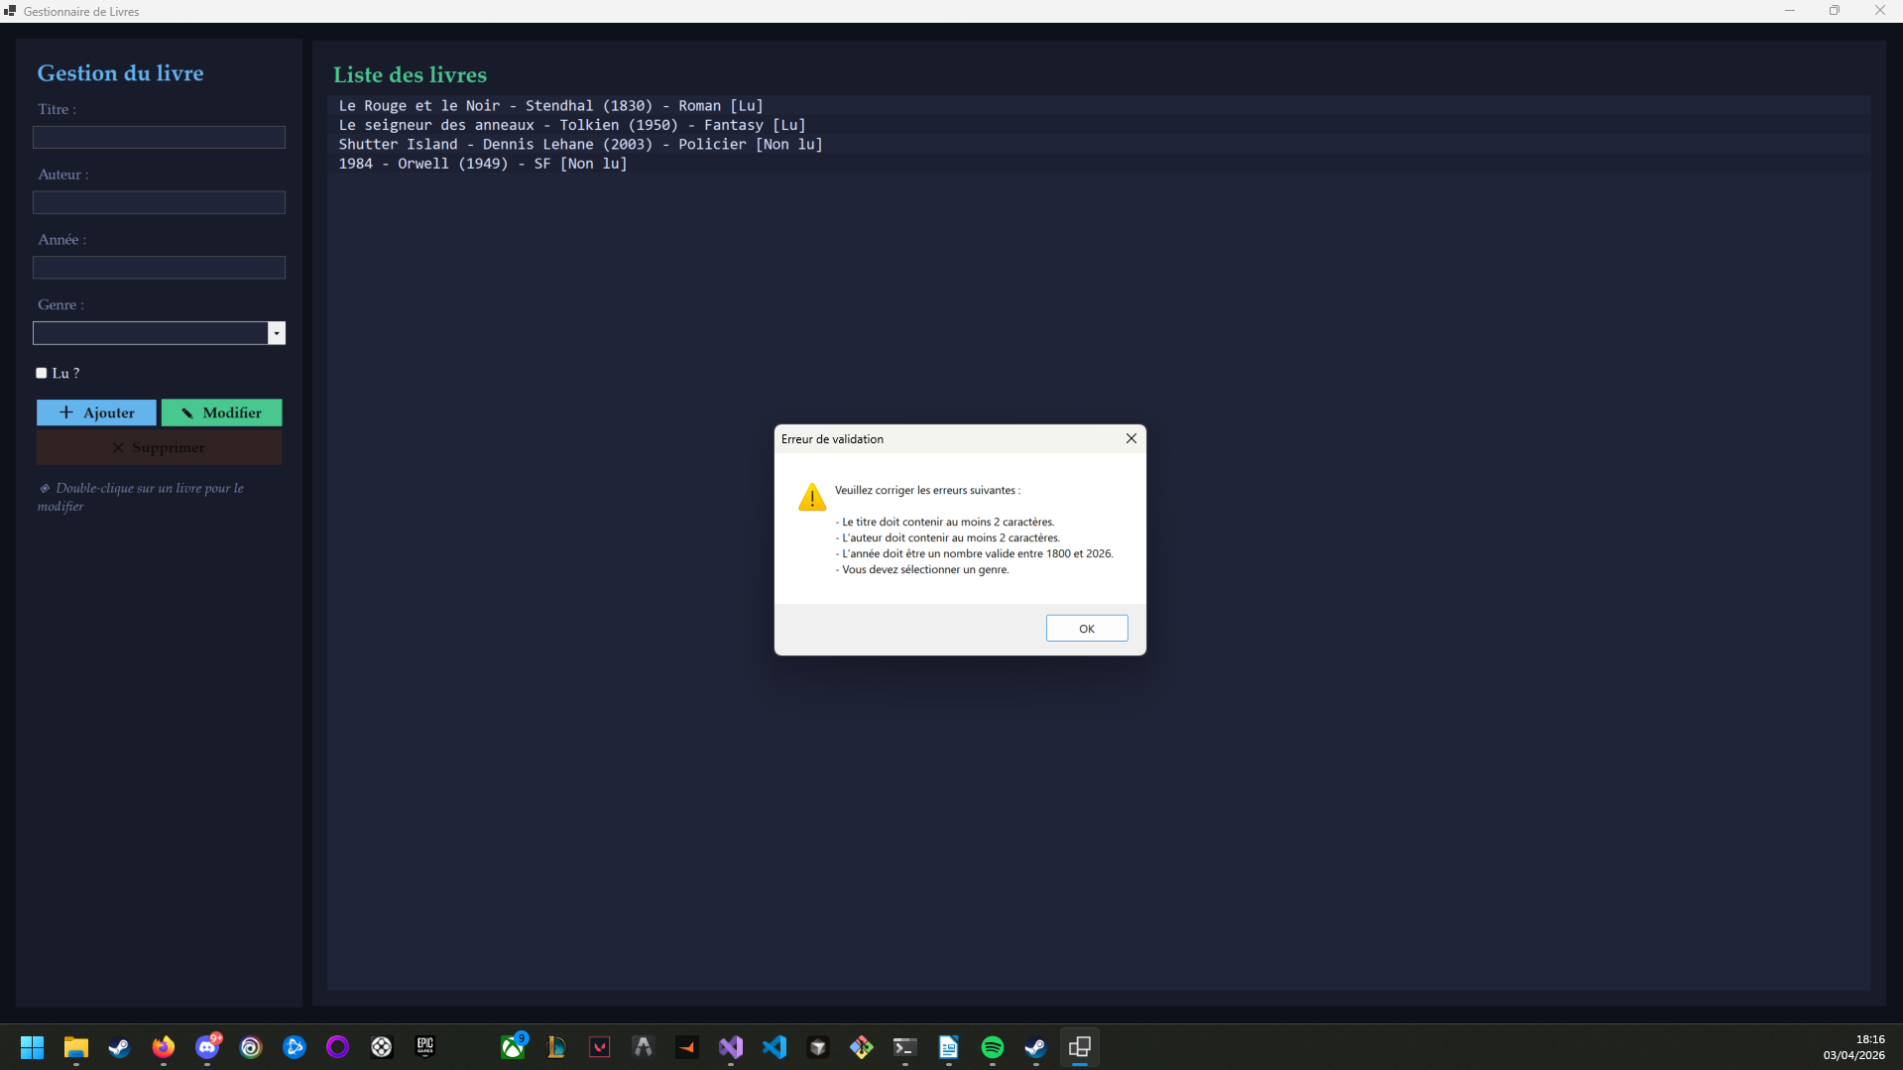
Capture 2 :

Capture 3 :
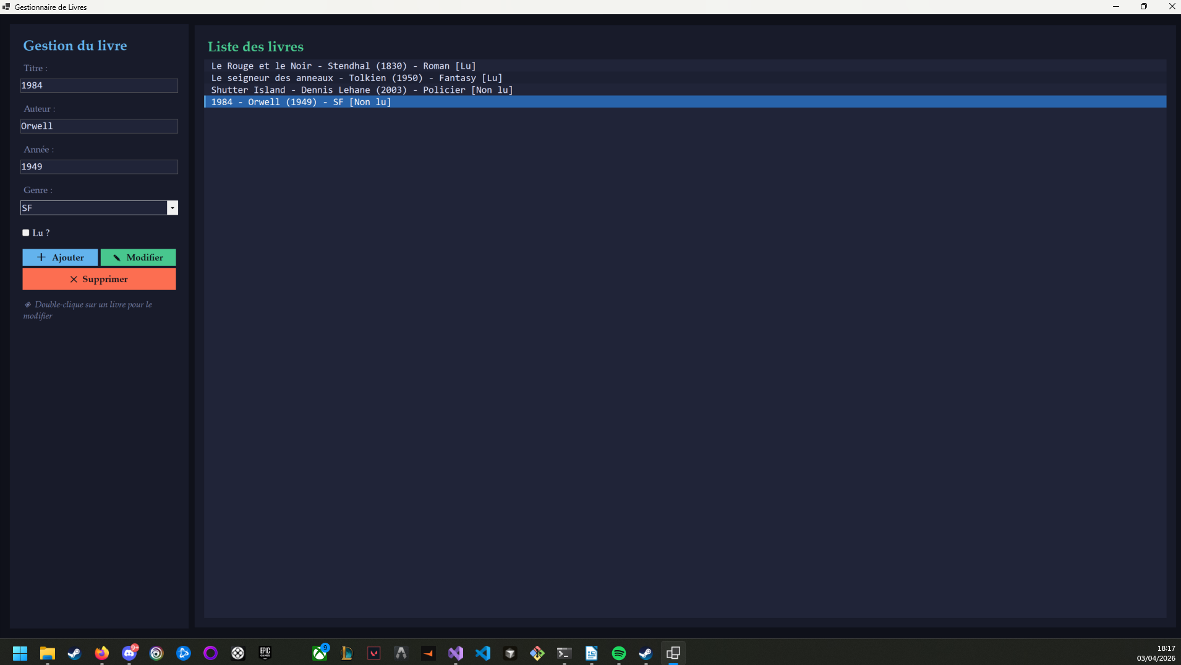

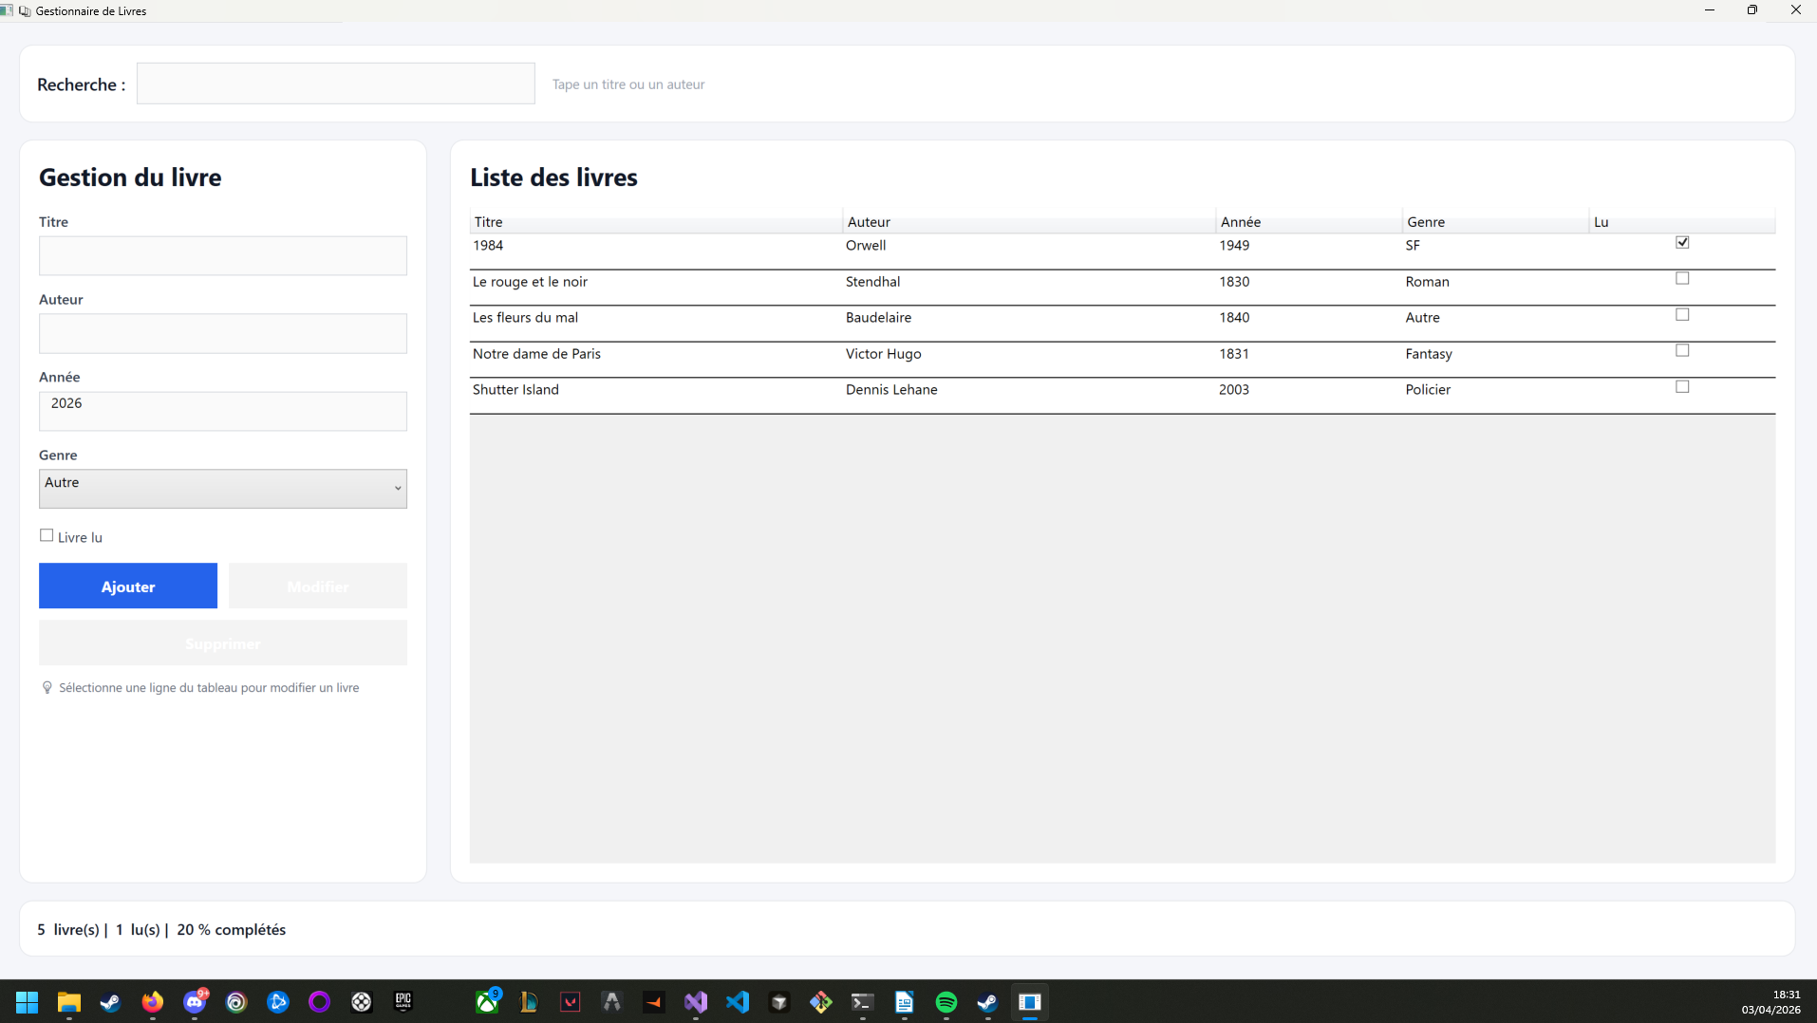
Partie 2)
Capture 4 :

Capture 5 :
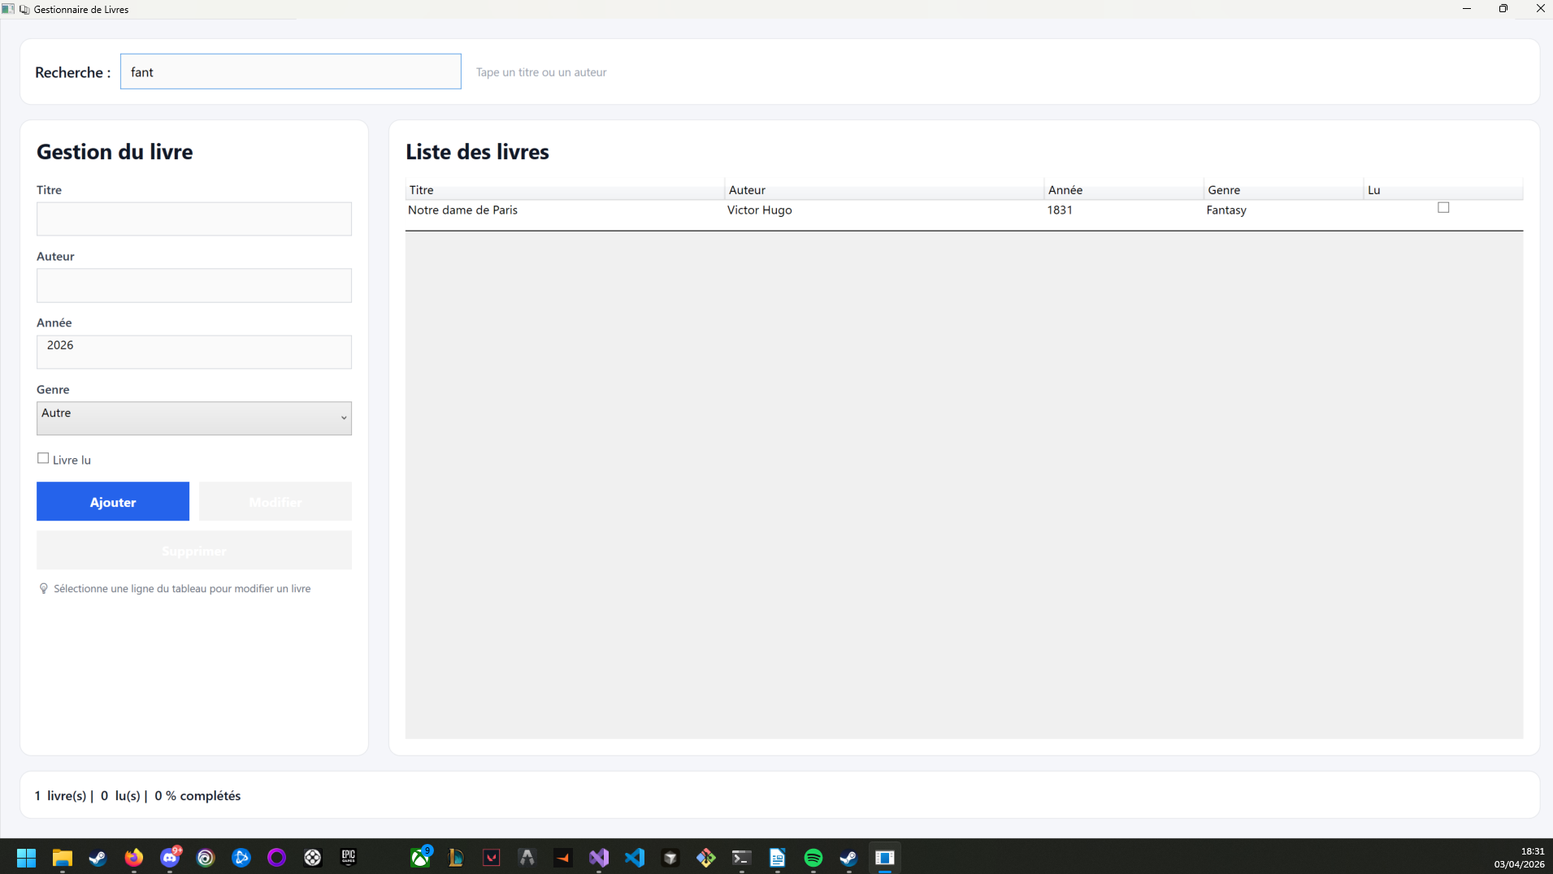

Capture 6 :

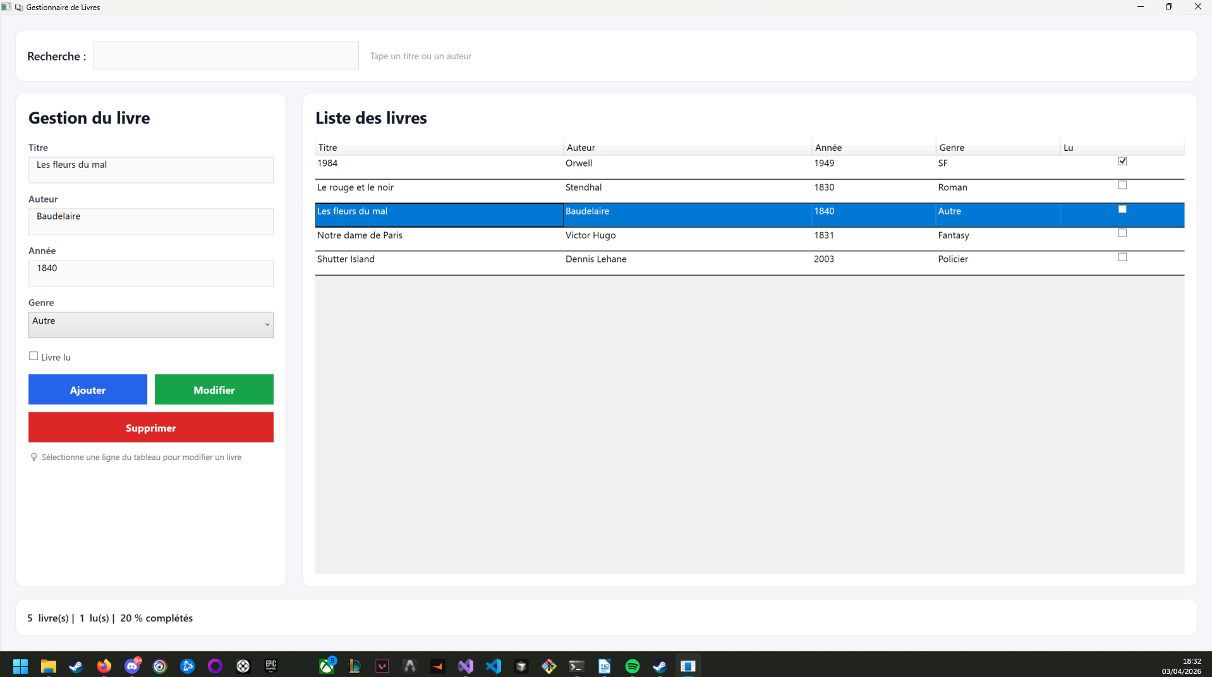

Capture 7 :
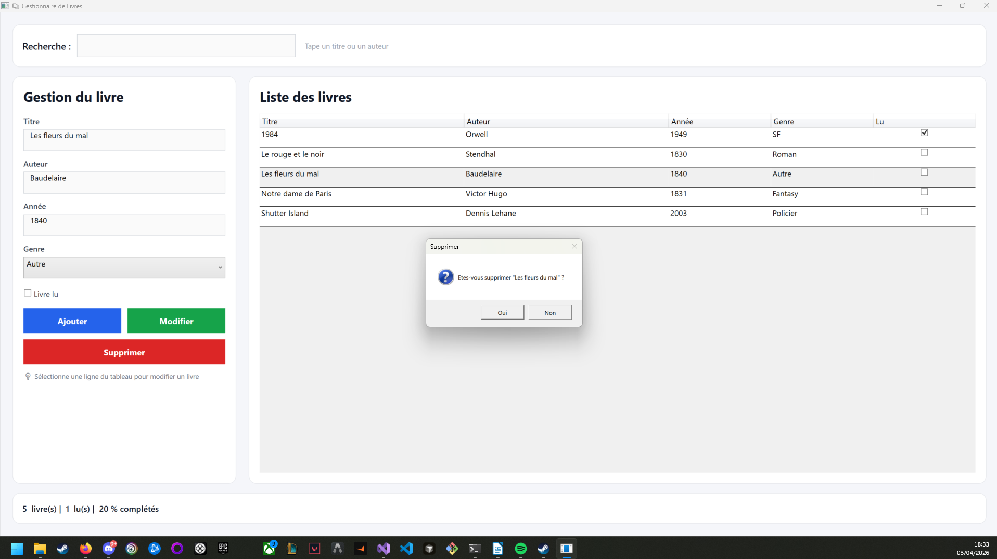

Capture 8 :

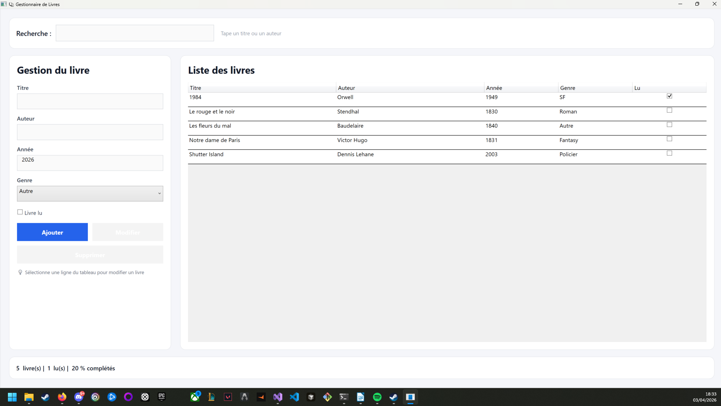

Partie 3)

Capture 9 :
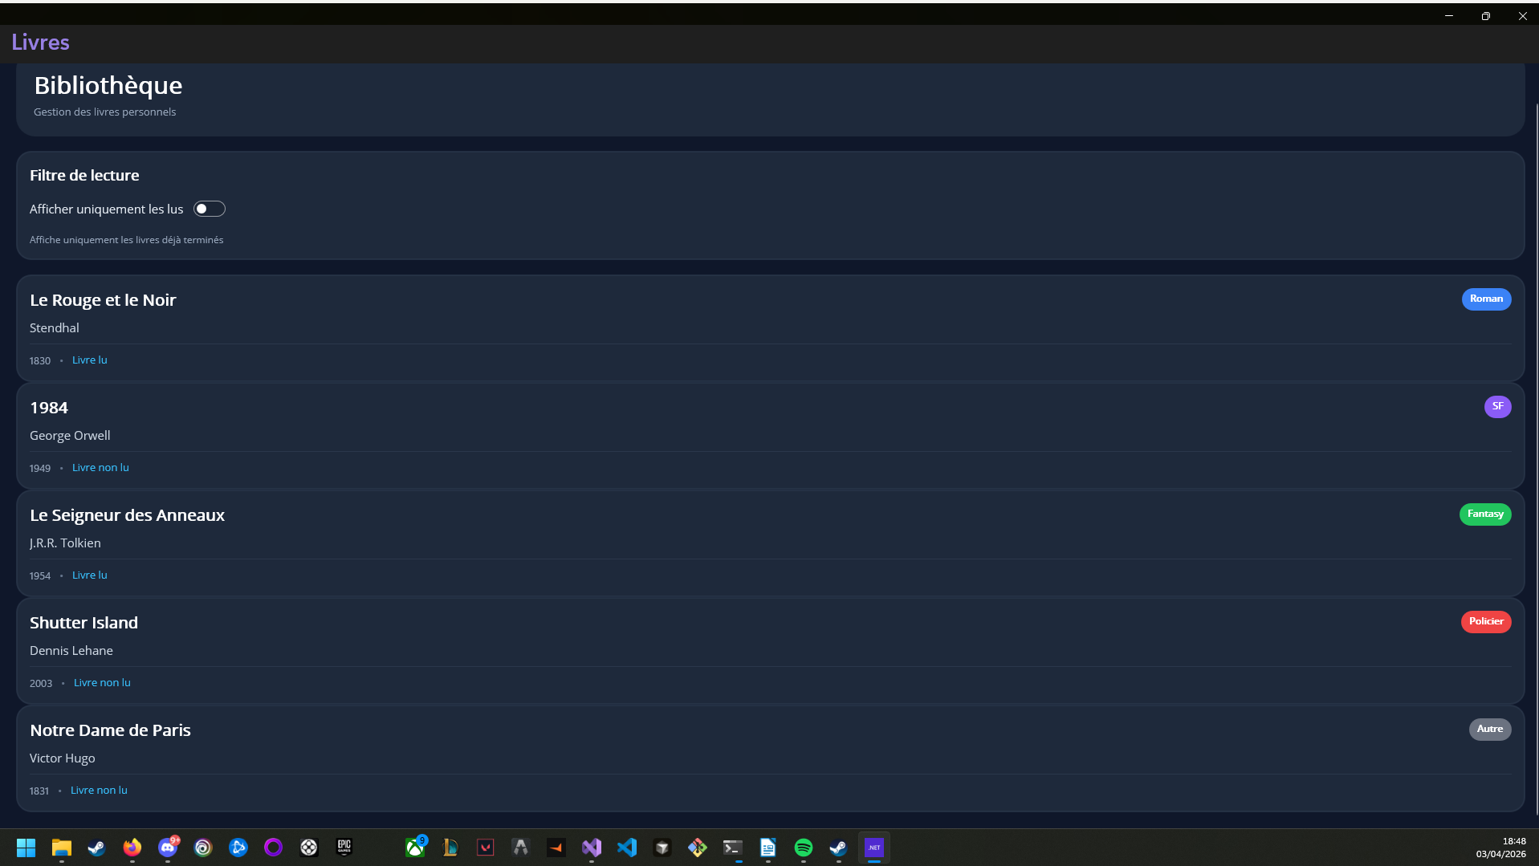

Bonus 1) Question à trou
public class RelayCommand : ICommand
{
private readonly Action<object?> _execute;
private readonly Func<object?, bool>? _canExecute;
public RelayCommand(Action<object?> execute, Func<object?, bool>? canExecute = null)
{
_execute = execute ?? throw new ArgumentNullException(nameof(execute));
_canExecute = canExecute;
}
public bool CanExecute(object? parameter) => _canExecute?.Invoke(parameter) ?? true;
public void Execute(object? parameter) => _execute(parameter);
public event EventHandler? CanExecuteChanged;
}

