**Association Rules**

# Question 1:

Perform the Apriori algorithm on the following example with a support threshold of *s*=33.34% and a confidence threshold *c*=60%. Show the candidate and frequent itemsets for each database scan. Show the associations generated.

|  |  |
| --- | --- |
| Transaction ID | Items |
| T1 | Hot Dogs, Buns, Ketchup |
| T2 | Hot Dogs, Buns |
| T3 | Hot Dogs, Coke, Chips |
| T4 | Chips, Coke |
| T5 | Chips, Ketchup |
| T6 | Hot Dogs, Coke, Chips |

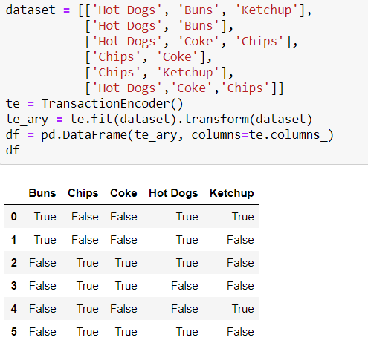

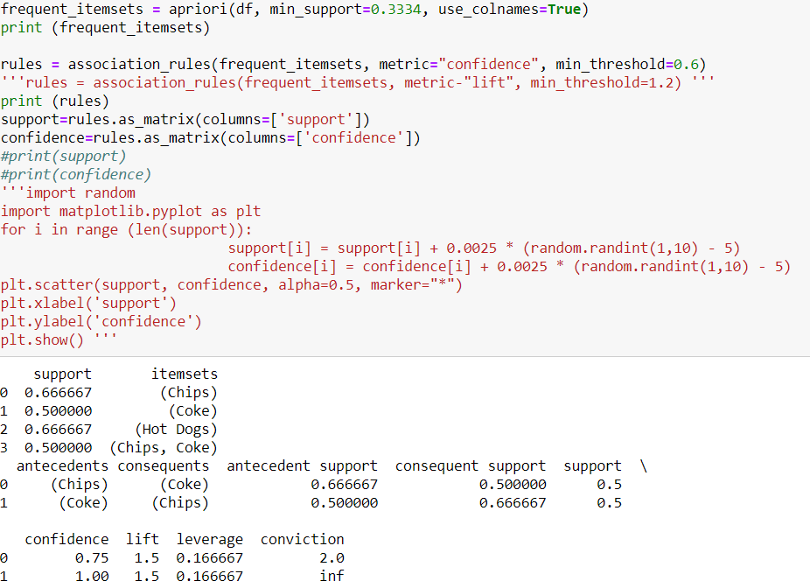

***Exercise 2:***

Giving the following database with 5 transactions and a minimum support threshold of 60% and a minimum confidence threshold of 80%, find all frequent itemsets using Apriori.

|  |  |
| --- | --- |
| **TID** | **Transaction** |
| T1 | {A, B, C, D, E, F} |
| T2 | {B, C, D, E, F, G} |
| T3 | {A, D, E, H} |
| T4 | {A, D, F, I, J} |
| T5 | {B, D, E, K} |

# 

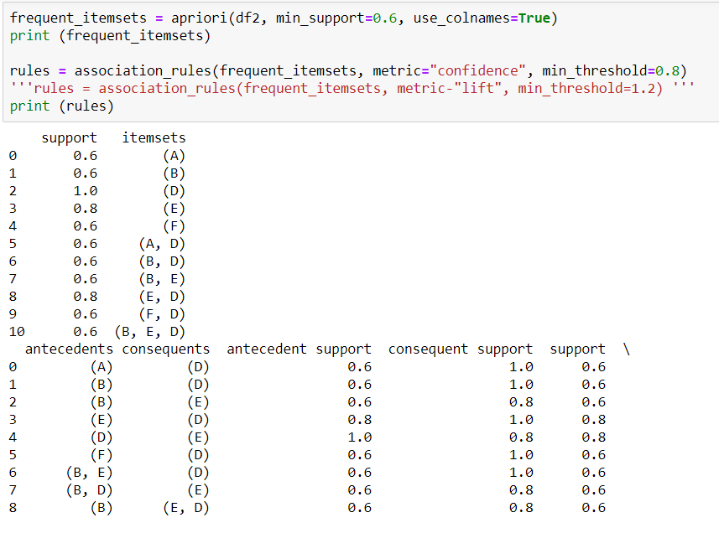

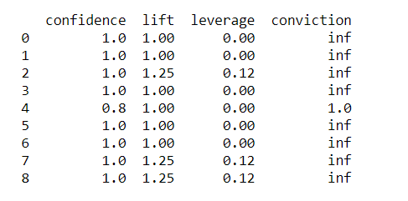

# Question 3:

Load a dataset described with nominal attributes. Run the Apriori algorithm to generate association rules.

