Convert Categorical Data to Numerical using dummy

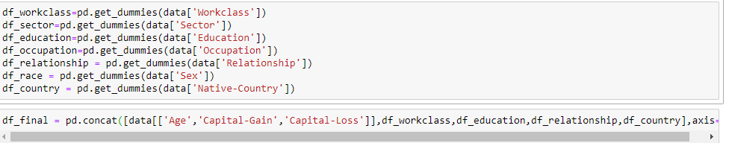

Generate ROC

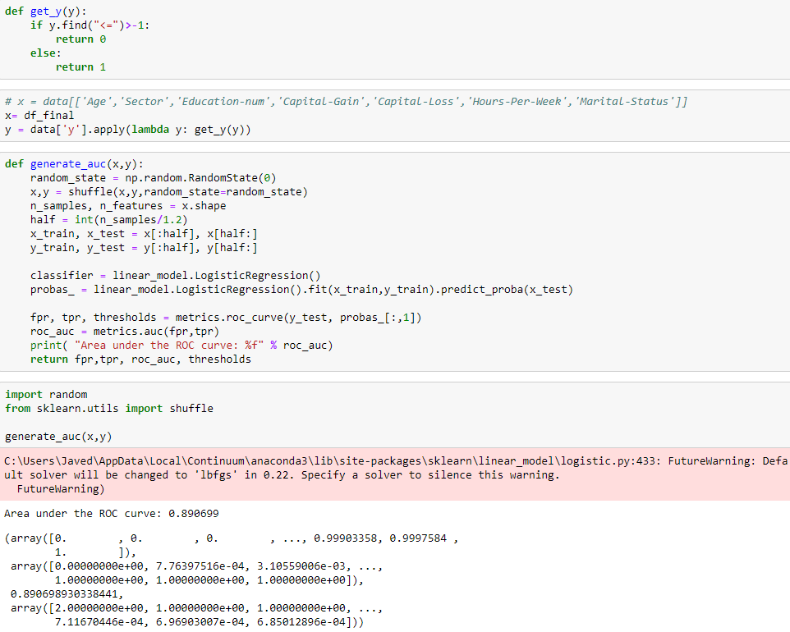

Generate the confusion matrix

