Group 5

Reading CSV

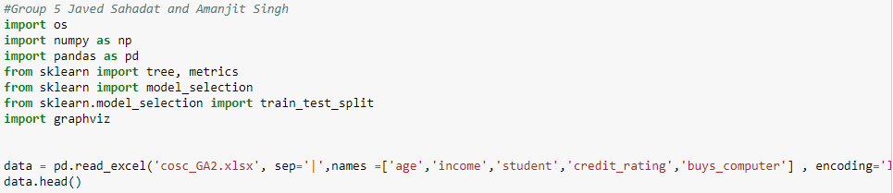

Split and train data

And make decision tree using entropy

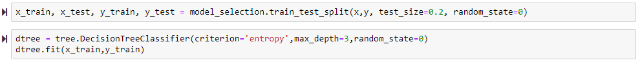

Print Accuracy

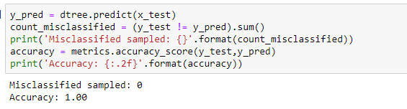

Print Tree

