1. Linear Regression Scatter Plot

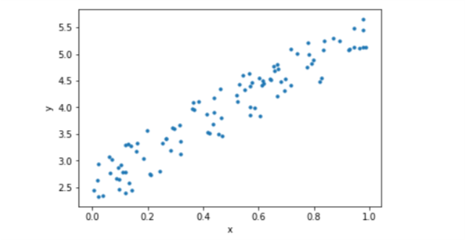

2. Finding coef of determination, intercept and slope using pandas and functions

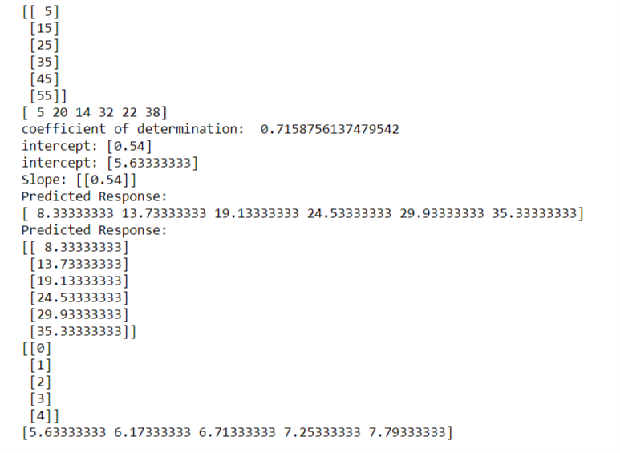

3. Scatter plot with observed values and predicted value

Slope, intercept, root mean squared error and r2 score

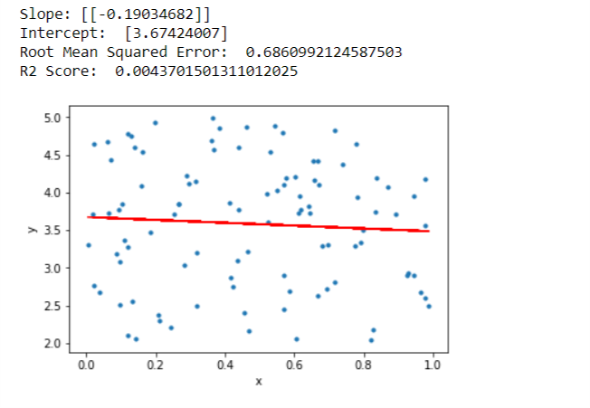

4. Example of multiple regression

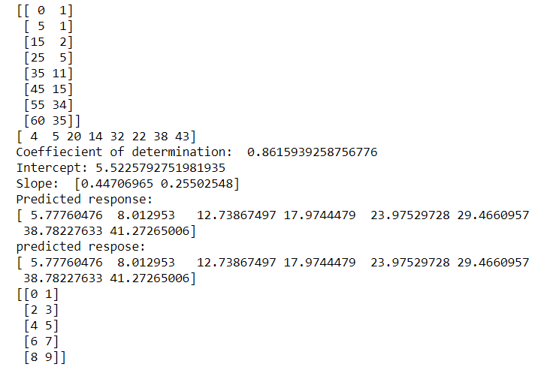

5. Confusion Matrix using sklearn

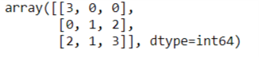

6. Confusion Matrix using pandas with labels

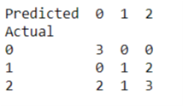

7. Confusion matrix norm

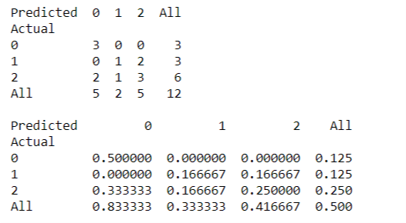

8. Confusion matrix representation using matplotlib

