1. Normalize Data

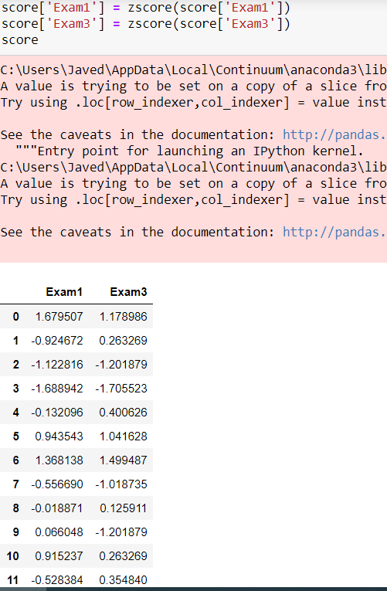

2. Covariance matrix

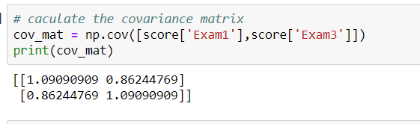

3. Eigenvalue and Eigenvector

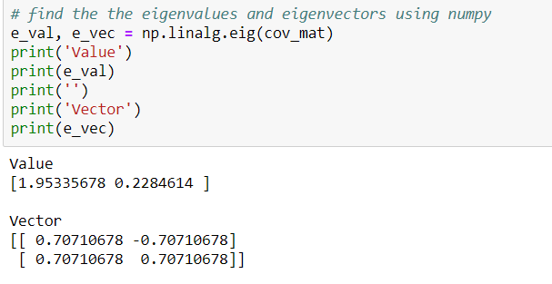

4. Sort Eigenvalues

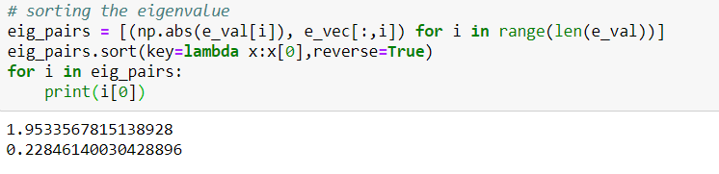

5. Eigenvector of PCA1

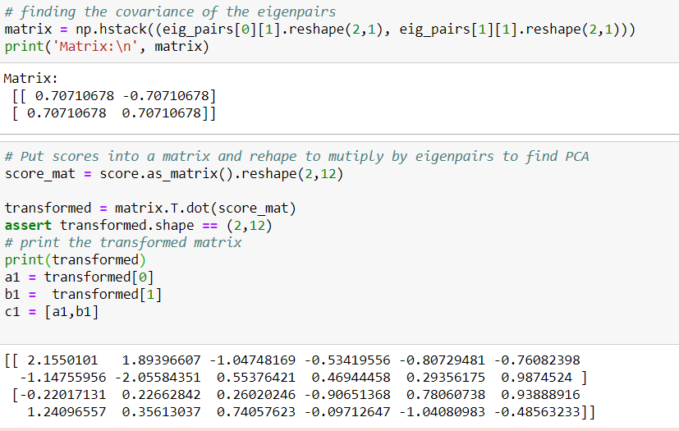

6.PCA2

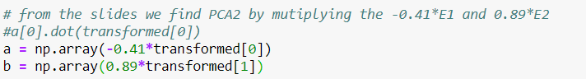

7. Find the variation

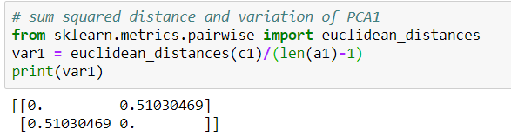

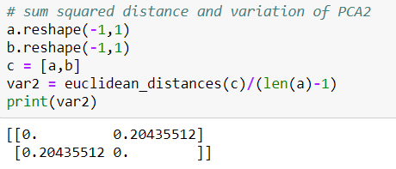

8. Total Variation and screeplot

