COSC 4364 Numerical Methods

Assignment 1

Output

1st Equation: x^3 - 6x^2 + 12x -8

Bisection Method

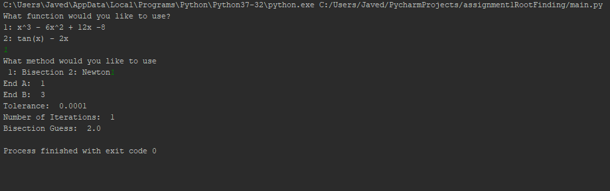

Newton’s Method

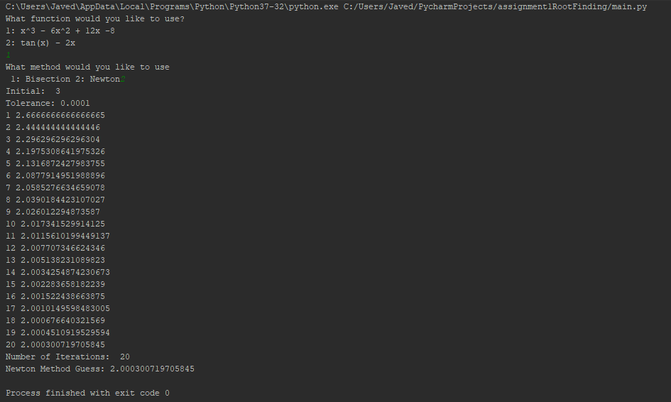

2nd Equation: tan(x) - 2x

Bisection Method

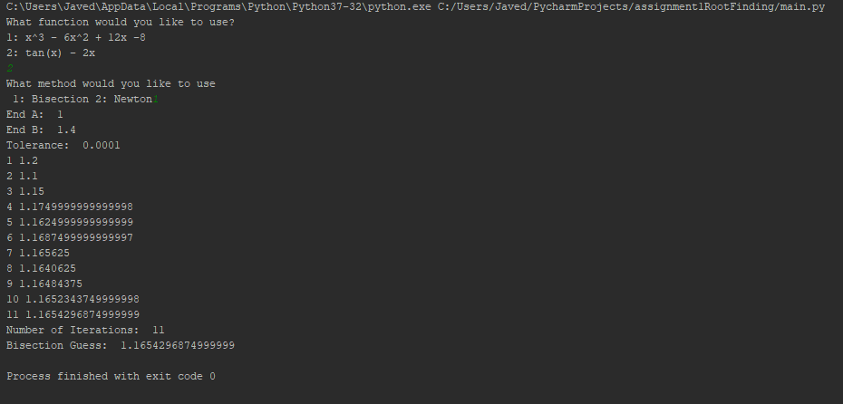

Newton’s Method

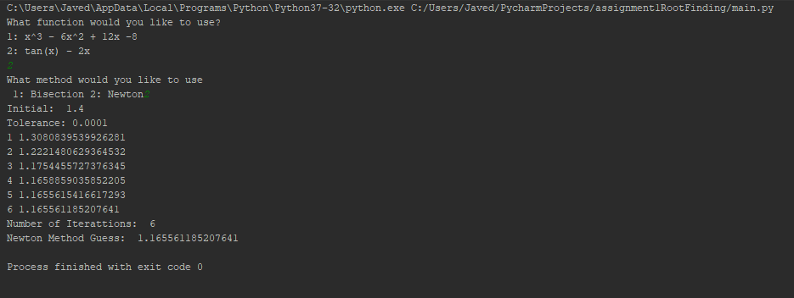

Report:

Bisection Method Explanation:

The bisection method is a way to find roots by narrowing down the interval which contain the roots. An interval is first chosen, a - b, which contains the root of the function. The interval is then sliced into two half portions. The half interval is checked to confirm which half the root is contained. The bisection method will continue to cut the interval into half continually into a resulting interval which is very small until a given tolerance is reached.

In pseudocode:

1. A midpoint c is calculated.
2. The function of c is calculated
3. If function(c) = 0 or (interval value b – interval value a) /2 < tolerance, then return c as solution
4. If number 3 is not satisfied, and function(a)\*function(c)<0 then b=c

Or function (b)\*function(c)>0 then a=c

Newton Method Explanation:

The newton method is another way to finds roots, by using an initial guess close to the real root. A function is approximated using a tangent line where an x intercept is calculated on the line. The x intercept will be the approximation of the function’s root. Finding the tangent and intercept will be iterated to find the best answer within a tolerance.

In pseudocode:

1. F’ is calculated, then x1 is equal to the newton method computation
2. If the results of the newton method is within a certain tolerance, we stop iteration and print result.
3. If the solution is not found we set x0(initial guess) to x1

Newton Method vs Bisection Method

Newton method assumes a function f to have a continuous derivative. The Newton method will not find a solution if started too far away from the root. When the Newton method converges, it does so faster than the bisection method. The Newton method uses the fact that x intercept calculated from a tangent line is approximately the root of a function. Bisection method depends on the halving the interval where the root is contained. It gains accuracy only after each iteration. The Newton method has time complexity of O (logn) while the bisection method has complexity of O (n)

Analysis of answers:

For answer 1, the Bisection method only required one iteration to find an answers while the Newton Method used 20 iterations. The bisection method in this case seem to give an exact answer.

For answer 2, the Newton method required less iterations to find an answer, while the bisection method used more iterations.

In both cases the answers were very close to each other, the bisection method for 1 seem to be better for find the root. Equation 2, the Newton method looks to be the closest to find the real root. (Answers were compared to roots using Wolfram Alpha).

Conclusion:

The Newton method requires a continuous derivative and good initial guess. Newton method will converge fasters than the bisection method, the bisection method will have guaranteed convergence if the method is started in the interval of the real root. Since the Newton method has time complexity of O (logn) it will run faster for large numbers vs Bisection method which is O (n) and will take longer to compute.