# Traditional Chinese Calligraphy Recognition Using Convolution Neural Network

##### Houze Liu

College of Engineering

Northeastern University

[liu.hou@husky.neu.edu](mailto:liu.hou@husky.neu.edu)

***Abstract*-** *Our goal of this project is to recognize Traditional Chinese Calligraphy in different styles. We will train Convolutional Neural Network on 100 labeled classes, each of which represents one kind of Chinese character written in different Calligraphy styles. For every kind of character, 100 images are provided. We preprocess our images to have 128x128, and constructed different models to test on different depths and filter numbers. All models were tested on another unlabeled test set to evaluate top-5 accuracy on recognition task.*

T

1. Introduction

raditional Chinese calligraphy (TCC) is an essential part of Chinese traditional art and culture. The earliest TCC work can be dated back to 11 century BC. Along the history of Chinese culture, calligraphy has been developed far beyond recording on paper. Being able to write calligraphy was regarded as an evidence of being educated, intellectual and even privileged. Nowadays it becomes pure formats for art performing. Prior to our project, many approaches have been introduced. Most are based on certain feature extraction and K-nearest neighbor technique. On the other hand, CNN has been widely used on hand-written character recognition. Therefore we want to explore the performance of CNN on TCC style recognition. However, even though TCC is one special type of hand-written characters, it doesn’t make recognizing TCC styles and recognizing hand-written characters more similar tasks. Most TCC are written by traditional Chinese brushes, which make the strokes much thicker than normal hand-written characters and as a result store more shape information. What’s more, same Chinese character written in simplified form and in traditional form respectively can vary dramatically in body structure and layout. Last but not least, some TCC styles were created for aesthetic purpose at the very beginning, making characters written in those styles very hard to recognize even for natives.

东 寒

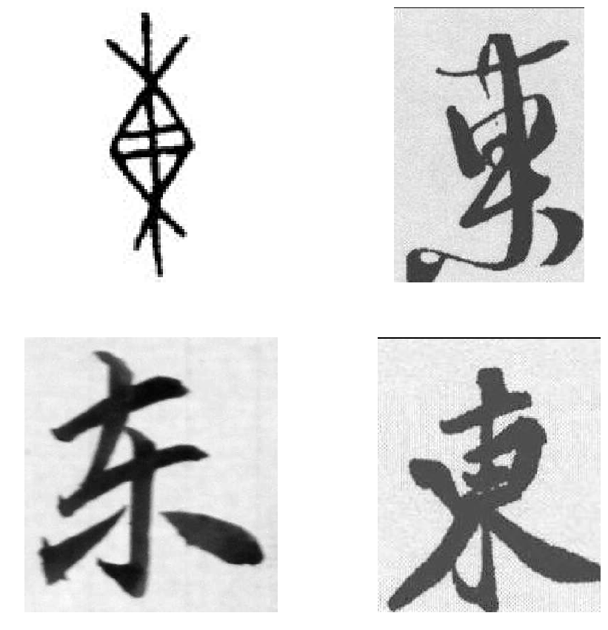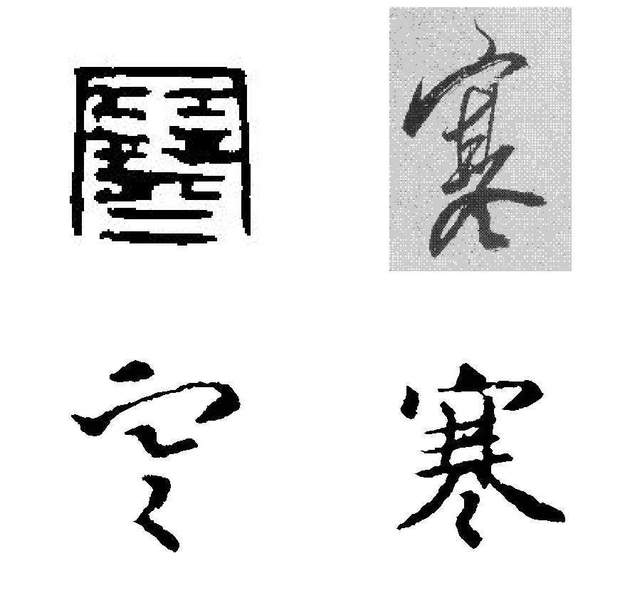

Figure 1. Two characters in different forms

1. Related Work

Blank

2. Methods

Blank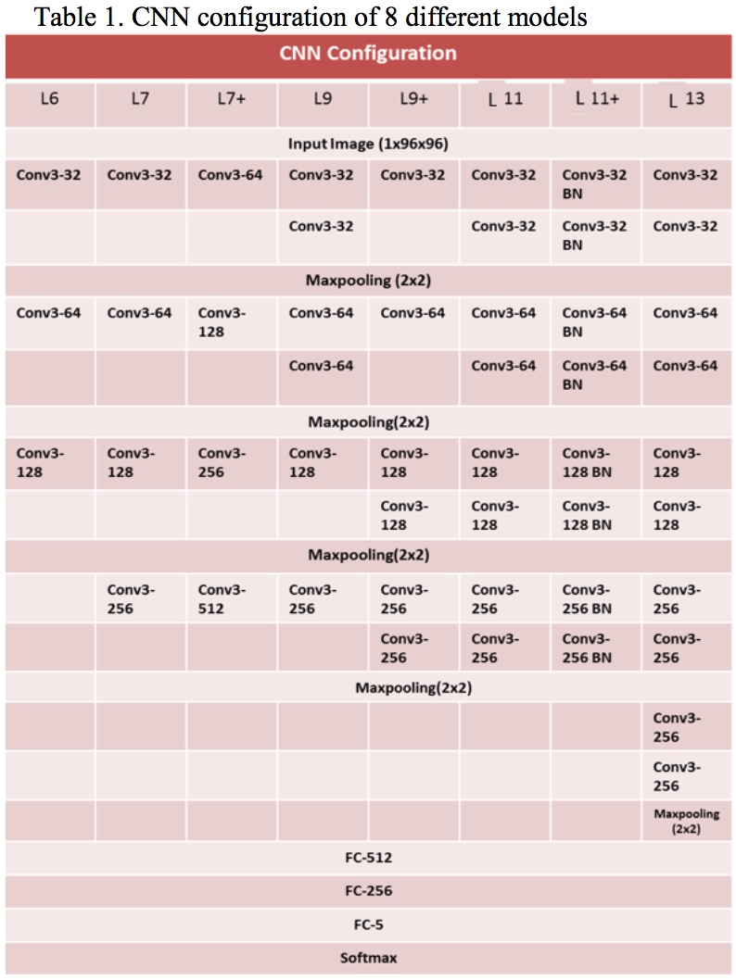

## A. Bits and Pieces together

## B. Use of Simulation software

1. Dataset and Pre-processing

We resized every image from its original size to 96 as the size of shorter side, remaining longer side scaled proportional to shorter side. Then we adjust images to size of 128x128, padding the sides less than and cropping the sides larger than 128. So we get all images uniformly 128x128 and keep as much shape information as possible.

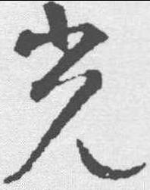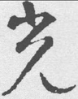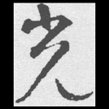

Size: 251x198 Size: 122x96 Size: 128x128

Figure 2. Pre-processing: Raw Image, Resized, Center Cropped

Here below is

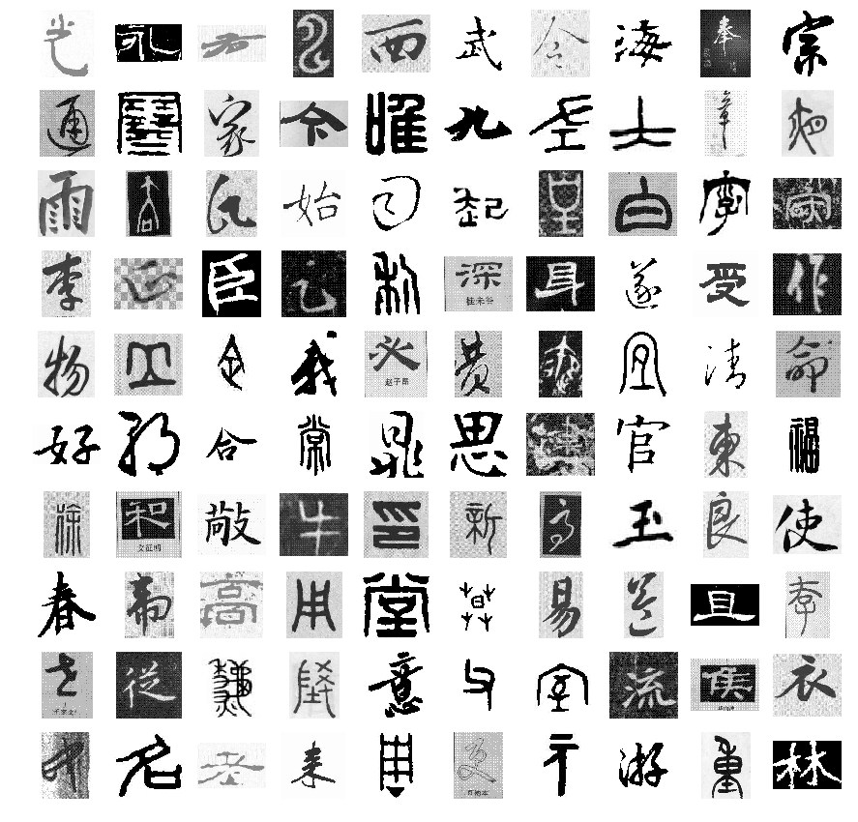

Figure 3. Dataset visualization

1. Experiments

Code and Documentation:

<https://github.com/HouHouHouHouHouHou/7390>

Result:

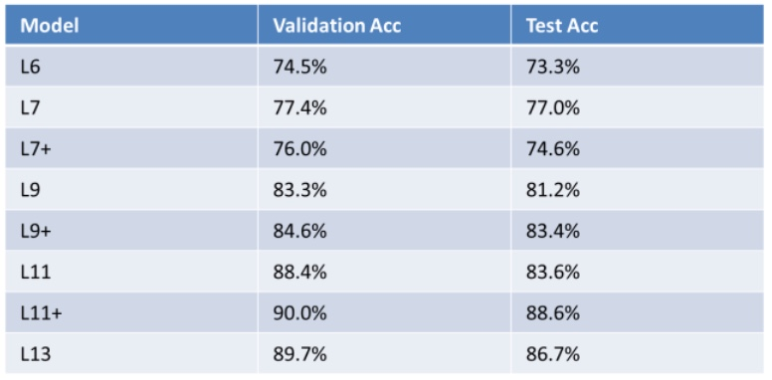

1. CONCLUSION

In this project, we explored the performance of CNN models on TCC recognition. We constructed 8 different models with different number of convolutional layers and different number of filters. And we found that increasing number of convolutional layers, in other word, building deeper network models increases the overall recognition accuracy of the model. And increasing number of filters didn’t increase the accuracy in our case. We also found that the best model in our configurations is the 11-layer network with batch normalization.

References

1. Boqi Li. “Convolution Neural Network for Traditional Chinese Calligraphy Recognition,” CS231N course project
2. Simonyan, Karen, and Andrew Zisserman."Very deep convolutional networks for large-scale image recognition," International Conference on Learning Representations, 2015.
3. Ioffe, Sergey, and Christian Szegedy."Batch normalization: Accelerating deep network training by reducing internal covariate shift," arXiv preprint arXiv:1502.03167 (2015).
4. He, Kaiming, et al."Delving deep into rectifiers: Surpassing human-level performance on imagenet classification," Proceedings of the IEEE International Conference on Computer Vision, 2015.
5. Pengyuan Lyu, Xiang Bai, Cong Yao, et al.“Auto-Encoder Guided GAN for Chinese Calligraphy Synthesis,” arXiv preprint arXiv:1706.08789v1, 27 Jun 2017.
6. TinyMind.cn database.“TinyMind first TCC recognition competition,”

<http://www.tinymind.cn/competitions/41?from=blog>