chardev.c Makefile

chardev.c

/*

 * chardev.c: Creates a read-only char device that says how many times

 * you have read from the dev file

 */

#include <linux/cdev.h>

#include <linux/delay.h>

#include <linux/device.h>

#include <linux/fs.h>

#include <linux/init.h>

#include <linux/irq.h>

#include <linux/kernel.h>

#include <linux/module.h>

#include <linux/poll.h>

/* Prototypes - this would normally go in a .h file */

static int device_open(struct inode *, struct file *);

static int device_release(struct inode *, struct file *);

static ssize_t device_read(struct file *, char __user *, size_t, loff_t *);

static ssize_t device_write(struct file *, const char __user *, size_t, loff_t *);

#define SUCCESS 0

#define DEVICE_NAME "chardev" /* Dev name as it appears in /proc/devices */

#define BUF_LEN 80 /* Max length of the message from the device */

/* Global variables are declared as static, so are global within the file. */

static int major; /* major number assigned to our device driver */

enum {

    CDEV_NOT_USED = 0,

    CDEV_EXCLUSIVE_OPEN = 1,

};

/* Is device open? Used to prevent multiple access to device */

static atomic_t already_open = ATOMIC_INIT(CDEV_NOT_USED);

static char msg[BUF_LEN + 1]; /* The msg the device will give when asked */

static struct class *cls;

static struct file_operations chardev_fops = {

    .read = device_read,

    .write = device_write,

    .open = device_open,

    .release = device_release,

};

static int __init chardev_init(void)

{

    major = register_chrdev(0, DEVICE_NAME, &chardev_fops);

    if (major < 0) {

        pr_alert("Registering char device failed with %d\n", major);

        return major;

    }

    pr_info("I was assigned major number %d.\n", major);

    cls = class_create(THIS_MODULE, DEVICE_NAME);

    device_create(cls, NULL, MKDEV(major, 0), NULL, DEVICE_NAME);

    pr_info("Device created on /dev/%s\n", DEVICE_NAME);

    return SUCCESS;

}

static void __exit chardev_exit(void)

{

    device_destroy(cls, MKDEV(major, 0));

    class_destroy(cls);

    /* Unregister the device */

    unregister_chrdev(major, DEVICE_NAME);

}

/* Methods */

/* Called when a process tries to open the device file, like

 * "sudo cat /dev/chardev"

*/

static int device_open(struct inode *inode, struct file *file)

{

    static int counter = 0;

    if (atomic_cmpxchg(&already_open, CDEV_NOT_USED, CDEV_EXCLUSIVE_OPEN))

        return -EBUSY;

    sprintf(msg, "I already told you %d times Hello Hou!\n", counter++);

    try_module_get(THIS_MODULE);

    return SUCCESS;

}

/* Called when a process closes the device file. */

static int device_release(struct inode *inode, struct file *file)

{

/* We're now ready for our next caller */

    atomic_set(&already_open, CDEV_NOT_USED);

/* Decrement the usage count, or else once you opened the file, you will

* never get rid of the module.

*/

    module_put(THIS_MODULE);

    return SUCCESS;

}

 /* Called when a process, which already opened the dev file, attempts to

 * read from it.

 */

static ssize_t device_read(struct file *filp, /* see include/linux/fs.h */

    char __user *buffer, /* buffer to fill with data */

    size_t length, /* length of the buffer */

    loff_t *offset)

{

/* Number of bytes actually written to the buffer */

    int bytes_read = 0;

    const char *msg_ptr = msg;

    if (!*(msg_ptr + *offset)) { /* we are at the end of message */

        *offset = 0; /* reset the offset */

        return 0; /* signify end of file */

    }

    msg_ptr += *offset;

    /* Actually put the data into the buffer */

    while (length && *msg_ptr) {

    /* The buffer is in the user data segment, not the kernel

    * segment so "*" assignment won't work. We have to use

    * put_user which copies data from the kernel data segment to

    * the user data segment.

    */

    put_user(*(msg_ptr++), buffer++);

    length--;

    bytes_read++;

}

    *offset += bytes_read;

    /* Most read functions return the number of bytes put into the buffer. */

    return bytes_read;

}

    /* Called when a process writes to dev file: echo "hi" > /dev/hello */

    static ssize_t device_write(struct file *filp, const char __user *buff,

    size_t len, loff_t *off)

    {

        pr_alert("Sorry, this operation is not supported.\n");

        return -EINVAL;

    }

module_init(chardev_init);

module_exit(chardev_exit);

MODULE_LICENSE("GPL");

Makefile

obj-m += chardev.o

PWD := $(CURDIR)

all:

    make -C /lib/modules/$(shell uname -r)/build M=$(PWD) modules

clean:

    make -C /lib/modules/$(shell uname -r)/build M=$(PWD) clean

cat /proc/devices

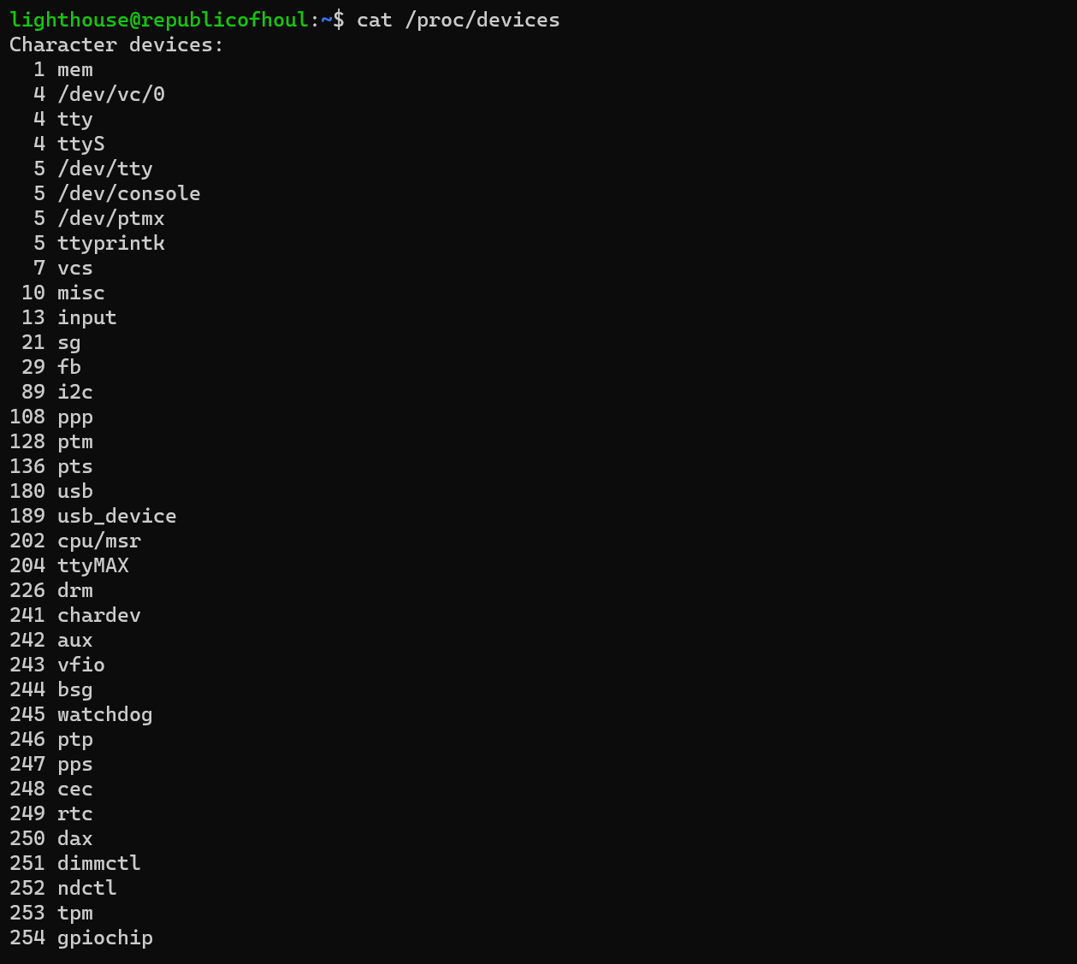

dmseg output

