Checkpoint MongoDB
Create database called « contact »
- Open any type of terminal
- First w type mongosh(help us to type commands to mange database) and enter
- Type use contact , so it display to us « switched to db contact »

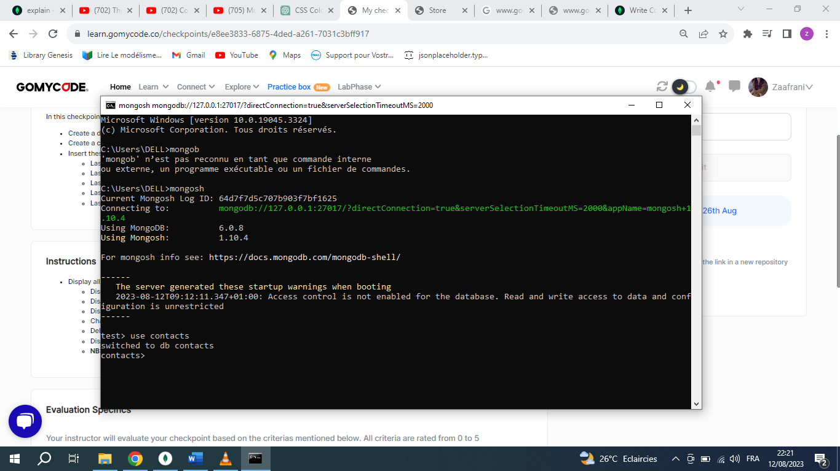
- Display all databases : show dbs
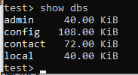

Create collection called « contactlist»
- Cls to clear terminal
- Type db.createcollection(«contactlist »)
- Ok :1 means operation is successfully done

Insert these documents « contactlist»
- To insert documents we have 2 methodes :
- «insertOne : to insert just one document
- insertMany : to insert many documents in the same time
- we have many documents so we use insertMany,so we will type : db.contactlist.insertMany({first document},{sacend document},..)
=>terminal will display inside of object « acknowledged : true » means command done successfully and MongoDB generate for each document id (« id » : ObjectId(« .. »)
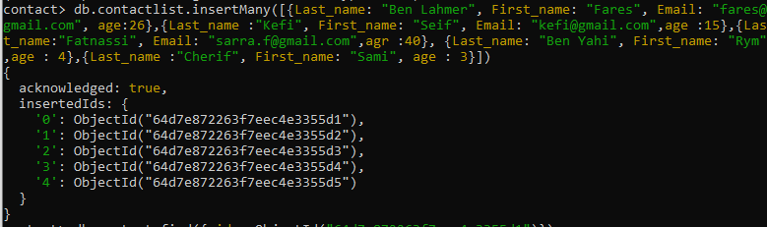

➔if we like to display all document just type « db.contactlist.find()
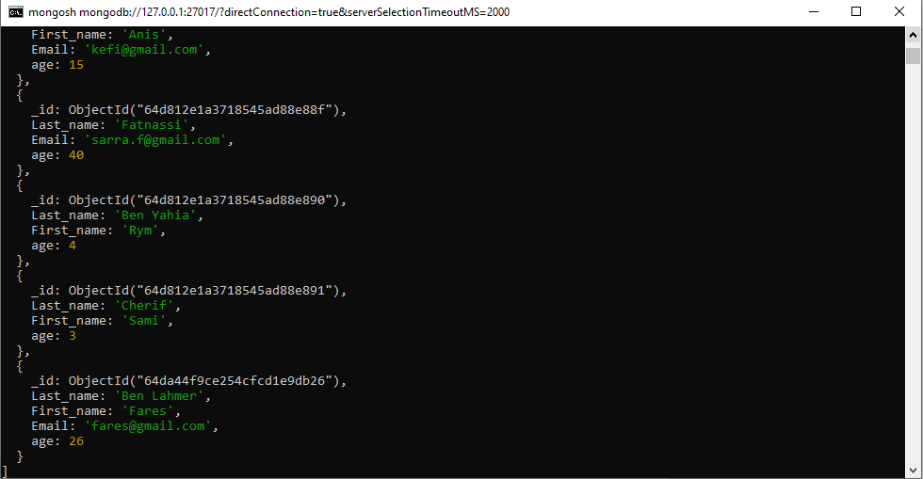
Display all the information about only one person using his ID.
- to display specific document we should use methode find() and include a specific id
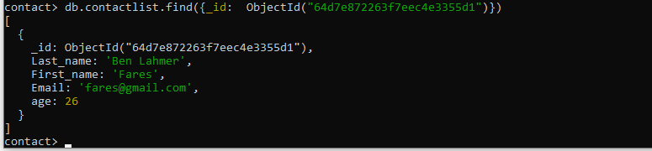
Display all the contacts with an age >18.
- Use methode find({condition}) and include the condition
- The condition :display all document that have value of field(age) greeter then($set ) 18
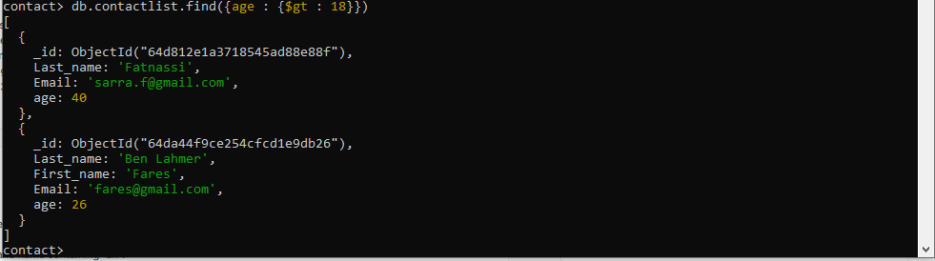
Display all the contacts with an age>18 and name containing "ah"
- Use operator $and to associate 2 condition in the same time
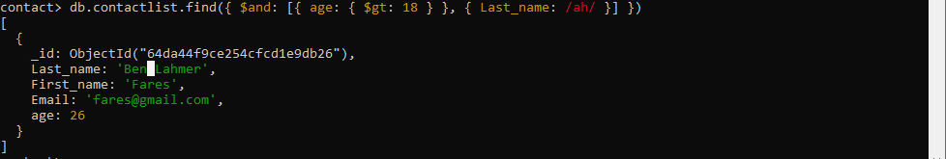
Change the contact's first name from "Kefi Seif" to "Kefi Anis"
- Display all document use command db.contactlist.find({})

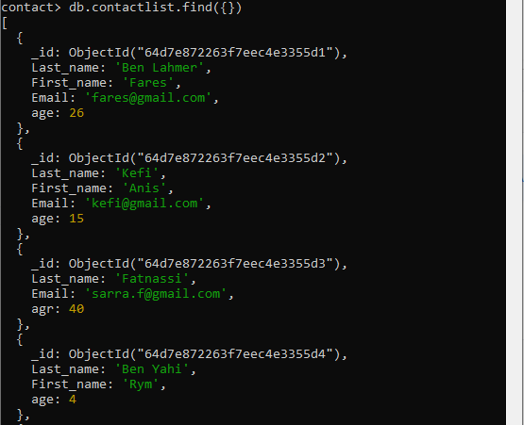
- Shoose document that you will modify and copy his id
- db.contactlist.updateOne() will take as first parameter id then the sacend parameter we modifie our ducument using $set
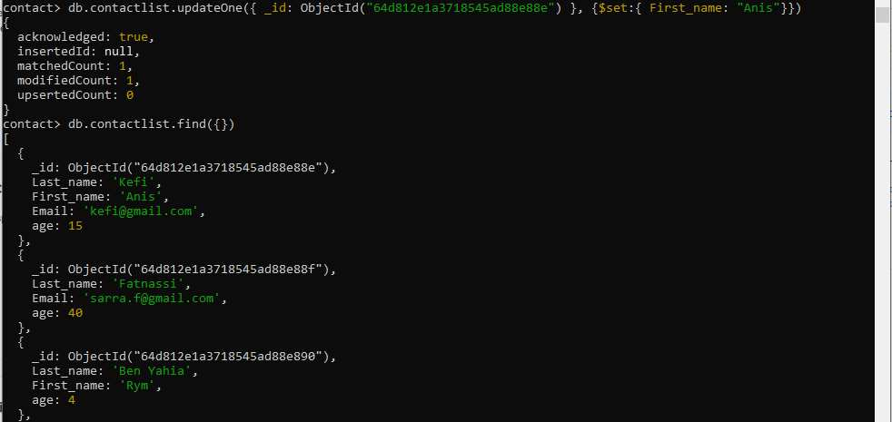

Delete the contacts that are aged under <5
- we have 2 methodes :
- deleteOne() : it will delete just one document that satisfie the condition
- deleteMany() : it will delete all documents that satisfie the condition(we choose this methode including the condition(less then 5)using $lt)
➔we have 2 document deleted that satisfie the condition
- display the rest of document using db.contactlist.find({})
