CSCI 202 Programming Assignment - State Capitals and Unique Words

Introduction
This program consists of two parts. The first part reads words from a text file, stores them in a set, and displays all unique words in ascending order. The second part uses a map to store state-capital pairs and allows the user to query the capital city of any state.
1. Readme Documentation
Title: CSCI 202 Programming Assignment - State Capitals and Unique Words

Introduction:
This program consists of two parts. The first part reads words from a text file, stores them in a set, and displays all unique words in ascending order. The second part uses a map to store state-capital pairs and allows the user to query the capital city of any state.

Implementation Details:
1. **Nonduplicate Words**: The program reads from a file and uses a set to store words without duplicates. It then displays the words sorted in ascending order.
2. **State and Capital Map**: The program uses a map to store state-capital pairs. The user is prompted to enter a state, and the program displays the capital for that state.

How to Run:
1. Compile the code using a C++ compiler.
2. Run the executable. In the case of the first program, make sure to provide the `input.txt` file in the same directory.
3. For the state-capital program, input the state name when prompted.

---

### Step 4: **Flowchart / Flowgorithm / Raptor**

- **Nonduplicate Words Program**:
- Start → Read file → For each word:
- Add to set → End of file → Print sorted set
- End

- **State and Capital Map Program**:
- Start → Initialize state-capital map → Prompt user for input → Check if state exists in map → Display capital → End

### Step 5: **UML Diagram**

**For the State and Capital Program**, the UML diagram could look something like this:

2.Flowchart for Nonduplicate Words Program
The flowchart for the Nonduplicate Words Program is as follows:
Start
|
|--> Open file
| |
| |--> [File open failed] --> Display error --> End
|
|--> [File opened] --> Read word
| |
| |--> Add word to set
| |
| |--> [End of file?] --> No --> Read next word
| | --> Yes --> Print sorted words
|
End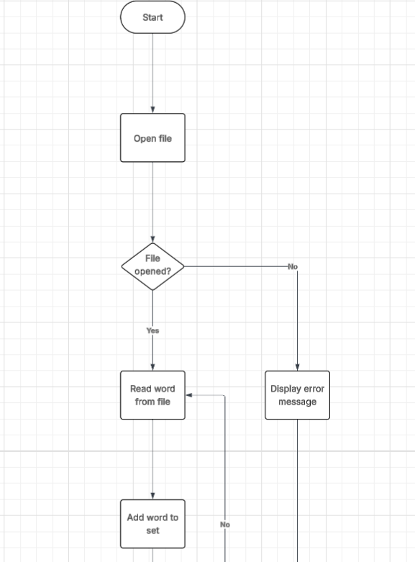
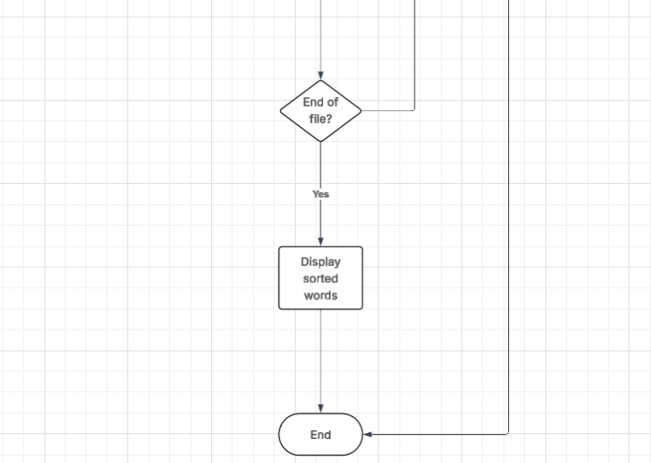
3.UML Diagram for State and Capital Map Program
The UML Diagram for the State and Capital Map Program is as follows:
Class: StateCapitalMap
Attributes:
- stateCapitalMap: map<string, string>
Methods:
+ getCapital(state): string
+ addStateCapital(state, capital): void
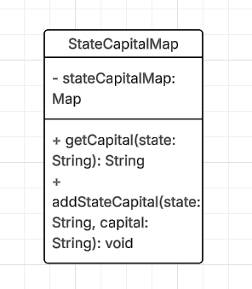
Use Case Diagram for State and Capital Map Program
The Use Case Diagram for the State and Capital Map Program is as follows:
1. User enters state name.
2. System displays capital of the entered state.
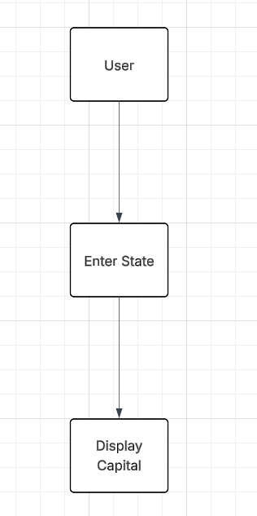
4. Source code :
for Nonduplicate Words Program (Using Set)
# Include necessary libraries
#include <iostream>
#include <fstream>
#include <set>
#include <string>
int main() {
std::set<std::string> uniqueWords; // Set to store non-duplicate words
std::ifstream file("input.txt"); // Open file for reading
std::string word;
if (!file) {
std::cerr << "Error opening file!" << std::endl;
return 1;
}
// Read words from file and insert them into the set
while (file >> word) {
uniqueWords.insert(word);
}
// Display words in ascending order (automatically done by set)
std::cout << "Unique words in ascending order:" << std::endl;
for (const auto& w : uniqueWords) {
std::cout << w << std::endl;
}
file.close();
return 0;
}
- for State and Capital Map Program
# Include necessary libraries
#include <iostream>
#include <map>
#include <string>
int main() {
// Create a map with state names as keys and capital cities as values
std::map<std::string, std::string> stateCapitalMap = {
{"California", "Sacramento"},
{"Texas", "Austin"},
{"Florida", "Tallahassee"},
{"New York", "Albany"},
{"Illinois", "Springfield"}
};
std::string state;
std::cout << "Enter a state name: ";
std::getline(std::cin, state);
// Check if the state is in the map and display the capital
if (stateCapitalMap.find(state) != stateCapitalMap.end()) {
std::cout << "The capital of " << state << " is "
<< stateCapitalMap[state] << "." << std::endl;
} else {
std::cout << "State not found." << std::endl;
}
return 0;
}
5. Screen shots of three use cases

Use case 1
Unique words in ascending order:
apple
banana
grape
kiwi
mango
orange
watermelon

----------------------------------------

Enter a state name: State not found.
- Exit Code 0
Use Case 2 : Finding a Valid State Capital
Unique words in ascending order:
apple
banana
grape
kiwi
mango
orange
watermelon

----------------------------------------

Enter a state name: The capital of California is Sacramento.

- Exit Code 0
Use Case 3 : Searching for Non-existent State
Unique words in ascending order:
apple
banana
grape
kiwi
mango
orange
watermelon

----------------------------------------

Enter a state name: State not found.
Exit Code 0

