**SAMPLE RUN 1 (Opening Screen)**

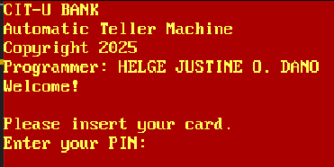

**SAMPLE RUN 2 (WRONG PIN)**

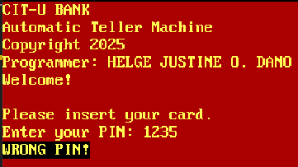

**SAMPLE RUN 3 (WRONG PIN)**

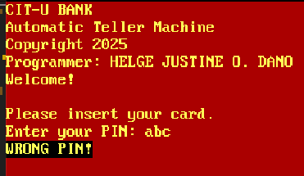

**SAMPLE RUN 4 (CORRECT PIN: 1234)**

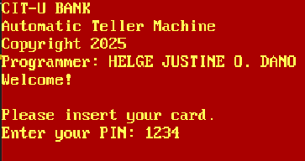

**SAMPLE RUN 5 (CORRECT PIN = display MAIN MENU)**

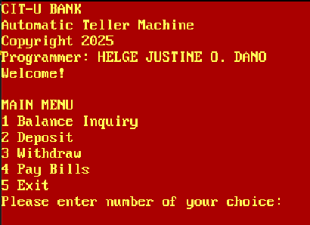

**SAMPLE RUN 6 (WRONG CHOICE FROM MAIN MENU)**

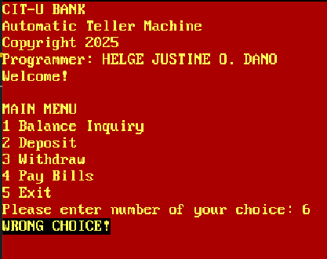

**SAMPLE RUN 7 (WRONG CHOICE FROM MAIN MENU)**

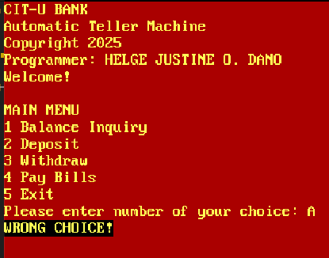

**SAMPLE RUN 8 (BALANCE INQUIRY)**

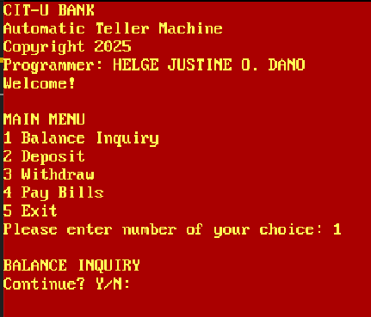

**SAMPLE RUN 9 (Continue? Y/N n OR N)**

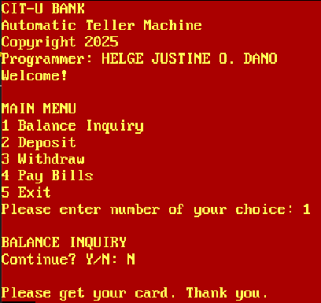

**SAMPLE RUN 10 (Continue? Y/N: y or Y = CLEAR SCREEN and display MAIN MENU)**

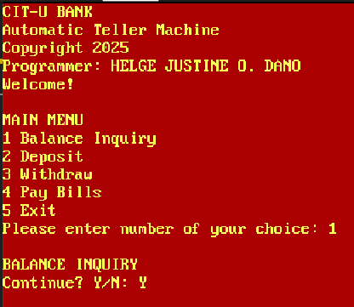

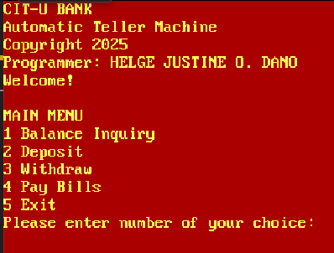

**SAMPLE RUN 11 (DEPOSIT)**

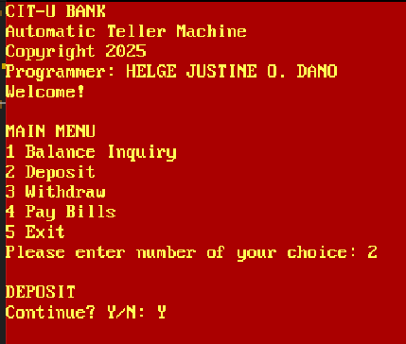



**SAMPLE RUN 12 (WITHDRAW)**

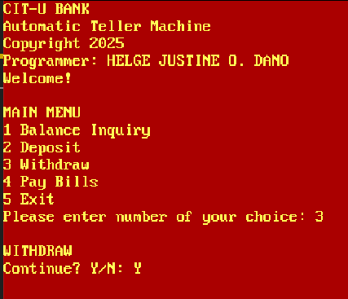



**SAMPLE RUN 13 (PAY BILLS)**

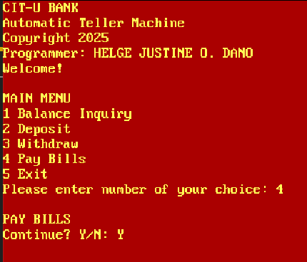



**SAMPLE RUN 14 (EXIT)**

