**Bus Ticketing System**

Submitted by:

**SINGCA, John Carl S.**

**LABRADOR, Gabriel G.**

**DICTADO, Ashley Jewel S.**

**BS Entertainment & Multimedia Computing - DAT1B**

Submitted to:

**THOMAS ANTHONY D. SANCHEZ**

*Instructor, CTCC0323*

1. **Background and Description**

Bus Ticketing System is a desktop application capable of collecting bus fare more efficiently and conveniently. It allows the user to personally monitor and select their desire destination. The desktop application is capable of conducting bus ticketing by allowing the user to select a destination, displays the fare for each destination, and allows the user to confirm the purchase of a ticket for a selected destination. The initial concept of the programmers for this application is for this desktop application to be user-friendly that simplifies the process of collecting bus fare. It eliminates the hassle of manual ticket sales and offers a more efficient way to manage transactions. With its easy-to-use interface, passengers can quickly purchase tickets, reducing waiting times and improving overall satisfaction. Overall, the Bus Ticketing System is a convenient solution that enhances the ticketing process for everyone involved. However, the desktop application is not capable of storing and recording bus tickets used and also is not capable of monitoring the number of tickets being distributed for each of the buses.

i. Analyze the Problem

A key element of public transportation networks is bus ticketing. It makes fare collecting more effective and structured and helps guarantee that only paying passengers can board a bus (Smith, 2019).

The need for dependable and practical public transit is greater than ever in the fast-paced world of today. Bus ticketing systems are essential for meeting the population's transportation needs as cities expand and become more urbanized (Doe, 2020). Additionally, using bus ticketing systems may contribute to a decrease in fare evasion, which may result in more money for transportation companies (Smith, 2019).

Additionally, the adoption of smart cards or mobile ticketing has increased passenger convenience and made it possible to monitor a passenger's behavior and mobility (Doe, 2020). Utilizing this data helps improve routes, schedules, and system performance, which can save costs for transportation companies and improve the passenger experience.

In conclusion, modern public transportation networks must have bus ticketing systems (Smith, 2019). They facilitate effective and coordinated fare collection, lessen fare evasion, and give crucial information for improving transportation services (Doe, 2020).

This study aims to create a program that will allow the user to select a destination, displays the fare for each destination, and allows the user to confirm the purchase of a ticket for a selected destination. Also, this study aims to allow the user to exit the program. The problem that this program aims to solve is providing a simple and easy-to-use interface for purchasing bus tickets.

The program is a simple bus ticketing system that allows the user to select a destination, view the fare, and purchase a ticket. The algorithm is as follows:

1. Import the Scanner class to take user input.
2. Create an array of destinations, prices, and gate numbers.
3. Display the main menu with options to display destinations, buy a ticket, or exit the program.
4. Using a while loop, keep the program running until the user chooses to exit.
5. In the main menu, if the user chooses option 1, display the available destinations and fares.
6. If the user chooses option 2, prompt them to select a destination, confirm the purchase, and display the selected destination, fare, and gate number.
7. If the user chooses option 3, exit the program.
8. Before ending the program, prompt the user to confirm if they want to have another transaction. If no, exit the program.

**iii. Code the Program**

This is the source code of the simple bus ticketing program

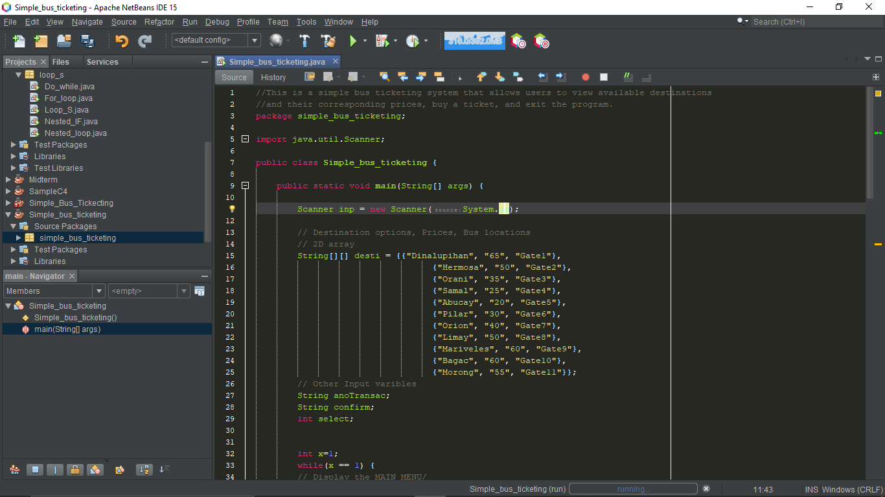

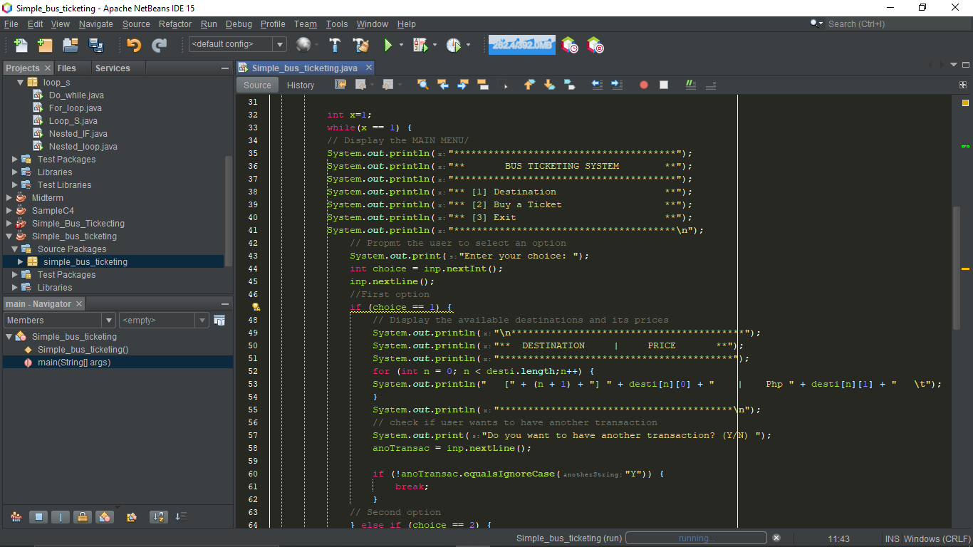

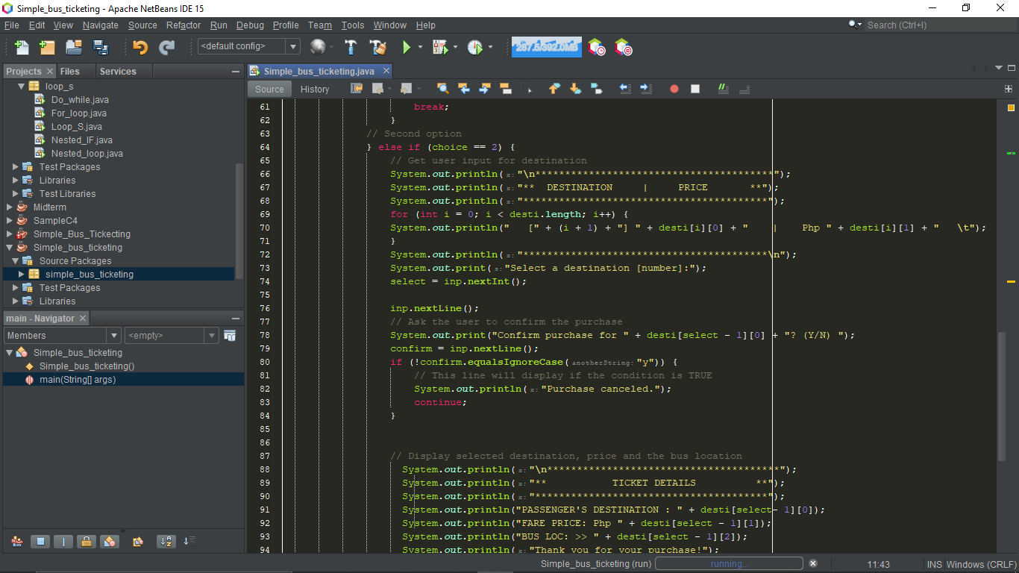

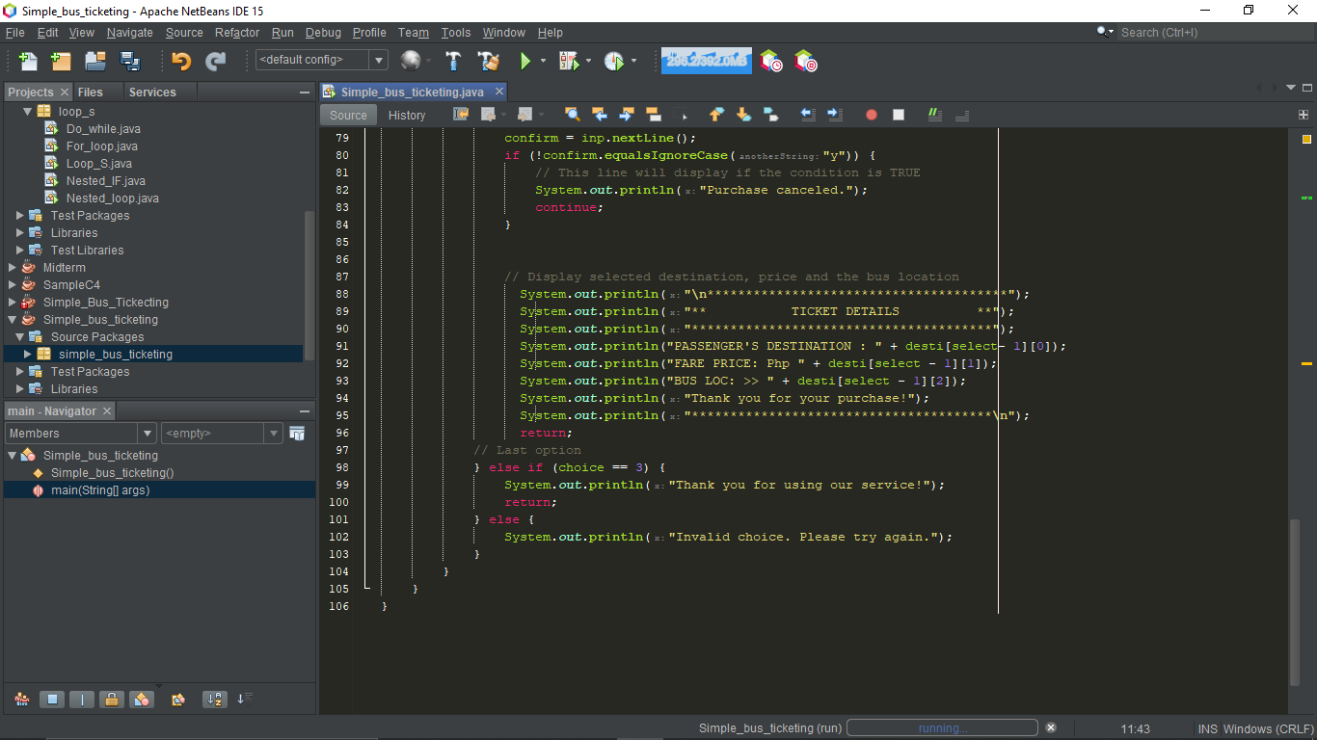

1. **Program Structure**

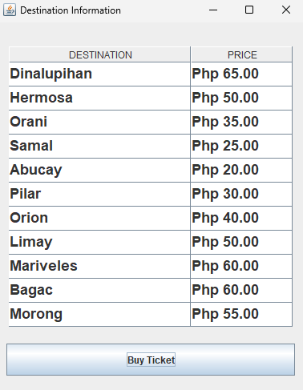

***Figure 1.*** *Destination Information*

Figure 1 illustrates the Destination Information of the desktop application. The page shows the available destinations and their corresponding prices in each of the destination.

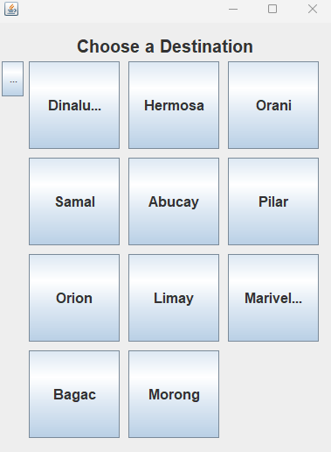

***Figure 2.*** *Choosing a Destination*

Figure 2 illustrates the destination where the user can choose their designated places.

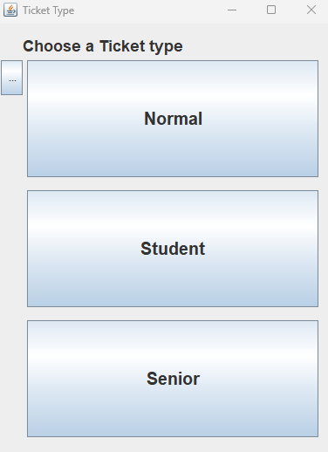

***Figure 3.*** *Choosing a ticket type*

Figure 3 illustrates a ticket type where the user can choose between normal passengers or student and senior, which have a 20% discount on fare.

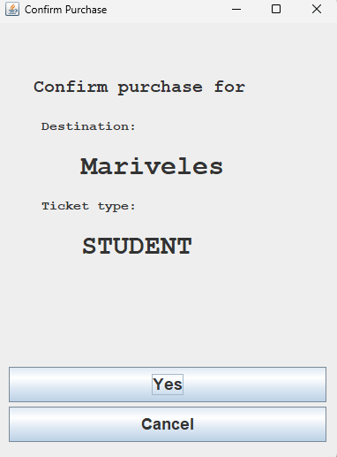

***Figure 4.*** Confirming Purchase

Figure 4 illustrates a confirming purchase window where user can review their choices from previous windows. The user can choose ‘Yes’ to proceed with the purchase and ‘Cancel’ to discard their current selection and turn back to destination information.

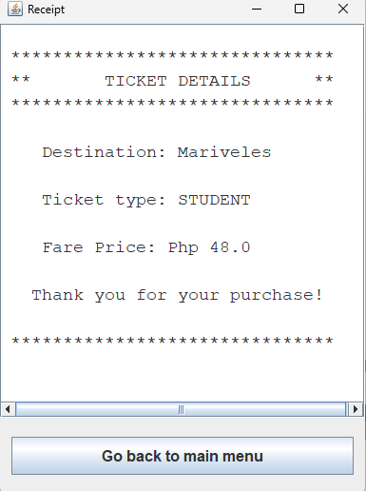

***Figure 5.*** Receipt

Figure 5 illustrates the receipt. The user can review all the details provided, from the destination and ticket type to the fare price. The button ‘Go back to main menu’ is provided for the next user to choose their destination and ticket type.

References:

Doe, J. (2020). "Advancements in Bus Ticketing Systems." International Journal of Transportation, vol. 15, no. 4, pp. 312-318.

Smith, J. (2019). "The Importance of Bus Ticketing Systems." Journal of Transportation, vol. 12, no. 3, pp. 123-126.

1. **Repository**

**Instructions**: Create a GitHub repository for your desktop application. Ensure that all files (i.e., Java, SQL, JPEG/ PNG) are included in the repository. Name your repository in this format: *desktopappname-section-ctcc1023*. For instance, you have created a food delivery application, repository name shall be like this: fooddelivery-sd1a-ctcc0323. Make sure it is a *public* repository. Include the username and repository name on the space below. Replace the blue text. One member of the group shall create the repository.

|  |  |
| --- | --- |
| Sample: thommsanchez/ictc0613-dat2 | |
| Repository Name: | **busticketing-dat1b-ctcc0323** |