**Mini-Course in Crypto Economics: Pre-course questionaire**

The purpose of this questionaire is to understand you and to provide the best course experience for you. So you have incentive to answer all questions truthfully.   
  
This questionaire counts for 2% of your final grades for completeness. We will ask you to fill in the same questionaire after this course. Let's engage ourselves to the fullest in this course and celebrate our remarkable milestones very shortly.   
  
No matter where you are right now, accept it and embrace it for with no doublt we will celebrate our remarkable accomplishment very shortly, all together!

Academic Information

Basic information[矩阵文本题] *

|  |  |
| --- | --- |
|  |  |
| Your Last Name | ________________________ |
| Your First Name | ________________________ |
| Your ECNU Student ID | ________________________ |
| Your Team No. | ________________________ |
| Your Team Name | ________________________ |

Are you a team leader? [单选题] *

|  |
| --- |
| ○Yes |
| ○No |

Provide Team Slogan [填空题] *

_________________________________

Provide Team Logo [上传文件题] *

Demographic Information

Your current location (country) [单选题] *

|  |
| --- |
| ○Afghanistan |
| ○Albania |
| ○Algeria |
| ○Andorra |
| ○Angola |
| ○Antigua and Barbuda |
| ○Argentina |
| ○Armenia |
| ○Australia |
| ○Austria |
| ○Azerbaijan |
| ○Bahamas, The |
| ○Bahrain |
| ○Bangladesh |
| ○Barbados |
| ○Belarus |
| ○Belgium |
| ○Belize |
| ○Benin |
| ○Bhutan |
| ○Bolivia |
| ○Bosnia and Herzegovina |
| ○Botswana |
| ○Brazil |
| ○Brunei |
| ○Bulgaria |
| ○Burkina Faso |
| ○Burma |
| ○Burundi |
| ○Cambodia |
| ○Cameroon |
| ○Canada |
| ○Cape Verde |
| ○Central African Republic |
| ○Chad |
| ○Chile |
| ○China |
| ○Colombia |
| ○Comoros |
| ○Congo, Democratic Republic of the |
| ○Congo, Republic of the |
| ○Costa Rica |
| ○Cote d'Ivoire |
| ○Croatia |
| ○Cuba |
| ○Cyprus |
| ○Czech Republic |
| ○Denmark |
| ○Djibouti |
| ○Dominica |
| ○Dominican Republic |
| ○East Timor (see Timor-Leste) |
| ○Ecuador |
| ○Egypt |
| ○El Salvador |
| ○Equatorial Guinea |
| ○Eritrea |
| ○Estonia |
| ○Ethiopia |
| ○Fiji |
| ○Finland |
| ○France |
| ○Gabon |
| ○Gambia, The |
| ○Georgia |
| ○Germany |
| ○Ghana |
| ○Greece |
| ○Grenada |
| ○Guatemala |
| ○Guinea |
| ○Guinea-Bissau |
| ○Guyana |
| ○Haiti |
| ○Holy See |
| ○Honduras |
| ○Hungary |
| ○Iceland |
| ○India |
| ○Indonesia |
| ○Iran |
| ○Iraq |
| ○Ireland |
| ○Israel |
| ○Italy |
| ○Jamaica |
| ○Japan |
| ○Jordan |
| ○Kazakhstan |
| ○Kenya |
| ○Kiribati |
| ○Kosovo |
| ○Kuwait |
| ○Kyrgyzstan |
| ○Laos |
| ○Latvia |
| ○Lebanon |
| ○Lesotho |
| ○Liberia |
| ○Libya |
| ○Liechtenstein |
| ○Lithuania |
| ○Luxembourg |
| ○Macau |
| ○Macedonia |
| ○Madagascar |
| ○Malawi |
| ○Malaysia |
| ○Maldives |
| ○Mali |
| ○Malta |
| ○Marshall Islands |
| ○Mauritania |
| ○Mauritius |
| ○Mexico |
| ○Micronesia |
| ○Moldova |
| ○Monaco |
| ○Mongolia |
| ○Montenegro |
| ○Morocco |
| ○Mozambique |
| ○Namibia |
| ○Nauru |
| ○Nepal |
| ○Netherlands |
| ○Netherlands Antilles |
| ○New Zealand |
| ○Nicaragua |
| ○Niger |
| ○Nigeria |
| ○North Korea |
| ○Norway |
| ○Oman |
| ○Pakistan |
| ○Palau |
| ○Palestinian Territories |
| ○Panama |
| ○Papua New Guinea |
| ○Paraguay |
| ○Peru |
| ○Philippines |
| ○Poland |
| ○Portugal |
| ○Qatar |
| ○Romania |
| ○Russia |
| ○Rwanda |
| ○Saint Kitts and Nevis |
| ○Saint Lucia |
| ○Saint Vincent and the Grenadines |
| ○Samoa |
| ○San Marino |
| ○Sao Tome and Principe |
| ○Saudi Arabia |
| ○Senegal |
| ○Serbia |
| ○Seychelles |
| ○Sierra Leone |
| ○Singapore |
| ○Slovakia |
| ○Slovenia |
| ○Solomon Islands |
| ○Somalia |
| ○South Africa |
| ○South Korea |
| ○South Sudan |
| ○Spain |
| ○Sri Lanka |
| ○Sudan |
| ○Suriname |
| ○Swaziland |
| ○Sweden |
| ○Switzerland |
| ○Syria |
| ○Tajikistan |
| ○Tanzania |
| ○Thailand |
| ○Timor-Leste |
| ○Togo |
| ○Tonga |
| ○Trinidad and Tobago |
| ○Tunisia |
| ○Turkey |
| ○Turkmenistan |
| ○Tuvalu |
| ○Uganda |
| ○Ukraine |
| ○United Arab Emirates |
| ○United Kingdom |
| ○United States |
| ○Uruguay |
| ○Uzbekistan |
| ○Vanuatu |
| ○Venezuela |
| ○Vietnam |
| ○Yemen |
| ○Zambia |
| ○Zimbabwe |

Your current location (city) [填空题] *

_________________________________

Your current timezone [单选题] *

|  |
| --- |
| ○UTC (7.5°W~7.5°E) |
| ○UTC+1 (7.5°E~22.5°E) |
| ○UTC+2 (22.5°E~37.5°E) |
| ○UTC+3 (37.5°E~52.5°E) |
| ○UTC+4 (52.5°E~67.5°E) |
| ○UTC+5 (67.5°E~82.5°E) |
| ○UTC+6 (82.5°E~97.5°E) |
| ○UTC+7 (97.5°E~112.5°E) |
| ○UTC+8 (112.5°E~127.5°E) |
| ○UTC+9 (127.5°E~142.5°E) |
| ○UTC+10 (142.5°E~157.5°E) |
| ○UTC+11 (157.5°E~172.5°E) |
| ○UTC12 (172.5°E~172.5°W) |
| ○UTC-11 (172.5°W~157.5°W) |
| ○UTC-10 (157.5°W~142.5°W) |
| ○UTC-9 (142.5°W~127.5°W) |
| ○UTC-8 (127.5°W~112.5°W) |
| ○UTC-7 (112.5°W~97.5°W) |
| ○UTC-6 (97.5°W~82.5°W) |
| ○UTC-5 (82.5°W~67.5°W) |
| ○UTC-4 (67.5°W~52.5°W) |
| ○UTC-3 (52.5°W~37.5°W) |
| ○UTC-2 (37.5°W~22.5°W) |
| ○UTC-1 (22.5°W~7.5°W) |

Your gender [单选题] *

|  |
| --- |
| ○Female |
| ○Male |

LinkedIn Page [填空题] *

_________________________________

Professional headshot [上传文件题] *

**Course Survey Questions**

(Bloom's Taxonomy)

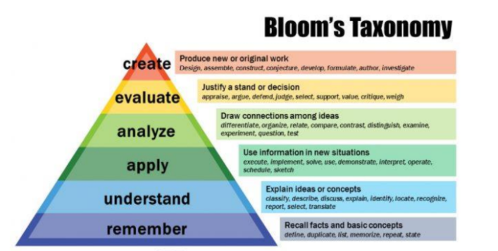

Questions Evaluate “Remember”

Can you define what money is in essence? [单选题] *

|  |
| --- |
| ○No |
| ○Yes, please explain _________________ |

Can you define what blockchain is [单选题] *

|  |
| --- |
| ○No |
| ○Yes, please explain _________________ |

Can you define how a smart contract is different from the traditional contract? [单选题] *

|  |
| --- |
| ○No |
| ○Yes, please explain _________________ |

Questions Evaluate “Understand”

Can you explain why we need money? [单选题] *

|  |
| --- |
| ○No |
| ○Yes, please explain _________________ |

Can you explain why blockchain is decentralized? [单选题] *

|  |
| --- |
| ○No |
| ○Yes, please explain _________________ |

Can you explain why centralized finance is costly? [单选题] *

|  |
| --- |
| ○No |
| ○Yes, please explain _________________ |

Questions Evaluate “Apply”

Can you elaborate why division of labor and trading matter in economics? [单选题] *

|  |
| --- |
| ○No |
| ○Yes, please explain _________________ |

Can you explain in one use case how a smart contract can be used for business? [单选题] *

|  |
| --- |
| ○No |
| ○Yes, please explain _________________ |

Can you explain why over-collateralization is required for the stability of stable coins? [单选题] *

|  |
| --- |
| ○No |
| ○Yes, please explain _________________ |

Questions Evaluate “Analyze”

Can you elaborate the advantages of commodity money and fiat money? [单选题] *

|  |
| --- |
| ○No |
| ○Yes, please explain _________________ |

Can you elaborate why smart contracts are transparent? [单选题] *

|  |
| --- |
| ○No |
| ○Yes, please explain _________________ |

Can you compare the traditional bank with banks on the blockchain? [单选题] *

|  |
| --- |
| ○No |
| ○Yes, please show _________________ |

Questions Evaluate “Evaluate”

Can you explain why Maker does not involve a middleman? [单选题] *

|  |
| --- |
| ○No |
| ○Yes, please explain |

Can you explain why the stability of the collateral is a challenge for Maker? [单选题] *

|  |
| --- |
| ○No |
| ○Yes, please explain _________________ |

Can you evaluate the pro & cons of a decentralized finance project/product? [单选题] *

|  |
| --- |
| ○No |
| ○Yes, please elaborate using a business case _________________ |

Questions Evaluate” Create”

Have you ever demonstrated your idea in a recorded video your insights for how blockchain or decentralized finance makes the impossible possible? [单选题] *

|  |
| --- |
| ○No |
| ○Yes, please upload the video or provide the link _________________ |

Video about blockchain [上传文件题]

Are you able to create a business model canvas for a decentralized finance project?  
  
  
(http://www.strategyzer.com/canvas)  
[单选题] *

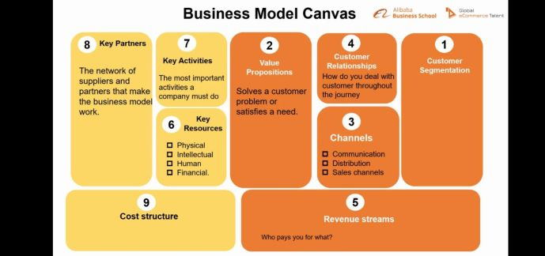

|  |
| --- |
| ○No |
| ○Yes, please upload the evidence _________________ |

Model cavas [上传文件题]

Have you ever demonstrate the pro & cons of a decentralized finance project in a recorded debate? [单选题] *

|  |
| --- |
| ○No |
| ○Yes, please upload the video or provide the link _________________ |

Video about decentralized finance project [上传文件题]

Have you ever demonstrate the limitations of an existing decentralized finance project and how you can improve upon it? [单选题] *

|  |
| --- |
| ○No |
| ○Yes, please provide evidence _________________ |

Limitations of an existing decentralized finance project [上传文件题]

Have you ever present a decentralized finance project in teamwork, experience peer-evalution, and have a final deliverable in slides and video? [单选题] *

|  |
| --- |
| ○No |
| ○Yes, please provide evidence |

Decentralized finance project [上传文件题]

Carry these questions with you for the next two weeks and take every opportunity to find an answer by immersing yourself in lectures, asking questions, conversing with others, researching, creating and reflecting.   
  
We believe you can bring the best out of yourself! The only limit for you, if any, is the unlimited sky!   
  
Crypto Economics, WOW, this is a brand new world. Welcome on board, future global leaders, you will reinvent the universe.

