Each tree is described phytomere by phytomere.

For each phytomere, the following information are recorded:

* length of internodes (IL),
* internode diameter (D),
* leaf length (LL),
* leaf width (LWi).

The diameter between nodes is the average of two perpendicular diameters. The leaf length is measured from the tip of the blade to the base of the blade and to the leaf corresponded to the maximum width of the sheet.

The internodes and the leaves are dried in an oven at 70 C for 72 hours. They are weighed (We) in an anhydrous bath state on a balance with an accuracy of 0.01 g. the Leaf area (LA) is determined using a plugin from Image J Software (Toaster).

The internode volume (V) is approximated considering it as a cylinder $V=Pi* IL* D^{2}/4$

**Example:**

The allometric relations should be in the form:

$$IWe=0.70* V$$

$$LWe=0.007 {\left(LL* LWi\right)}^{1.02}$$

Where $IWe$ is the internode fry mass and $LWe$ is the leaf dry mass.

The Linear regression model is calculated via excel. Using the Analysis ToolPak addon. On the data tab, there is a group called “Analysis”, you click on “Data analysis”

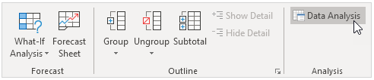

If the “Analysis” group is not present on the toolbar, you can activate it by going to “File > option > Add-ins”. Then, select Analysis ToolPak and click on the Go button.

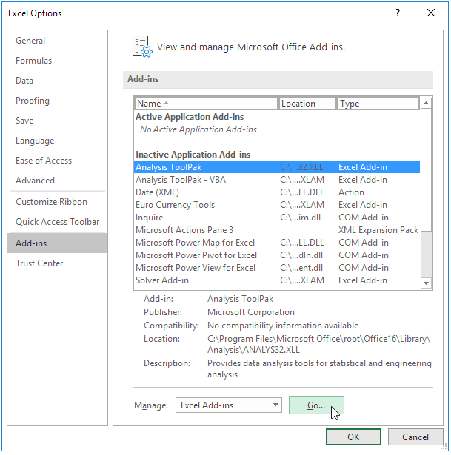

Check Analysis ToolPak and click on OK.

