Houston Volunteer Lawyers

1111 Bagby, Suite FLB 300

Houston, TX 77002

{{ client }}

{{ client.address.block() }}

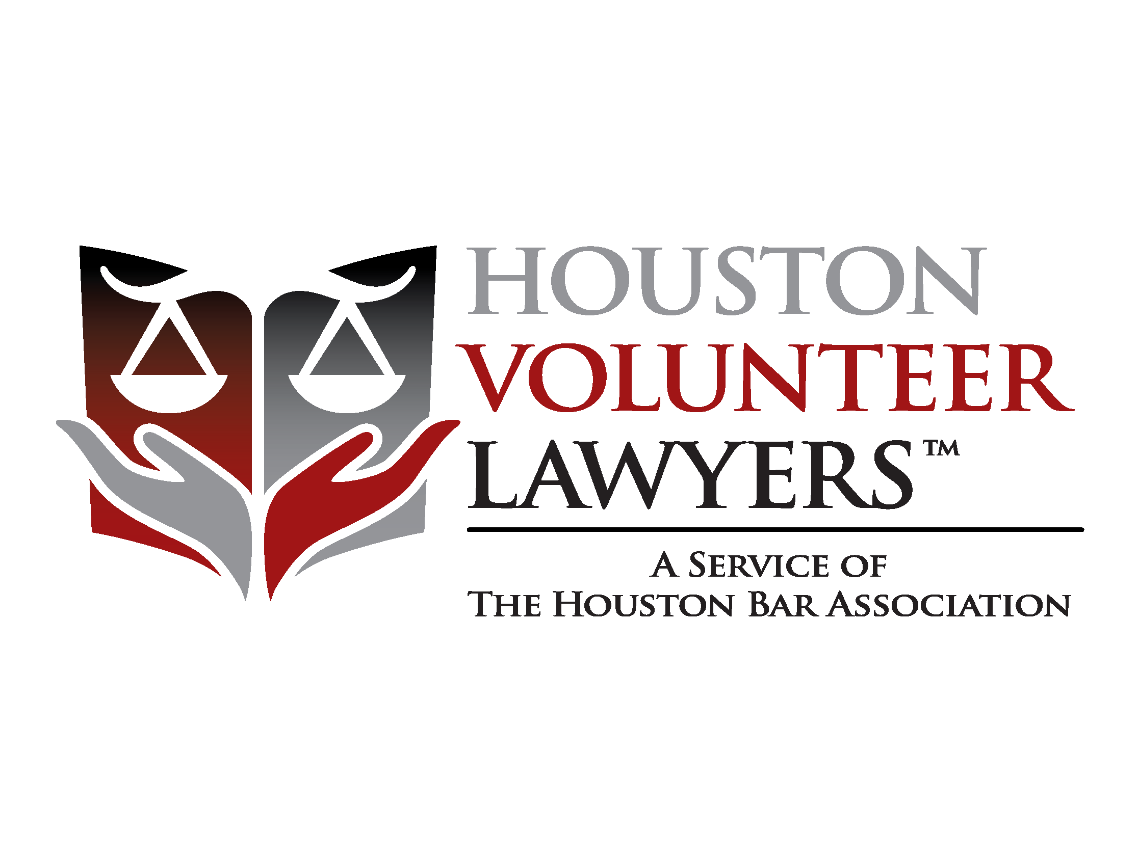

1111 Bagby, Suite FLB 300

Houston, TX 77002

Phone: (713) 228-0735

Fax: (713) 228-5826

www.makejusticehappen.org

{{ today() }}

{{ client }}

{{ client.address.block() }}

**RE: {{ casenumber }} : {{ LPC }}**

{{r single_to_double_newlines(value(clientmessage.text)) | paragraphs | markdown }}