Houston Volunteer Lawyers

1111 Bagby, Suite FLB 300

Houston, TX 77002

{{ pbadvocate }}

{{ pbadvocate.firm }}

{{ pbadvocate.address.block() }}

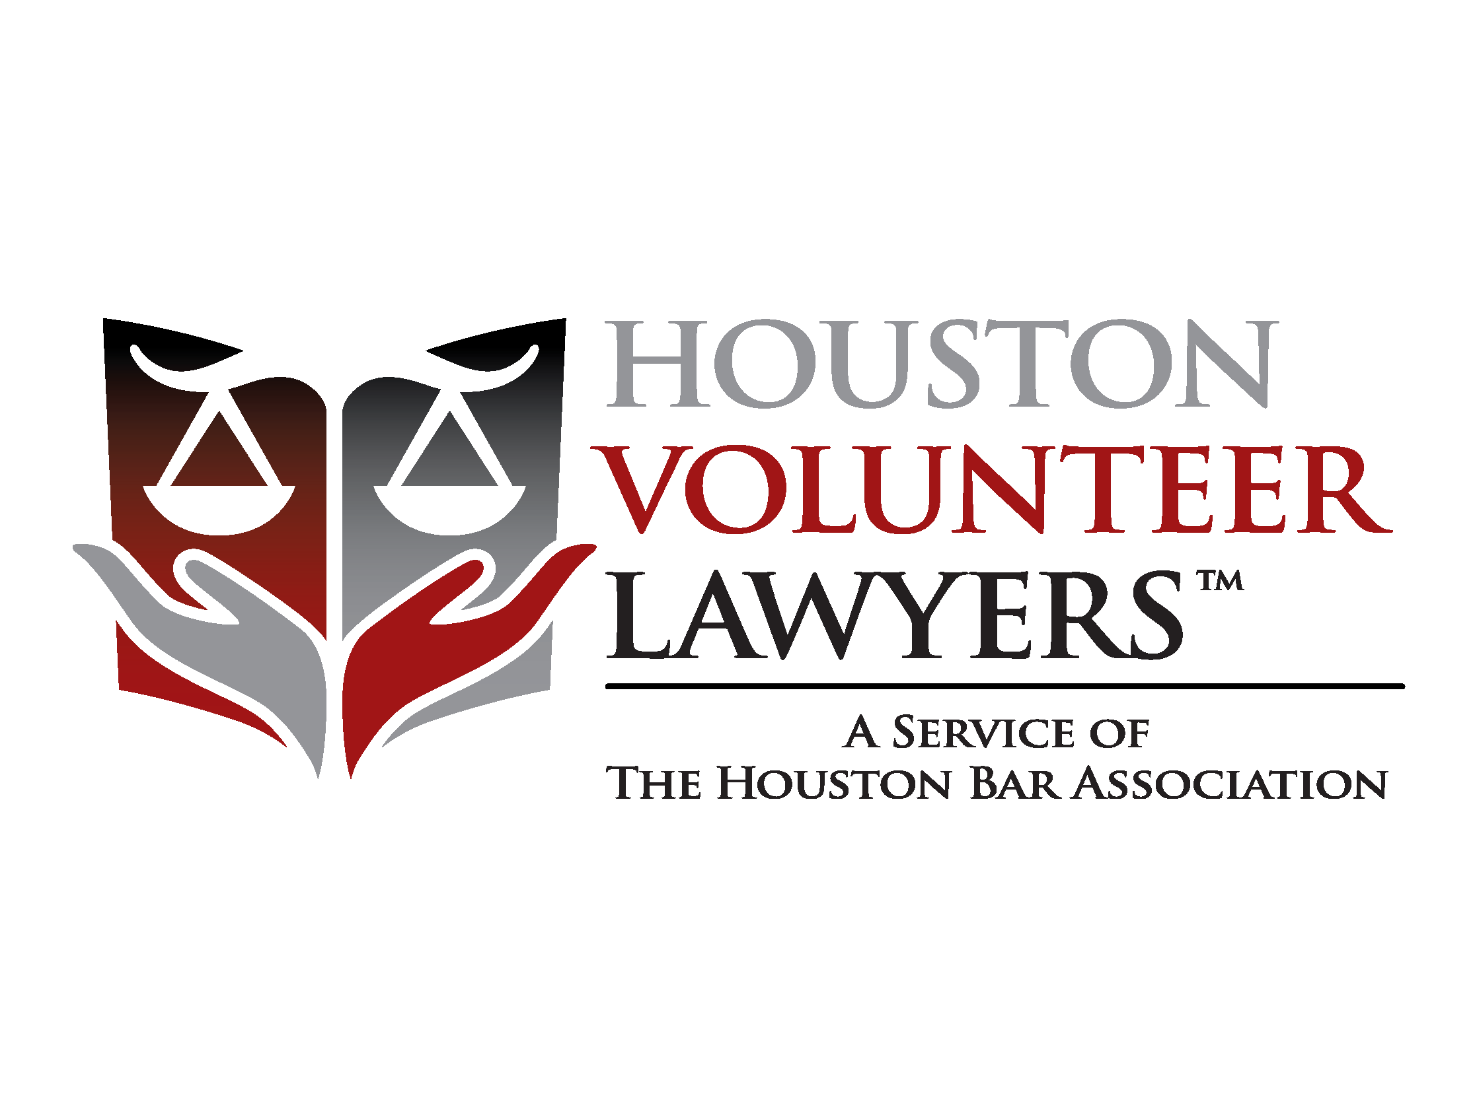

1111 Bagby, Suite FLB 300

Houston, TX 77002

Phone: (713) 228-0735

Fax: (713) 228-5826

www.makejusticehappen.org

{{ today() }}

{{ pbadvocate }}

{{ pbadvocate.firm }}

{{ pbadvocate.address.block() }}

**RE: {{ casenumber }} : {{ LPC }}**

**{{ client }}**

{{r single_to_double_newlines(value(clientmessage.text)) | markdown }}