

Hover Race
User’s Manual

©Copyright 1996 GrokkSoft inc.
Table of contents

Introduction
Game Modes
Practice
Split-Screen
Network (Using the Internet Meeting Room)
Network (Without the Internet Meeting Room)
Game elements
HoverCraft
Rockets
Arrows
Speed Ramps
Refuel zones
Display
Keyboard Layout
The Essentials
Hover Control
Second player controls
Camera Control
Some useful Hints

Introduction

Hover Race is an original multi-player racing game specially designed to be played over a network (including the Internet). The game also offers a practice mode and a split screen mode for those who wants to play off-line.

Your goal is to be the first to drive your turbine engine propelled hovercraft to the finish line. You will need all your dexterity to handle the power of this engine. Like in a steeplechase, you will have to leap over rivers and other obstacles. You will have also have to make some strategic choice because Hover Race tracks offers more than one optimal line.

Hover Race is not a traditional racing game. It offers a lot of interesting features like the bouncing rockets to put your opponents out-of-control or the speed ramps that will launch you as a pinball ball.

Game Modes

Practice

In the practice mode, you are the only racer on the track. This mode let you explore all the subtleties without having to deal with the harassment of the other players.

This mode can also be used to race against the clock; an option liked be perfectionist people.

To play a practice game simply select the Practice option in the Game menu. You will then be asked to select a track. Once you will have selected the track, the game will begin.

In the future version of the game, this mode will let you race against yourself. You will record one or more of your races and you will be able to replay these previous races while driving your own HoverCraft. You will even be allowed to interact with the other HoverCrafts.

Split-Screen

This mode let two players play against each other on a single computer. To play a split-screen game simply select the Split Screen option in the Game menu. You will then be asked to select a track. Once you will have selected the track, the game will begin.

Network (Using the Internet Meeting Room)

If you have access to the Internet you will find that it is very easy to play a multi-player HoverRace game. All you have to to is to select the menu option Game|Network|Internet Meeting Room. The following dialog will appear:
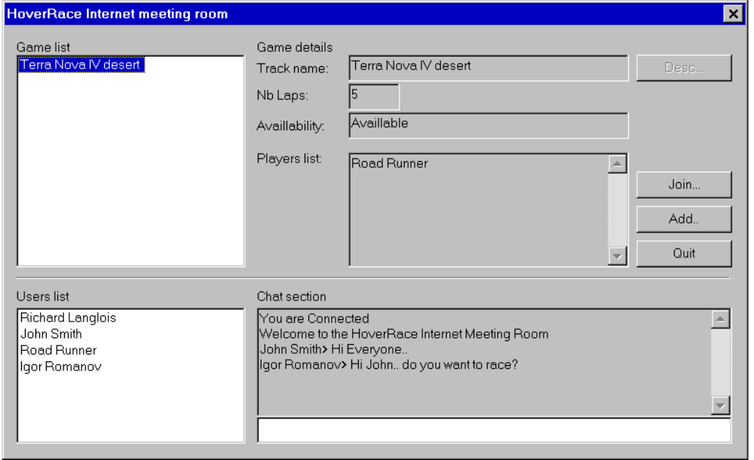
Game list:
List of the games that can be joined. Once a game is started, it is removed from that list.

Game Details:
Details about the selected game(from the Game list)

Join:
Join the selected game

Add:
Add a game to the list

Quit:
Leave the Internet Meeting Room

Users list:

Users that are currently connected

Chat section:

Section that allow you to talk to the other players

Network (Without the Internet Meeting Room)

The network mode allow up to 8 players to play together over a TCP/IP network(Internet or LAN). To play a network game, one of the players must initiate the communication process by selecting the Game|Network|Create a server menu option. The user will first be asked to select a track. It will then be asked to provide a player’s name a TCP port number. We strongly suggest you to not change the default port; modify the default setting only if you encounter some compatibility problems between applications. Just press OK and you will see a screen displaying other players when they will connect to the current session. Once all the other players are connected, you can press OK to begin the game. On the top of the screen you will see your IP address, this content of this field must be known by the other players, they need it to connect to your computer. Be aware this field may contain more than one IP address if your computers have more than one communication adapter. If it is the case, all the other player must connect to the same IP address or the game will not work correctly.

The other players must connect to the server by using the Game|Network|Connect to server menu option. Once they will have selected this option, they will be asked to provide a Player’s name, the IP address of the server and the port number of the server. The IP address of the server must be provided in its numeric format because text aliases are not allowed yet. If you did not change the default port on the server, you do not need to change it here.

A dedicated server that will allow an almost unlimited number of players is also scheduled.

Game elements

HoverCraft

This is you racing vehicle. Driving a HoverCraft in not complicated but it asks a lot of dexterity. The HoverCraft have almost no adherence. That mean that it will skid in all curves.

The first driving control is the steering control. This control let you modify the orientation of the HoverCraft. By changing its orientation the HoverCraft will not instantly change its course. Changing the orientation simply change the direction of the force that will be applied to the vehicle by the propulsion engine.

The second driving control is the turbine power control. This control only has two states, ON or OFF. Most of the time you will keep the turbine ON. You usually turn it off only if you get out of control or if you want to do a special move like a 360. It can also be useful to turn the turbine off if you are getting low in fuel.

The third and last driving command is the jump. The HoverCraft can jump if it is not already in the air. Jumping is usually used to avoid obstacles or to climb steps.

Rockets

Rockets can be launched by the HoverCrafts. Once it has been launched, the rocket will flight at high speed and bounce on the walls until it will hit an HoverCraft or until it will get out of fuel. If a HoverCraft is hit by a rocket, the driver will temporary lose the control of his vehicle.

Arrows

Arrows appear on walls and they indicate the direction you should go. They are tree color of arrows, the grays, the greens and the reds.

The grays are usually founded along straight lines. The greens and the reds are found in curves. Green arrows indicate you can safely bounce on that wall to negotiate a curve. Red arrows indicate that the wall is oriented in a way that will make you bounce in the bad direction if you hit it.



Speed Ramps

Speed ramps launched you at high speed. Once you have been launched you usually bounce on the walls like a pinball ball. You can still control your HoverCraft but because of the speed the control is very limited.

The most important thing to remember is that you are launched in the direction that the HoverCraft is facing. You must orient your HoverCraft before entering the speed zone or you will be launched in an undesired direction.
Speed Ramps are identified by the following pattern: 

Refuel zones

Refuel zones let you refill your energy source. When you enter a Refuel Zone, your fuel level slowly rises. These zones are identified by the following pattern:



Display

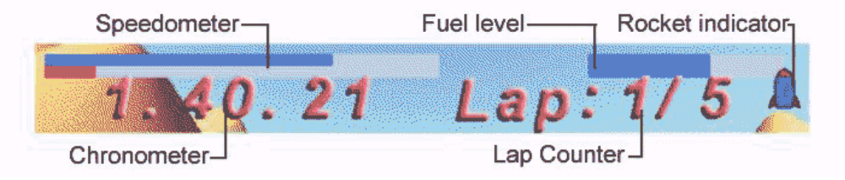

Keyboard Layout

The Essentials

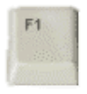 | F1 - Display on-line Help
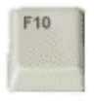 | F10 - Display the menu  Normally there is no menu displayed if you are playing in full screen mode. Use this command to display it.

Hover Control

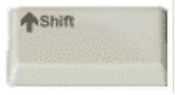 | Shift - Turbine Control  This is the gas pedal of the HoverCraft. If you get out of fuel, you can pump that key to move your hovercraft.
 | Left - Steer left  Rotates the HoverCraft on the left
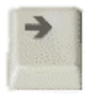 | Right - Steer right  Rotates the HoverCraft on the right
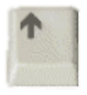 | Up - Jump  Makes the HoverCraft jump
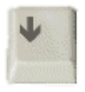 | Down - Break  Not a real break. It is only a shortcut that reorients the HoverCraft in the opposite direction of its absolute speed. If you turn the turbine ON you will break.
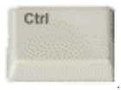 | Ctrl - Fire  Use this control to launch a rocket

Note: All these controls can be modified with the Setting|Properties menu option.

Second player controls

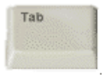 | Tab - Turbine Control  This is the gas pedal of the HoverCraft
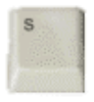 | S - Steer left  Rotates the HoverCraft on the left
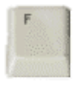 | F - Steer right  Rotates the HoverCraft on the right
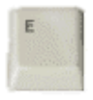 | E - Jump  Makes the HoverCraft jump
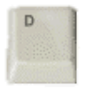 | D - Break  Not a real break. It is only a shortcut that reorients the HoverCraft in the opposite direction of its absolute speed. If you turn the turbine ON you will break.
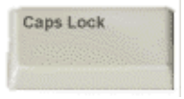 | Caps Lock - Fire  Use this control to launch a rocket
Note: All these controls can be modified with the Setting|Properties menu option.

Camera Control

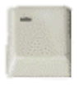 | Minus - Reduce viewing area  Reduce the viewing area and improve the refresh rate
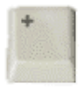 | Plus - Enlarge the viewing area
 | PgUp - Look up  Makes the camera look higher
 | PgDn - Look down  Makes the camera look lower
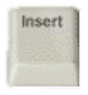 | Insert - Zoom-in  Reduce viewing angle
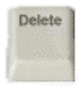 | Delete - Zoom-out  Enlarge viewing angle
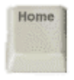 | Home - Restore camera position

Some useful Hints

Play in full screen mode

You will get a better feeling if you play in full screen mode. Use the Setting menu to switch in full screen mode. ALT+ENTER will bring you back in window mode.

Get a good refresh rate

A better refresh rate will improve your control over your HoverCraft. To get a better refresh rate you can reduce the window size, select a lower resolution mode or reduce the displaying area with the MINUS key

Always turn more that it seem needed

Because you always skid when you turn, you must greatly over-turn.

Turn the turbine off when you lose control

If you keep the turbine on you can enter a steady bouncing state. Simply release the turbine control if it append

Avoid side hollow

If you think that you are going to fall in a hollow, you just have to jump and try to regain the safe surface. Because the HoverCraft is propelled by a turbine, you can control it even if you are not touching the ground.

Launch rocket against your followers

You can use walls to launch rocket on hovercrafts that are following you. Simply launch a rocket on a wall in front of you, it will then bounce and with some lock it will hit the HoverCraft that is following you.

Refuel at strategic times

Do not wait until the last fuel drop to refuel. The pit-stop may be too crowded at that moment and you will loss your time.

Adjust camera setting in Split-Screen mode

Zoom-out, it will help a lot. You can also adjust the camera to look lower.

Use the “Chat” feature to talk to the other players (Network Mode only)

Just type your message and press Enter

