

**课 程 实 验 报 告**

**课程名称： 射频识别技术原理及应用**

**专业班级： 物联网1501**

**学 号： U201514888**

**姓 名： 陈艺欣**

**指导教师： 甘早斌**

**报告日期： 2018.5.22**

**计算机科学与技术学院**

**目 录**

1 实验一 低频读写器实验 3

1.1 实验目的 3

1.2 实验内容及结果 3

1.3 实验体会与总结 4

1.4 核心源码说明 5

2 实验二 高频读写器实验ISO14443A 9

2.1 实验目的 9

2.2 实验内容及结果 9

2.3 实验体会与总结 14

2.4 核心源码说明 15

3 实验三 高频读写器实验ISO15693 29

3.1 实验目的 29

3.2 实验内容及结果 29

3.3 实验体会与总结 32

3.4 核心源码说明 33

4 实验四 超高频读写器实验 53

4.1 实验目的 53

4.2 实验内容及结果 53

4.3 实验体会与总结 55

4.4 开发实例源码 55

1 实验一 低频读写器实验

1.1 实验目的

通过本次实验了解博创科技 RFID 读写器的结构组成，熟悉各个模块的功能，掌握试验箱的连接和操作方法。掌握串口命令参数的意义和设置方式。

了解低频读写器的基本原理，学会如何使用实训软件对低频读写器进行读卡操作（验证性实验）。

学习和掌握在低频读写器的编程操作，对标签进行读操作，了解低频读写器的工作机理，并完成一个示例程序。

1.2 实验内容及结果

1、完成低频读写器的标签读取试验；

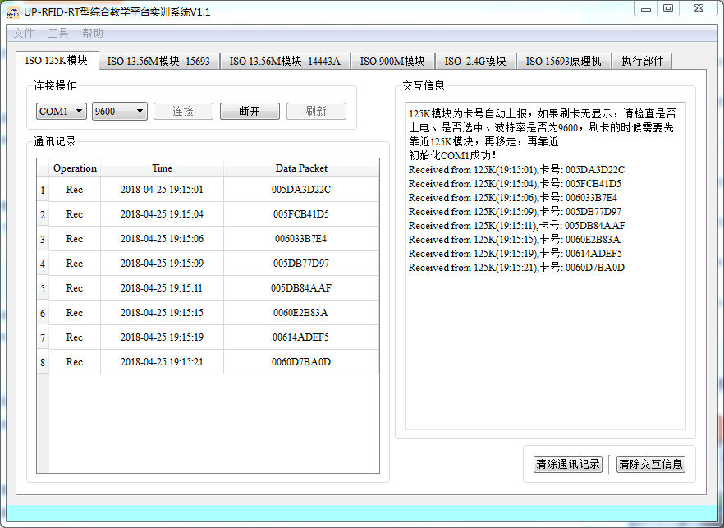

图 1 反复循环读取十张低频电子标签

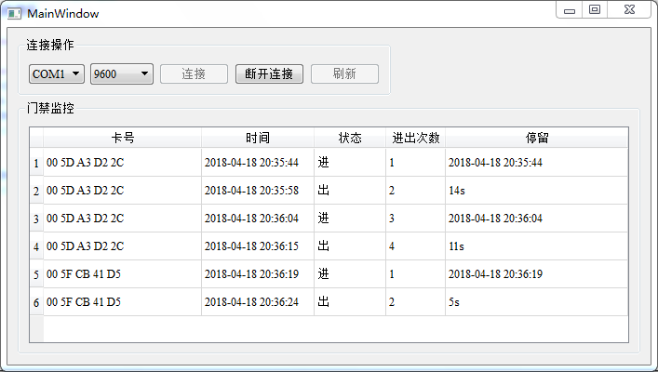

图 2 记录保存进出的历史记录、停留时间

1.3 实验体会与总结

思考题：

1. 通过试验箱，反复循环读取十张低频电子标签。在读取过程中可能会遇到哪些问题或发生哪些现象，并分析遇到的这些问题或现象的原因；

2、在利用低频读写器模拟门禁系统中，如何获取读写器发送过来的卡号？请写出相应的函数体（含注释），并说明函数的调用方法

|  |
| --- |
| */\*\**  *\* @brief MainWindow::readData*  *\* 读取串口数据*  *\*/*  void MainWindow::readData()  {  **if**(serialPort->bytesAvailable() < 5)  **return**;  QByteArray data = serialPort->readAll();  **if**(m125dll->LF125K_FrameAnalysis((uint8 *)(data.data())) == 0)  {  QString tagId = CharStringtoHexString(tr(" "),data.data(),data.length());  }  }  QByteArray data = serialPort->readAll();*//读取串口发来的数据*  *//Qt有自带的封装好的函数，可以直接调用，但是读取到的数据QByteArray型，要想转化成QString，还要经过进一步调用CharStringtoHexString的函数，能使卡号显示出来。* |

总结：

通过这次实验，我大概了解了低频读写器API函数的调用方法。

1.4 核心源码说明

|  |
| --- |
| #include "mainwindow.h"  #include "ui_mainwindow.h"  #include "recordtablemodel.h"  #include <QMessageBox>  #include <QDebug>  */\*\*\*\*\*\*\*\*\*\*\*\*\*\*\*\*\*\*\*\*\*\*\*\*\*\*\*\*\*\*\*\*\*\*\*\*\*\**  *\*作者: jianghj@up-tech.com*  *\*日期: 2016-09-30*  *\*描述: 125K演示程序主要代码,此处模拟的人员通道,进出需要刷卡,*  *\* 125K在实际应用中主要也是这个功能,比如小区的门禁卡.*  *\* 注意:人为主动刷卡,2.4G是被动刷卡*  *\*\*\*\*\*\*\*\*\*\*\*\*\*\*\*\*\*\*\*\*\*\*\*\*\*\*\*\*\*\*\*\*\*\*\*\*\*\*\*/*  MainWindow::MainWindow(QWidget *parent) :  QMainWindow(parent),  ui(**new** Ui::MainWindow)  {  ui->setupUi(**this**);  **this**->fillPortsParameters(ui->baudRateBox);*//波特率填充*  **this**->serialPort = **new** QSerialPort(**this**);  db = **new** Database(**this**);*//连接数据库*  model = **new** RecordTableModel(**this**);  ui->tableView->setModel(model);  ui->tableView->resizeColumnsToContents();  ui->tableView->horizontalHeader()->setStretchLastSection(true);  intValidator = **new** QIntValidator(0, 4000000,**this**);  ui->btn_connect->setEnabled(true);  ui->btn_refresh->setEnabled(true);  ui->btn_disconnect->setEnabled(false);  **this**->on_btn_refresh_clicked();  m125dll = **new** M125Dll();  *//关联相关槽函数*  connect(ui->baudRateBox, SIGNAL(currentIndexChanged(int)),**this**, SLOT(checkCustomBaudRatePolicy(int)));  connect(serialPort, SIGNAL(error(QSerialPort::SerialPortError)), **this**, SLOT(handleError(QSerialPort::SerialPortError)));*//收到串口错误信息*  connect(serialPort, SIGNAL(readyRead()), **this**, SLOT(readData()));*//收到串口信息*  }  MainWindow::~MainWindow()  {  model->submitAll();  **delete** model;  **delete** db;  **delete** m125dll;  **delete** intValidator;  **delete** serialPort;  **delete** ui;  }  *//Baudrate parameter init*  void MainWindow::fillPortsParameters(QComboBox *box)  {  box->clear();  box->addItem(QStringLiteral("9600"), QSerialPort::Baud9600);  box->addItem(QStringLiteral("19200"), QSerialPort::Baud19200);  box->addItem(QStringLiteral("38400"), QSerialPort::Baud38400);  box->addItem(QStringLiteral("57600"), QSerialPort::Baud57600);  box->addItem(QStringLiteral("115200"), QSerialPort::Baud115200);  box->addItem(tr("Custom"));  }  */\*\**  *\* @brief MainWindow::on_btn_connect_clicked*  *\* 连接串口*  *\*/*  void MainWindow::on_btn_connect_clicked()  {  QString name = ui->serialNameBox->currentText();  QString baud = ui->baudRateBox->currentText().trimmed();  **if**(baud.isEmpty())  {  QMessageBox::critical(**this**, tr("Error"), "波特率输入错误！");  **return** ;  }  serialPort->setPortName(name);  serialPort->setBaudRate(baud.toInt(),QSerialPort::AllDirections);  **if** (serialPort->open(QIODevice::ReadWrite)) {  ui->btn_connect->setEnabled(false);  ui->btn_disconnect->setEnabled(true);  ui->btn_refresh->setEnabled(false);  } **else** {  ui->btn_connect->setEnabled(true);  ui->btn_refresh->setEnabled(true);  ui->btn_disconnect->setEnabled(false);  QMessageBox::warning(**this**,tr("提示"),tr("初始化%1失败！请检查串口是否已经被占用？").arg(name),QMessageBox::Yes);  }  }  */\*\**  *\* @brief MainWindow::on_btn_disconnect_clicked*  *\* 断开连接*  *\*/*  void MainWindow::on_btn_disconnect_clicked()  {  **if**(!serialPort->isOpen())  **return** ;  serialPort->close();  ui->btn_connect->setEnabled(true);  ui->btn_refresh->setEnabled(true);  ui->btn_disconnect->setEnabled(false);  }  */\*\**  *\* @brief MainWindow::on_btn_refresh_clicked*  *\* 刷新按钮点击事件*  *\*/*  void MainWindow::on_btn_refresh_clicked()  {  QStringList list = getSerialName();  ui->serialNameBox->clear();  ui->serialNameBox->addItems(list);  }  */\*\**  *\* @brief MainWindow::checkCustomBaudRatePolicy*  *\* @param idx combox被选中的索引值*  *\* 设置自定义波特率*  *\*/*  void MainWindow::checkCustomBaudRatePolicy(int idx)  {  QComboBox *box = **dynamic_cast**<QComboBox*>(QObject::sender());  bool isCustomBaudRate = !box->itemData(idx).isValid();  box->setEditable(isCustomBaudRate);  **if** (isCustomBaudRate) {  box->clearEditText();  box->setValidator(intValidator);  }  }  */\*\**  *\* @brief MainWindow::readData*  *\* 读取串口数据*  *\*/*  void MainWindow::readData()  {  **if**(serialPort->bytesAvailable() < 5)  **return**;  QByteArray data = serialPort->readAll();  **if**(m125dll->LF125K_FrameAnalysis((uint8 *)(data.data())) == 0)  {  QString tagId = CharStringtoHexString(tr(" "),data.data(),data.length());*//获取标签ID*  QString time = CurrentDateTime();*//获取时间*  int index = model->findRecord(tagId);*//查询此标签记录*  **if**(index >= 0 )  {  QString text = model->record(index).value(2).toString();  **if**(text == tr("进"))  model->updateRecord(index,tagId,time,tr("出"));  **else**  model->updateRecord(index,tagId,time,tr("进"));  }  **else** {  model->addRecord(tagId,time,tr("进"));  }  }  }  */\*\**  *\* @brief MainWindow::handleError*  *\* @param error SerialPortError枚举类,详细请看SerialPortError的定义*  *\* 处理错误信息*  *\*/*  void MainWindow::handleError(QSerialPort::SerialPortError error)  {  **if** (error == QSerialPort::ResourceError) {  QMessageBox::critical(**this**, tr("Critical Error"), serialPort->errorString());  **this**->on_btn_disconnect_clicked();  }  } |

2 实验二 高频读写器实验ISO14443A

2.1 实验目的

通过本次实验了解高频读写器的基本原理，学会如何使用高频读写器，掌握 串口命令参数的意义和设置方式。

阅读和了解 ISO14443A 协议的主要内容，进一步加深对 S50 卡的存储结构和 ISO14443A 协议的理解，掌握 ISO14443A 协议的常用命令的含义和用法。

通过高频读写器的实验，掌握对 S50 卡各个扇区数据的读写方法，并熟悉高 频读写器（ISO14443A）API 函数。

2.2 实验内容及结果

1、完成 ISO14443A 协议下标签寻卡、唤醒、休眠实验；

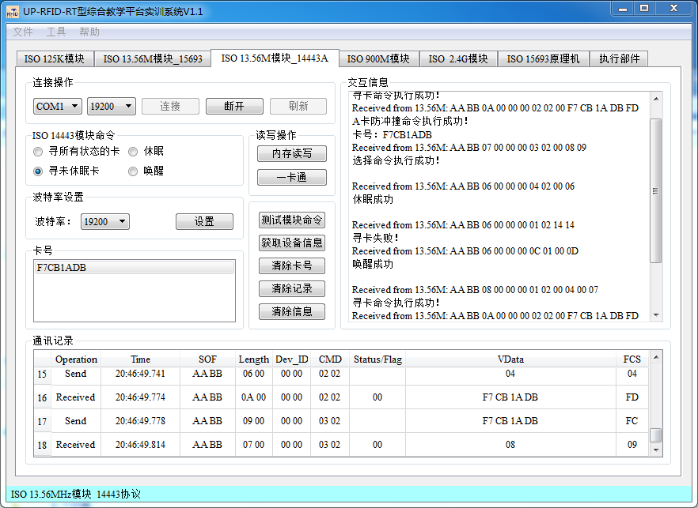

图 3 寻卡、唤醒、休眠

1. 完成 ISO14443A 协议下标签内存读写实验；

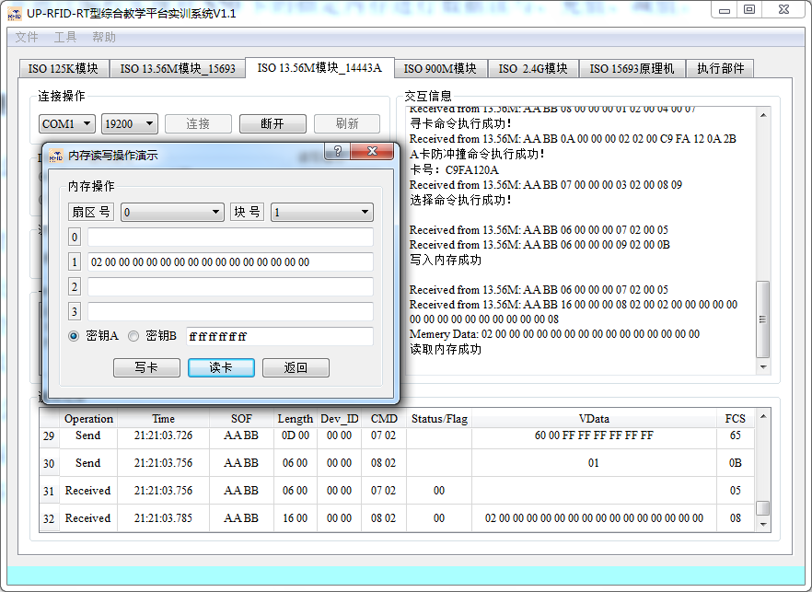

图 4 读卡实验

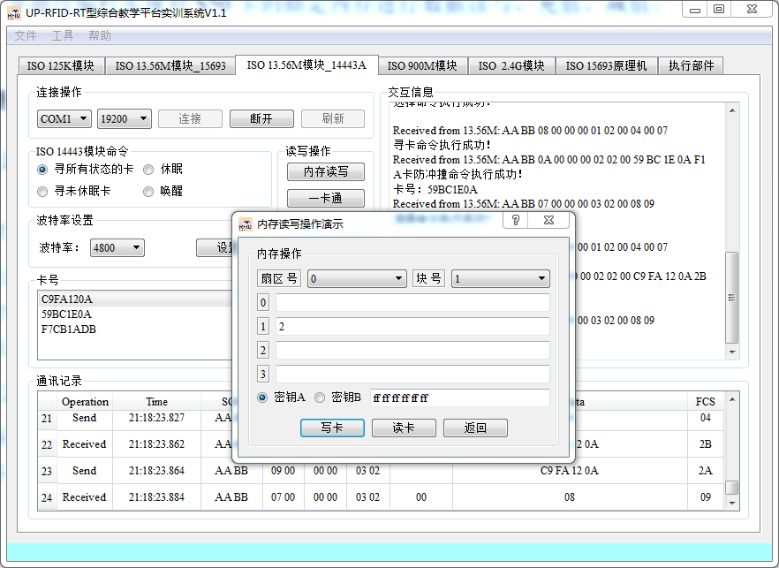

图 5 写卡实验

1. 完成 ISO14443A 协议下标签一卡通实验；

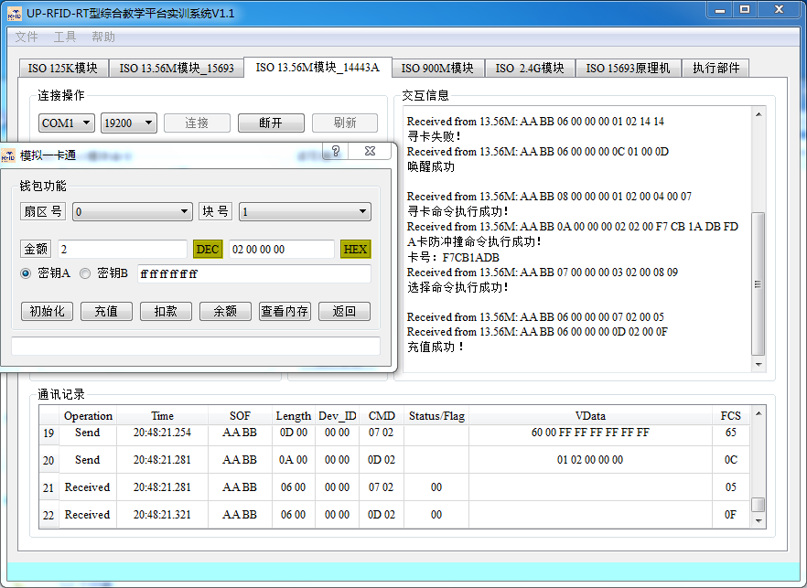

图 6 一卡通充值

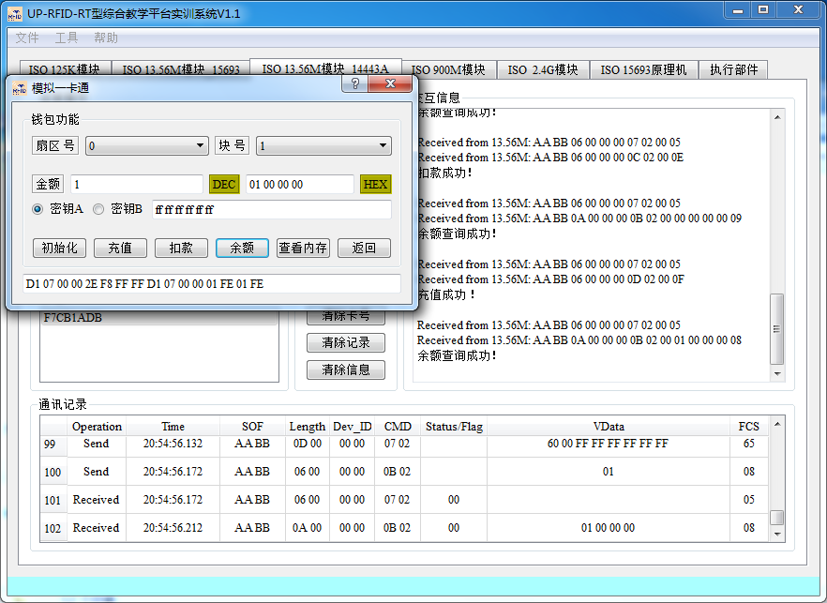

图 7 一卡通查询余额

4、 熟悉和了解高频 HF1356M 14443A 开发实例，掌握高频读写器（14443A） API 函数，并通过编程实现对 S50 卡的指定内存进行数据读写、充值、减值

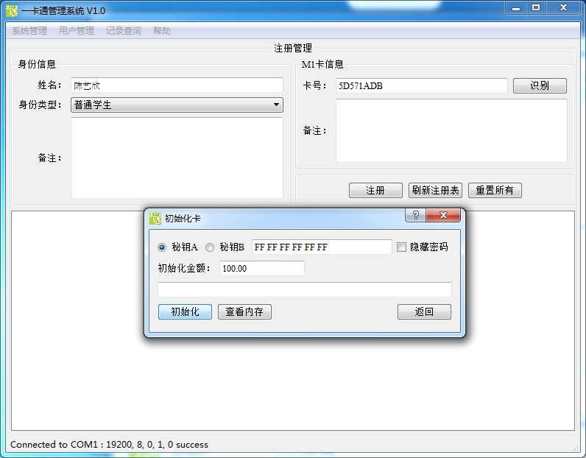

图 8 写卡

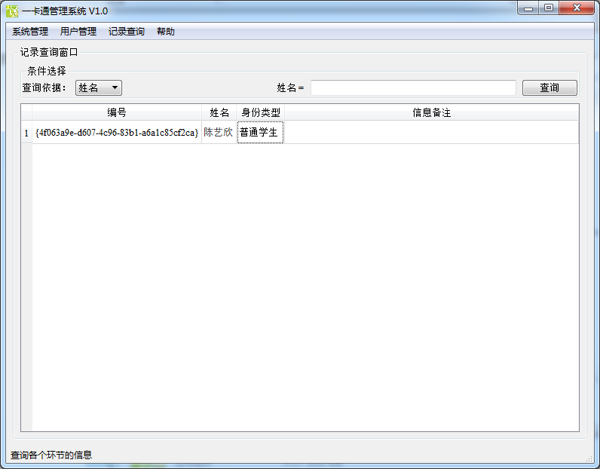

图 9 读卡

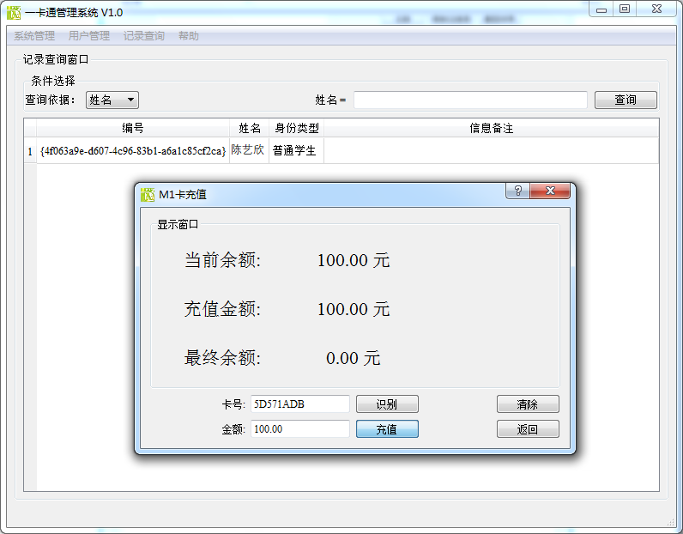

图 10 充值

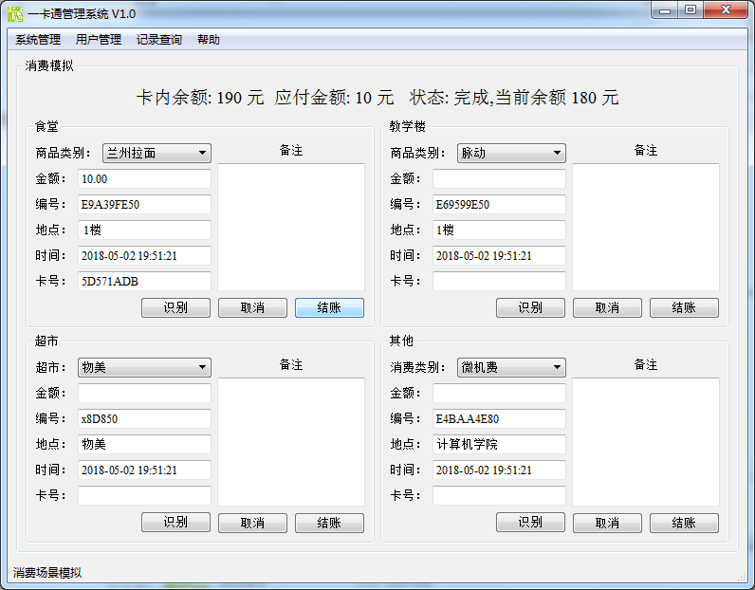

图 11减值

2.3 实验体会与总结

1、S50 卡共有 16个扇区，请问第4扇区的绝对块地址号是多少？请详细说明计算的方法和依据。

S50把1K字节的容量分为16个扇区(Sector0-Sector15)，每个扇区包括4个数据块(Block0-Block3，我们也将16个扇区的64个块按绝对地址编号为0~63)，每个数据块包含16个字节(Byte0-Byte15)，64*16=1024。所以，第4扇区绝对地址号是：3*4=12，为12。

2、S50 卡第 1 扇区第 0块是否可读写？为什么？

可以读写，因为只有第0扇区，第0块号为卡序列号，不能为只读的，其他的可以读写。

3、“S50 卡共有 16个扇区，每个扇区由 4 块组成，第 4 块为控制块，其余三块为数据块，都可用于存储数据”。这句话正确吗？如果不正确，请改正。

不正确，控制块也可以用于存储数据。

4、S50 卡的数据块用于存储数据时，可以有哪几种用途？

所有扇区都由3个块组成，每个块由16字节用于存储数据(扇区0只有两个数据块，一个只读的厂商数据块)。数据块可以设置为：读写块，例如用于非接触门禁管理，有效命令： read, write;数值块，例如用于电子钱包，允许执行电子钱包功能(有效的命令是:读、写增量、减量、恢复、转移)。数值块有一个固定的数据格式允许错误检测和校正和备份管理。

5、如何将一张空白的 S50 卡初始化成电子钱包？

可将卡放入读卡器，点击寻卡功能，找到该卡，执行读卡、写卡、初始化卡等功能，就能将卡初始化为电子钱包。

总结：通过这次的实验，加深了我们对于标签读写与控制的理解，也对老师在课堂上讲的只是有了更加深入的理解，只有实际动手去操作了才能感受到RFID的种种知识以及理念。理论与实践相结合，使得我们对于这门课有了更好的了解，对知识的把握也更加深刻了。

2.4 核心源码说明

|  |
| --- |
| 写卡 dialogccardconfig.cpp |
| #include "dialogcardconfig.h"  #include "ui_dialogcardconfig.h"  #include <QRegExp>  #include <QValidator>  #include <QDebug>  #include <QMessageBox>  */\*\*\*\*\*\*\*\*\*\*\*\*\*\*\*\*\*\*\*\*\*\*\*\*\*\*\*\*\*\*\*\*\*\*\*\*\*\**  *\*作者: jianghj@up-tech.com*  *\*日期: 2016-09-20*  *\*描述: 注册之后卡的配置对话框,主要用于初始化卡的存储格式,初始化金额*  *\*\*\*\*\*\*\*\*\*\*\*\*\*\*\*\*\*\*\*\*\*\*\*\*\*\*\*\*\*\*\*\*\*\*\*\*\*\*\*/*  DialogCardConfig::DialogCardConfig(QWidget *parent, SerialPortThread *serialPortThread) :  QDialog(parent),  ui(**new** Ui::DialogCardConfig)  {  currentOps = -1 ;  ui->setupUi(**this**);  m1356dll = **new** M1356Dll();  **this**->serialPortThread = serialPortThread;  connect(serialPortThread,SIGNAL(receivedMsg(QByteArray)),**this**,SLOT(onDecodeFrame(QByteArray)));*//收到信息*  QRegExp rx("^[0-9a-fA-F]{17}");  QValidator* validator = **new** QRegExpValidator(rx, **this**);  ui->lineEdit_Pwd->setValidator(validator);  ui->lineEdit_Pwd->setInputMask(tr("HH HH HH HH HH HH"));  rx.setPattern("^[1-9]{1,3}**\\**.[0-9]{1,2}");  validator = **new** QRegExpValidator(rx, **this**);  ui->initValue->setValidator(validator);  ui->initValue->installEventFilter(**this**);  ui->radioButtonA->setChecked(true);  ui->lineEdit_Pwd->setText(tr("FFFFFFFFFFFF"));  }  DialogCardConfig::~DialogCardConfig()  {  **this**->disconnect(serialPortThread);  **delete** ui;  }  */\*\**  *\* @brief DialogCardConfig::on_lineEdit_Pwd_cursorPositionChanged*  *\* @param arg1 原位置*  *\* @param arg2 新位置*  *\* 密码输入框光标位置发生改变时调用*  *\*/*  void DialogCardConfig::on_lineEdit_Pwd_cursorPositionChanged(int arg1, int arg2)  {  **if**(arg1 > arg2)  **return**;  int len = ui->lineEdit_Pwd->text().length();  int tem = 5 - (len - 5)/2;  int cursorPositon = len - tem;  **if**(arg2 > cursorPositon)  ui->lineEdit_Pwd->setCursorPosition(cursorPositon);  }  */\*\**  *\* @brief DialogCardConfig::on_checkBox_clicked*  *\* @param checked 如果选中为true,否则为false*  *\* 显示密钥复选框点击事件*  *\*/*  void DialogCardConfig::on_checkBox_clicked(bool checked)  {  **if**(checked)  ui->lineEdit_Pwd->setEchoMode(QLineEdit::Password);  **else**  ui->lineEdit_Pwd->setEchoMode(QLineEdit::Normal);  }  */\*\**  *\* @brief DialogCardConfig::eventFilter*  *\* @param obj 产生事件的对象*  *\* @param event Qt事件*  *\* @return bool型值,表明此事件是否处理了*  *\* 事件过滤器*  *\*/*  bool DialogCardConfig::eventFilter(QObject *obj, QEvent *event)  {  **if**(obj == ui->initValue)  {  **if**(event->type() == QEvent::FocusOut)  {  QString value = ui->initValue->text();  **if**(value.length() == 0)  ui->initValue->setText(tr("1.00"));  **else** if(value.endsWith('.'))  ui->initValue->setText(value + tr("00"));  **else** if(!value.contains('.'))  ui->initValue->setText(value + tr(".00"));  **else** if(value.right(value.length() - value.indexOf('.')).length() == 2)  ui->initValue->setText(value + tr("0"));  }  }  **return** QDialog::eventFilter(obj,event);  }  */\*\**  *\* @brief DialogCardConfig::onDecodeFrame*  *\* @param frame 14443的响应帧*  *\* 串口接收槽函数*  *\*/*  void DialogCardConfig::onDecodeFrame(QByteArray bytes)  {  M1356_RspFrame_t frame = m1356dll->M1356_RspFrameConstructor(bytes);  qDebug() <<"data: " << frame.vdata << frame.cmd << frame.sof;  **if**(frame.cmd.remove(" ") == "0702" && frame.status == "00")*//授权成功*  {  **switch** (currentOps) {  **case** 0: *//init*  {  uint16 frameLen;  quint8 buffer[5];  uint8 *p;  QString str = ui->initValue->text();  buffer[0] = 0x9;*//绝对块号,这样的最好定义成宏,方便修改*  memset(buffer+1, 0, 5);  float test = str.toFloat();  memcpy(buffer + 1,&test,4);  p = m1356dll->RC632_SendCmdReq(RC632_CMD_M1INITVAL,buffer,5);  frameLen = BUILD_UINT16(p[0], p[1]);  serialPortThread->writeData((char *)(p + 2 ),frameLen);  currentOps = -1;  }  **break**;  **case** 1: *//mem*  {  uint16 frameLen;  quint8 buffer[1];  uint8 *p;  buffer[0] = 0x9;  p = m1356dll->RC632_SendCmdReq(RC632_CMD_M1READ,buffer,1);  frameLen = BUILD_UINT16(p[0], p[1]);  serialPortThread->writeData((char *)(p + 2 ),frameLen);  currentOps = -1;  }  **break**;  **default**:  **break**;  }  }  **else** **if**(frame.cmd.remove(" ") == "0802")  {  ui->lineEditMemData->setText(frame.vdata);  }  }  */\*\**  *\* @brief DialogCardConfig::on_btn_Init_clicked*  *\* 初始化按钮点击事件*  *\*/*  void DialogCardConfig::on_btn_Init_clicked()  {  **if**(!serialPortThread->serialPortIsOpen())  {  QMessageBox::warning(**this**,tr("温馨提示"),tr("请先连接读卡器后再试！"),QMessageBox::Yes);  **return**;  }  **if**(ui->lineEdit_Pwd->text().length() != 17)  {  QMessageBox::warning(**this**, "Error", tr("请在密钥区输入6个字节密钥！"));  **return**;  }  **this**->authentication();  currentOps = 0 ;  }  */\*\**  *\* @brief DialogCardConfig::on_btn_MemData_clicked*  *\* 查看内存数据*  *\*/*  void DialogCardConfig::on_btn_MemData_clicked()  {  **if**(!serialPortThread->serialPortIsOpen())  {  QMessageBox::warning(**this**,tr("温馨提示"),tr("请先连接读卡器后再试！"),QMessageBox::Yes);  **return**;  }  **if**(ui->lineEdit_Pwd->text().length() != 17)  {  QMessageBox::warning(**this**, "Error", tr("请在密钥区输入6个字节密钥！"));  **return**;  }  **this**->authentication();  currentOps = 1;  }  */\*\**  *\* @brief DialogCardConfig::authentication*  *\* 授权*  *\*/*  void DialogCardConfig::authentication()  {  uint16 frameLen;  quint8 buffer[8];  uint8 *p;  **if**(ui->radioButtonA->isChecked())  buffer[0] = 0x60; *// A密钥*  **else**  buffer[0] = 0x61; *// B 密钥*  buffer[1] = 0x09; *// 绝对块号*  QString str = ui->lineEdit_Pwd->text().remove(" "); *//六字节*  QSTRING_TO_HEX(str, (uint8*)(buffer+2),6);  p = m1356dll->RC632_SendCmdReq(RC632_CMD_AUTHENTICATION,buffer,8);*//获取卡密码*  frameLen = BUILD_UINT16(p[0], p[1]);  serialPortThread->writeData((char *)(p + 2 ),frameLen);*//写卡*  }  */\*\**  *\* @brief DialogCardConfig::on_btn_Return_clicked*  *\* 返回按钮点击事件*  *\*/*  void DialogCardConfig::on_btn_Return_clicked()  {  **this**->close();  } |
|  |
| 读卡 |
| #include "settingsdialog.h"  #include "ui_settingsdialog.h"  #include <QtSerialPort/QSerialPortInfo>  #include <QIntValidator>  #include <QLineEdit>  QT_USE_NAMESPACE  */\*\**  *\* @brief blankString*  *\* 默认填充,也就是说串口属性信息不存在时显示"N/A"*  *\*/*  **static** **const** char blankString[] = QT_TRANSLATE_NOOP("SettingsDialog", "N/A");  */\*\*\*\*\*\*\*\*\*\*\*\*\*\*\*\*\*\*\*\*\*\*\*\*\*\*\*\*\*\*\*\*\*\*\*\*\*\**  *\*作者: jianghj@up-tech.com*  *\*日期: 2016-09-20*  *\*描述: 串口连接对话框,通过此页面可以对串口进行详细的配置*  *\*\*\*\*\*\*\*\*\*\*\*\*\*\*\*\*\*\*\*\*\*\*\*\*\*\*\*\*\*\*\*\*\*\*\*\*\*\*\*/*  SettingsDialog::SettingsDialog(QWidget *parent) :  QDialog(parent),  ui(**new** Ui::SettingsDialog)  {  ui->setupUi(**this**);  intValidator = **new** QIntValidator(0, 4000000, **this**);  ui->baudRateBox->setInsertPolicy(QComboBox::NoInsert);  connect(ui->btn_Apply, SIGNAL(clicked()), **this**, SLOT(apply()));  connect(ui->serialPortInfoListBox, SIGNAL(currentIndexChanged(int)), **this**, SLOT(showPortInfo(int)));  connect(ui->baudRateBox, SIGNAL(currentIndexChanged(int)), **this**, SLOT(checkCustomBaudRatePolicy(int)));  connect(ui->serialPortInfoListBox, SIGNAL(currentIndexChanged(int)), **this**, SLOT(checkCustomDevicePathPolicy(int)));  fillPortsParameters();  fillPortsInfo();  updateSettings();  }  SettingsDialog::~SettingsDialog()  {  **delete** ui;  }  */\*\**  *\* @brief SettingsDialog::settings*  *\* @return 串口配置信息*  *\* 作为一个常量返回当前串口配置*  *\*/*  SettingsDialog::Settings SettingsDialog::settings() **const**  {  **return** currentSettings;  }  */\*\**  *\* @brief SettingsDialog::showPortInfo*  *\* @param idx 选中的串口名的索引值*  *\* 显示串口相关的详细信息*  *\*/*  void SettingsDialog::showPortInfo(int idx)  {  **if** (idx == -1)  **return**;  QStringList list = ui->serialPortInfoListBox->itemData(idx).toStringList();*//获取信息列表*  ui->descriptionLabel->setText(tr("描述: %1").arg(list.count() > 1 ? list.at(1): tr(blankString)));  ui->manufacturerLabel->setText(tr("制造商: %1").arg(list.count() > 2 ? list.at(2) : tr(blankString)));  ui->serialNumberLabel->setText(tr("序列号: %1").arg(list.count() > 3 ? list.at(3) : tr(blankString)));  ui->locationLabel->setText(tr("位置: %1").arg(list.count() > 4 ? list.at(4) : tr(blankString)));  ui->vidLabel->setText(tr("厂商标识: %1").arg(list.count() > 5 ? list.at(5) : tr(blankString)));  ui->pidLabel->setText(tr("产品ID: %1").arg(list.count() > 6 ? list.at(6) : tr(blankString)));  }  */\*\**  *\* @brief SettingsDialog::apply*  *\* 应用按钮点击事件*  *\*/*  void SettingsDialog::apply()  {  updateSettings();  hide();  emit applySettings();  }  */\*\**  *\* @brief SettingsDialog::checkCustomBaudRatePolicy*  *\* @param idx 索引值*  *\* 监控是否选择了custom项(波特率)*  *\*/*  void SettingsDialog::checkCustomBaudRatePolicy(int idx)  {  bool isCustomBaudRate = !ui->baudRateBox->itemData(idx).isValid();  ui->baudRateBox->setEditable(isCustomBaudRate);  **if** (isCustomBaudRate) {  ui->baudRateBox->clearEditText();  QLineEdit *edit = ui->baudRateBox->lineEdit();  edit->setValidator(intValidator);  }  }  */\*\**  *\* @brief SettingsDialog::checkCustomDevicePathPolicy*  *\* @param idx 索引值*  *\* 监控是否选择了custom项(串口名)*  *\*/*  void SettingsDialog::checkCustomDevicePathPolicy(int idx)  {  bool isCustomPath = !ui->serialPortInfoListBox->itemData(idx).isValid();  ui->serialPortInfoListBox->setEditable(isCustomPath);  **if** (isCustomPath)  ui->serialPortInfoListBox->clearEditText();  }  */\*\**  *\* @brief SettingsDialog::fillPortsParameters*  *\* 串口参数信息*  *\*/*  void SettingsDialog::fillPortsParameters()  {  ui->baudRateBox->addItem(QStringLiteral("9600"), QSerialPort::Baud9600);  ui->baudRateBox->addItem(QStringLiteral("19200"), QSerialPort::Baud19200);  ui->baudRateBox->addItem(QStringLiteral("38400"), QSerialPort::Baud38400);  ui->baudRateBox->addItem(QStringLiteral("115200"), QSerialPort::Baud115200);  ui->baudRateBox->addItem(tr("Custom"));  ui->baudRateBox->setCurrentIndex(1);  ui->dataBitsBox->addItem(QStringLiteral("5"), QSerialPort::Data5);  ui->dataBitsBox->addItem(QStringLiteral("6"), QSerialPort::Data6);  ui->dataBitsBox->addItem(QStringLiteral("7"), QSerialPort::Data7);  ui->dataBitsBox->addItem(QStringLiteral("8"), QSerialPort::Data8);  ui->dataBitsBox->setCurrentIndex(3);  ui->parityBox->addItem(tr("None"), QSerialPort::NoParity);  ui->parityBox->addItem(tr("Even"), QSerialPort::EvenParity);  ui->parityBox->addItem(tr("Odd"), QSerialPort::OddParity);  ui->parityBox->addItem(tr("Mark"), QSerialPort::MarkParity);  ui->parityBox->addItem(tr("Space"), QSerialPort::SpaceParity);  ui->stopBitsBox->addItem(QStringLiteral("1"), QSerialPort::OneStop);  #ifdef Q_OS_WIN  ui->stopBitsBox->addItem(tr("1.5"), QSerialPort::OneAndHalfStop);  #endif  ui->stopBitsBox->addItem(QStringLiteral("2"), QSerialPort::TwoStop);  ui->flowControlBox->addItem(tr("None"), QSerialPort::NoFlowControl);  ui->flowControlBox->addItem(tr("RTS/CTS"), QSerialPort::HardwareControl);  ui->flowControlBox->addItem(tr("XON/XOFF"), QSerialPort::SoftwareControl);  }  */\*\**  *\* @brief SettingsDialog::fillPortsInfo*  *\* 填充串口描述信息*  *\*/*  void SettingsDialog::fillPortsInfo()  {  ui->serialPortInfoListBox->clear();  QString description;  QString manufacturer;  QString serialNumber;  foreach (**const** QSerialPortInfo &info, QSerialPortInfo::availablePorts()) {  QStringList list;  description = info.description();  manufacturer = info.manufacturer();  serialNumber = info.serialNumber();  list << info.portName()  << (!description.isEmpty() ? description : blankString)  << (!manufacturer.isEmpty() ? manufacturer : blankString)  << (!serialNumber.isEmpty() ? serialNumber : blankString)  << info.systemLocation()  << (info.vendorIdentifier() ? QString::number(info.vendorIdentifier(), 16) : blankString)  << (info.productIdentifier() ? QString::number(info.productIdentifier(), 16) : blankString);  ui->serialPortInfoListBox->addItem(list.first(), list);  }  ui->serialPortInfoListBox->addItem(tr("Custom"));  }  */\*\**  *\* @brief SettingsDialog::updateSettings*  *\* 更新串口配置*  *\*/*  void SettingsDialog::updateSettings()  {  currentSettings.name = ui->serialPortInfoListBox->currentText();  **if** (ui->baudRateBox->currentIndex() == 4) {  currentSettings.baudRate = ui->baudRateBox->currentText().toInt();  } **else** {  currentSettings.baudRate = **static_cast**<QSerialPort::BaudRate>(  ui->baudRateBox->itemData(ui->baudRateBox->currentIndex()).toInt());  }  currentSettings.stringBaudRate = QString::number(currentSettings.baudRate);  currentSettings.dataBits = **static_cast**<QSerialPort::DataBits>(  ui->dataBitsBox->itemData(ui->dataBitsBox->currentIndex()).toInt());  currentSettings.stringDataBits = ui->dataBitsBox->currentText();  currentSettings.parity = **static_cast**<QSerialPort::Parity>(  ui->parityBox->itemData(ui->parityBox->currentIndex()).toInt());  currentSettings.stringParity = ui->parityBox->currentText();  currentSettings.stopBits = **static_cast**<QSerialPort::StopBits>(  ui->stopBitsBox->itemData(ui->stopBitsBox->currentIndex()).toInt());  currentSettings.stringStopBits = ui->stopBitsBox->currentText();  currentSettings.flowControl = **static_cast**<QSerialPort::FlowControl>(  ui->flowControlBox->itemData(ui->flowControlBox->currentIndex()).toInt());  currentSettings.stringFlowControl = ui->flowControlBox->currentText();  }  */\*\**  *\* @brief SettingsDialog::on_btn_Refresh_clicked*  *\* 刷新按钮点击事件*  *\*/*  void SettingsDialog::on_btn_Refresh_clicked()  {  **this**->fillPortsInfo();  } |
|  |
| 充值 rechargedialog.cpp |
| #include "rechargedialog.h"  #include "ui_rechargedialog.h"  #include "database/dbmanager.h"  #include <QRegExp>  #include <QRegExpValidator>  */\*\*\*\*\*\*\*\*\*\*\*\*\*\*\*\*\*\*\*\*\*\*\*\*\*\*\*\*\*\*\*\*\*\*\*\*\*\**  *\*作者: jianghj@up-tech.com*  *\*日期: 2016-09-20*  *\*描述: 充值对话框,本对话框需要检测管理员是否登陆*  *\*\*\*\*\*\*\*\*\*\*\*\*\*\*\*\*\*\*\*\*\*\*\*\*\*\*\*\*\*\*\*\*\*\*\*\*\*\*\*/*  RechargeDialog::RechargeDialog(QWidget *parent,SerialPortThread *serialPortThread) :  QDialog(parent),  ui(**new** Ui::RechargeDialog)  {  ui->setupUi(**this**);  currentOps = -1;  last_value = 0.0;  **this**->serialPortThread = serialPortThread;  connect( **this**->serialPortThread,SIGNAL(receivedMsg(QByteArray)),**this**,SLOT(onDecodeFrame(QByteArray)));*//连接收到信息槽与信号*  m1356dll = **new** M1356Dll();  messageBox = **new** QMessageBox(**this**);  messageBox->setStandardButtons(QMessageBox::Yes);  messageBox->setWindowTitle(tr("温馨提示"));  messageBox->setIcon(QMessageBox::Warning);  connect(**this**,SIGNAL(calcOps(float)),**this**,SLOT(on_readValue(float)));*//连接槽与信号*  QRegExp rx("^[1-9]{1,3}**\\**.[0-9]{1,2}");  QRegExpValidator *validator = **new** QRegExpValidator(rx, **this**);  ui->lineEdit_money->setValidator(validator);  ui->lineEdit_money->installEventFilter(**this**);  }  RechargeDialog::~RechargeDialog()  {  **delete** m1356dll;  **delete** messageBox;  **delete** ui;  }  */\*\**  *\* @brief RechargeDialog::on_btn_recharge_clicked*  *\* 充值按钮点击事件*  *\*/*  void RechargeDialog::on_btn_recharge_clicked()  {  QString cardId = ui->lineEdit_cardId->text();  **if**(cardId.count() <= 2)  {  ui->labelMessage->setText(tr("好像没看见卡号,请先读取卡号!"));  **return**;  }  QString recharge = ui->lineEdit_money->text();  float money = recharge.toFloat();  QString currentValue = ui->label_currentValue->text().split(tr(" ")).at(0);  **if**(money == 0.0)  {  ui->labelMessage->setText(tr("请填写充值金额!"));  **return**;  }  ui->label_chargeValue->setText(recharge + tr(" 元"));  last_value = money + currentValue.toFloat();  **if**(last_value >= 999.99)  {  ui->labelMessage->setText(tr("如果充值,您卡内余额超限,为了您的财产安全,请先消费后再充"));  **return**;  }  **this**->authentication();  currentOps = 20;  }  */\*\**  *\* @brief RechargeDialog::eventFilter*  *\* @param obj 触发的对象*  *\* @param event 当前的事件*  *\* @return 此处只在RechargeDialog前面过滤,返回值含义未变*  *\* 事件过滤器*  *\*/*  bool RechargeDialog::eventFilter(QObject *obj, QEvent *event)  {  **if**(obj == ui->lineEdit_money)  {  **if**(event->type() == QEvent::FocusOut)  {  QString value = ((QLineEdit *)obj)->text();  **if**(value.length() == 0)  ((QLineEdit *)obj)->setText(tr("0.00"));  **else** if(value.endsWith('.'))  ((QLineEdit *)obj)->setText(value + tr("00"));  **else** if(!value.contains('.'))  ((QLineEdit *)obj)->setText(value + tr(".00"));  **else** if(value.right(value.length() - value.indexOf('.')).length() == 2)  ((QLineEdit *)obj)->setText(value + tr("0"));  }  }  **return** QDialog::eventFilter(obj,event);  }  */\*\**  *\* @brief RechargeDialog::on_btn_return_clicked*  *\* 返回按钮点击事件*  *\*/*  void RechargeDialog::on_btn_return_clicked()  {  **this**->close();  }  */\*\**  *\* @brief RechargeDialog::authentication*  *\* 授权操作*  *\*/*  void RechargeDialog::authentication()  {  uint16 frameLen;  quint8 buffer[8];  uint8 *p;  buffer[0] = 0x60; *// A密钥*  buffer[1] = 0x09; *// 绝对块号*  **for**(int i = 2 ; i < 8 ; i ++)  buffer[i] = 0xFF;  p = m1356dll->RC632_SendCmdReq(RC632_CMD_AUTHENTICATION,buffer,8);*//连接串口*  frameLen = BUILD_UINT16(p[0], p[1]);  serialPortThread->writeData((char *)(p + 2 ),frameLen);*//写数据*  }  */\*\**  *\* @brief RechargeDialog::on_btn_clear_clicked*  *\* 清除按钮点击事件*  *\*/*  void RechargeDialog::on_btn_clear_clicked()  {  ui->label_chargeValue->setText(tr("0.00 元"));  ui->label_currentValue->setText(tr("0.00 元"));  ui->label_lastValue->setText(tr("0.00 元"));  ui->lineEdit_cardId->clear();  ui->lineEdit_money->clear();  ui->labelMessage->clear();  }  */\*\**  *\* @brief ConsumePage::on_readValue*  *\* @param value 卡内余额*  *\* 读取卡内余额后调用*  *\*/*  void RechargeDialog::on_readValue(float value)  {  **switch** (currentOps) {  **case** 21:  currentOps = -1;  ui->label_currentValue->setText(QString::number(value,'f',2) + tr(" 元"));  **break**;  **case** 20:  {  currentOps = -1;  ui->label_lastValue->setText(QString::number(value,'f',2) + tr(" 元"));  RechargeTableModel *rechargemodel = **new** RechargeTableModel(**this**);  rechargemodel->bindTable();  rechargemodel->addRecord(ui->lineEdit_cardId->text(),CurrentDateTime(),  ui->label_currentValue->text().split(tr(" ")).at(0),  ui->label_chargeValue->text().split(tr(" ")).at(0),  ui->label_lastValue->text().split(tr(" ")).at(0),tr("校园充值中心"));  ui->labelMessage->setText(tr("充值成功!"));  ui->lineEdit_cardId->clear();  ui->lineEdit_money->setText(tr("0.00"));  }  **break**;  **default**:  **break**;  }  }  */\*\**  *\* @brief RechargeDialog::on_btn_inventory_clicked*  *\* 识别按钮点击事件*  *\*/*  void RechargeDialog::on_btn_inventory_clicked()  {  **if**(!serialPortThread->serialPortIsOpen())  {  messageBox->setText(tr("请先连接读卡器后再试！"));  messageBox->exec();  **return**;  }  uint16 frameLen;  quint8 buffer[1];  uint8 *p;  memset(buffer, 0, 1);  buffer[0] = RC632_14443_ALL;  p = m1356dll->RC632_SendCmdReq(RC632_CMD_REQUEST_A,buffer,1);  frameLen = BUILD_UINT16(p[0], p[1]);  serialPortThread->writeData((char *)(p + 2 ),frameLen);  **this**->on_btn_clear_clicked();  }  */\*\**  *\* @brief RechargeDialog::on_cardIdReceived*  *\* @param tagId 卡号*  *\* 接收到卡号时调用*  *\*/*  void RechargeDialog::on_cardIdReceived(QString tagId)  {  bool flag = false;  RegisterTableModel *model = **new** RegisterTableModel(**this**);  model->bindTable();  model->findRecord(tagId);  **if**(model->findRecord(tagId) == -1)  flag = true;  ui->lineEdit_cardId->setText(tagId);  **if**(flag)  {  messageBox->setText("该卡未注册,不能使用,谢谢!");  messageBox->exec();  ui->btn_recharge->setEnabled(false);  }  **else**  {  ui->btn_recharge->setEnabled(true);  currentOps = 21;  **this**->authentication();  }  }  */\*\**  *\* @brief RechargeDialog::onDecodeFrame*  *\* @param bytes 接收到的数据*  *\* 串口接收槽函数*  *\*/*  void RechargeDialog::onDecodeFrame(QByteArray bytes)  {  M1356_RspFrame_t frame = m1356dll->M1356_RspFrameConstructor(bytes);  **if**(frame.status == "00")  {  **if**(frame.cmd.remove(" ") == "0702")*//授权成功*  {  **switch** (currentOps) {  **case** 20: *//init*  {  uint16 frameLen;  quint8 buffer[5];  uint8 *p;  buffer[0] = 0x9;  memset(buffer+1, 0, 5);  float value = last_value;  memcpy(buffer + 1,&value,4);  p = m1356dll->RC632_SendCmdReq(RC632_CMD_M1INITVAL,buffer,5);  frameLen = BUILD_UINT16(p[0], p[1]);  serialPortThread->writeData((char *)(p + 2 ),frameLen);  }  **break**;  **case** 21: *//value*  {  uint16 frameLen;  quint8 buffer[1];  uint8 *p;  buffer[0] = 0x9;  p = m1356dll->RC632_SendCmdReq(RC632_CMD_M1READVAL, (**const** uint8*)buffer, 1);  frameLen = BUILD_UINT16(p[0], p[1]);  serialPortThread->writeData((char *)(p + 2 ),frameLen);  }  **break**;  **default**:  **break**;  }  }  **else** **if**(frame.cmd.remove(" ") == "0B02" && currentOps == 21)  {  Float2Bytes temp;  QSTRING_TO_HEX(frame.vdata.remove(" "),(quint8 *)temp.value_b,4);  QString modify_value = QString::number(temp.value_f,'f',2);  emit calcOps(modify_value.toFloat());  }  **else** **if**(frame.cmd.remove(" ") == "0A02" && currentOps == 20)  {  emit calcOps(last_value);  }  }  **else** {  **if**(frame.cmd.remove(" ") == "0702")*//授权成功*  {  messageBox->setText(tr("授权失败,请将卡放到可识别区域!"));  messageBox->exec();  currentOps = -1;  }  **else** **if**(frame.cmd.remove(" ") == "0B02")  {  messageBox->setText(tr("读卡失败,请注意卡和读卡器之间的距离"));  messageBox->exec();  currentOps = -1;  }  **else** **if**(frame.cmd.remove(" ") == "0A02")  {  messageBox->setText(tr("写卡失败,请将卡放到可识别区域!"));  messageBox->exec();  currentOps = -1;  }  }  } |

3 实验三 高频读写器实验ISO15693

3.1 实验目的

通过本次实验了解高频读写器的基本原理，学会如何使用高频读写器，掌握系统命令参数的意义和设置方式。

进一步加深对ISO15693协议下标签的存储结构以及ISO15693协议的理解。通过读写器试验箱，掌握对 ISO15693 协议下标签读写操作以及 ISO15693 协议标签存储结构的功能，并熟悉高频读写器 API 函数。

3.2 实验内容及结果

1、完成 ISO15693 协议下的单标签和多标签手工寻卡和自动寻卡；

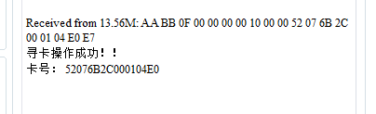

图 12 单标签寻卡

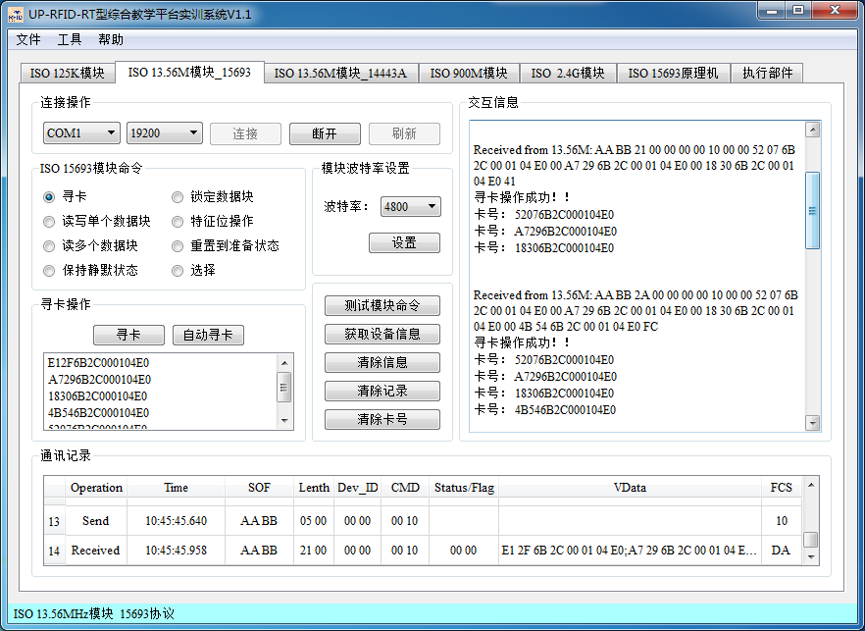

图 13 多标签寻卡

2、根据标签内存地址，完成 ISO15693 协议下标签指定地址的数据读写实验；

3、根据标签内存地址，完成 ISO15693 协议下标签指定地址范围的内存数据读取实验；

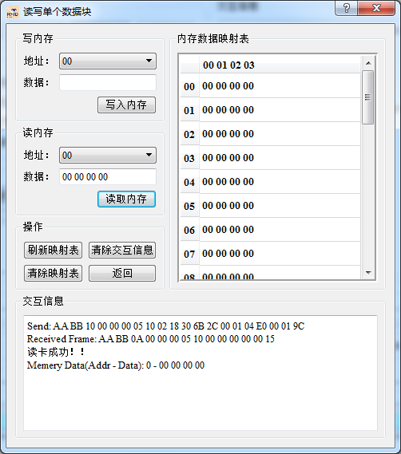

图 14 指定地址范围读卡实验

4、ISO15693 协议的命令，完成标签静默状态设置、重置到准备状态、标签选择命令实验；

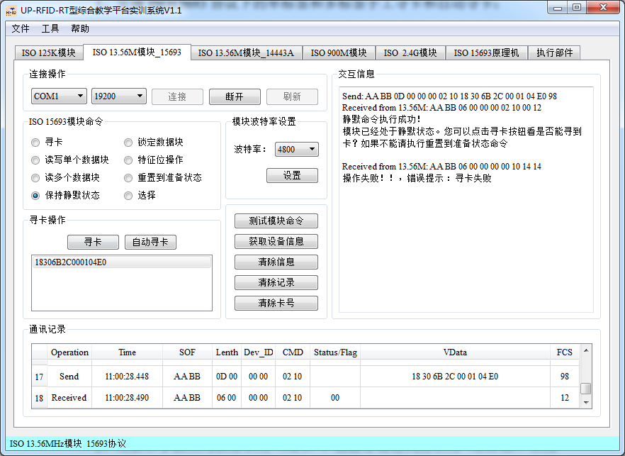

图 15 静默实验

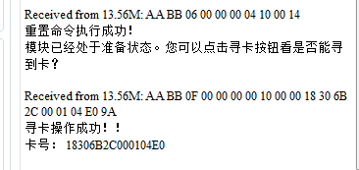

图 16 恢复实验

5、完成 ISO15693 协议下标签 DSFID、AFI 的读写和块安全位的读取实验；

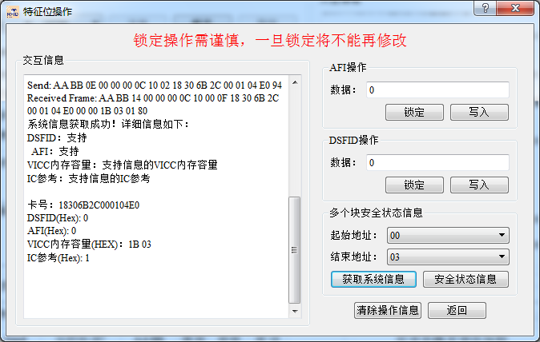

图 17 DSFID、AFI 的读写和块安全位的读取实验

6、熟悉和了解高频 HF1356M 15693 开发实例，掌握高频读写器 API 函数，并通过编程实现 ISO15693 协议下标签的读写功能

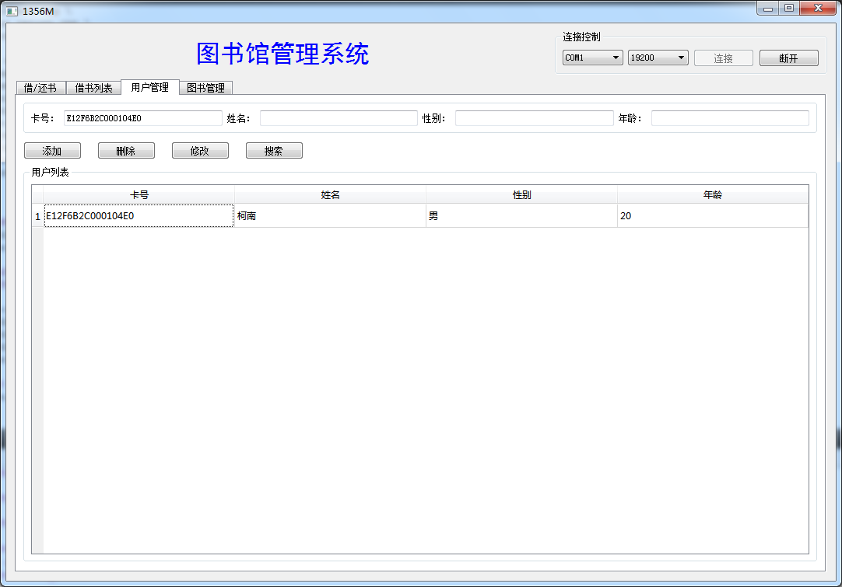

图 18 开发实例

3.3 实验体会与总结

1、什么是 AFI？AFI 如何编码？在通过编程对 AFI 进行读写、锁定时，其对应 ISO15693 的协议命令代码、上位机对读写器的命令代码和数据包分别是怎么样的?

AFI是应用标示的简称，在ISO15693的电子标签中就有AFI写和锁。用户可以自己写一个关键字作为标签的类别。AFI被编码在一个字节里，由两个半字节组成，AFI的高半位字节，用于编码一个特定的或所有应用族，AFI的低半位字节用于编码一个特定的或所有应用子族。子族不同于0的，有其自己的所有权。

2、什么是DSFID？在通过编程对DSFID进行读写、锁定时，其对应ISO15693的协议命令代码、上位机对读写器的命令代码和数据包分别是怎么样的？

特殊功能 DSFID（数据存储格式标识符）可用来表示数据在存储器中的存储结构，具 体内容请自己查阅相关文档。数据存储格式标识符（DSFID）数据存储格式标识符指出了数据在内存中是怎样构成的。DSFID 被相应的命令编程和锁定。DSFID 被编码在一个字节里。DSFID 允许即时知 道数据的逻辑组织。假如标签不支持 DSFID 的编程，标签将以值“0”作为应答。

3、ISO15693协议的电子标签 ID 有何特点?

ISO/IEC 15693 协议标准的高频 RFID 无源 IC 卡，专为供应链与运筹管理应用所设计，具 有高度防冲突与长距离运作等优点，适合于高速、长距离应用。

总结：通过这次实验，我学会了通过试验箱对 ISO15693 协议下标签指定内存地址的数据进行读写操作，加深了对应用族标识符（AFI）、数据存储格式标识符（DSFID）以及锁理解，了解了握高频读写器 API 函数的调用方法。

3.4 核心源码说明

|  |
| --- |
| Edit[0]->setText(Card_id);  #ifndef BOOKSMANAGE_H  #define BOOKSMANAGE_H  #include <QObject>  #include <QWidget>  #include <QVBoxLayout>  #include <QHBoxLayout>  #include <QGridLayout>  #include <QPushButton>  #include <QLineEdit>  #include <QLabel>  #include <QTableWidget>  #include <QHeaderView>  #include <QMessageBox>  #include <QGroupBox>  #include "sqlite.h"  #define Button_Count_BOOKS 4*//按钮个数*  #define Edit_Count_BOOKS 6*//文本框个数*  #define Label_Count_BOOKS 6*//标签个数*  #define Table_Column_BOOKS 6*//表格列数*  **enum** Button_Index_Books{Add_Books = 0, Delete_Books, Updata_Books, Select_Books};*//读卡、添加按钮、删除按钮、更新按钮、搜索按钮*  **enum** Edit_Index_Books{ID_Books = 0, Name_Books, Author_Books, PublishingHouse_Books, Count_Books, Residue_Books};*//编号、书名、作者、出版社、总数、剩余*  **class** **BooksManage** : **public** QWidget*//图书管理界面*  {  Q_OBJECT  **public**:  **explicit** BooksManage(QWidget *parent = 0);  void SetSlot();*//设置槽函数*  void ShowTable(QSqlQuery query);*//显示表函数*  void ClearEdit();*//清空文本框*  void Clear();*//清空文本框和表格信息*  void SetCard(QString cardID);  **public** slots:  void add_books();*//添加按钮槽*  void delete_books();*//删除按钮槽*  void updata_books();*//更新按钮槽*  void select_books();*//搜索按钮槽*  void get_table_line(int row, int col);*//单击表格一行触发的槽*  **private**:  QPushButton *Button[Button_Count_BOOKS];*//按钮*  QLineEdit *Edit[Edit_Count_BOOKS];*//文本框*  QLabel *Label[Label_Count_BOOKS];*//标签*  QTableWidget *Table;*//表格*  Sqlite *sql;*//数据库相关操作类*  };  #endif *// BOOKSMANAGE_H*  #include "borrow_return.h"  *//借书界面*  Borrow_Return::Borrow_Return(QWidget *parent) : QWidget(parent)  {  QString LabelNameUser[] = {"卡号：", "姓名：", "性别：", "年龄："}; *//标签文本*  *//布局*  QGridLayout *MainLayout = **new** QGridLayout();*//主布局*  QVBoxLayout *UserLayout = **new** QVBoxLayout();*//用户区域布局*  QVBoxLayout *RightLayout = **new** QVBoxLayout();*//右侧布局*  QHBoxLayout *ButtonLayout = **new** QHBoxLayout();*//右侧布局*  *//组合框*  QGroupBox *BooksGroupBox = **new** QGroupBox();  QGroupBox *UserGroupBox = **new** QGroupBox();  sql = **new** Sqlite();  *//初始化文本框和标签 将文本框和标签添加到布局中*  **for**(int i = 0; i < Edit_Count_BORROW_RETURN; i++)  {  QHBoxLayout *Layout = **new** QHBoxLayout();  Edit_User[i] = **new** QLineEdit();  Label_User[i] = **new** QLabel(LabelNameUser[i]);  Edit_User[i]->setFocusPolicy(Qt::NoFocus); *//设置为禁止编辑*  Layout->addWidget(Label_User[i]);  Layout->addWidget(Edit_User[i]);  UserLayout->addLayout(Layout);  }  *//借还书单选按钮*  Borrow = **new** QRadioButton("借书");  Return = **new** QRadioButton("还书");  Borrow->setChecked(true);  Function = **new** QButtonGroup();  Function->addButton(Borrow);*//单选按钮加入按钮组*  Function->addButton(Return);  ButtonLayout->addWidget(Borrow);  ButtonLayout->addWidget(Return);  UserLayout->addLayout(ButtonLayout);  UserGroupBox->setTitle("用户信息");*//设置标题*  UserGroupBox->setLayout(UserLayout);  UserGroupBox->setFixedSize(200,300);*//设置大小*  Table = **new** QTableWidget();*//表格*  Table->setColumnCount(Table_Column_BORROW_RETURN);*//设置列数*  Table->setSelectionBehavior ( QAbstractItemView::SelectRows);*//选择方式为选中整行*  Table->setEditTriggers ( QAbstractItemView::NoEditTriggers );*//不可编辑*  Table->horizontalHeader()->setSectionResizeMode(QHeaderView::Stretch);*//列宽度自适应*  RightLayout->addWidget(Table);  BooksGroupBox->setTitle("借书列表");*//设置组合框标题*  BooksGroupBox->setLayout(RightLayout);  */*设置图片*/*  QLabel *Picture = **new** QLabel();  QImage *jpg = **new** QImage(":/img/img/book.jpg");  Picture->setPixmap(QPixmap::fromImage(*jpg));  MainLayout->addWidget(UserGroupBox,0,0,1,1);  MainLayout->addWidget(BooksGroupBox,0,1,2,1);  MainLayout->addWidget(Picture,1,0,1,1);  MainLayout->setSpacing(20);  **this**->setLayout(MainLayout);  }  *//表格显示*  void Borrow_Return::ShowTable(QSqlQuery query)  {  *//设置表格表头*  Table->setHorizontalHeaderLabels(QStringList()<<"卡号"<<"书名"<<"作者"<<"出版社"<<"总数（本）"<<"剩余（本）");  **if**(!query.next())  {  Table->setRowCount(0);*//表格设置行数*  **return**;  }  */*计算record表中数据行数*/*  query.last();*//跳转到最后一条数据*  int nRow = query.at() + 1;*//取所在行数*  Table->setRowCount(nRow);*//表格设置行数*  int row = 0;  query.first();*//返回第一条数据*  **do**  {  **for** (int col = 0; col<7; col++)*//按字段添加数据*  {  *//表格中添加数据库中的数据*  Table->setItem(row, col, **new** QTableWidgetItem(query.value(col).toString()));  }  row++;*//行数增加*  }**while**(query.next());  }  *//设置用户信息(卡ID)*  void Borrow_Return::SetInfo(QString cardID)  {  *//将用户信息显示到文本框中*  QSqlQuery query = sql->SelectUser(cardID);  **if**(query.next())*//如果是用户*  {  **for**(int i=0; i < Edit_Count_BORROW_RETURN; i++)  {  Edit_User[i]->setText(query.value(i).toString());  }  *//将书信息显示到表格中*  ShowTable(sql->SelectBooksOfBorrow(cardID));*//显示表格内容*  **return**;  }  query = sql->SelectBooks(cardID);  **if**(query.next())*//如果是书*  {  **if**(Edit_User[CardId_User_Borrow]->text().isEmpty())  {  **return**;  }  **if**(Borrow->isChecked())  {  **if**(sql->SelectRecord(Edit_User[CardId_User_Borrow]->text(), query.value(0).toString()).next())  {  **return**;  }  **if**(query.value(5).toInt() <= 0)  {  **return**;  }  **if**(sql->InsertRecord(Edit_User[CardId_User_Borrow]->text(), query.value(0).toString()))*//将用户ID和书籍编号添加到数据表中*  {  *//书籍的剩余数量-1*  sql->UpdataBooks(query.value(0).toString(),query.value(1).toString(),query.value(2).toString(),query.value(3).toString(),query.value(4).toInt(),query.value(5).toInt()-1);  }  }  **else**  {  **if**(!sql->SelectRecord(Edit_User[CardId_User_Borrow]->text(), query.value(0).toString()).next())  {  **return**;  }  **if**(sql->DeleteRecord(Edit_User[CardId_User_Borrow]->text(), query.value(0).toString()))*//将用户ID和书籍编号添加到数据表中*  {  *//书籍的剩余数量+1*  sql->UpdataBooks(query.value(0).toString(),query.value(1).toString(),query.value(2).toString(),query.value(3).toString(),query.value(4).toInt(),query.value(5).toInt()+1);  }  }  ShowTable(sql->SelectBooksOfBorrow(Edit_User[0]->text()));*//显示表格内容*  }  }  *//清空文本框和刷新表格*  void Borrow_Return::Clear()  {  **for**(int i = 0; i < Edit_Count_BORROW_RETURN; i++)  {  Edit_User[i]->clear();  }  ShowTable(sql->SelectBooksOfBorrow(Edit_User[0]->text()));*//显示表格内容*  } #include "record.h"  *//还书界面*  Record::Record(QWidget *parent) : QWidget(parent)  {  QVBoxLayout *MainLayout = **new** QVBoxLayout();*//主布局*  QHBoxLayout *TableLayout = **new** QHBoxLayout();*//表格布局*  QHBoxLayout *ButtonLayout = **new** QHBoxLayout();*//按钮布局*  QHBoxLayout *EditLayout = **new** QHBoxLayout();*//按钮布局*  QVBoxLayout *TopLayout = **new** QVBoxLayout();*//上部布局*  QStringList LabelText,ButtonText;  ButtonText<<"搜索"<<"删除";  **for**(int i=0; i<Button_Count_Record; i++)  {  Button[i] = **new** QPushButton();  Button[i]->setText(ButtonText.at(i));  ButtonLayout->addWidget(Button[i]);  }  ButtonLayout->addStretch();  LabelText<<"用户卡号"<<"书籍卡号";  QString pattern("[A-Fa-f9-0]*");  QRegExp regExp(pattern);  **for**(int i=0; i<Edit_Count_Record; i++)  {  Label[i] = **new** QLabel();  Label[i]->setText(LabelText.at(i));  EditLayout->addWidget(Label[i]);  Edit[i] = **new** QLineEdit();  EditLayout->addWidget(Edit[i]);  Edit[i]->setValidator(**new** QRegExpValidator(regExp, **this**));  }  *//组合框*  QGroupBox *TabGroupBox = **new** QGroupBox();  QGroupBox *GroupBox = **new** QGroupBox();  sql = **new** Sqlite();  Table = **new** QTableWidget();*//表格*  Table->setColumnCount(Table_Column_Record);*//设置列数*  Table->setSelectionBehavior ( QAbstractItemView::SelectRows);*//选中整行*  Table->setEditTriggers ( QAbstractItemView::NoEditTriggers );*//不可编辑*  Table->horizontalHeader()->setSectionResizeMode(QHeaderView::Stretch);*//列宽度自适应*  TableLayout->addWidget(Table);  TopLayout->addLayout(EditLayout);  GroupBox->setLayout(TopLayout);  TabGroupBox->setTitle("借书列表");*//设置组合框标题*  TabGroupBox->setLayout(TableLayout);*//这是组合框布局*  *//设置布局*  MainLayout->addWidget(GroupBox);  MainLayout->addLayout(ButtonLayout);  MainLayout->addWidget(TabGroupBox);  **this**->setLayout(MainLayout);  SetSlot();  }  void Record::SetSlot()  {  connect(Button[Delete_Record],SIGNAL(clicked()),**this**,SLOT(delete_record()));*//删除按钮连接槽函数delete_Record()*  connect(Button[Select_Record],SIGNAL(clicked()),**this**,SLOT(select_record()));*//查找按钮连接槽函数select_Record()*  connect(Table,SIGNAL(cellClicked(int,int)),**this**,SLOT(get_table_line(int, int)));*//表格单击事件连接槽函数get_table_line(int, int)*  }  *//搜索按钮单击事件*  void Record::select_record()  {  QSqlQuery query;  query = sql->SelectRecord(Edit[UserID_Record]->text(),Edit[BookID_Record]->text());  ShowTable(query);*//更新表格*  ClearEdit();*//清空文本框*  }  *//删除按钮槽函数*  void Record::delete_record()  {  *//删除书籍*  bool ret = sql->DeleteRecord(Edit[UserID_Record]->text(),Edit[BookID_Record]->text());  **if**(!ret)  {  QMessageBox::warning(NULL, "warning", "删除失败！", QMessageBox::Yes, QMessageBox::Yes);  **return**;  }  QMessageBox::warning(NULL, "warning", "删除成功！", QMessageBox::Yes, QMessageBox::Yes);  ClearEdit();*//清空文本框*  ShowTable(sql->SelectRecord());*//更新表格*  }  *//清空文本框*  void Record::ClearEdit()  {  **for**(int i = 0; i < Edit_Count_Record; i++)  {  Edit[i]->clear();  }  }  *//单击表格 在文本框中显示表格点击的行的数据*  void Record::get_table_line(int row, int col)  {  **for**(int i = 0; i < Edit_Count_Record; i++)  {  Edit[i]->setText(Table->item(row,i)->text());  }  }  *//显示表格*  void Record::ShowTable(QSqlQuery query)  {  *//表头*  Table->setHorizontalHeaderLabels(QStringList()<<"用户卡号"<<"书籍卡号");  **if**(!query.next())  {  Table->setRowCount(0);*//表格设置行数*  **return**;  }  */*计算record表中数据行数*/*  query.last();*//跳转到最后一条数据*  int nRow = query.at() + 1;*//取所在行数*  Table->setRowCount(nRow);*//表格设置行数*  int row = 0;  query.first();*//返回第一条数据*  **do**  {  **for**(int col = 0; col < Table->columnCount(); col++)  {  Table->setItem(row, col, **new** QTableWidgetItem(query.value(col).toString()));*//显示信息*  }  row++;  }**while**(query.next());  }  *//清空文本框和表格*  void Record::Clear()  {  ShowTable(sql->SelectRecord());  }  *//设置卡号*  void Record::SetCard(QString cardID)  {  QSqlQuery query = sql->SelectUser(cardID);  **if**(query.next())*//如果是用户*  {  Edit[UserID_Record]->setText(cardID);*//显示用户卡号*  **return**;  }  query = sql->SelectBooks(cardID);  **if**(query.next())*//如果是书*  {  Edit[BookID_Record]->setText(cardID);*//显示用户卡号*  }  } #include "sqlite.h"  Sqlite::Sqlite()  {  }  */*连接数据库*/*  bool Sqlite::Connect()  {  db = QSqlDatabase::addDatabase("QSQLITE");  db.setDatabaseName(DATABASE);  **if**(!db.open()) **return** false;  QSqlQuery query;  query.exec("create table user_15693 (cardID vchar, name vchar, gender vchar, age int, primary key (cardID))");  query.exec("create table books_15693 (booksID vchar, name vchar, author vchar, publishing_house vchar, count int, residue int, primary key (booksID))");  query.exec("create table record_15693 (cardID vchar, booksID vchar, FOREIGN KEY (cardID ) REFERENCES user(cardID), FOREIGN KEY (booksID ) REFERENCES user(booksID))");  **return** true;  }  *//打印SQL语句*  bool Sqlite::ExecSQL(QString cmd)  {  QSqlQuery query;  qDebug()<<cmd.toUtf8().data();  **return** query.exec(cmd);  }  *//添加语句*  bool Sqlite::Insert(QString table, QString value)  {  QString cmd = "insert into " + table + " values(" + value + ");";  **return** ExecSQL(cmd);  }  *//删除语句*  bool Sqlite::Delete(QString table, QString where)  {  QString cmd = "delete from " + table + " where " + where + ";";  **return** ExecSQL(cmd);  }  *//修改语句*  bool Sqlite::Updata(QString table, QString value,QString where)  {  QString cmd = "update " + table + " set " + value +" where " + where + ";";  **return** ExecSQL(cmd);  }  *//查询语句*  QSqlQuery Sqlite::Select(QString table, QString value, QString where)  {  QString cmd;  **if**(where.isEmpty())  {  cmd = "select " + value + " from " + table + ";";  }  **else**  {  cmd = "select " + value + " from " + table + " where " + where + ";";  }  QSqlQuery query;  qDebug()<<cmd.toUtf8();  query.exec(cmd);  **return** query;  }  *//向user表中添加*  bool Sqlite::InsertUser(QString cardID, QString name, QString gender, int age)  {  **return** Insert("user_15693", "'"+cardID+"', '"+name+"', '"+gender+"', "+QString::number(age));  }  *//向books表中添加*  bool Sqlite::InsertBooks(QString booksID, QString name, QString author, QString publishing_house, int count, int residue)  {  **return** Insert("books_15693", "'"+booksID+"', '"+name+"', '"+author+"', '"+publishing_house+"', "+QString::number(count)+", "+QString::number(residue));  }  *//向record表中添加*  bool Sqlite::InsertRecord(QString cardID, QString booksID)  {  **return** Insert("record_15693", "'"+cardID+"', '"+booksID+"'");  }  *//删除user表中数据*  bool Sqlite::DeleteUser(QString cardID, QString name, QString gender, int age)  {  QString where;  **if**( !cardID.isEmpty() )  where += ("cardID = '" + cardID +"' ");  **if**( !name.isEmpty() )  {  **if**(where.isEmpty())  where += ("name = '" + name+"' ");  **else**  where += ("and name = '" + name+"' ");  }  **if**( !gender.isEmpty() )  {  **if**(where.isEmpty())  where += ("gender = '" + gender+"' ");  **else**  where += ("and gender = '" + gender+"' ");  }  **if**( age != -1 )  {  **if**(where.isEmpty())  where += ("age = " + QString::number(age));  **else**  where += ("and age = " + QString::number(age));  }  **return** Delete("user_15693", where);  }  *//删除books表中数据*  bool Sqlite::DeleteBooks(QString booksID, QString name, QString author, QString publishing_house, int count, int residue)  {  QString where;  **if**( !booksID.isEmpty() )  where += ("booksID = '" + booksID +"' ");  **if**( !name.isEmpty() )  {  **if**(where.isEmpty())  where += ("name = '" + name+"' ");  **else**  where += ("and name = '" + name+"' ");  }  **if**( !author.isEmpty() )  {  **if**(where.isEmpty())  where += ("author = '" + author+"' ");  **else**  where += ("and author = '" + author+"' ");  }  **if**( !publishing_house.isEmpty() )  {  **if**(where.isEmpty())  where += ("publishing_house = '" + publishing_house+"' ");  **else**  where += ("and publishing_house = '" + publishing_house+"' ");  }  **if**( count != -1 )  {  **if**(where.isEmpty())  where += ("count = " + QString::number(count)+" ");  **else**  where += ("and count = " + QString::number(count)+" ");  }  **if**( residue != -1 )  {  **if**(where.isEmpty())  where += ("residue = " + QString::number(residue)+" ");  **else**  where += ("and residue = " + QString::number(residue)+" ");  }  **return** Delete("books_15693", where);  }  *//删除record表中数据*  bool Sqlite::DeleteRecord(QString cardID, QString booksID)  {  QString where;  **if**( !cardID.isEmpty() )  where += ("cardID = '" + cardID +"' ");  **if**( !booksID.isEmpty() )  {  **if**(where.isEmpty())  where += ("booksID = '" + booksID+"' ");  **else**  where += ("and booksID = '" + booksID+"' ");  }  **return** Delete("record_15693", where);  }  *//修改user表中数据*  bool Sqlite::UpdataUser(QString cardID, QString name, QString gender, int age)  {  **return** Updata("user_15693","cardID = '"+cardID+"', name = '"+name+"', gender = '"+gender+"', age = "+QString::number(age), "cardID = '"+cardID+"'");  }  *//修改books表中数据*  bool Sqlite::UpdataBooks(QString booksID, QString name, QString author, QString publishing_house, int count, int residue)  {  **return** Updata("books_15693","booksID = '"+booksID+"', name = '"+name+"', author = '"+author+"', publishing_house = '"+publishing_house+"', count = "+QString::number(count)+", residue = "+QString::number(residue), "booksID = '"+booksID+"'");  }  *//查询user表中数据*  QSqlQuery Sqlite::SelectUser(QString cardID, QString name, QString gender, int age)  {  QString where;  **if**( !cardID.isEmpty() )  where += ("cardID = '" + cardID +"' ");  **if**( !name.isEmpty() )  {  **if**(where.isEmpty())  where += ("name = '" + name+"' ");  **else**  where += ("and name = '" + name+"' ");  }  **if**( !gender.isEmpty() )  {  **if**(where.isEmpty())  where += ("gender = '" + gender+"' ");  **else**  where += ("and gender = '" + gender+"' ");  }  **if**( age != -1 )  {  **if**(where.isEmpty())  where += ("age = " + QString::number(age));  **else**  where += ("and age = " + QString::number(age));  }  **return** Select("user_15693", "*", where);  }  *//查询books表中数据*  QSqlQuery Sqlite::SelectBooks(QString booksID, QString name, QString author, QString publishing_house, int count)  {  QString where;  **if**( !booksID.isEmpty() )  where += ("booksID = '" + booksID +"' ");  **if**( !name.isEmpty() )  {  **if**(where.isEmpty())  where += ("name = '" + name+"' ");  **else**  where += ("and name = '" + name+"' ");  }  **if**( !author.isEmpty() )  {  **if**(where.isEmpty())  where += ("author = '" + author+"' ");  **else**  where += ("and author = '" + author+"' ");  }  **if**( !publishing_house.isEmpty() )  {  **if**(where.isEmpty())  where += ("publishing_house = '" + publishing_house+"' ");  **else**  where += ("and publishing_house = '" + publishing_house+"' ");  }  **if**( count != -1 )  {  **if**(where.isEmpty())  where += ("count = " + QString::number(count));  **else**  where += ("and count = " + QString::number(count));  }  **return** Select("books_15693", "*", where);  }  QSqlQuery Sqlite::SelectRecord(QString cardID, QString booksID)  {  QString where;  **if**( !cardID.isEmpty() )  where += ("cardID = '" + cardID +"' ");  **if**( !booksID.isEmpty() )  {  **if**(where.isEmpty())  where += ("booksID = '" + booksID+"' ");  **else**  where += ("and booksID = '" + booksID+"' ");  }  **return** Select("record_15693", "*", where);  }  *//查找借的书*  QSqlQuery Sqlite::SelectBooksOfBorrow(QString cardID)  {  **return** Select("books_15693", "*", "booksID in (select booksID from record_15693 where cardID = '"+cardID+"')");  } #include "tools.h"  #include <QDebug>  Tools::Tools(QObject *parent) : QObject(parent)  {  list = **new** QStringList();  }  *//获取当前PC可用的串口名*  QStringList Tools::getSerialName()  {  QStringList temp;  foreach (**const** QSerialPortInfo &info, QSerialPortInfo::availablePorts())  {  QSerialPort serial;  serial.setPort(info);  **if** (serial.open(QIODevice::ReadWrite))  {  **if**(! list->contains(info.portName(),Qt::CaseSensitive))  list->insert(0,info.portName());  serial.close();  temp << info.portName();  }  }  **for**(int i = 0 ; i < list->size() ; i ++)  {  **if**(!temp.contains(list->at(i)))  list->removeAt(i);  }  **return** *list;  }  *///获取当前日期和时间*  QString Tools::CurrentDateTime()  {  QDateTime dt;  QTime time;  QDate date;  dt.setTime(time.currentTime());  dt.setDate(date.currentDate());  **return** dt.toString("yyyy-MM-dd hh:mm:ss");  }  *///获取当前的时间*  QString Tools::CurrentTime()  {  QTime time;  **return** time.currentTime().toString("hh:mm:ss");  }  *///获取当前的时间*  QString Tools::CurrentMTime()  {  QTime time;  **return** time.currentTime().toString("hh:mm:ss.zzz");  }  *///普通字符串转为16进制字符串*  QString Tools::CharStringtoHexString(QString space, **const** char * src, int len)  {  QString hex = "";  **if**(space == NULL)  {  **for**(int i = 0 ; i < len ; i ++)  {  hex += QString("%1").arg(src[i]&0xFF,2,16,QLatin1Char('0'));  }  **return** hex.toUpper();  }  **else**  {  **for**(int i = 0 ; i < len ; i ++)  {  hex += space + QString("%1").arg(src[i]&0xFF,2,16,QLatin1Char('0'));  }  **return** hex.right(hex.length() - space.length()).toUpper();  }  }  *//QString 转 Hex char \**  quint8 Tools::StringToHex(QString string, quint8 *hex)  {  QString temp;  quint8 len = string.length();  **for**(quint8 i=0; i<len; i+=2)  {  temp = string.mid(i, 2);  hex[i/2] = (quint8)temp.toInt(0,16);  }  **return** len/2;  }  *///普通字符串转为16进制字符串*  QString Tools::CharStringtoHexString(QString space, **const** char * src, int start, int end)  {  QString hex = "";  **if**(space == NULL)  {  **for**(int i = start ; i < end ; i ++)  {  hex += QString("%1").arg(src[i]&0xFF,2,16,QLatin1Char('0'));  }  **return** hex.toUpper();  }  **else**  {  **for**(int i = start ; i < end ; i ++)  {  hex += space + QString("%1").arg(src[i]&0xFF,2,16,QLatin1Char('0'));  }  **return** hex.right(hex.length() - space.length()).toUpper();  }  }  *//用于导出数据库中的数据到文件，csv格式的文件可以用Excel打开*  void Tools::export_table(**const** QAbstractItemModel &model)  {  QString fileName = QFileDialog::getSaveFileName(0, QObject::tr("保存记录"), "/", "files(*.csv)");  QFile file(fileName);  **if**(file.open(QFile::WriteOnly|QFile::Truncate)){  QTextStream out(&file);  QString str;  str.clear();  **for**(int i=0; i<model.columnCount(); i++)  str.append(model.headerData(i, Qt::Horizontal).toString()).append(",");  out<<str<<"**\r\n**";  **for**(int row=0; row<model.rowCount(); row++){  str.clear();  **for**(int col=0; col<model.columnCount(); col++)  str.append(model.data(model.index(row,col)).toString()).append(",");  out<<str<<"**\r\n**";  }  file.close();  }  } #include "booksmanage.h"  BooksManage::BooksManage(QWidget *parent) : QWidget(parent)  {  QString LabelName[] = {"卡号：", "书名：", "作者：", "出版社：", "总数（本）", "剩余（本）"};*//标签文本*  QString ButtonName[] = {"添加", "删除", "修改", "搜索"};*//按钮文本*  QVBoxLayout *MainLayout = **new** QVBoxLayout();*//主布局*  QHBoxLayout *ButtonLayout = **new** QHBoxLayout();*//按钮布局*  QHBoxLayout *EditLayout = **new** QHBoxLayout();*//文本框布局*  QHBoxLayout *TableLayout = **new** QHBoxLayout();*//表格布局*  QGroupBox *BookTable = **new** QGroupBox();*//表格区域*  QGroupBox *BookInfo = **new** QGroupBox();*//信息*  sql = **new** Sqlite();  **for**(int i = 0; i < Edit_Count_BOOKS; i++) *//初始化文本框和标签*  {  Edit[i] = **new** QLineEdit();  Label[i] = **new** QLabel(LabelName[i]);  EditLayout->addWidget(Label[i]);*//将文本框和标签添加到布局中*  EditLayout->addWidget(Edit[i]);  }  QString pattern("[A-Fa-f9-0]*");  QRegExp regExp(pattern);  Edit[ID_Books]->setValidator(**new** QRegExpValidator(regExp, **this**));  pattern="[9-0]{3}";  regExp.setPattern(pattern);  Edit[Count_Books]->setValidator(**new** QRegExpValidator(regExp, **this**));  Edit[Residue_Books]->setValidator(**new** QRegExpValidator(regExp, **this**));  BookInfo->setLayout(EditLayout);*//设置信息组合框的布局*  **for**(int i = 0; i < Button_Count_BOOKS; i++)*//初始化按钮*  {  Button[i] = **new** QPushButton();  Button[i]->setText(ButtonName[i]);  ButtonLayout->addWidget(Button[i]);*//按钮添加到布局中*  }  ButtonLayout->addStretch(0);  ButtonLayout->setSpacing(20);  Table = **new** QTableWidget();  Table->setColumnCount(Table_Column_BOOKS);  Table->setSelectionBehavior ( QAbstractItemView::SelectRows);*//选中整行*  Table->setEditTriggers ( QAbstractItemView::NoEditTriggers );*//不可编辑*  Table->horizontalHeader()->setSectionResizeMode(QHeaderView::Stretch);*//列宽度自适应*  TableLayout->addWidget(Table);  BookTable->setLayout(TableLayout);  BookTable->setTitle("图书列表");  MainLayout->addWidget(BookInfo);  MainLayout->addLayout(ButtonLayout);  MainLayout->addWidget(BookTable);  MainLayout->setSpacing(10);  **this**->setLayout(MainLayout);  SetSlot();  }  void BooksManage::SetSlot()*//设置槽函数*  {  connect(Button[Add_Books],SIGNAL(clicked()),**this**,SLOT(add_books()));*//添加按钮连接槽函数add_books()*  connect(Button[Delete_Books],SIGNAL(clicked()),**this**,SLOT(delete_books()));*//删除按钮连接槽函数delete_books()*  connect(Button[Updata_Books],SIGNAL(clicked()),**this**,SLOT(updata_books()));*//修改按钮连接槽函数updata_books()*  connect(Button[Select_Books],SIGNAL(clicked()),**this**,SLOT(select_books()));*//查找按钮连接槽函数select_books()*  connect(Table,SIGNAL(cellClicked(int,int)),**this**,SLOT(get_table_line(int, int)));*//表格单击事件连接槽函数get_table_line(int, int)*  }  void BooksManage::add_books()*//添加按钮槽函数*  {  int residue;*//图书的剩余数量*  */*文本框为空时显示错误提示*/*  QString LabelName[] = {"卡号：", "书名：", "作者：", "出版社：", "总数（本）"};  **for**(int i = 0; i < Edit_Count_BOOKS-1; i++)  {  **if**(Edit[i]->text().isEmpty())  {  QMessageBox::warning(NULL, "warning", LabelName[i]+"不能为空！", QMessageBox::Yes, QMessageBox::Yes);  **return**;  }  }  **if** (sql->SelectUser(Edit[ID_Books]->text()).next())  {  QMessageBox::warning(NULL, "warning", "卡号已经注册为用户！", QMessageBox::Yes, QMessageBox::Yes);  **return**;  }  **if** (Edit[Residue_Books]->text().toInt() > Edit[Count_Books]->text().toInt())  {  QMessageBox::warning(NULL, "warning", "剩余数量不可以超出总数！", QMessageBox::Yes, QMessageBox::Yes);  **return**;  }  */*不填写剩余数量默认为总数量*/*  **if** (Edit[Residue_Books]->text().isEmpty())  {  residue = Edit[Count_Books]->text().toInt();  }  **else**  {  residue = Edit[Residue_Books]->text().toInt();  }  *//向数据库中添加书籍*  bool ret = sql->InsertBooks(Edit[ID_Books]->text(),Edit[Name_Books]->text(),Edit[Author_Books]->text(),Edit[PublishingHouse_Books]->text(),Edit[Count_Books]->text().toInt(),residue);  **if**(!ret)  {  QMessageBox::warning(NULL, "warning", "添加失败，卡号已存在！", QMessageBox::Yes, QMessageBox::Yes);  **return**;  }  QMessageBox::warning(NULL, "warning", "添加成功！", QMessageBox::Yes, QMessageBox::Yes);  ClearEdit(); *//清空文本框*  ShowTable(sql->SelectBooks());*//更新表格*  }  *//删除按钮槽函数*  void BooksManage::delete_books()  {  **if** (!Edit[ID_Books]->text().isEmpty() && sql->SelectUser(Edit[ID_Books]->text()).next())  {  QMessageBox::warning(NULL, "warning", "卡号已经注册为用户！", QMessageBox::Yes, QMessageBox::Yes);  **return**;  }  **if** (!Edit[ID_Books]->text().isEmpty() && !sql->SelectBooks(Edit[ID_Books]->text()).next())  {  QMessageBox::warning(NULL, "warning", "卡号不存在！", QMessageBox::Yes, QMessageBox::Yes);  **return**;  }  int Count,Residue;  **if**(Edit[Residue_Books]->text().isEmpty())  Residue = -1;  **else**  Residue = Edit[Residue_Books]->text().toInt();  **if**(Edit[Count_Books]->text().isEmpty())  Count = -1;  **else**  Count = Edit[Count_Books]->text().toInt();  *//删除书籍*  bool ret = sql->DeleteBooks(Edit[ID_Books]->text(),Edit[Name_Books]->text(),Edit[Author_Books]->text(),Edit[PublishingHouse_Books]->text(),Count,Residue);  **if**(!ret)  {  QMessageBox::warning(NULL, "warning", "删除失败！", QMessageBox::Yes, QMessageBox::Yes);  **return**;  }  QMessageBox::warning(NULL, "warning", "删除成功！", QMessageBox::Yes, QMessageBox::Yes);  ClearEdit();*//清空文本框*  ShowTable(sql->SelectBooks());*//更新表格*  }  *//修改按钮单击事件*  void BooksManage::updata_books()  {  **if** (!Edit[ID_Books]->text().isEmpty() && sql->SelectUser(Edit[ID_Books]->text()).next())  {  QMessageBox::warning(NULL, "warning", "卡号已经注册为用户！", QMessageBox::Yes, QMessageBox::Yes);  **return**;  }  **if** (!Edit[ID_Books]->text().isEmpty() && !sql->SelectBooks(Edit[ID_Books]->text()).next())  {  QMessageBox::warning(NULL, "warning", "卡号不存在！", QMessageBox::Yes, QMessageBox::Yes);  **return**;  }  **if** (Edit[Residue_Books]->text().toInt() > Edit[Count_Books]->text().toInt())  {  QMessageBox::warning(NULL, "warning", "剩余数量不可以超出总数！", QMessageBox::Yes, QMessageBox::Yes);  **return**;  }  *//修改书籍信息*  bool ret = sql->UpdataBooks(Edit[ID_Books]->text(),Edit[Name_Books]->text(),Edit[Author_Books]->text(),Edit[PublishingHouse_Books]->text(),Edit[Count_Books]->text().toInt(), Edit[Residue_Books]->text().toInt());  **if**(!ret)  {  QMessageBox::warning(NULL, "warning", "修改失败！", QMessageBox::Yes, QMessageBox::Yes);  **return**;  }  QMessageBox::warning(NULL, "warning", "修改成功！", QMessageBox::Yes, QMessageBox::Yes);  ClearEdit();*//清空文本框*  ShowTable(sql->SelectBooks());*//更新表格*  }  *//搜索按钮单击事件*  void BooksManage::select_books()  {  QSqlQuery query;  **if**(Edit[Count_Books]->text().isEmpty())  query = sql->SelectBooks(Edit[ID_Books]->text(),Edit[Name_Books]->text(),Edit[Author_Books]->text(),Edit[PublishingHouse_Books]->text());  **else**  query = sql->SelectBooks(Edit[ID_Books]->text(),Edit[Name_Books]->text(),Edit[Author_Books]->text(),Edit[PublishingHouse_Books]->text(),Edit[Count_Books]->text().toInt());  ShowTable(query);*//更新表格*  ClearEdit();*//清空文本框*  }  *//显示表格*  void BooksManage::ShowTable(QSqlQuery query)  {  Table->setHorizontalHeaderLabels(QStringList()<<"卡号"<<"书名"<<"作者"<<"出版社"<<"总计（本）"<<"剩余（本）");  **if**(!query.next())  {  Table->setRowCount(0);*//表格设置行数*  **return**;  }  */*计算record表中数据行数*/*  query.last();*//跳转到最后一条数据*  int nRow = query.at() + 1;*//取所在行数*  Table->setRowCount(nRow);*//表格设置行数*  int row = 0;  query.first();*//返回第一条数据*  **do**  {  **for** (int col = 0; col<Table->columnCount(); col++)*//按字段添加数据*  {  *//表格中添加数据库中的数据*  Table->setItem(row, col, **new** QTableWidgetItem(query.value(col).toString()));  }  row++;*//行数增加*  }**while**(query.next());  }  *//清空文本框*  void BooksManage::ClearEdit()  {  **for**(int i = 0; i < Edit_Count_BOOKS; i++)  {  Edit[i]->clear();  }  }  *//单击表格 在文本框中显示表格点击的行的数据*  void BooksManage::get_table_line(int row, int col)  {  **for**(int i = 0; i < Edit_Count_BOOKS; i++)  {  Edit[i]->setText(Table->item(row,i)->text());  }  }  void BooksManage::SetCard(QString cardID)  {  Edit[ID_Books]->setText(cardID);  }  *//清空文本框和更新表格*  void BooksManage::Clear()  {  ClearEdit();  ShowTable(sql->SelectBooks());  } |

4 实验四 超高频读写器实验

4.1 实验目的

通过本次实验了解超高频读写器的基本原理，学会如何使用超高频读写器，掌握超高频读写器和标签参数的含义和设置方法。

进一步加深对 Gen2 协议下标签的存储结构以及 Gen2 协议的理解。通过读写器试验箱，掌握对Gen2 协议下标签读写操作，并熟悉超高频读写器 API 函数的调用。

4.2 实验内容及结果

1、超高频读写器的基本认知，完成超高频读写器频率和功率读取和设置实验；

2、完成 Gen2 协议下单标签和多标签识别实验；

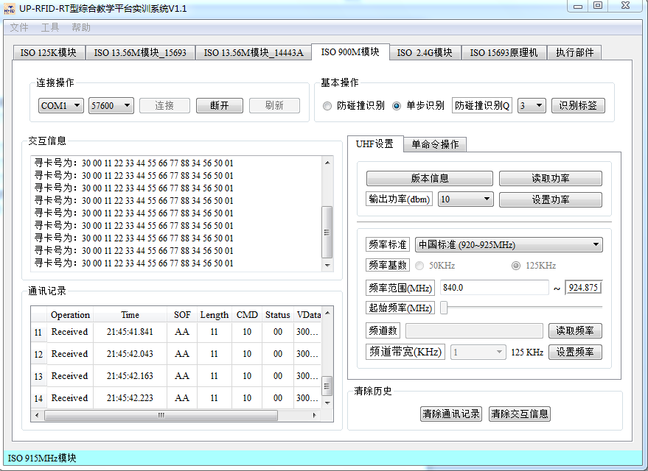

图 19 单标签识别实验

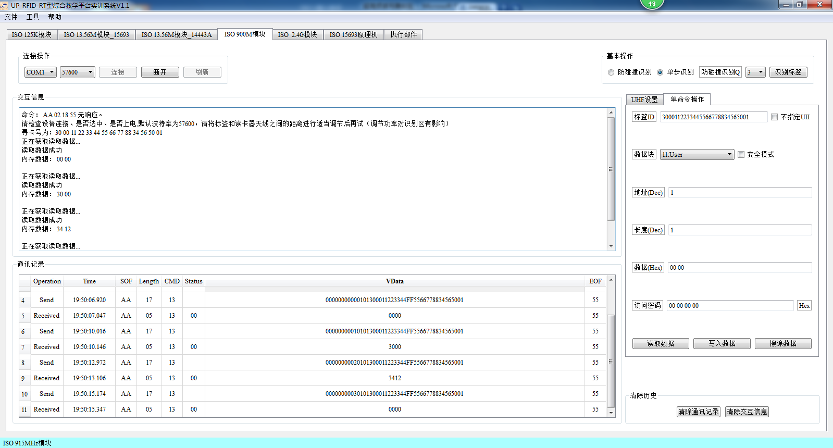

图 20 多标签实验

两张卡重叠地读取（即一张在上一张在下），只能读取到下面的卡。

3、执行 Gen2 协议下单命令操作实验，并分别对 EPC 标签各个存储区进行读写擦除操作试验；

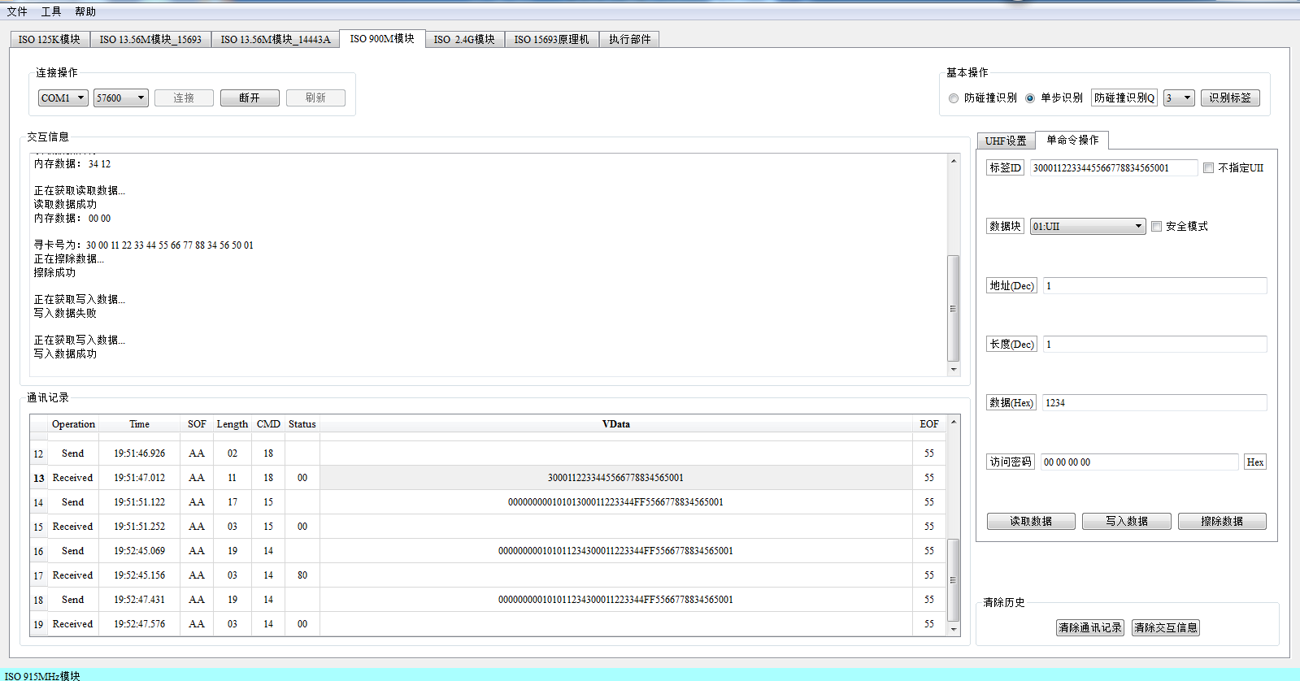

图 21 读写擦除

4、熟悉和了解超高频 UHF-900M 开发实例，掌握超高频读写器 API 函数，并通过编程实现 Gen2 协议下标签的读写功能。

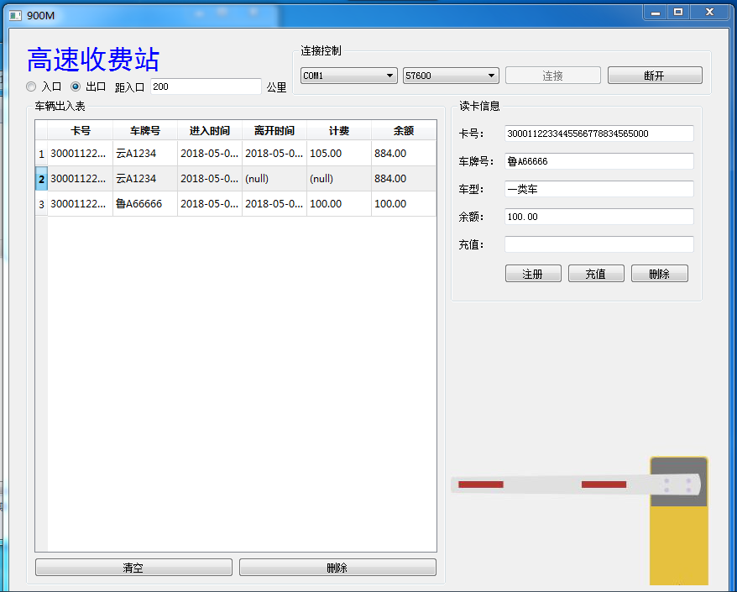

图 22 开发实例

4.3 实验体会与总结

1、试从定性和定量两个方面分析读写器功率与标签读写距离的关系；

功率越大读取标签的距离就越大，功率一定的情况下，距离越小越灵敏。

2、EPC 标签存储器分为哪几个区？各区有何功能？

Reserved区：存储Kill Password（灭活口令）和Access Password（访问口令）；

1. EPC 标签可以通过哪些措施来保证各个存储区的信息安全？

TID区：存储标签识别号码，每个TID号码应该是唯一的；User区：存储用户定义的数据。

1. EPC 和 TID 分别表示什么含义？二者结构有何特点？

EPC（Electronic Product Code），展品电子代码，对供应链中的对象进行全球唯一的标识；TID，RFID电子标签识别号，是标签之间身份区别的标志，具有唯一性。

总结：通过这次实验，我学会了通过试验箱对 Gen2 协议下标签指定存储区的数据读写，加深了对Gen2 协议下标签存储器结构的理解，了解了读写器功率和频率对电子标签读写的影响，了解了访问密码的用途和使用方法，了解了超高频读写器 API 函数的调用方法。

4.4 开发实例源码

|  |
| --- |
| #include "regist_widget.h"  #include <QMessageBox>  #include <QDebug>  Regist_Widget::Regist_Widget(QWidget *parent) : QWidget(parent)  {  */*注册账号界面 按钮和标签的文本*/*  char Button_Name[][50] = {"提交","重置","取消"};  char Label_Name[][50] = {"卡号：","车牌号：", "金额：", "车型："};  QVBoxLayout *label_layout = **new** QVBoxLayout();*//标签的布局*  */*实例化标签，将标签添加到布局中*/*  **for**(int i = 0; i < LABEL_COUNT_REGIST; i++)  {  Label[i] = **new** QLabel();  Label[i]->setText(Label_Name[i]);  label_layout->addWidget(Label[i]);  }  label_layout->setSpacing(30);  QVBoxLayout *edit_layout = **new** QVBoxLayout();*//文本框的布局*  */*实例化文本框， 将文本框添加到布局中*/*  **for**(int i = 0; i < EDIT_COUNT_REGIST; i++)  {  Edit[i] = **new** QLineEdit();  edit_layout->addWidget(Edit[i]);  }  QString pattern("[9-0]{3}");  QRegExp regExp(pattern);  Edit[Balance_Regist]->setValidator(**new** QRegExpValidator(regExp, **this**));  pattern = "[**\u4e00**-**\u9fa5**]{1}[A-Fa-f]{1}[9-0]{5}";  regExp.setPattern(pattern);  Edit[Plate_number_Regist]->setValidator(**new** QRegExpValidator(regExp, **this**));  */*实例化车类型下拉列表*/*  Types = **new** QComboBox();  */*将类型添加到列表中*/*  QStringList types_text;  types_text<<"一类车"<<"二类车"<<"三类车"<<"四类车"<<"五类车";  Types->addItems(types_text);  */*将列表添加到布局中*/*  edit_layout->addWidget(Types);  */*说明标签*/*  instruction = **new** QLabel("一类车:0.5元/公里 二类车:1元/公里 **\n**三类车:1.5/公里 四类车:1.8/公里 **\n**五类车:2/公里");  edit_layout->setSpacing(30);*//设置间距*  */*按钮布局*/*  QHBoxLayout *button_layout = **new** QHBoxLayout();  */*实例化按钮，将按钮添加到布局中*/*  **for**(int i = 0; i< BUTTON_COUNT_REGIST; i++)  {  PushButton[i] = **new** QPushButton();  PushButton[i]->setText(Button_Name[i]);  button_layout->addWidget(PushButton[i]);  }  button_layout->setSpacing(30);  */*设置总体布局*/*  QGridLayout *mainlayout = **new** QGridLayout();  mainlayout->addLayout(label_layout,0,0,1,1);  mainlayout->addLayout(edit_layout,0,1,1,1);  mainlayout->addWidget(instruction, 1,1,1,2);  mainlayout->addLayout(button_layout,2,0,1,2);  **this**->setLayout(mainlayout);  */*按钮的单机事件连接槽*/*  connect(PushButton[Regist_Regist], SIGNAL(clicked()), **this**, SLOT(Uhf_Regist_Button_Click())); *//连接按钮单击事件连接Uhf_Connect_Button_Click()函数*  connect(PushButton[Rese_Registt], SIGNAL(clicked()), **this**, SLOT(Uhf_Rese_Button_Click()));*//断开按钮单击事件连接Uhf_Disconnect_Button_Click()函数*  connect(PushButton[Cancel_Regist], SIGNAL(clicked()), **this**, SLOT(Uhf_Cancel_Button_Click()));*//注册按钮单击事件连接Uhf_Update_Button_Click()函数*  }  void Regist_Widget::Uhf_Regist_Button_Click()  {  *//标签中显示的文本，用于在提示框中显示*  char Label_Name[][50] = {"卡号：","车牌号：", "金额：", "车型："};  */*如果文本框中存在空，则提示不能为空*/*  **for**(int i = 0; i < EDIT_COUNT_REGIST; i++)  {  **if**(Edit[i]->text().isEmpty())  {  char warning[256];  sprintf(warning,"%s不能为空",Label_Name[i]);  QMessageBox::warning(NULL, "warning", warning, QMessageBox::Yes, QMessageBox::Yes);  **return**;  }  }  Sqlite sql;  QSqlQuery Sqlite;  */*查询卡号是否已经存在*/*  char where[256];  sprintf(where,"cardID = '%s'",Edit[ID_Regist]->text().toUtf8().data());  Sqlite = sql.select("user", where);  **if**(Sqlite.next())  {  QMessageBox::warning(NULL, "warning", "已存在此卡", QMessageBox::Yes, QMessageBox::Yes);  **return**;  }  */*将文本框中的信息添加到数据库*/*  sql.add_user(Edit[ID_Regist]->text().toUtf8().data(), Edit[Plate_number_Regist]->text().toUtf8().data(), Types->currentText().toUtf8().data(), Edit[Balance_Regist]->text().toInt());  QMessageBox::warning(NULL, "warning", "注册成功", QMessageBox::Yes, QMessageBox::Yes);  */*清空文本框*/*  **for**(int i = 0; i < EDIT_COUNT_REGIST; i++)  {  Edit[i]->clear();  }  }  void Regist_Widget::Uhf_Rese_Button_Click()  {  */*清空文本框*/*  **for**(int i = 0; i < EDIT_COUNT_REGIST; i++)  {  Edit[i]->clear();  }  }  void Regist_Widget::Uhf_Cancel_Button_Click()  {  */*关闭窗口*/*  **this**->close();  }  void Regist_Widget::Set_CardID(QString Card_id)  {  Edit[0]->setText(Card_id);  }  #include "sqlite.h"  Sqlite::Sqlite()  {  }  */*连接数据库*/*  bool Sqlite::connect()  {  db = QSqlDatabase::addDatabase("QSQLITE");  db.setDatabaseName(DATABASE);  **if**(!db.open()) **return** false;  QSqlQuery query;  */*创建user表 cardID和plate_number作为联合主键*/*  *//卡号、车牌号、车类型、余额*  query.exec("create table user_900M (cardID vchar, plate_number vchar, type vchar, balance float, primary key (cardID,plate_number))");  */*创建record表 cardID和plate_number作为外键*/*  *//卡号、车牌号、进入时间、出去时间、计费、余额*  query.exec("create table record_900M (cardID vchar, plate_number vchar, inTime vchar, outTime vchar, consumption float, balance float,FOREIGN KEY (cardID ) REFERENCES user(cardID), FOREIGN KEY (plate_number ) REFERENCES user(plate_number))");  **return** true;  }  */*添加user数据*/*  bool Sqlite::add_user(char *cardID, char *plate_number, char *type, float balance)  {  char command[256];  sprintf(command, "insert into user_900M values('%s', '%s', '%s', %2f);", cardID, plate_number, type, balance);  qDebug("ADD USER:%s**\n**",command);  QSqlQuery query;  **return** query.exec(command);  }  */*添加record数据*/*  bool Sqlite::add_record(char *cardID, char *plate_number, char *inTime, char *outTime, float consumption,float balance)  {  char command[256];  sprintf(command, "insert into record_900M values('%s', '%s', '%s', '%s', %2f, %2f);", cardID, plate_number, inTime, outTime, consumption, balance);  qDebug("ADD RECORD:%s**\n**",command);  QSqlQuery query;  **return** query.exec(command);  }  */*更改user中的数据*/*  bool Sqlite::update_user(char *cardID, char *plate_number, float balance)  {  char command[256];  sprintf(command, "update user_900M set balance = %2f where cardID = '%s' and plate_number = '%s'", balance, cardID, plate_number);  QSqlQuery query;  qDebug("UPDATE USER:%s**\n**",command);  **return** query.exec(command);  }  *//更改record中的数据*  bool Sqlite::update_record(char *cardID, char *plate_number, char *inTime, char *outTime, float consumption,float balance)  {  char command[256];  sprintf(command, "update record_900M set outTime = '%s', consumption = %2f, balance = %2f where cardID = '%s' and plate_number = '%s' and inTime = '%s'", outTime, consumption, balance, cardID, plate_number, inTime);  QSqlQuery query;  qDebug("UPDATE RECORD:%s**\n**",command);  **return** query.exec(command);  }  *//查找（表名称，条件）*  QSqlQuery Sqlite::select(**const** char *table, char *where)  {  char command[256];  sprintf(command, "select * from %s", table);  **if**(where!=NULL)  {  char tmp[256];  strcpy(tmp,command);  sprintf(command,"%s where %s",tmp,where);  }  QSqlQuery query;  qDebug("SELECT:%s**\n**",command);  query.exec(command);  **return** query;  }  *//删除（表名称，条件）*  bool Sqlite::del(**const** char *table, char *where)  {  char command[256];  sprintf(command, "delete from %s", table);  **if**(where!=NULL)  {  char tmp[256];  strcpy(tmp,command);  sprintf(command,"%s where %s",tmp,where);  }  QSqlQuery query;  qDebug("DEL:%s**\n**",command);  **return** query.exec(command);  }  Sqlite::~Sqlite()  {  db.close();  } #include "uhf_thread.h"  #include <QMessageBox>  #include <QDebug>  #include <QObject>  UHF_Thread::UHF_Thread(QObject *parent) : QThread(parent)  {  serialport = **new** QSerialPort();  Dll = **new** M900Dll();*//dll链接库*  }  UHF_Thread::~UHF_Thread()  {  }  void UHF_Thread::run()  {  char data[1024];  *//帧的标志，数据的长度，长度，指令，状态，数据数组下标*  int flag = UHF_RPC_SOF, length=0, len=0, cmd=0, status=0, index = 0;  **while**(nRunFlag)  {  char ch;  **if**(serialport->bytesAvailable())*//如果可以读取*  {  **if**(!serialport->read(&ch,1) || (ch&0xff) == 0xff)*//如果没有读到数据 或者 读到的是0xff 退出本次循环*  **continue**;  **switch**(flag)  {  **case** UHF_RPC_SOF:*//头*  */*初始化长度、数组和数组下标*/*  len = 0;  index = 0;  memset(data,0,**sizeof**(data));  **if**((ch&0xff) == UHF_SOF)  flag = UHF_RPC_LEN;  **break**;  **case** UHF_RPC_LEN:*//长度*  len = ch;  flag = UHF_RPC_CMD;  **break**;  **case** UHF_RPC_CMD:*//指令*  cmd = ch;  flag = UHF_RPC_STA;  len--;  **break**;  **case** UHF_RPC_STA:*//状态*  status = ch;  flag = UHF_RPC_DAT;  len--;  length = len-1;*//length 是数据的长度*  **break**;  **case** UHF_RPC_DAT:*//数据*  len--;  **if**(len > 1)  {  data[index++] = ch;  }**else** **if**(len == 1)  {  flag = UHF_RPC_EOF;  }**else** **if**(len <= 0)  {  flag = UHF_RPC_SOF;  }  **break**;  **case** UHF_RPC_EOF:*//尾*  flag = UHF_RPC_SOF;  **if**((ch&0xff) == UHF_EOF)  {  Process_data(cmd,data,length,status);*//数据处理*  serialport->clear();  }  **break**;  **default**:  flag = UHF_RPC_SOF;  **break**;  }  }  QThread::msleep(10);  }  }  void UHF_Thread::Process_data(int cmd, char data[], int length, int status)  {  Tools tools;  **switch**(cmd)  {  **case** UHFCMD_GET_STATUS:*// 询问状态*  **break**;  **case** UHFCMD_GET_POWER:*// 读取功率*  **break**;  **case** UHFCMD_SET_POWER:*// 设置功率*  **break**;  **case** UHFCMD_GET_FRE:*// 读取频率*  **break**;  **case** UHFCMD_SET_FRE:*// 设置频率*  **break**;  **case** UHFCMD_GET_VERSION:*// 读取版本信息*  **break**;  **case** UHFCMD_INVENTORY:*// 识别标签（单标签识别）*  emit **this**->cardID(tools.CharStringtoHexString(NULL,data,length));*//发送信号cardID（）*  **break**;  **case** UHFCMD_INVENTORY_ANTI:*// 识别标签（防碰撞识别）*  **break**;  **case** UHFCMD_STOP_GET:*// 停止操作*  **break**;  **case** UHFCMD_READ_DATA:*// 读取标签数据*  **break**;  **case** UHFCMD_WRITE_DATA:*// 写入标签数据*  **break**;  **case** UHFCMD_ERASE_DATA:*// 擦除标签数据*  **break**;  **case** UHFCMD_LOCK_MEM:*// 锁定标签*  **break**;  **case** UHFCMD_KILL_TAG:*// 销毁标签*  **break**;  **case** UHFCMD_INVENTORY_SINGLE: *// 识别标签（单步识别）*  **break**;  **case** UHFCMD_WIEGAND_INVENTORY:*// 韦根识别*  **break**;  **case** UHFCMD_SINGLE_READ_DATA:*// 读取标签数据（不指定UII）*  **break**;  **case** UHFCMD_SINGLE_WRITE_DATA:*// 写入标签数据（不指定UII）*  **break**;  **default**:  **break**;  }  }  bool UHF_Thread::UART_Disconnect()  {  serialport->close();  **return** true;  }  */*连接串口*/*  bool UHF_Thread::UART_Connect(QString ComName,int Baudrate)  {  serialport->setPortName(ComName); *//端口号*  serialport->setBaudRate(Baudrate); *//波特率*  serialport->setDataBits(QSerialPort::Data8);*//数据位*  serialport->setParity(QSerialPort::NoParity);*//奇偶校验*  serialport->setStopBits(QSerialPort::OneStop);*//停止位*  serialport->setFlowControl(QSerialPort::NoFlowControl);*//流控制*  **if** (serialport->open(QIODevice::ReadWrite))*//以读写方式打开*  {  qDebug("OPNE SUCCESS!");  **return** true;  }  **else**  {  qDebug("OPNE FAILED!");  **return** false;  }  }  bool UHF_Thread::UHF_INIT()*//初始化UHF*  {  char *data = (char *)Dll->UHF_Connect();*//获取连接发送指令*  int len = serialport->write(data+1,data[0]);*//发送数据，data,len*  **if**(len)  {  qDebug("WRITE SUCCESS!");  }  **else**  {  qDebug("WRITE FAILED!");  }  **return** true;  }  bool UHF_Thread::Read_CardID()  {  char *data = (char *)Dll->UHF_Inventory();*//获取读卡指令*  **if**(serialport->write(data+1,data[0]))*//data,len*  {  qDebug("WRITE SUCCESS!");  }  **else**  {  qDebug("WRITE FAILED!");  }  **return** true;  } |