**Xiang Pan 潘翔**

**1900941520**

[**hover@hust.edu.cn**](mailto:hover@hust.edu.cn)

# Q1

I change the current and got the follow images. We can get the conclusion that there is a threshold for the HH model, with and when the currents up to the threshold, the shape of spike is almost the same. If the current value is higher, and the frequence will be higher.

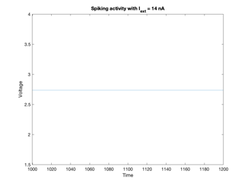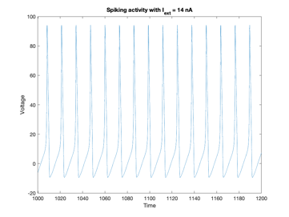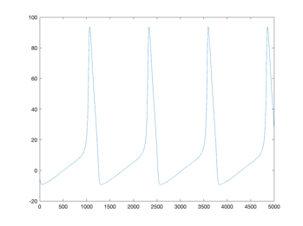

**Image 1.1 hh_func(current,noise):(4,0) (7,0) (14,0) and the** **spike image after** **amplified**